|  |  |
| --- | --- |
| LIGN 110: Phonetics | Fall 2020 |
| Section M 9-9:50 Week 1 | October 5, 2020 |

|  |  |
| --- | --- |
| TA | Yuan Chai [ɥɛn˩˥ ʈʂʰai˩˥] |
| Email | [yuc521@ucsd.edu](mailto:yuc521@ucsd.edu) |
| Section time | M 9 – 9:50 AM |
| Office hour | T 11 AM – 12 PM |
| Zoom link | <https://ucsd.zoom.us/my/ychai> |

* **The materials for the section will be emailed to you before the start of the section. The keys will be emailed to you after each section.**
* **All the materials are also available on** [**https://yuanucsd.github.io/website/lign110fall2020.html**](https://yuanucsd.github.io/website/lign110fall2020.html)

**What to expect in this section?**

* A place to do exercises relating to the class materials;
* A space to ask questions about the class materials, quizzes, assignments, and project;
* Any comments or discussions related to the class are welcome.

**What to prepare?**

* Watch the asynchronous lectures and attend the synchronous lectures on Thursday (if your time zone allows) of the previous week;
* Read the assigned readings of the previous week;
* Participate in the exercises; memorize the IPA symbols; practice saying and transcribing words. Don’t worry if you cannot get everything at the beginning. You will master it by the end of the quarter.

**Goals of Section Week 1**

* Be able to distinguish phonemes from allophones;
* Be able to distinguish voiced from voiceless sounds;
* Familiarize yourself with the name of the passive and active articulators;
* Be able to name the place of articulation for sounds in English.

**Exercises**

1. **English consonants** (Textbook p.40 Q4 & 5) The following words all have the vowel /i/, /ɪ/, /ʊ/ (as in “put”), or /ʌ/ (as in “putt”). Transcribe these words and pay attention to the consonants. Some of the consonant sounds have special symbols: /ŋ/, as in “song”, /ɹ/, as in “are”; and /ʃ/, as in wash. Note that /ŋ/ is a single sound, although usually written with two letters -ng.
2. be /bi/
3. leaks /liks/
4. neat /nit/
5. piece /pis/
6. deal /dil/
7. sing /sɪŋ/
8. trick /tɹɪk/
9. ship /ʃɪp/
10. wick /wɪk/
11. rid /ɹɪd/
12. wring /ɹɪŋ/
13. nicked /nɪkt/
14. squish /skwɪʃ/
15. book /bʊk/
16. nut /nʌt/
17. foot /fʊt/
18. lug /lʌg/
19. good /gʊd/
20. should /ʃʊd/
21. **Voiceless vs. voiced** (Textbook p.41, Q12) Note the difference in voicing between the initial consonants. Transcribe the following words:
22. myth /mɪθ/
23. three /θɹi/
24. thee /ði/
25. save (vowel: /ej/) /sejv/
26. safe (vowel: /ej/) /sejf/
27. nose (vowel: /ow/) /nowz/
28. keys (vowel: /i/) /kiz/
29. kiss (vowel: /ɪ/) /kɪs/
30. **Pronounce IPA** (Textbook p.41, Q10) Pronounce:
31. sæg
32. pʌg
33. zɛn
34. pʊt
35. mejt
36. mɪl
37. ʃɪm
38. læs
39. wʌn
40. væt
41. kʌd
42. kʊd
43. **Transcription practice** (Textbook p.42 Q15) Correct these transcriptions:
44. glue /glju/ **/glu/**
45. knives /knajvz/ **/najvz/**
46. reef /ɹɪf/ **/ɹif/**
47. shoot /sut/ **/ʃut/**
48. chew /cu/ **/tʃu/**
49. yes /yɛs/ **/jɛs/**
50. jump /jʌmp/ **/dʒʌmp/**
51. gouge /gawz/ **/gawdʒ/**
52. wealth /wɛlð/ **/wɛlθ/**
53. bloom /blʊm/ **/blum/**
54. done /dəwn/ **/dʌn/**
55. roy /ɹoj/ **/ɹɔj/**
56. says /sez/ **/sɛz/**
57. lamb /læmb/ **/læm/**
58. **Phonemic vs. allophonic (broad vs. narrow) transcription** (review Book Chapter 3 and the Weeks 0-1 Lecture: Review of phonemes and allophones)

|  |  |  |  |
| --- | --- | --- | --- |
|  | **phonemic (broad)** | **allophonic (narrow)** | **hint** |
| 1. pick (example) | **/**pɪk**/** | [pʰɪk] | aspiration |
| 1. type | /tajp/ | [tʰajp] | aspiration |
| 1. topic | /ˈtɑpɪk/ | [ˈtʰɑpɪk] | aspiration |
| 1. please | /pliz/ | [pl̥iːz̥] | devoicing |
| 1. feel | /fil/ | [fiːɫ] | /l/ allophone |
| 1. dream | /dɹim/ | [dʒɹiːm] | /d/ allophone |
| 1. key | /ki/ | [k̟ʰiː] | /k/ allophone |
| 1. cook | /kʊk/ | [k̠ʰiː] | /k/ allophone |
| 1. tenth | /tɛnθ/ | [tʰɛ̃n̪θ] | dental assimilation |
| 1. width | /wɪdθ/ | [wɪd̪θ] | dental assimilation |
| 1. city | /sɪti/ | [sɪɾi] | /t/ tapping |
| 1. letter | /ˈlɛtəɹ/ or /ˈlɛtə˞/ | [ˈlɛɾəɹ] or [ˈlɛɾə˞] | /t/ tapping |
| 1. ladder | /ˈlædəɹ/ or /ˈlædə˞/ | [ˈlæɾəɹ] or [ˈlæɾə˞] | /t/ tapping |
| 1. button | /ˈbʌtn̩/ | [ˈbʌʔn̩] | /t/ glottalization |
| 1. meet you | /mitju/ | [mitʃju] | palatalization |
| 1. stop | /stɑp/ | [stɑp̚] | unrealized stop |

1. **Naming the place of articulation (Textbook p.5 for answer)**

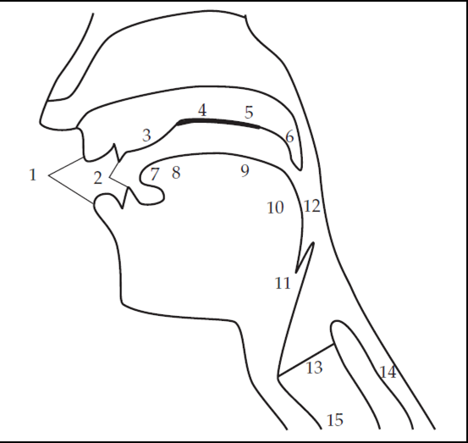

1. lips

2. teeth

3. alveolar ridge

4. palate

5. velum

6. uvula

7. tip

8. blade

9. back

10. root

11. epiglottis

12. pharyngeal wall

13. vocal folds

14. esophagus

15. trachea