Lab 1 Report

Simulating Quantum Circuits with QISKit

Author: B08901049 Yuan-Chia Chang

Instructor: Professor Hao-Chung Cheng

TA: Chia-Yi Chou

Created: 9/29/2021(Wed)

Last edited: 10/10/2021(Sun)

Contact: b08901049@ntu.edu.tw

Collaborator: B08901002 Chen-Han Lin, B08901209 Yu-Hsiang Lin

Q1

(e)

Circuit diagram

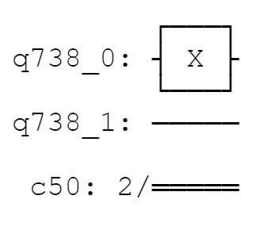

Statevector

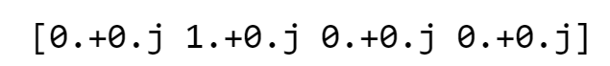

Bloch sphere

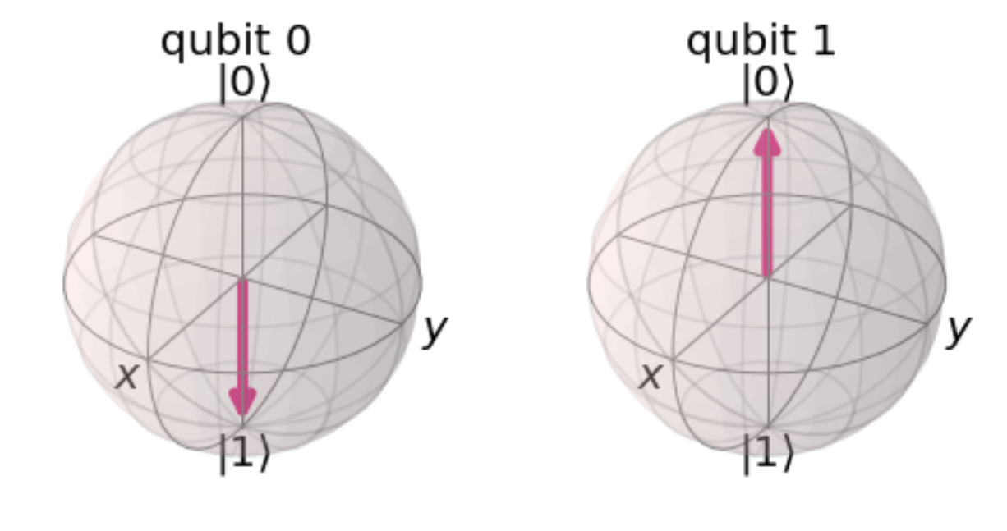

Measurement

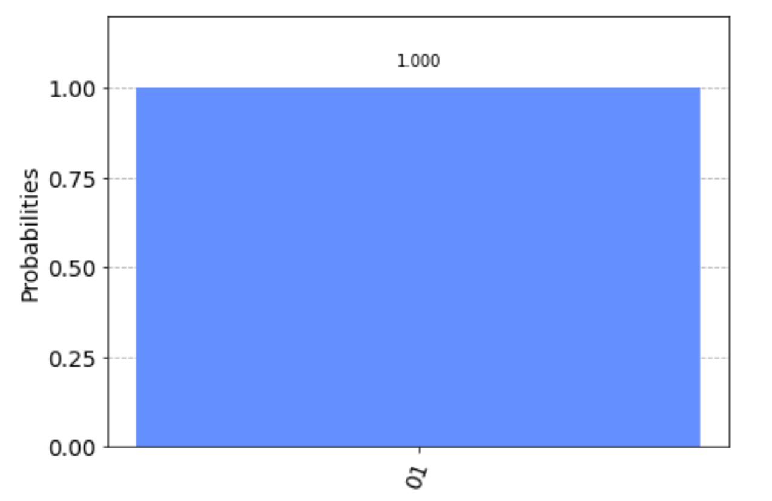

100% of 01, which means the first qubit(q[0]) is definitely 1, and the second qubit(q[1]) is definitely 0.

(f)

Measurement

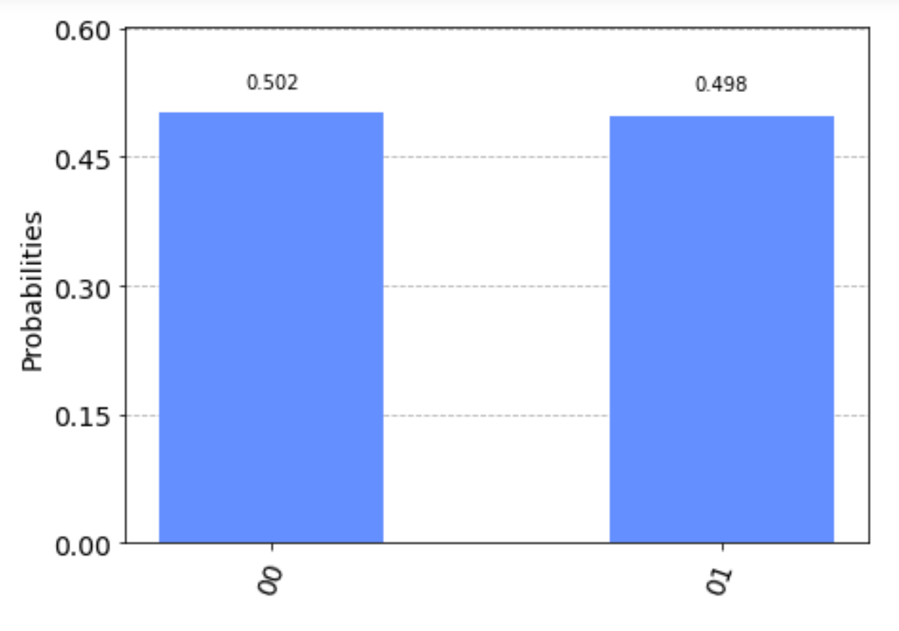

For the first bit, it has 50% probability of being 0, and 50% probability of being 1. For the second bit, it is definitely 0.

(g)

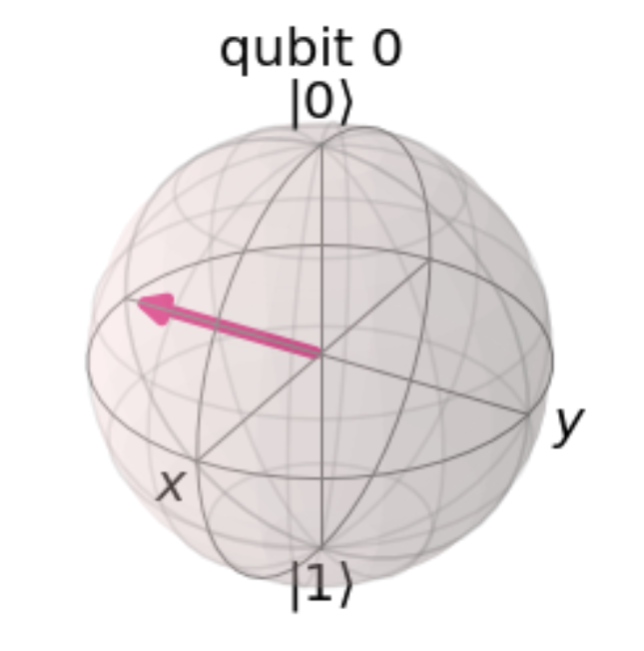

(h)

Circuit Diagram

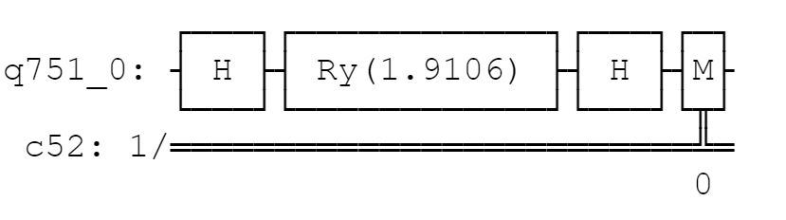

Measurement

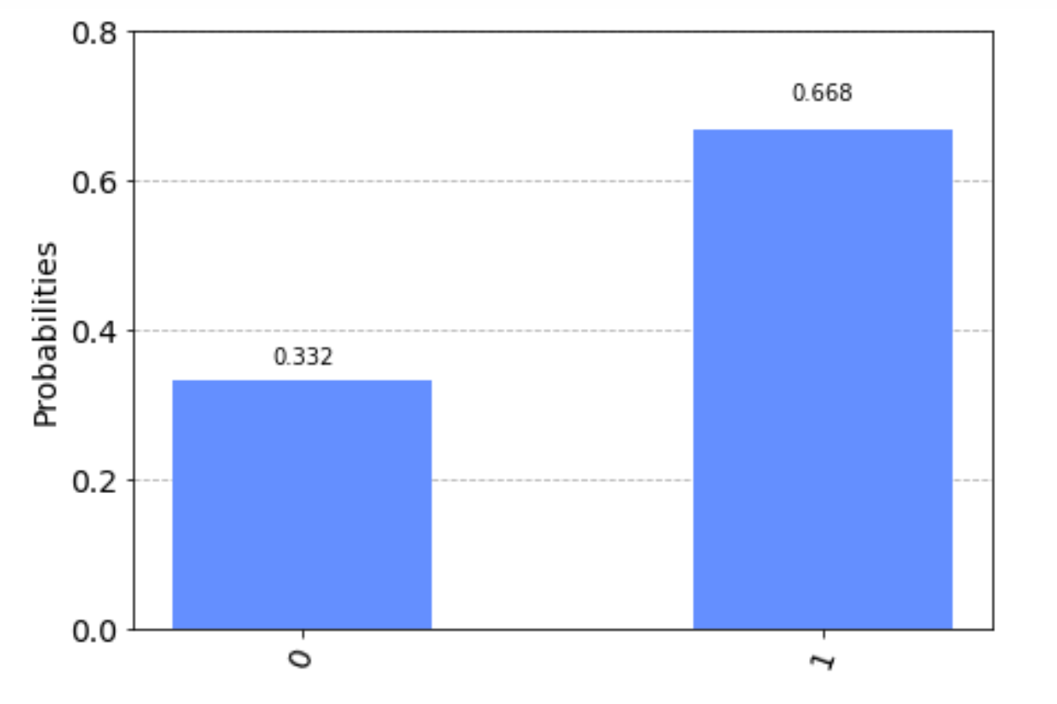

For two H gates, we change the basis from computational basis to Hadamard basis.

Between two H gates, we use rotation-Y gates. For the rotation-Y gates,

For getting |-> state 2/3 probability, , ,,

The state is not unique. For example, we can add any rotation-X gate behind the rotation-Y gate, whose angle is independent of the measuring result.

Bonus

For any single qubit state, it can be limited to the form

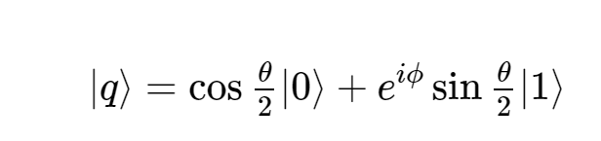

(<https://qiskit.org/textbook/ch-states/single-qubit-gates.html>)

Hence, if we apply a U3 gate on |0> state, we can obtain

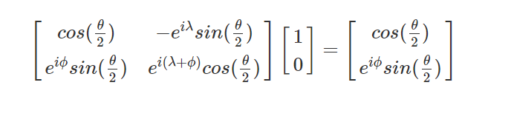

Which is composed of

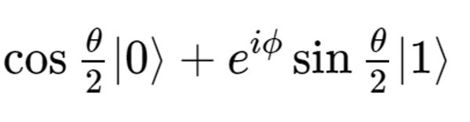

Hence, we justify that the U3 gate can equivalently act as any 1-qubit gate.

Q2

(a)

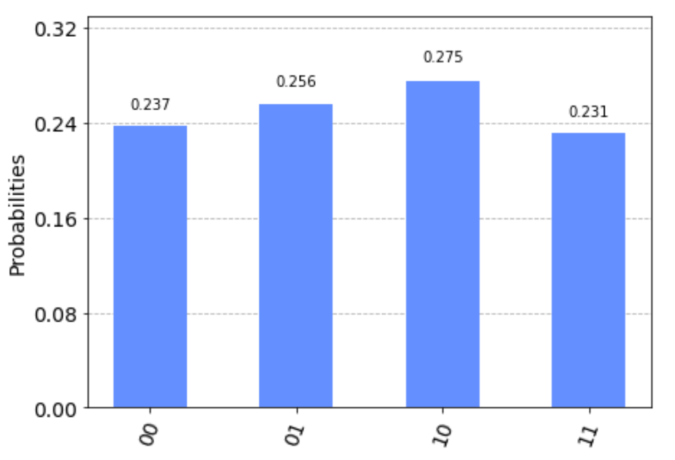

We get equal probability of 00, 01, 10, 11 states.

(b)

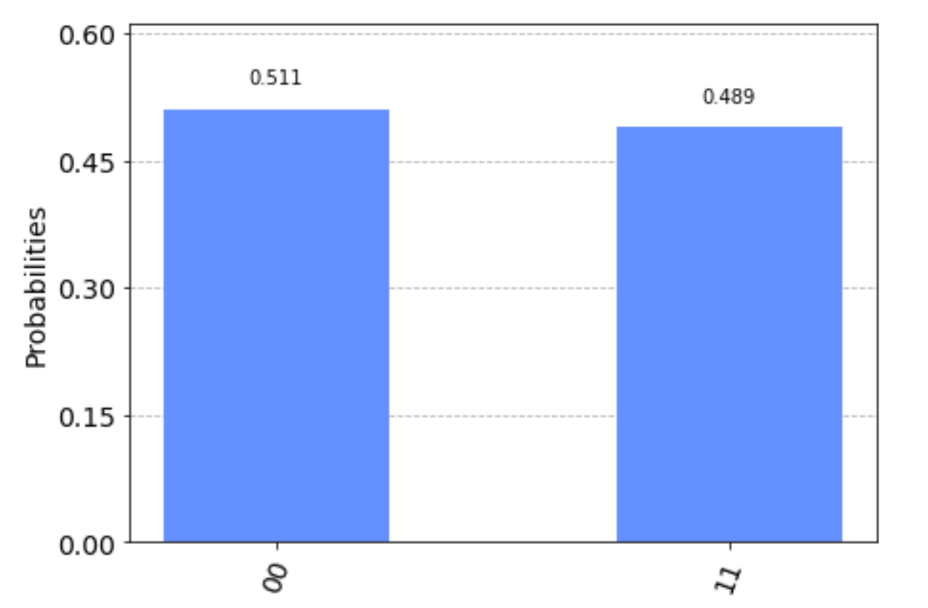

If the first classical bit is 1, and the second classical bit is definitely 1.

There is 50% probability of getting 1 on the first classical bit.

(c)

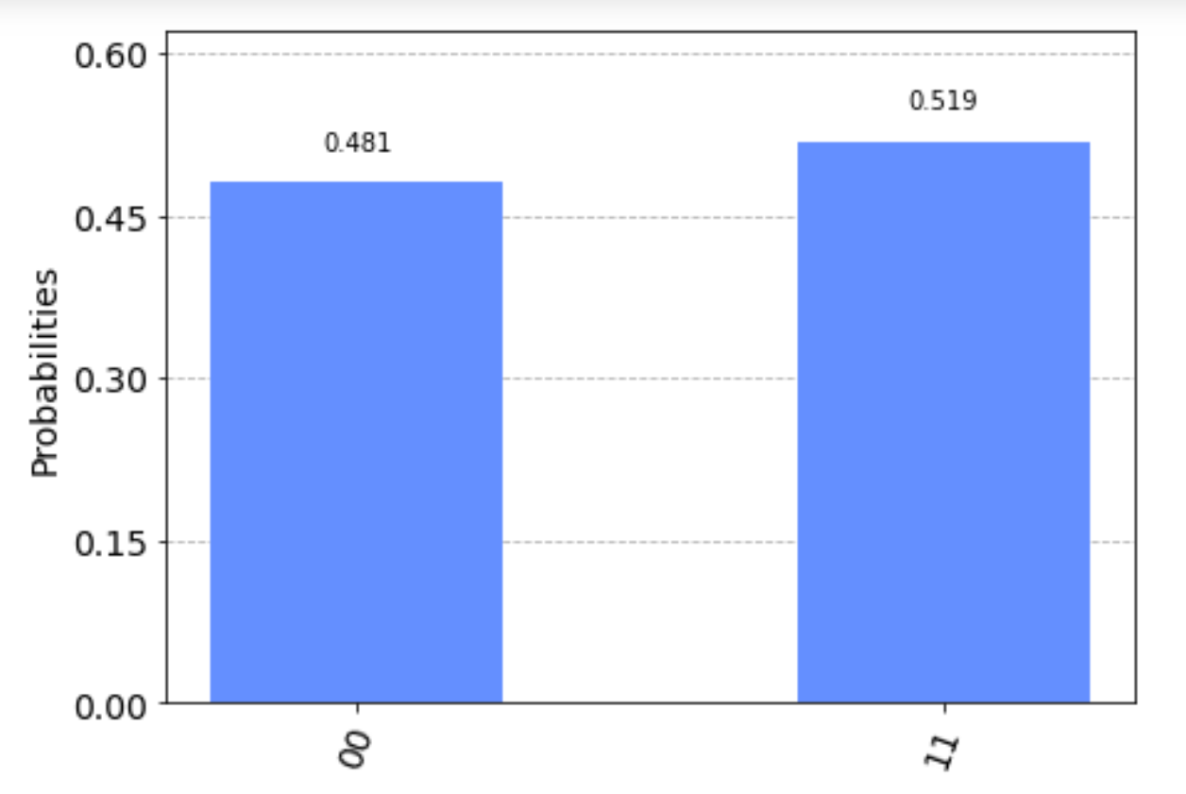

(d)

Yes,

Phi –

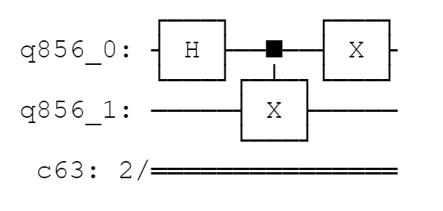

Psi +

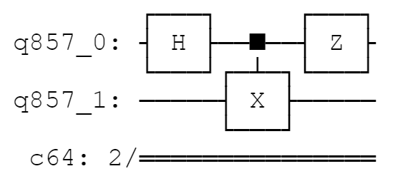

Psi –

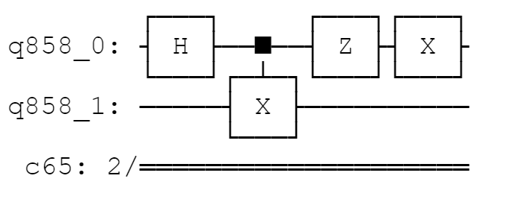

(e)

For Swap gate:

Before swap



After swap



For 3 controlled-X gate

Before



After



Q3

(a)

For

1. in computational basis:

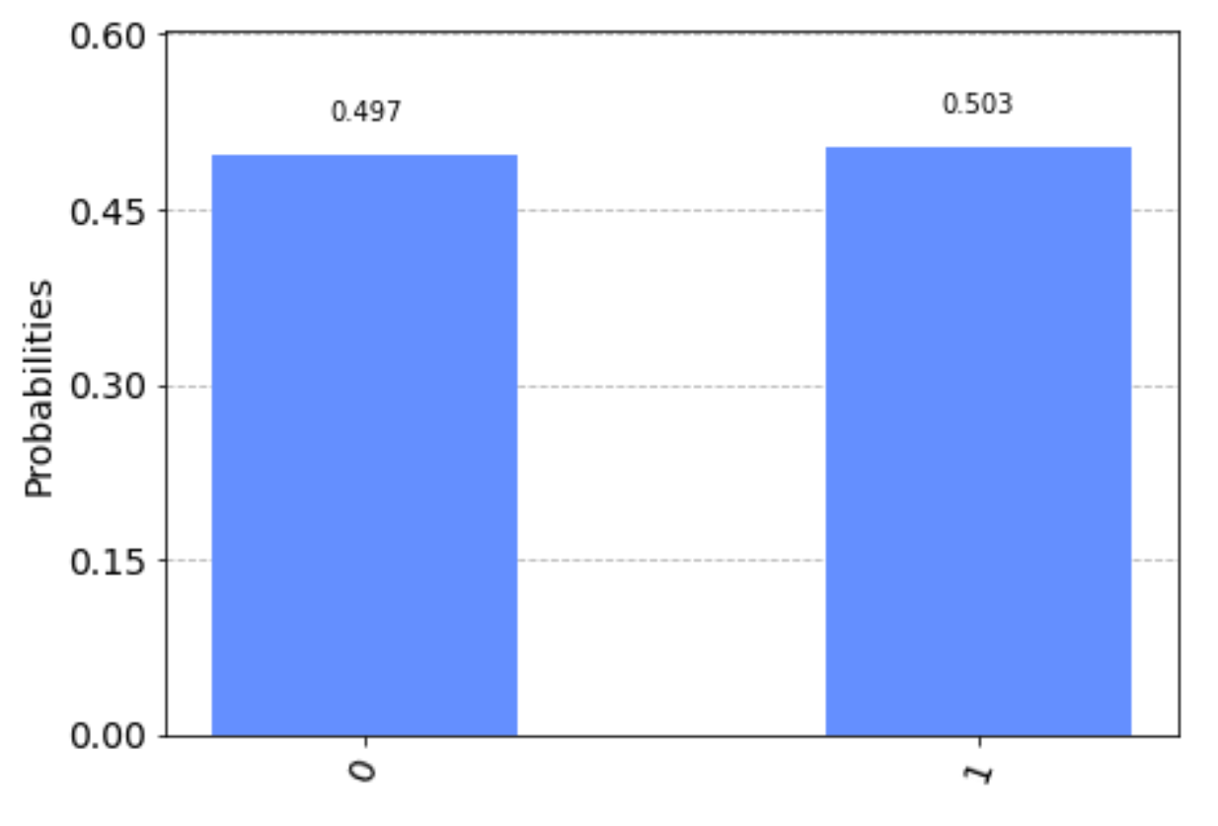

1. in rotation basis

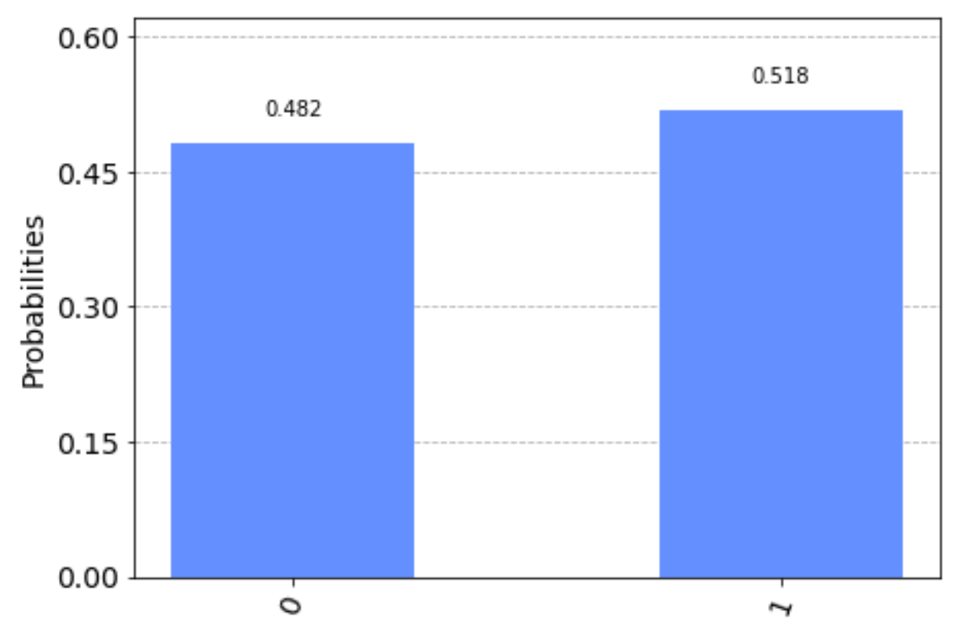

1. in Hadamard basis

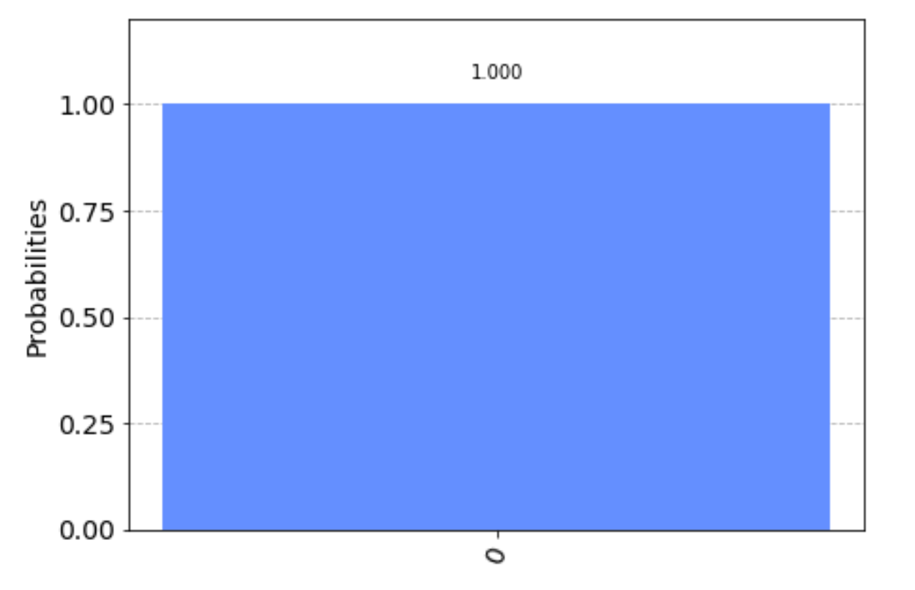

For :

1. in computational basis:

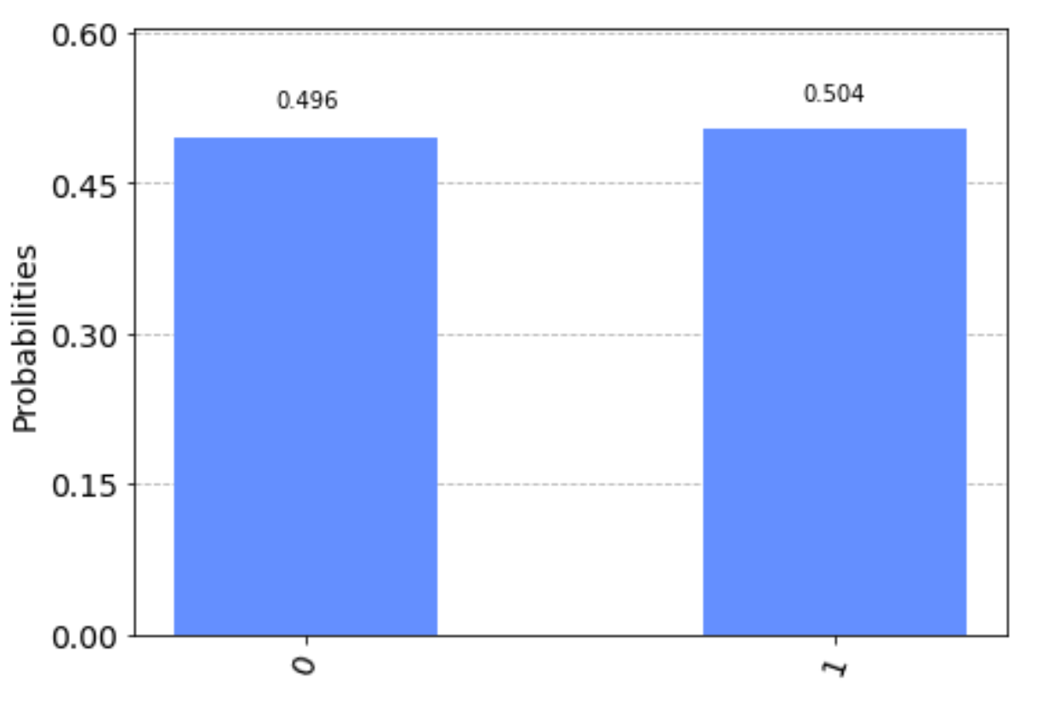

1. in rotation basis

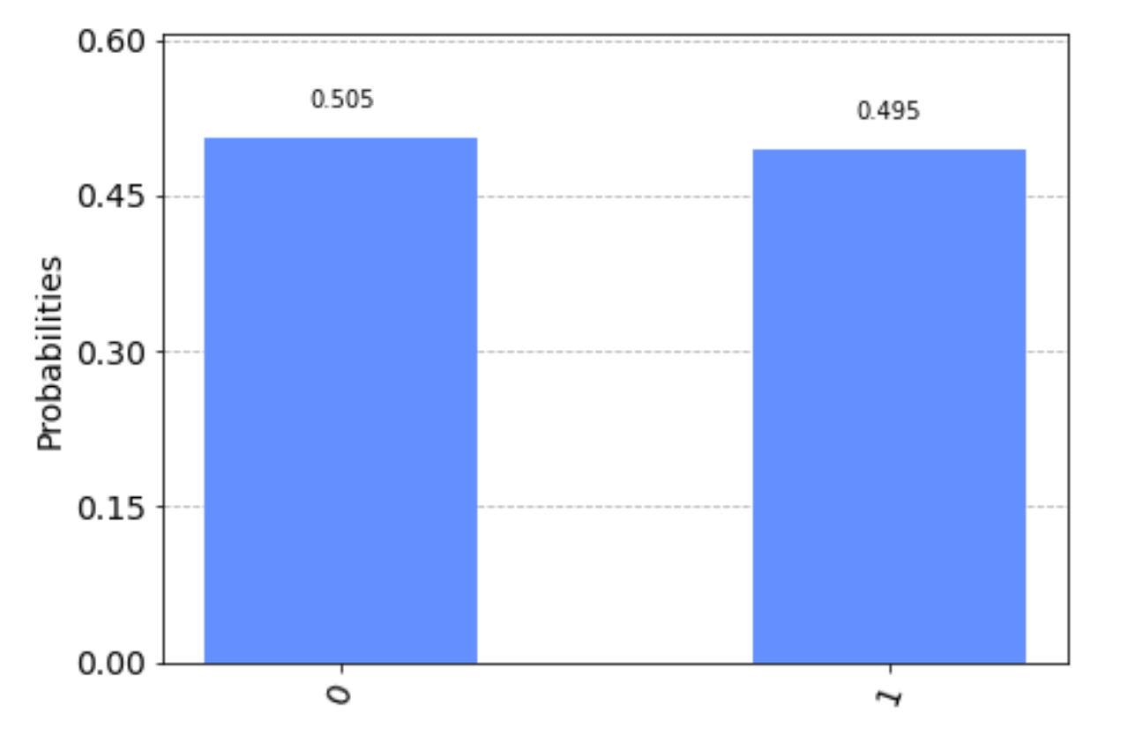

1. in Hadamard basis

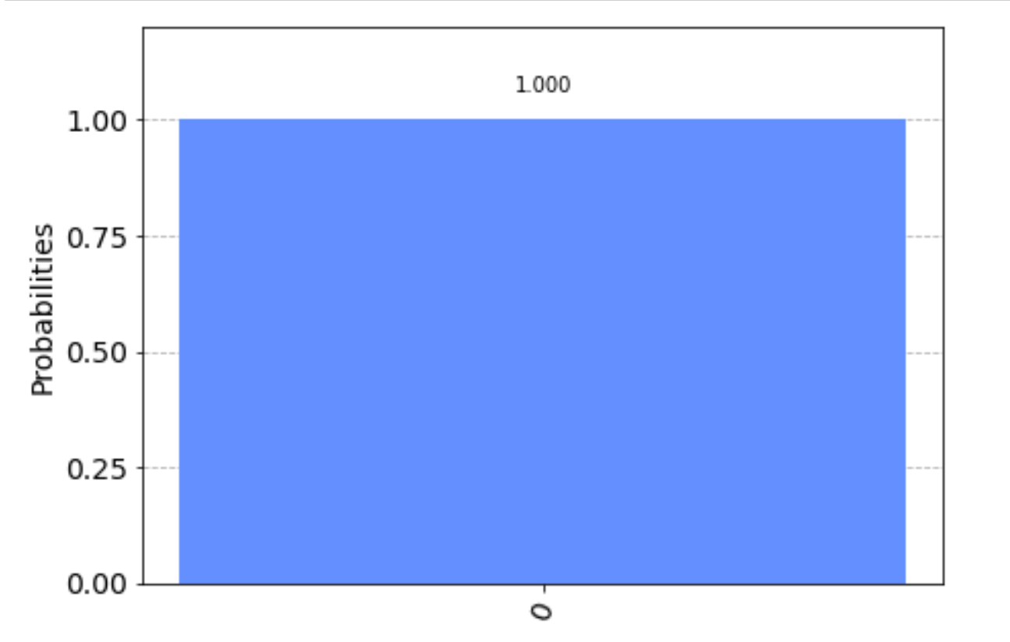

We cannot distinguish the above two by measurement.

(b)

For

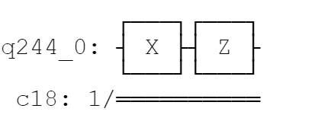



1. in computational basis:

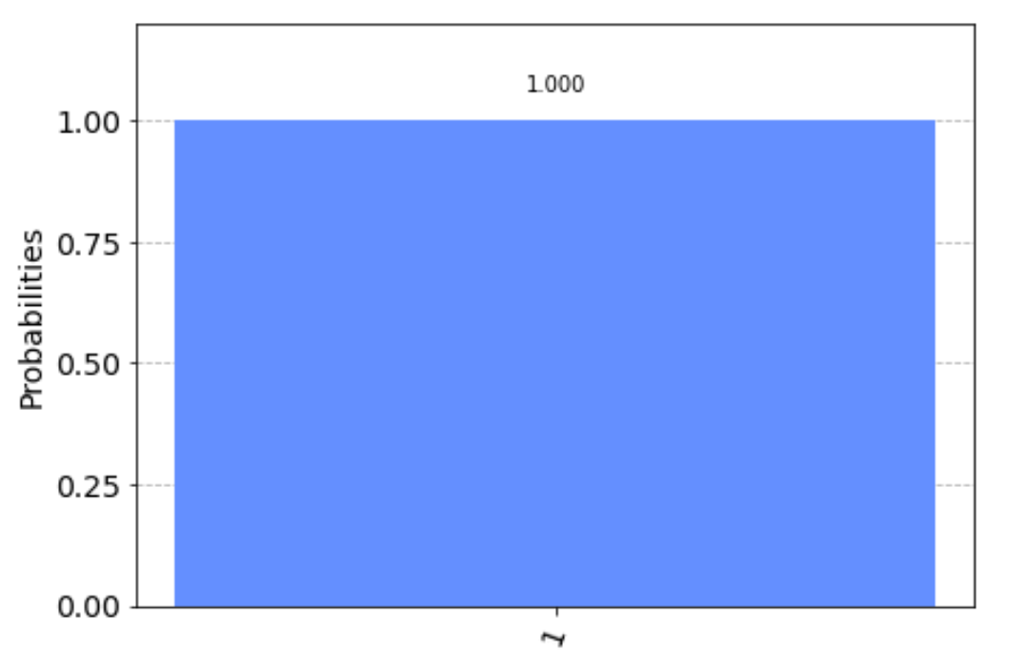

1. in rotational basis:

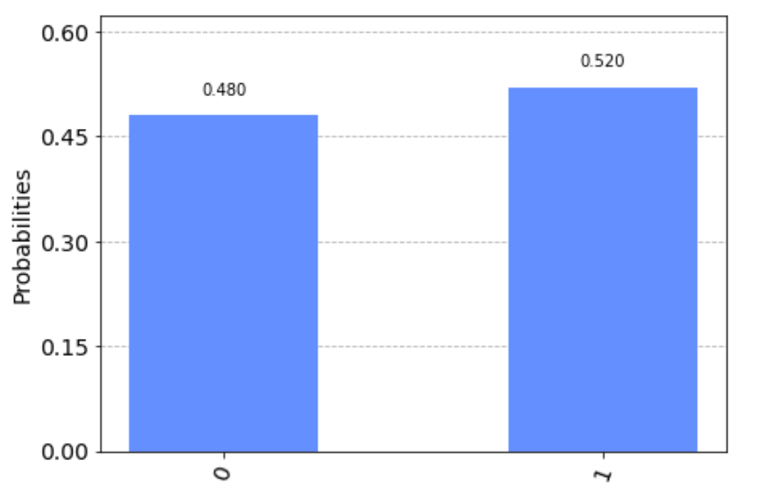

1. in Hadamard basis:

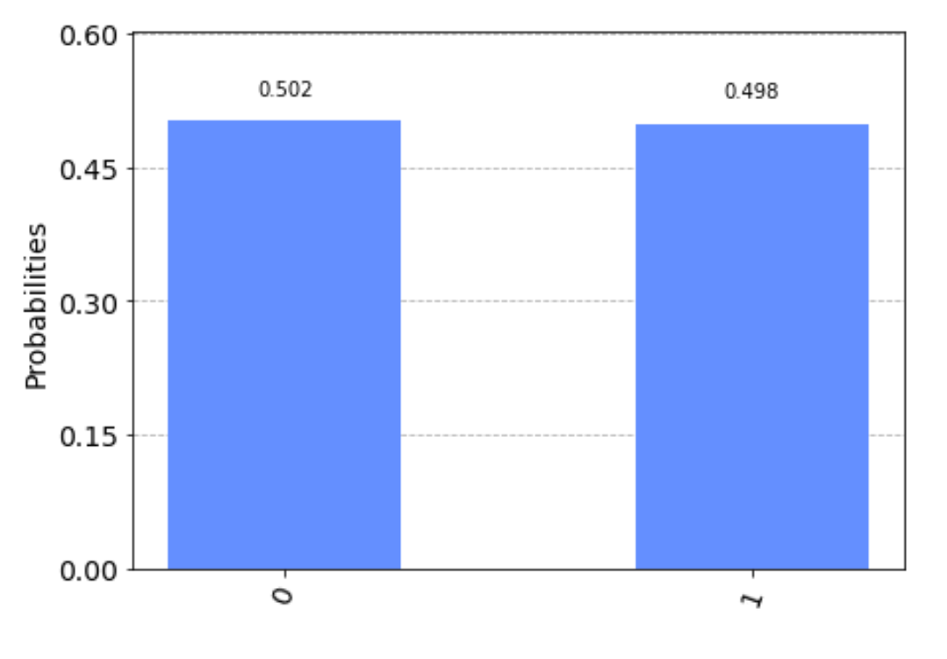

For

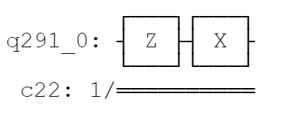

Statevector

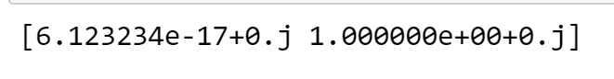

1. in computational basis:

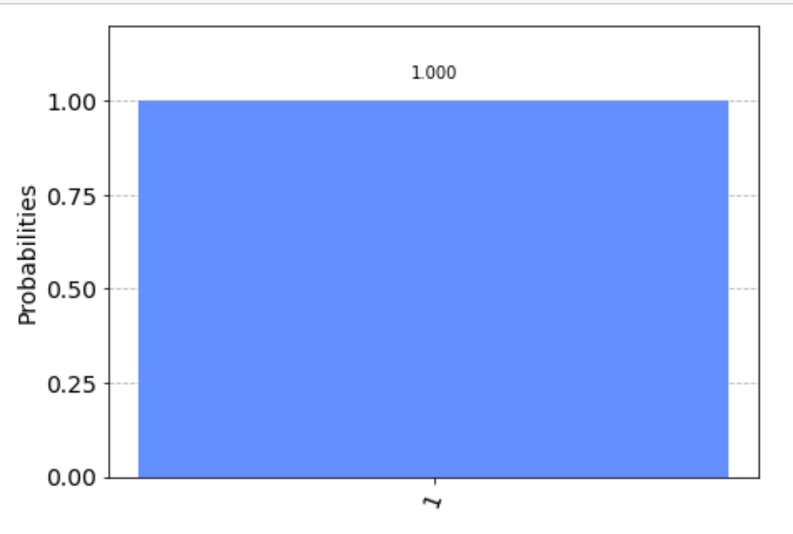

1. in rotational basis:

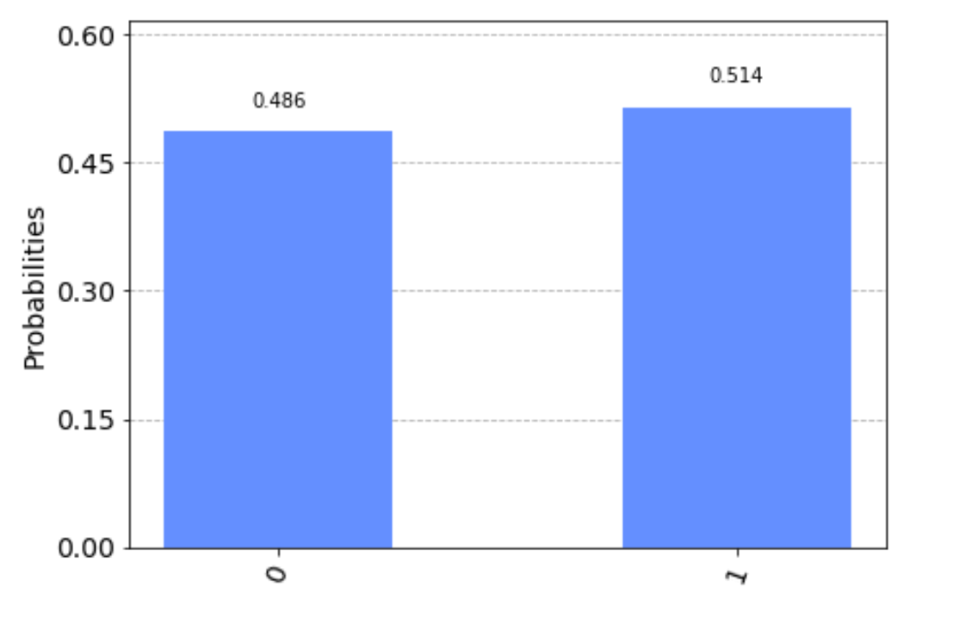

1. in Hadamard basis:

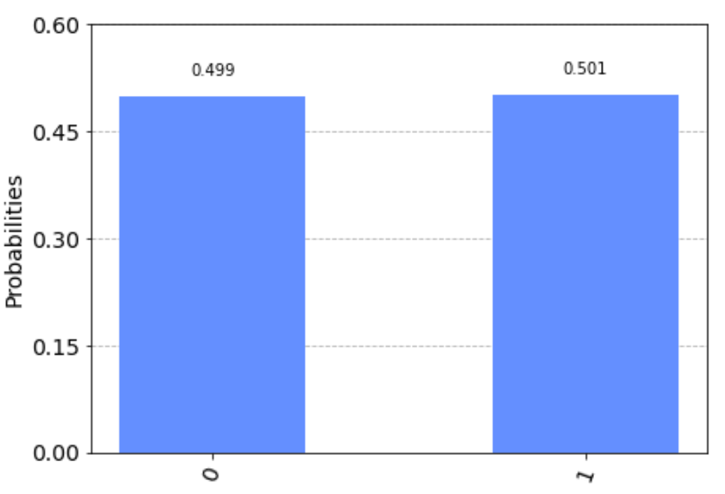

We cannot distinguish the above two by measurement.

(c)

For

1. in computational basis:

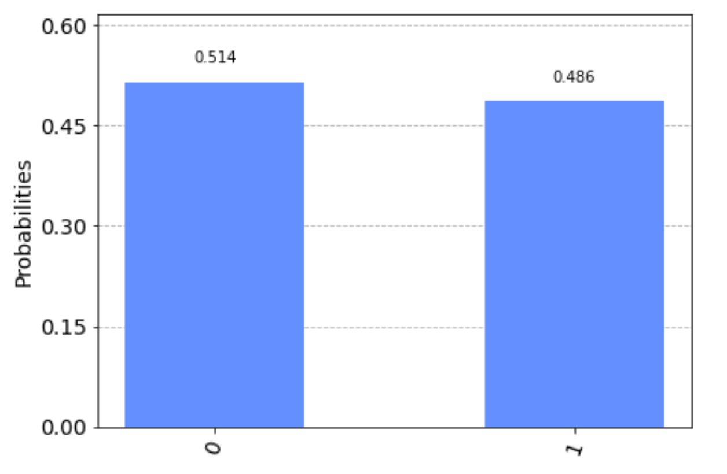

1. in rotation basis

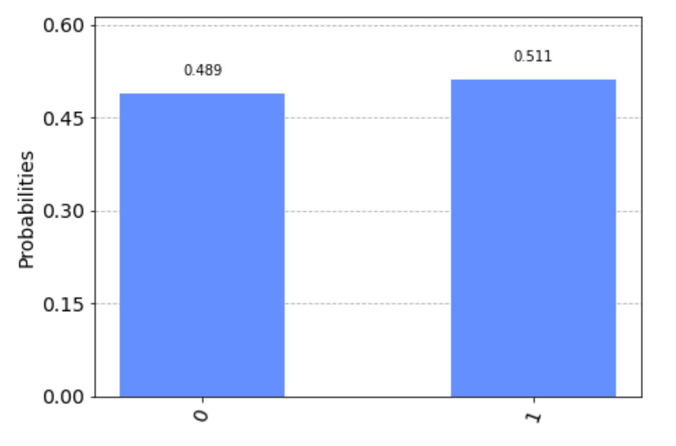

1. in Hadamard basis

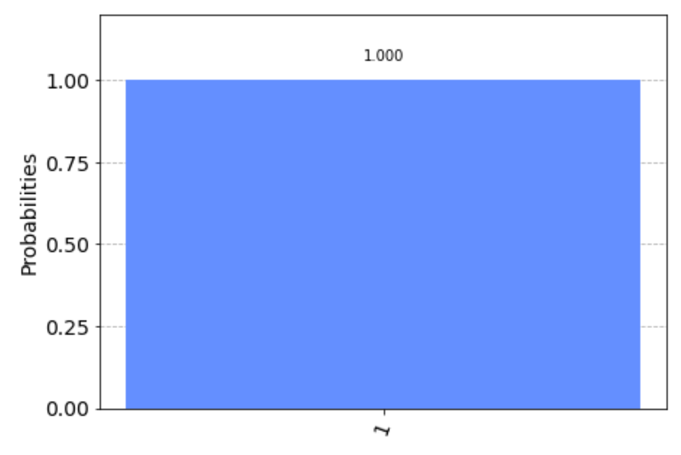

For :

1. in computational basis:

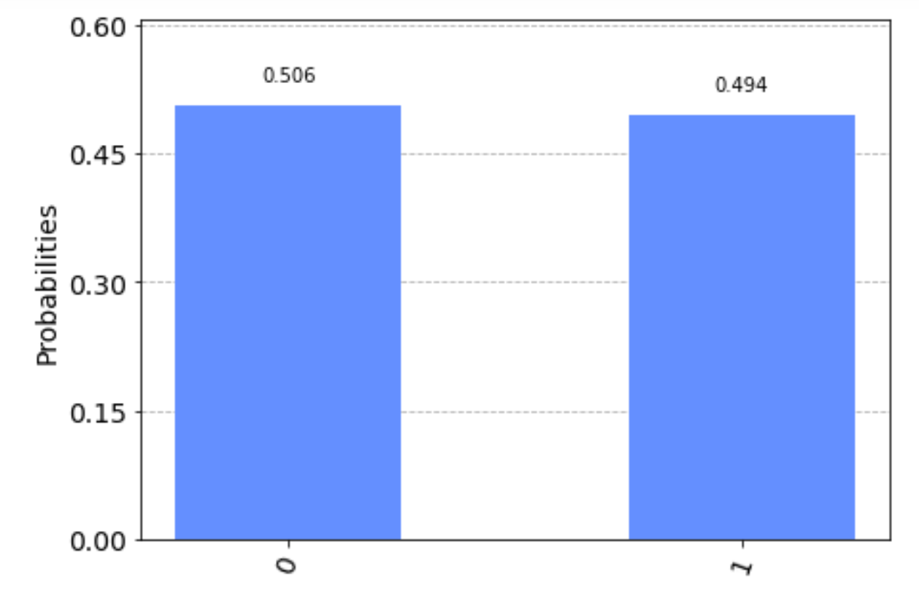

1. in rotation basis

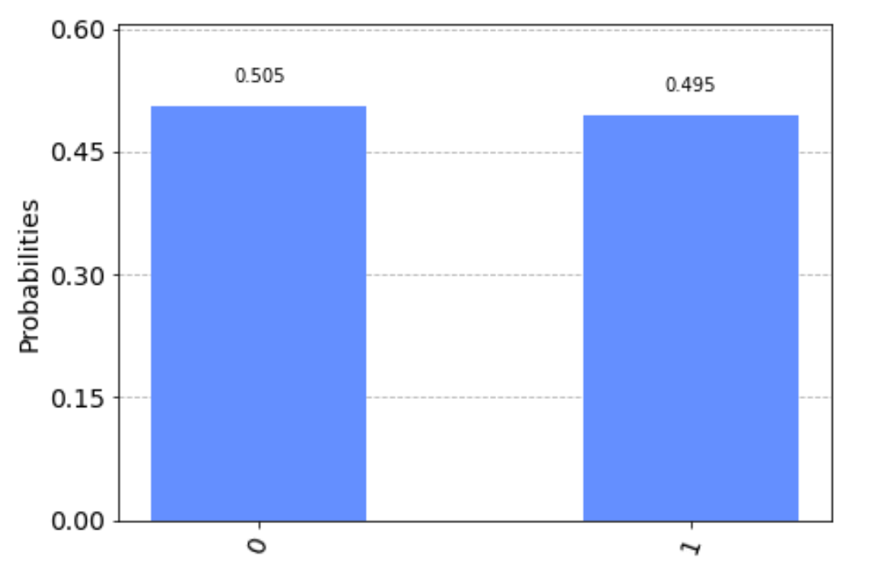

1. in Hadamard basis

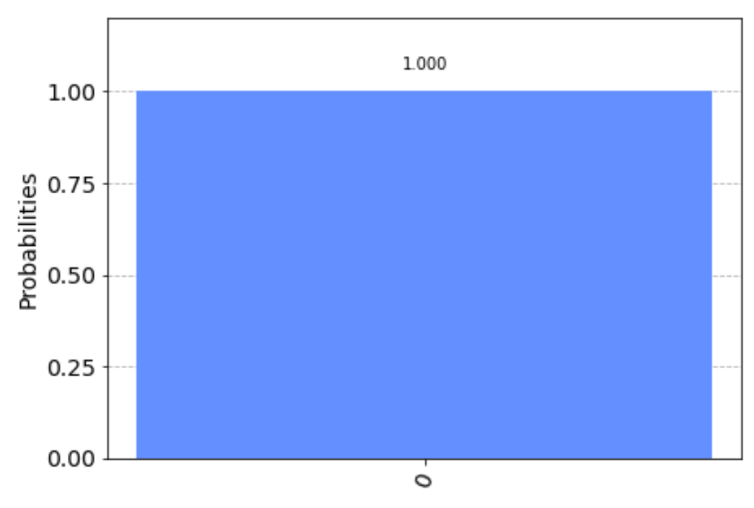

We cannot consider them to be equivalent as well because in Hadamard basis, the first qubit state is 100% 1, however, the first qubit state is 100% 0.

Q4

If

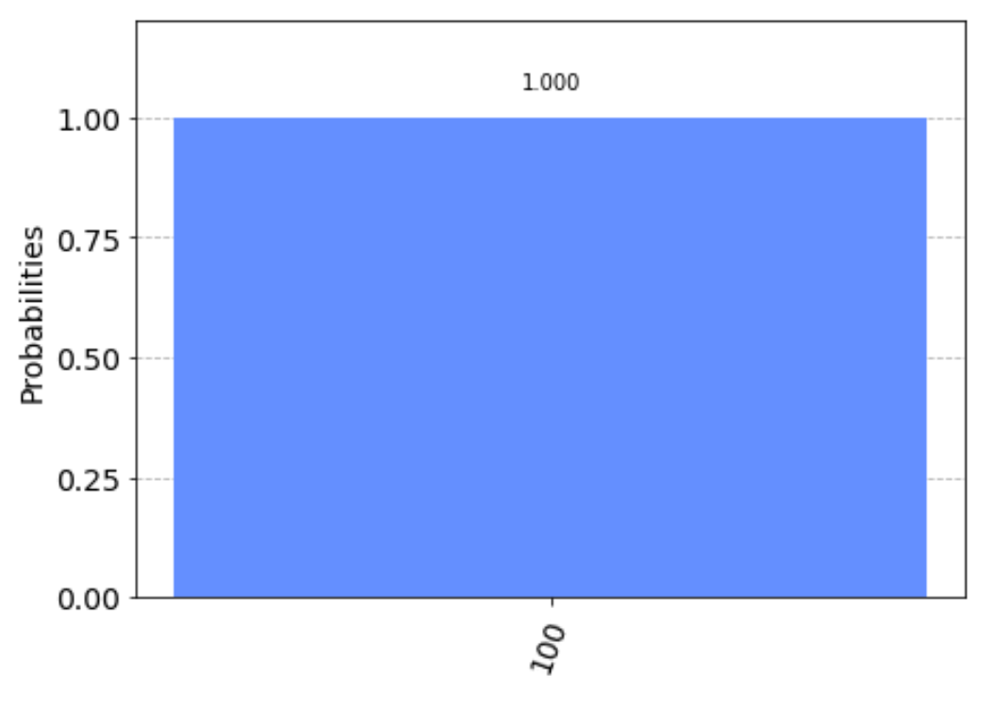

The probability of the third qubit is 0 is 0.

If

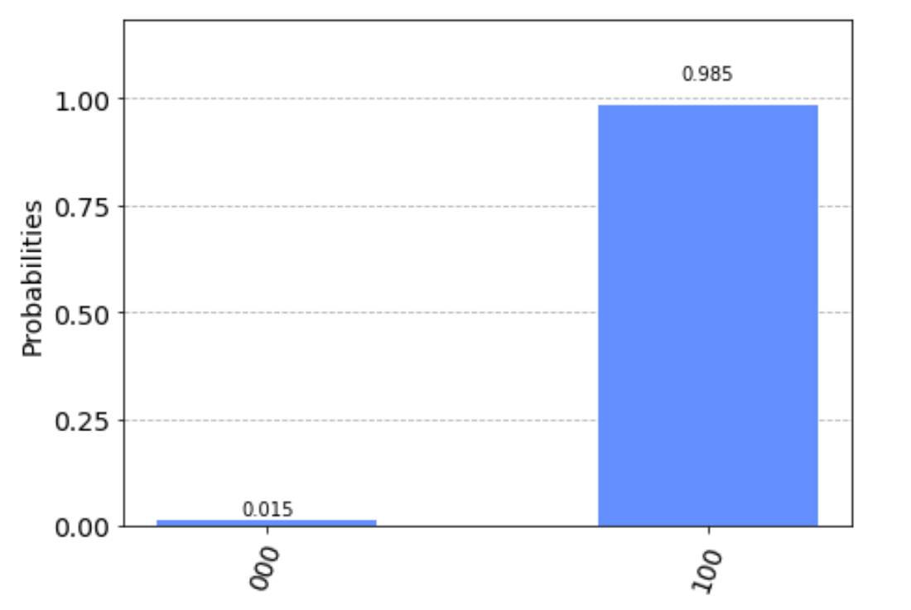

The probability of the third qubit is 0 is 0.015

If

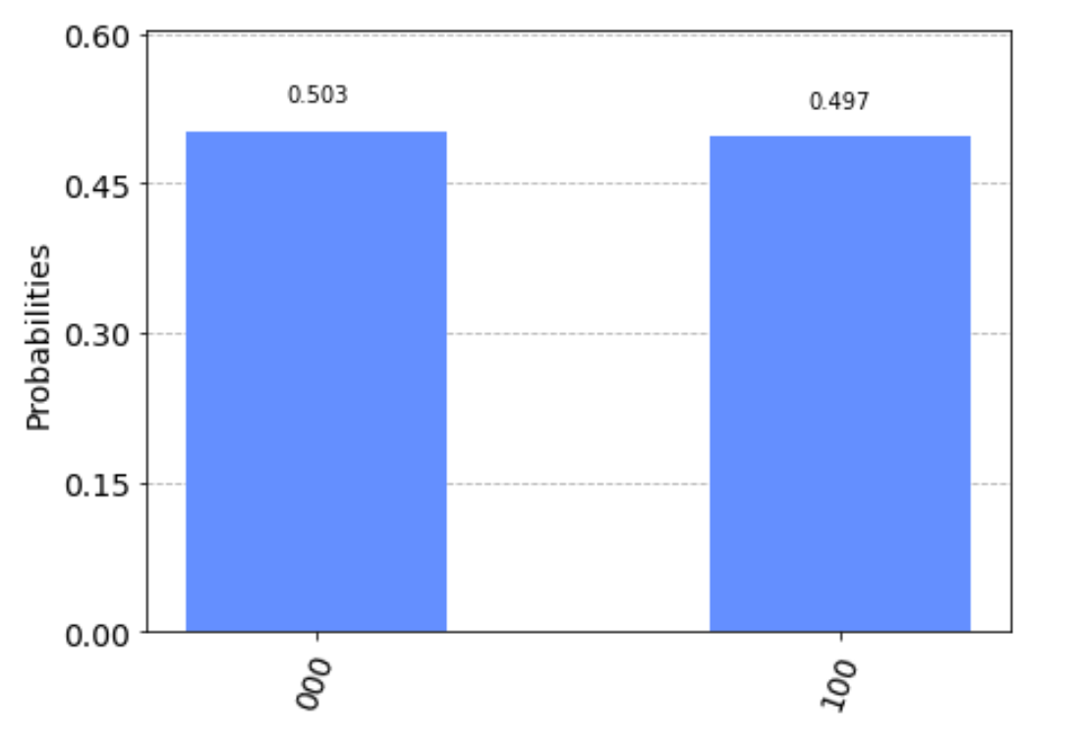

The probability of the third qubit is 0 is 0.5

If the two states are indeed the same (up to a global phase), the swap test can’t tell them which states they are.

Prove that the probability of the third qubit is 0 is

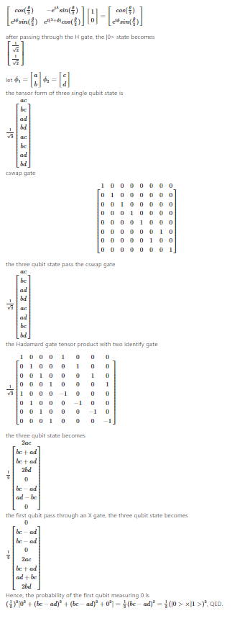

Q5

(a)

[11, 14, 24, 10, 25, 15, 27, 28, 3, 13, 17, 25, 6, 7, 12, 9, 29, 13, 0, 3]

The list is not random because it is still a simulator by classical computer.

(b)

[30, 2, 1, 31, 6, 15, 16, 10, 17, 16, 31, 30, 19, 4, 6, 3, 8, 0, 9, 28]

The list is random because it is generated by real quantum computer.

Bonus

1. We can use following methods to check randomness.

( recourse: https://www.fourmilab.ch/random/)

1. Entropy: We can compress the random sequence, if the entropy is n bits per number, it is the random sequence.
2. Chi-square test: We can use chi-square distribution to simulate a random sequence. If the average of simulation is expected in 99%, the sequence is almost random.
3. Arithmetic mean: it is simply summing all the numbers in the sequence and get the arithmetic mean. If the mean is not ，the sequence is not random
4. Monte Carlo value of pi: We can project parts of the sequence onto a square grid. If the projection is in the circle of the square grid, we call it a hit. Because the hit on the square grid is also random, we can expect that the hitting percentage should be
5. Serial correlation coefficient: We can calculate the correlation for number depending on the previous number. If the correlation is nearly zero, is is possibly random.
6. Yes, if we only have a qubit, we can generate n times to make n bit random number. The reason is that for a random generator from 0 to , there is to generate every number. For the method, it is independent to generate every 0 or 1. Hence, it is 2 of the power n to generate every n binary number, that is, there is to generate every number between 0 to .

Appendix

Source code

https://github.com/yuanchiachang/CommLab/blob/main/Lab1/src/Lab1.ipynb