Lab 2 Report

Applications of Quantum Information Processing

Author: B08901049 Yuan-Chia Chang

Instructor: Professor Hao-Chung Cheng

TA: Chia-Yi Chou

Created: 10/11/2021(Mon)

Last edited: 10/20/2021(Wed)

Contact: b08901049@ntu.edu.tw

Collaborator: B08901002 Chen-Han Lin, B08901209 Yu-Hsiang Lin

Q1[1]

(a)

alice_bits = [0,0,0,1]

if we use the qasm_simulator, bob_bits will always identify with alice_bits [0,0,0,1]

BER = 0%

SER = 0%

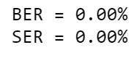

The relation between BER and SER is the same, 0%.

(b)

alice_bits = [0,1,0,1], on real devices

BER = 6.592%

SER = 12.402%

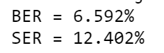

We can see that the SER is approximately twice of BER.

Using the mathematical analysis, the probability of a bit corrected transmitted is

1 BER. A system contains 2 bit string. The transmission between two bits is independent. Hence the probability of a system corrected transmitted is . , which is approximately 2BER when BER is small. For the more accurate calculation of SER = = 12.75%, which is 0.99% from the real SER. By comparison, SER = 2BER = 13.184%, which is 6.3% from the real SER.

Q2[2]

Prepare for initial state(From Lab1 1(h))

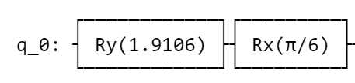

(i)

∣ψ⟩B = [0.55768−0.21132𝑖, 0.78868−0.14943𝑖]

∣ψ ′ ⟩B = [0.55768−0.21132𝑖0.78868−0.14943𝑖]

= 1

(ii)

The circuit for teleportation and reversing the outcome to 0 state to verify the identity before and after transfer.

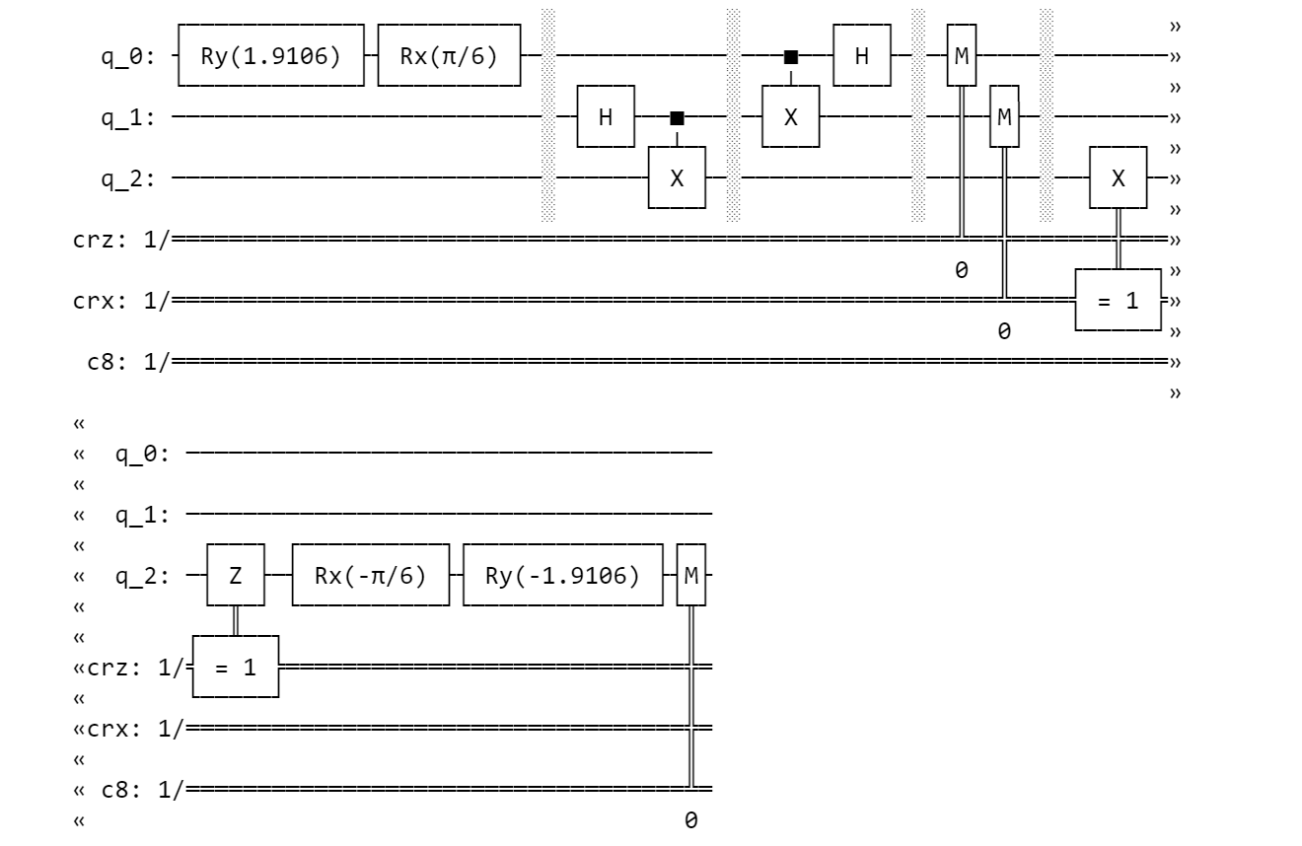

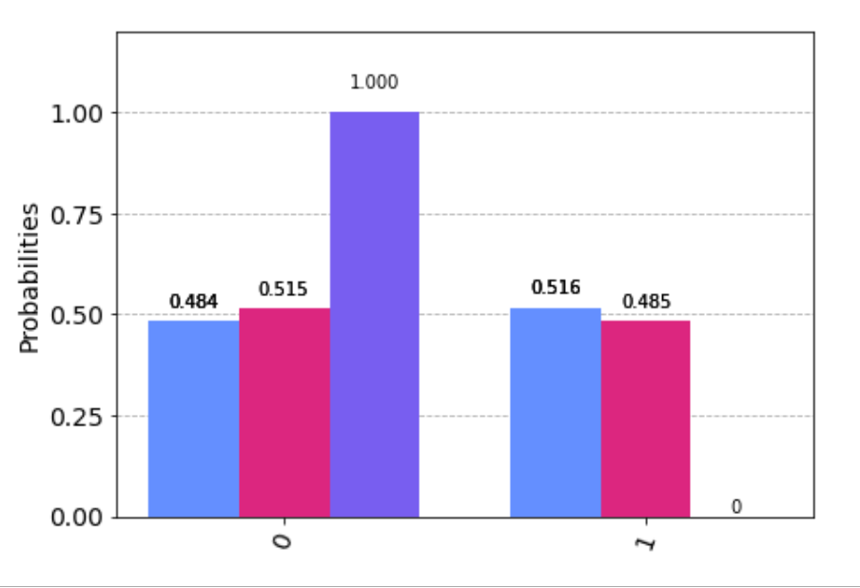

The measurement is to the third classical bit, which is 100% 0 state.

(iii)

The circuit for teleportation and using the swap test to verify the identity before and after transfer.

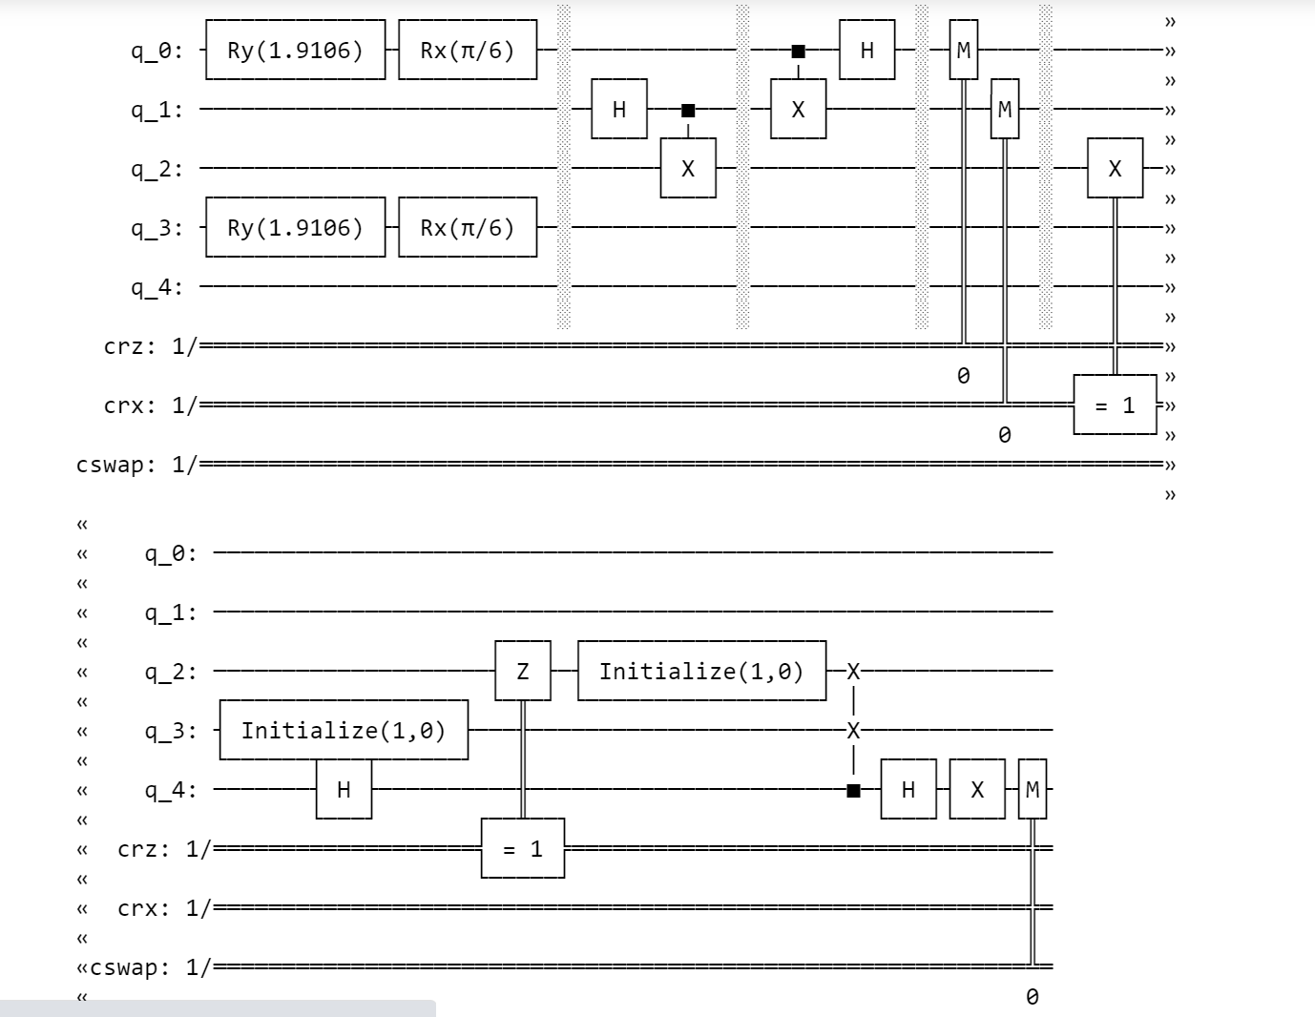

The measurement of the swap test(the rightmost result)

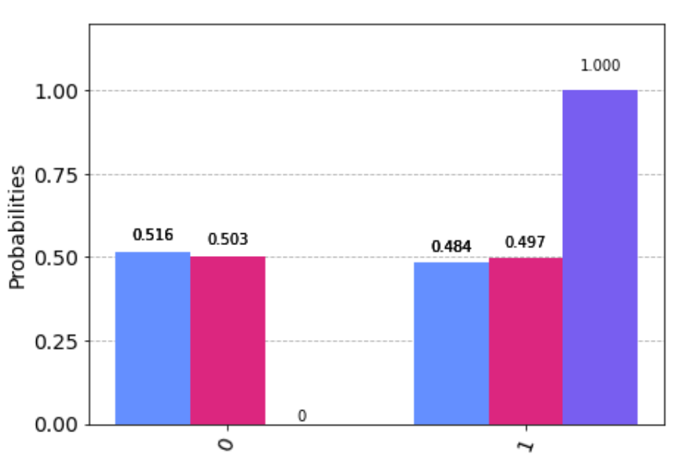

The measurement is to the third classical bit, which is 100% 1 state. The result means that the two qubits state is identical.

(b)[3]

The circuit that create between q0 and q3 and reverse it to 00 state.

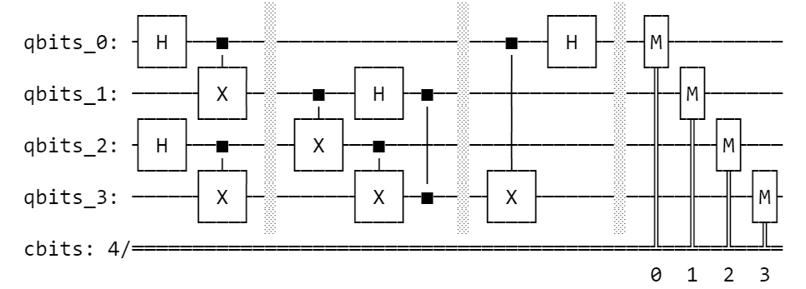

We create a function to validate which state is |q0q3> and add the cnot gate between q[0] and q[3] and the h gate on q[0] for reversing the state to 00 state.

The result of reversing |q0q3> to 00 state

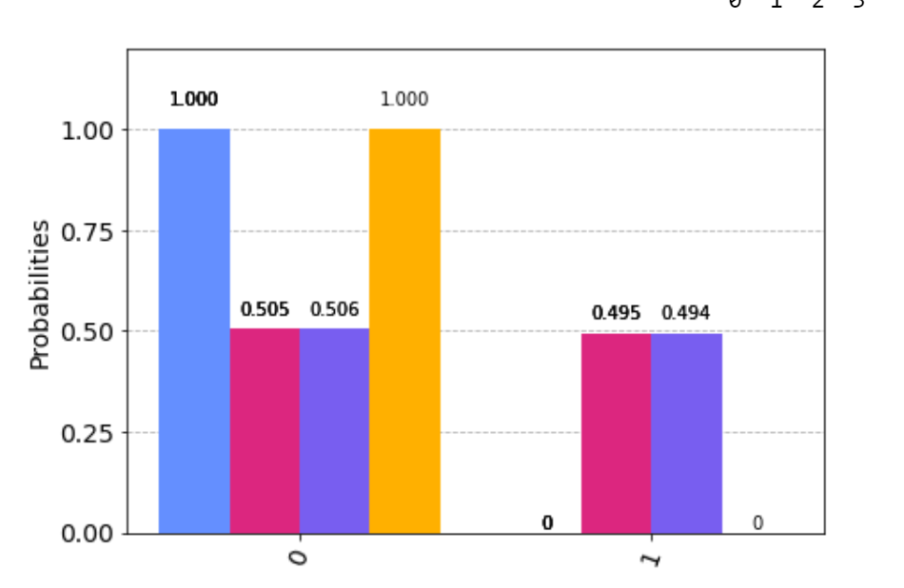

The result shows that the q[0] and q[3] are always 0. Hence, before reversing, we create an entangled state between Alice and Bob through Charlie.

Q3

(a)

the performance (the probability of Eve guessing correctly Alice’s bits) in the scenario that Eve would equally choose two bases for decoding



Mathematical Analysis

For Eve, there are 50% choosing the same basis with Alice and 50% choosing the different basis with Alice. If Eve choose the same basis, the bit Eve get will be 100% correct. If Eve choose the different basis with Alice, the bit Eve get will be 50% correct. Overall, The correctness of the bit that Eve will get is

(b)

the probability of Eve guessing correctly by using Breidbart basis



Mathematical Analysis

Breidbart basis is the midway of computational basis and Hadamard basis. Also, the correctness of the bit would not depend on 0 or 1 Alice generate. Hence, we only analyze on generating 0 and encoded in computational basis.

Eve will decode 0 bit to

Hence, the probability we measure 0 will be

Overall Correctness of measurement will also be

Bonus

the performance (the probability of Eve guessing correctly Alice’s bits) in the scenario that Eve would equally choose three bases for decoding

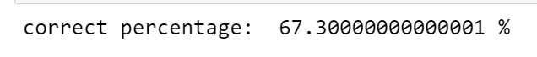

Mathematical Analysis

For Eve, there are probability choosing the same basis with Alice and probability choosing the different basis with Alice. If Eve choose the same basis, the bit Eve get will be 100% correct. If Eve choose the different basis with Alice, the bit Eve get will be 50% correct. Overall, The correctness of the bit that Eve will get is

basis Eve can choose at best



Mathematical Analysis

The best basis we choose is the midway of computational basis, Hadamard basis and rotational basis. Also, the correctness of the bit would not depend on 0 or 1 Alice generate. Hence, we only analyze on generating 0 and encoded in computational basis.

If we regard the computational basis 0 is z axis, rotational basis 0 is y axis, and the Hadamard basis 0 is x axis, then the midway of the three basis is z = y = x. For decoding the basis to the z axis, we find that the line is with the xz plane, and with the z axis. Hence, we apply and on the qubit. If the original qubit is 0, it will decode to

Hence, the probability we measure 0 will be

Overall Correctness of measurement will also be

Appendix

Code: <https://github.com/yuanchiachang/CommLab/blob/main/Lab2/src/Lab2.ipynb>

Reference :

[1] https://qiskit.org/textbook/ch-algorithms/superdense-coding.html

[2] https://qiskit.org/textbook/ch-algorithms/teleportation.html

[3] https://github.com/SowmitraDas/Quantum-Repeater-using-Quantum-Circuits/blob/main/Elements%20-%20Entanglement%20Swapping.ipynb

[4] https://qiskit.org/textbook/ch-algorithms/quantum-key-distribution.html