Lab 4 Report

Source Coding

Author: B08901049 Yuan-Chia Chang

Instructor: Professor Hao-Chung Cheng

TA: Yuan-Pon Chen

Created: 11/15/2021(Mon)

Last edited: 11/16/2021(Tue)

Contact: b08901049@ntu.edu.tw

Collaborator: B08901002 Chen-Han Lin, B08901209 Yu-Hsiang Lin

Q1.

(a)

$$H[X]=-\sum_{j}{p_{j}logp_{j}}=-(0.2×log(0.2)+0.05×log(0.05)+0.005×log(0.005)+0.2×log(0.2)+0.3×log(0.3)+0.05×log(0.05)+0.045×log(0.045)+0.15×log(0.15))≅2.5321$$

(b)

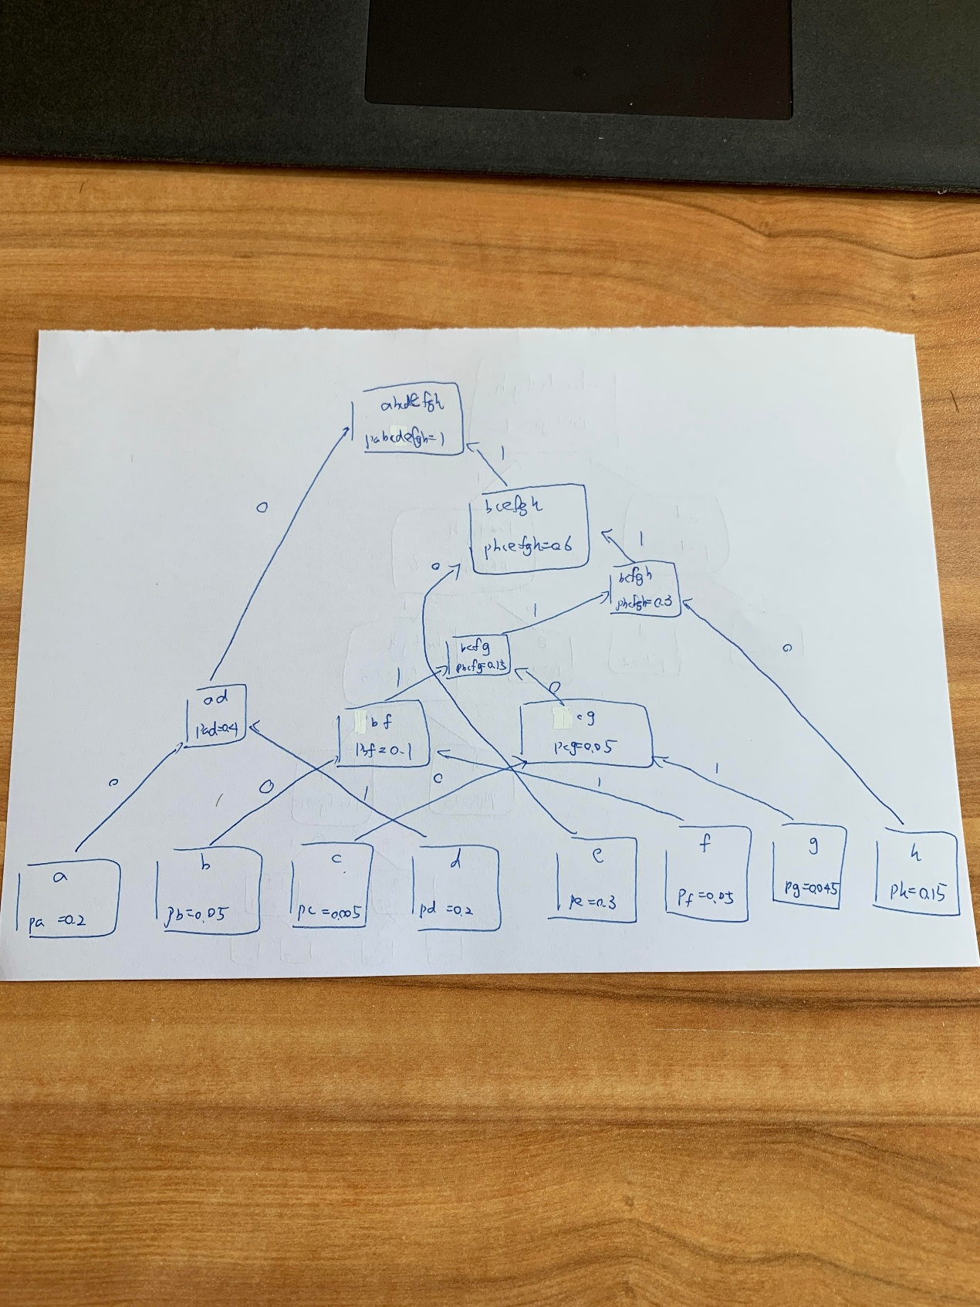

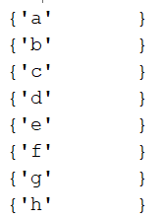 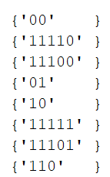

(c)

$$\sum_{j=1}^{M}{2^{-l(a_{j})}}=2^{-2}+2^{-5}+2^{-5}+2^{-2}+2^{-2}+2^{-5}+2^{-5}+2^{-3}=1≤1$$

Which holds Kraft inequality.

(d)

$E[l(a_{j})]= \sum_{j=1}^{M}{p_{j}l(a_{j})}=(0.2×2+0.05×5+0.005×5+0.2×2+0.3×2+0.05×5+0.045×5+0.15×3)=2.6$, which is larger than $H[X]≅2.5321$. Hence, Huffman Coding satisfies the source coding theorem.

(e)

1110100111000011110

(f)

gacab

(g)

By definition,

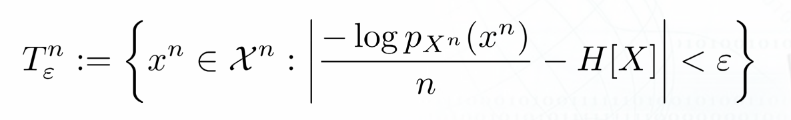

Also, due to the independence of $x^{1},x^{2},..,x^{n}$, $\frac{-logp_{X^{n}}(x^{n})}{n}=\frac{-\sum_{i=1}^{n}{logp_{X}(x^{i})}}{n}$

Hence, we want to find $2.43=H[X]-ε<\frac{\sum_{i=1}^{n}{-logp_{X}(x^{i})}}{n}<H[X]+ε=2.63$

$$for n = 10, 24.3<\sum_{i=1}^{10}{-logp_{X}(x^{i})}<26.3$$

$$-logp_{X}\left(a\right)=2.3219,-logp_{X}\left(b\right)=4.3219,-logp_{X}\left(c\right)=7.6439,$$

$$-logp_{X}\left(d\right)=2.3219,-logp_{X}\left(e\right)=1.7370,-logp_{X}\left(f\right)=4.3219,$$

$$-logp_{X}(h)=4.4739,-logp_{X}(h)=2.7370$$

Hence, we can find 10 symbols abedehedde， $\sum_{i=1}^{10}{-logp_{X}(x^{i})}=2.3219+1.7370+4.3219+2.3219+1.7370+4.4739+1.7370+2.3219+2.3219+1.7370=25.0314$, which is between 24.3 and 26.3. Hence abedehedde is a typical set of X with ε = 0.1 and n = 10.

Q2

(a)[1]

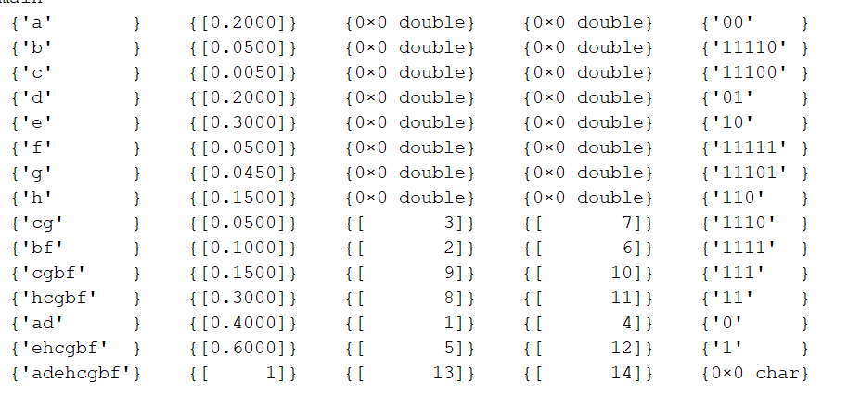

(b)

bin_seq: 1110100111000011110

which is identical with the result of 1e.

(c)

sym_seq: gacab

which is identical with the result of 1f.

Q3.

(a)

random sequence: deaheeaaed

random bit sequence: 011000110101000001001

length of random bit sequence: 21

(b)

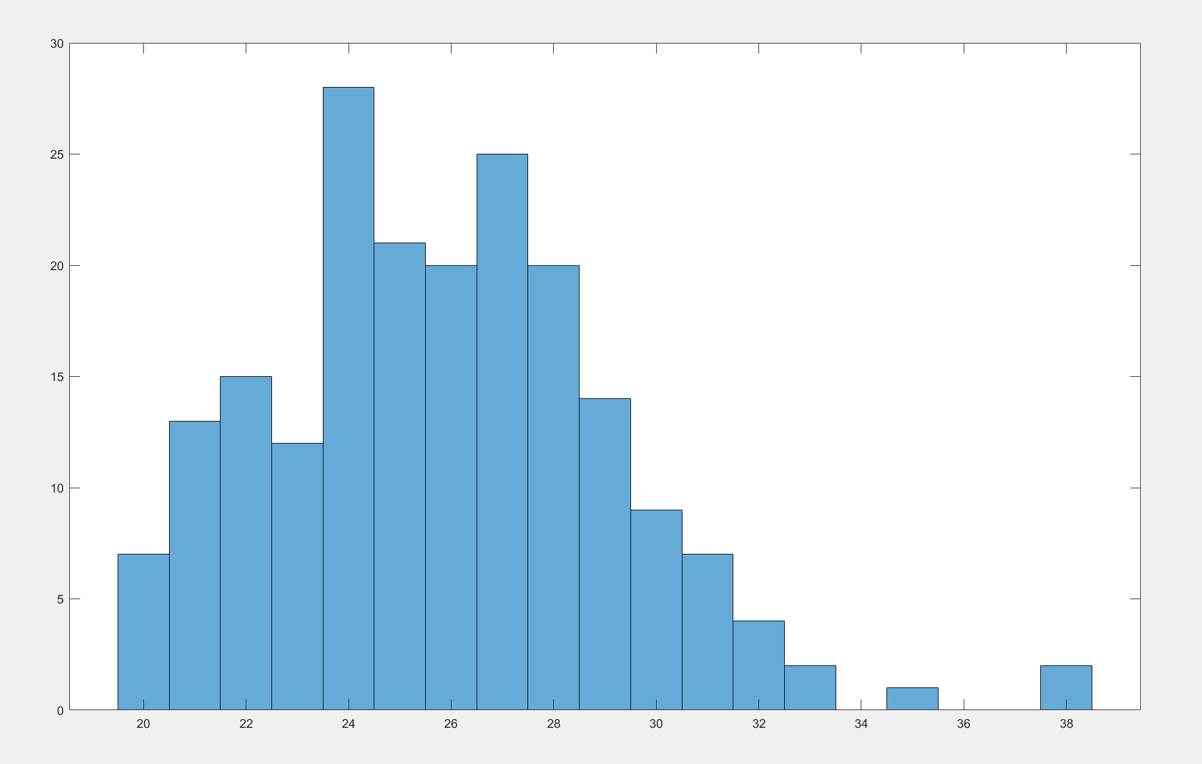

$$L_{n}\left(R\right)=25.8450$$

(c)

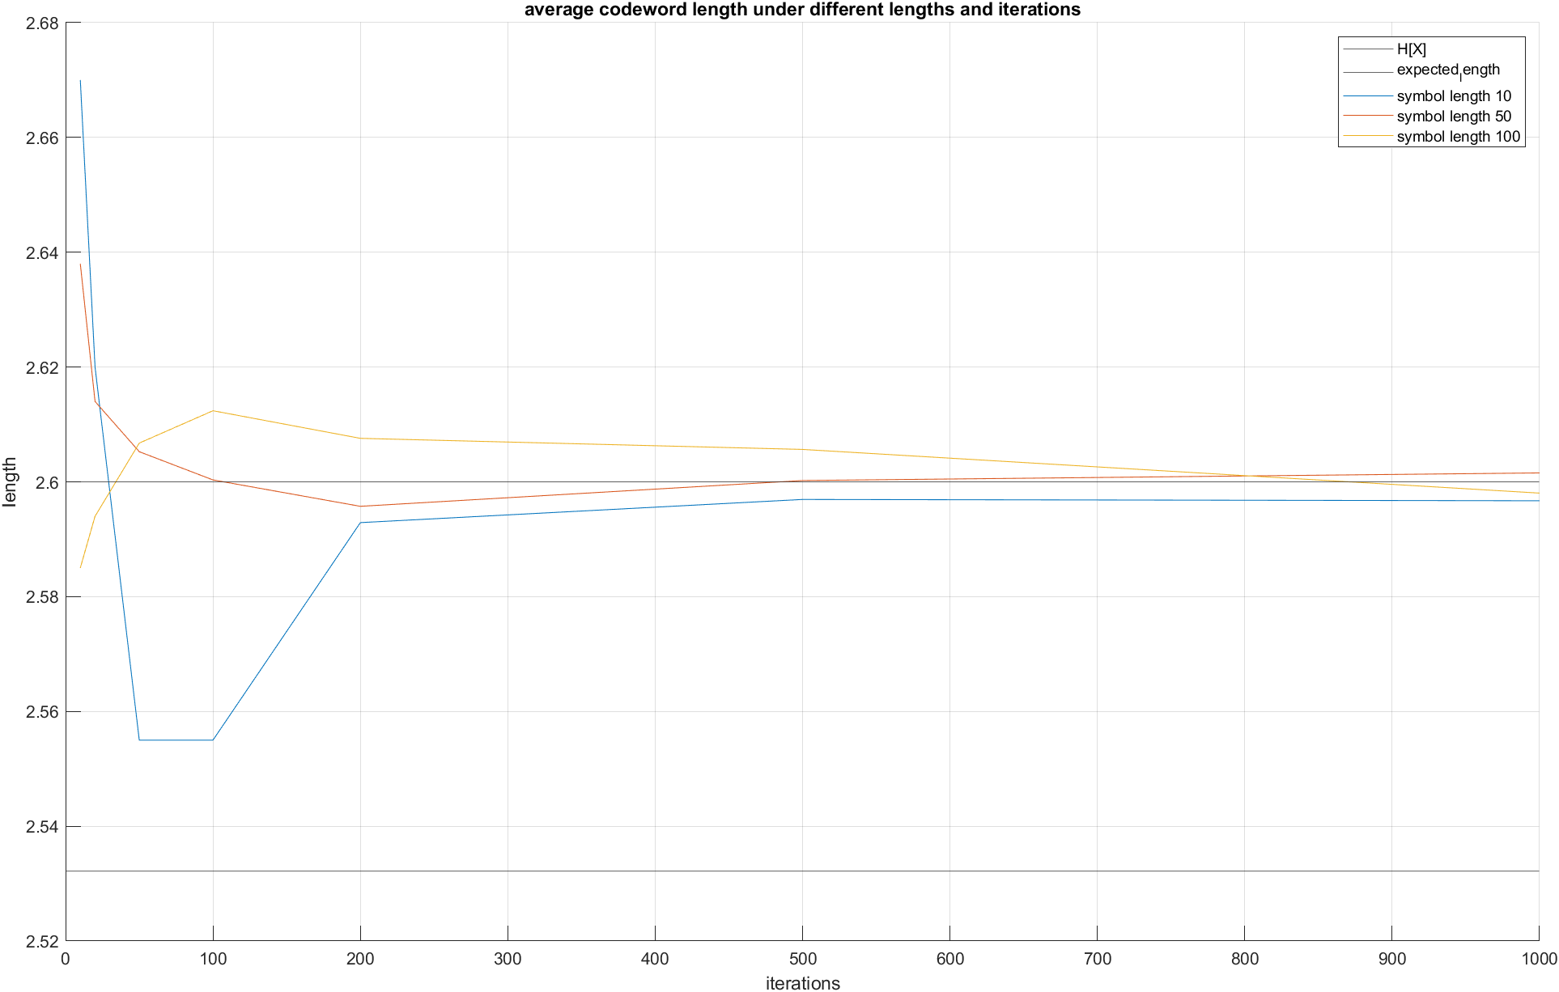

(d)

For symbol length 10, 50, 100, the average codeword length converges to 2.6, which is the expected codeword length. However, symbol length 100 converges faster than symbol length 50, and symbol length 50 converges faster than symbol length 10.

For large iterations, the average codeword length is almost definitely larger than entropy according to source coding theorem.

Appendix

Code

<https://github.com/yuanchiachang/CommLab/blob/main/Lab4/src>

Reference

[1] <https://www.cnblogs.com/klchang/p/13174608.html>