Lab 5 Report

Channel Coding

Author: B08901049 Yuan-Chia Chang

Instructor: Professor Hao-Chung Cheng

TA: Yuan-Pon Chen

Created: 11/22/2021(Mon)

Last edited: 11/25/2021(Thu)

Contact: b08901049@ntu.edu.tw

Collaborator: B08901002 Chen-Han Lin, B08901209 Yu-Hsiang Lin

Q1.

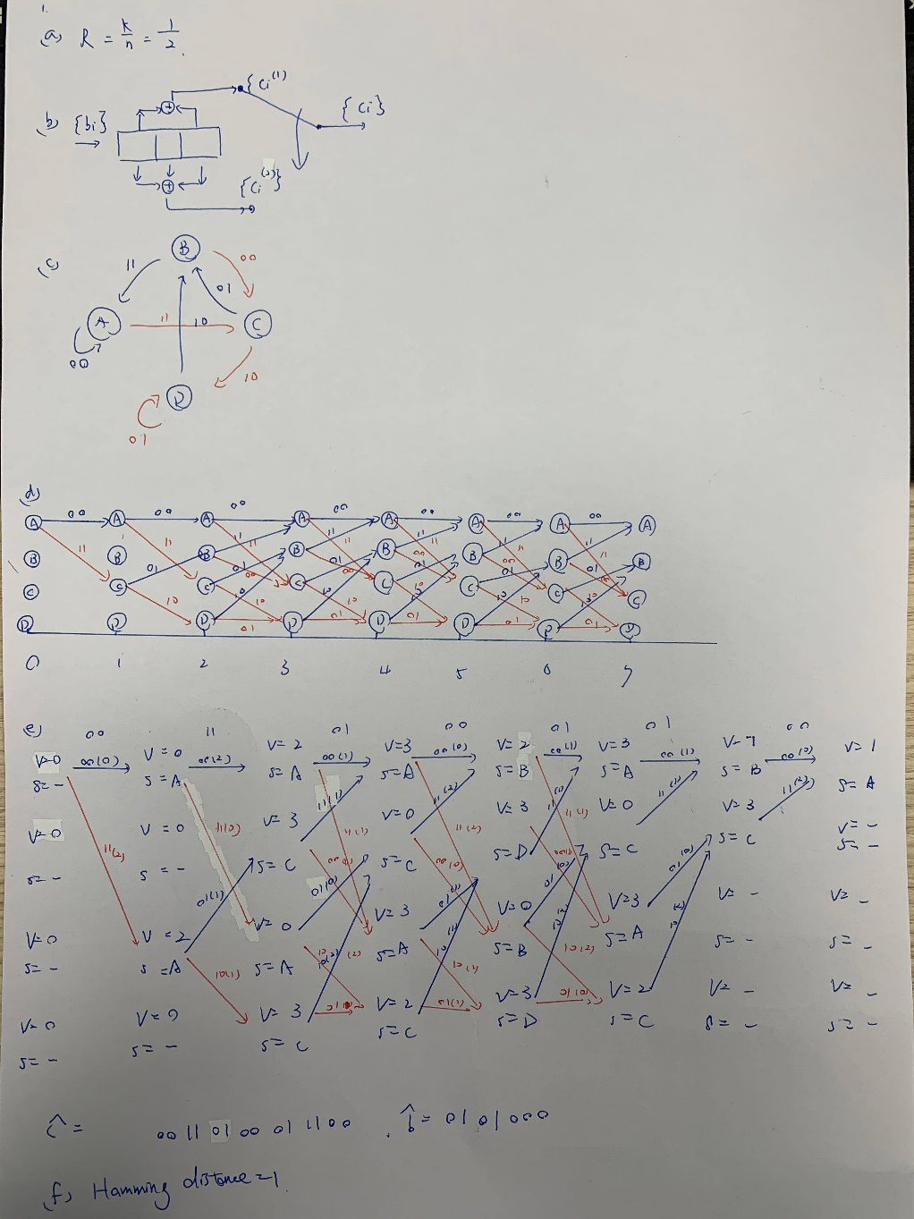

Q2

(a)



Which is the same taught in class.

(b)

The decoded bit is



For 1(e)

The decoded bit is

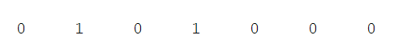

Which is the same with 1(e).

(c)

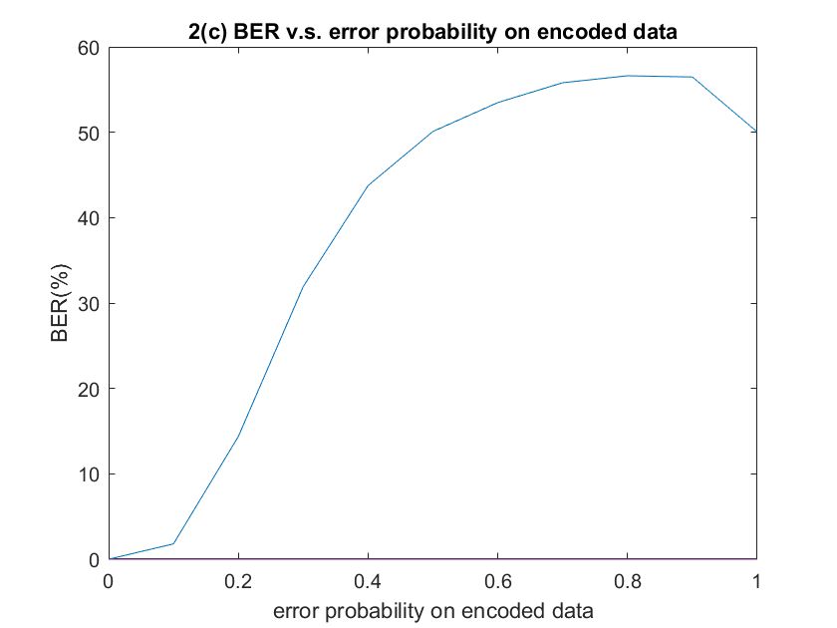

When $p>\frac{1}{2}$, BER is higher but appropriately 50%. For p = 1, BER is exactly 50%.

The reason that large p leads BER to 50% but not 100% is large p makes the encoded bit sequence meaningless, hence the decoded bit sequence is random compared to the original bit sequence. Hence BER = 50%.

Q3

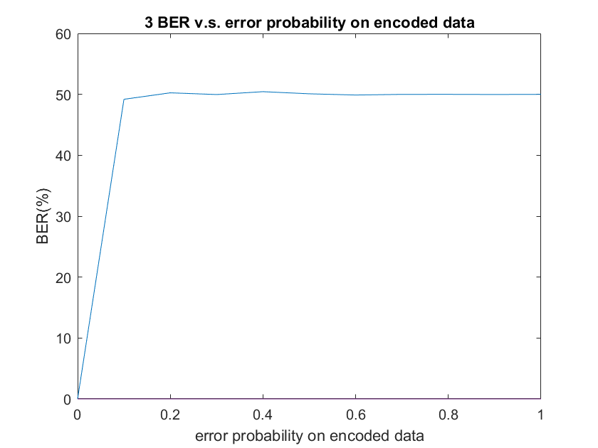

In 2(c). BER increases slowly when p is small, and beyond 50% when $0.6≤p≤0.9$. In Q3, BER jumps to 50% when p = 0.1 and maintains 50 % when $0.2≤p≤1$. The reason is that in Q3, $R=\frac{k}{n}=\frac{1}{2}$. Channel coding adds less redundant bits in encoded bit sequence, the ability to against the noise is worse than the encoded bit sequence in 2(c), which $R=\frac{k}{n}=\frac{1}{3}$. To verify my assumption, let error probability from 0.001 to 0.01, and the result shows below.

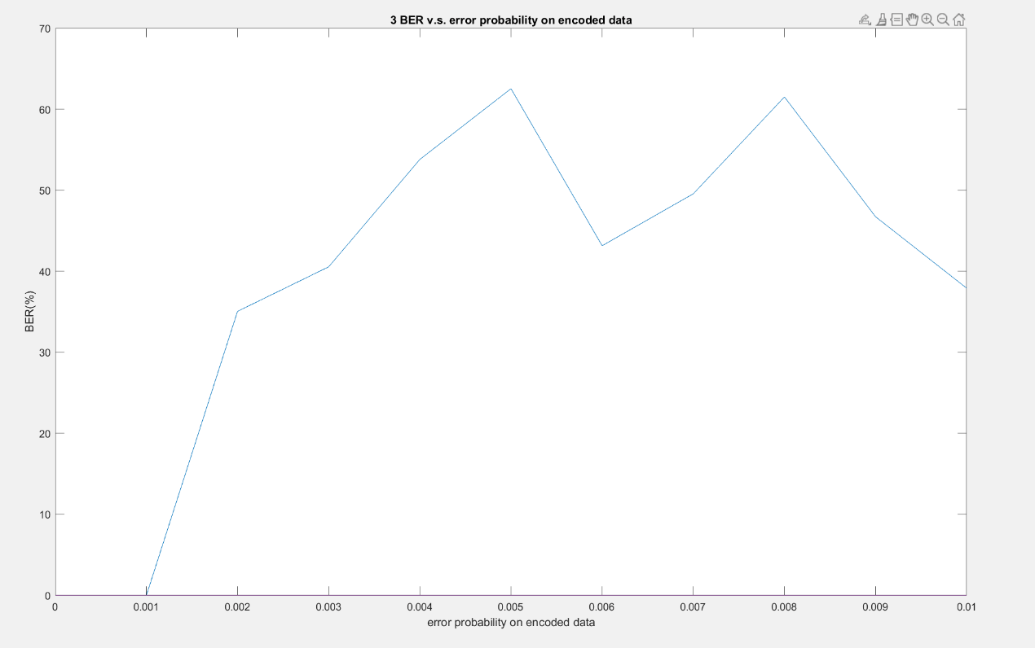

For p smaller than 0.004, BER is not always 50%. However, when p = 0.002, BER = 35%, which is much larger than p, which means that channel coding in Q3 is not a good approach because little corruption in encoded bit leads to huge BER.

Appendix

Code

<https://github.com/yuanchiachang/CommLab/blob/main/Lab5/src>