Lab 6 Report

Digital Modulation

Author: B08901049 Yuan-Chia Chang

Instructor: Professor Hao-Chung Cheng

TA: Yuan-Pon Chen

Created: 12/3/2021(Fri)

Last edited: 12/8/2021(Wed)

Contact: b08901049@ntu.edu.tw

Collaborator: B08901002 Chen-Han Lin, B08901209 Yu-Hsiang Lin

Q1.

Please check the file

<https://github.com/yuanchiachang/CommLab/blob/main/Lab6/src/symbol_mapper.m>



bin_seq: the binary sequence we want to symbol mapping

M: the size of every symbol

d: the minimum distance among the constellation points

name: the name of modulations

For example, if the input is a 30-bit binary sequence



Then the output will be an array with 15 complex numbers

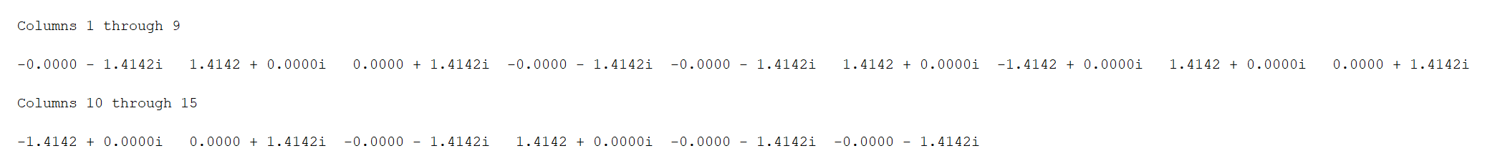

Q2

(a)

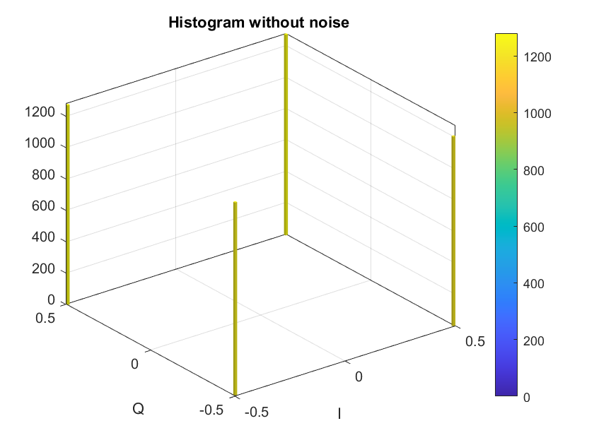

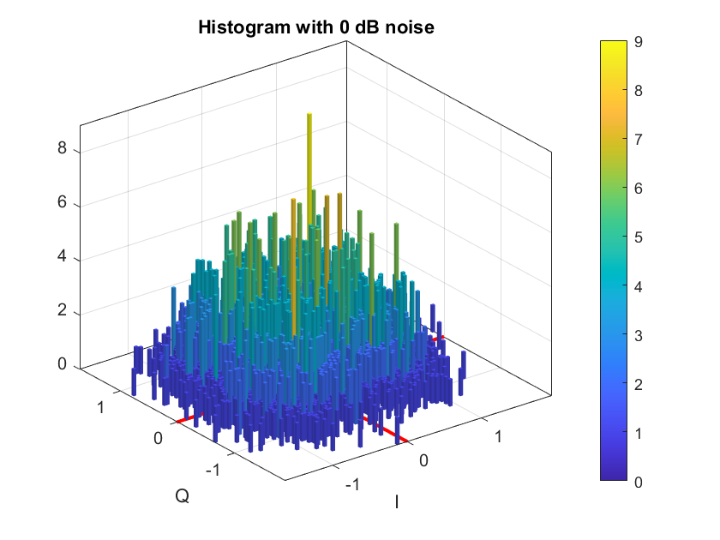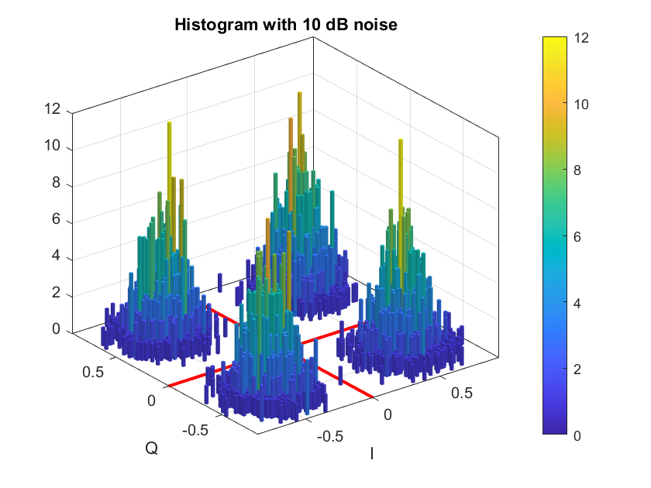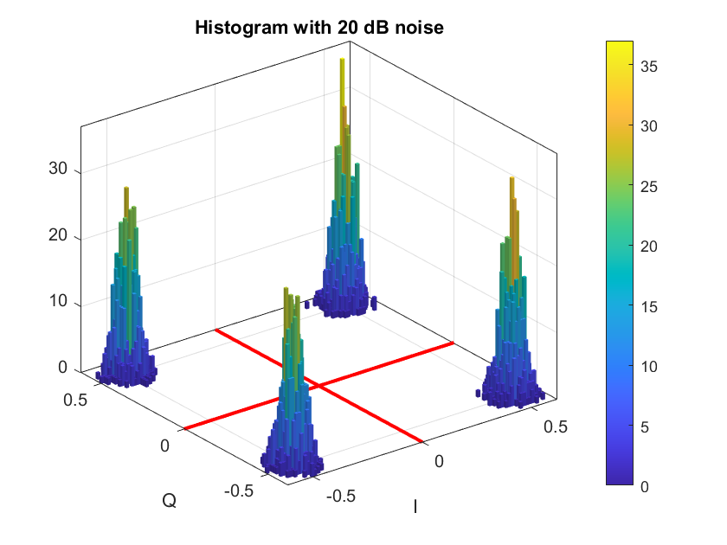

(b)

Please check the file

<https://github.com/yuanchiachang/CommLab/blob/main/Lab6/src/symbol_demapper.m>

In Q2(a)

SER:0.1446

SER:0(due to the lack of bits)

SER:0(due to the lack of bits)

Q3

(Sorry for not plotting 2PAM, 4PAM, 8PAM, 16PAM on the same figure due to my   
negligence, same problems for PSK, QAM)

(a)

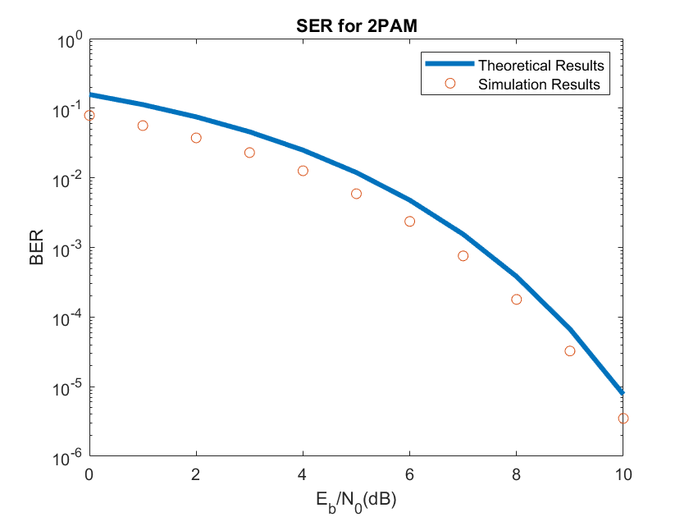

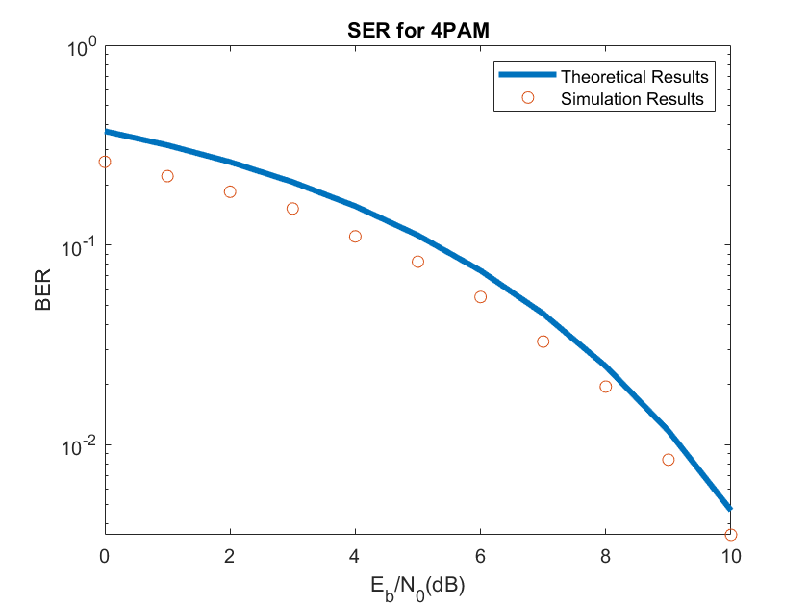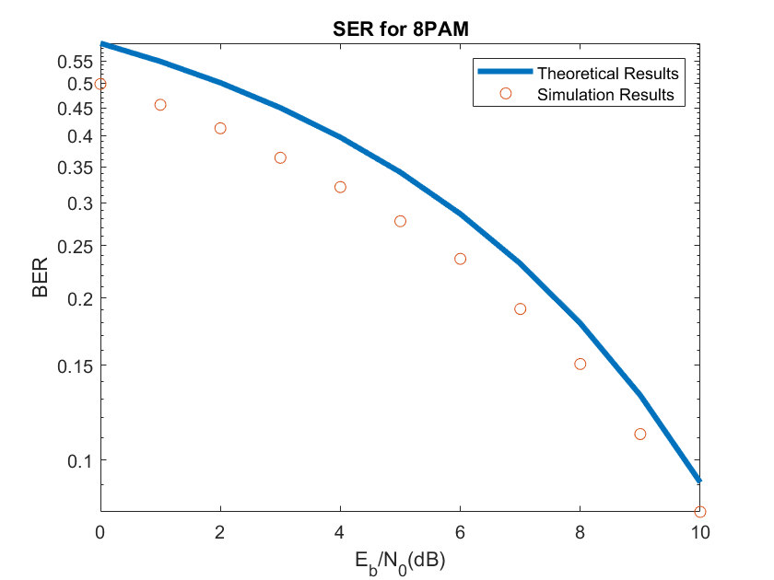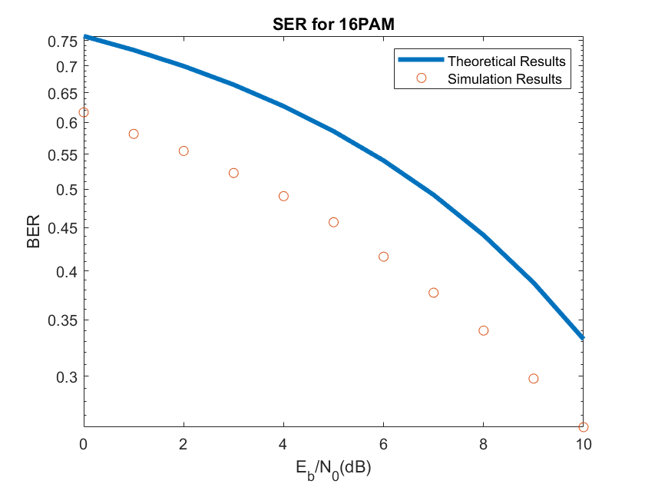

(b)

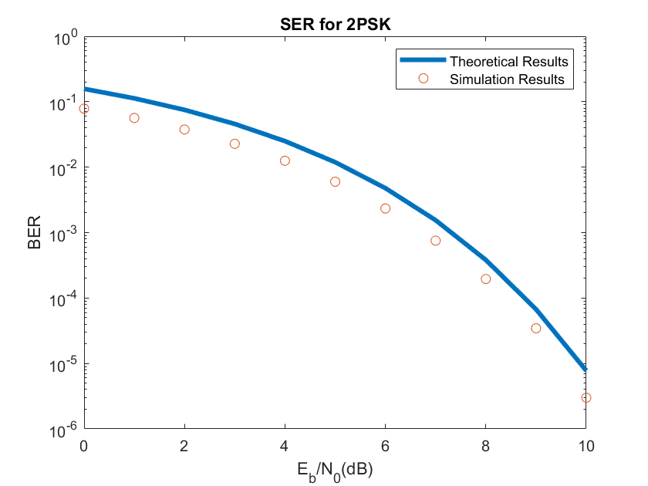

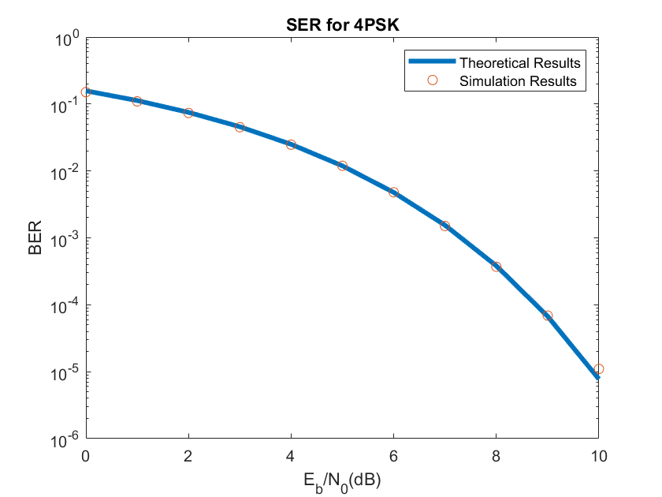

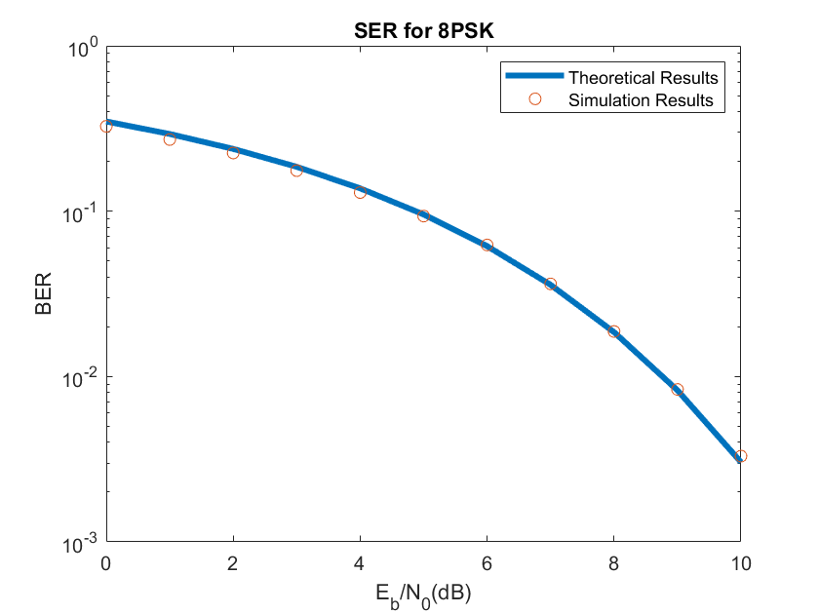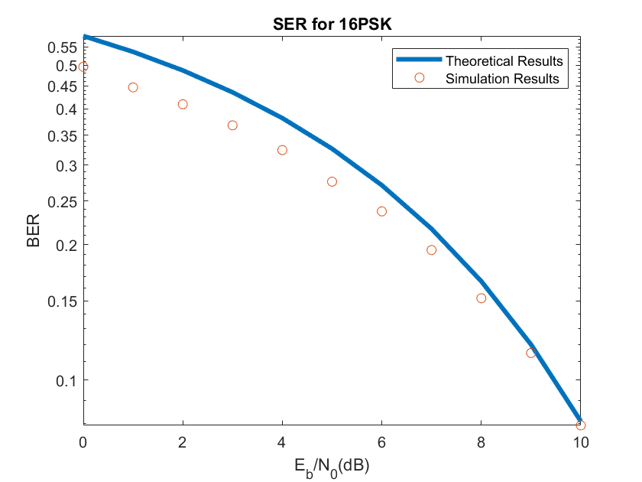

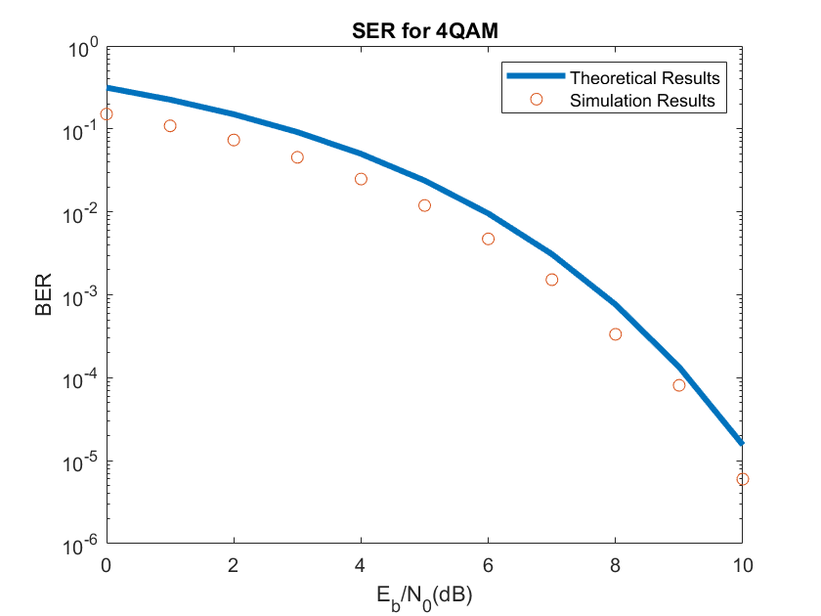

(c)

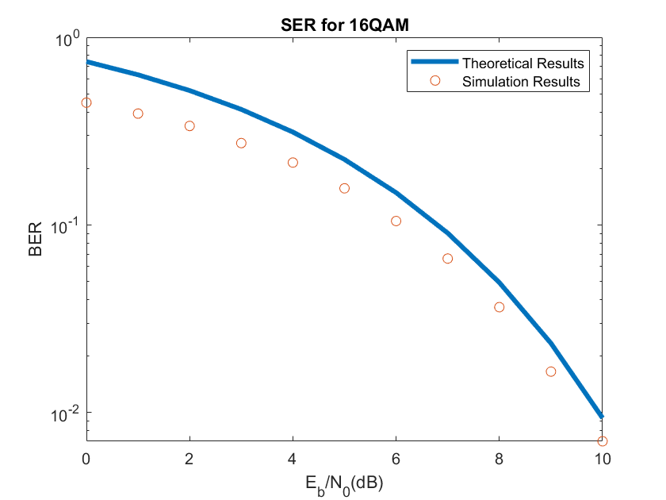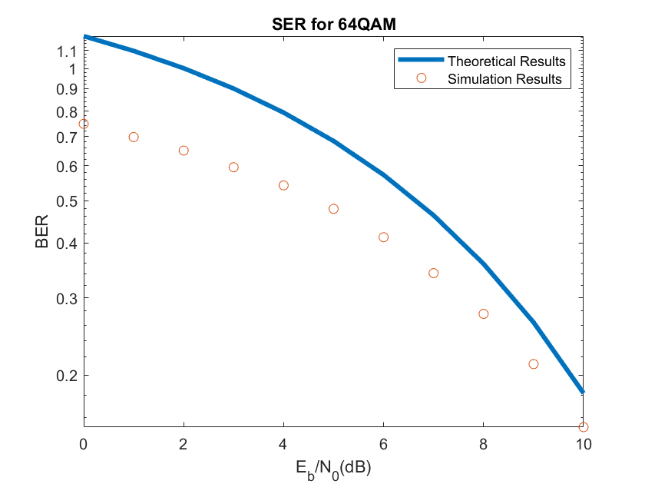

(d)

1.Almost Every simulation result has lower error probability than the theoretical upper bound, which supports the correction of the code.

2. larger dB, smaller M will lead to smaller SER. Specifically, for 10dB, M=2, name= “PSK” or “PAM”, and for 10dB, M=4, name=”QAM”, the SER is approximately . For 2PSK and 4PSK, the theoretical upper bound is identical.

3. Larger M will lead to fewer running time. The reason is that for the same length of input sequence, larger M make the length of symbol sequence smaller.

4. the simulation result of 4-PSK and 8-PSK is closest to the theoretical upper bound.

5. For 2PAM, 2PSK, 4PSK, 4QAM, the theoretical upper bound is when SNR = 10dB. For other constellation methods, the theoretical upper bound is higher than . For the same of saving time, there are 2000000 bits when operating 2PAM, 2PSK, 4PSK, 4QAM, while 120000 bits when operating other constellation methods.

Q4

(a)(b)

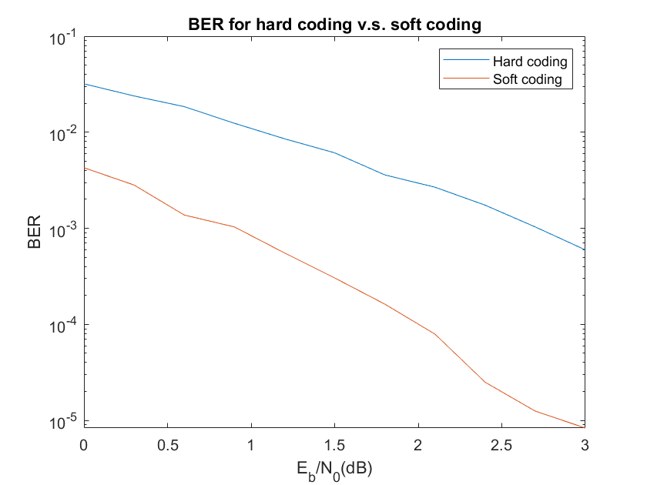

This figure shows that the performance of soft coding is better than hard coding. BER of soft coding is approximately 1% to 10% of BER of hard coding.

Appendix

Code

<https://github.com/yuanchiachang/CommLab/blob/main/Lab6/src>

Reference

<https://openhome.cc/Gossip/AlgorithmGossip/GrayCode.htm#Java>