**实验报告七**

**姓名：袁楚 班级：应统一班 学号：117060400114 指导老师：林卫中**

实验名称：函数和代码复用

实验目的：（1）掌握函数的定义和调用方法

1. 理解函数的参数传递的过程以及变量的作用范围
2. 了解lambda函数
3. 掌握时间日期标准库的使用
4. 理解函数递归的定义和使用方法

实验题目：（1）实例5.3的反递归

1. 汉诺塔的计算
2. 七段数码管的每一段的颜色随机绘制

实现算法:

(1)def reverse(s):

if s == "":

return s

else:

return s[-1] + reverse(s[0:-1])

str = input("请输入一个字符: ")

print(reverse(str))

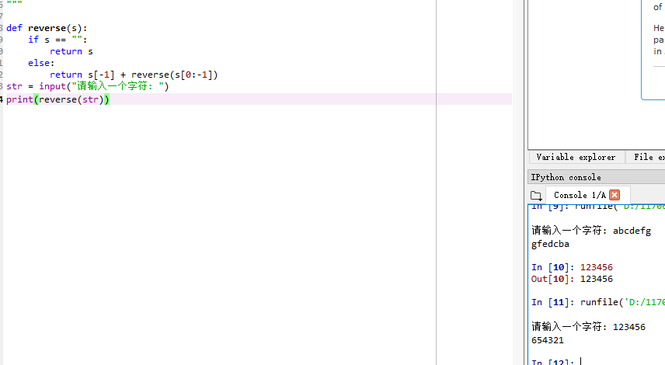

(2)

def hanoi(a, b, c, n):

if n == 1:

print(a + "-->" + c)

else:

hanoi(a, c, b, n-1)

hanoi(a, b, c, 1)

hanoi(b, a, c, n-1)

hanoi('a', 'b', 'c', 5)



(3)import turtle, datetime, random

def drawGap():

turtle.penup()

turtle.fd(5)

def drawLine(draw):

drawGap()

turtle.colormode(255)

r = random.randint(0, 255)

g = random.randint(0, 255)

b = random.randint(0, 255)

turtle.pencolor((r, g, b))

turtle.pendown() if draw else turtle.penup()

turtle.fd(40)

drawGap()

turtle.right(90)

def drawDigit(digit):

drawLine(True) if digit in [2,3,4,5,6,8,9]else drawLine(False)

drawLine(True) if digit in [0,1,3,4,5,6,7,8,9]else drawLine(False)

drawLine(True) if digit in [0,2,3,5,6,8,9]else drawLine(False)

drawLine(True) if digit in [0,2,6,8,]else drawLine(False)

turtle.left(90)

drawLine(True) if digit in [0,4,5,6,8,9]else drawLine(False)

drawLine(True) if digit in [0,2,3,5,6,7,8,9]else drawLine(False)

drawLine(True) if digit in [0,1,2,3,4,7,8,9]else drawLine(False)

turtle.left(180)

turtle.penup()

turtle.fd(20)

def drawDate(date):

for i in date:

if i == '-':

turtle.pencolor("yellow")

turtle.write('年',font=("Arial", 18,"normal"))

turtle.fd(40)

elif i == '=':

turtle.pencolor("blue")

turtle.write('月',font=("Arial", 18,"normal"))

turtle.fd(40)

elif i == '+':

turtle.pencolor("red")

turtle.write('日',font=("Arial", 18,"normal"))

turtle.fd(40)

else:

drawDigit(eval(i))

def main():

turtle.setup(800, 350, 200, 200)

turtle.penup()

turtle.fd(-350)

turtle.pensize(5)

drawDate(datetime.datetime.now().strftime('%Y-%m=%d+'))

turtle.hideturtle()

turtle.down()

main()

