**实验报告十五**

**姓名:袁楚 班级：应统一班 学号: 117060400114 指导老师：林卫中**

1. 兵乓球赛

from random import random

def printIntro():

print("这个程序模拟两个选手A和B的某种竞技比赛")

print("程序运行需要A和B的能力值（以0到1之间的小数表示）")

def getInputs():

a = eval(input("请输入选手A的能力值(0-1): "))

b = eval(input("请输入选手B的能力值(0-1): "))

n = eval(input("模拟比赛的场次: "))

return a, b, n

def simNGames(n, probA, probB):

winsA, winsB = 0, 0

for i in range(n):

scoreA, scoreB = simOneGame(probA, probB)

if scoreA >= scoreB:

winsA += 1

else:

winsB += 1

return winsA, winsB

def gameOver(a,b):

if (a<10 and b==9) or (a==11 and b<10):

return True

elif (a>=10 and b-a==2) or (b>=10 and a-b==2):

return True

return False

def simOneGame(probA, probB):

scoreA, scoreB = 0, 0

serving = 0#0:0表示A发球；1表示B发球

t = 0

while not gameOver(scoreA, scoreB):

if serving == 0:

if random() < probA:

scoreA += 1

else:

scoreB += 1

else:

if random() < probB:

scoreB += 1

else:

scoreA += 1

t += 1

if t%2 == 0:

serving = (serving+1)%2

return scoreA, scoreB

def printSummary(winsA, winsB):

n = winsA + winsB

print("竞技分析开始，共模拟{}场比赛".format(n))

print("选手A获胜{}场比赛，占比{:0.1%}".format(winsA, winsA/n))

print("选手B获胜{}场比赛，占比{:0.1%}".format(winsB, winsB/n))

def main():

printIntro()

probA, probB, n = getInputs()

winsA, winsB = simNGames(n, probA, probB)

printSummary(winsA, winsB)

main()

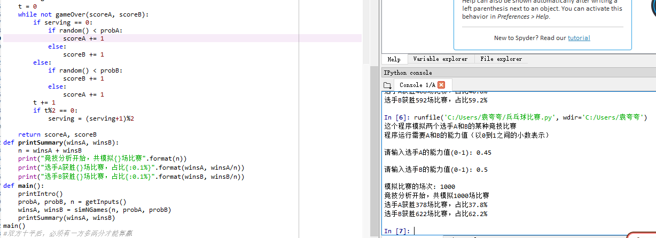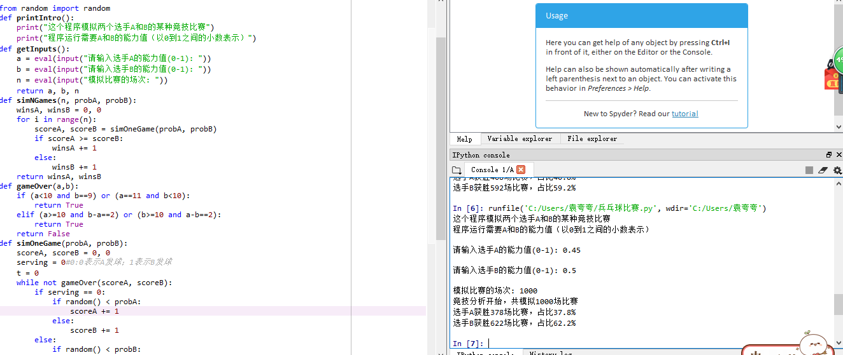

1. 篮球赛

from random import*

def printIntro():

print("这个程序模拟两个选手A和B的某种竞技比赛")

print("程序运行需要A和B的能力值（以0到1之间的小数表示）")

def getInputs():

a1 = eval(input("请输入A队伍的投篮得分能力值(0-1): "))

a2 = eval(input("请输入B队伍的投篮得分能力值(0-1): "))

b1 = eval(input("请输入A队伍的篮板球能力值(0-1)："))

b2 = eval(input("请输入B队伍的篮板球能力值(0-1)："))

n = eval(input("模拟比赛的场次: "))

return a1, a2, b1, b2, n

def simNGames(n, goleA,goleB,boardA,boardB):

winsA, winsB = 0, 0

for i in range(n):

scoreA, scoreB = simOneGame(goleA,goleB,boardA,boardB)

if scoreA > scoreB:

winsA += 1

else:

winsB += 1

return winsA, winsB

def gameOver(t):

return t >= 12*60

def simOneGame(goleA,goleB,boardA,boardB):

scoreA, scoreB = 0, 0

serving = 0

time = 0

while not gameOver(time):

t = randint(1,24)

time += t

if t == 24:

serving = (serving + 1)%2

else:

if serving == 0:

if random() < goleA:

scoreA += 1

serving = 1

else:

if random() < boardA:

serving=0

else:

serving = 1

else:

if random() < goleB:

scoreB += 1

serving = 0

else:

if random() < boardB:

serving = 1

else:

serving=0

return scoreA, scoreB

def printSummary(winsA, winsB):

n = winsA + winsB

print("竞技分析开始，共模拟{}场比赛".format(n))

print("A队获胜{}场比赛，占比{:0.1%}".format(winsA, winsA/n))

print("B队获胜{}场比赛，占比{:0.1%}".format(winsB, winsB/n))

def main():

printIntro()

goleA,goleB,boardA,boardB,n = getInputs()

winsA, winsB = simNGames(n,goleA,goleB,boardA,boardB )

printSummary(winsA, winsB)

main()

