I have carefully read the letter by Zou et al. concerning the claimed spectral gap (absorption feature) in the sub-GeV to GeV range in the observer frame, which is interpreted as evidence for photodissociation of deuterium in the GRB jet.
The idea of searching for high-energy gamma-ray absorption features in GRBs as a probe of nucleosynthesis in the jet is highly interesting (see, e.g., Beloborodov 2003 for an overview). However, there are several major issues regarding both the data analysis and its interpretation.
我仔细阅读了邹等人关于观察者帧中亚GeV到GeV范围内声称的光谱间隙（吸收特征）的信，这被解释为伽马射线暴射流中氘光解的证据。
在伽马射线暴中寻找高能伽马射线吸收特征作为喷流中核合成的探针的想法非常有趣（例如，概述见Beloborodov 2003）。然而，在数据分析及其解释方面存在几个主要问题。
While I have a number of concerns related to the modeling of the prompt emission—such as the inference of the dissipation radius and the apparent confusion between internal shock scenarios and multi-blackbody fits—I will first focus on what I consider the most critical point of the letter: the statistical significance of the claimed sub-GeV–GeV absorption feature.
虽然我对瞬时辐射的建模有一些担忧，例如耗散半径的推断以及内部冲击情景和多黑体拟合之间的明显混淆，但我将首先关注我认为这封信中最关键的一点：所声称的亚GeV-GeV吸收特征的统计显著性。
Response (1)：Thanks for the response. Before the responding to the extraction of statistical significance of the claimed sub-GeV–GeV absorption feature, we want to give a response to the prompt emission mechanism. From the spectral modeling results, it is evident that there exist two different components in the prompt emission. The modelings with BAND+PL, mBB+PL and mBB + BAND with a gap in high-energy band (i.e. the 0-events from 0.6 GeV to 1.2 GeV are not added in the modeling; in the previous version, they are included) have been performed and the results are updated Figure 3 in APPENDIX B.
We compare the goodness of fit of mBB in MeV emission with that of BAND as follows,
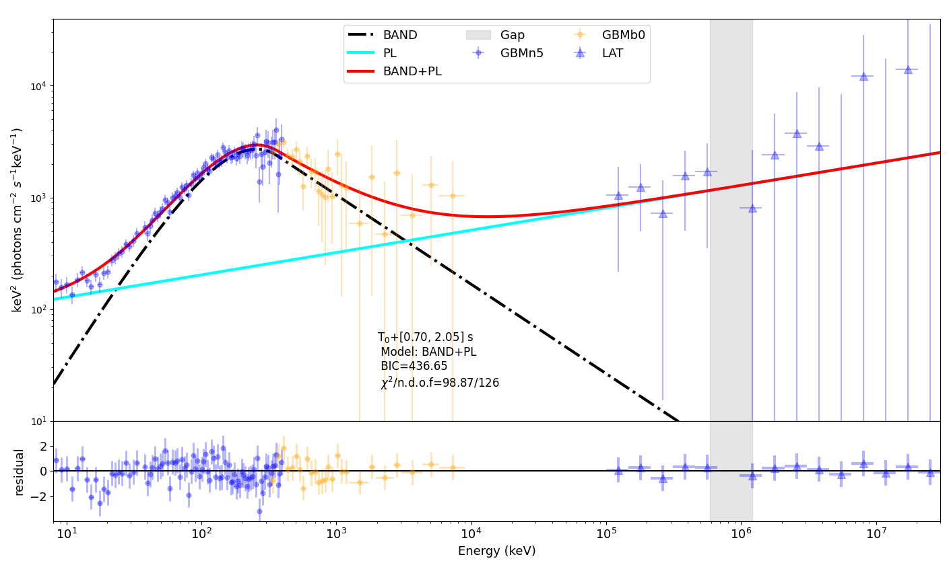
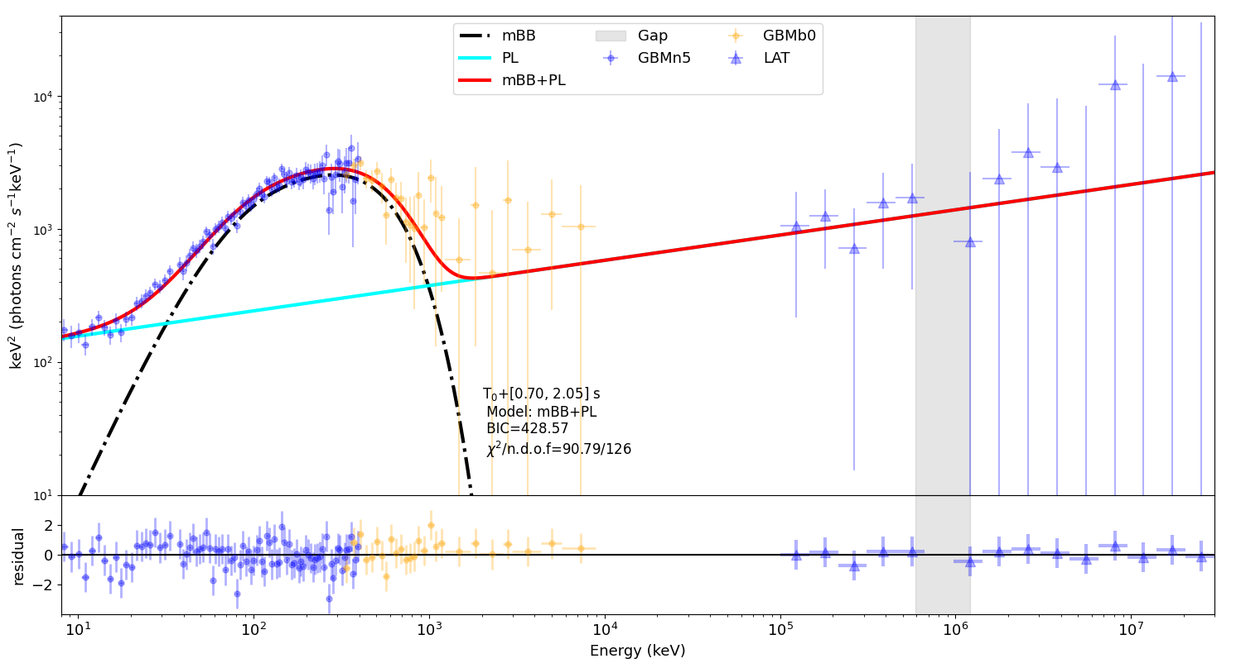
From the resid distribution from 40 keV to 300 keV, there exists a systematic bias in the modeling with BAND function, while it is much better in modeling with mBB. This means that mBB model fits the data better than BAND in MeV emission, and the changes on BIC is ΔBIC= 8.1, which shows a strong preference for mBB. Therefore, we think mBB+PL is the best model. In addition, the low-energy photon index for the peaking component is about -0.06, although it cannot be decisive evidence for the quasi-thermal emission.
we could discuss the most likely interpretations as below,
- If the peaking MeV component is quasi-thermal:
there exist seed photons in the outflow. Some of them become the component of a broad energy band from keV to GeV via inverse Compton (IC) scattering by relativistic electrons. However, not all photons are emitted, especially for those with lower energy (even produced from the IC scattering), which corresponds to a larger cross section; moreover, as electrons are cooled, the cross section of electron-photon scattering becomes larger (see the Eq (8) in the revised version). They will be thermalized below the photosphere, and emitted when the radius reaches Rph (see Eqs (B1) and (B2)). Rph ≲ 10¹¹⁻¹³ cm, the observed time delay ~(1+z)R/cΓ² relative to the keV to GeV component is very small (≲ a few milliseconds). This means this two components arrive almost simultaneously, which is consistent with the observation (we have used the cross-correlation function (CCF) to obtain the time lag between emission < 20 keV (the contamination from quasi-thermal component<7%) and that of 50-100 keV, the lag is determined to be around 0. Although the prompt emission is a superposition of two components, this implies that there is not very large time delay between these two components.).

- If the peaking MeV component is non-thermal:
The synchrotron self-Compton (SSC) process in the internal shocks could also account for the two components in the prompt phase. The peaking MeV component comes from synchrotron emission of the accelerated electrons, while some of them behave as seed photons for the IC scattering. However, peaking MeV emission should not be quasi-thermal since σ_{KN} <1, which is not consistent with the modeling results that the mBB function is better than the BAND function in describing peak MeV emission (more discussions are put in Response (7) to the second referee to prove that SSC process is not consistent with the observation).

In conclusion, we think the first explanation is more consistent with the observations. In this case, the radius for the PL component from IC emission should be smaller than that of quasi-thermal component. The prompt emissions from keV to GeV are interpreted as a superposition of quasi-thermal emission (described by a multi-blackbody model) and non-thermal emission from inverse Compton (IC) scattering by relativistic electrons produced in the internal shocks. In addition, because most energy in the prompt phase are from the PL component (2.6 times that of peaking component), and L_{k} is estimated from the the PL component; Γ used in the analysis is estimated from the model-independent approach (the lower limit estimated by the photon of highest energy, see the Appendix C); thus the emission mechanism of MeV peaking component do not affect the calculation and conclusion much.

Another modification in the revised manuscript is the redshift. The recent detailed multiwavelength analysis of GRB 210704A determines that the most likely redshift is z=2.34 (Please see the D. L. A. Pieterse et al MNRAS 548, stag555 (2026)), and this points to a collapsar nature. In the following analysis, we use z=2.34 to estimate the Lorentz factor and to determine the energetics of the comoving frame. The estimation of Γ is performed via two approaches, (1) with the quasi-thermal component; from Eq (C5) and Refs [54, 55] (see the details in Appendix C), the estimate of Γ is approximately proportional to ((1+z)² d_{L})^{1/4}, for z=0.27, d_{L} =4.38e27 cm, for z=2.34, d_{L} =5.95e28 cm, thus the estimate of Γof z=2.34 is about 2 times that of z=0.27. (2) the LAT photon of the highest energy (16.01 GeV) is used to provide the lower limit of Γ by the constraint from the pair production of the high-energy photons and the target MeV photons; The . The lower limit of Γ is about 500, about two times that of z=0.27 (Γ≥200). Thus, the commoving frame energetics, E_{rest}=E_{obs} (1+z)/2Γ remains almost unchanged. The corresponding modification is shown in Abstract, Introduction, Observation and Spectral Anomaly in the revised version (the differences are denoted in red and in blue in diff.pdf).

*************
The procedure used by the authors to claim the presence of this feature does not appear to be statistically justified for Fermi/LAT data. Based on the information provided in the current manuscript, my understanding is that the authors extract data in the 100 MeV–10 GeV range (slightly extending above 10 GeV) using gtburst, import it into XSPEC, fit it with a power-law (PL), and then assess the significance of the gap by simulating a large number of PL spectra to estimate a p-value.
作者声称存在这一特征的程序似乎在费米/LAT数据中没有统计学依据。根据当前手稿中提供的信息，我的理解是，作者使用gtburst提取100 MeV-10 GeV范围内的数据（略高于10 GeV），将其导入XSPEC，用幂律（PL）拟合，然后通过模拟大量PL光谱来估计p值，从而评估差距的显著性。
Such an approach would be appropriate if one were working with raw LAT photon data. However, Fermi/LAT data products generated through gtburst have already been processed using the standard likelihood analysis implemented in the Fermi Science Tools, where a spectral model (in this case, a power law) is already assumed. As a result, the spectral points exported to XSPEC are not model-independent: they implicitly carry the assumptions of the likelihood analysis. Consequently, testing deviations from a power-law using these pre-modeled data can lead to biased or circular conclusions.
如果使用原始LAT光子数据，这种方法是合适的。然而，通过gtburst生成的Fermi/LAT数据产品已经使用费米科学工具中实现的标准似然分析进行了处理，其中已经假设了光谱模型（在这种情况下，幂律）。因此，导出到XSPEC的谱点不是模型独立的：它们隐含地携带了似然分析的假设。因此，使用这些预先建模的数据测试与幂律的偏差可能会导致有偏见或循环的结论。
For exceptionally bright GRBs with very high photon statistics, the use of such pre-processed LAT spectra in XSPEC may still provide reasonable approximations. However, in this case the authors claim the detection of an absorption feature at a second level of data processing (i.e., after model-dependent reduction via gtburst), which makes the result particularly questionable.
对于光子统计非常高的异常明亮的伽马射线暴，在XSPEC中使用这种预处理的LAT光谱仍然可以提供合理的近似值。然而，在这种情况下，作者声称在第二级数据处理（即通过gtburst进行模型相关缩减后）检测到了吸收特征，这使得结果特别值得怀疑。
The appropriate method to test for deviations from a single power-law in LAT data is to perform a full likelihood analysis within the Fermi Science Tools, comparing a baseline PL model with an alternative model (e.g., PL multiplied by a narrow absorption component), and evaluating the likelihood ratio. This approach properly accounts for photon-level information, including the probability that each detected photon is associated with the GRB versus Galactic diffuse emission, isotropic background, or other sources in the field. If a statistically significant absorption feature is present, it should manifest as a robust improvement in the likelihood.
测试LAT数据中与单个幂律偏差的适当方法是在费米科学工具中进行全似然分析，将基线PL模型与替代模型（例如，PL乘以窄吸收分量）进行比较，并评估似然比。这种方法正确地考虑了光子级信息，包括每个检测到的光子与伽马射线暴、银河系漫射发射、各向同性背景或场中其他源相关的概率。如果存在统计上显著的吸收特征，则应表现为可能性的显著提高。

Response (2): Thanks for the response. According to your suggestions, we perform the unbinned full likelihood analysis as follows:
The modeling with PL is performed with gtlike; for a combined model, gtburst (GUI) and gtlike (CLI) are both supported for full likelihood analysis, but we find there is not options for a combined model, e.g. PL+absorption line. For gtlike, a “FileFunction” option is allowed for fixed spectral shape and the sole parameter is a multiplicative normalization. To obtain the best parameter for PL with a gap, a parameter scanning is performed, i.e., the full likelihood is perform for each parameter (index) and extract the minimum –log(likelihood) and the error (the difference between index of the minimum –log(likelihood) and that of –log(likelihood)+/-0.5).
The –log(likelihood) for modeling with PL is 39.18 (with gtlike), index=1.73+/-0.13:
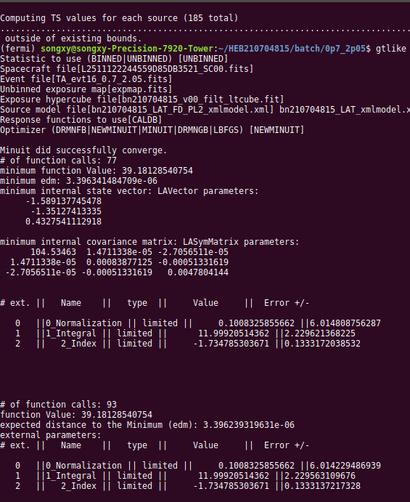
The –log(likelihood) scanning for PL +gap (0.64-1.17 GeV) is shown a s below, index=1.70^{+0.13}_{-0.12}, the minimum –log(likelihood)=34.53. 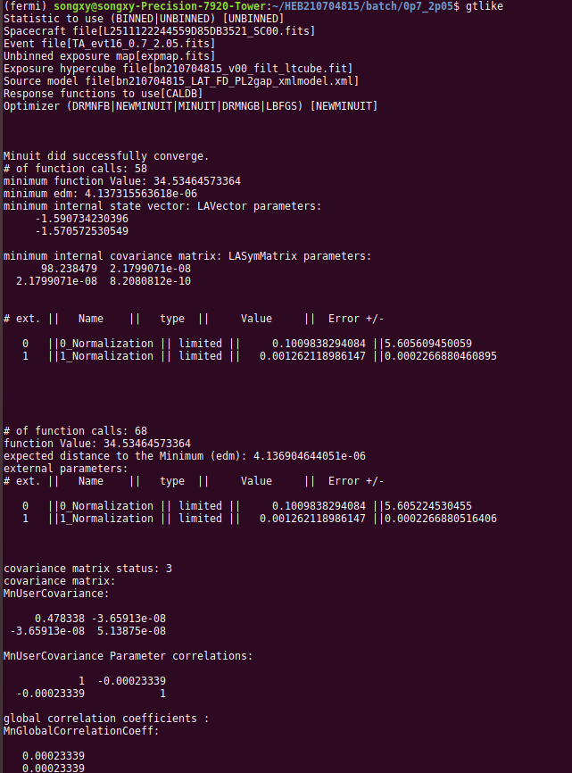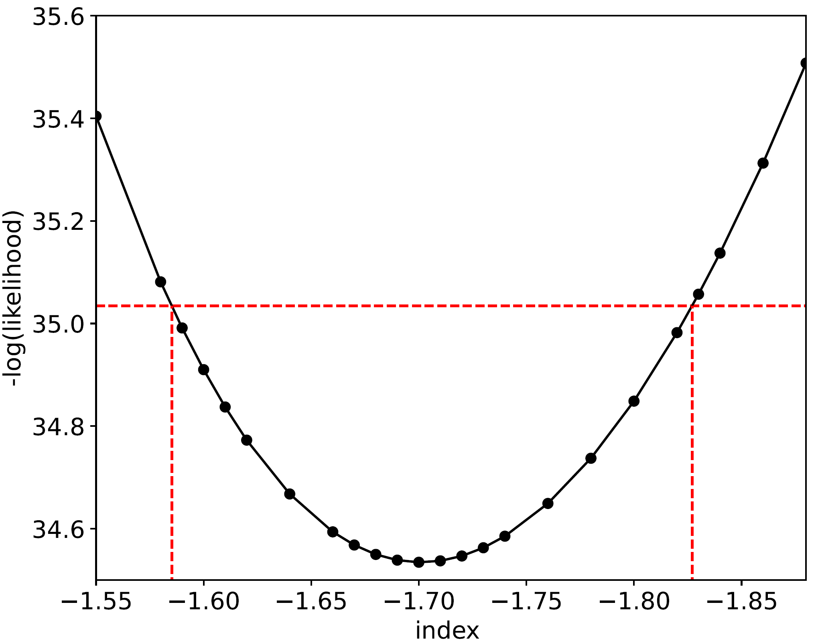

For the unbinned likelihood fitting, changes on Akaike and Bayes (BIC) Information Criteria ( AIC=-2log(L)+2*n and BIC=-2log(L)+ n*log(N), n : the number of free parameters, N: the number of data points) are the same.ΔBIC (orΔAIC)=9.2, this means a strong preference for PL with gap (Δ between 2 and 6 indicates positive evidence; 6–10 indicates strong evidence; and > 10 implies very strong evidence , see MNRAS 463, 1144 (2016) )
Thus, we think there is a strong preference for the gap.
We had tried to perform a modeling with PL +gabs, but because of low statistics around the gap, the parameters of the absorption line cannot be constrained well. Thus we propose that a specific detailed absorption line (e.g. gabs) is not used in this procedure, the reasons are as follows: 1) in this case, the statistics of the events around gap is not high enough to determine the parameters (the line width, line depth and line energy, the modeling has been tried before, but the extracted parameters are of great uncertainties), which caused “overfitting” by redundant parameters; 2) In fact the central energies of the gap varies with time even in this short time interval, and it is fortunate that there exists overlap from 0.6 GeV to 1.2 GeV. Even the statistics are high enough, a time-resolved analysis is necessary for determining the specific parameters of an absorption line.
We intended to perform the p-value test with raw LAT data, the raw LAT data cannot be obtained from the web. Since it is a not appropriate method with processed data, we delete the corresponding text in the revised version. The updated text is in lines 66-87 in the revised version.

**************
Furthermore, even if a spectral gap is present, its physical interpretation is not unique. The feature could arise from intrinsic spectral evolution or the superposition of different emission components. For example, the prompt emission spectrum (extending from keV to GeV energies) may exhibit a cutoff at sub-GeV energies due to internal photon-photon absorption, while an early afterglow component could emerge at higher energies. The combination of these components could mimic an apparent gap. Such alternative scenarios should be explicitly tested before attributing the feature to narrow absorption.
此外，即使存在光谱间隙，其物理解释也不是唯一的。该特征可能源于内在光谱演化或不同发射成分的叠加。例如，由于内部光子吸收，瞬发发射光谱（从keV延伸到GeV能量）可能会在亚GeV能量处出现截止，而早期余辉成分可能会在更高的能量处出现。这些组件的组合可以模拟一个明显的差距。在将该特征归因于窄吸收之前，应明确测试此类替代方案。
(这个应该是所说的多成分辐射的排除， 在PRL版中没提， 因而referee会发问)
Response (3): Thanks for the suggestion. Some other possible interpretations are discussed and ruled out for the following reasons:
- For the cutoff at sub-GeV energies due to internal photon-photon absorption, while early afterglow component could emerge at higher energies:
- first, Γ estimated with quasi-thermal component is in the range of 500-900, the optical depth for pair production of a high-energy photon and a target MeV photon is calculated in the Appendix C added in the revised version, τ_{γγ} ≥1 of about photon with the energy of about 1 GeV emitted at a radius 10¹¹ cm requires Γ ≤170 (because simultaneously emitted with MeV emission of the peak flux, a larger radius requires a smaller upper limit of Γ), thus this gap (or cutoff) cannot be caused by the pair production. Furthermore, even if the photon of highest energy (16.1 GeV) is from the afterglow with the large radius~10¹⁵ cm, the lower limit of Γ =260；if with radius~10¹¹ cm, the lower limit of Γ =500.
- In addition, an alternative absorption mechanism for the cutoff to generate an observed absorption with a center energy of about 1 GeV (the rest energy is 0.511 MeV), photon-photon pair production (γ + γ e⁺ + e⁻) in high-energy photons requires a much larger Lorentz Factor, e.g. Gamma ≈ 3000, than the estimate. Therefore, it is unlikely unless there exists sufficient evidence for an extremely large Lorentz Factor~3000.
- In addition, most of GeV photons (especially for those has a correlation with energy envelop of sub-GeV photons) are unlikely from external shocks. From the model prediction in R. Barniol Duran & P. Kumar, MNRAS 412, 522–528 (2011), it takes a few seconds for electrons in the external forward shock to be accelerated so that they can produce 100 MeV photons and it takes somewhat longer time for them to produce GeV photons. Based on this model, the peaking time of high-energy photons ia taken as deceleration time t_{d} (≈0.8s /(1+z) for GRB 210704A) relative to trigger time, the time delay of ~1 GeV to 100 MeV should be about 0.5 td. However, the observed of 100 MeV and GeV emission arrives almost simultaneously, and the delay time of sub-GeV emissions is too short.
Therefore, we turn to photon-matter interactions. The above discussion is added in the revised version in lines 82-102 in the revised version.

----------------------------------------------------------------------
Report of Referee B -- LQ20255/Zou
----------------------------------------------------------------------
Referee report on Zou et al: "Spectroscopic Signature of r-process Nucleosynthesis in a Gamma-Ray Burst: Resonant Deuterium Absorption in GRB 210704A"
I find the paper treats an exciting idea and a potentially interesting discovery of a ~GeV spectral absorption line.
I feel the significance of the line and the interpretation is not rigorous enough. For this reason I cannot recommend the paper, but I am open on hearing the authors' rebuttal.
我发现这篇论文提出了一个令人兴奋的想法，并发现了一条~GeV光谱吸收线，这可能很有趣。
我觉得这条线的意义和解释不够严谨。因此，我不能推荐这篇论文，但我愿意听取作者的反驳。
Main points:
The estimates of the Lorentz factor are extremely important piece of this analysis. I think the authors need to sketch at least in broad terms how they arrived to the value they use.
洛伦兹因子的估计是这一分析中极其重要的部分。我认为作者需要至少从广义上概述他们是如何达到他们使用的价值的。
Response (4)：Thank you very much for this very critical comment. We checked carefully for the estimates of the Lorentz factor, and found out the previous estimates were problematic.

---
In the previous version:
The estimates of Γ were obtained by two approaches, which were not presented in details in the previous manuscript. We list in the following:
(1) the quasi-thermal component in the prompt emission could be used in estimating the possible range of Γ;
(2) the photon of the highest energy (16.1 GeV) is used to provide the lower limit of Γ by the constraint from the pair production of the high-energy photons and the target MeV photons. This approach is model-independent.
These details are added in the Appendix C.
Another modification in the revised manuscript is the redshift. The recent detailed multiwavelength analysis of GRB 210704A determines that the most likely redshift is z=2.34 (Please see the D. L. A. Pieterse et al MNRAS 548, stag555 (2026)), and this points to a collapsar nature. In the following analysis, we use z=2.34 to estimate the Lorentz factor and to determine the energetics of the comoving frame. The estimation of Γ is performed via two approaches, (1) with the quasi-thermal component; from Eq (C5) and Refs [54, 55] (see the details in Appendix C), the estimate of Γ is approximately proportional to ((1+z)² d_{L})^{1/4}, for z=0.27, d_{L} =4.38e27 cm, for z=2.34, d_{L} =5.95e28 cm, thus the estimate of Γof z=2.34 is about 2 times that of z=0.27. (2) the LAT photon of the highest energy (16.01 GeV) is used to provide the lower limit of Γ by the constraint from the pair production of the high-energy photons and the target MeV photons. In this method, Γ is proportional to (1+z) and the change on z has no impact on the commoving energies. The lower limit of Γ is 500, about two times that of z=0.27 (Γ≥200). Thus, the commoving frame energetics, E_{rest}=E_{obs} (1+z)/2Γ remains almost unchanged. The corresponding modification is shown in Abstract, Introduction, Observation and Spectral Anomaly in the revised version (the differences are denoted in red and in blue in diff.pdf).

The key problem of such estimate is the one-zone model. The lower limit given by compactness problem should never output a reasonable value. It is always

---
In current modified version:

This also effects the optical depth estimate in section “”. We also modified it totally…

*********
The spectral analysis proceeds along unorthodox lines. It is clear that the Band function alone is not a good description of the data. Next in line in terms of complexity would be Band + power law. The Band function in the mBB+Band is also unconventional. A power law would be a better addition. It is hard to assess the goodness of these fits, without reported parameters.
光谱分析沿着非正统的路线进行。很明显，仅使用Band函数并不能很好地描述数据。在复杂性方面，下一步将是Band+幂律。mBB+Band中的Band功能也是非传统的。幂律将是一个更好的补充。如果没有报告的参数，很难评估这些拟合的优劣。
Response (5)：Thanks for the suggestion. The modelings with BAND+PL, mBB+PL with a gap in high-energy band (i.e. the 0-events from 0.6 GeV to 1.2 GeV are not added in the modeling; in the previous version, they are included) have been performed and the results are updated Figure 3 in APPENDIX B.
It is evident that there exist two different components in the prompt emission; the component of a broad energy band has a different origin from that of the peaking component in the MeV energy band. We compare the goodness of fit of mBB in MeV emission with that of BAND as follows,


From the resid distribution from 40 keV to 300 keV, there exists a systematic bias in the modeling with BAND function, while it is much better in modeling with mBB. This means that mBB model fits the data better than BAND in MeV emission, and the changes on BIC is ΔBIC= 8.1, which shows a strong preference for mBB. The ΔBIC of mBB+PL to mBB+BAND is 1.8<2, and BAND is not a unconventional model for the component of broad energy band. Therefore, we think mBB+PL is the best model. In addition, the low-energy photon index for the peaking component is about -0.1, although it cannot be decisive evidence for the quasi-thermal emission.

************
I think the MC simulations don't address the proper question by looking only below 1.21 GeV for a comparable or wider "hole" in the photon counts. I'd suggest asking what is the probability of a "hole" in the full data, 590 MeV or wider, from just assuming the measured power law parameters. This will result in photons from roughly the same range as observed. Alternatively you may require the hole be centered around 1 GeV. Have the authors tried fitting e.g. a line profile? That would allow for more rigorous discussions.
我认为MC模拟并没有通过仅在1.21 GeV以下寻找光子计数中可比或更宽的“空穴”来解决正确的问题。我建议问一下，仅仅假设测量的幂律参数，在完整数据中出现590 MeV或更宽的“洞”的概率是多少。这将导致光子来自与观测到的大致相同的范围。或者，您可能需要将孔的中心设在1 GeV左右。作者是否尝试过拟合线条轮廓？这将允许进行更严格的讨论。

Response (5): Thanks for the comments. In Response (2) to the first referee, we have used the Fermitools to perform the standard unbinned full likelihood analysis to obtain the significance of the gap. This approach properly accounts for photon-level information, including the probability that each detected photon is associated with the GRB versus Galactic diffuse emission, isotropic background, or other sources in the field. The changes on Akaike and Bayes (BIC) Information Criteria are the same, and ΔBIC (or ΔAIC)=9.2, this means a strong preference for PL with gap (Δ between 2 and 6 indicates positive evidence; 6–10 indicates strong evidence; and > 10 implies very strong evidence , see MNRAS 463, 1144 (2016) ). In addition, a time-resolved analysis reveals that the upper energy envelope of the sub-GeV photons and the lower energy envelope of GeV photons evolve synchronously, maintaining the gap structure, with this strong correlation. Thus we think the gap is statistically significant.
The estimation of p-value using MC simulation is not used and deleted in the revised version. The updated text is in lines 66-87 in the revised version. We expect that the p-value will be larger if we find a "hole" in the full data, because the statistics become lower as the energy increases for a power law spectrum.
We had tried to perform a modeling with PL +gabs, but because of low statistics around the gap, the parameters of the absorption line cannot be constrained well. Thus we proposed a specific detailed absorption line (e.g. gabs) is not used in this procedure, the reason is that in this case, the statistics of the events around gap is not high enough to determine the parameters (the line width, line depth and line energy, the modeling has been tried before, but the extracted parameters are of great uncertainties), which caused “overfitting” by redundant parameters. In fact the central energies of the gap varies with time even in this short time interval (it is fortunate that there exists overlap from 0.6 GeV to 1.2 GeV). Even the statistic is enough, a time-resolved analysis is necessary for determining the specific parameters of an absorption line.

************
Eq. (4) make sure it is as you intend it. Using the luminosity for calculating the comoving number density is more widespread, especially with short duration. Using E is fine too, just please double check.
方程式（4）确保它如你所愿。使用光度来计算共动数密度更为普遍，尤其是在短持续时间内。使用E也可以，请仔细检查。
Response (6): Thanks very much for the suggestion. If using the luminosity for calculating the comoving number density, it should be
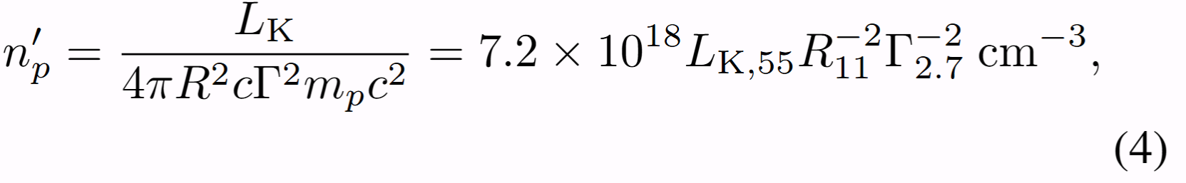
And the optical depth for the photodissociation of the deuterium is
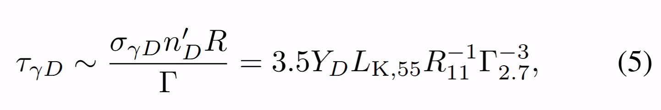
The text is updated in the sections “Optical depths for photon-electron and photon-deuteron interactions in relativistic internal shocks” and “Discussion”.

************
The interpretation part: I could not tease out what scenario the authors are considering. Is it synchrotron self-Compton in the internal shocks? Or inverse Compton from another photon source and internal shock electrons? I was trying to understand the relevance of the Klein Nishina calculations. Using the Band function of figure 4a is highly unusual. The bulk of the energy is in the component peaking at a few hundred keV and that should be the internal shock spectrum.
解释部分：我无法梳理出作者正在考虑的情况。是内部冲击中的同步加速器自康普顿吗？还是来自另一个光子源和内部冲击电子的逆康普顿？我试图理解Klein Nishina计算的相关性。使用图4a的Band函数是非常不寻常的。大部分能量存在于峰值在几百keV的分量中，这应该是内部冲击谱。
Response (7): Thanks for the comments. In MeV band (8-1000 keV), most energy are constributed from the peaking component, while the energy of the component from keV to ~10 GeV is about 2.6 times that of the peaking component in MeV (in T₀+[0.7, 2.05] s , L_{γ, peak}=3.7e53 erg s⁻¹ and L_{γ, keV-GeV}=1.0e54 erg s⁻¹ ).
we could discuss the most likely interpretations as below,
- If the peaking MeV component is quasi-thermal:
there exist seed photons in the outflow, and some of them become the component of a broad energy band from keV to GeV via inverse Compton (IC) scattering by relativistic electrons. However, not all photons are emitted, especially for those with lower energy, which corresponds to a larger cross section; moreover, as electrons are cooled, the cross section of electron-photon scattering becomes larger. They will be thermalized below the photosphere, when the radius reaches Rph (see the Appendix Eqs (B1) and (B2)). Rph ≲ 10¹¹⁻¹³ cm, the observed time delay ~(1+z)R/cΓ² relative to the keV to GeV component is very small (≲ a few milliseconds). This means this two components arrive almost simultaneously, which is consistent with the observation.

- If the peaking MeV component is non-thermal:
In SSC process, photon source is from the synchrotron emission of the electrons accelerated in the inernal shocks, while the high energy component could be from the Inverse Compton scattering of part of . It seems reasonable for two observed components. However, the peaking MeV emission should be not quasi-thermal since σ_{KN} <1, which is not consistent with the modeling results that mBB function is better than BAND function in describing the MeV peaking emission. Secondly, given L_{γ, peak}=4*10⁵³ erg s⁻¹ in T₀+[0.7, 2.05] s, similar fractions of electrons and magnetic field and Ep~ 250 keV, from the B. Zhang and H. Yan, ApJ 726, 90 (2011), the typical electron Lorentz factor γ_{e,p} is estimated by
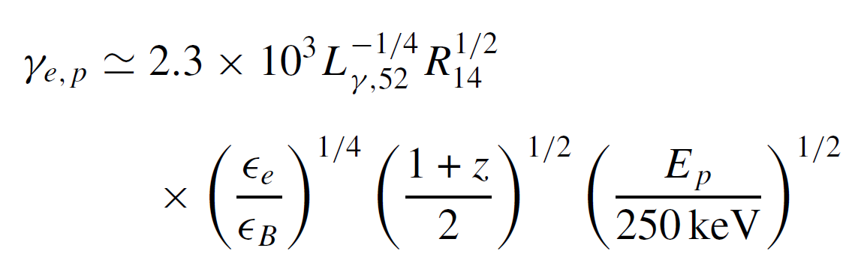
. γ_{e,p} ≥10^{3.5} requires the peaking component is emitted at a larger radius (R~10¹⁴ cm). If the internal shocks occur at such a large radius, the optical depth for the photondissociation of deutron is much less than 1. If the internal shocks occur at 10¹¹ cm, it is not reasonable that synchrotron emission has a much larger radius because τ_{KN} (Eobs~ 250 keV) must be less than 1.

In conclusion, we think the first case is more consistent with the observations. In addition, because most energy in the promt phase are from the keV to GeV component, and L_{k} is estimated from the the keV to GeV component (L_{γ, keV-GeV}=1.0e54 erg s⁻¹ , radiative efficiency <10% for the internal shock, Lk~1.0e55 erg s⁻¹ ) , the emission mechanism of MeV peaking component do not affect the calculation and conclusion.
Because the electrons are accelerated to be relativistic, the electron-photon scattering is in the KN regime, the observation that the photons are emitted requires that τ_{KN} <1 for the keV to GeV emission. For example, γ_{m} ~10⁶ could satisfy that τ_{KN} (Eobs~10 keV)<1. This is why we perform the Klein Nishina calculations.
The discussion and conclusion about the emission mechanism in the prompt phase are added in Appendix B (lines 317-349) in the revised version.

************
The other problematic aspect is that the spectral component that arises in many GRBs in addition to the prompt keV-MeV peak (around 10 keV and at GeV energies) is usually attributed to external shocks. The line the authors discuss would need a different interpretation in this case.
另一个有问题的方面是，除了瞬时keV MeV峰值（约10keV和GeV能量）外，许多伽马射线暴中出现的光谱分量通常归因于外部冲击。在这种情况下，作者所讨论的线路需要不同的解释。
Response (8): Thanks for the suggestion. If the keV-GeV component is caused by the external shocks, there are some observations which are difficult to be explained:
- From the model prediction in R. Barniol Duran & P. Kumar, MNRAS 412, 522–528 (2011), it takes a few seconds for electrons in the external forward shock to be accelerated so that they can produce 100 MeV photons and it takes somewhat longer time for them to produce GeV photons. Based on this model, the peaking time of high-energy photons is taken as deceleration time t_{d} (=0.8s /(1+z) for GRB 210704A) relative to trigger time, the time delay of ~1 GeV to 100 MeV should be about 0.5 td. However, the observed of 100 MeV and GeV emission arrives alomost simultaneously, and the delay time of sub-GeV emissions is too short.
- In some individual case studies of GRB 090902B (Liu&Wang ApJ 730 ,1 (2011)) and GRB 090510 (He et al. ApJ 733, 22(2011)) all suggest that the external shock model cannot interpret the prompt GeV data. The modelling in Ref A.Maxham,B.-B. Zhang and B. Zhang MNRAS 415, 77–82 (2011) suggests that it is possible to use the external shock model to interpret GeV emission after the prompt emission phase, but not during the prompt emission phase. For GRB 210704A, the high-energy prompt emission traces the MeV emission well (See Figure 1 in the revised version), and we think this implies an internal origin.
Therefore, we think the dominant component of prompt high-energy emission in T₀+[0.7, 2.05] s could not be from external shocks. In addition, it is difficult to interpret the GeV photons which behaves a correlation with the the upper energy envelope of sub-GeV photons if GeV photons are from external shocks. This discussion is added in the revised version in lines 93-99.

We also made other modifications.

While

