Tan Li Yuan 1004326

2.2

IP

H1: 10.0.0.2

H2: 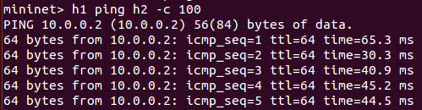10.0.0.2

3.1

It takes 1.1s to download a webpage on h1 from h2

HTTP session starts off with a slow start, where cwnd = 1. 2. 4. …

cwnd increases exponentially

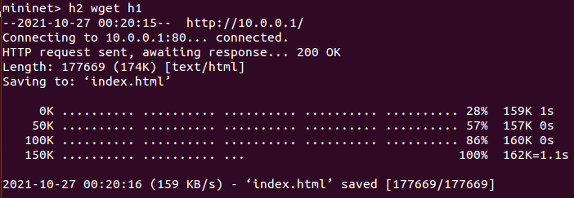

3.2

ping average = 47.840s (without iperf)

ping average = 739.271s (with iperf)

wget takes 5.3s instead (with iperf)

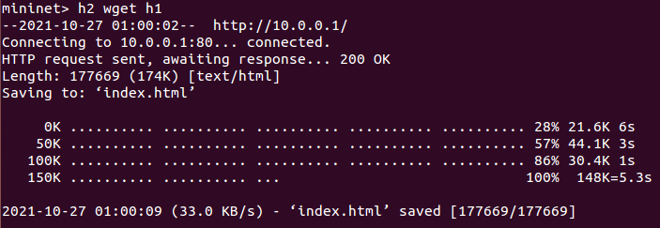

Some of the bandwidth is utilized by iperf, and this would greatly reduce the effective bandwidth available for the file download.

3.3

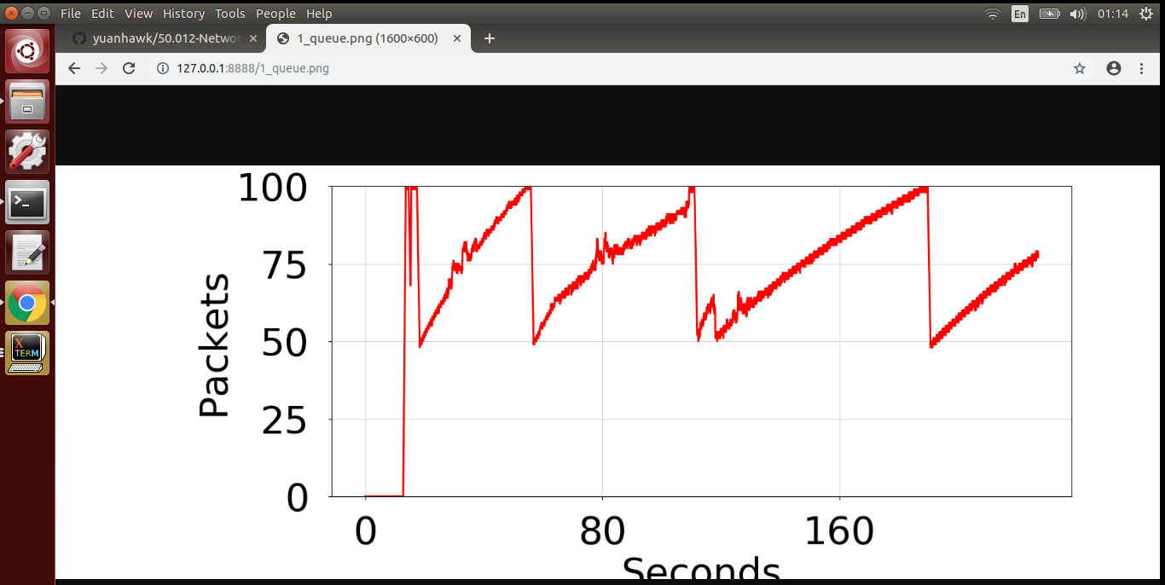

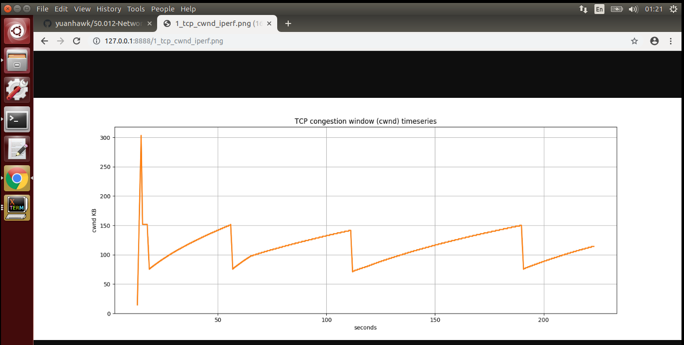

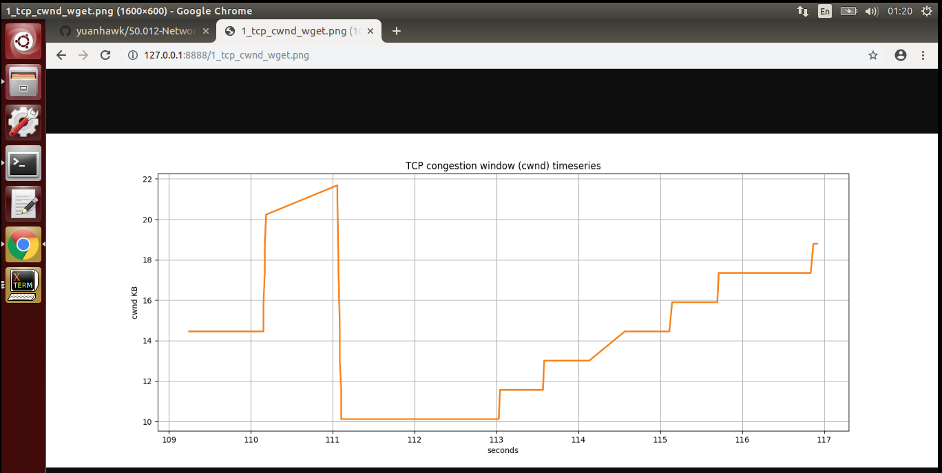

3.4

minq

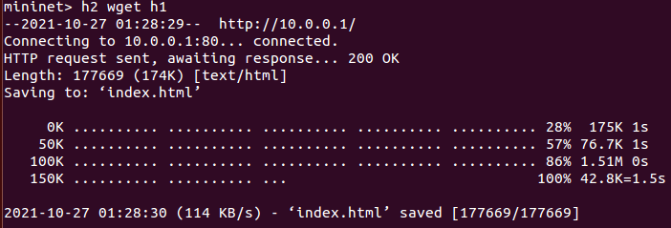

time = 1.5s

minimal change

