Tan Li Yuan 1004326

2.2

IP

H1: 10.0.0.2

H2: 10.0.0.2

(Refer to 2_2.txt)

(cat submissions/2_2.txt)

3.1

* It takes 1.1s to download a webpage on h1 from h2
* HTTP session starts off with a slow start, where cwnd = 1. 2. 4. … cwnd increases exponentially

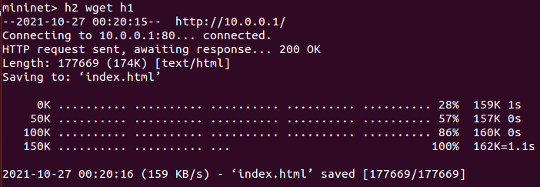

3.2

ping average = 47.840ms (without iperf)

(Refer to 3_2_1.txt)

(cat submissions/3_2_1.txt)

ping average = 739.271ms (with iperf)

(Refer to 3_2_1.txt)

(cat submissions/3_2_2.txt)

* Ping average increases by 691.431ms.

wget takes 5.3s instead (with iperf)

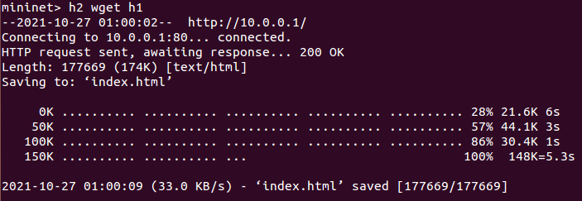

* Some of the bandwidth is utilized by iperf, and this would greatly reduce the effective bandwidth available for the file download.

3.3

Saved in 1_tcpprobe.txt & 1_sw0-qlen.txt

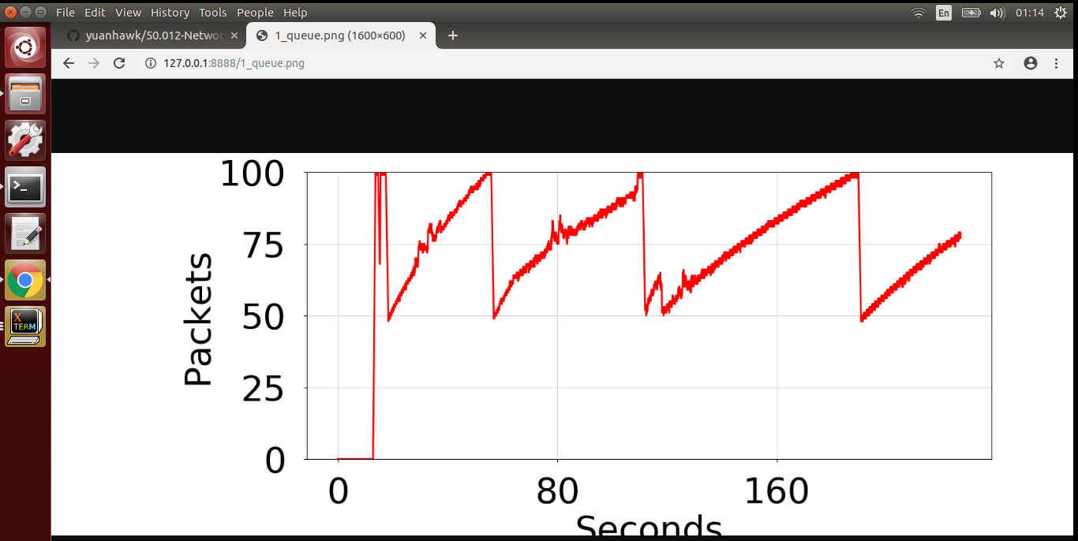Buffer takes a longer to reach the max cwnd of estimated 148 KB

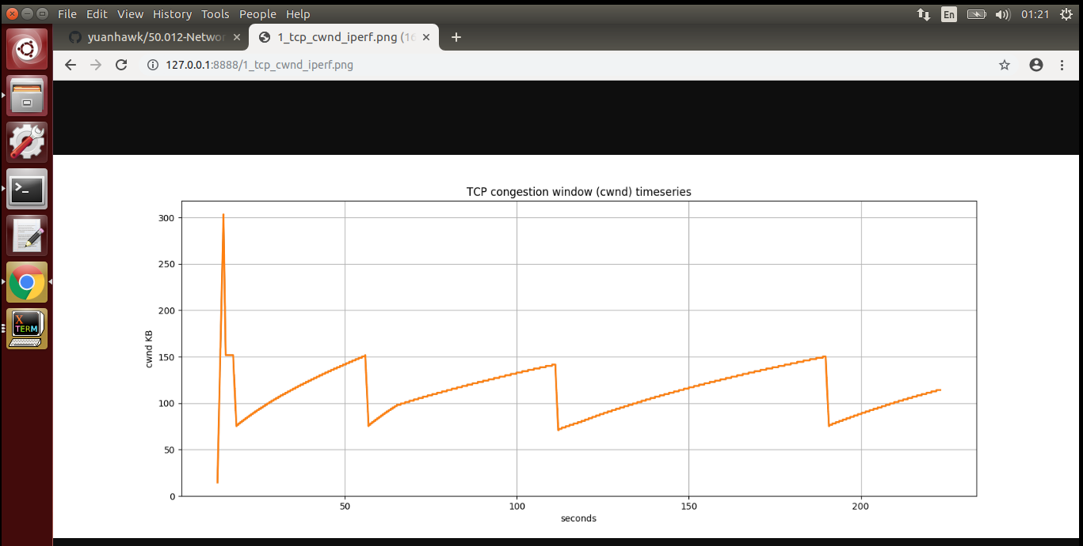Occasional multiplicative decrease in cwnd from 150 to 75 KB

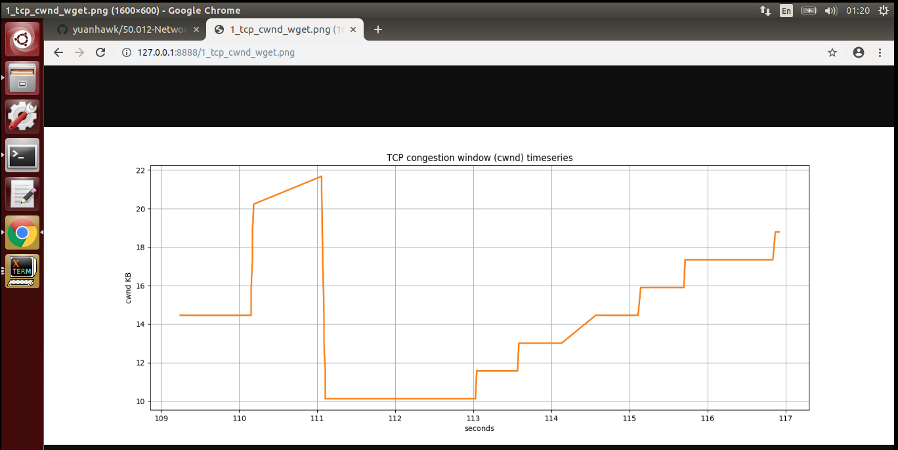

Max cwnd takes a longer duration to reach (>4s)

3.4

minq

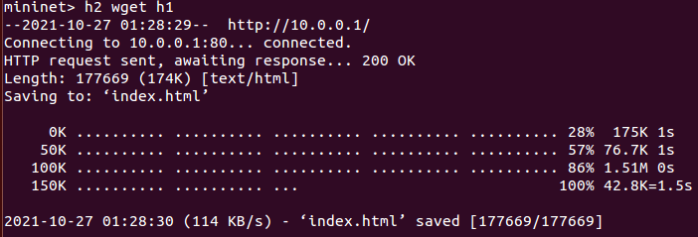

time = 1.5s

minimal change

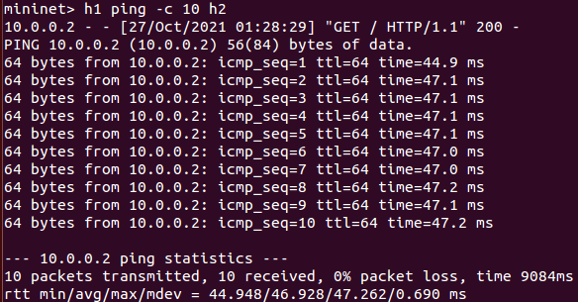

10 pkts 46.928 ms

100 pkts 40.625 ms

Minimal differences between 100 pks vs 10 pkts (est 6 ms)

* 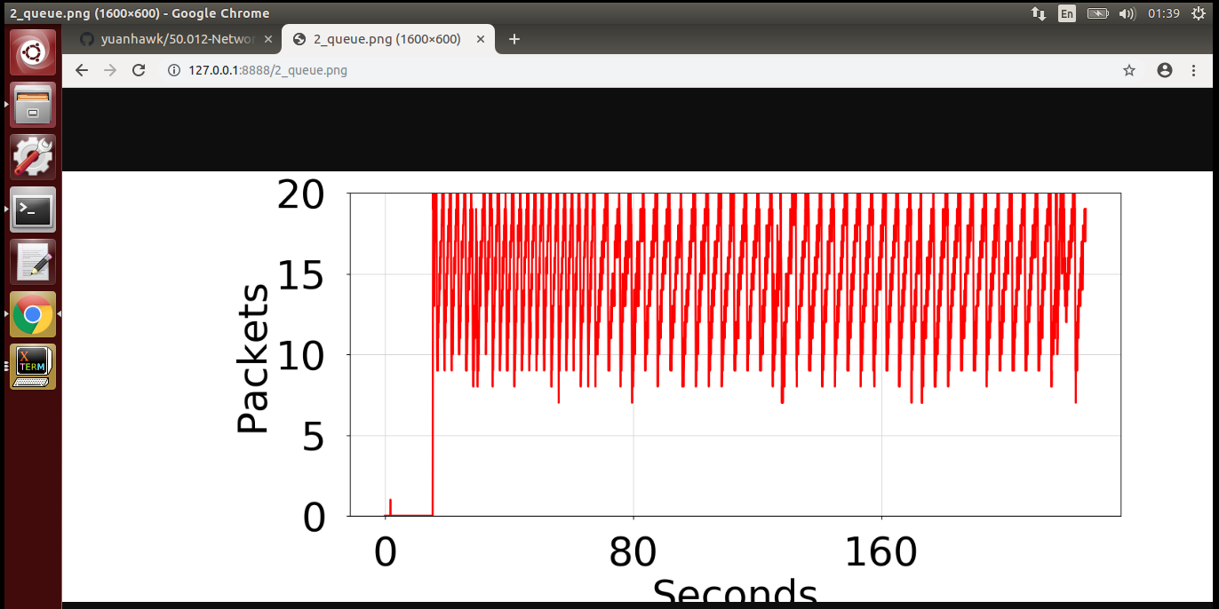Buffer reaches the max cwnd of 20+ very quickly
* 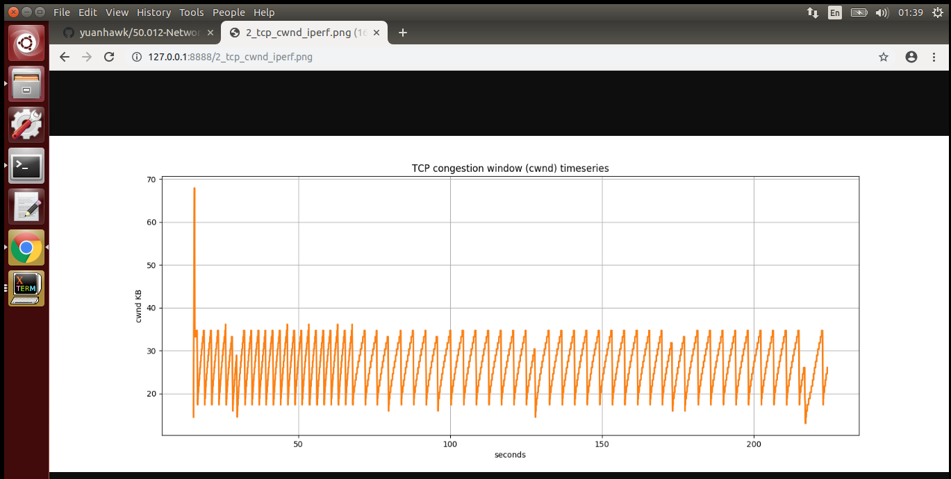Very frequent multiplicative decrease in cwnd from 32 to 16 KB. ssthresh is much lower in experiment 1, where cwnd fell from 150KB to 32KB.
* 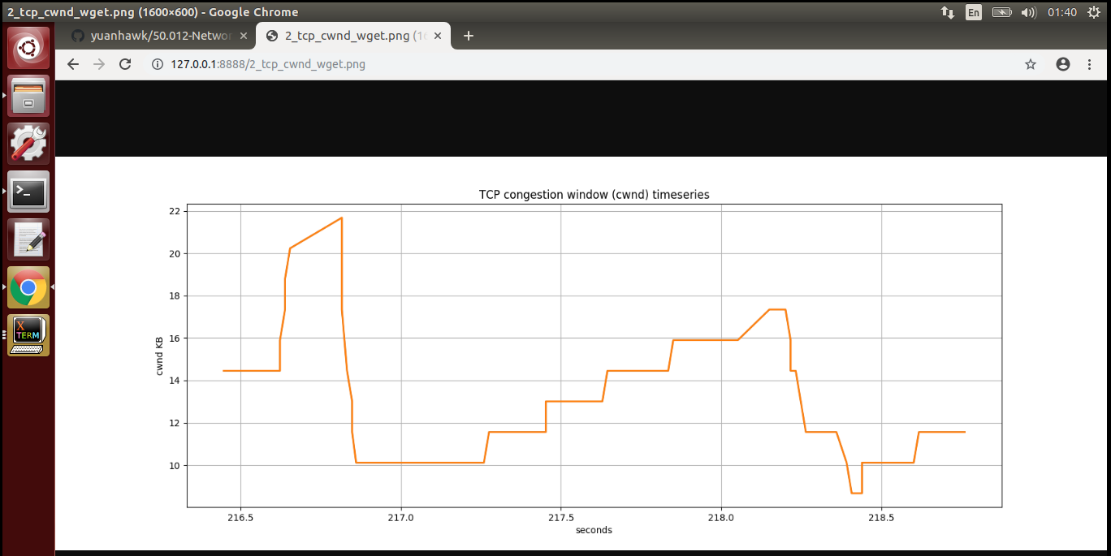Max cwnd is reached in a shorter period (est. 0.9s)

When the queue size is smaller, max cwnd is reached in a shorter period, thus iperf observes a multiplicative decrease more frequently. This would allow the TCP throughput to reach the equal bandwidth share more quickly and thereby achieving equitable TCP bandwidth sharing. As such, the wget gets its equal share of bandwidth more quickly.