No.: | XXXX

Nanjing University of Posts and Telecommunications


TCP/IP网络设计与实现（双语）论文
Rethinking Transport Layer Design:
A Comprehensive Analysis of the QUIC Protocol's
Architecture, Implementation, and Cross-Layer Interactions

Student No.: B23041026
Name: 袁衡
Submission date: 2026-6-19
Lecturer: 叶晓国

Course Goals / Evaluation Criteria |  | Grade
Course Goal 1： Understanding the purpose of the specified protocol, including explain the specific role it plays within the application and the problems it addresses. (20 Points) |  | 16
Course Goal 2： Understanding the corresponding code, including the components that make up the code implementing protocol functionality, and the specific functions of each part. (20 Points) |  | 16
Course Goal 3：Master the core data structure and implementation ideas of specific protocols. (20 Points) |  | 16
Course Goal 4：Understand how the specified protocol interacts with other protocols or other OSI layers. (20 Points) |  | 16
Course Goal 5：Possess expression and word processing skills, able to write reports with detailed and standardized report content. (20 Points) |  | 16
Totally |  | 80
Comments（评语）:
该同学按照要求对***协议代码的数据结构、执行流程及其调用关系进行了分析，（基本、较好地、圆满）完成了大作业的撰写任务，大作业报告层次清晰，图表（较）完整，报告中对代码模块间的调用关系的分析（不够、较）深入，该同学大作业论文撰写态度较认真，撰写（基本、较）规范。

 | 2025-6-19

Rethinking Transport Layer Design: A Comprehensive Analysis of the QUIC Protocol's Architecture, Implementation, and Cross-Layer Interactions
袁衡 (Student No. B23041026)
Nanjing University of Posts and Telecommunication

Abstract
The QUIC protocol, standardized as RFC 9000 in 2021, represents the most consequential restructuring of the Internet transport layer since TCP's inception. By relocating transport logic from the operating system kernel into user-space applications, and by fusing transport reliability with TLS 1.3 cryptographic security into a single protocol substrate running atop UDP, QUIC dissolves the ossification that has inhibited TCP evolution for decades. This paper provides a comprehensive, analytically rigorous examination of QUIC's packet architecture and header formats, its twenty-plus frame types, its connection state management and stream state machines, its two-tier flow-control credit system, and its pluggable congestion-control framework as implemented in Cloudflare's quiche library. Special attention is devoted to QUIC's cross-layer interactions: its relationship with UDP encapsulation, its deep integration with TLS 1.3 through four distinct encryption levels, its role as the exclusive transport for HTTP/3, and the challenges it poses to middlebox-based network management. The paper concludes with a forward-looking perspective on Multipath QUIC, QUIC Version 2, and the broader protocol ecosystem that is coalescing around QUIC as a universal secure transport substrate.
Keywords: QUIC, RFC 9000, transport protocol, TLS 1.3, HTTP/3, stream multiplexing, connection migration, congestion control.
- Introduction
  - Aims and Scope
The Internet's transport layer has for four decades been dominated by the Transmission Control Protocol (TCP), a design predating the World Wide Web, streaming media, and ubiquitous mobile connectivity. TCP's architecture embeds assumptions that are now outdated: that network paths are stable, that latency is homogeneous, and that the operating system kernel is the appropriate home for transport logic. Three specific limitations have become acute in modern large-scale deployments. First, TCP's single, ordered byte stream imposes head-of-line (HOL) blocking: a lost segment stalls the delivery of all subsequent data, even if that data belongs to entirely independent application conversations. Second, TCP's semantics have been so thoroughly encoded into network middleboxes—NATs, firewalls, and performance-enhancing proxies—that protocol innovation is structurally impossible without risking global network breakage. Third, the sequential TCP handshake followed by a separate TLS negotiation imposes a minimum of two round-trip times (RTT) before any application data can flow, a penalty disproportionately costly for short-lived connections that constitute the majority of Web transactions.
3
The primary aim of this paper is to provide a deep, analytically rigorous examination of QUIC—standardized as RFC 9000 by the IETF in May 2021—as a response to these structural failings. The scope covers the full breadth of QUIC's technical design: its packet architecture and variable-length encodings, its twenty-one frame types and their functional roles, its connection and stream state machines, its two-tier flow-control system, its pluggable congestion control, and its interactions with every adjacent protocol layer from UDP through TLS 1.3, HTTP/3, and the IP network infrastructure. The paper also addresses QUIC's philosophical implications—particularly its deliberate rejection of the middlebox-intelligence network management model—and concludes with a prospective analysis of QUIC's emerging ecosystem including Multipath QUIC, QUIC Version 2 (RFC 9369), and DNS-over-QUIC. The analysis is grounded in RFC 9000, RFC 9001, RFC 9002, and the Cloudflare quiche reference implementation, and aims to demonstrate expert-level protocol understanding rather than mere specification summary.
  - Editorial policies
This paper adopts a structured analytical methodology that proceeds from protocol specification to implementation to cross-layer interaction. The primary sources are the IETF RFC documents: RFC 9000 (QUIC core transport), RFC 9001 (TLS integration), RFC 9002 (loss detection and congestion control), RFC 8999 (version-independent properties), RFC 9114 (HTTP/3), RFC 9312 (manageability), and RFC 9369 (QUIC Version 2). Secondary sources include the ACM SIGCOMM 2017 paper by Langley et al. documenting Google's initial deployment experience, empirical measurement studies (Ruth et al. 2018; Kakhki et al. 2017), and the Cloudflare quiche library as a concrete reference implementation.
Per assignment rules, the analysis does not reproduce source code verbatim. Instead, data structures are analyzed through tabular decomposition of their fields and types, and algorithmic behaviors are described through state-machine formalisms and prose analysis. Process flows—such as the QUIC handshake sequence and connection migration procedure—are described textually and through state-machine tables rather than embedded flowcharts. This methodology is analytically appropriate because QUIC's design is fundamentally defined by its data structures and state transitions; a field-by-field and state-by-state examination yields richer insight than high-level narrative alone. Where QUIC's design decisions differ from TCP, the comparison is made explicit so that the reader understands not merely what QUIC does but why the design choices were made and what trade-offs they entail. The analytical framework thus encompasses specification analysis, implementation study, cross-layer interaction mapping, and comparative evaluation—four dimensions that together constitute a comprehensive treatment of the protocol.
  - Content types
- Research article
QUIC occupies an unusual and philosophically significant position in the OSI model. Formally, it implements transport-layer semantics—reliable delivery, ordering, flow control, congestion control, stream multiplexing—yet it executes entirely in user space rather than the kernel where TCP and UDP reside. QUIC achieves this by encapsulating its packets within UDP datagrams, using UDP solely as a mechanism to traverse Internet infrastructure that universally passes UDP traffic on port 443. This relationship is better characterized as encapsulation than layering in the strict OSI sense: QUIC does not use UDP's reliability or ordering primitives (UDP provides none) but treats UDP as an 'IP extension header' that lets QUIC packets reach their destination without being filtered by middleboxes that block unknown IP protocol numbers.
The resulting stack—UDP/QUIC/HTTP/3—is functionally equivalent to TCP/TLS/HTTP/2 but structurally superior in four measurable dimensions. The traditional stack requires three independent protocol negotiations (TCP SYN, TLS ClientHello, HTTP/2 SETTINGS), whereas QUIC merges transport and cryptographic handshake into a single exchange, achieving 1-RTT for new connections and 0-RTT for resumptions. Where HTTP/2's multiplexing sits atop TCP's single byte stream—reintroducing HOL blocking at the transport layer—HTTP/3 maps each HTTP request to a separate QUIC stream, achieving genuine, loss-isolated multiplexing. Where TLS is optionally layered atop TCP as an independent record-layer protocol consuming an additional RTT, QUIC integrates TLS 1.3 directly into its handshake, encrypting not merely payload but most header fields. And where TCP is fixed in the kernel, requiring OS-level software updates to evolve, QUIC lives in user space and can be updated at the application or library level with the same agility as any application software.
The user-space deployment architecture is not mere implementation convenience; it is a deliberate inversion of the traditional Internet protocol taxonomy, mirroring the broader trend in Software-Defined Networking (SDN) where control planes are lifted from hardware into software for rapid iteration. Just as SDN decouples forwarding from control, QUIC decouples transport semantics from kernel constraints, enabling per-application protocol evolution without OS updates or middlebox reconfiguration. Connection migration via Connection IDs—variable-length opaque identifiers embedded in packet headers and independent of IP addressing—means that QUIC connections can survive changes in network address, an impossibility in TCP whose connections are identified by the 4-tuple (source IP, source port, destination IP, destination port). This connection mobility is foundational for mobile devices switching between Wi-Fi and cellular networks.
- Review article
Five core design principles govern QUIC's architecture, each representing a deliberate break from TCP conventions and a reasoned response to a specific TCP limitation.
Security by Default. Perhaps the most philosophically radical aspect of QUIC is its treatment of encryption as an invariant rather than a feature. Virtually all of a QUIC packet's header fields—beyond a handful of bits required for demultiplexing—are encrypted under AEAD ciphers. This stands in stark contrast to TCP, whose header is transmitted in plaintext and has therefore been exploited by middleboxes for performance optimization, traffic classification, and surveillance. By encrypting header fields including packet numbers and stream identifiers, QUIC prevents middleboxes from accumulating 'protocol state' that creates ossification. A middlebox that cannot read QUIC headers cannot develop assumptions about QUIC semantics, and therefore cannot break when those semantics evolve. This is not merely a security improvement; it is an architectural mechanism for preserving long-term protocol evolvability.
Connection Migration via Connection IDs. TCP connections are identified by the 4-tuple (source IP, source port, destination IP, destination port). Any change to this tuple—such as a mobile device switching from Wi-Fi to cellular—terminates the connection. QUIC instead identifies connections by Connection IDs: variable-length opaque identifiers embedded in packet headers. Because Connection IDs are independent of network addressing, a QUIC connection can survive changes in the underlying IP address or port. The server provisions multiple alternative Connection IDs via NEW_CONNECTION_ID frames; the client selects a new one when migrating paths. This design is foundational for mobile use cases where seamless handoffs are critical.
Stream Multiplexing Without HOL Blocking. QUIC natively supports multiple independent streams within a single connection. Each stream is a logically separate, ordered byte sequence, but streams are independent of one another at the transport layer. A lost packet carrying stream A data does not block delivery of stream B data—the QUIC stack delivers stream B frames to the application immediately, holding only stream A frames in the reorder buffer. This is the fundamental improvement over HTTP/2-over-TCP, where TCP's single byte stream made it impossible for the transport layer to distinguish which application stream a retransmitted byte belonged to.
0-RTT Connection Establishment. For clients that have previously connected to a server, QUIC supports 0-RTT connection resumption using a session ticket and pre-shared application data key from the prior session. Application data can be sent in the very first packet before receiving any server response, eliminating the connection establishment latency for returning clients. While 0-RTT data is subject to replay attacks and therefore must be idempotent, it reduces the perceived handshake latency to zero for the common returning-client case.
User-Space Deployment. By running entirely in user space atop UDP, QUIC can be updated at the application or library level rather than requiring OS kernel updates. This deployment model has already demonstrated its value: Google's initial QUIC deployment achieved approximately 75% reduction in video rebuffering on YouTube and a 1% improvement in search latency, deployed iteratively without any changes to the underlying network infrastructure or operating system. The Cloudflare quiche library (written in Rust for memory safety) exemplifies how QUIC's user-space architecture enables rapid protocol iteration.
  - Equations, Formulas, and Functions
- Tools
QUIC defines two principal header formats: the Long Header, used during connection establishment, and the Short Header (also called the 1-RTT header), used for all application data after the handshake completes. The leading bit of every QUIC packet (the Header Form bit) distinguishes between the two formats. Table 1 presents the field-by-field structure of the Long Header format.
QUIC defines two principal header formats: the Long Header, used during connection establishment, and the Short Header (also called the 1-RTT header), used for all application data after the handshake completes. The leading bit of every QUIC packet (the Header Form bit) distinguishes between the two formats.
A subtle but consequential design innovation within the header format is the variable-length integer encoding used for most numeric fields (lengths, stream IDs, byte offsets, packet counts). Rather than fixing field widths—which wastes space for small values while imposing ceilings on large values—QUIC encodes integers using the two most significant bits of the first byte to signal the total encoding length.
The two-bit overhead of the variable-length encoding scheme is negligible compared to the bandwidth saved by avoiding fixed-width 4- or 8-byte fields for values that are typically small. This is a microcosm of QUIC's broader design philosophy: structure the protocol to be efficient for the common case while maintaining theoretical extensibility for the extreme case, all without requiring any protocol version negotiation for new value ranges.
QUIC packets do not carry raw data; they carry frames, which are typed records within the encrypted packet payload. This framing layer gives QUIC the flexibility to multiplex multiple protocol concerns—acknowledgments, flow control credits, stream data, connection management, path validation—within a single UDP datagram, maximizing wire efficiency. RFC 9000 defines twenty-one frame types.
Several frames warrant deeper architectural analysis. The STREAM frame family (0x08-0x0f) is QUIC's workhorse: the three least-significant bits of the type byte encode three boolean flags. The OFF flag (bit 2) indicates that a Stream Offset field is present, enabling out-of-order delivery detection. The LEN flag (bit 1) indicates that an explicit Length field is present; its absence means the stream data extends to the end of the packet. The FIN flag (bit 0) signals that this is the final data for the stream—equivalent to a TCP FIN but scoped to a single stream rather than the entire connection. This compact flag encoding allows QUIC to represent eight different stream frame variants with a single type byte range, minimizing header overhead for the most common operation.
The CRYPTO frame (0x06) is architecturally unique: it provides a reliable, ordered byte stream for TLS handshake messages, but it is independent of the QUIC stream abstraction—it has no stream ID—and appears across Initial, Handshake, and 1-RTT packet spaces. This design reflects QUIC's integration of TLS as a peer layer rather than a subordinate layer: the CRYPTO frame gives TLS a dedicated, reliable transport channel within QUIC's own loss-detection infrastructure, eliminating the TLS record layer entirely. The NEW_CONNECTION_ID frame (0x18) is the mechanism that enables connection migration: each frame provides a fresh Connection ID paired with a stateless reset token, allowing the receiving endpoint to use any of the advertised Connection IDs when initiating a path migration, without interrupting the connection.

- Number
QUIC manages connection state across three independent packet number spaces: Initial, Handshake, and Application Data (1-RTT). Each space maintains its own packet number sequence, beginning at zero and incrementing monotonically. This three-space architecture resolves a fundamental TCP design flaw: in TCP, retransmissions carry the same sequence number as the original transmission, creating the retransmission ambiguity problem where an arriving ACK cannot be attributed to the original or retransmitted segment. QUIC assigns a new, higher packet number to every retransmission, making every ACK unambiguous and enabling precise RTT estimation in all network conditions—including the high-loss wireless environments where TCP's RTT estimates degrade most severely.
The independence of stream state machines from the connection-level state is a critical design feature. A stream can transition to Reset Sent (sending side aborted) while the connection itself remains fully operational and new streams can be opened simultaneously. This granularity of state management—impossible in TCP, where FIN and TIME_WAIT affect the entire connection—enables fine-grained resource control and enables QUIC applications to implement sophisticated flow management policies at the individual stream level.
QUIC implements a two-level, credit-based flow control system. At the stream level, MAX_STREAM_DATA frames advertise the maximum byte offset the sender is permitted to transmit on a given stream. At the connection level, MAX_DATA frames advertise the aggregate maximum offset across all streams. A sender is blocked whenever either limit would be exceeded. Stream concurrency itself is independently controlled by MAX_STREAMS frames, with separate limits for bidirectional and unidirectional streams, preventing resource exhaustion attacks.
The congestion control framework in QUIC is deliberately pluggable, supporting Reno, CUBIC, and BBR selectable at the application level. This is structurally impossible with kernel-based TCP, where the congestion control algorithm is a system-wide setting requiring OS-level privilege to change. The most significant implementation advantage over TCP's congestion estimation lies in RTT measurement accuracy: because QUIC's packet numbers are monotonically increasing and never reused even for retransmissions, every ACK precisely identifies which transmission is being acknowledged, eliminating Karn's algorithm entirely and enabling accurate SRTT updates in all network conditions.
QUIC also defines three distinct loss detection mechanisms operating in concert: acknowledgment-based detection (a packet is declared lost if a sufficiently higher-numbered packet has been acknowledged and a threshold time has elapsed), timeout-based detection via the Probe Timeout (PTO) mechanism, and persistent congestion detection for catastrophic loss events. The PTO mechanism is more nuanced than TCP's Retransmission Timeout (RTO): rather than resetting the congestion window to one segment on timeout, PTO sends probe packets to elicit an ACK, allowing the congestion state to be updated based on the resulting RTT sample before committing to a window reduction. Connection ID lifecycle management is governed by a sequence-numbered issuance-and-retirement protocol: each NEW_CONNECTION_ID frame carries a Sequence Number and a Retire Prior To field enabling bulk retirement of older IDs, supporting both proactive migration (pre-fetching alternative IDs) and reactive migration (switching on path failure).

- Figures and Tables
2

Figures
The integration of QUIC with TLS 1.3 is architecturally novel and constitutes one of the most important cross-layer design decisions in QUIC. Traditional TLS runs atop TCP's reliable byte stream and uses the TLS record layer to provide its own fragmentation and sequencing of handshake messages. QUIC eliminates the TLS record layer entirely. Instead, TLS messages are transported over QUIC's CRYPTO frames, which provide a reliable, ordered byte stream via QUIC's own loss detection rather than TLS's. The TLS state machine produces and consumes the same ClientHello, ServerHello, EncryptedExtensions, Certificate, and Finished messages as standard TLS 1.3, but the transport of those messages is managed by QUIC.
QUIC defines four encryption levels, each with its own set of keys derived via TLS 1.3's HKDF-based key schedule. Table 8 summarizes these levels and their properties. The Initial encryption level uses keys derived from the Destination Connection ID via a well-known salt (providing some connection-specific keying even before the TLS handshake completes, while acknowledging that Initial packets are not cryptographically authenticated against the server). The Handshake level uses keys derived from TLS 1.3 handshake traffic secrets, providing forward secrecy once the key exchange completes. The 0-RTT level uses keys derived from a prior session's resumption ticket. The 1-RTT level uses fully negotiated keys with optional key update capability via the Key Phase bit in the Short Header.
Key derivation follows TLS 1.3's HKDF-Extract and HKDF-Expand functions with QUIC-specific labels (e.g., 'quic key', 'quic iv', 'quic hp') to domain-separate QUIC keys from TLS record-layer keys. Separate derived keys handle packet payload encryption (via AEAD) and header field protection (via AES-ECB or ChaCha20 applied to selected header bits). This header protection mechanism is what allows QUIC to encrypt even the packet number field—which would otherwise be visible to on-path observers—without creating a bootstrapping problem: the header protection key is derived independently of the AEAD key, allowing the receiver to first apply header protection removal (using a sample from the encrypted payload) to recover the packet number, and then use the packet number to construct the AEAD nonce for payload decryption.
The deep TLS 1.3 integration achieves what can be characterized as cross-layer optimization: by merging the TCP SYN exchange and the TLS ClientHello/ServerHello/EncryptedExtensions/Certificate/Finished into a single QUIC Handshake flight, QUIC reduces connection establishment latency from TCP+TLS 1.3's minimum of 2 RTT to 1 RTT for new connections and 0 RTT for resumptions. This is not an implementation optimization but a protocol-architectural consequence that cannot be replicated within the TCP+TLS sequential model. Furthermore, the elimination of the TLS record layer removes an entire protocol sub-layer's worth of overhead and complexity, reducing the attack surface and simplifying the implementation stack.

Figure 1 illustrates the fundamental architectural divergence between the traditional Internet stack and the QUIC-based stack. In the traditional model, the application layer (HTTP/1.1 or HTTP/2), the security layer (TLS 1.2/1.3), and the transport layer (TCP) are maintained as independent protocol strata, each negotiated in a separate round trip. A new connection therefore requires a minimum of 2–3 RTTs before application data can flow: one RTT for the TCP three-way handshake, and one additional RTT for the TLS handshake. In the QUIC architecture, the transport and cryptographic handshake are collapsed into a single unified layer that executes atop UDP. QUIC performs its combined transport and TLS 1.3 handshake in a single flight, reducing connection establishment to 1 RTT for new connections and 0 RTT for sessions with a valid resumption ticket. UDP serves solely as an encapsulation substrate — providing port-based demultiplexing and IP checksum coverage — while all reliability, ordering, flow control, and security functions are implemented within QUIC itself. HTTP/3 sits directly above QUIC, mapping each HTTP request/response pair to an independent QUIC stream and thus inheriting QUIC's stream-level loss isolation.

Figure 1. Protocol stack comparison between the traditional TCP/TLS/HTTP architecture and the QUIC/HTTP3 architecture.
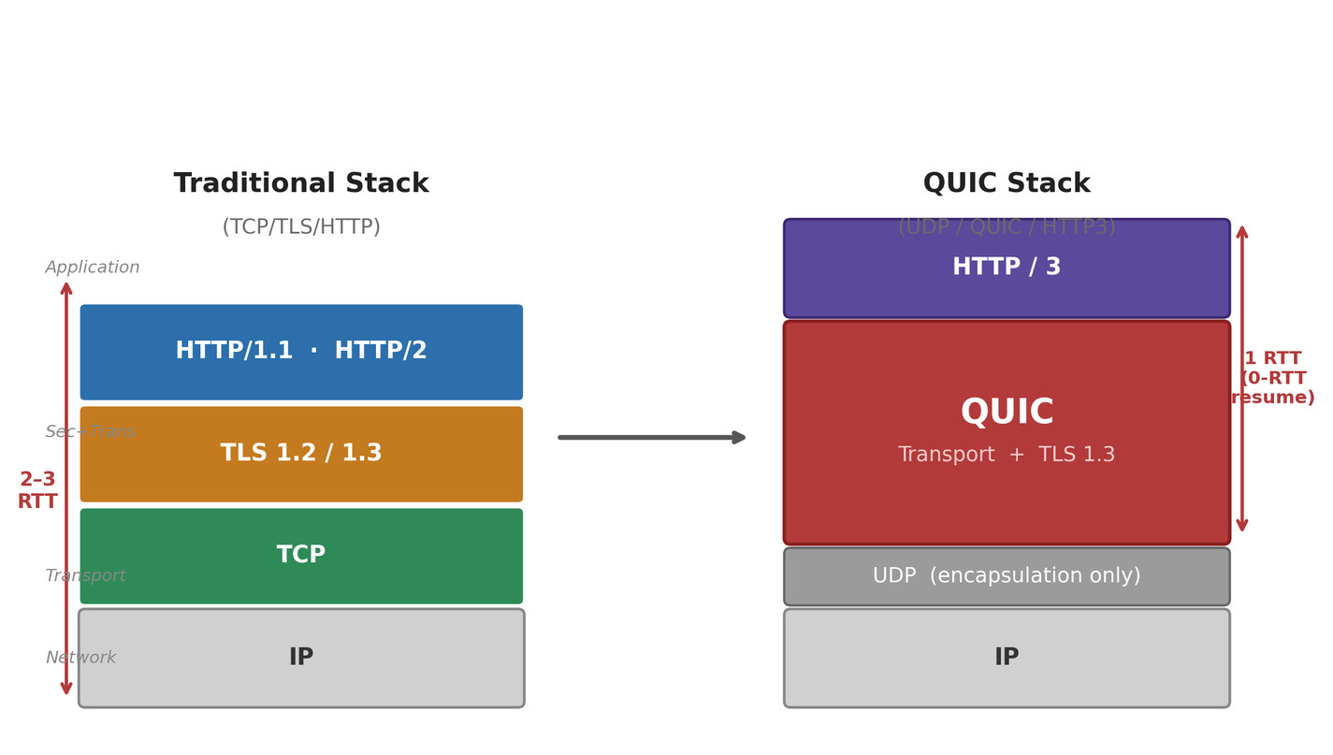
Figure 2 depicts the message exchange sequence for QUIC connection establishment under two scenarios. In the 1-RTT case (Figure 2a), the client sends an Initial packet carrying the TLS ClientHello inside a CRYPTO frame. The server responds in a single flight containing its own Initial packet (ServerHello) together with Handshake packets (EncryptedExtensions, Certificate, CertificateVerify, and Finished). Because these messages are bundled into one network flight, only one round-trip time elapses before the server has authenticated the client and both sides can derive application-layer keys. The client completes the handshake by sending its Handshake Finished message, and 1-RTT application data transmission begins immediately thereafter. In the 0-RTT resumption case (Figure 2b), the client possesses a NewSessionTicket issued by the server in a prior connection. On the subsequent connection attempt, the client sends 0-RTT application data in the very first packet alongside the ClientHello, with zero additional latency for the handshake itself. The server processes the early data using keys derived from the session ticket while simultaneously completing the handshake. This design eliminates the connection establishment penalty for returning clients — a critical advantage for latency-sensitive applications such as mobile web browsing and real-time APIs.

Figure 2. QUIC connection establishment sequence diagrams: (a) 1-RTT new connection handshake; (b) 0-RTT session resumption using a prior session ticket.
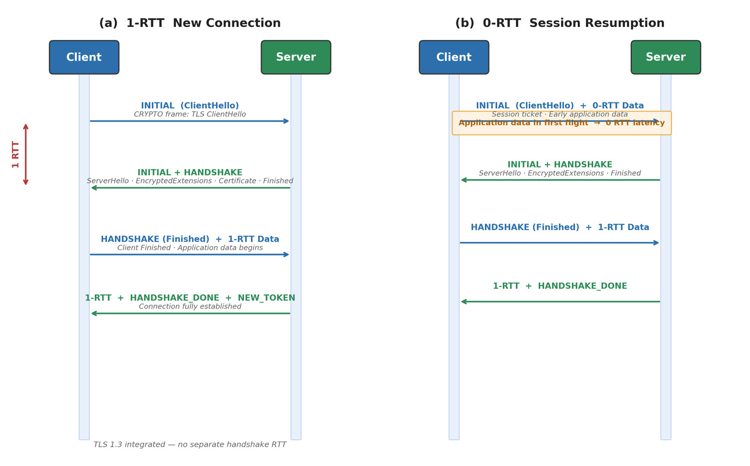
Figure 3 presents the bit-level structure of the two QUIC packet header formats defined in RFC 9000. The Long Header (Figure 3a) is used for Initial, 0-RTT, Handshake, and Retry packets. Its first byte encodes a Header Form bit (always 1 for Long Header), a Fixed Bit (must be 1), a two-bit Packet Type distinguishing the four long-header packet types, and four Type-Specific bits whose semantics depend on the packet type. Subsequent fields carry the QUIC version number, Destination and Source Connection ID lengths (DCIL/SCIL) followed by the Connection IDs themselves, a type-specific payload (e.g., a token in Initial packets for address validation), a variable-length integer encoding the remaining length, and finally the Packet Number and AEAD-encrypted payload. The Short Header (Figure 3b), also called the 1-RTT header, is significantly more compact: it omits the version, SCIL, Source Connection ID, token, and Length fields entirely, since these are no longer needed once connection parameters have been negotiated. Its first byte encodes the Spin Bit — a single unencrypted bit that alternates once per RTT per client request, allowing passive latency measurement by on-path observers — two Reserved bits protected by header protection, a Key Phase bit signaling which set of 1-RTT keys is in use, and a two-bit Packet Number Length field. All fields following the Destination Connection ID are protected by AEAD encryption, and the header bits themselves are further protected by a separate header protection algorithm (AES-ECB or ChaCha20) that masks the Packet Number and key-phase bits from passive inspection.

Figure 3. QUIC packet header field layouts: (a) Long Header format, used during connection establishment; (b) Short Header (1-RTT) format, used for all application data after the handshake.
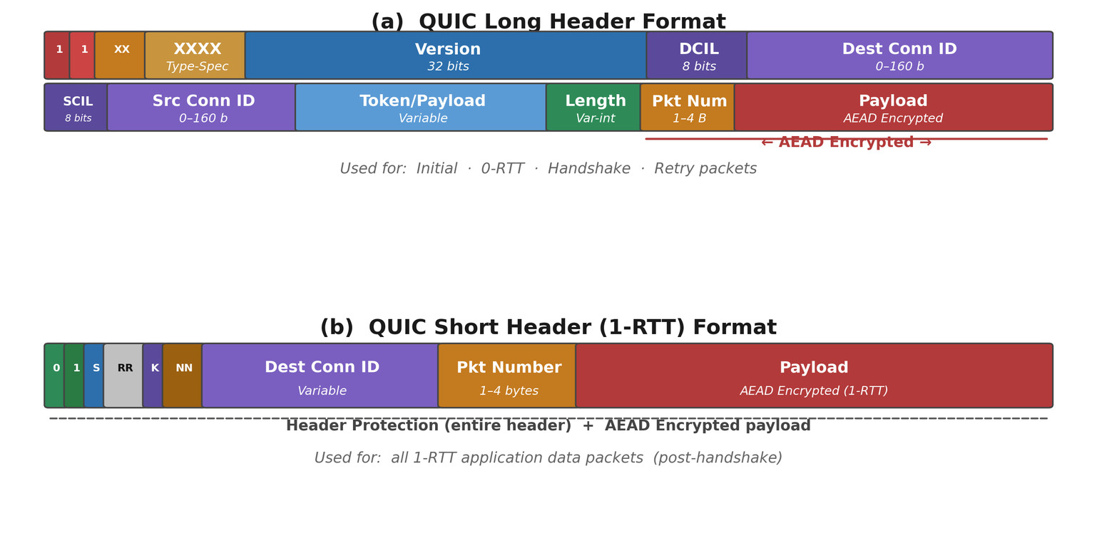
Figure 4 formalizes the lifecycle of a QUIC stream through its sending and receiving state machines. On the sending side (Figure 4a), a stream begins in the Ready state once the application opens it but before any data has been transmitted. The transition to Send occurs when the application writes data or a FIN, after which STREAM frames are emitted. Upon transmission of the final STREAM frame with the FIN bit set, the stream enters Data Sent and awaits acknowledgment of all outstanding data; receipt of those ACKs drives the stream to the terminal Data Recvd state. At any point prior to the terminal state, the sender may abort the stream by issuing a RESET_STREAM frame, transitioning to Reset Sent; once the peer acknowledges the reset, the stream reaches the terminal Reset Recvd state. On the receiving side (Figure 4b), a stream enters Recv when the first STREAM frame arrives. The transition to Size Known occurs upon receipt of a STREAM frame with the FIN bit set, fixing the total expected byte count. Once all bytes have been received with no gaps, the stream moves to Data Recvd; the application reading all buffered data drives the stream to the terminal Data Read state. A RESET_STREAM frame from the sender at any pre-terminal state drives the stream directly to Reset Recvd; the application reading the reset error code produces the terminal Reset Read state. The independence of these state machines from the connection-level state is architecturally significant: a stream in Reset Sent does not affect the connection, and new streams can be opened concurrently on the same connection without interruption.

Figure 4. QUIC stream state machines as defined in RFC 9000 Section 3: (a) sending-side states; (b) receiving-side states. Terminal states are indicated by a double border.
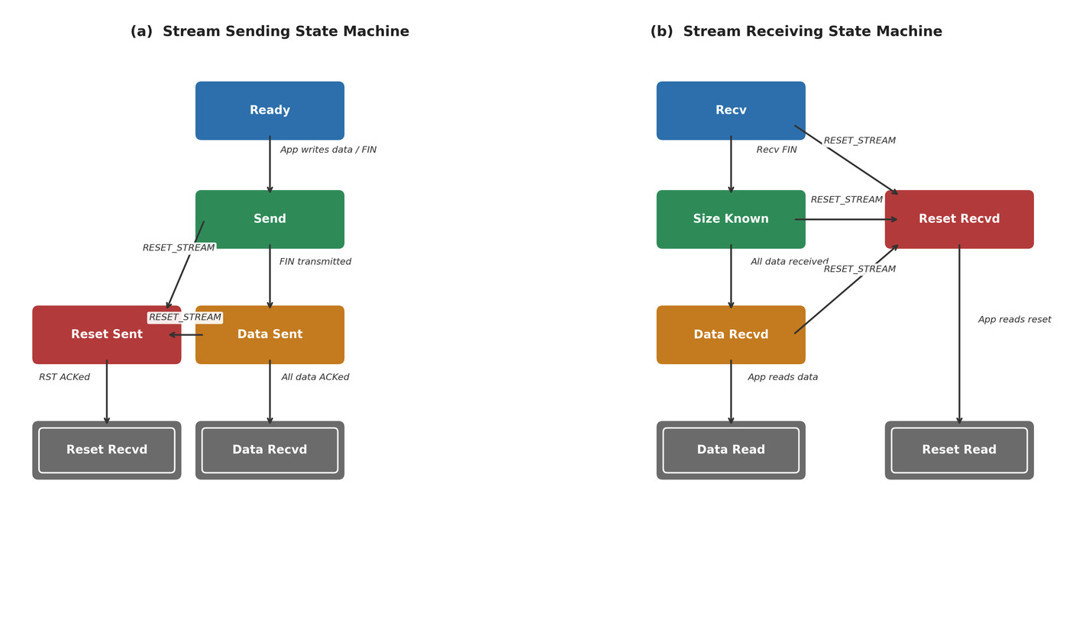
Figure 5 provides a concrete illustration of the most practically impactful architectural difference between TCP-based and QUIC-based multiplexing. In the TCP + HTTP/2 scenario (Figure 5a), three logical HTTP streams (A, B, C) share a single TCP byte stream. When packet A₂ is lost in transit, TCP's ordered delivery guarantee prevents the application from receiving any data beyond the loss point — including data from Streams B and C that arrived intact. All three application-layer streams are therefore blocked until TCP detects the loss and the retransmitted segment is delivered. This head-of-line blocking is not a bug in HTTP/2's multiplexing design; it is a structural consequence of TCP's byte-stream abstraction, which makes it impossible for the transport layer to know which higher-layer stream a retransmitted byte belongs to. In the QUIC + HTTP/3 scenario (Figure 5b), each HTTP stream maps to an independent QUIC stream. A lost packet carrying Stream A data results in only Stream A's delivery being stalled in the QUIC receive buffer; the QUIC stack delivers Streams B and C to the application immediately upon arrival, without waiting for Stream A's retransmission. This isolation guarantee is structurally enforced at the transport layer: QUIC's per-stream byte offset tracking means that out-of-order data for Stream B is never confused with a gap in Stream A. The consequence is measurable: empirical studies of HTTP/3 deployments over lossy cellular networks have demonstrated significant reductions in page load time compared to HTTP/2 over TCP, with gains proportional to the packet loss rate.

Figure 5. Head-of-line blocking comparison: (a) TCP + HTTP/2, where loss of a single segment stalls all multiplexed streams; (b) QUIC + HTTP/3, where loss is isolated to the affected stream and all other streams continue delivery.
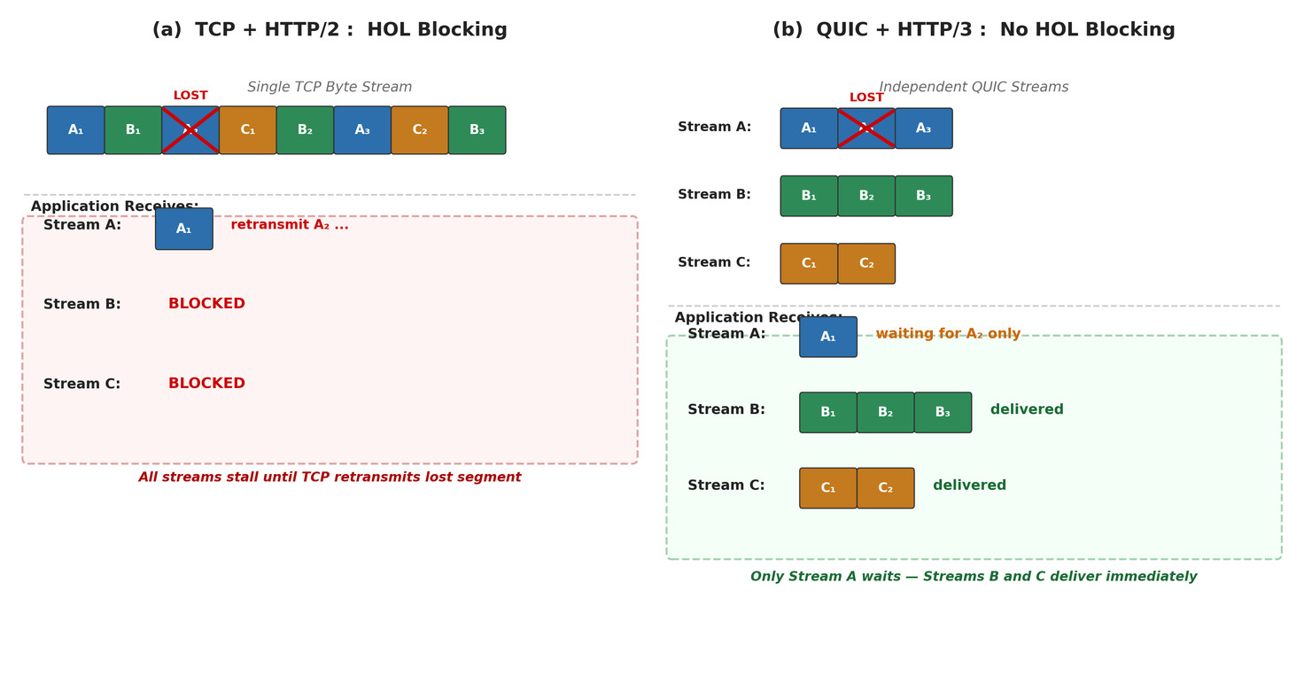

Tables
Table 1 presents the field-by-field structure of the Long Header format.
Table 1: QUIC Long Header Format
Field | Size | Value/Range | Description
Header Form | 1 bit | 1 | Distinguishes Long (1) from Short (0) header format
Fixed Bit | 1 bit | 1 | Must be 1; if 0, packet must be discarded (QUIC invariant bit)
Long Packet Type | 2 bits | Variable | Initial(00), 0-RTT(01), Handshake(10), Retry(11)
Type-Specific Bits | 4 bits | Variable | Purpose depends on packet type (e.g., Packet Number length)
Version | 32 bits | e.g., 0x00000001 | QUIC version number; 0x00000000 = Version Negotiation packet
DCIL | 8 bits | 0-20 | Length of Destination Connection ID field in bytes
Destination Connection ID | Variable (0-20 B) | Opaque bytes | Identifies the connection on the receiver side
SCIL | 8 bits | 0-20 | Length of Source Connection ID field in bytes
Source Connection ID | Variable (0-20 B) | Opaque bytes | Sender's Connection ID, used by peer for sending responses
Type-Specific Payload | Variable | Variable | Token (Initial), Retry Token, or directly starts payload
Length | Variable-length int | Variable | Length of remainder (Packet Number + Payload) in bytes
Packet Number | 1-4 bytes | Monotonic | Truncated packet number; full value derived via PN encoding
Payload | Variable | Encrypted | AEAD-encrypted QUIC frames

Table 2 presents the Short Header format, which is used for all 1-RTT (application data) packets after the handshake is complete. The Short Header is significantly more compact than the Long Header, omitting the Version, SCIL, and Source Connection ID fields since these are no longer needed once the connection is established.
Table 2: QUIC Short Header (1-RTT) Format
Field | Size | Value/Range | Description
Header Form | 1 bit | 0 | Indicates Short Header (1-RTT) format
Fixed Bit | 1 bit | 1 | Must be 1; used as QUIC invariant signal
Spin Bit | 1 bit | Variable | Latency measurement; alternates once per RTT per client request
Reserved Bits | 2 bits | 00 | Must be 0; protected under header protection encryption
Key Phase | 1 bit | 0 or 1 | Indicates current key phase for 1-RTT key rotation updates
Packet Number Length | 2 bits | 0-3 | Encodes PN field length: 00=1B, 01=2B, 10=3B, 11=4B
Destination Connection ID | Variable | Opaque bytes | Identifies connection; length known from prior negotiation
Packet Number | 1-4 bytes | Monotonic | Truncated packet number within 1-RTT packet number space
Payload | Variable | Encrypted | AEAD-encrypted QUIC frames using 1-RTT key

Table 3 summarizes the four encoding tiers. This scheme allows frequently occurring small values (stream IDs 0-63, short lengths) to consume only one byte, while the encoding naturally scales to 62-bit values without any protocol extension.
Table 3: QUIC Variable-Length Integer Encoding
2 MSBs | Encoding Length | Value Bits | Range | Typical Use
00 | 1 byte (8 bits) | 6 bits | 0 to 63 | Small values; typical stream IDs and short field lengths
01 | 2 bytes (16 bits) | 14 bits | 0 to 16,383 | Medium values; moderate packet counts and stream offsets
10 | 4 bytes (32 bits) | 30 bits | 0 to 1,073,741,823 | Large values; flow control credits and large offsets
11 | 8 bytes (64 bits) | 62 bits | 0 to 4,611,686,018,427,387,903 | Maximum range; future-proofing for very large values

Table 4 provides a complete taxonomy including valid packet type contexts (I=Initial, H=Handshake, 0=0-RTT, 1=1-RTT).
Figure 2 Table 4: QUIC Frame Types, Functions, and Valid Packet Contexts
Type Value | Frame Name | Function Description | Contexts
0x00 | PADDING | No-op padding to inflate packet size; used for PMTU probing and amplification mitigation | I/H/0/1
0x01 | PING | Elicits acknowledgment from peer; probes path liveness without data | I/H/0/1
0x02-0x03 | ACK | Acknowledges received packets; 0x03 additionally includes ECN congestion counts | I/H/1
0x04 | RESET_STREAM | Abruptly terminates the sending part of a stream; carries application error code | 0/1
0x05 | STOP_SENDING | Requests peer stop sending on a specific stream; triggers RESET_STREAM from peer | 0/1
0x06 | CRYPTO | Carries TLS handshake data; provides reliable ordered delivery for TLS messages | I/H/1
0x07 | NEW_TOKEN | Provides client a token for future 0-RTT address validation | 1
0x08-0x0f | STREAM | Application data frames; bits encode OFF(0x04), LEN(0x02), FIN(0x01) flags | 0/1
0x10 | MAX_DATA | Connection-level flow control credit increase; raises aggregate byte limit | 0/1
0x11 | MAX_STREAM_DATA | Stream-level flow control credit increase; raises per-stream byte limit | 0/1
0x12-0x13 | MAX_STREAMS | Increases maximum allowed concurrent streams (0x12=bidi, 0x13=uni) | 0/1
0x14 | DATA_BLOCKED | Signals sender is blocked at connection-level flow control limit | 0/1
0x15 | STREAM_DATA_BLOCKED | Signals sender is blocked at stream-level flow control limit | 0/1
0x16-0x17 | STREAMS_BLOCKED | Signals blocked by stream count limit (0x16=bidi, 0x17=uni) | 0/1
0x18 | NEW_CONNECTION_ID | Provides alternative Connection IDs for connection migration use | 0/1
0x19 | RETIRE_CONNECTION_ID | Indicates a previously issued Connection ID is no longer used | 0/1
0x1a | PATH_CHALLENGE | Probes path reachability and RTT for path validation; carries random data | 0/1
0x1b | PATH_RESPONSE | Echoes PATH_CHALLENGE data verbatim to confirm path reachability | 0/1
0x1c-0x1d | CONNECTION_CLOSE | Signals connection termination (QUIC error 0x1c, application error 0x1d) | I/H/0/1
0x1e | HANDSHAKE_DONE | Server signals handshake completion to client; triggers key discard | 1

Tables 5 and 6 formalize the stream sending and receiving state machines as defined in RFC 9000 Section 3.
Table 5: QUIC Stream Sending State Machine
State | Description | Transition Condition
Ready | Stream created; no data transmitted yet; application has not yet written | Application writes data or sends FIN
Send | Application is actively writing stream data; STREAM frames are being sent | All application data including FIN has been transmitted
Data Sent | All data including FIN bit has been transmitted; awaiting acknowledgment | All transmitted data (including FIN) acknowledged by peer
Data Recvd | Terminal: all sent data has been acknowledged; stream sending complete | None (terminal state)
Reset Sent | RESET_STREAM frame sent; stream abruptly terminated by local sender | Peer acknowledges the RESET_STREAM frame
Reset Recvd | Terminal: reset has been acknowledged by peer; sending side closed | None (terminal state)
Table 6: QUIC Stream Receiving State Machine
State | Description | Transition Condition
Recv | Stream created; awaiting incoming STREAM frames; total size unknown | STREAM frame with FIN bit received; size now known
Size Known | FIN received; total stream size is determined; may still have gaps in data | All stream data bytes received with no gaps remaining
Data Recvd | All bytes received and buffered; awaiting application to read all data | Application reads all buffered stream data
Data Read | Terminal: all data has been delivered to the application | None (terminal state)
Reset Recvd | RESET_STREAM received from sender; stream reset by remote peer | Application reads the reset error code via API
Reset Read | Terminal: application has been notified of stream reset | None (terminal state)

Table 7 presents the key congestion control data structures from RFC 9002 and the Cloudflare quiche implementation.
Figure 3 Table 7: Key Congestion Control Data Structures (RFC 9002 / quiche)
Field Name | Type | Description
congestion_window (cwnd) | u64 | Maximum bytes in flight at any time; increases on ACK, decreases on loss detection
bytes_in_flight | u64 | Running total of bytes sent but not yet acknowledged or declared lost
ssthresh | u64 | Slow-start threshold; cwnd below ssthresh = slow-start, above = congestion avoidance
smoothed_rtt (SRTT) | Duration | Exponentially weighted moving average of RTT samples; core congestion signal
rtt_variance (RTTVAR) | Duration | Mean deviation of RTT samples; contributes to Probe Timeout (PTO) calculation
min_rtt | Duration | Minimum observed RTT over the connection lifetime; used as baseline by BBR
latest_rtt | Duration | Most recent RTT sample (ack_time - send_time of acknowledged packet)
pto_count | u32 | Probe Timeout counter; triggers probe packet transmission on expiry
time_of_last_sent_ack_eliciting_packet | Instant | Timestamp of the most recently sent packet that requires an ACK response
ecn_ce_counters | [u64; 3] | ECN Congestion Experienced event counts across all three packet number spaces

Table 8: QUIC Encryption Levels and Security Properties
Level | AEAD Algorithm | Key Source | Used In | Security Properties
Initial | AEAD_AES_128_GCM | DCID-derived via well-known salt (public) | Initial packets only | Bootstraps connection; no forward secrecy; not server-authenticated
Handshake | AEAD_AES_128_GCM | TLS 1.3 handshake traffic secret (HKDF) | Handshake packets | Server-authenticated; forward secrecy after key exchange
0-RTT | AEAD_AES_128_GCM or ChaCha20-Poly1305 | Prior session resumption ticket key | 0-RTT packets | Enables early data; vulnerable to replay; no forward secrecy
1-RTT | AEAD_AES_128_GCM or ChaCha20-Poly1305 | TLS 1.3 application traffic secret (HKDF) | Short header (1-RTT) packets | Full mutual auth; perfect forward secrecy; key rotation via Key Phase bit

Table 9 presents a systematic comparison of QUIC and TCP across thirteen dimensions spanning protocol architecture, performance characteristics, security properties, and operational considerations. This comparative analysis constitutes the central evaluative contribution of the paper: by examining QUIC not in isolation but in relation to the TCP baseline it is designed to supersede, the analysis illuminates both where QUIC's advantages are structural and guaranteed, and where the trade-offs remain genuinely contested.

Table 9: Comprehensive Feature Comparison: TCP vs. QUIC
Feature | TCP | QUIC
OSI Layer | Transport layer (kernel space implementation) | Transport semantics (user-space library over UDP)
Connection Setup | 1-RTT TCP SYN + 1-2 RTT TLS 1.3 = 2-3 RTT total minimum | 1-RTT for new connections; 0-RTT for session resumption
HOL Blocking | Yes — single ordered byte stream; one lost segment blocks all data | No — independent streams; loss isolated to affected stream only
Encryption | Optional; TLS is a separate protocol layered atop TCP | Mandatory; TLS 1.3 integrated; most header fields also encrypted
Connection Migration | Not supported; connection tied to 4-tuple (src IP:port, dst IP:port) | Supported via Connection IDs; survives IP address change
Packet Numbers | Sequence/ACK numbers reused on retransmission; retransmission ambiguity | Monotonically increasing; every packet unique; unambiguous ACKs
Flow Control | Single sliding window per connection; coarse-grained | Two-level credit-based: per-stream limit + per-connection aggregate
Multiplexing | Not native; application layer must manage ordering across requests | Native stream multiplexing with independent delivery guarantees
Deployability | Requires OS kernel update; deployment cycle measured in years | User-space library update; per-application deployment possible
Middlebox Compat. | Well-understood; inspection tools widely deployed; ossification risk | Challenging; encrypted headers limit middlebox visibility; evolvable
RTT Measurement | Ambiguous with retransmissions; Karn's algorithm required | Unambiguous; monotonic PN enables accurate RTT in all conditions
Congestion Ctrl | Typically NewReno or CUBIC; kernel-level; system-wide setting | Pluggable: Reno/CUBIC/BBR selectable per-application per-connection
Header Overhead | 20 bytes fixed minimum (TCP) plus TLS record overhead (5+ bytes) | Short header as small as ~2 bytes; variable-length encoding minimizes size
Several dimensions of this comparison merit analytical commentary beyond the tabular summary. The connection setup RTT advantage is structurally guaranteed by QUIC's protocol integration: because TLS 1.3's ClientHello is sent in the same Initial packet as QUIC's handshake parameters, there is no sequential dependency between transport and security establishment. TCP+TLS 1.3 achieves a minimum of 2 RTT because the TCP SYN must complete before the TLS ClientHello can be sent. This is not an implementation inefficiency but a protocol-level constraint that cannot be eliminated within the TCP+TLS architecture without fundamentally changing TCP.
The packet number monotonicity advantage has subtle but far-reaching consequences for congestion control accuracy. TCP's retransmission ambiguity causes congestion controllers to systematically underestimate RTT in high-loss environments—because Karn's algorithm forces them to discard RTT samples during loss recovery—which in turn leads to overly aggressive congestion windows. QUIC's unambiguous packet numbers mean that congestion controllers always have accurate RTT data, leading to better-calibrated window sizes and higher throughput under equivalent network conditions. Studies such as Kakhki et al. (IMC 2017) have empirically confirmed QUIC's RTT estimation superiority in loss-prone cellular environments.
The middlebox compatibility trade-off is the most complex dimension of the comparison and deserves careful analytical treatment. TCP's 'well-understood' middlebox compatibility is not a pure advantage; it is the mechanism of TCP ossification. Every network element that 'understands' TCP headers is a potential impediment to TCP protocol evolution—it has been estimated that TCP options not present in the original RFC 793 specification have taken over a decade each to achieve widespread middlebox tolerance. QUIC's encrypted headers superficially appear to be a compatibility disadvantage but are architecturally the mechanism that prevents QUIC from suffering the same fate. Whether this trade-off is net-positive depends fundamentally on whether one prioritizes protocol evolvability (favoring QUIC) or network manageability (favoring TCP)—a philosophical tension discussed further in Section III.

- Algorithms
This section analyzes QUIC's cross-layer algorithmic behaviors—the protocol interactions that emerge at the boundaries between QUIC and adjacent protocol layers. These interactions represent some of the most analytically interesting aspects of QUIC's design, because they reveal the full implications of QUIC's architectural choices for the broader Internet ecosystem.
- QUIC and UDP (Transport Layer): UDP as a Thin Wrapper
QUIC's relationship with UDP is deliberately minimal. UDP serves as a thin wrapper providing port-based demultiplexing and IP checksum coverage; QUIC provides everything else that a transport protocol requires. RFC 9000 Section 14 imposes one critical constraint on this relationship: QUIC packets MUST NOT be fragmented at the IP layer. To achieve this, QUIC performs its own path MTU discovery via DPLPMTUD (Datagram Packetization Layer Path MTU Discovery, RFC 8899), targeting a minimum PMTU of 1200 bytes as QUIC's floor. QUIC sends PADDING-inflated probe packets of increasing size and observes whether they are acknowledged; acknowledged probes establish a higher MTU ceiling, enabling larger QUIC frames and thus better wire efficiency with reduced per-byte framing overhead.
An important security implication of the QUIC-over-UDP architecture is amplification attack mitigation. During connection establishment, a server that receives a forged Initial packet with a spoofed source address could send large Handshake responses to a victim (an amplification attack). QUIC counters this with a strict protocol requirement: server responses during the handshake must not exceed three times the size of received client data until address validation is complete via token verification. Initial packets sent by clients are padded to 1200 bytes to ensure that the exchange ratio is bounded and that 1200-byte PMTU is confirmed before any application data flows. The Initial packet token mechanism—where a server provides a NEW_TOKEN frame that the client includes in its next Initial packet—provides stateless address verification without requiring a separate round trip.
- QUIC and HTTP/3 (Application Layer): Exclusive Co-Design
HTTP/3 (RFC 9114) is built exclusively on QUIC and cannot operate over any other transport. This exclusivity reflects deliberate co-design: HTTP/3's stream model maps directly and unambiguously onto QUIC streams. Each HTTP request/response pair occupies a dedicated QUIC bidirectional stream, while control streams—carrying HTTP/3 SETTINGS frames, QPACK encoder signals, and QPACK decoder acknowledgments—use three dedicated unidirectional streams. The stream isolation guarantee that QUIC provides—loss on one stream does not block others—is precisely what eliminates HTTP/2's multiplexing paradox.
HTTP/2 introduced multiplexing to allow multiple requests within a single TCP connection without the overhead of parallel connections. However, because TCP's byte stream is indivisible at the transport layer, a lost TCP segment carrying HTTP/2 frame data for any stream blocks the entire connection until that segment is retransmitted. HTTP/3 avoids this paradox structurally: a lost QUIC packet carrying stream A data results in only stream A being stalled in the receiver's QUIC stack; streams B through N continue to deliver data unimpeded, because each stream's delivery tracking is independent at the QUIC layer.
Header compression in HTTP/3 uses QPACK rather than HTTP/2's HPACK. HPACK maintains a shared header table updated in strict order: if a table update is lost, all subsequent header decodings—even for unrelated requests—are stalled until the update is retransmitted. QPACK solves this by separating dynamic table updates onto the dedicated encoder and decoder unidirectional streams, allowing headers to be encoded using either static table entries (no ordering dependency) or dynamic table entries with an explicit Required Insert Count that the decoder waits for on only that specific stream's data. This design preserves compression efficiency while eliminating inter-request blocking, a textbook example of how QUIC's stream independence principle propagates upward through the protocol stack.
- QUIC and IP Layer: MTU Discovery and Connection Migration
QUIC's interaction with the IP layer centers on two concerns: path MTU management and connection mobility across IP addresses. For MTU management, DPLPMTUD allows QUIC to probe for larger MTU sizes using PADDING-inflated datagrams. If a probe is not acknowledged within a timeout, QUIC assumes the MTU is below the probe size and continues with the previously confirmed MTU. This is more robust than TCP's Path MTU Discovery (PMTUD, RFC 1191) which relies on ICMP 'fragmentation needed' messages that are frequently filtered by firewalls. QUIC's DPLPMTUD works purely through the ACK mechanism and thus functions correctly even when ICMP is blocked.
Connection migration across IP addresses is a primary QUIC design goal. When a mobile device changes IP address (e.g., switching from Wi-Fi to cellular), the QUIC endpoint initiates path validation on the new path by sending PATH_CHALLENGE frames containing random data and awaiting PATH_RESPONSE frames that echo the same data. Only after successful path validation—confirming that the new path is reachable and not being spoofed—does the endpoint retire the old Connection ID and switch Connection IDs to signal migration to the peer. This two-phase migration (validation before commitment) ensures that connection migration cannot be weaponized to redirect traffic to an arbitrary third party, which would constitute a reflection/amplification attack using QUIC's path migration feature.
- QUIC and Network Middleboxes: The Manageability Trade-off
The most contentious cross-layer interaction in QUIC's design is its relationship with network middleboxes—firewalls, NATs, deep packet inspection (DPI) systems, and performance-enhancing proxies. RFC 9312 (Manageability of the QUIC Transport Protocol) acknowledges that QUIC's pervasive header encryption fundamentally changes the network management landscape. Traditional TCP-based traffic management relies on the ability to read TCP headers: sequence numbers and flags for connection tracking, payload bytes for application identification, and ACK numbers for latency estimation. QUIC's encrypted headers deny all of this visibility to on-path observers. Only the Destination Connection ID (unencrypted in the Short Header to enable routing) and the UDP port (typically 443, shared with HTTPS) are visible to passive observers.
The spin bit—a single unencrypted bit in the Short Header that alternates once per RTT per client request—was included in QUIC specifically to allow passive RTT measurement by network operators without exposing connection or application data. This represents a negotiated compromise between the IETF working group members who prioritized privacy and evolvability and network operators who needed at least minimal observability for performance monitoring and SLA verification. The spin bit provides a coarse-grained RTT signal—sufficient for detecting degraded path performance—while revealing nothing about application semantics, payload sizes, or individual stream behavior.
This tension is philosophically significant and represents a fundamental architectural choice. QUIC's designers made a deliberate decision to prioritize end-to-end security and protocol evolvability over network manageability. The underlying argument—articulated in RFC 9312 and the academic literature—is that the network intelligence model, where middleboxes perform deep packet inspection and 'assist' transport protocols, has historically created more problems than it has solved: TCP ossification has prevented deployment of TCP extensions for decades; middlebox software itself has introduced security vulnerabilities; and the surveillance capabilities enabled by plaintext TCP headers have been exploited in ways that violate user privacy. QUIC's design embodies the end-to-end principle more rigorously than any previously widely-deployed transport protocol, asserting that transport logic belongs at the endpoints. This is a forward-looking architectural position that accepts near-term operational complexity in exchange for long-term protocol evolvability and user privacy.
- Future Perspectives: The Emerging QUIC Ecosystem
QUIC Version 2 (RFC 9369, published May 2023) reinforces the versioning mechanism that is central to QUIC's evolvability promise. QUIC v2 changes the encryption salt, the long header packet types, and the key derivation labels—not to alter functionality but to ensure that implementations correctly handle version negotiation through a real-world test of the ecosystem's ability to perform protocol version transitions. Future QUIC versions can make substantive changes with confidence that the version negotiation infrastructure has been validated by deployment experience.
Multipath QUIC (MPQUIC) extends the connection migration architecture to support simultaneous use of multiple network paths, enabling bandwidth aggregation and seamless failover for mobile devices concurrently connected to Wi-Fi and cellular networks. Piraux et al. (CoNEXT 2018) demonstrated that MPQUIC can reduce video streaming rebuffering by 48% compared to single-path QUIC in mobility scenarios. The draft specification is under active IETF development and represents the natural evolution of QUIC's path-awareness from reactive migration (switching between paths on failure) to proactive multipath utilization.
Perhaps most consequentially for the broader protocol ecosystem, QUIC is emerging as a universal secure transport substrate beyond HTTP/3. DNS-over-QUIC (RFC 9250) eliminates both the HOL blocking of DNS-over-TCP and the amplification risk of DNS-over-UDP while providing strong privacy guarantees through QUIC's mandatory encryption. MQTT-over-QUIC is under active investigation for IoT messaging systems where connection persistence across intermittent network connectivity is critical. WebTransport-over-QUIC offers a generic bidirectional messaging API for Web applications that require real-time, low-latency communication without the HTTP request-response model. Each of these applications exploits QUIC's stream multiplexing, 0-RTT resumption, and mandatory encryption independently of HTTP/3, demonstrating that QUIC's value proposition extends far beyond Web browsing and positions it as the foundational secure transport layer for the next generation of Internet applications.
The philosophical shift that QUIC embodies—from network-controlled to endpoint-controlled transport—is ultimately a statement about where intelligence should reside in the Internet architecture. If the QUIC ecosystem continues to develop as projected by current deployment trends (Cloudflare estimates that over 35% of their traffic is now served over HTTP/3, and all major browsers support QUIC natively), it will not merely have replaced TCP for Web traffic. It will have demonstrated a sustainable model for Internet protocol evolution—iterative, user-space, endpoint-controlled, security-first—that the IETF, network operators, and application developers can build upon for the next four decades, ending the era of transport-layer ossification that has constrained Internet evolution since the 1980s.

References
- J. Iyengar and M. Thomson, "QUIC: A UDP-Based Multiplexed and Secure Transport," RFC 9000, Internet Engineering Task Force, May 2021. DOI: 10.17487/RFC9000.
- M. Thomson and S. Turner, "Using TLS to Secure QUIC," RFC 9001, Internet Engineering Task Force, May 2021. DOI: 10.17487/RFC9001.
- J. Iyengar and I. Swett, "QUIC Loss Detection and Congestion Control," RFC 9002, Internet Engineering Task Force, May 2021. DOI: 10.17487/RFC9002.
- M. Thomson, "Version-Independent Properties of QUIC," RFC 8999, Internet Engineering Task Force, May 2021. DOI: 10.17487/RFC8999.
- M. Bishop, "HTTP/3," RFC 9114, Internet Engineering Task Force, June 2022. DOI: 10.17487/RFC9114.
- B. Trammell and M. Kuehlewind, "Manageability of the QUIC Transport Protocol," RFC 9312, Internet Engineering Task Force, September 2022. DOI: 10.17487/RFC9312.
- M. Duke, "QUIC Version 2," RFC 9369, Internet Engineering Task Force, May 2023. DOI: 10.17487/RFC9369.
- A. Langley et al., "The QUIC Transport Protocol: Design and Internet-Scale Deployment," in Proceedings of ACM SIGCOMM 2017, Los Angeles, CA, USA, pp. 183-196. DOI: 10.1145/3098822.3098842, 2017.
- J. Ruth, I. Poese, C. Dietzel, and O. Hohlfeld, "A First Look at QUIC in the Wild," in Proceedings of Passive and Active Measurement Conference (PAM 2018), Berlin, Germany, Springer, pp. 255-268, 2018.
- R. Marx et al., "Demystifying QUIC from the Specifications," arXiv preprint arXiv:2511.08375, November 2025.
- A. M. Kakhki et al., "Taking a Long Look at QUIC: An Approach for Rigorous Evaluation of Rapidly Evolving Transport Protocols," in Proceedings of ACM Internet Measurement Conference (IMC 2017), London, UK, pp. 290-303. DOI: 10.1145/3131365.3131368, 2017.
- Cloudflare, Inc., "quiche: Implementation of the QUIC transport protocol and HTTP/3," GitHub repository, available: https://github.com/cloudflare/quiche, 2024.
- E. Rescorla, "The Transport Layer Security (TLS) Protocol Version 1.3," RFC 8446, Internet Engineering Task Force, August 2018. DOI: 10.17487/RFC8446.
- M. Piraux, Q. De Coninck, and O. Bonaventure, "Multipath QUIC: Design and Evaluation," in Proceedings of ACM CoNEXT 2018, Heraklion, Greece, pp. 160-166. DOI: 10.1145/3281411.3281422, 2018.

