四、代码审计题（1 题，共 15 分）
说明：主要针对 DVWA 的源码进行审计分析，主要包括几种常见的 Web 攻击：XSS 、 SQL 注入、文件上传、文件包含等，如果是 Low 、Medium 级别的代码，能给出绕过的方法，如果是 impossible 级别的代码，能分析出安全性很高的原因，里面有哪些关键的代码提升了安全性。

1、Command Injection
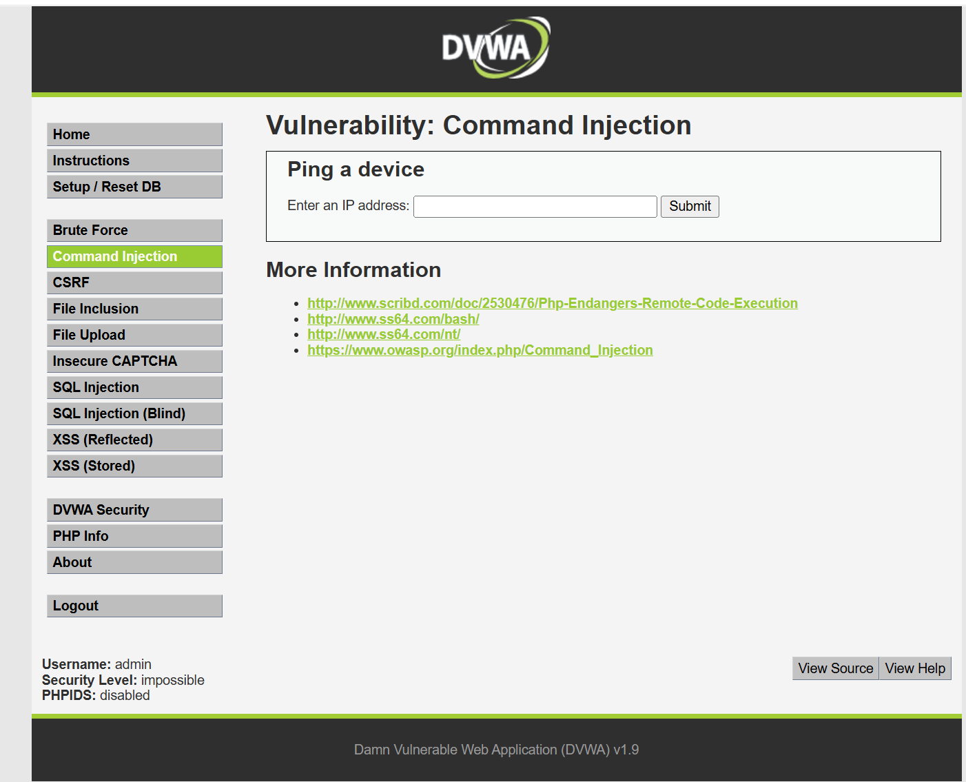
窗体顶端
窗体底端

Impossible：
<?php
if( isset( $_POST[ 'Submit' ] ) ) {
// Check Anti-CSRF token
checkToken( $_REQUEST[ 'user_token' ], $_SESSION[ 'session_token' ], 'index.php' );
// Get input
$target = $_REQUEST[ 'ip' ];
$target = stripslashes( $target );
// Split the IP into 4 octects
$octet = explode( ".", $target );
// Check IF each octet is an integer
if( ( is_numeric( $octet[0] ) ) && ( is_numeric( $octet[1] ) ) && ( is_numeric( $octet[2] ) ) && ( is_numeric( $octet[3] ) ) && ( sizeof( $octet ) == 4 ) ) {
// If all 4 octets are int's put the IP back together.
$target = $octet[0] . '.' . $octet[1] . '.' . $octet[2] . '.' . $octet[3];
// Determine OS and execute the ping command.
if( stristr( php_uname( 's' ), 'Windows NT' ) ) {
// Windows
$cmd = shell_exec( 'ping ' . $target );
}
else {
// *nix
$cmd = shell_exec( 'ping -c 4 ' . $target );
}
// Feedback for the end user
echo "<pre>{$cmd}</pre>";
}
else {
// Ops. Let the user name theres a mistake
echo '<pre>ERROR: You have entered an invalid IP.</pre>';
}
}
// Generate Anti-CSRF token
generateSessionToken();
?>
Low:
<?php
if( isset( $_POST[ 'Submit' ] ) ) {
// Get input
$target = $_REQUEST[ 'ip' ];
// Determine OS and execute the ping command.
if( stristr( php_uname( 's' ), 'Windows NT' ) ) {
// Windows
$cmd = shell_exec( 'ping ' . $target );
}
else {
// *nix
$cmd = shell_exec( 'ping -c 4 ' . $target );
}
// Feedback for the end user
echo "<pre>{$cmd}</pre>";
}
?>

Medium:
Command Injection Source
<?php
if( isset( $_POST[ 'Submit' ] ) ) {
// Get input
$target = $_REQUEST[ 'ip' ];
// Set blacklist
$substitutions = array(
'&&' => '',
';' => '',
);
// Remove any of the charactars in the array (blacklist).
$target = str_replace( array_keys( $substitutions ), $substitutions, $target );
// Determine OS and execute the ping command.
if( stristr( php_uname( 's' ), 'Windows NT' ) ) {
// Windows
$cmd = shell_exec( 'ping ' . $target );
}
else {
// *nix
$cmd = shell_exec( 'ping -c 4 ' . $target );
}
// Feedback for the end user
echo "<pre>{$cmd}</pre>";
}
?>

窗体顶端
窗体底端

窗体顶端
窗体底端

High:
<?php
if( isset( $_POST[ 'Submit' ] ) ) {
// Get input
$target = trim($_REQUEST[ 'ip' ]);
// Set blacklist
$substitutions = array(
'&' => '',
';' => '',
'| ' => '',
'-' => '',
'$' => '',
'(' => '',
')' => '',
'`' => '',
'||' => '',
);
// Remove any of the charactars in the array (blacklist).
$target = str_replace( array_keys( $substitutions ), $substitutions, $target );
// Determine OS and execute the ping command.
if( stristr( php_uname( 's' ), 'Windows NT' ) ) {
// Windows
$cmd = shell_exec( 'ping ' . $target );
}
else {
// *nix
$cmd = shell_exec( 'ping -c 4 ' . $target );
}
// Feedback for the end user
echo "<pre>{$cmd}</pre>";
}
?>

窗体顶端
窗体底端

2、CSRF
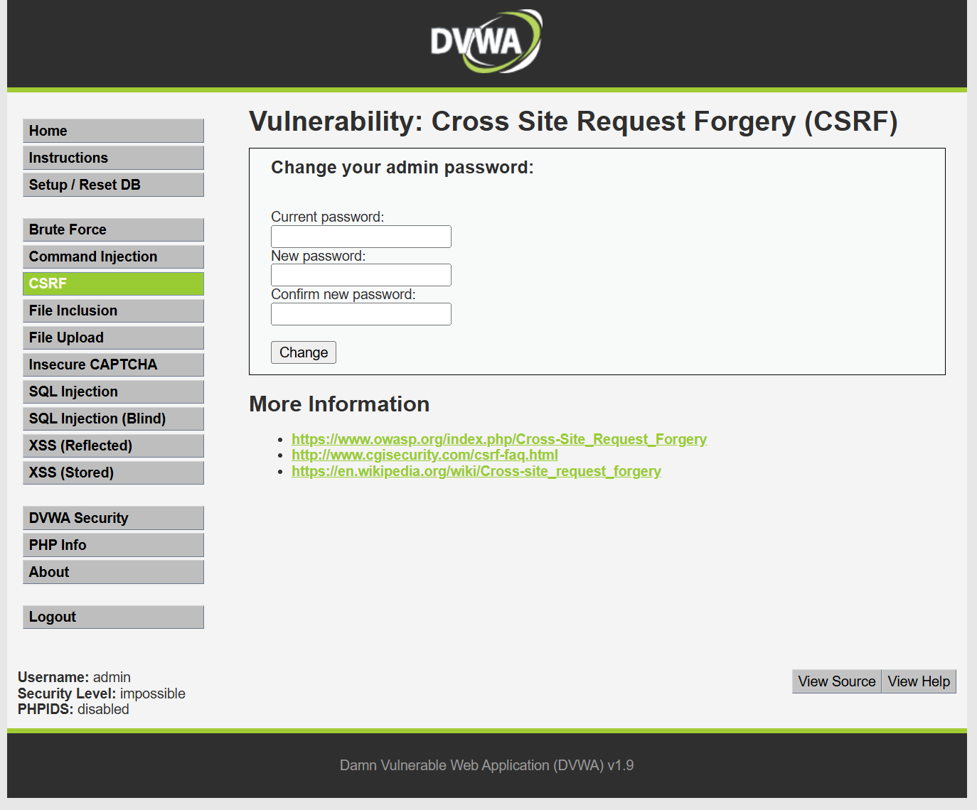

Impossible
<?php
if( isset( $_GET[ 'Change' ] ) ) {
// Check Anti-CSRF token
checkToken( $_REQUEST[ 'user_token' ], $_SESSION[ 'session_token' ], 'index.php' );
// Get input
$pass_curr = $_GET[ 'password_current' ];
$pass_new = $_GET[ 'password_new' ];
$pass_conf = $_GET[ 'password_conf' ];
// Sanitise current password input
$pass_curr = stripslashes( $pass_curr );
$pass_curr = mysql_real_escape_string( $pass_curr );
$pass_curr = md5( $pass_curr );
// Check that the current password is correct
$data = $db->prepare( 'SELECT password FROM users WHERE user = (:user) AND password = (:password) LIMIT 1;' );
$data->bindParam( ':user', dvwaCurrentUser(), PDO::PARAM_STR );
$data->bindParam( ':password', $pass_curr, PDO::PARAM_STR );
$data->execute();
// Do both new passwords match and does the current password match the user?
if( ( $pass_new == $pass_conf ) && ( $data->rowCount() == 1 ) ) {
// It does!
$pass_new = stripslashes( $pass_new );
$pass_new = mysql_real_escape_string( $pass_new );
$pass_new = md5( $pass_new );
// Update database with new password
$data = $db->prepare( 'UPDATE users SET password = (:password) WHERE user = (:user);' );
$data->bindParam( ':password', $pass_new, PDO::PARAM_STR );
$data->bindParam( ':user', dvwaCurrentUser(), PDO::PARAM_STR );
$data->execute();
// Feedback for the user
echo "<pre>Password Changed.</pre>";
}
else {
// Issue with passwords matching
echo "<pre>Passwords did not match or current password incorrect.</pre>";
}
}
// Generate Anti-CSRF token
generateSessionToken();
?>

Low:
<?php
if( isset( $_GET[ 'Change' ] ) ) {
// Get input
$pass_new = $_GET[ 'password_new' ];
$pass_conf = $_GET[ 'password_conf' ];
// Do the passwords match?
if( $pass_new == $pass_conf ) {
// They do!
$pass_new = mysql_real_escape_string( $pass_new );
$pass_new = md5( $pass_new );
// Update the database
$insert = "UPDATE `users` SET password = '$pass_new' WHERE user = '" . dvwaCurrentUser() . "';";
$result = mysql_query( $insert ) or die( '<pre>' . mysql_error() . '</pre>' );
// Feedback for the user
echo "<pre>Password Changed.</pre>";
}
else {
// Issue with passwords matching
echo "<pre>Passwords did not match.</pre>";
}
mysql_close();
}
?>

窗体顶端
窗体底端

Medium:
<?php
if( isset( $_GET[ 'Change' ] ) ) {
// Checks to see where the request came from
if( eregi( $_SERVER[ 'SERVER_NAME' ], $_SERVER[ 'HTTP_REFERER' ] ) ) {
// Get input
$pass_new = $_GET[ 'password_new' ];
$pass_conf = $_GET[ 'password_conf' ];
// Do the passwords match?
if( $pass_new == $pass_conf ) {
// They do!
$pass_new = mysql_real_escape_string( $pass_new );
$pass_new = md5( $pass_new );
// Update the database
$insert = "UPDATE `users` SET password = '$pass_new' WHERE user = '" . dvwaCurrentUser() . "';";
$result = mysql_query( $insert ) or die( '<pre>' . mysql_error() . '</pre>' );
// Feedback for the user
echo "<pre>Password Changed.</pre>";
}
else {
// Issue with passwords matching
echo "<pre>Passwords did not match.</pre>";
}
}
else {
// Didn't come from a trusted source
echo "<pre>That request didn't look correct.</pre>";
}
mysql_close();
}
?>

窗体顶端
窗体底端

High:
<?php
if( isset( $_GET[ 'Change' ] ) ) {
// Check Anti-CSRF token
checkToken( $_REQUEST[ 'user_token' ], $_SESSION[ 'session_token' ], 'index.php' );
// Get input
$pass_new = $_GET[ 'password_new' ];
$pass_conf = $_GET[ 'password_conf' ];
// Do the passwords match?
if( $pass_new == $pass_conf ) {
// They do!
$pass_new = mysql_real_escape_string( $pass_new );
$pass_new = md5( $pass_new );
// Update the database
$insert = "UPDATE `users` SET password = '$pass_new' WHERE user = '" . dvwaCurrentUser() . "';";
$result = mysql_query( $insert ) or die( '<pre>' . mysql_error() . '</pre>' );
// Feedback for the user
echo "<pre>Password Changed.</pre>";
}
else {
// Issue with passwords matching
echo "<pre>Passwords did not match.</pre>";
}
mysql_close();
}
// Generate Anti-CSRF token
generateSessionToken();
?>

窗体顶端
窗体底端

3、File Inclusion
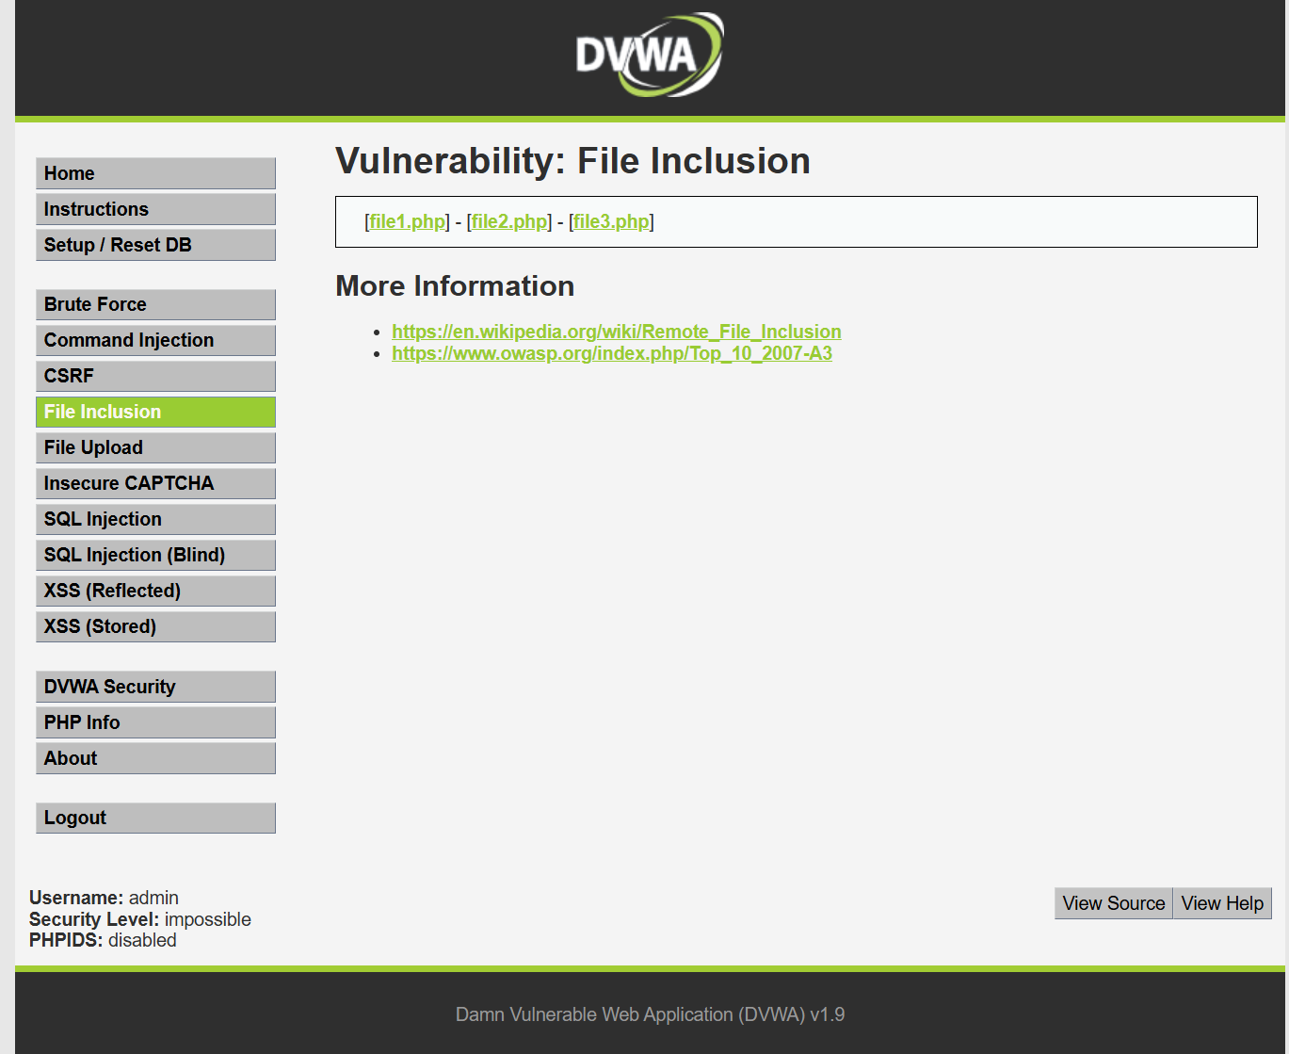

Impossible:
<?php
// The page we wish to display
$file = $_GET[ 'page' ];
// Only allow include.php or file{1..3}.php
if( $file != "include.php" && $file != "file1.php" && $file != "file2.php" && $file != "file3.php" ) {
// This isn't the page we want!
echo "ERROR: File not found!";
exit;
}
?>

Low:
File Inclusion Source
<?php
// The page we wish to display
$file = $_GET[ 'page' ];
?>

Medium:
File Inclusion Source
<?php
// The page we wish to display
$file = $_GET[ 'page' ];
// Input validation
$file = str_replace( array( "http://", "https://" ), "", $file );
$file = str_replace( array( "../", "..\"" ), "", $file );
?>

窗体顶端
窗体底端

窗体顶端
窗体底端
High:
<?php
// The page we wish to display
$file = $_GET[ 'page' ];
// Input validation
if( !fnmatch( "file*", $file ) && $file != "include.php" ) {
// This isn't the page we want!
echo "ERROR: File not found!";
exit;
}
?>

窗体顶端
窗体底端

窗体顶端
窗体底端

4、File Upload
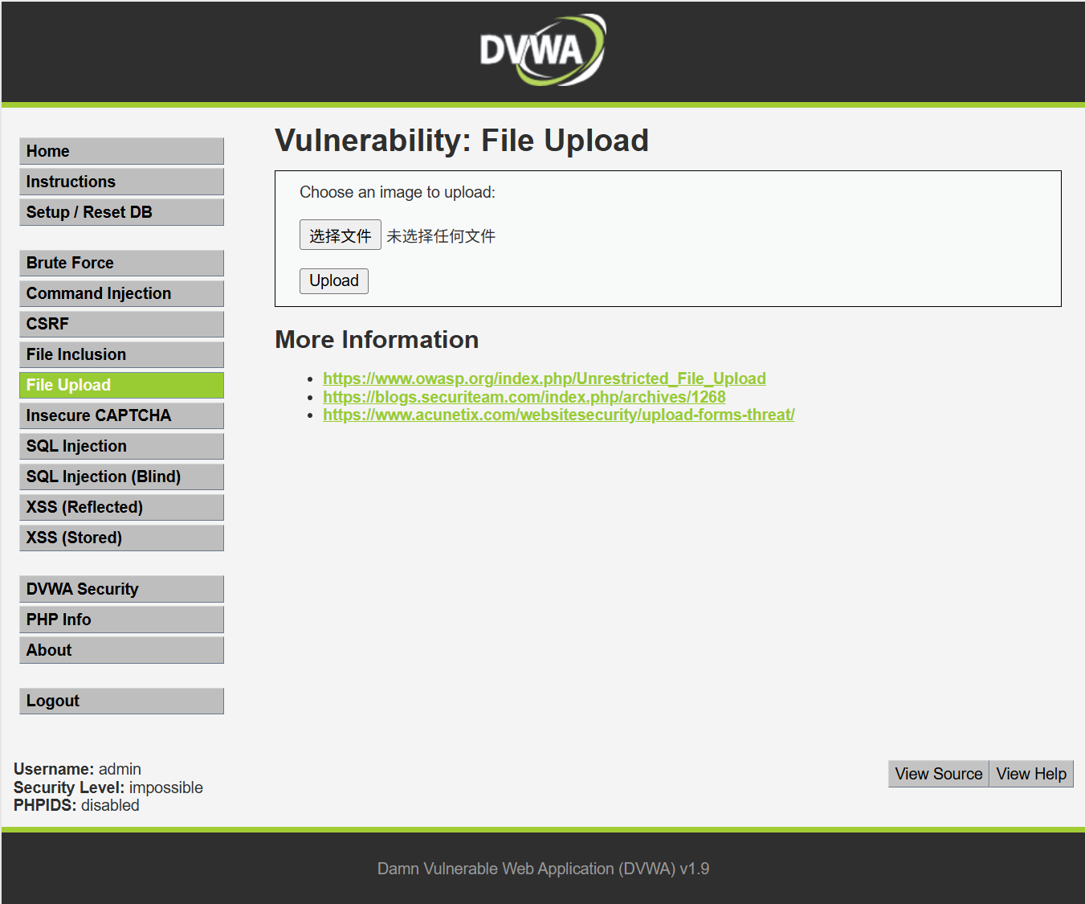

Impossible:
<?php
if( isset( $_POST[ 'Upload' ] ) ) {
// Check Anti-CSRF token
checkToken( $_REQUEST[ 'user_token' ], $_SESSION[ 'session_token' ], 'index.php' );
// File information
$uploaded_name = $_FILES[ 'uploaded' ][ 'name' ];
$uploaded_ext = substr( $uploaded_name, strrpos( $uploaded_name, '.' ) + 1);
$uploaded_size = $_FILES[ 'uploaded' ][ 'size' ];
$uploaded_type = $_FILES[ 'uploaded' ][ 'type' ];
$uploaded_tmp = $_FILES[ 'uploaded' ][ 'tmp_name' ];
// Where are we going to be writing to?
$target_path = DVWA_WEB_PAGE_TO_ROOT . 'hackable/uploads/';
//$target_file = basename( $uploaded_name, '.' . $uploaded_ext ) . '-';
$target_file = md5( uniqid() . $uploaded_name ) . '.' . $uploaded_ext;
$temp_file = ( ( ini_get( 'upload_tmp_dir' ) == '' ) ? ( sys_get_temp_dir() ) : ( ini_get( 'upload_tmp_dir' ) ) );
$temp_file .= DIRECTORY_SEPARATOR . md5( uniqid() . $uploaded_name ) . '.' . $uploaded_ext;
// Is it an image?
if( ( strtolower( $uploaded_ext ) == 'jpg' || strtolower( $uploaded_ext ) == 'jpeg' || strtolower( $uploaded_ext ) == 'png' ) &&
( $uploaded_size < 100000 ) &&
( $uploaded_type == 'image/jpeg' || $uploaded_type == 'image/png' ) &&
getimagesize( $uploaded_tmp ) ) {
// Strip any metadata, by re-encoding image (Note, using php-Imagick is recommended over php-GD)
if( $uploaded_type == 'image/jpeg' ) {
$img = imagecreatefromjpeg( $uploaded_tmp );
imagejpeg( $img, $temp_file, 100);
}
else {
$img = imagecreatefrompng( $uploaded_tmp );
imagepng( $img, $temp_file, 9);
}
imagedestroy( $img );
// Can we move the file to the web root from the temp folder?
if( rename( $temp_file, ( getcwd() . DIRECTORY_SEPARATOR . $target_path . $target_file ) ) ) {
// Yes!
echo "<pre><a href='${target_path}${target_file}'>${target_file}</a> succesfully uploaded!</pre>";
}
else {
// No
echo '<pre>Your image was not uploaded.</pre>';
}
// Delete any temp files
if( file_exists( $temp_file ) )
unlink( $temp_file );
}
else {
// Invalid file
echo '<pre>Your image was not uploaded. We can only accept JPEG or PNG images.</pre>';
}
}
// Generate Anti-CSRF token
generateSessionToken();
?>

Low:
<?php
if( isset( $_POST[ 'Upload' ] ) ) {
// Where are we going to be writing to?
$target_path = DVWA_WEB_PAGE_TO_ROOT . "hackable/uploads/";
$target_path .= basename( $_FILES[ 'uploaded' ][ 'name' ] );
// Can we move the file to the upload folder?
if( !move_uploaded_file( $_FILES[ 'uploaded' ][ 'tmp_name' ], $target_path ) ) {
// No
echo '<pre>Your image was not uploaded.</pre>';
}
else {
// Yes!
echo "<pre>{$target_path} succesfully uploaded!</pre>";
}
}
?>

Medium:
<?php
if( isset( $_POST[ 'Upload' ] ) ) {
// Where are we going to be writing to?
$target_path = DVWA_WEB_PAGE_TO_ROOT . "hackable/uploads/";
$target_path .= basename( $_FILES[ 'uploaded' ][ 'name' ] );
// File information
$uploaded_name = $_FILES[ 'uploaded' ][ 'name' ];
$uploaded_type = $_FILES[ 'uploaded' ][ 'type' ];
$uploaded_size = $_FILES[ 'uploaded' ][ 'size' ];
// Is it an image?
if( ( $uploaded_type == "image/jpeg" || $uploaded_type == "image/png" ) &&
( $uploaded_size < 100000 ) ) {
// Can we move the file to the upload folder?
if( !move_uploaded_file( $_FILES[ 'uploaded' ][ 'tmp_name' ], $target_path ) ) {
// No
echo '<pre>Your image was not uploaded.</pre>';
}
else {
// Yes!
echo "<pre>{$target_path} succesfully uploaded!</pre>";
}
}
else {
// Invalid file
echo '<pre>Your image was not uploaded. We can only accept JPEG or PNG images.
</pre>';
}
}
?>

窗体顶端
窗体底端

窗体顶端
窗体底端

窗体顶端
窗体底端

High:
<?php
if( isset( $_POST[ 'Upload' ] ) ) {
// Where are we going to be writing to?
$target_path = DVWA_WEB_PAGE_TO_ROOT . "hackable/uploads/";
$target_path .= basename( $_FILES[ 'uploaded' ][ 'name' ] );
// File information
$uploaded_name = $_FILES[ 'uploaded' ][ 'name' ];
$uploaded_ext = substr( $uploaded_name, strrpos( $uploaded_name, '.' ) + 1);
$uploaded_size = $_FILES[ 'uploaded' ][ 'size' ];
$uploaded_tmp = $_FILES[ 'uploaded' ][ 'tmp_name' ];
// Is it an image?
if( ( strtolower( $uploaded_ext ) == "jpg" || strtolower( $uploaded_ext ) == "jpeg" ||
strtolower( $uploaded_ext ) == "png" ) &&
( $uploaded_size < 100000 ) &&
getimagesize( $uploaded_tmp ) ) {
// Can we move the file to the upload folder?
if( !move_uploaded_file( $uploaded_tmp, $target_path ) ) {
// No
echo '<pre>Your image was not uploaded.</pre>';
}
else {
// Yes!Medium File Upload Source
Low File Upload Source
echo "<pre>{$target_path} succesfully uploaded!</pre>";
}
}
else {
// Invalid file
echo '<pre>Your image was not uploaded. We can only accept JPEG or PNG images.
</pre>';
}
}
?>

窗体顶端
窗体底端

5、 SQL Injection
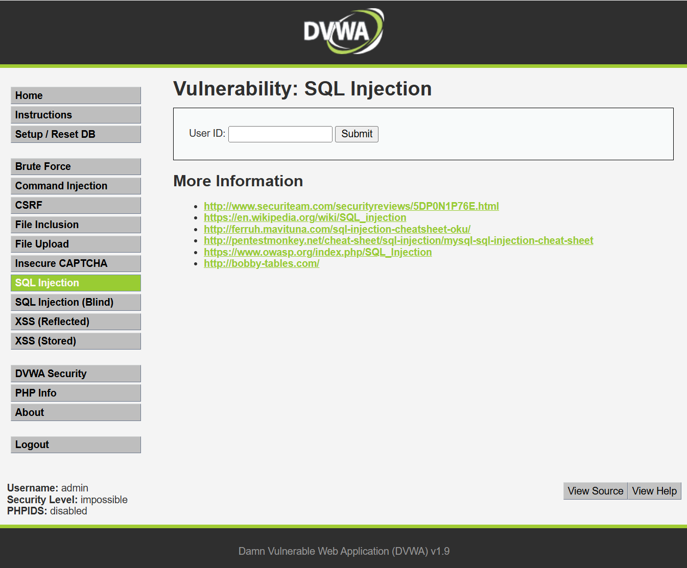

Impossible:
<?php
if( isset( $_GET[ 'Submit' ] ) ) {
// Check Anti-CSRF token
checkToken( $_REQUEST[ 'user_token' ], $_SESSION[ 'session_token' ], 'index.php' );
// Get input
$id = $_GET[ 'id' ];
// Was a number entered?
if(is_numeric( $id )) {
// Check the database
$data = $db->prepare( 'SELECT first_name, last_name FROM users WHERE user_id = (:id) LIMIT 1;' );
$data->bindParam( ':id', $id, PDO::PARAM_INT );
$data->execute();
$row = $data->fetch();
// Make sure only 1 result is returned
if( $data->rowCount() == 1 ) {
// Get values
$first = $row[ 'first_name' ];
$last = $row[ 'last_name' ];
// Feedback for end user
echo "<pre>ID: {$id}<br />First name: {$first}<br />Surname: {$last}</pre>";
}
}
}
// Generate Anti-CSRF token
generateSessionToken();
?>

Low:
<?php
if( isset( $_REQUEST[ 'Submit' ] ) ) {
// Get input
$id = $_REQUEST[ 'id' ];
// Check database
$query = "SELECT first_name, last_name FROM users WHERE user_id = '$id';";
$result = mysql_query( $query ) or die( '<pre>' . mysql_error() . '</pre>' );
// Get results
$num = mysql_numrows( $result );
$i = 0;
while( $i < $num ) {
// Get values
$first = mysql_result( $result, $i, "first_name" );
$last = mysql_result( $result, $i, "last_name" );
// Feedback for end user
echo "<pre>ID: {$id}<br />First name: {$first}<br />Surname: {$last}</pre>";
// Increase loop count
$i++;
}
mysql_close();
}
?>

窗体顶端
窗体底端

Medium:
<?php
if( isset( $_POST[ 'Submit' ] ) ) {
// Get input
$id = $_POST[ 'id' ];
$id = mysql_real_escape_string( $id );
// Check database
$query = "SELECT first_name, last_name FROM users WHERE user_id = $id;";
$result = mysql_query( $query ) or die( '<pre>' . mysql_error() . '</pre>' );
// Get results
$num = mysql_numrows( $result );
$i = 0;
while( $i < $num ) {
// Display values
$first = mysql_result( $result, $i, "first_name" );
$last = mysql_result( $result, $i, "last_name" );
// Feedback for end user
echo "<pre>ID: {$id}<br />First name: {$first}<br />Surname: {$last}</pre>";
// Increase loop count
$i++;
}
//mysql_close();
}
?>

窗体顶端
窗体底端

、

High:
<?php
if( isset( $_SESSION [ 'id' ] ) ) {
// Get input
$id = $_SESSION[ 'id' ];
// Check database
$query = "SELECT first_name, last_name FROM users WHERE user_id = '$id' LIMIT 1;";
$result = mysql_query( $query ) or die( '<pre>Something went wrong.</pre>' );
// Get results
$num = mysql_numrows( $result );
$i = 0;
while( $i < $num ) {
// Get values
$first = mysql_result( $result, $i, "first_name" );
$last = mysql_result( $result, $i, "last_name" );
// Feedback for end user
echo "<pre>ID: {$id}<br />First name: {$first}<br />Surname: {$last}</pre>";
// Increase loop count
$i++;
}
mysql_close();
}
?>

窗体顶端
窗体底端

6、SQL Injection (Blind)
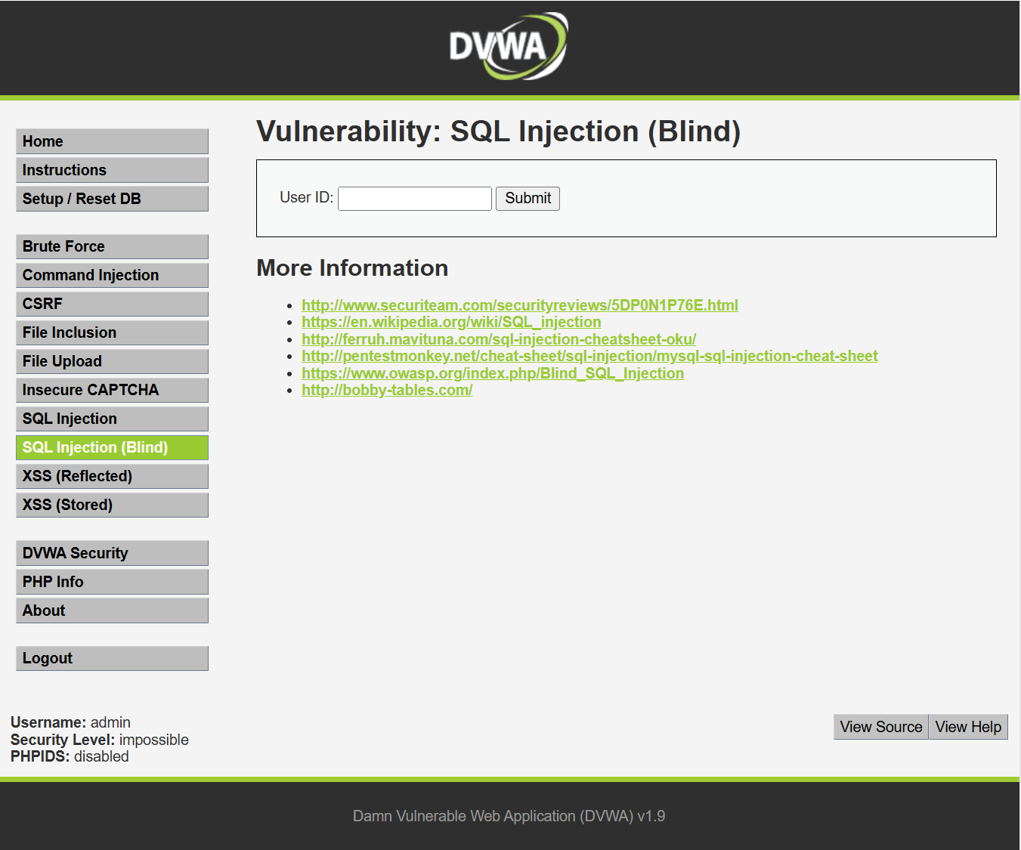

Impossible:
<?php
if( isset( $_GET[ 'Submit' ] ) ) {
// Check Anti-CSRF token
checkToken( $_REQUEST[ 'user_token' ], $_SESSION[ 'session_token' ], 'index.php' );
// Get input
$id = $_GET[ 'id' ];
// Was a number entered?
if(is_numeric( $id )) {
// Check the database
$data = $db->prepare( 'SELECT first_name, last_name FROM users WHERE user_id = (:id) LIMIT 1;' );
$data->bindParam( ':id', $id, PDO::PARAM_INT );
$data->execute();
// Get results
if( $data->rowCount() == 1 ) {
// Feedback for end user
echo '<pre>User ID exists in the database.</pre>';
}
else {
// User wasn't found, so the page wasn't!
header( $_SERVER[ 'SERVER_PROTOCOL' ] . ' 404 Not Found' );
// Feedback for end user
echo '<pre>User ID is MISSING from the database.</pre>';
}
}
}
// Generate Anti-CSRF token
generateSessionToken();
?>

窗体顶端
窗体底端
Low:
<?php
if( isset( $_GET[ 'Submit' ] ) ) {
// Get input
$id = $_GET[ 'id' ];
// Check database
$getid = "SELECT first_name, last_name FROM users WHERE user_id = '$id';";
$result = mysql_query( $getid ); // Removed 'or die' to suppress mysql errors
// Get results
$num = @mysql_numrows( $result ); // The '@' character suppresses errors
if( $num > 0 ) {
// Feedback for end user
echo '<pre>User ID exists in the database.</pre>';
}
else {
// User wasn't found, so the page wasn't!
header( $_SERVER[ 'SERVER_PROTOCOL' ] . ' 404 Not Found' );
// Feedback for end user
echo '<pre>User ID is MISSING from the database.</pre>';
}
mysql_close();
}
?>

Medium:
<?php
if( isset( $_POST[ 'Submit' ] ) ) {
// Get input
$id = $_POST[ 'id' ];
$id = mysql_real_escape_string( $id );
// Check database
$getid = "SELECT first_name, last_name FROM users WHERE user_id = $id;";
$result = mysql_query( $getid ); // Removed 'or die' to suppress mysql errors
// Get results
$num = @mysql_numrows( $result ); // The '@' character suppresses errors
if( $num > 0 ) {
// Feedback for end user
echo '<pre>User ID exists in the database.</pre>';
}
else {
// Feedback for end user
echo '<pre>User ID is MISSING from the database.</pre>';
}
//mysql_close();
}
?>

窗体顶端
窗体底端

窗体顶端
窗体底端

High:
<?php
if( isset( $_COOKIE[ 'id' ] ) ) {
// Get input
$id = $_COOKIE[ 'id' ];
// Check database
$getid = "SELECT first_name, last_name FROM users WHERE user_id = '$id' LIMIT 1;";
$result = mysql_query( $getid ); // Removed 'or die' to suppress mysql errors
// Get results
$num = @mysql_numrows( $result ); // The '@' character suppresses errors
if( $num > 0 ) {
// Feedback for end user
echo '<pre>User ID exists in the database.</pre>';
}
else {
// Might sleep a random amount
if( rand( 0, 5 ) == 3 ) {
sleep( rand( 2, 4 ) );
}
// User wasn't found, so the page wasn't!
header( $_SERVER[ 'SERVER_PROTOCOL' ] . ' 404 Not Found' );
// Feedback for end user
echo '<pre>User ID is MISSING from the database.</pre>';
}
mysql_close();
}
?>

窗体顶端
窗体底端

7、Reflected Cross Site Scripting (XSS)
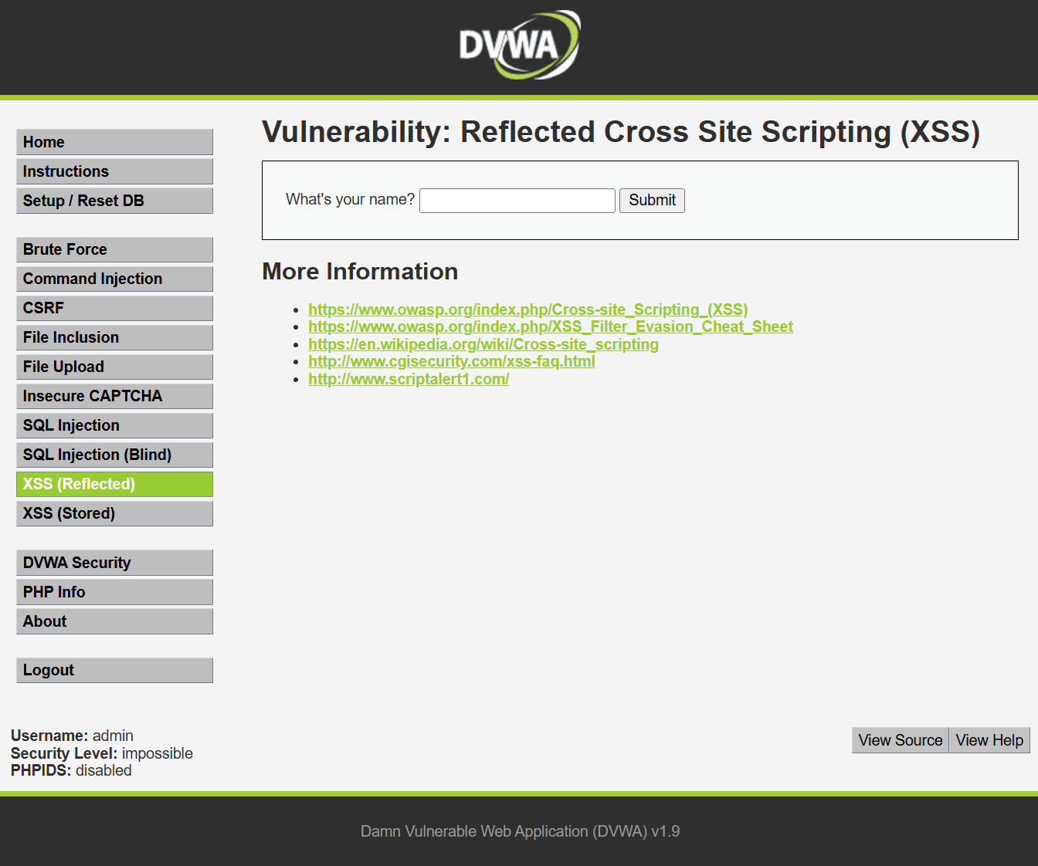

Impossible:
<?php
// Is there any input?
if( array_key_exists( "name", $_GET ) && $_GET[ 'name' ] != NULL ) {
// Check Anti-CSRF token
checkToken( $_REQUEST[ 'user_token' ], $_SESSION[ 'session_token' ], 'index.php' );
// Get input
$name = htmlspecialchars( $_GET[ 'name' ] );
// Feedback for end user
echo "<pre>Hello ${name}</pre>";
}
// Generate Anti-CSRF token
generateSessionToken();
?>

Low:
<?php
// Is there any input?
if( array_key_exists( "name", $_GET ) && $_GET[ 'name' ] != NULL ) {
// Feedback for end user
echo '<pre>Hello ' . $_GET[ 'name' ] . '</pre>';
}
?>

Medium:
<?php
// Is there any input?
if( array_key_exists( "name", $_GET ) && $_GET[ 'name' ] != NULL ) {
// Get input
$name = str_replace( '<script>', '', $_GET[ 'name' ] );
// Feedback for end user
echo "<pre>Hello ${name}</pre>";
}
?>

窗体顶端
窗体底端

窗体顶端
窗体底端
High:
<?php
// Is there any input?
if( array_key_exists( "name", $_GET ) && $_GET[ 'name' ] != NULL ) {
// Get input
$name = preg_replace( '/<(.*)s(.*)c(.*)r(.*)i(.*)p(.*)t/i', '', $_GET[ 'name' ] );
// Feedback for end user
echo "<pre>Hello ${name}</pre>";
}
?>

窗体顶端
窗体底端

窗体顶端
窗体底端

8、Stored Cross Site Scripting (XSS)
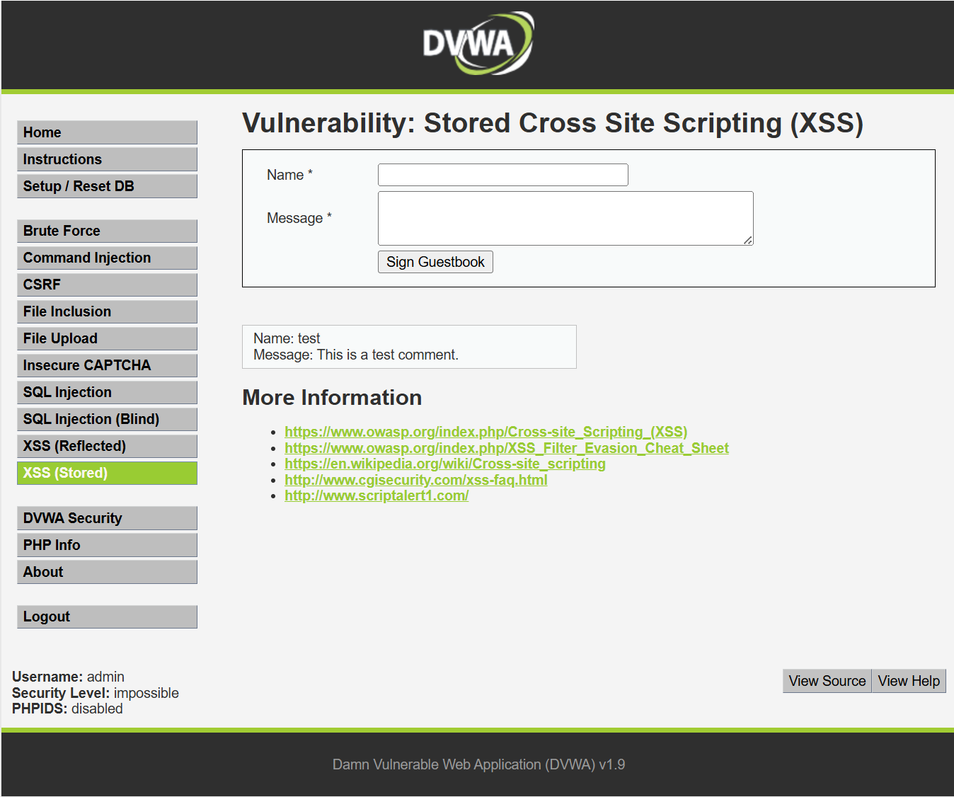

Impossible:
<?php
if( isset( $_POST[ 'btnSign' ] ) ) {
// Check Anti-CSRF token
checkToken( $_REQUEST[ 'user_token' ], $_SESSION[ 'session_token' ], 'index.php' );
// Get input
$message = trim( $_POST[ 'mtxMessage' ] );
$name = trim( $_POST[ 'txtName' ] );
// Sanitize message input
$message = stripslashes( $message );
$message = mysql_real_escape_string( $message );
$message = htmlspecialchars( $message );
// Sanitize name input
$name = stripslashes( $name );
$name = mysql_real_escape_string( $name );
$name = htmlspecialchars( $name );
// Update database
$data = $db->prepare( 'INSERT INTO guestbook ( comment, name ) VALUES ( :message, :name );' );
$data->bindParam( ':message', $message, PDO::PARAM_STR );
$data->bindParam( ':name', $name, PDO::PARAM_STR );
$data->execute();
}
// Generate Anti-CSRF token
generateSessionToken();
?>

Low:
<?php
if( isset( $_POST[ 'btnSign' ] ) ) {
// Get input
$message = trim( $_POST[ 'mtxMessage' ] );
$name = trim( $_POST[ 'txtName' ] );
// Sanitize message input
$message = stripslashes( $message );
$message = mysql_real_escape_string( $message );
// Sanitize name input
$name = mysql_real_escape_string( $name );
// Update database
$query = "INSERT INTO guestbook ( comment, name ) VALUES ( '$message', '$name' );";
$result = mysql_query( $query ) or die( '<pre>' . mysql_error() . '</pre>' );
//mysql_close();
}
?>

窗体顶端
窗体底端
Medium:
<?php
if( isset( $_POST[ 'btnSign' ] ) ) {
// Get input
$message = trim( $_POST[ 'mtxMessage' ] );
$name = trim( $_POST[ 'txtName' ] );
// Sanitize message input
$message = strip_tags( addslashes( $message ) );
$message = mysql_real_escape_string( $message );
$message = htmlspecialchars( $message );
// Sanitize name input
$name = str_replace( '<script>', '', $name );
$name = mysql_real_escape_string( $name );
// Update database
$query = "INSERT INTO guestbook ( comment, name ) VALUES ( '$message', '$name' );";
$result = mysql_query( $query ) or die( '<pre>' . mysql_error() . '</pre>' );
//mysql_close();
}
?>

窗体顶端
窗体底端

窗体顶端
窗体底端

High:
<?php
if( isset( $_POST[ 'btnSign' ] ) ) {
// Get input
$message = trim( $_POST[ 'mtxMessage' ] );
$name = trim( $_POST[ 'txtName' ] );
// Sanitize message input
$message = strip_tags( addslashes( $message ) );
$message = mysql_real_escape_string( $message );
$message = htmlspecialchars( $message );
// Sanitize name input
$name = preg_replace( '/<(.*)s(.*)c(.*)r(.*)i(.*)p(.*)t/i', '', $name );
$name = mysql_real_escape_string( $name );
// Update database
$query = "INSERT INTO guestbook ( comment, name ) VALUES ( '$message', '$name' );";
$result = mysql_query( $query ) or die( '<pre>' . mysql_error() . '</pre>' );
//mysql_close();
}
?>

窗体顶端
窗体底端

窗体顶端
窗体底端

