**Outputs from various softwares -- single population**

DATA



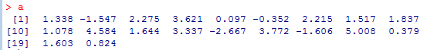

1. R Output

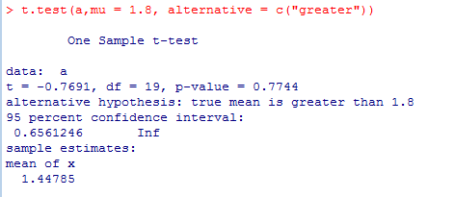

1. Minitab Output:

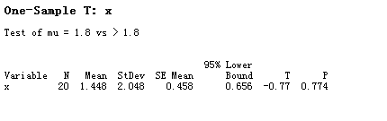

1. SPSS Output:

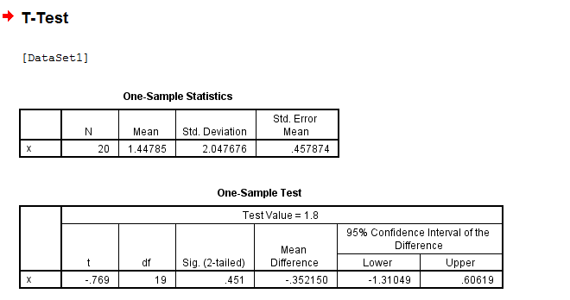

1. SAS Output:

