外文翻译
原文1
Presenting Risks Introduced By Android Application Permissions In A User-Friendly Way
Abstract :
The emergence of Android as a leading Operating System in terms of market coverage induced the rapid emergence of many mobile applications. A lot of these applications are prone to misuse because of their design. This paper deals with a new method of informing user whether applications installed on his device are potentially harmful or not. The introductory part provides some insight into security mechanisms used in Android. The main part deals with research we based our work on, proposal of our own methodology based on permission model and its implementation in application for real-time offline analysis of installed applications on device running Android. The last part of this paper deals with the evaluation of achievements reached by our methodology implemented in standalone application.

1. Introduction
Operating system Android is currently the most widespread operating system (OS) for mobile phones, tablets and other devices. Its development began in 2003 in Android Inc. The first phone with Android was released by HTC in 2008 in USA and reached central Europe in summer 2009. Android is operating system built on Linux architecture. Due to the fact that mobile devices have limited hardware resources, this architecture had to be modified to fit this situation. Securing an open platform requires robust security architecture and precisely designed security system. Even though it is possible to provide security at the application level ( by means of cryptography or steganography ), this does not provide protection against the security leaks at the level of operating system modules. But multi-layer architecture of Android provides necessary flexibility in development and also certain level of protection. Security measures were designed with regard to developer community—experts can easily work with these mechanisms, beginners are protected by default settings. Despite these measures, there are ways to circumvent them. One of them is misusing over-privileged applications. In this paper we propose a new approach in detecting these applications and presenting the results to the user.
The following part of this paper deals with the overview of the permission model and its connection to Android security. The third part presents prior research in this field, which we used as a reference starting point in our work. Next two parts describe our method of detecting over-privileged applications and tests conducted with proof-of-concept application, respectively. This paper is concluded in the sixth part.

2. Permission model
From the beginning, OS Android is being developed as an open mobile platform. It enables applications to use built-in hardware and software along with both local and remote data to grant users desired comfort and functionality. Along with all this the OS must provide means to secure user data, applications and whole device.
On the OS level Android provides security of Linux kernel, along with secure inter-process communication between applications running in different processes. These security features on OS level make sure that even native applications are subjected to application sandboxing. This way system prevents harmful applications from damaging other applications, device or OS itself [4].
Applications run in application sandbox and have access to limited system resources. System manages application access to resources. These restrictions are implemented by various means. Some possibilities are restricted by lack of corresponding Application Programming Interfaces (APIs), others by, e.g., role separation. Sensitive APIs can only be used by trusted applications and are protected by permission system. Permissions are divided into four groups based on level of protection (for illustration see Figure 1):
Normal: permissions on the application level, they do not pose a serious risk when they are used by the application.
Dangerous: permissions which can cause leaks and manipulation with sensitive data or exploit potentially dangerous system resources. They need to be explicitly confirmed by user during installation of application. Here belong for example:
Location data from GPS ( ACCESS FINE LOCATION ).
Network/data connection ( ACCESS NETWORK STATE ).
Telephony ( CALL PHONE).
SMS/MMS functions (WRITE SMS).
Access to system configuration ( CHANGE CONFIGURATION).
Signature: permissions assignable only to applications signed with private key corresponding with certificate of application calling it. They are used by developers to share information among their applications.
Signature-or-system: special type of permission assignable only to applications installed in system image which are signed with the same certificate as system image [5] [6].
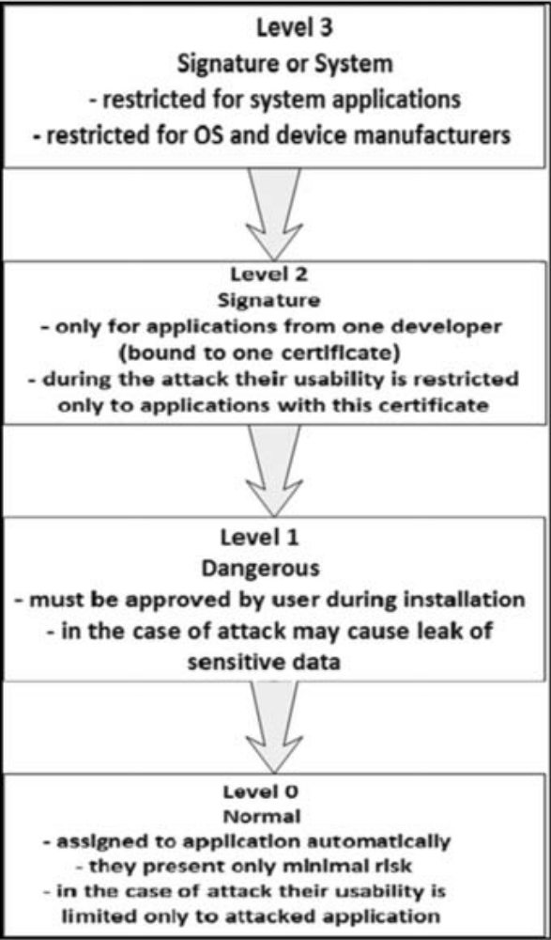
Figure 1 Android permission model.
Aside from the above mentioned division, permissions are also divided in a way of accepting them:
Time-of-use: user must confirm this permission when executing sensitive operation (e.g., acc Install-time: accepted when installing application, user accepts them as one; he cannot choose which permissions to accept and which to deny, see Figure 2. Figureess to device location). It is the only way to prevent applications to access device resources.
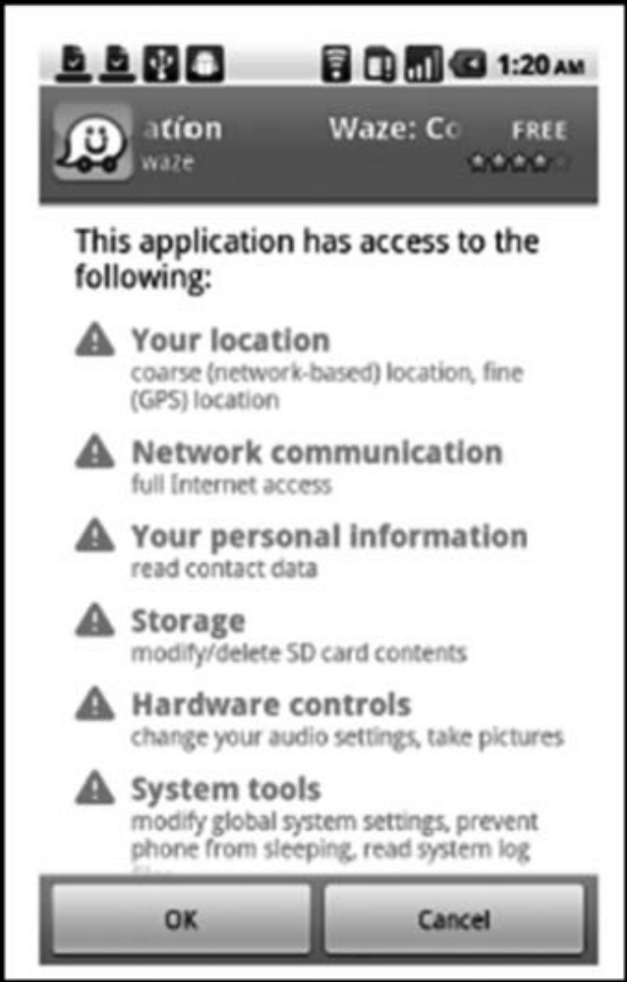
Figure 2 Example of application installation [7].
System resources marked as dangerous are accessible only from the OS. Applications must have these requirements specified by permissions in manifest. During installation these permissions are displayed to user and he can accept or reject them. After accepting these permissions the installation continues and these permissions are accepted by the system. It is not possible to choose which permissions to accept, they must be accepted as one and that can lead to security incidents. Permissions are assigned to an application for the whole time it is installed on the device and cannot be manipulated by anyone. They are removed in the moment the application is deleted from the device. They can be revised in application settings and can be restricted by shutting down global functionality, such as Wi-Fi or GPS. If the application is trying to access a feature that is not allowed to, it invokes a security exception and error message in the application. Security checks for protected API permissions are done on the lowestpossible level to prevent their circumventing. Some device capabilities are not accessible to third-party applications but can be used by pre-installed applications. The complete list of permissions is available on website dedicated to Android development [5] [6]. Other mobile platforms also use security mechanisms based on permissions, e.g., IOS by Apple [8], but their usage is different.

Author: Juraj Varga, Peter Muska
Nationality: USA
Originate from: Tatra Mountains Mathematical Publications, 2015

译文1
以用户友好的方式呈现Android应用权限风险
摘要：
Android作为领先的操作系统在市场覆盖方面的出现，促使了许多移动应用的迅速出现。 许多这些应用程序由于其设计而容易被滥用。本文讨论了一种通知用户安装在他的设备上的应用程序是否可能有害的新方法。介绍部分介绍了Android中使用的安全机制。 主要处理基于我们工作的研究，基于权限模型的自己的方法的建议，以及在运行Android的设备上对已安装应用程序进行实时离线分析的应用程序的实现。本文的最后一部分是关于我们在独立应用程序中实现的方法所取得的成果的评估。
Android是目前用于手机，平板电脑和其他设备的最广泛的操作系统（OS）。它的开发始于2003年的Android公司。第一款搭载Android的手机于2008年在美国发布，并于2009年夏季到达欧洲中部。Android是基于Linux架构的操作系统。由于移动设备硬件资源有限，因此必须对此架构进行修改以适应这种情况。保护开放平台需要强大的安全架构和精确设计的安全系统。尽管可以在应用程序级别（通过密码术或隐写术）提供安全性，但这并不能防止操作系统模块级别的安全漏洞。但Android的多层架构提供了必要的开发灵活性和一定的保护水平。安全措施是针对开发者社区设计的，专家可以很容易地使用这些机制，初学者通过默认设置进行保护。尽管采取了这些措施，但也有办法规避这些措施。其中之一是滥用超级特权应用程序。在本文中，我们提出了一种新的方法来检测这些应用程序并将结果呈现给用户。
本文的以下部分涉及权限模型的概述及其与Android安全性的连接。 第三部分介绍了该领域的先期研究成果，并以此作为我们工作的参考出发点。 接下来的两个部分分别描述了我们用概念证明应用程序来检测过度特权应用程序和测试的方法。 本文在第六部分总结。
Android操作系统从一开始就是作为一个开放的移动平台而开发的。它使应用程序能够使用内置的硬件和软件以及本地和远程数据来授予用户所需的舒适性和功能。除此之外，操作系统必须提供手段来保护用户数据，应用程序和整个设备。
在操作系统级别上，Android提供了Linux内核的安全性，以及在不同进程中运行的应用程序之间的安全进程间通信。 OS级别的这些安全功能确保即使是本机应用程序也受到应用程序沙箱的限制。这种方式可以防止有害应用程序破坏其他应用程序，设备或操作系统本身。
应用程序在应用程序沙箱中运行，并可访问有限的系统资源。系统管理应用程序访问资源。这些限制是通过各种手段来实现的。缺少相应的应用程序编程接口（API）会限制一些可能性，其他的则由角色分离来限制。敏感的API只能由受信任的应用程序使用，并受权限系统的保护。根据保护级别将权限分为四组：
正常：在应用程序级别的权限，当它们被应用程序使用时，它们不构成严重的风险。
危险：可能导致敏感数据泄露和操纵的权限，或利用潜在危险的系统资源。它们需要在安装应用程序时由用户明确确认。
例如：
来自GPS（ACCESS FINE LOCATION）的位置数据。
网络/数据连接（ACCESS NETWORK STATE）。
电话（CALL PHONE）。
短信/彩信功能（写短信）。
进入系统配置（CHANGE CONFIGURATION）。
签名：仅可分配给使用与调用该应用程序证书私钥签名的应用程序的权限。他们被开发者用来在他们的应用程序之间共享信息。
签名或系统：仅可分配给系统映像中安装的应用程序的特殊类型的权限，这些应用程序使用与系统映像相同的证书进行签名。
除了上面提到的部分之外，权限也是以接受它们的方式划分的：
使用时间：用户在执行敏感操作时必须确认此权限（例如，安装时间：安装应用程序时接受）。这是防止应用程序访问设备资源的唯一方法。
标记为危险的系统资源只能从操作系统访问。应用程序必须具有由清单中的权限指定的这些需求在安装过程中，这些权限会显示给用户，他可以接受或拒绝这些权限。接受这些权限后，安装将继续，系统将接受这些权限。无法选择要接受的权限，必须将其接受为一个，这可能会导致安全事件。权限被分配给应用程序，一直安装在设备上，不能被任何人操纵。从应用程序中删除应用程序时，它们将被删除。它们可以在应用程序设置中进行修改，并可以通过关闭全球功能（如Wi-Fi或GPS）来进行限制。如果应用程序尝试访问不允许的功能，则会调用应用程序中的安全异常和错误消息。安全检查受保护的API权限是在尽可能低的级别上进行的，以防止它们的绕过。某些设备功能不能被第三方应用程序访问，但可以被预安装的应用程序使用。完整的权限列表可在致力于Android开发的网站上获得。其他移动平台也使用基于权限的安全机制，例如苹果的IOS，但是它们的使用是不同的。

作者：Juraj Varga, Peter Muska
国籍：美国
出处：Tatra Mountains Mathematical Publications, 2015

原文2
Software processes for the development of electronic commerce systems
Abstract :
The development of electronic commerce (EC) systems is subject to different conditions than that of conventional software systems. This includes the introduction of new activities to the development process and the removal of others. An adapted process must cope with important idiosyncrasies of EC system development: EC systems typically have a high degree of interaction, which makes factors like ergonomics, didactics and psychology especially important in the development of user interfaces. Typically, they also have a high degree of integration with existing software systems such as legacy or groupware systems. Integration techniques have to be selected systematically in order not to endanger the whole software development process. This article describes the development of an EC system and it generalizes salient features of the software process used. The result is a process model which can be used for other highly integrative EC system development projects. The processes described are determined by short process lifecycles, by an orientation towards integration of legacy systems and by a strict role-based cooperation approach. q 2002 Elsevier Science B.V. All rights reserved.
1. Introduction
In this paper, electronic commerce (EC) is defined as conducting transactions of any kind by means of electronic media, especially the Internet. The roles of suppliers and customers in these transactions can be adopted by different parties, such as consumers (C), administrations (A), businesses (B) or even their employees (E) [20–22]. The parties involved in EC transactions use information technology (IT) systems to automate their transactions [2,5]. The examples used in this paper are business-to employee (B2E) EC systems. The EC portal system discussed in this article is an integration platform for different software systems: conventional (i.e. non-EC) software systems such as legacy and office systems as well as other EC based systems such as shop systems.
In the same way that conventional application software systems are developed according to conventional software development processes, special software development processes are necessary to delineate the development of EC systems [3,7,9,11]. These software development processes for EC systems differ from those for conventional application software systems in the following aspects:
They include provisions for new or adapted activities and roles performing them:
System integration is very important in EC settings, because often, many heterogeneous systems have to be integrated and these do not necessarily have a long lifetime. Therefore the add-on or replacement of components should be planned beforehand.
The need for attractive and user-friendly user interfaces is very pressing. One reason for this is that often, users are of various kinds with differing backgrounds, not known personally making it difficult to obtain feedback. Roles for graphical design activities are needed in order to provide these user interfaces.
Content is an integral part of most EC systems and important regarding quality, quantity and frequency of change. Roles and activities for managing this content are needed.
They must take into account that EC software development is a very distributed process. That is, the roles mentioned above are often adopted by different parties: software companies develop software components, multimedia companies develop graphical features for the interface and specialized content providers supply the content.
These aspects are discussed in the following. In EC system settings, many predefined building blocks, like shop systems, content management systems etc. are often developed by small software suppliers with special expertise in their field. Companies generally do not want to be dependent on these small suppliers. So, when designing an EC system, one should have in mind that some components might be replaced and others might be added at a later point in time. Thus, focus should be put on system integration activities during the software development from an early stage on. This challenge clearly indicates that paradigms known from component-based systems and architectures [23] are well-suited for EC systems as well. Components in the sense of component models like Enterprise JavaBeans or DCOM are the building blocks from which EC systems are built [25]. If an EC system needs to be integrated into an existing infrastructure, the requisite methods, concepts and software tools for the integration must be available [18]. The methods, concepts and software tools used, as well as the software developers involved, depend on how the integration is undertaken. For example, security aspects (use of firewalls, cryptography etc.) might have to be taken into account. These security aspects then not only have to be considered during implementation, but also during the design of the EC system. Also, it must be decided if direct sales processes for products or services should be electronically supported by an EC system. If support for products is required, the EC system has to be integrated with an open or closed inventory control system of the merchant. Integration with conventional domain-specific, highly individual application software systems is also usually required when supporting direct sales processes for services. These individual application software systems, termed ‘legacy systems’, are used by all kinds of businesses such as insurance companies, governmental agencies, banks, power utilities etc. [13].
While conventional application software systems might win user acceptance mainly through their functionality and can be positioned against market competitors in that way, aspecial class of EC systems (e.g. shop systems) also have to win user (i.e. customer) acceptance via the user interface. The user interface not only presents content in a certain layout, but also guides and supports the user. The tasks concerning the selection of content and its presentation are not included in most conventional software development processes. The roles performing them are specialists for software ergonomics, didactics, graphical design and psychology.
Performance is a second factor influencing user acceptance of EC systems. This becomes more evident when looking at the negative effects of an EC system with poor performance: users tend to quit their visit to a site after waiting for 8–15 s [17] for a response, resulting in loss of revenue and image for the company associated with the site. Therefore, characterization of customer behavior, workload forecasting and performance modelling become very prominent activities [24]. Two characteristics of EC customer behavior aggravate workload characterization in EC settings: peak-like request bursts and high-volume data requests that are not typically found in conventional software systems [16].
Another major factor in acceptance of many EC systems (e.g. shop systems) is being up-to-date—not only regarding the content, but equally important, content presentation. In most conventional software application systems, data of different types and structures is managed and processed in different ways. The more data managed by the application software system, the more up-to-date it is. In addition, for a shop system to stay up-to-date, the presentation of its content must be kept up-to-date. This means that even if the data remains mostly unchanged, its presentation is subject to change over time. In the productive/maintenance phase, the functionality of a shop system may remain largely constant, while the presentation of the content is modified and adapted at certain time intervals by specialists for software ergonomics, didactics, graphic design and psychology. Extensive statistical testing permits the measurement of customer acceptance levels with time. And from these statistics, it can be deduced which parts of the presentation should be changed.
The roles involved in the development of an EC system are more specialized and more widely spread between participating suppliers than is normally the case with conventional software systems development. Some of the roles and their activities have already been mentioned: specialists for software ergonomics, didactics, screen design and psychology, performance engineers, content engineers and software developers with expertise in a multitude of technologies such as programming languages like Java, component models and other frameworks such as Enterprise JavaBeans, Servlets or Java Server Pages, or middleware at different levels such as XML, SOAP and RMI. In most cases, this variety of required skills is not found in one single supplier such as a software company. Collaboration between many suppliers with specialized skills such as multimedia design companies, software companies including freelancers as experts and content providers is far more likely to be the case. A process for the development of EC systems has to take this distribution into account, by considering contract settlement (legal and technical in terms of interface contracts) and means for easing communication between suppliers.

译文2
电子商务系统的软件开发过程
电子商务系统的发展受到与传统软件系统不同的条件的限制。这包括在开发过程中引入新的活动和移除其他活动。一个适应的过程必须应对电子商务系统发展的重要特质：EC系统通常有一个高度互动，这使得人机工程学，教学法和心理学等因素在用户界面的开发中尤为重要。通常，它们还与现有的软件系统（如遗留、群件系统）高度集成。必须系统地选择集成技术，以免危及整个软件开发过程。本文描述了电子商务系统的开发，并概括了所使用的软件过程的显著特点。其结果是一个可用于其他高度集成的电子商务系统开发项目的过程模型。所描述的流程是由短流程生命周期，以传统系统整合为导向，并采用严格的基于角色的合作方法。
1 介绍
本文将电子商务定义为通过电子媒介，特别是因特网进行任何形式的交易。供应商和客户在这些交易中的作用可以由不同的当事人，如消费者（c）、行政当局（a）、企业（B）甚至雇员（e）来实施。参与电子商务交易的当事人利用信息系统的自动化交易。本文中使用的例子是企业对员工（B2E）的电子商务系统。本文讨论的EC门户系统是不同软件系统的集成平台：传统的（非EC）软件系统，如遗留系统和办公系统，以及基于EC的其他系统，如车间系统。
与传统的应用软件系统按照传统的软件开发流程开发的方式相同，特殊的软件开发流程对于描述EC系统的开发是必要的。 EC系统的这些软件开发过程在以下几个方面不同于传统的应用软件系统：
它们包括新的或适应的活动和执行它们的角色的规定：
系统集成在电子商务环境中非常重要，因为常常需要集成许多异构系统，这些系统不一定有很长的寿命。因此，部件的添加或更换应该事先计划好。
需要有吸引人和用户友好的用户界面是非常重要的。这样做的一个原因是，用户往往是各种不同背景的人，不知道个人很难获得反馈。为了提供这些用户接口，图形设计活动所需的角色是必需的。
内容是大多数电子商务系统的一个组成部分，在质量、数量和频率上都很重要。管理此内容的角色和活动是必需的。
他们必须考虑到EC软件开发是一个非常分散的过程。也就是说，上述角色经常被不同的方所采用：软件公司开发软件组件，多媒体公司为接口开发图形功能，专门的内容提供商提供内容。
这些方面将在以下方面进行讨论。在EC系统设置中，许多预定义的构建块，如商店系统、内容管理系统等，通常由具有专业知识的小型软件供应商开发。公司一般不希望依赖这些小供应商。因此，在设计电子商务系统时，应该考虑一些组件可能被替换，而其他组件可能在稍后的时间点添加。因此，在软件开发的早期阶段，应该把重点放在系统集成活动上。这一挑战清楚地表明，基于组件的系统和体系结构所知道的范例也非常适合于EC系统。在组件模型的语义成分如EJB或DCOM是积木，EC系统是建立[。如果EC系统需要集成到现有的基础设施中，则必须具备集成的必要方法、概念和软件工具。所使用的方法、概念和软件工具以及所涉及的软件开发人员都依赖于集成是如何进行的。例如，可能需要考虑安全方面（使用防火墙、加密等）。这些安全方面不仅要在执行过程中考虑，还要在电子商务系统的设计过程中考虑。此外，必须决定，如果产品或服务的直接销售过程应由电子商务系统的电子支持。如果需要对产品进行支持，EC系统必须与商家的开放式或封闭式库存控制系统相结合。在支持服务的直接销售过程时，通常需要与传统的特定于域的、高度独立的应用软件系统进行集成。这些单独的应用软件系统，被称为“遗留系统”，被各种各样的企业使用，如保险公司、政府机构、银行、电力公司等等。
而传统的应用软件系统可能主要通过功能赢得用户的认可和可定位在市场上的竞争对手那样，电子商务系统的一类（例如商店系统）必须赢得用户（即客户）通过用户接口验收。用户界面不仅在一定的布局中呈现内容，而且还引导和支持用户。在大多数传统的软件开发过程中不包括关于内容选择和表示的任务。角色表演是软件工程学，心理学专家教授、和图形设计。
性能是影响用户接受电子商务系统的第二个因素。当看到性能不佳的电子商务系统的负面影响时，这种情况就变得更加明显了：用户在等待8 - 15秒响应后，往往会放弃访问站点，从而导致与网站相关的公司的收入和形象的损失。因此，刻画顾客行为、工作量预测和绩效建模成为非常突出的活动。EC客户行为的两个特点加剧了EC设置中的工作量特性：峰值请求突发和大容量数据请求，这些请求通常不在传统软件系统中出现。
接受许多EC系统（例如商店系统）的另一个主要因素是最新的 - 不仅关于内容，同样重要的是内容呈现。在大多数传统的软件应用系统中，不同类型和结构的数据以不同的方式进行管理和处理。应用软件系统管理的数据越多，它就越新。另外，要使店铺系统保持最新，其内容的陈述必须保持最新。这意味着，即使数据基本保持不变，其表述也会随时间而改变。在生产/维护阶段，商店系统的功能可能基本保持不变，而内容的呈现则由软件人机工程学，教学法，平面设计和心理学的专家在一定的时间间隔进行修改和调整。广泛的统计测试可以随时间测量客户的接受程度。从这些统计数据中可以推断出哪些部分应该改变。
与传统的软件系统开发相比，EC系统开发所涉及的角色更为专业化，在参与供应商之间更为广泛地传播。已经提到了一些角色和他们的活动：软件人机工程学，教学法，屏幕设计和心理学，性能工程师，内容工程师和软件开发专家，他们拥有多种技术，如Java，组件模型等编程语言诸如Enterprise JavaBeans，Servlet或Java Server Pages之类的框架，或诸如XML，SOAP和RMI等不同级别的中间件。在大多数情况下，在软件公司这样的单一供应商中没有找到这种各种所需的技能。许多具有专业技能的供应商，如多媒体设计公司，包括自由职业者在内的软件公司作为专家和内容提供商之间的合作更有可能成为现实。电子商务系统的开发过程必须考虑到这种分配，考虑合同结算（在接口合同方面的法律和技术）和便利供应商之间沟通的手段。

作者：Volker Gruhna, Lothar Scho pe
国籍：美国
出处：信息与软件科技（10）2002

