# Abstract

With my limited years of career as a Data Analysis professional, I’ve seen so many organizations are not utilizing their reports or dashboards. In fact, oftentimes, people build all kinds of ad-hoc reports just to illustrate the same thing over and over.

With that being said, I’d like to share a little bit about my personal Report Building ideology, which I found useful on report user retention. I mean, if my reports are getting the most attention and retention, that means I can lay back and relax more often while becoming more important. Who doesn’t want that?

So let’s dive in.

# Step 1: Draw Out the Question

I see so many reports being reworked over and over again due to a lack of this step. I admit, when I first started my career, I made the same mistake. With all the cool visualization tools out there, Power BI, Tableau, or QlikView, I wanted to put everything I know about the subject into the dashboard. I wanted to build the best, the most informative, and the most sophisticated dashboard so that I could show off my skill and looked smart. But the fact is, you can build the most sophisticated kitchen knife that can do many things, but if that knife can’t even cut a vegetable properly, it is not a good kitchen knife.

The same thing applies to Dashboard Building. If I know the purpose of my dashboard is to do ABC, then everything in this dashboard is better evolving around ABC.

1. I mentioned it many times, and I will keep saying this until everyone remembers it. We need first to define what the question we are trying to answer. This step will set the direction of this dashboard. For instance, when I was questioning how I could reduce my Azure cost, the number of cars produced probably wouldn’t help.
2. Once the question is defined, on the first page, we want to have three things upon landing:
   1. What is the current status of that question? (Focus point).
   2. Were we like this before? (historical)
   3. What are the difference makers? We need to have the most influential attributes (top three) considered here.

# Step 2: Outline the Report Structure

If you are a dashboard designer, you probably heard the phrase “*Story Telling*” a billion times. For those who don’t know, long story short, “*Story Telling*” is how to present your dashboard in a *Logical* way. I know a lot of you are very smart. Many conclusions are very intuitive to you. However, when you stand in a report consumer’s view, it may not be that clear after all. This is where you need to *Guide* them and let them *find* the answer in your dashboard/report.

To do this, we need to draw out an outline based on the outcomes from Step 1:

1. We need to have a Landing page that tells us what the focus point (the question we are trying to answer) is on this dashboard. Is that a problem now (compare to before)? If so, what may be the top causes for that problem?
2. Once we know one attribute that is causing the issue, we need to have a dedicated page for that attribute. And yes, we need one page for each attribute if there is more than one. The goal for the second page is simply to generate more detailed questions or answers around that specific attribute.
3. If one layer of detailed information is not enough, we will redo bullet point 2 and have one more layer of information until all the questions are answered.
4. Have a page of raw data in the end so that if the end-user is questioning the data integrity, they can do a self diagnose first.

I will use a capacity planning dashboard as an example:

What is causing throttle of my capacity?:

1. What is our ideal capacity?
2. What is our current capacity?
3. What is causing our capacity changes (increase/decrease):
   1. Labor
   2. Materials
   3. Market

With this structure in mind, I will design my dashboard with 5 (6 is optional) pages:

1. Landing Page – Answers the question: What is causing the throttle of my capacity?
2. Labor Page – Answers how does labor throttles my capacity?
3. Materials –Answers how does Material throttles my capacity?
4. Market – Answers how does Market throttles my capacity?
5. Detailed information – Table of data if the user wants to dive in.
6. (Optional) Q&A –Natural Language Processing out of the box.

# Step 3: Select Visuals

Now we have a focus point and a dashboard structure. Now is time to build the dashboard. One of the other common factors of abandoned reports is some of the visuals are not making sense. If you found yourselves oftentimes struggles on which visual other than *the Table* to pick, this is the section for you.

Personally, I’d like to think of a visual as a dimension model. The only difference would be this model only allows one, or occasionally two fact values. The number of dimensions is defined by how many attributes are allowed by a graph.

Let’s say one visual has *n* attributes available for you to play with. Then you will have *1* fact and *n-1* dimension or *2* facts and *n-2* dimensions. However, there is a magic number of 2 for dimensions. If you have more than 2, the visual tends to be busy for the user. Ie. Combined line chart and bar chart with segmentations.

For instance:

1. A pie/donut chart has two attributes (*value/percentage, and segmentation*). Then *value* will be *the Fact*, and the *segmentation* will be the dimension.
2. A bubble chart can have six attributes:
   1. X-axis
   2. Y-axis
   3. Size
   4. Color
   5. Group
   6. Time (play axis)

Where Both Size and Color can be serving as facts. However, I do recommend only use size as the Fact.

1. The table visual is the only visual that can represent as many attributes as possible, but it is also the busiest one.

With that being said, everything on the same page is recommended to have the same Fact for unified information delivery. (exceptions may apply.)

# Step 4: Assemble

This is where we are going to need some UX design. Remember, UX design is for users, not for ourselves. Oftentimes, when we first develop something, because we put so many thoughts into it, it just made sense to us. However, it may be a different case for the end-users. Here I’m going to use a demo dashboard, which is an actual dashboard design I saw with one client, to demonstrate some of the frequent opportunities:

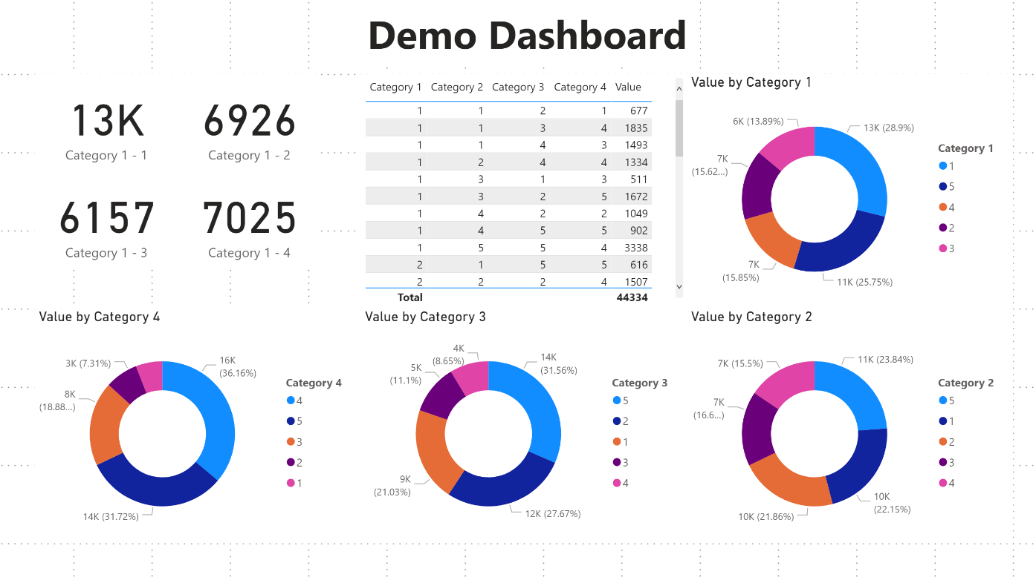

You probably heard that people always read dashboards from top left to bottom right. Well, with this example, some of you may already find that’s not true. For some of you, when you looked at this page, your eyes were captured by the middle section automatically. This is because everything on this page is:

* 1. In similar sizes
  2. Looks the same

But this middle one is different. The other will look at those four cards for the same reason. In fact, most of you will only glance through the table and four cards and never bother with the other four pie charts. That is because, first of all, those pie charts are too similar, and, secondly, they do not explain those four cards and the table. They are irrelevant. So that brings out our following points:

1. Generally, we will have a focus point on the visual, which will attract focus by either the layout, color, or size of it. The focus should be the direct answer to the very first question we are trying to answer.
2. Once the middle session of this portion attracts my vision, if I do not understand on my first glance, by nature, I start to look for explanations. If no explanation is found, I start to ignore the rest of the information on the page. If the first visual cannot connect with the user’s understanding, this will always happen.
3. Generally, we read dashboards the same way we read books or comics. It is either a Z pattern or reverse Z patten. The current report design is not the most friendly for people to attract their focus.
4. Color unification. On the first page, the color light-blue represents many different things, i.e., different things in each category. If we can unify the color representation across the entire dashboard, it would be easier for users to understand.
5. Branding and layout. Dashboards can be improved a lot by some simple branding and unified theme using a branding template.
6. General (a little bit of everything) views are excellent but not recommended in Reports. They are better for Dashboard Pins.
7. If you want to present one Fact in two different aspects, use toggles instead of different pages. Changing the page may also change people’s mindsets.
8. Tables are terrific for content representations but tell nothing at first glance and can easily be overwhelming. Typically, I recommend adding a Drill Through capability for tables.

# Conclusion

I know this is a speedy walkthrough on my dashboard design ideology. I may come up with something else to talk about each point individually. In general, I think every dashboard development process should be in those four steps:

1. **Define the question**: this is where we need to talk to the business to understand what they are trying to achieve.
2. **Draw out the Report Structure**: this is where the storytelling kicks in. We need to make sure the structure is logical for users to understand.
3. **Select Visuals**: different visuals have different capabilities. This topic should be a post for its own. However, generally, I’d like to see visuals as their own dimension models.
4. **Assemble**: After everything is ready, we can put everything together. The rule of thumb is to try to put ourselves into end-user’s shoes. It is for them to use, not for us. The dashboard will have no value if we are the only people who understand it.