

SCSM2223-CROSS-PLATFORM APPLICATION DEVELOPMENT
SEMESTER II, SESSION 2025/2026
SECTION 04

CHAPTER 8 — INDIVIDUAL ASSIGNMMENT
REPORT

LECTURER: DR. HISHAMMUDDIN BIN ASMUNI

NAME | MATRIC NUMBER
KHOO YUAN MAN | A24CS0096

Screenshots
1. Main Employee Directory page
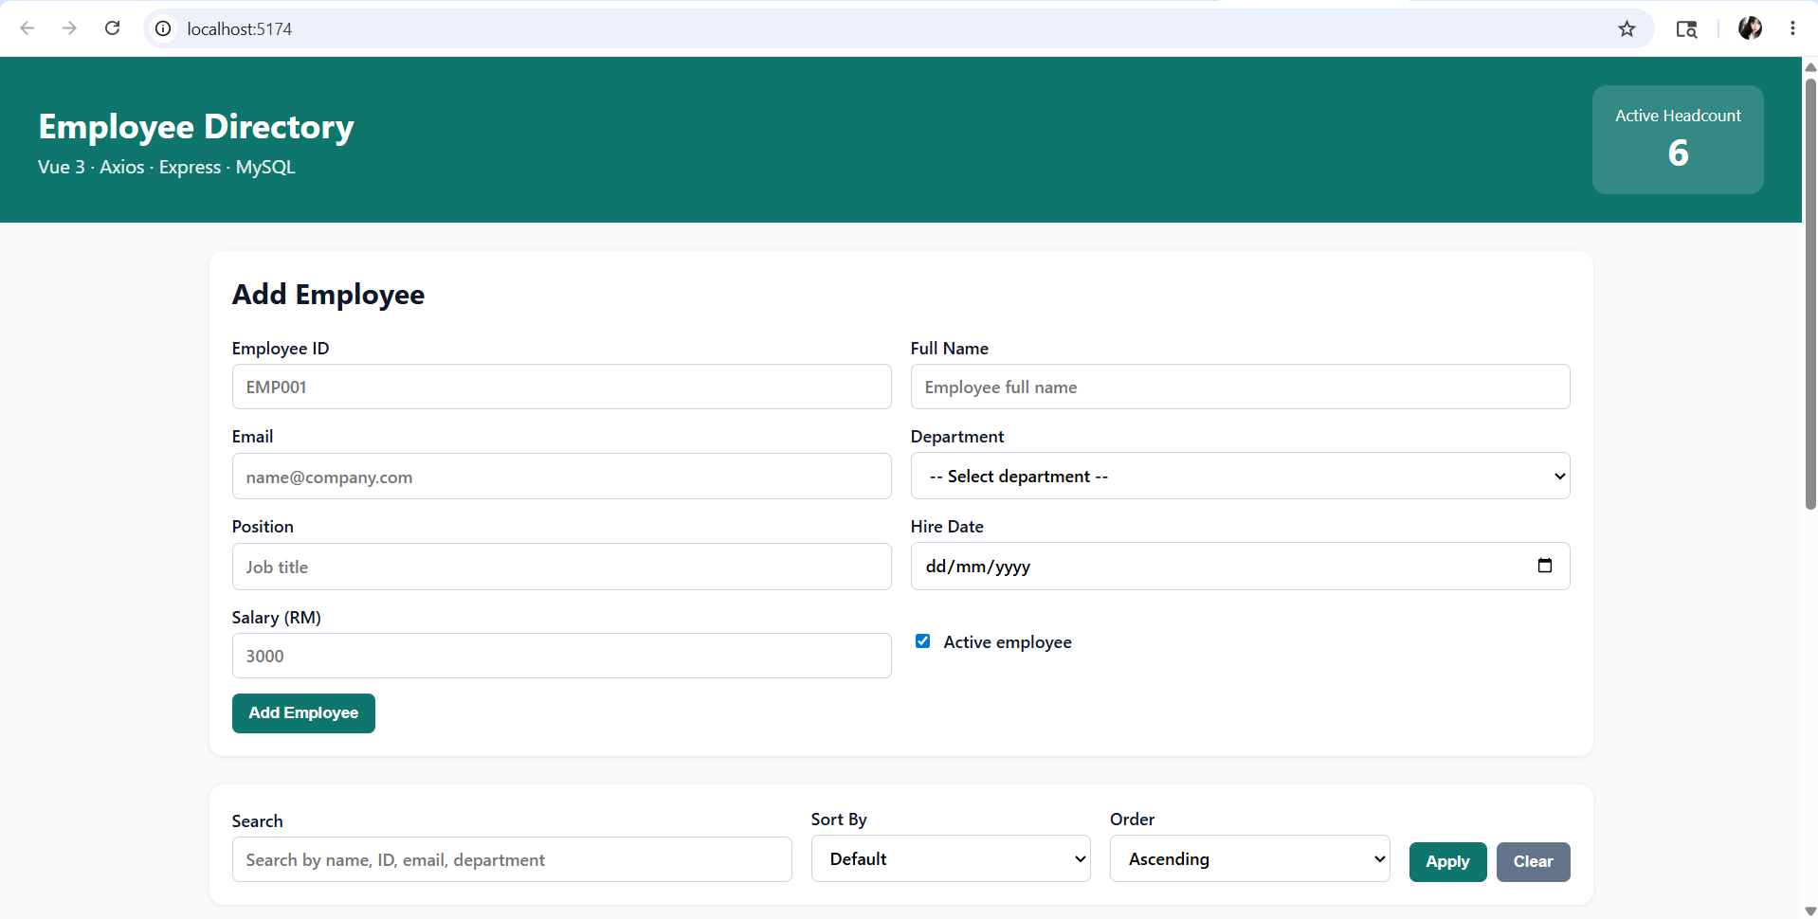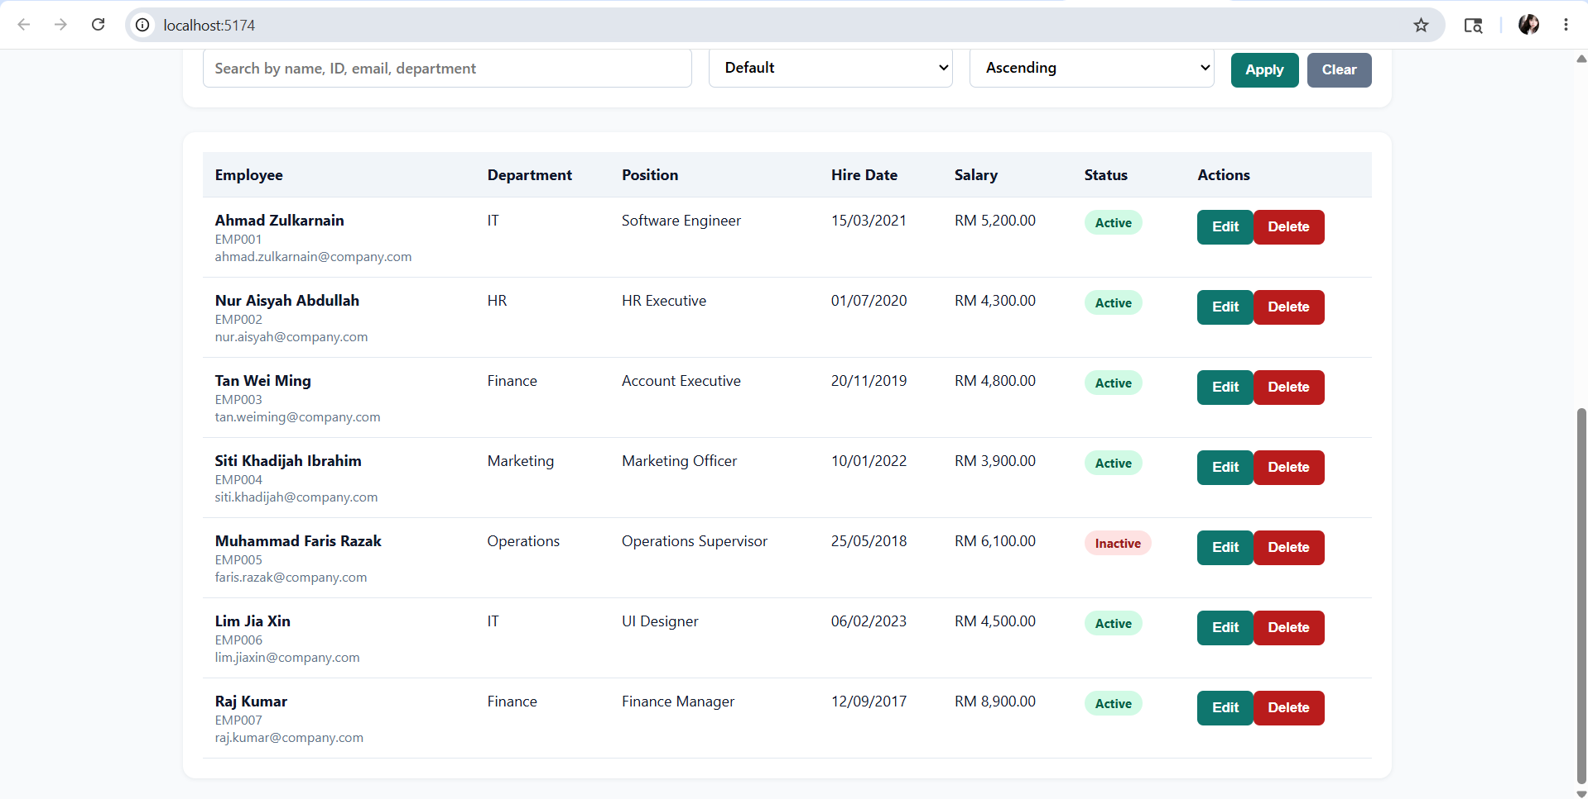
2. Add employee form
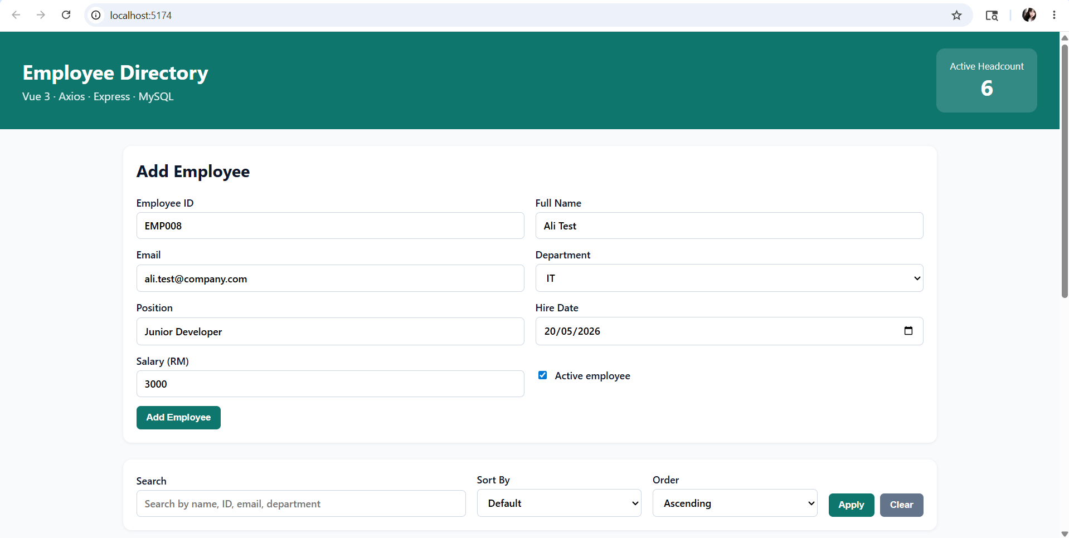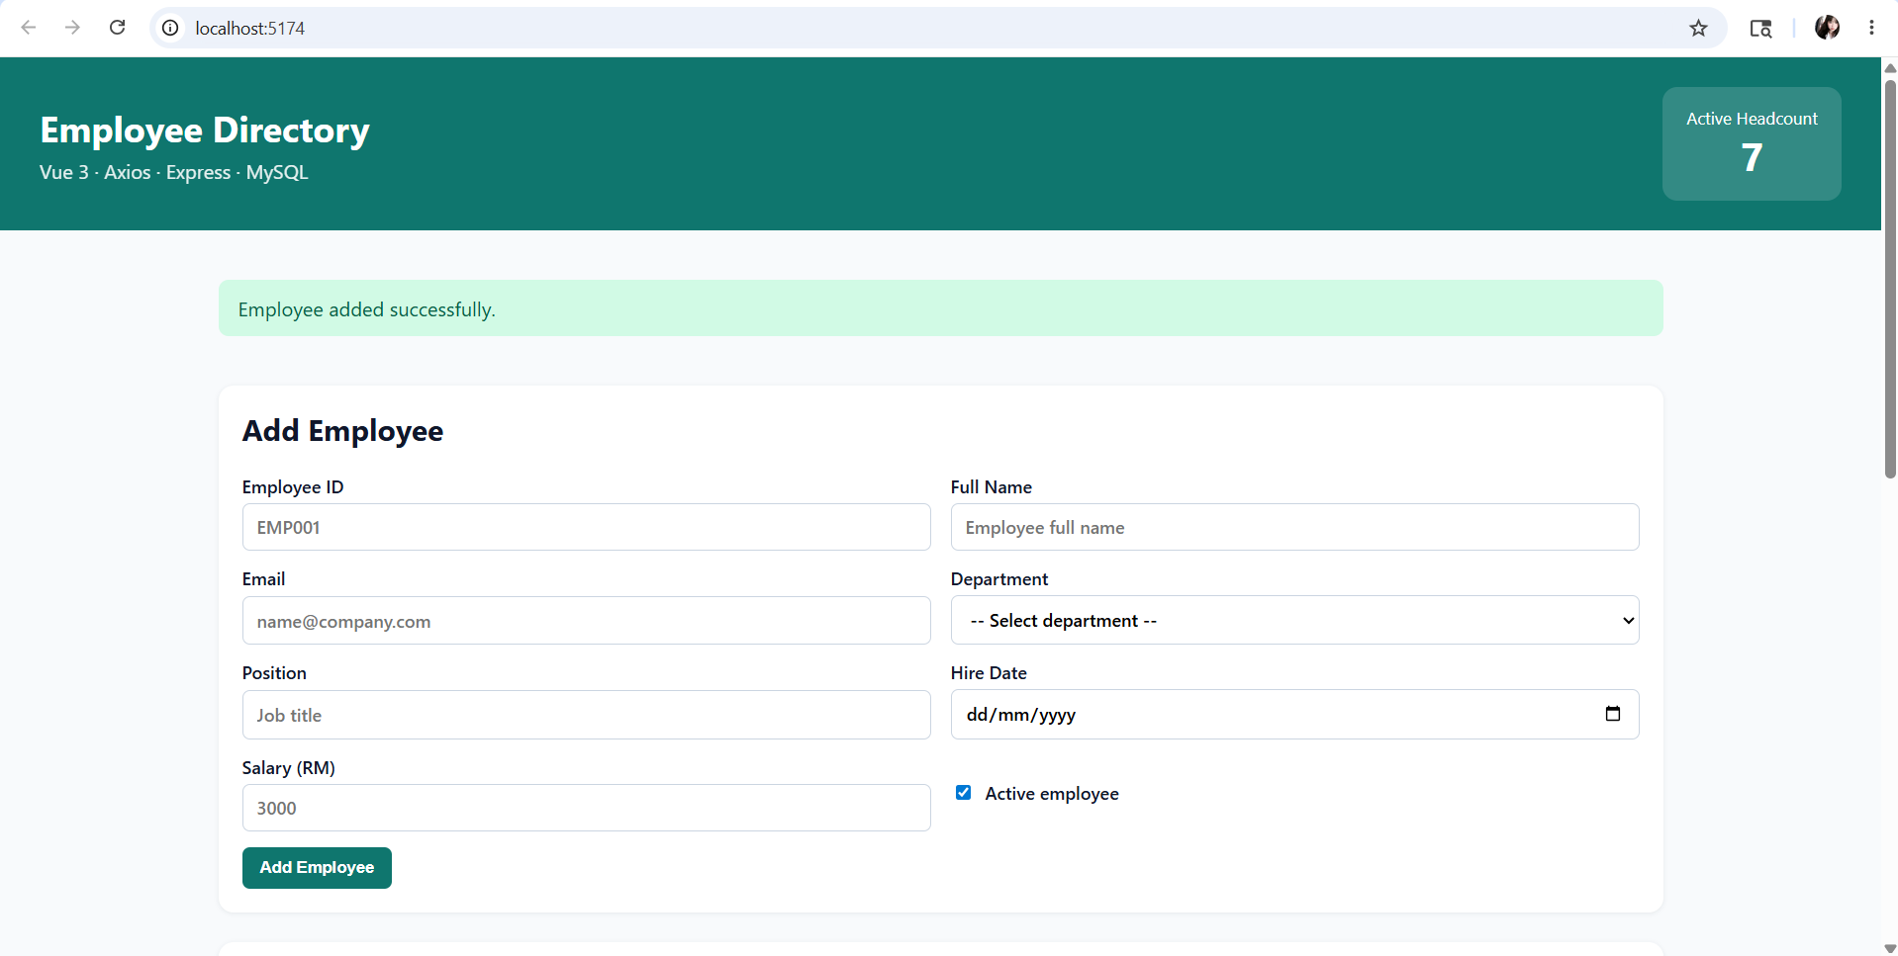
(Fill the table) (Successful message)
3. Employee table
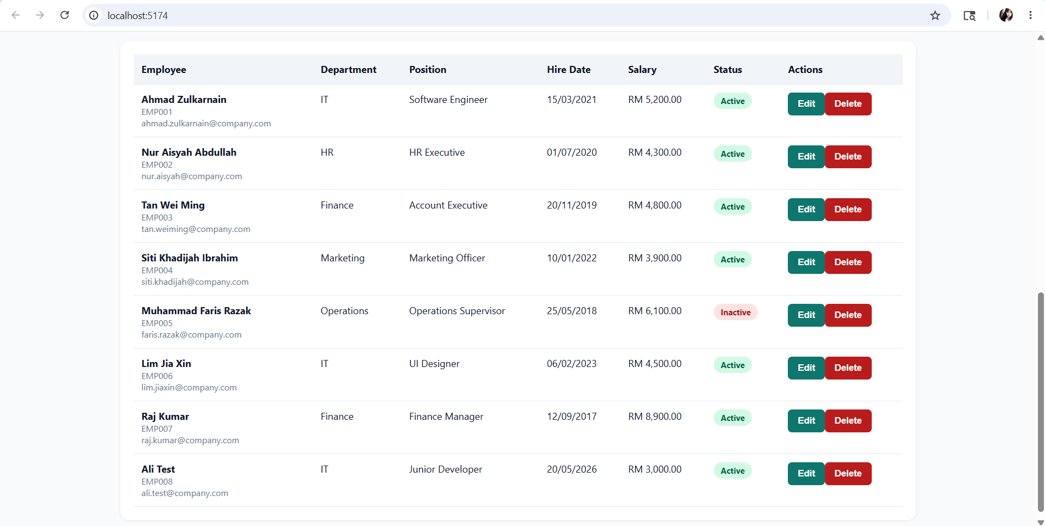
(Updated data after adding new employee)
4. Search result
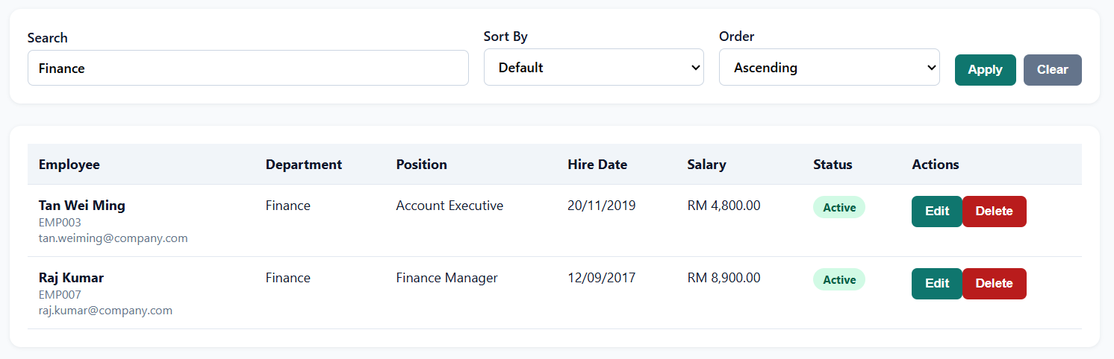
(Search Finance, only Finance employees appear.)
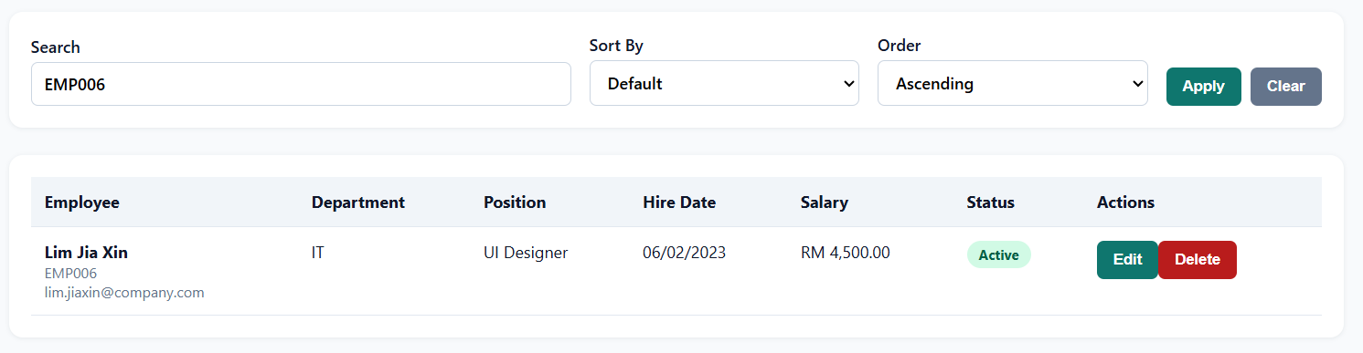
(Search EMP006, matching employee appears.)
5. Sort result
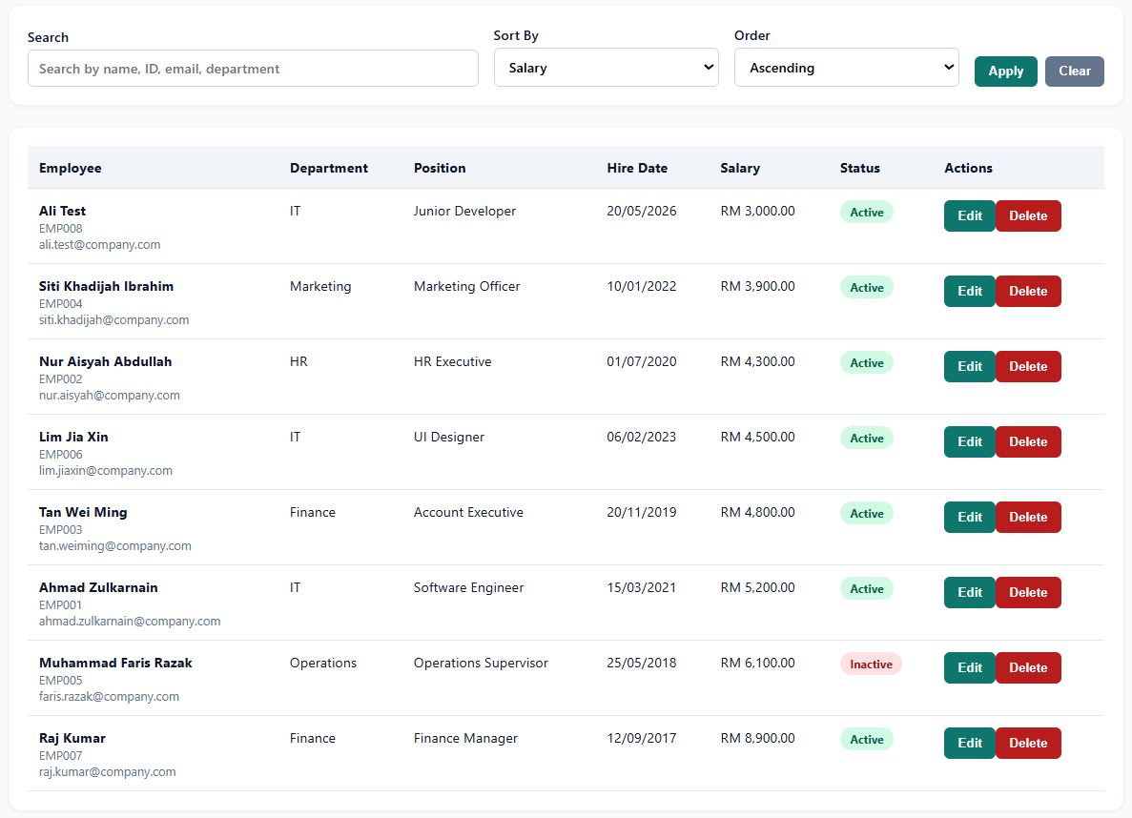
(Sort by salary and ascending.)
6. Edit employee
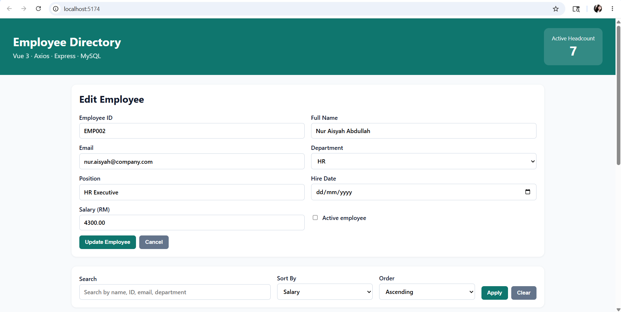
7. Delete confirmation
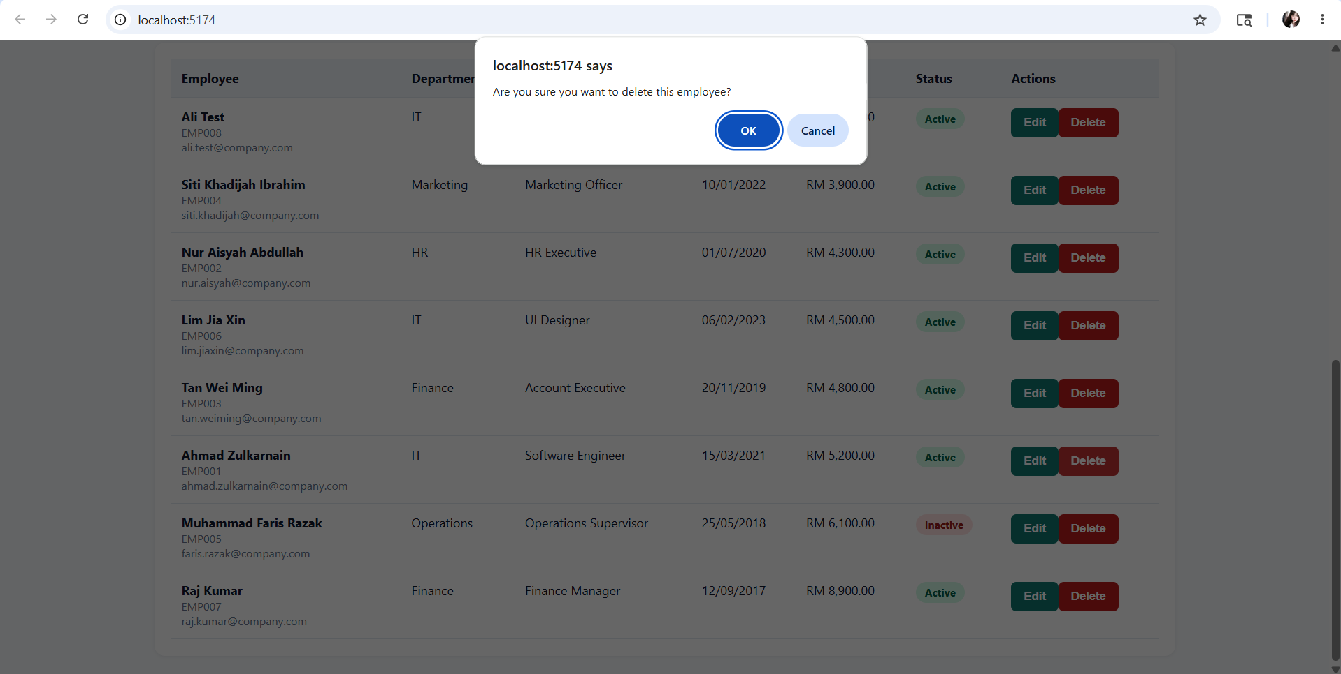 (When click “Delete” employee)
8. MySQL table in HeidiSQL
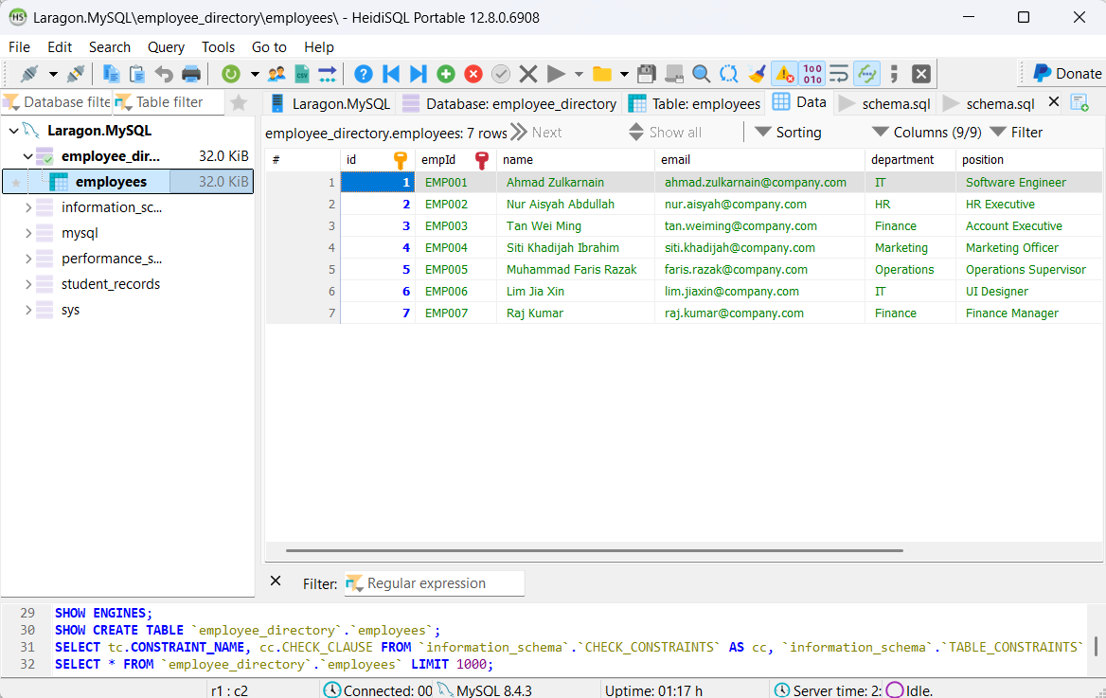
(After load data, run, refresh, then view data table of employee directory.)

Learning Outcomes
LO1: Connect Vue to Backend
The Vue frontend connects to the Express backend using Axios. The backend runs on port 3001 and the frontend runs on port 5174.
LO2: Axios HTTP Client
The project uses a single Axios instance in src/api/employeeApi.js. It includes a baseURL, timeout, default headers, request interceptor and response interceptor.
LO3: Form Handling in Vue
The EmployeeForm.vue component uses v-model, .trim and .number modifiers. It validates employee ID, name, email, department, position, hire date and salary before submitting.
LO4: Persistent CRUD
The Express API supports POST, GET, PUT and DELETE endpoints. All changes are saved in the MySQL employees table using prepared statements.

Challenges and Solutions
One of the challenges I faced was the Vue frontend could not load employee data because the frontend and backend were running on different ports. To solve this, I made sure the Express backend runs on http://localhost:3001 and the Vue frontend runs on http://localhost:5174. I also used cors() in server/index.js so that the Vue app can send Axios requests to the backend.

