Mitigating Bias in Loan Default Prediction
using a Classical and Hybrid Quantum-Classical Approach

Tan Dai Ngo (V01073190), Jeremy Perkins (V00501015), Naomi Phan (V01097400),
Joyce van de Vegte (V00102221), Yuanming Wang (V01028720), Da Zhang (V01062902)
1. Introduction
Predicting loan defaults accurately is crucial for national financial stability and credit accessibility. In 2026, total consumer debt in Canada reached $2.66 trillion, while consumer insolvencies surged by nearly 19 percent year-over-year, reaching the highest insolvency rate in 17 years [1]. About 1.5 million Canadians miss at least one credit payment per quarter, with auto loan delinquencies rising to 2.42 percent and mortgage balance delinquencies climbing 32 percent nationally [1][2]. For financial institutions, inaccurate credit risk evaluation leads to an estimated $1.3 billion in hidden fraud and unrecovered defaults [1][3]. Conversely, overly conservative traditional credit-scoring models penalize applicants and force Canadians to seek out high-cost private lenders where default rates exceed two percent [4]. Building an advanced machine learning model bridges this gap by maintaining high predictive precision while improving credit equity across diverse demographic groups.
Financial institutions that loan money use verified information from client application forms to make loan approval decisions. These decisions are informed by records of whether past clients repaid their loans or defaulted on them. Were a model to misclassify a new client as someone who would default on a loan, a loan application would be inappropriately rejected, with potentially severe consequences for the borrower. The converse problem from the bank’s perspective is approving a loan that ultimately defaults.
The question of fairness is sometimes overlooked in machine learning applications. The features that inform models for loan default delineate numerous subgroupings of loan applicants: young and old, low- and high-income, renters and homeowners, and so on. This investigation seeks to identify sources of bias in a loan default dataset, and to address them by introducing fairness constraints in prediction modelling.
2. Problem Statement
The project aims to examine model bias in loan default prediction. The dataset [5] selected for the project contains 45,000 detailed borrower applications labelled with the loan repayment outcome: default or paid. Features in the dataset include: age, gender, education, income, employment experience (years), home ownership, requested loan amount, loan intent, interest rate, ratio of loan amount to annual income, credit history, credit score, and previous loan defaults.
Model biases can be learned as a result of imbalances in the dataset, not only by label (loan repaid or not), but also by feature imbalances such as gender, education, or home ownership. A trained model displays bias if its performance metrics vary for demographic subgroups. It is recognized that since default data contains only applicants who were previously accepted for a loan, the dataset is not representative of all loan applicants. Financial institutions use the reject inference method [6][7] to hypothesize whether the rejected group would have defaulted.
When training a model to predict loan default, accuracy is always of importance, but this project emphasizes the detection and control of bias, and fairness interventions may cause reductions in prediction accuracy. Success of final models is measured by how well each model balances performance and fairness. Anticipated impacts from the viewpoints of both the financial institution and the client are considered, as each experiences different costs of misclassification in a loan decision setting. A model’s FNR (false negative rate) captures the events where a borrower who actually defaults is predicted as non-defaulting, costly from the lender’s perspective. A model’s FPR (false positive rate) captures the events where a borrower who would have repaid is predicted as likely to default, which is costly from the borrower’s perspective.
3. Background
Loan default and loan approval prediction have been widely studied, e.g. [8]-[12]. Many studies have also investigated fairness and bias, e.g. [13]-[15], but it is not common to compare multiple models with and without feature engineering, as is undertaken here. In general, there are three strategies to control bias, which are cleaning the data before training, constraining the model during training, and adjusting the predictions after training [16].
Quantum extreme learning machines (QELM) are presented as a promising feature engineering approach in several references [17][18][19], but few references apply this idea to one-dimensional classification tasks [20]. In light of the success achieved for image classification tasks [21], the referenced sensitivity of QELM to subtle patterns, and the dearth of exploration of the topic in the available literature, QELM was deemed worth exploring for the present loan default classification task.
4. Approach
4.1 Pre-processing
An exploratory data analysis phase was useful in identifying the features having the highest correlations with the target, loan default status, specifically loan as percent of income, loan interest rate and renter status (Figure A.1). This initial phase also identified a binary feature requiring special attention. Of the individuals recorded as having previous loan defaults on file, none defaulted in the entire dataset. Due to this data deficiency, models trained including this feature counterintuitively increased in accuracy by predicting that previous loan defaulters would definitely not default. For this reason, the previous loan defaults feature was removed, an important debiasing step that might easily be missed in practice.
The view of outliers became more nuanced as the project work proceeded. A distinction was made between “impossible” data that must be erroneous and outlying data that might unreasonably influence model predictions. Seven “physically impossible” outliers were removed from the original dataset. These included five individuals with an age of 144 and two individuals with an employment experience of 123 years.
After removing hard outliers, the dataset was randomly split into two parts, 80% in the training set and 20% for the final test set.
The iForest [22] algorithm was applied to the training dataset at the 5% level, flagging 1,800 outlying samples and leaving 34,194 samples for training in the dataset. Without greater domain expertise, it is difficult to judge the line between bad records and legitimate minority edge cases that are key to reliable discrimination. For this reason, a modest 5% of outliers were separated using iForest to be modeled separately. Note the importance of splitting training and test data before the application of the Isolation Forest, to avoid data leakage.
Balancing a dataset adjusts the distributions of its features to discourage a model from making predictions that favour a majority group; a balanced dataset makes it more difficult for a model to learn biases in a dataset. To address class imbalance in the training dataset (77.8% no default vs 22.2% default), the SMOTE algorithm [23] was applied to augment the training set with synthetic samples to even the numbers of default and no-default examples. Of the categorical features in the dataset, it was decided that education (high school, associate, bachelor, master, doctorate) should be treated as an ordinal variable. Standard SMOTE generated new data points within the convex hull of existing training samples, but it quickly became evident that SMOTE was interpolating categorical and ordinal features in a nonsensical way. A related tool, SMOTE-NC [24], capable of generating data for both numeric and categorical data, was used instead. To handle mixed data types, SMOTE-NC applies a distance penalty for mismatched categories when identifying nearest neighbours, and then assigns categorical values to new synthetic samples by adopting the most frequent category occurring among those neighbours. The ordinal category, education, was placed among the numeric features and SMOTE-NC-produced values were rounded to the nearest integer.
One additional feature, loan as a percentage of income, was considered for removal, as this feature can be computed directly from other features, specifically loan amount and income. However, experiments revealed that a neural network cannot compute this ratio on its own, and XGBoost is robust to multicollinearity. Keeping the feature enabled both models to classify loan default instances better, signalling that the loan-to-income ratio is important in detecting default.
To prepare for model training, several versions of the training dataset were created. XGBoost models required no scaling and one-hot encoding; neural network models required scaling and one-hot encoding; quantum feature engineering required scaling to angles and no categorical encoding.
Three feature engineering methods were investigated: QELM (quantum extreme learning machine) [25][26][27], PCA (principal components analysis), and RFF (random Fourier features).
Two independent QELM feature sets, reservoir-based and Ising-based, were generated using the PennyLane open-source library for quantum computing and simulation. Figure 1 depicts a portion of one layer of the Ising circuit; the rows correspond to qubits, which in the actual circuit would number 12, one for each feature. The numeric features from the dataset were coded as angles between 0 and $π$ radians (quantum rotation gates are cyclic with period 2$π$, so this strategy prevents distinct numeric features from mapping to the same state). Categorical and ordinal features were mapped at equidistant angles around a circle. Once features are expressed as n qubits, a quantum circuit transforms the features into a 2^{n} dimensional space. Qubit measurements form a probability distribution, and “observables” report expected values for qubits and their interactions, producing 78 quantum features in all. The motivation for choosing quantum feature engineering (QELM) was specifically to explore its potential to highlight correlations among features to assist in the identification and reduction of model bias, rather than simply to increase model power or accuracy. QELM is purported to be highly sensitive to detecting patterns in data, which we hypothesized would amplify biases in the features, making them easier to identify and mitigate. By mapping features into a higher-dimensional quantum space, this approach was intended to help reduce overfitting to spurious correlations, thereby allowing Fairlearn debiasing interventions to translate more effectively to the test set. Compared with the kernel trick, which also leverages the feature space into a higher-dimensional space, QELM is assumed to target hidden feature correlations to identify and mitigate bias, whereas standard kernels focus only on classification.
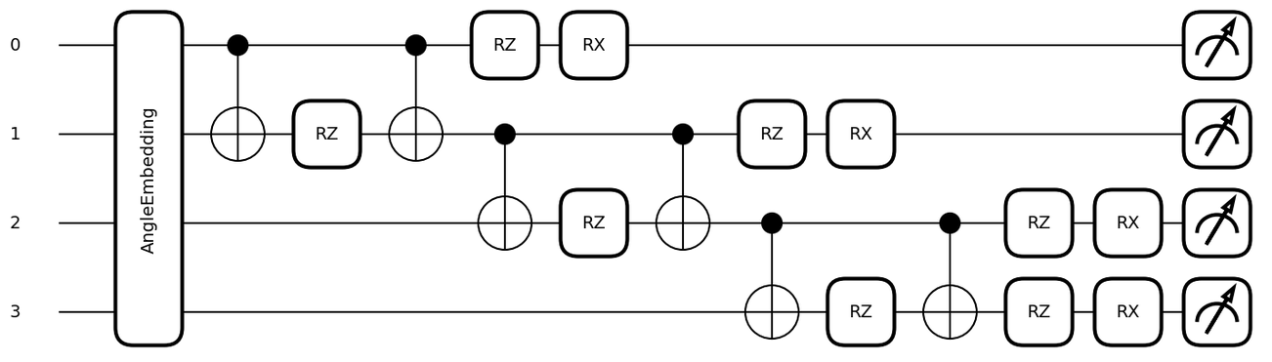
Figure 1: Ising quantum extreme learning machine circuit.
The RFF approach has some commonality with QELM. It also relies on a random but fixed set of rotations, but applies these to input features in a deterministic manner. A PCA feature set containing 95% of the variance in the original dataset was also created. While RFF and PCA features were initially used for model training, these feature engineering approaches were abandoned because of their unsuitability for datasets containing categorical features.
4.2 Model Training
XGBoost [28][29], a widely used industry standard that covers both continuous and categorical features, and a feedforward neural network [30] were trained and compared. Models were coded with Object-Oriented Programming (OOP) for code reusability. This design choice provides a single base class that consists of common methods such as hyperparameter tuning, evaluation, and logging that are necessary for all XGBoost and neural network experiments. To satisfy additional processing criteria for certain trials, base classes are extended with add-on configurations, such as the scale_pos_weight parameter for addressing the issue of class imbalance in the training dataset for the Weighted XGBoost model. By following OOP principles, the entire complex project pipeline, consisting of multiple XGBoost and Neural Network analyses, can be decomposed into smaller tasks with minimal added lines of code and consistent, easily adjustable parameter settings across all models. At the same time, the overview for each stage (preprocessing phases, SMOTE application, or fairness wrapping) of the project is easily tracked.
The XGBoost models were tuned for unbalanced training data, post-SMOTE training data, and unbalanced training data treated with XGBoost-native class balancing through weight scaling. Neural network models were tuned for the unbalanced training data, as well as the SMOTE-treated training data. Hyperparameter tuning was conducted using a randomized search with standard 5-fold cross-validation over the training data, with each fold used once as a validation fold. Tuned parameters for both models are listed in Table A.1. Models with tuned hyperparameters were retrained using the full training set, and the trained models were evaluated on the held-out test set.
4.3 Fairness
After a study of bias and fairness resources [27][31] and a careful examination of model metrics, it was determined that while overall model-level reporting remained essential for assessing test accuracy and absolute FPR and FNR, it was not sufficient to address more granular questions of bias on a per-feature scale.
Metrics of FPR disparity and FNR disparity were selected to reveal bias per feature. For each categorical feature, the FPR and FNR for each level were reported, and the disparity was taken as the maximum minus minimum value for each. Numerical features were first quantile-binned. For example, for age, the FNR disparity would be computed as the maximum FNR for any age bin minus the minimum FNR for any age bin. The objective is to push the equalized odds difference between the maximum and minimum metric rates across all levels for a feature below a desired threshold. A model is considered to be biased if its bias metrics differ substantially across the bins for an examined feature.
The challenge of exerting control over bias was met by the discovery of the Fairlearn package [32], a toolkit that provides functionality to address and mitigate fairness issues in AI applications. Fairlearn offered a method to apply constraints to model training on a per-feature basis. Fairlearn adds fairness as an additional mathematical constraint to the model’s usual optimization objective. With Fairlearn, the model is optimized while also satisfying a specified fairness requirement across different groups. Fairlearn’s reduction methods achieve this by transforming the fairness-constrained problem into a sequence of weighted learning problems, allowing the training process to balance predictive performance and fairness. These constraints were applied to age and income features. Negligible bias was present for gender, so this feature was not used. Three cost weightings were investigated for the relative importance of FPR disparity vs FNR disparity: 70/30, 50/50, and 30/70.
To avoid losing important information held by the 2,243 “soft” outliers removed by iForest, these outliers formed a separate training set that was used to train XGBoost and neural network outlier models. The iForest trained on training data was applied to test data, producing a set of “normal” test data and a set of outlier test data. Predictions for outlier test data were made using models trained on outlier training data, and these predictions were combined with predictions for “normal” data to compute performance metrics. As it was impossible to apply SMOTE to outlier data, predictions for outlier test data in SMOTE models were made using their “no SMOTE” counterparts. The pipeline is described in Figure 2.
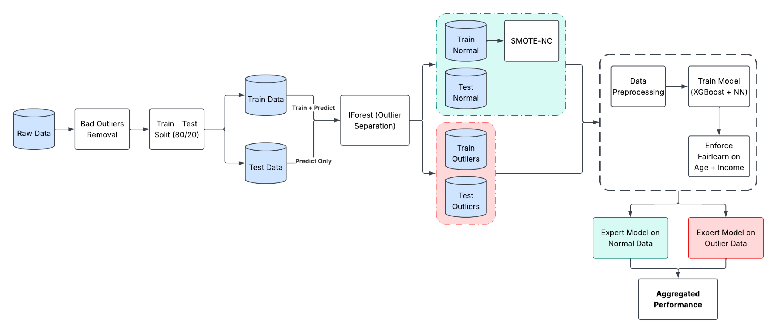
Figure 2: Pipeline including fairness interventions.
5. Experimental Results
As expected, SMOTE balanced the dataset with an equal number of loan defaults and no defaults. Some small shifts in categorical and numerical data occurred during this process, as shown in Figures A.2 and A.3. Figure 3 captures test results for the models with and without SMOTE. XGBoost accuracy (91.4%) is not much affected by the application of SMOTE (91.5%), but neural network accuracy (89.4%) suffers somewhat with SMOTE (84.2%).

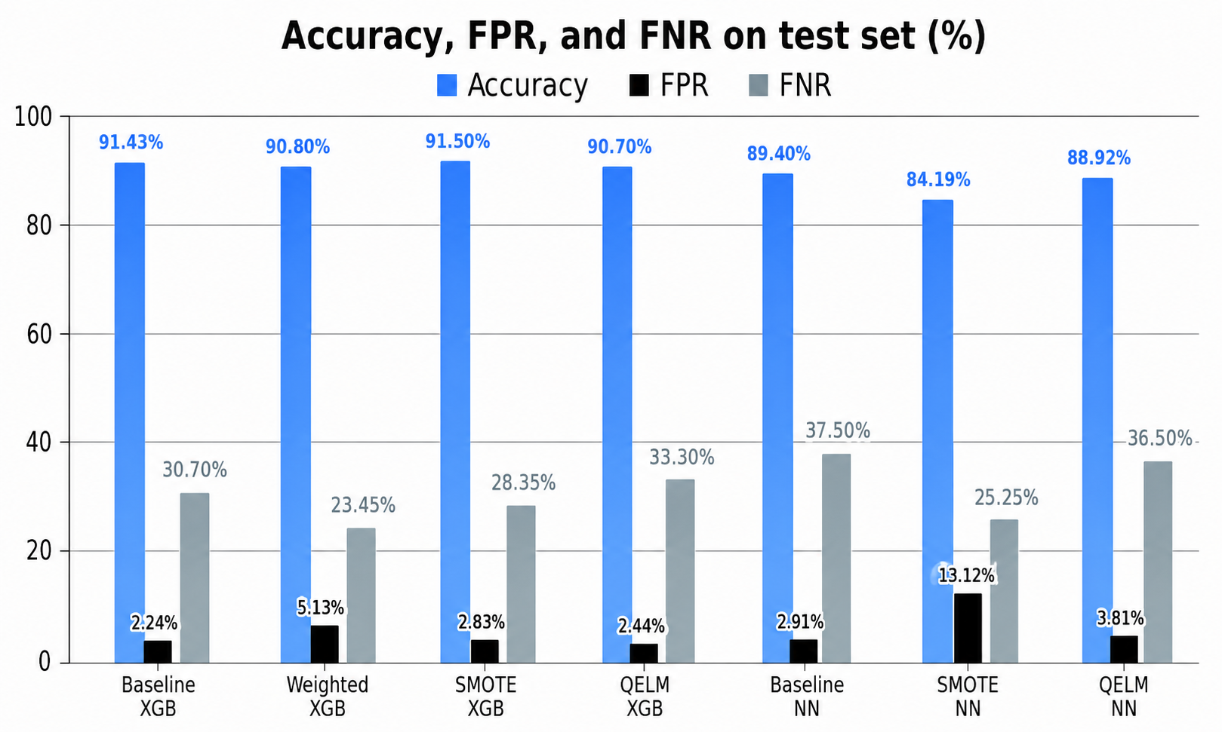
Figure 3: Test results for XGBoost and neural network (NN) models (with SMOTE and QELM).
Quantum-engineered features were tested for all models, with results also presented in Figure 3. Detailed evaluation metrics for all models, including: accuracy, F1-score, precision, recall, TPR (true positive rate), TNR (true negative rate), FPR, and FNR, are presented in Table A.2.
Fairlearn constraints were applied to all model variations (70/30 weighting), with results seen in Figure 4. Overall accuracy is lower and error rates are higher, when Fairlearn is used.
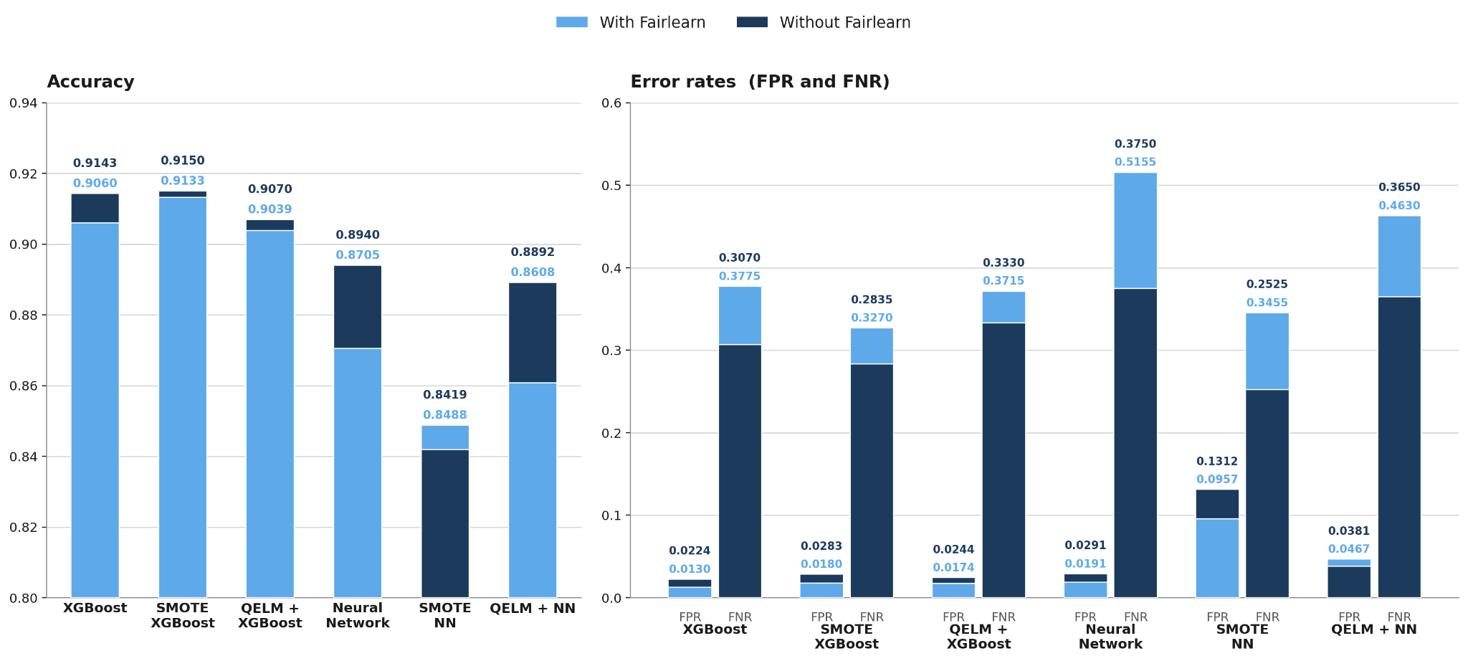
Figure 4: Accuracy and error rates for models with and without Fairlearn constraints.
The 95% Hoeffding confidence intervals with Bonferroni adjustment in Figure 5 show substantial overlap among most models, indicating that there is insufficient evidence to identify a single statistically superior model. However, NN_SMOTE is a notable exception: its confidence interval lies entirely above those of all other models. This provides evidence that NN_SMOTE has a statistically higher test error and therefore performs significantly worse than the other models considered.
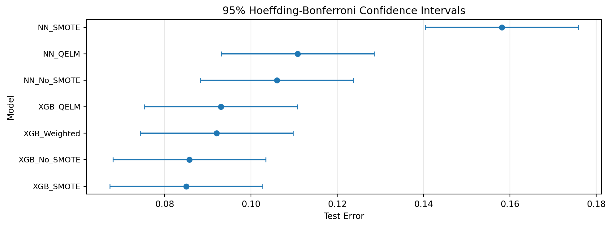
Figure 5: Hoeffding-Bonferroni confidence intervals for test error
A per-feature heatmap for FPR and FNR disparity is shown in Figure 6 for the no SMOTE neural network model. Fairlearn constraints are imposed on age and income only. When Fairlearn places heavier weighting on FPR disparity than FNR disparity, reductions in FPR disparity can be achieved; when heavier weighting is placed on FNR disparity, reductions in FNR disparity can be achieved. Even for just two features, the optimization problem is challenging enough that disparity cannot be simultaneously reduced for both FPR and FNR disparity. Note that FPR disparities are small in absolute terms. Additionally, because the dataset is imbalanced (77.8% no default), shifting the cost matrix to penalize FPs (70/30) naturally aligns the model’s more conservative predictions with the majority class, recovering overall test accuracy from 84.5% to 87.0%, as we would expect.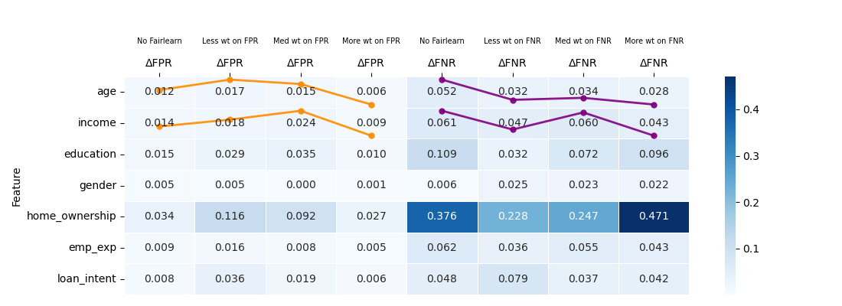
Figure 6: Per-feature FPR and FNR disparity heatmap for no SMOTE neural network model.
The application of SMOTE to the neural network model dilutes the ability of Fairlearn to reduce FPR and FNR disparity. Similar trends occur, but with very small changes (Figure A.4). For XGBoost models, Fairlearn does not behave predictably (Figure A.5). Shifts in weights due to Fairlearn may cause tree structure to vary abruptly, leading to a complex, nondifferentiable optimization surface; in addition, XGBoost and Fairlearn weight adjustments may conflict.
Figure 7 illustrates the effect of adding quantum feature engineering. Four models are compared. On the left, the baseline neural network model (NN_No_SMOTE) is compared against its quantum-enhanced counterpart (NN_QELM), with few significant differences. On the right, the Fairlearn 50/50 neural network model (NN_Fairlearn_5050) is compared to its quantum-enhanced partner (NN_QELM_Fairlearn_5050). The QELM Fairlearn model highlighted in yellow is notable because it presents a model with overall lower bias, though interestingly this model does not show lower bias for the two constrained features of age and income.
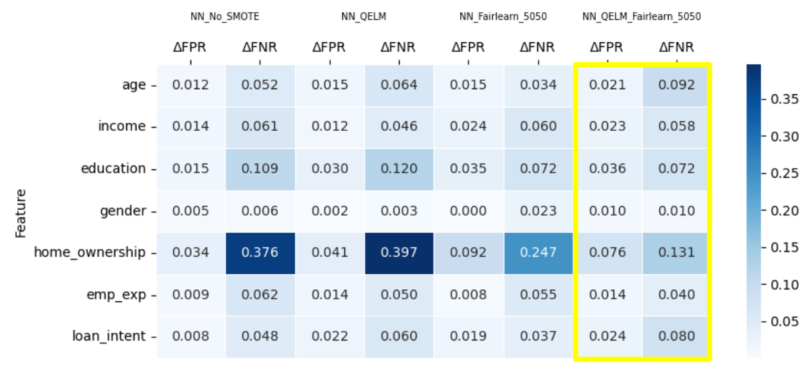
Figure 7: Evaluation of quantum-enhanced models.
6. Discussion and Conclusions
The training dataset consists of a list of people who have already been approved for loans, with labels that indicate whether they paid or defaulted on those loans. The dataset itself is biased in terms of who is included. If there are certain minority groups who are not being granted loans as often, they will certainly be underrepresented. Since lower-income minorities may be underrepresented, the model will tend to predict that they will default. Previous research [15] has used a variety of solutions to overcome this problem. We recognize that our application of SMOTE involves assumptions about the missing data: We infer that the censored population shares similar underlying distributions among the features, and this may not be the case.
SMOTE was applied to address imbalance in the dataset. While it dampened accuracy for the neural network model, notable improvements were seen in FNR for both XGBoost and neural network models (Figures 3 and 4), which would be a favourable outcome for a financial institution’s evaluations. In the case of the neural network model without Fairlearn, FNR reduced from 0.3750 to 0.3455 with the inclusion of SMOTE, and with Fairlearn, from 0.5155 to 0.3455.
When combined with Fairlearn, quantum feature engineering reduced absolute FNR for the neural network model (0.463 compared to 0.5155, Figure 4); FPR increased very slightly but remained at a low level. Indeed, the QELM feature engineering plus Fairlearn neural network approach produced a model with overall low bias (Figure 7). The quantum circuit was able to rotate and entangle the features in such a way that Fairlearn debiasing translated well to the test set. These gains were not at the expense of accuracy (87.05% compared to 86.08%). PCA applied after QELM to reduce noise among quantum features did not substantially affect the outcomes.
Fairlearn constraints were effective in reducing bias for selected features when the objective function was weighted towards the bias metric of interest, though it is also clear from Figure 5 that bias for other features may increase as a result. These results point to correlations between features, for example, between income and home ownership status. Debiasing one feature may increase bias in another.
It was anticipated that models judged more “fair” would suffer in accuracy. For XGBoost models, accuracy was not unduly impacted by debiasing measures, but the same was not true for neural network models (Figure 4), where, in particular, SMOTE reduced accuracy.
As an exploratory analysis step, a logistic regression analysis revealed statistically significant linear interactions between socioeconomic features: income x home ownership, age x income, education x income, age x interest rate. Future work might examine the effects of adding these interaction terms to existing models and quantum feature engineering.
7. References
[1] Equifax Canada, "Market Pulse Quarterly Consumer Credit Trends and Insights Report," Equifax Inc., Toronto, ON, Canada, Q1 2026.
[2] Canada Mortgage and Housing Corporation (CMHC), "Residential Mortgage Industry Report," CMHC, Ottawa, ON, Canada, Research Report, 2025.
[3] Equifax Global, "Global Credit Trends and Fraud Risk in Retail Lending," Equifax Inc., Atlanta, GA, USA, Tech. Rep., 2025.
[4] Real Estate Institute of Canada (REIC), "Mortgage Market Stress and Non-Bank Default Projections," REIC, Toronto, ON, Canada, Industry Insight Rep., 2025.
[5] S. Bhardwaj, “Loan Approval | Classification,” kaggledatasets, Aug. 20, 2025. https://www.kaggle.com/datasets/sumit12100012/loan-approval-classification/data (accessed July 07, 2026).
[6] Z. Guo, X. Ao and Q. He, "Transductive Semi-Supervised Metric Network for Reject Inference in Credit Scoring," in IEEE Transactions on Computational Social Systems, vol. 11, no. 2, pp. 1675-1684, April 2024, doi: 10.1109/TCSS.2023.3276274.
[7] Y. Xia, “A Novel Reject Inference Model Using Outlier Detection and Gradient Boosting Technique in Peer-to-Peer Lending,” IEEE Access, vol. 7, pp. 92893–92907, 2019, doi: https://doi.org/10.1109/access.2019.2927602.
[8] N. Amy, N. Nasir, N. Ismail, U. Malaysia, and J. Bahru, “A Predictive Approach to Loan Approval Decisions Using Logistics Regression,” vol. 32, pp. 88–95, 2025, Available: https://science.utm.my/procscimath/wp-content/uploads/sites/605/2025/11/88-95-NURUL-AMY-NAZLIEN-BINTI-NASIR_DR-NORASLINDA.pdf
[9] “Loan Default Prediction Using Machine Learning Techniques and Deep Learning ANN Model | IEEE Conference Publication | IEEE Xplore.”. Available: https://ieeexplore.ieee.org/document/10420221.
[10] R. Nancy Deborah, S. Alwyn Rajiv, A. Vinora, C. Manjula Devi, S. Mohammed Arif, and G. S. Mohammed Arif, “An Efficient Loan Approval Status Prediction Using Machine Learning,” 2023 International Conference on Advanced Computing Technologies and Applications (ICACTA), pp. 1–6, Oct. 2023, doi: 10.1109/icacta58201.2023.10392691.
[11] A. Haque and M. M. Hassan, “Bank Loan Prediction Using Machine Learning Techniques,” American Journal of Industrial and Business Management, vol. 14, no. 12, pp. 1690–1711, Jan. 2024, doi: 10.4236/ajibm.2024.1412085.
[12] E. Owusu, R. Quainoo, S. Mensah, and Justice Kwame Appati, “A Deep Learning Approach for Loan Default Prediction Using Imbalanced Dataset,” International Journal of Intelligent Information Technologies, vol. 19, no. 1, pp. 1–16, Mar. 2023, doi: 10.4018/ijiit.318672.
[13] T. Mählmann, “Biases in estimating bank loan default probabilities,” Journal of Risk, June 21, 2005. https://www.risk.net/journal-risk/2161192/biases-estimating-bank-loan-default-probabilities.
[14] M. Ghahremani, H. A. Otieno, M. Kazreen, and S. Shiaeles, “Machine Learning‐Based Loan Approval Automation: Enhancing Efficiency, Accuracy and Fairness in Credit Decision‐Making,” Expert Systems, vol. 43, no. 7, May 2026, doi: 10.1111/exsy.70307.
[15] Kuber Sarwal and S. R. Islam, “Algorithmic Lending Bias: Evaluating the Fairness of Historical Redlining in Loan Approvals,” 2021 IEEE International Conference on Big Data (Big Data), pp. 7412–7416, Dec. 2024, doi: 10.1109/bigdata62323.2024.10825978.
[16] S. Caton and C. Haas, "Fairness in Machine Learning: A Survey," arXiv:2010.04053, 2020.
[17] Emergent Mind, “Quantum Extreme Learning Machines,” @emergentmind, 2025. https://www.emergentmind.com/topics/quantum-extreme-learning-machines-qelms (accessed Jun. 13, 2026).
[18] A. De Lorenzis, M.P. Casado, N. Lo Gullo, “Behind the scenes of the Quantum Extreme Learning Machines,” Arxiv.org, 2022. https://arxiv.org/html/2509.06873v1.
[19] J. Pandit, “Quantum Feature Engineering: A Beginner’s Guide,” Medium, June 10, 2025. https://medium.com/quantum-computing-and-ai-ml/quantum-feature-engineering-a-beginners-guide-8346a28f2ea7.
[20] U Sainz de la Maza Gamboa, “Quantum extreme learning machine for classification tasks”, PhD thesis, Universidad del País Vasco/Euskal Herriko Unibertsitatea, 2022.
[21] A. De Lorenzis et al., “Harnessing quantum extreme learning machines for image classification,” Physical Review Applied, vol. 23, no. 4, Apr. 2025, doi: 10.1103/physrevapplied.23.044024.
[22] Scikit Learn, “sklearn.ensemble.IsolationForest — scikit-learn 0.23.1 documentation,” scikit-learn.org. https://scikit-learn.org/stable/modules/generated/sklearn.ensemble.IsolationForest.html (accessed July 08, 2026).
[23] J. Brownlee, “SMOTE for Imbalanced Classification with Python,” Machine Learning Mastery, Jan. 16, 2020. https://machinelearningmastery.com/smote-oversampling-for-imbalanced-classification/
[24] “SMOTENC — Version 0.11.0,” imbalanced-learn.org. https://imbalanced-learn.org/stable/references/generated/imblearn.over_sampling.SMOTENC.html (accessed July 08, 2026).
[25] P.-W. Huang and P. Rebentrost, “Post-variational quantum neural networks,” arXiv.org, 2023. https://arxiv.org/abs/2307.10560.
[26] W. Xiong et al., “On fundamental aspects of quantum extreme learning machines,” Quantum Machine Intelligence, vol. 7, no. 1, Feb. 2025, doi: 10.1007/s42484-025-00239-7.
[27] E. Perrier, “Quantum Fair Machine Learning,” arXiv.org, 2021. https://arxiv.org/abs/2102.00753 (accessed July 08, 2026).
[28] “XGBoost Python Package — XGBoost 2.0.0 documentation,” xgboost.readthedocs.io. https://xgboost.readthedocs.io/en/stable/python/index.html
[29] T. Chen and C. Guestrin, “XGBoost: A Scalable Tree Boosting System,” Proc. of the 22nd ACM SIGKDD Int’l Conf. on Knowledge Discovery and Data Mining, pp. 785-794, 2016.
[30] scikit-learn, “1.17. Neural Network Models (supervised) — scikit-learn 0.23.1 Documentation,” scikit-learn.org, 2025. https://scikit-learn.org/stable/modules/neural_networks_supervised.html ‌
[31] A. Saha, R. Ranjan, B.C. Sahana, “Advancement of Loan Approval System for Diverse Applicants with Machine Learning Framework,” 14th IEEE International Conference on Communication Systems and Network Technologies 2025. https://ieeexplore.ieee.org/document/10968457
[32] Fairlearn, “Fairlearn,” fairlearn.org, 2025. https://fairlearn.org/ (accessed July 07, 2026).
Appendix
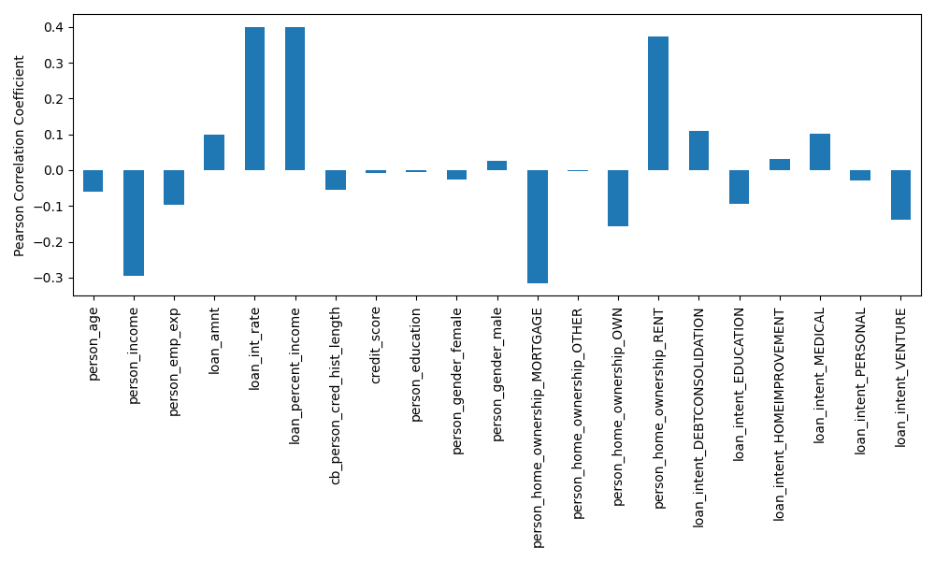
Figure A.1: Correlations between features and loan default target.

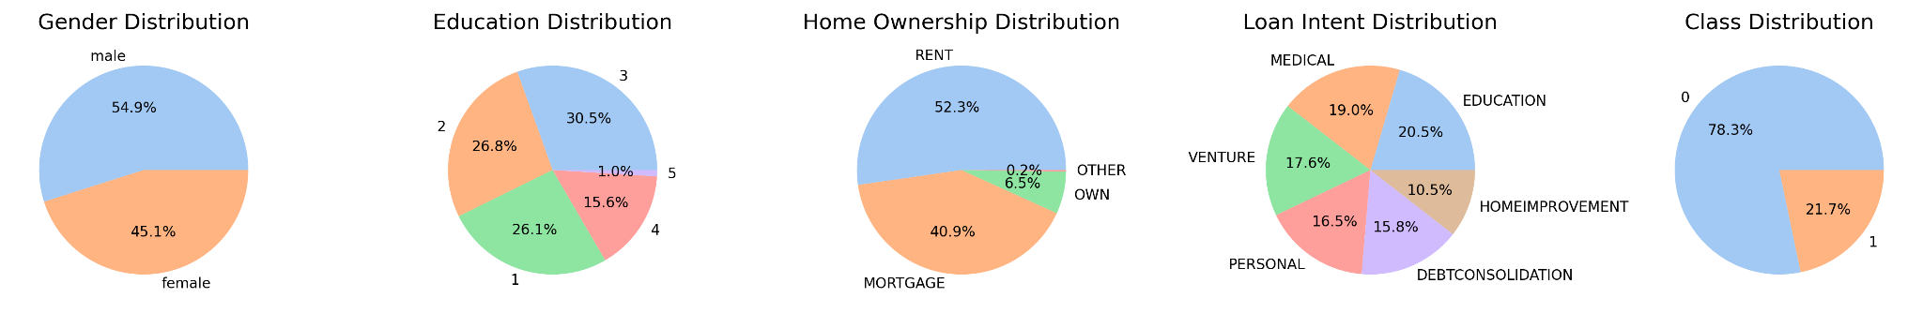
(a) Before SMOTE
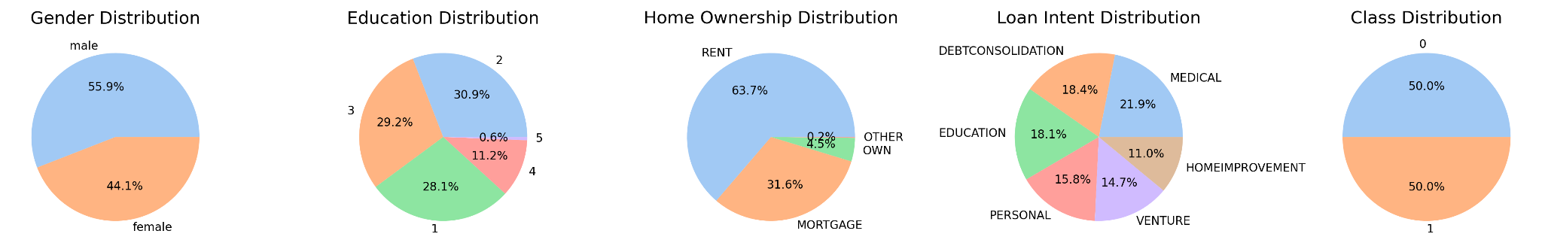
(b) After SMOTE
Figure A.2: Distribution of categorical features before SMOTE and after SMOTE.
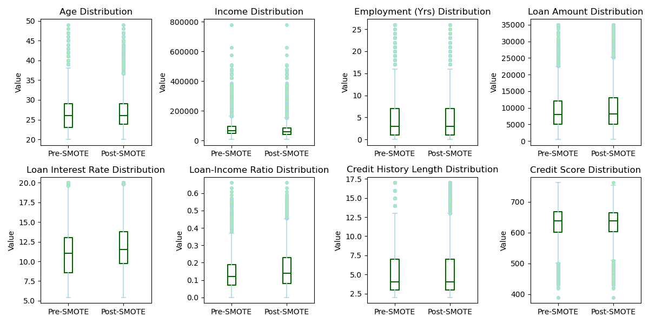
Figure A.3: Distribution of numerical features before SMOTE and after SMOTE.
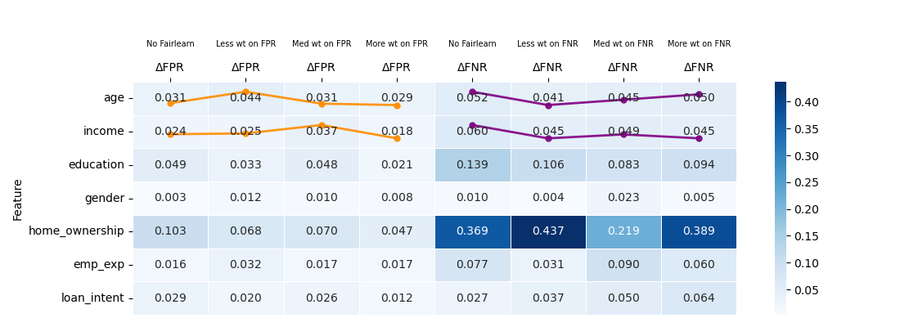
Figure A.4: Per-feature FPR and FNR disparity heatmap for SMOTE neural network model.
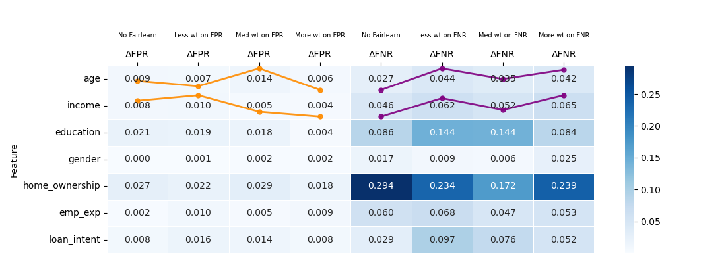
Figure A.5: Per-feature FPR and FNR disparity heatmap for no SMOTE XGBoost model.
Model | Hyperparameters
XGBoost | - n_estimators  - max_depth  - learning_rate  - min_child_weight  - reg_lambda: L2 regularization  - reg_alpha: L1 regularization
Neural Network | - number of layers  - hidden nodes per layer  - activation  - optimizer

Table A.1: Hyperparameters tuned

Model | Accuracy | F1-score | Precision | Recall | TPR | TNR | FPR | FNR
Baseline XGBoost | 0.9143 | 0.7824 | 0.8983 | 0.6930 | 0.6930 | 0.9776 | 0.0224 | 0.3070
Fairlearn XGBoost | 0.9060 | 0.7464 | 0.9319 | 0.6225 | 0.6225 | 0.9870 | 0.0130 | 0.3775
QELM Fairlearn XGBoost | 0.9039 | 0.7440 | 0.9115 | 0.6285 | 0.6285 | 0.9826 | 0.0174 | 0.3715
Weighted XGBoost | 0.9080 | 0.7871 | 0.8101 | 0.7655 | 0.7655 | 0.9487 | 0.0513 | 0.2345
SMOTE XGBoost | 0.9150 | 0.7893 | 0.8786 | 0.7165 | 0.7165 | 0.9717 | 0.0283 | 0.2835
SMOTE Fairlearn XGBoost | 0.9133 | 0.7753 | 0.9144 | 0.6730 | 0.6730 | 0.9820 | 0.0180 | 0.3270
Baseline NN | 0.8940 | 0.7238 | 0.8597 | 0.6250 | 0.6250 | 0.9709 | 0.0291 | 0.3750
Fairlearn NN | 0.8705 | 0.6246 | 0.8785 | 0.4845 | 0.4845 | 0.9809 | 0.0191 | 0.5155
QELM Fairlearn NN | 0.8608 | 0.6316 | 0.7666 | 0.5370 | 0.5370 | 0.9533 | 0.0467 | 0.4630
SMOTE NN | 0.8419 | 0.6775 | 0.6196 | 0.7475 | 0.7475 | 0.8688 | 0.1312 | 0.2525
SMOTE Fairlearn NN | 0.8488 | 0.6580 | 0.6614 | 0.6545 | 0.6545 | 0.9043 | 0.0957 | 0.3455
Table A.2: Metrics for all models.

