Progress Report: Classical and hybrid quantum-classical ML analysis
of bias in loan default prediction
Group Members: Tan Dai Ngo (V01073190), Jeremy Perkins (V00501015), Naomi Phan (V01097400), Joyce van de Vegte (V00102221), Yuanming Wang (V01028720), Da Zhang (V01062902)
- The Problem
The project examines bias in loan default prediction. A model that misclassifies a new client as someone who would default on a loan could have potentially severe consequences for a borrower. The converse problem from the bank’s perspective is approving a loan that ultimately defaults.
The dataset [1] selected for the project contains 45,000 detailed borrower applications labelled with the loan repayment outcome: default or paid. It is recognized that since default data contains only applicants who were previously accepted for a loan, the dataset is not representative of all loan applicants. Financial institutions use the reject inference method [2][3] to hypothesize whether the rejected group would have defaulted.
- Goals
At the outset, the main goal of the project was to evaluate whether machine learning models could predict loan default accurately. Accuracy remains a goal, but emphasis has shifted to the detection and control of bias in the modelling of the problem. Many discussions about the metrics most suitable for revealing bias have led to a more mature view of model assessment. Metrics now include both overall model reports as well as reports per feature. The success of our final models will be measured by how well each model balances performance and fairness.
A great deal of care was taken in designing the data preprocessing pipeline. For example, the train/test split was originally made after the removal of outliers via isolation forest, but this ordering was reworked to avoid data leakage, whereby the test data influences the training dataset. Due to the unbalanced nature of the training dataset, the Synthetic Minority Oversampling Technique (SMOTE) [4] was used to create a dataset for training with equal numbers of default and no-default examples. Preprocessing pipeline details are provided in the “Plan” section.
XGBoost [5][6] and neural network [7] baseline models have been prepared to predict loan default, as detailed in the “Initial Results” section. Key evaluation metrics include: accuracy, precision, recall, F1 score, false positive rate (FPR), false negative rate (FNR), and test error. Per-feature metrics of FNR and FPR are more important for assessing and addressing bias than is overall test accuracy. The FNR captures the events where a borrower who actually defaults is predicted as non-defaulting, costly from the lender’s perspective. The FPR captures the events where a borrower who would have repaid is predicted as likely to default, which is costly from the borrower’s perspective.
Several feature engineering methods have been implemented to complement model training. These include: QELM (quantum extreme learning machine), PCA (principal components analysis), and RFF (random Fourier features). Model performance with and without feature engineering will be analyzed and compared.
The ongoing work of the project is to measure and reduce bias in the trained models. We intend to compare model performances across borrower subgroups by attributes such as gender, age, education, or income. A model is considered to be biased if its bias metrics, such as FNR and FPR, differ substantially across those groups (rather than error rates, as first conceived). To formally quantify this, we calculate the disparities between the maximum and minimum metric rates across all levels for a given feature. Our objective is to minimize this equalized odds difference.
- Plan and progress-to-date
Seven “physically impossible” outliers were removed from the original dataset. These included five individuals with an age of 144 and two individuals with an employment experience of 123 years. Initially, this step was followed by isolation forest outlier removal. But by doing this, the entire distribution of the dataset was used to identify outliers, which contaminated the training set with knowledge of the test set. Therefore, the train/test split was performed immediately after the hard outlier removal.
The iForest [8] algorithm was applied to the training dataset at the 5% level, resulting in the exclusion of 1,800 outlying samples and leaving 34,194 samples for training.
To address class imbalance in the training dataset (77.8% no default vs 22.2% default), the SMOTE algorithm was applied as one means of reducing model bias. It was decided that education (high school, associate, bachelor, master, doctorate) should be treated as an ordinal variable. Standard SMOTE generates new data points within the convex hull of existing training samples, but it quickly became evident that SMOTE was interpolating categorical and ordinal features in a useless way. A related tool, SMOTE-NC [9][10], generates data for both numeric and categorical data, more appropriate for our dataset. The ordinal category, education, was placed among the numeric features and SMOTE-NC-produced values were rounded to the nearest integer.
Models were coded with Object-Oriented-Programming (OOP) style for code reusability. The overview for each stage (preprocessing phases, SMOTE application, or fairness wrapping) of the project can be easily tracked through a main file, avoiding missing any critical implementation steps along the way. The XGBoost models were tuned for unbalanced training data, post-SMOTE training data, and unbalanced training data treated with XGBoost-native class balancing through weight scaling. Neural network models were trained for the unbalanced training data as well as the SMOTE-treated training data.
Two independent QELM [11][12][13][14] feature sets were generated using the PennyLane open-source library for quantum computing and simulation. For both of the QELM approaches explored, numeric features were coded as angles and probabilistic expectations derived from a quantum circuit. The features can be applied as input to any model. RFF and PCA are not ideal matches for a dataset having both numeric and categorical features that are one-hot encoded, due to the sparsity of the resulting space. As we finalize our models, we will analyze in what ways QELM, RFF or PCA might differentiate performance, as measured by our fairness metrics, and verify their applicability to the task.
To explore model behaviours in a more granular way, metrics were generated per feature, and the values of each metric were reported for each level of each feature. For example, FNR could be examined for every level of home ownership (rent, own, mortgage, other). Categorical variables are naturally suited to this analysis. Numeric features were quantile-binned in such a way as to create somewhat flat counts across the bins, and the “disparity” (maximum minus minimum) of each metric was taken for each feature. For example, for age, the FNR disparity would be computed as the maximum FNR for any age bin minus the minimum FNR for any age bin. The disparities computed in this way were formed into a heatmap for visualization. An example is supplied in the “Initial results” section.
Having focused our attention on metrics that would reveal bias in a useful way, we turned our attention to the means by which we could exert control over bias in particular features. We encountered Fairlearn [15], a toolkit that provides functionality to address and mitigate fairness issues in AI applications. Fairlearn offers a method to apply constraints to model training using metrics such as FNR and FPR, and these constraints can be applied globally or on a per-feature basis. We are exploring what impact this approach will have on our disparity metric heatmaps and also on model accuracy.
As described in Appendix A, our team is on track for scheduled tasks. We have consulted a variety of resources to develop our knowledge of bias and fairness [16][17], as well as to familiarize ourselves with relevant tools [4-9] and feature engineering possibilities, particularly quantum methods. Dr Muller offered suggestions and resources regarding our quantum feature engineering efforts.
- Task breakdown
A Gantt chart showing completed and remaining tasks is provided in Appendix A.
(a) Exploratory Data Analysis
The same methods used for exploratory data analysis were used to study the impacts of SMOTE-NC and also to examine possible skew in training features that should be corrected.
(b) Dataset Balancing
SMOTE, which creates synthetic examples from a minority group, has been a useful approach to begin the debiasing of the dataset, crucially applied to the training data only. As discussed, SMOTE-NC has been key for our application, as our dataset includes both numeric and categorical data.
(c) Data Pre-Processing
The view of outliers became more nuanced as the project work proceeded. A distinction was made between “impossible” data that must be erroneous and outlying data that might unreasonably influence model predictions. To avoid removing legitimate minority edge cases that would be key to reliable discrimination, a modest 5% of outliers were removed using iForest. After removing hard outliers, but before using iForest, the dataset was randomly split into two parts, 80% in the training set and 20% for the final test set. Hyperparameter tuning is conducted with the standard 5-fold cross-validation over the training data, with each fold used once as a validation fold. Training and testing are applied in two separate phases, and during the design of the pre-processing pipeline, care was taken to prevent data leakage.
Several feature-engineering front ends have been prepared: QELM, PCA, and RFF. Of these, QELM and RFF have the potential to highlight differences among features in the dataset by mapping them to a higher-dimensional space. Higher dimensionality alone (QELM and RFF) does not guarantee that underlying patterns in data can be captured more effectively. The mapping must preserve or reveal class-relevant structure rather than amplify noise. To date, better accuracy has not been achieved with these feature engineering approaches. Still, there is the possibility that there will be differences in fairness metrics when our models are retrained with fairness constraints, so feature engineering measures will continue to be explored.
(d) Model Training
Previous research [15] has used a variety of solutions to overcome the problem that rejected loan applicants are not present in the dataset. We recognize that our application of SMOTE involves assumptions about the missing data, specifically that the censored population shares similar underlying distributions among the features, and that this may not be the case.
We selected XGBoost as one of our models, as it is a widely used industry standard that covers both continuous and categorical features. A feedforward neural network will also be trained and compared as a benchmark for comparison. Logistic regression is included among the models as a baseline and sanity check.
(e) Performance Evaluation
For each model, performance metrics will provide an overall view, and fairness disparity heatmaps will provide a more detailed per-feature view. Our original plan was to compare tuned baseline models to tuned debiased models; we are currently adopting the idea that to address bias in our model predictions, we must train the models with penalties applied to suitable fairness metrics. We currently have results for constraining the FNR and FPR disparities for age and income. The 2,243 “soft” (not impossible) outliers (5% of the training data) removed by iForest were set aside and will be evaluated separately.
Finally, after training models with and without feature engineering front ends, we may consider an ensemble voting method across several models to exploit the strengths of individual modelling approaches.
- Initial results
Figures 1 and 2 illustrate how data distributions shifted for training data before and after SMOTE. Notice in particular the effect on class distribution. The value of implementing SMOTE was evident in testing with neural network models. Classification accuracy for the class 1 minority group (loan default) improved. Applying SMOTE also improved the ROC-AUC ratio (which captures how many loan defaults were correctly predicted compared to how many non-defaulters were incorrectly labelled as defaulting) and the PR-AUC ratio (which focuses on the ability of the model to predict loan defaults without too many false positives).
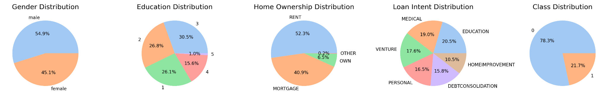
(a) Before SMOTE
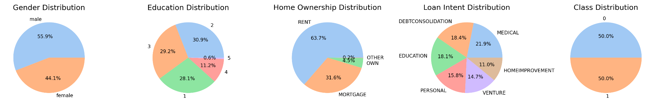
(b) After SMOTE
Figure 1. Distribution of categorical features before SMOTE and after SMOTE.
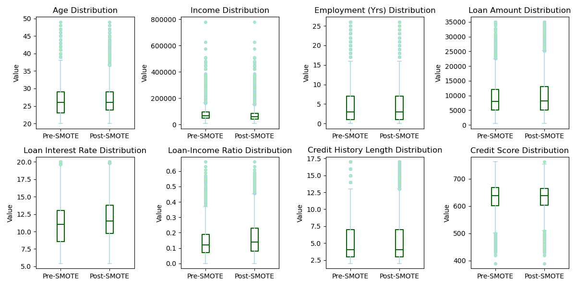
Figure 2. Distribution of numerical features before SMOTE and after SMOTE.
Bias metric disparity heatmaps are created from the range for each metric over all bins of each feature (a sample is provided in Figure 3). With a solid pipeline tailored to the requirements of each model and a more focused view of assessing bias, we are ready to explore the fairness landscape using Fairlearn constraints. We expect to examine how reductions in bias for one fairness may have impacts on the bias for other metrics. Tables 1 and 2 capture some of our current model performance metrics.
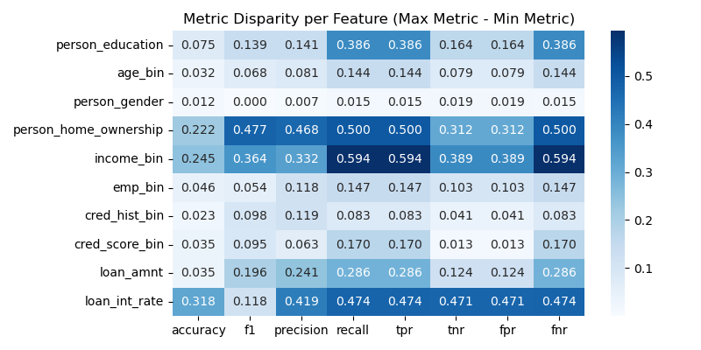
Figure 3. Disparity Heatmap for Logistic Regression.
Model | Accuracy | F1-score | Precision | Recall | TPR | TNR | FPR | FNR
Baseline XGBoost | 0.9127 | 0.7809 | 0.8822 | 0.7005 | 0.7005 | 0.9733 | 0.0267 | 0.2995
SMOTE XGBoost | 0.9140 | 0.7884 | 0.8697 | 0.7210 | 0.7210 | 0.9691 | 0.0309 | 0.2790
Weighted XGBoost | 0.9109 | 0.7858 | 0.8435 | 0.7355 | 0.7355 | 0.9610 | 0.0390 | 0.2645
QELM + SMOTE + XGBoost | 0.8958 | 0.7488 | 0.8062 | 0.6990 | 0.6990 | 0.9520 | 0.0480 | 0.3010
XGBoost with Fairlearn constraints on age and income | 0.9065 | 0.7530 | 0.9125 | 0.6410 | 0.6410 | 0.9824 | 0.0176 | 0.3590
QELM + SMOTE + XGBoost with  Fairlearn constraints on age and income | 0.8985 | 0.7417 | 0.8541 | 0.6555 | 0.6555 | 0.9680 | 0.0320 | 0.3445
Table 1. Metrics for XGBoost models with feature engineering and fairness constraints.
Model | Accuracy | F1-score | Precision | Recall | TPR | TNR | FPR | FNR
Baseline Neural Network | 0.8953 | 0.7284 | 0.8604 | 0.6315 | 0.6315 | 0.9707 | 0.0293 | 0.3685
SMOTE Neural Network | 0.8424 | 0.6801 | 0.6197 | 0.7535 | 0.7535 | 0.8678 | 0.1322 | 0.2465
QELM + SMOTE Neural Network | 0.8331 | 0.6544 | 0.6061 | 0.7110 | 0.7110 | 0.8680 | 0.1320 | 0.2890
NN with Fairlearn constraints on age and income | 0.8678 | 0.6183 | 0.8623 | 0.4820 | 0.4820 | 0.9780 | 0.0220 | 0.5180
QELM + SMOTE + NN with  Fairlearn constraints on age and income | 0.8395 | 0.6426 | 0.6363 | 0.6490 | 0.6490 | 0.8940 | 0.1060 | 0.3510
Table 2. Metrics for neural network models with feature engineering and fairness constraints.
References
[1] S. Bhardwaj, “Loan Approval | Classification,” kaggledatasets, Aug. 20, 2025. https://www.kaggle.com/datasets/sumit12100012/loan-approval-classification/data (accessed July 07, 2026).
[2] Z. Guo, X. Ao and Q. He, "Transductive Semi-Supervised Metric Network for Reject Inference in Credit Scoring," in IEEE Transactions on Computational Social Systems, vol. 11, no. 2, pp. 1675-1684, April 2024, doi: 10.1109/TCSS.2023.3276274.
[3] Y. Xia, “A Novel Reject Inference Model Using Outlier Detection and Gradient Boosting Technique in Peer-to-Peer Lending,” IEEE Access, vol. 7, pp. 92893–92907, 2019, doi: https://doi.org/10.1109/access.2019.2927602.
[4] J. Brownlee, “SMOTE for Imbalanced Classification with Python,” Machine Learning Mastery, Jan. 16, 2020. https://machinelearningmastery.com/smote-oversampling-for-imbalanced-classification/
[5] “XGBoost Python Package — xgboost 2.0.0 documentation,” xgboost.readthedocs.io. https://xgboost.readthedocs.io/en/stable/python/index.html
[6] T. Chen and C. Guestrin, “XGBoost: A Scalable Tree Boosting System,” Proc. of the 22nd ACM SIGKDD Int’l Conf. on Knowledge Discovery and Data Mining, pp. 785-794, 2016.
[7] scikit-learn, “1.17. Neural Network Models (supervised) — scikit-learn 0.23.1 Documentation,” scikit-learn.org, 2025. https://scikit-learn.org/stable/modules/neural_networks_supervised.html ‌
[8] Scikit Learn, “sklearn.ensemble.IsolationForest — scikit-learn 0.23.1 documentation,” scikit-learn.org. https://scikit-learn.org/stable/modules/generated/sklearn.ensemble.IsolationForest.html (accessed July 08, 2026).
[9] “SMOTENC — Version 0.11.0,” imbalanced-learn.org. https://imbalanced-learn.org/stable/references/generated/imblearn.over_sampling.SMOTENC.html (accessed July 08, 2026).
[10] “Imbalanced classification: order of oversampling vs. scaling features? [closed],” Stack Overflow, Jan. 21, 2018. https://stackoverflow.com/questions/48369464/imbalanced-classification-order-of-oversampling-vs-scaling-features (accessed July 08, 2026).
[11] “Quantum Extreme Learning Machines,” @emergentmind, 2025. https://www.emergentmind.com/topics/quantum-extreme-learning-machines-qelms (accessed Jun. 13, 2026).
[12] A. De Lorenzis, M.P. Casado, N. Lo Gullo, “Behind the scenes of the Quantum Extreme Learning Machines,” Arxiv.org, 2022. https://arxiv.org/html/2509.06873v1.
[13] P.-W. Huang and P. Rebentrost, “Post-variational quantum neural networks,” arXiv.org, 2023. https://arxiv.org/abs/2307.10560.
[14] W. Xiong et al., “On fundamental aspects of quantum extreme learning machines,” Quantum Machine Intelligence, vol. 7, no. 1, Feb. 2025, doi: 10.1007/s42484-025-00239-7.
[15] Fairlearn, “Fairlearn,” fairlearn.org, 2025. https://fairlearn.org/ (accessed July 07, 2026).
[16] A. Saha, R. Ranjan, B.C. Sahana, “Advancement of Loan Approval System for Diverse Applicants with Machine Learning Framework,” 14th IEEE International Conference on Communication Systems and Network Technologies 2025. https://ieeexplore.ieee.org/document/10968457
[17] E. Perrier, “Quantum Fair Machine Learning,” arXiv.org, 2021. https://arxiv.org/abs/2102.00753 (accessed July 08, 2026).

Appendix A: Task Breakdown and Timeline
