**Segmentation using K-Means Algorithm**

K-Means is a least-squares partitioning method that divide a collection of objects into K groups. The algorithm iterates over two steps:

1. Compute the mean of each cluster.
2. Compute the distance of each point from each cluster by computing its distance from the corresponding cluster mean. Assign each point to the cluster it is nearest to.
3. Iterate over the above two steps till the sum of squared within group errors cannot be lowered any more.

The initial assignment of points to clusters can be done randomly. In the course of the iterations, the algorithm tries to minimize the sum, over all groups, of the squared within group errors (weighted average), which are the distances of the points to the respective group means. Convergence is reached when the objective function (i.e., the residual sum-of-squares) cannot be lowered any more. The groups obtained are such that they are geometrically as compact as possible around their respective means.

Input images:

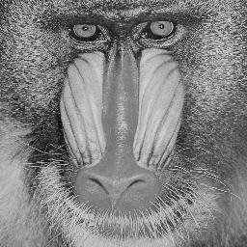

Output:

