3D Reconstruction Project

**Project Overview:**

First of all, what I chose to do in my final project is to implement the default project offered by professor which is to build a high-quality 3D model of an object by using pipeline he outlined in class (**3D reconstruction from 2D images**). And the pipeline which will be used in my project roughly divide into loads and decodes images, triangulates, builds mesh, aligns mesh, writes aligned mesh out to file, loads in and displays the final results. And this is my steps schedule for finishing this project.

1. Collecting Scan Data (default project scans)
2. Assembling hardware (cameras, calibration)
3. Decode and triangulate images
4. Builds mesh and aligns mesh
5. Combining meshes into a final model
6. Rendering final model

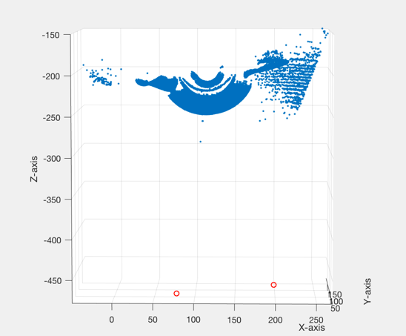In my last progress report, I talked about the steps I finished which are first steps (Collecting Scan Data, assembling hardware, Decode and triangulate images). For this part, I think the camera calibration is very important since it directly influences the result of each mesh. In the beginning my mesh is like several images

Figure 1. With better camera

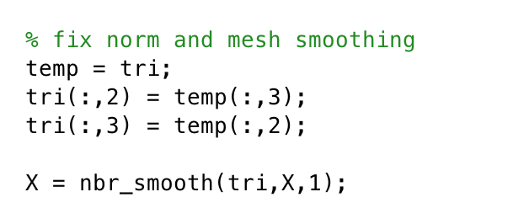which means there are all flatted. After fixing the camera, I finally get the better meshes which are more curved and three-dimensional. Also, it helps my next steps, mesh alignment, a lot. Also, I used nbr_smooth.m which provided by professor to implement the mesh smoothing to make the mesh better. Besides, I fixed the color error, the color in the back and face are inverted, in my first meshes.

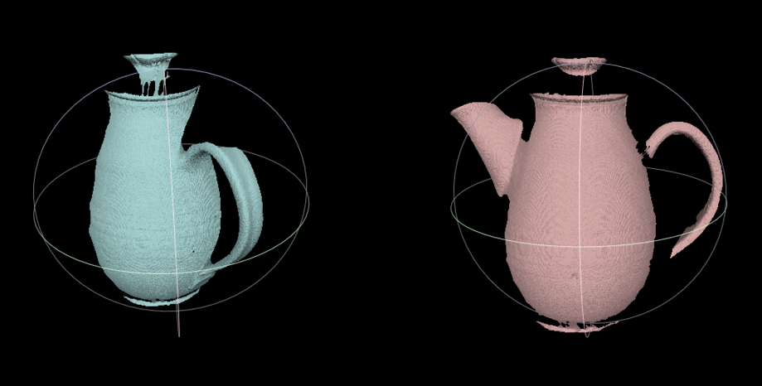 For my mesh alignment, what I decided to do is use **Meshlab** to do it directly since I thought it is too hard to implement by myself. I used the alignment tool inside the Meshlab and aligned them by using point based gluing. Then, I flatted it into one layer Figure 2. Point based gluing in Meshlab

We can clearly find out this version of model still has many holes in each side. So I used possion reconstruction tool inside meshlab to fix the hole problems.

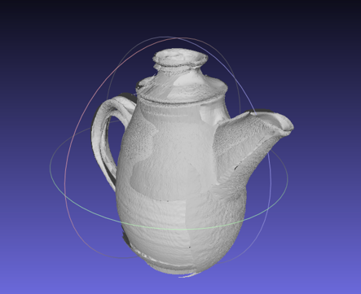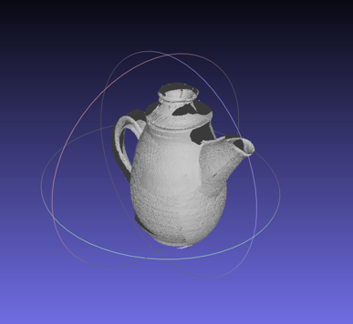

Figure 3(left). Rough 3D Model with holes

Figure 4(right). Final 3D Model in Maya

**Data Sets:**

My data set is the scan images of a teapot from different sides. There are several groups of images provided by professor Fowlkes in the google drive. These images are from seven different positions (grabs) and divided into seven folders. In each folder, there are twenty pairs of images which consists of left side and right side. The resolution for each image is 1920X1280.

Below is the sample of the images

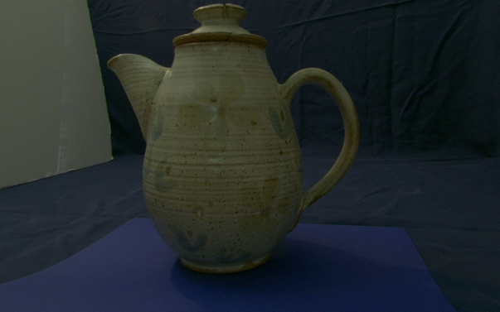 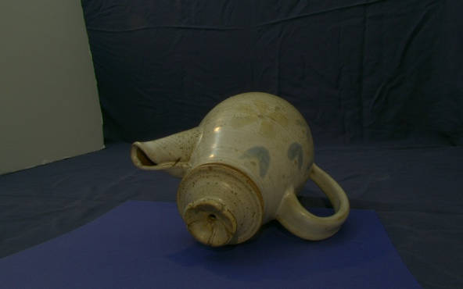

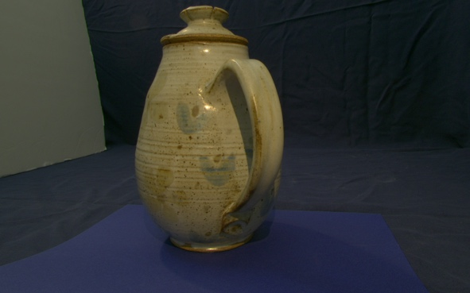 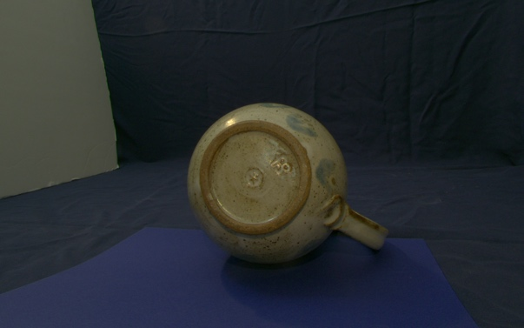

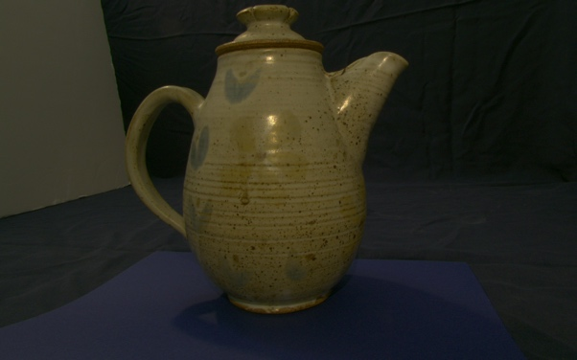 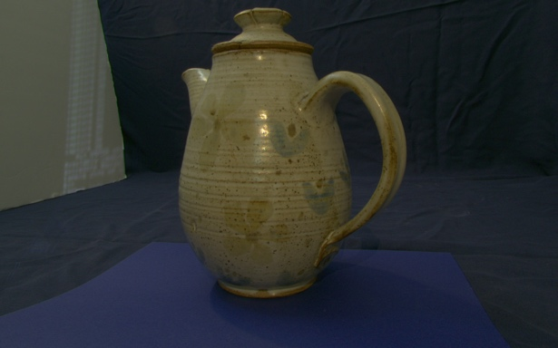

**Algorithms:**

The Algorithms I implemented in this project are sequenced just like the pipeline I talked before. Firstly, the image decoding and reconstructing. This part I used the decode.m and reconstruct.m that I did in my last programing assignment. Then, during mesh building part, I used the smoothing algorithm provided by professor, the nbr_smooth. This algorithm’s main idea is to collect the neighbors points for each point in the mesh and then “interpolate” them between the average of each pair of neighbor point. For mesh alignment, the alignment algorithms in meshlab is to have the user click points in two images and user need to click at least four points which are in same 3D global position (referenced by ). Then, it will combine these two images together based on the points user clicked. After that, in order to fill the holes, I used the mesh possion reconstruction algorithms inside the meshlab. It uses the points and normal to build the surface by using passion surface reconstruction approach.

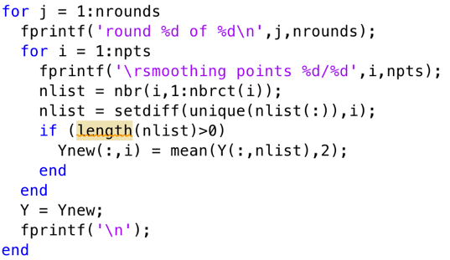 Figure 5. nbr_smooth.m

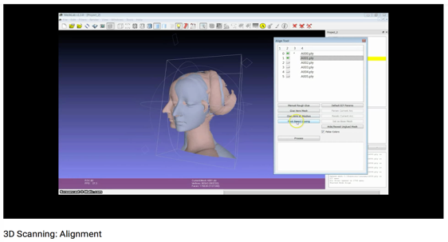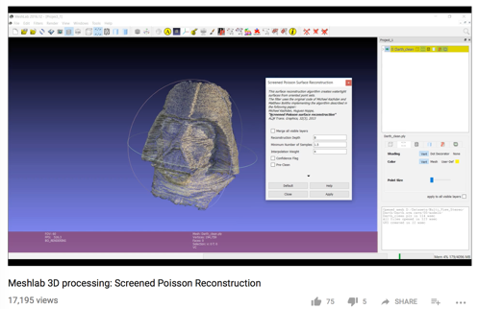

Figure 6. https://www.youtube.com/watch?v=4g9Hap4rX0k Figure 7. https://www.youtube.com/watch?v=fZI925P1aXw

**Results:**

Raw meshes VS. After aligned VS. after possion reconstruct

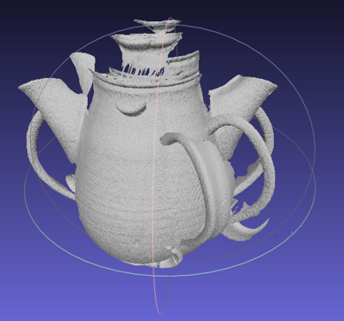 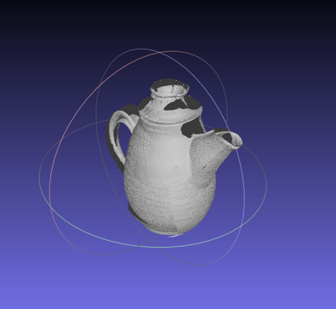 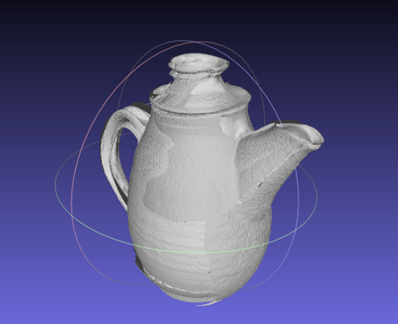

the original image VS. final 3D model

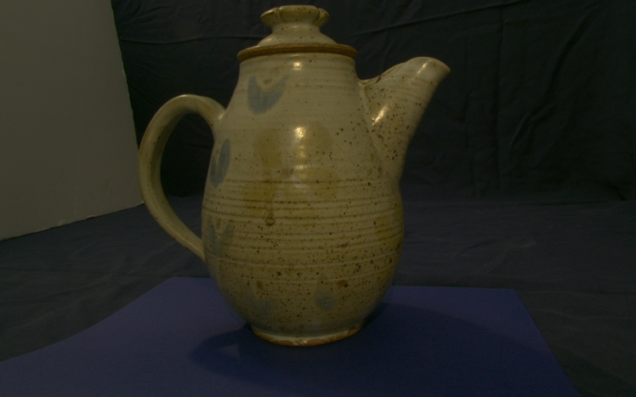 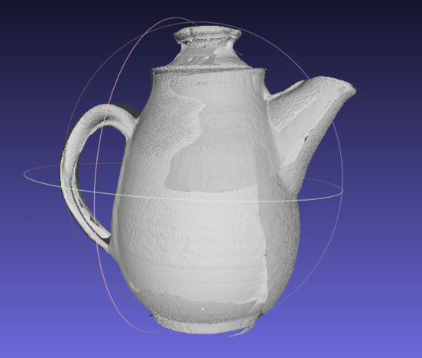

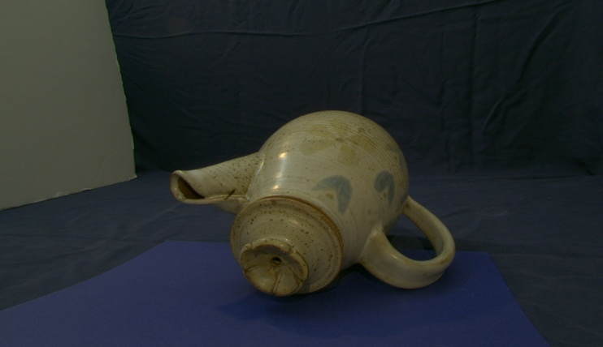 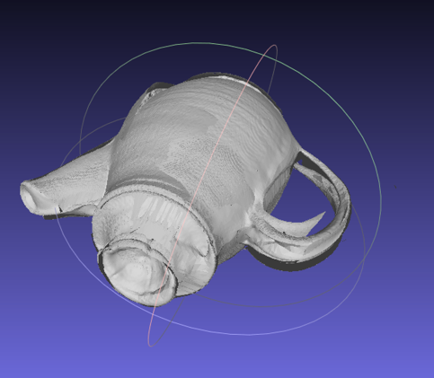

**Evaluation:**

For this project, I used lots of knowledge that I learned in this class. Since the project I have chosen to do is the default project which is not too hard or too easy for me. In the beginning of doing this project, I thought it will be a very cool project because I can build a 3D model based on a real thing. That’s means I am able to translate any object in the real world into 3D models after finishing this project. However, the ideal is fullness and the reality is very skinny. I get the trouble of dealing with the camera calibration at the start. For a long time after, my computer desktop always has three windows when I was doing this project which are “piazza”, “lecture notes” and “matlab”. The scan image I firstly chose is an object called “manny”, a puppet. But I soon find it will be too hard to do mesh alignment since its shape is too complicated. So I choose to “teapot” as my data set.

The most successful thing of this project is to see my “teapot” become better and better by going though all of the pipeline I planed. Also, to learn some new knowledge such as mesh smoothing, mesh alignment and possion reconstruction. To be honestly, I didn’t implement every algorithm by myself in my project but used many codes from last homework. Also, for the mesh alignment and possion reconstruction part, I used meshlab’s tool directly. And I feel very shame for doing so. If I get more time to finish this project, I am sure that I can implement them on my own code.

In conclusion, I truly felt the attractiveness of computer graphics by doing this project and taking this class. I will try my best to learn some thing more about Computer graphic in the future academic life.

**Appendix: Software:**

Decode.m ---- modified version of a function you wrote earlier for an assignment

Reconstruct.m ---- modified version of a function you wrote earlier for an assignment

Mesh.m -- modified version of a function you wrote earlier for an assignment

Nbr_smoothing.m ---- copy of a function provided by the instructor

Mesh_2_ply.m -- copy of a function provided by the instructor

Main_pipeline_demo.m ---- written entirely by myself