Situation:
- Our Baldwin D431 Organ (D431) is wearing down. Long term maintenance and parts no longer available. Sound quality is also deteriorating with each repair. Please see illustration 1 and 2 for details.
- Worship need for the organ exists.
- Equivalent organ could cost between $80,000 and $120,000.

Solution proposition:
- Two phases approach. Focusing on mitigating degraded sound quality issue first then based on the result to proceed on further upgrades.
- Phase 1: Applying organ sound enhancement through PC software to improve sound quality. Please see illustration 3 for details.
- Phase 2: Upgrade amplifiers, audio effect processor, power distribution, and audio cables. Please see illustration 4 for details.
- Mitigation and upgrade applied will work with either existing organ or its replacement.

Opportunity:
- Immediate mitigation against deteriorating sound quality.
- Enriched sound to support worship needs.
- Avoid costly organ replacement in the short term.
- More time to determine D431 replacement direction.
- Gaining expertise on D431 maintenance.
- Gaining expertise on D431 modification as an organ replacement alternative.

Limitations:
- Doesn't address aging D431 console hardware situation.
- Doesn't remove the need of individual D431 console repairs in the long term.
- Only delay D431 organ replacement.

Other options considered:
- Initiate organ replacement fund raising campaign.
- Locate spare parts from used Baldwin D431 organ. Cost about $10000 and required local expertise to swap and repair. No long term maintenance guarantee.

Risks:
- Unforeseen technical complexity to be addressed upon detail implementation. This can increase implementation labor, duration, and cost.
- The long term impact of mitigation made to the Baldwin D431 is unknown.

Cost:
Phase 1: Applying organ sound enhancement through PC software to improve sound quality.
- PC computer, touch screens, and accessories: $1,800 – $2,500
- Sound enhancement software: $0 (custom developed open source software)
- Labors: 20 – 100 volunteering hours

Phase 2: Upgrade amplifiers, audio effect processor, power distribution, and audio cables.
- 16 channels power amplifier, 16+ channel PC audio interface, filtered power distribution, and cabling kits: $1,700 - $6,000
- Wiring and device configuration: 20 – 100 volunteering hours

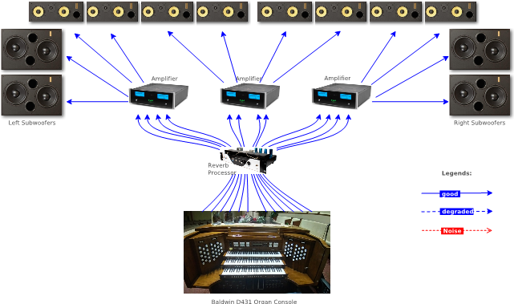Illustration 1: Ideal Condition
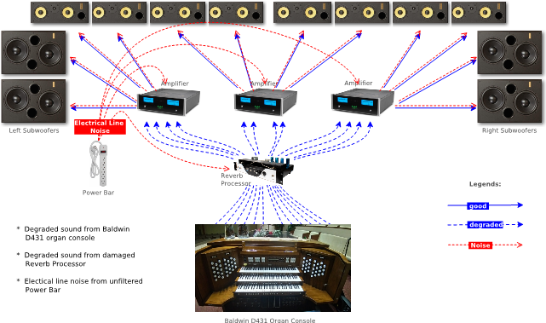Illustration 2: Current Condition
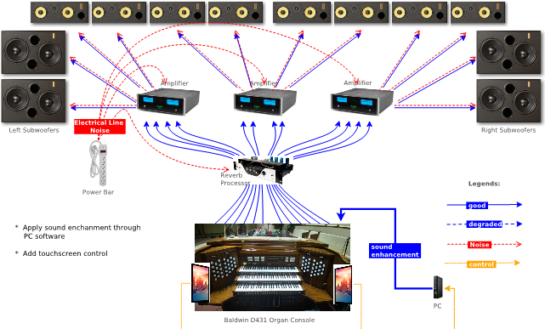Illustration 3: Phase 1 Mitigation
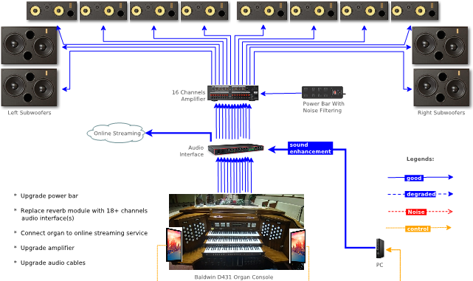Illustration 4: Phase 2 Upgrade

