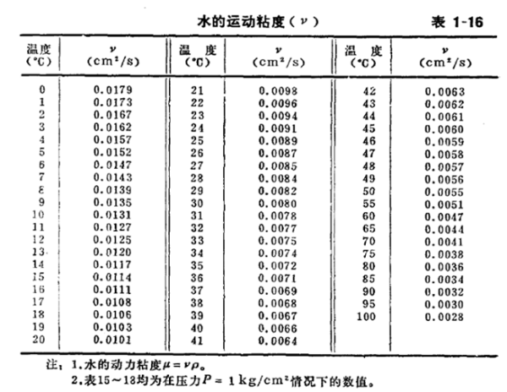

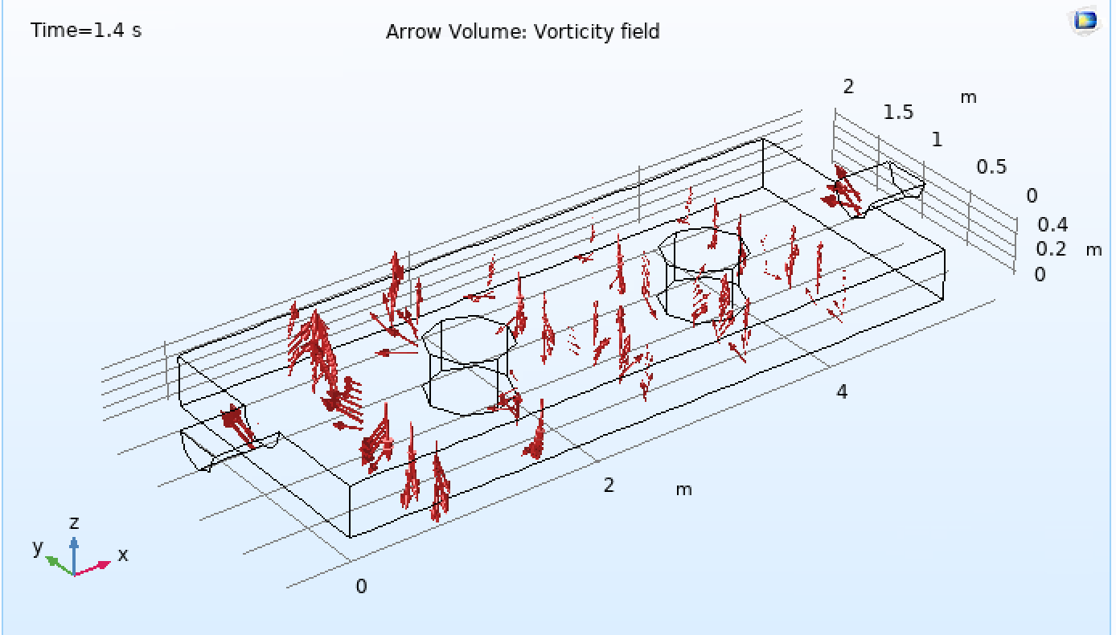

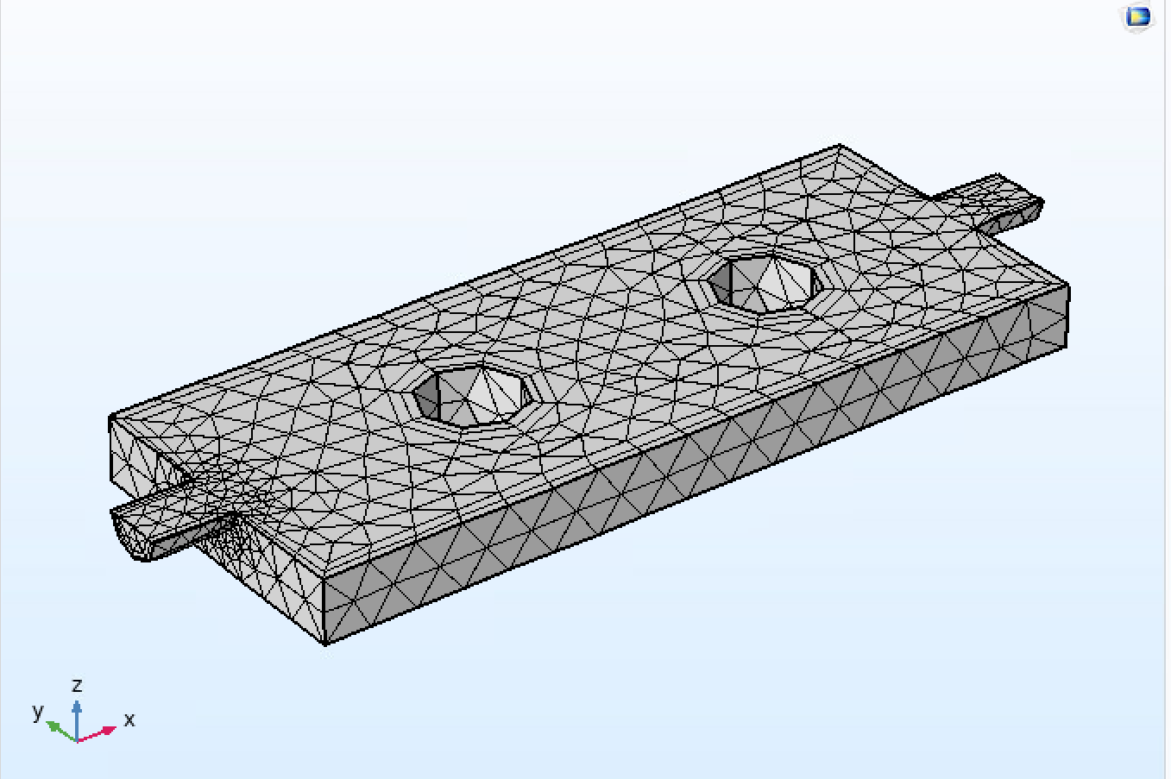

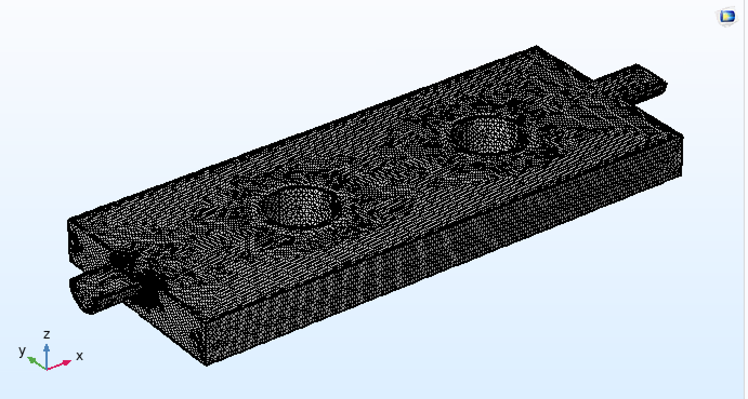

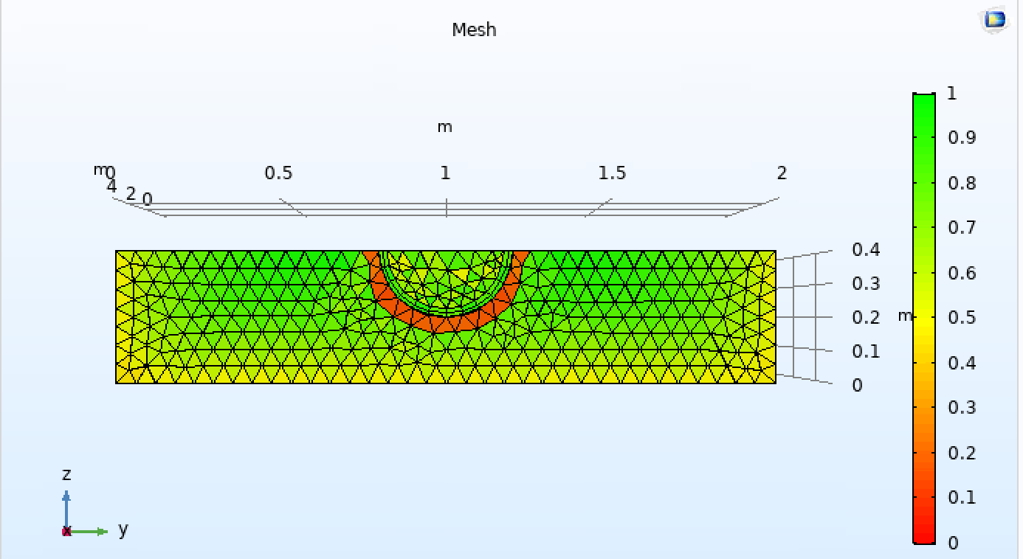

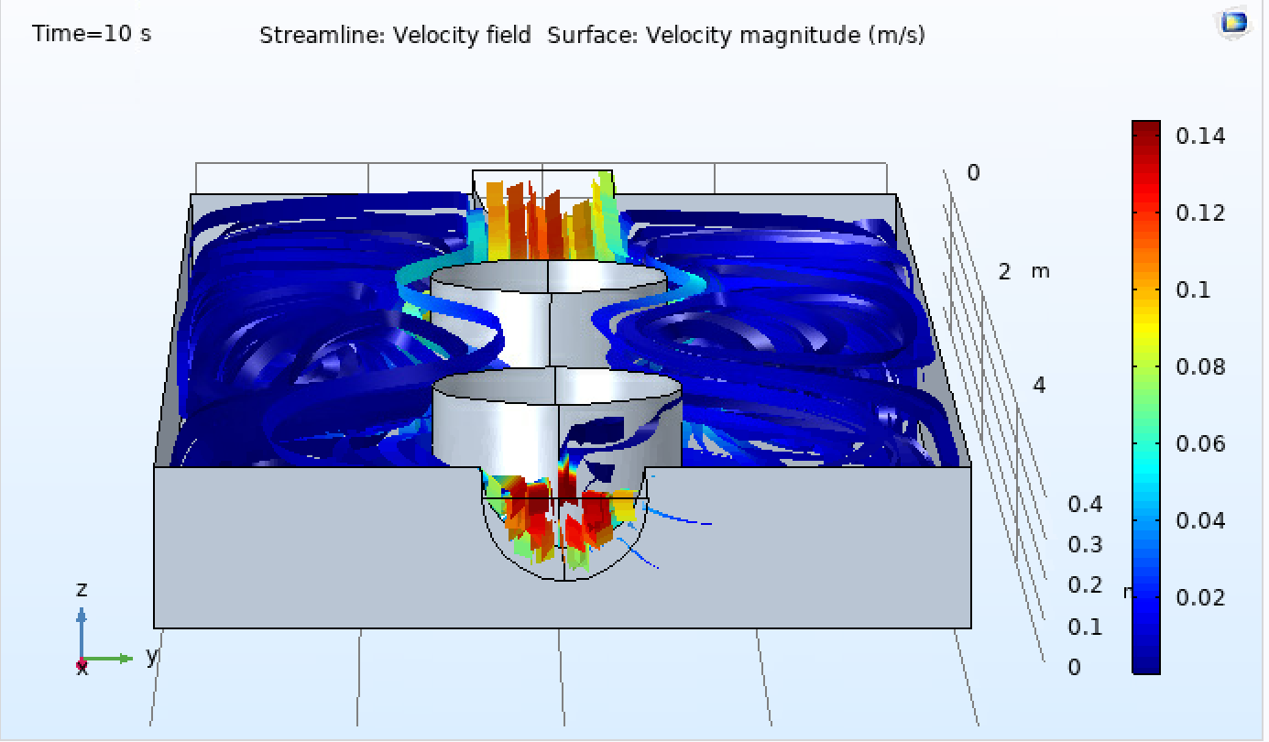



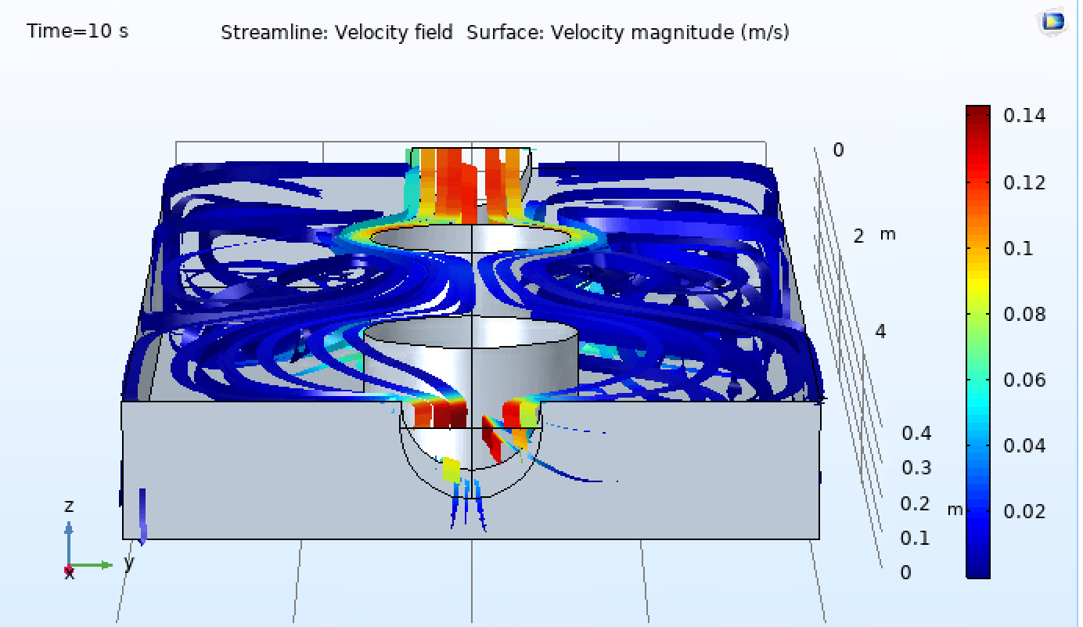



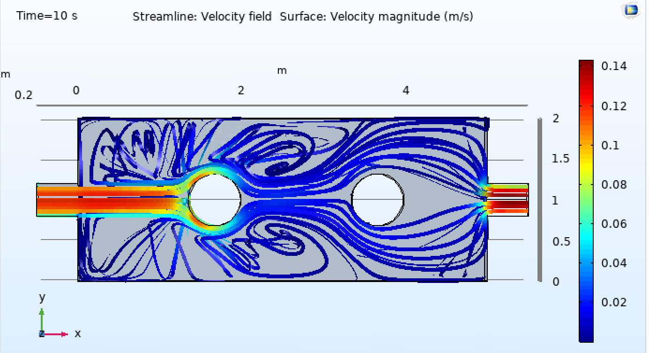

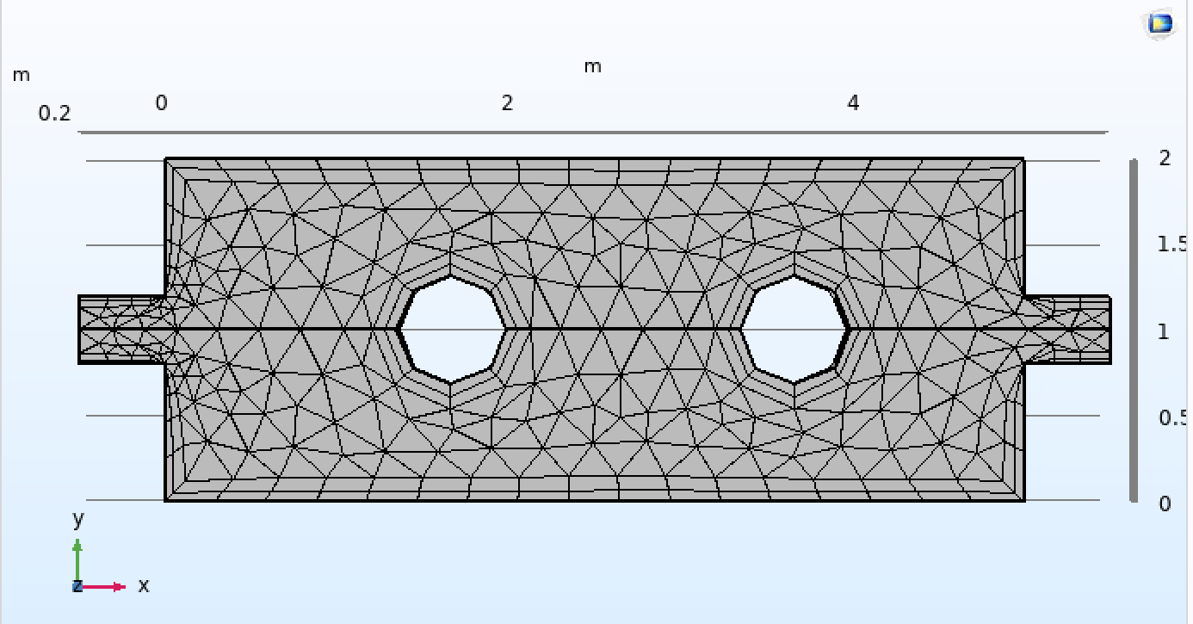

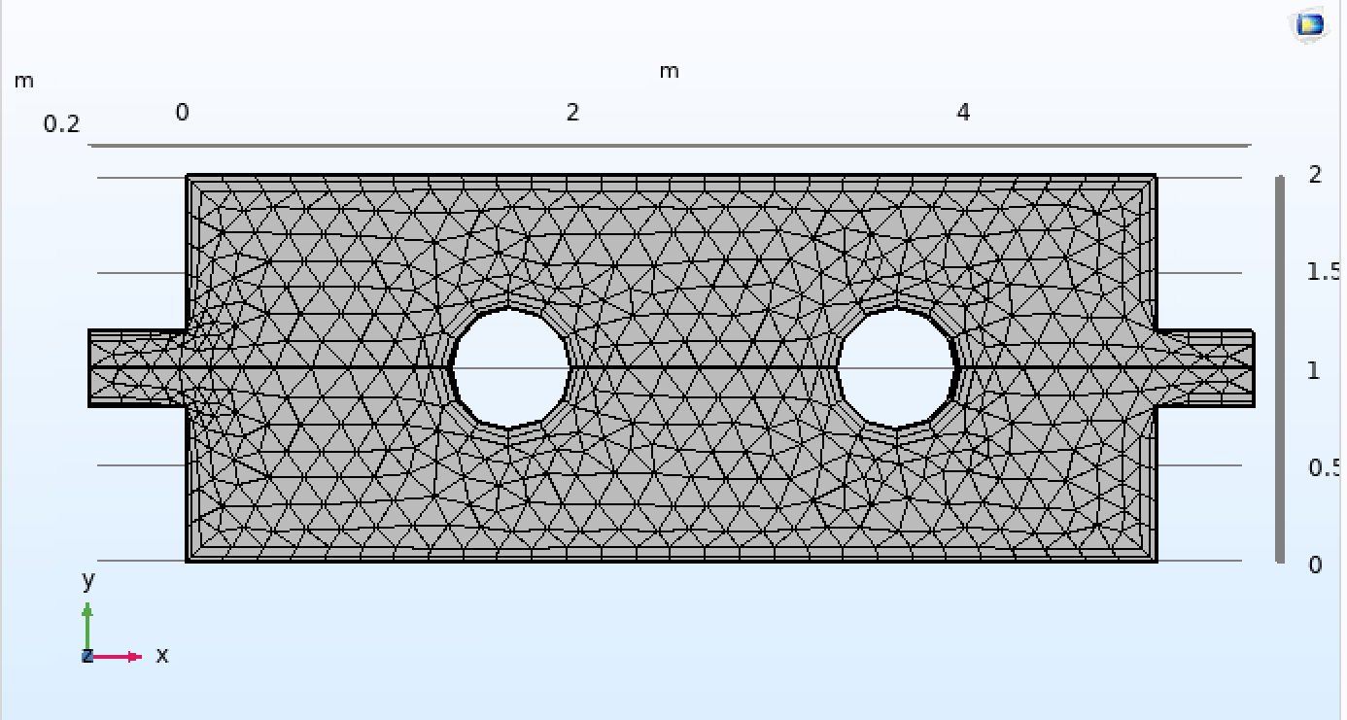

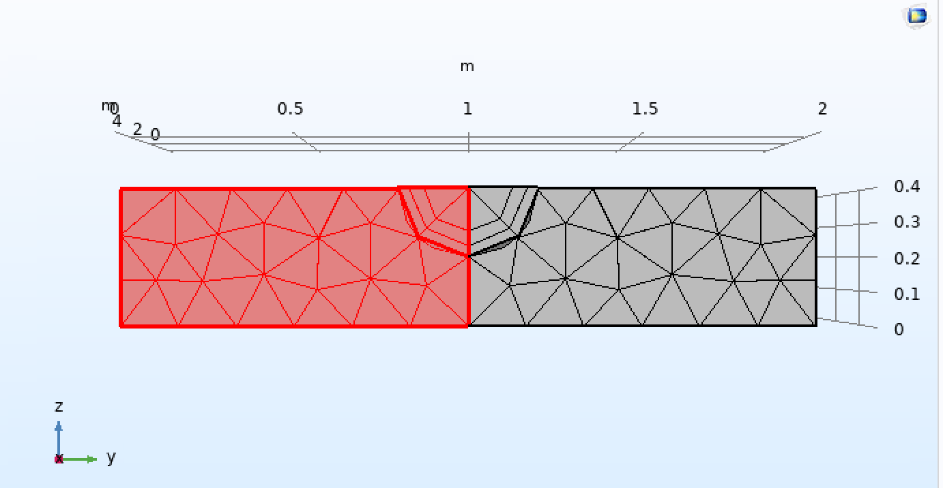

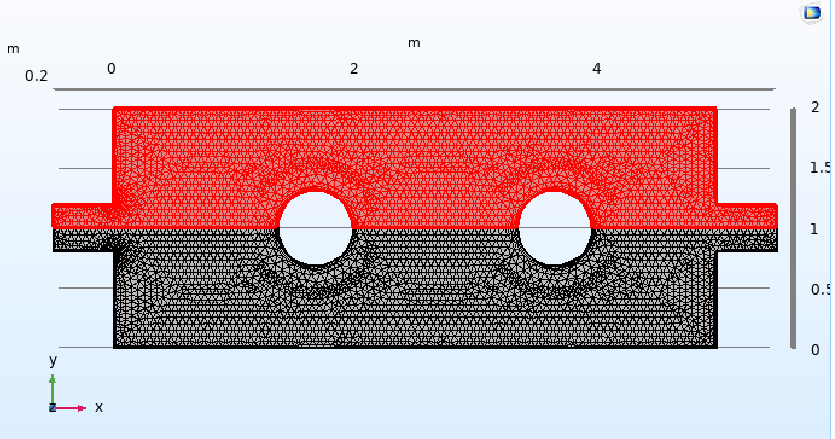

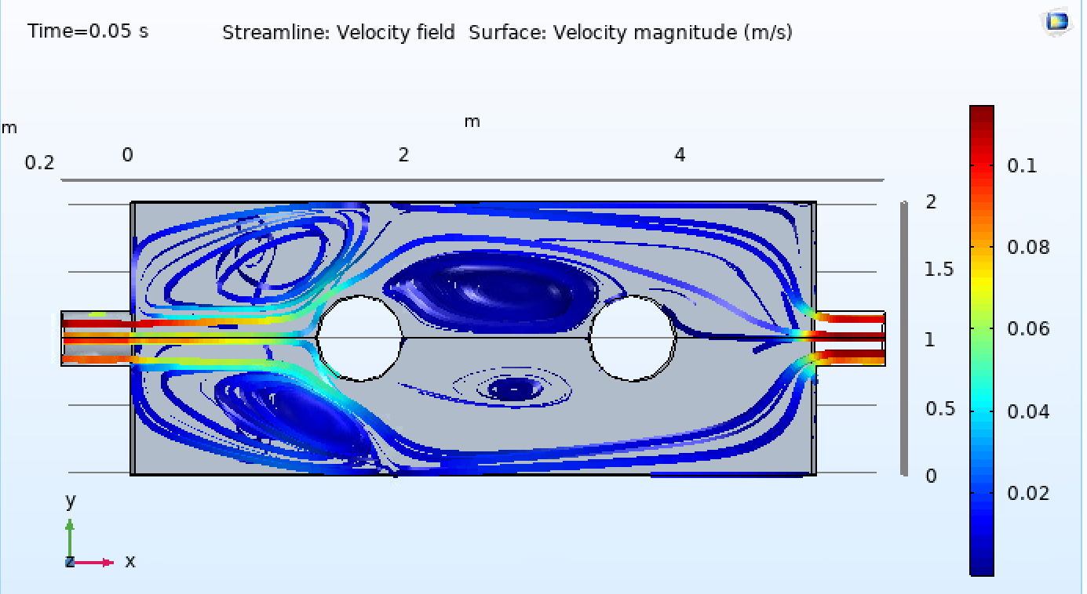



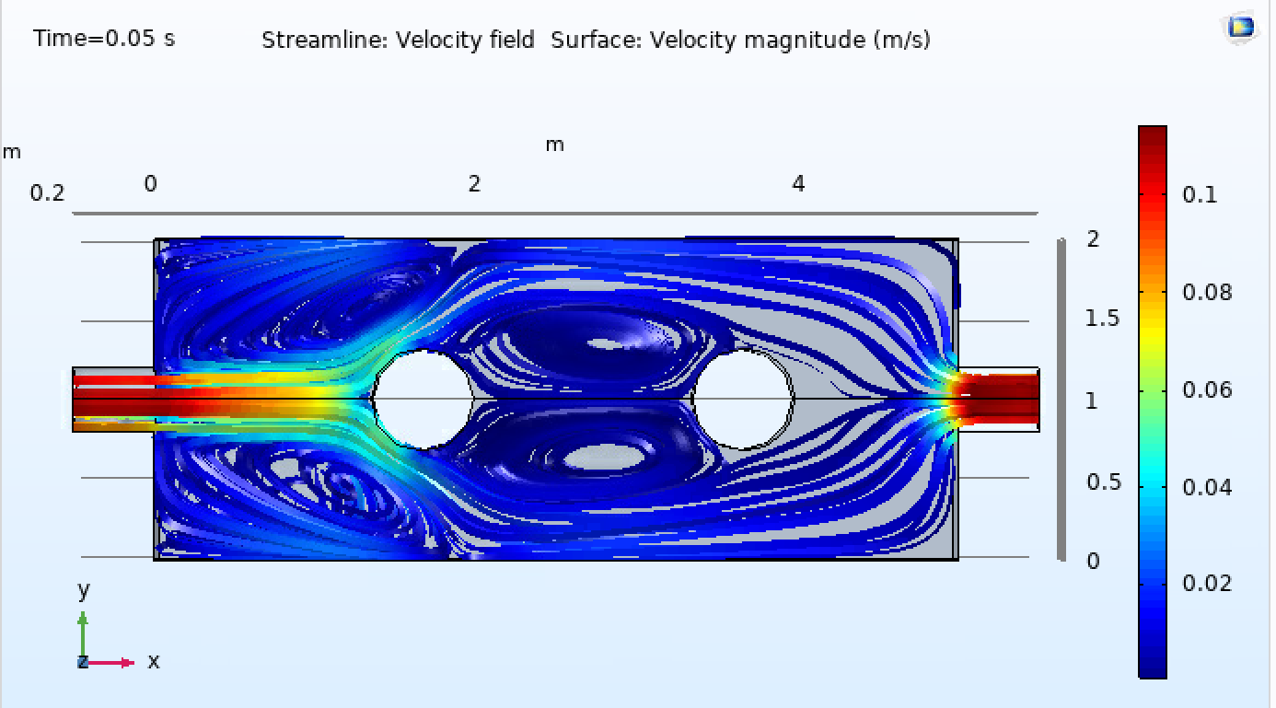



**WATER 25℃ Dynamic Viscosity μ = νρ: 8.90×10-4pa.s 0.1 m/s input speed**

(High Reynolds Number now --- inviscid)

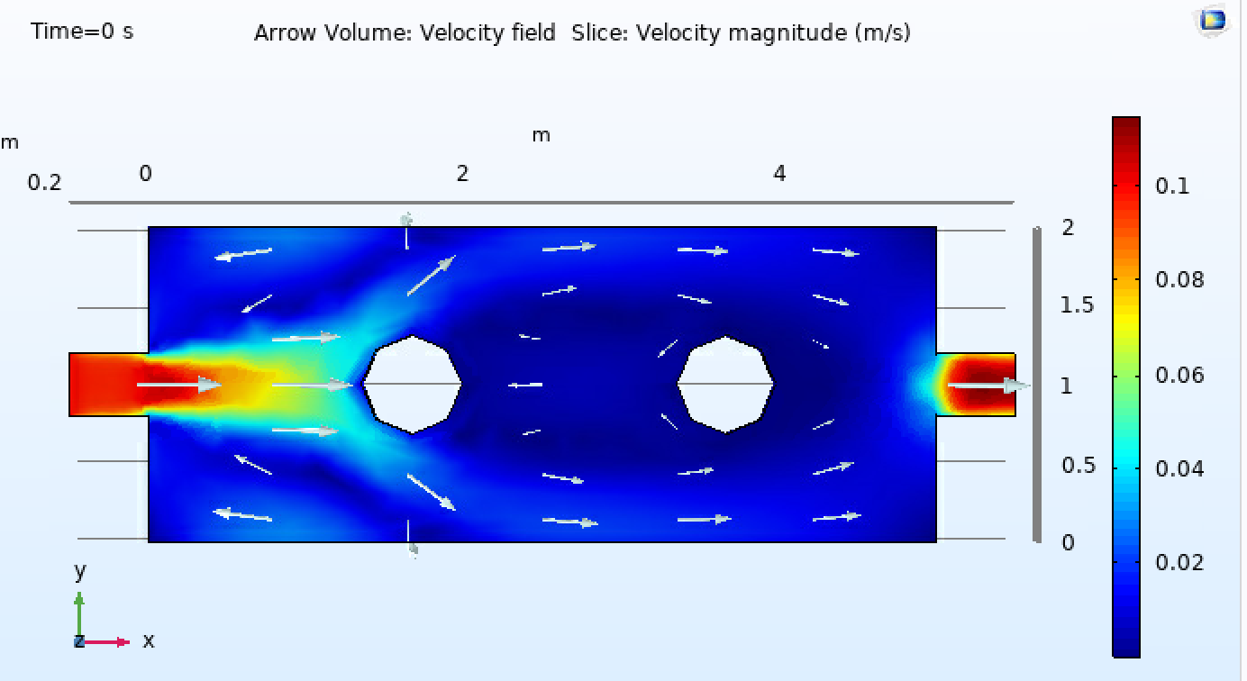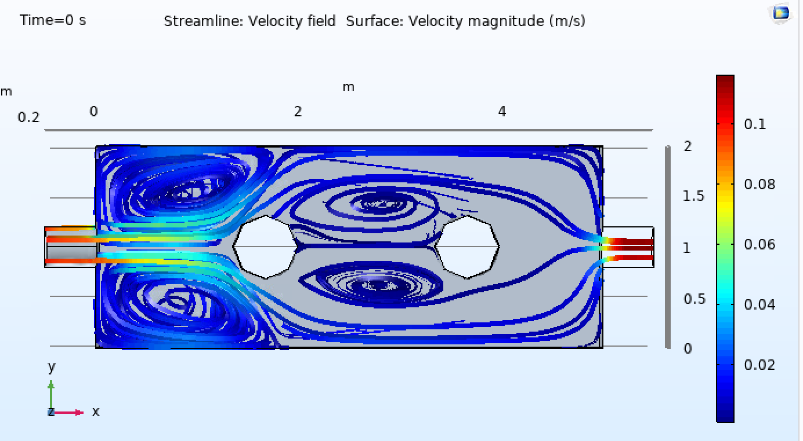

WATER 25℃ Dynamic Viscosity μ = νρ: 8.90×10-4pa.s 0.001 m/s input speed

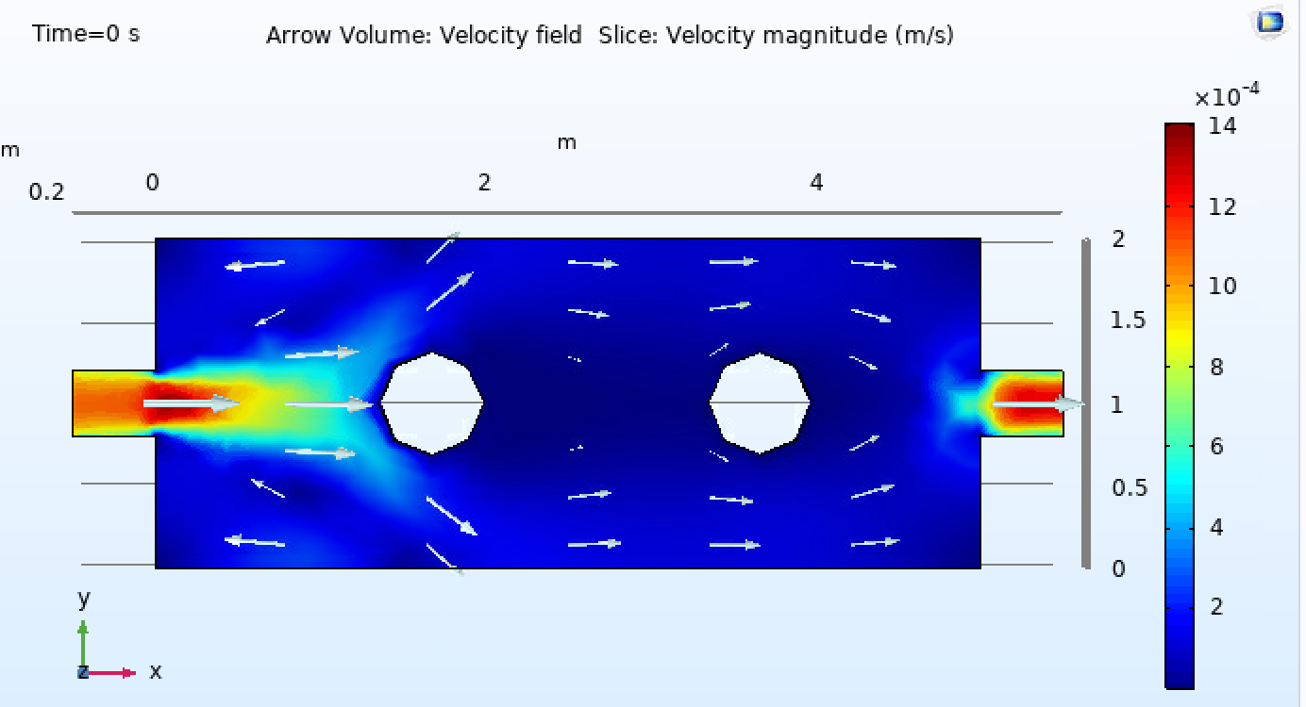

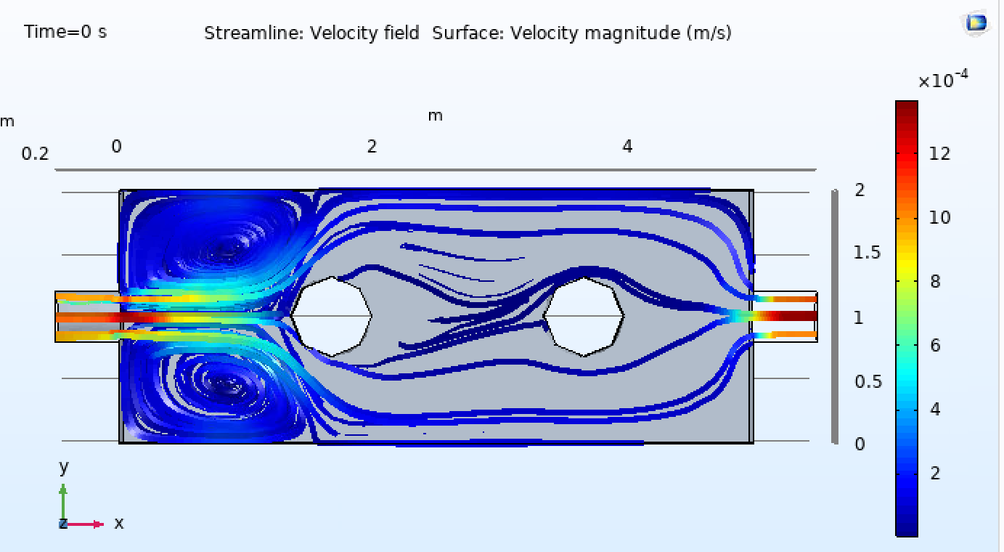

WATER 25℃ Dynamic Viscosity μ = νρ: 8.90×10-4pa.s 0.0001 m/s input speed

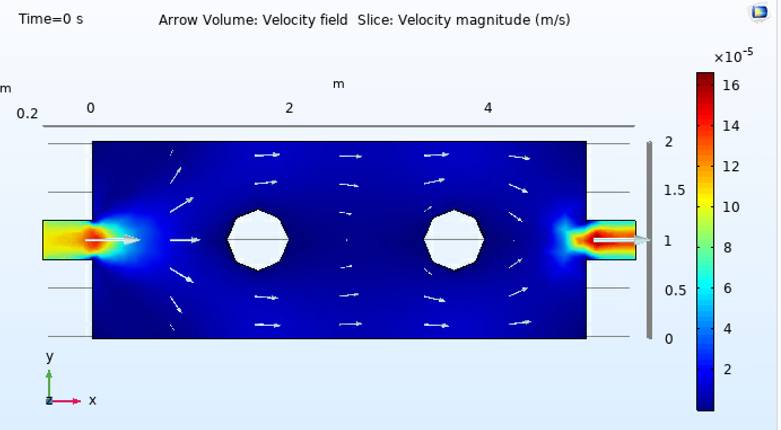

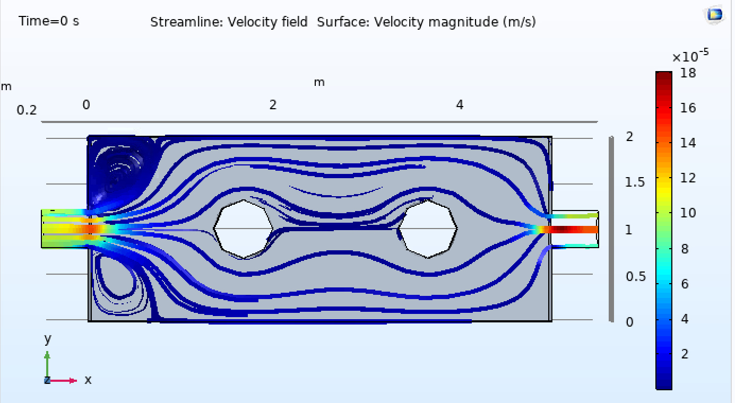

WATER 100℃ Dynamic Viscosity μ = νρ: 2.8×10-4pa.s ρ=958.4 0.1 m/s input speed

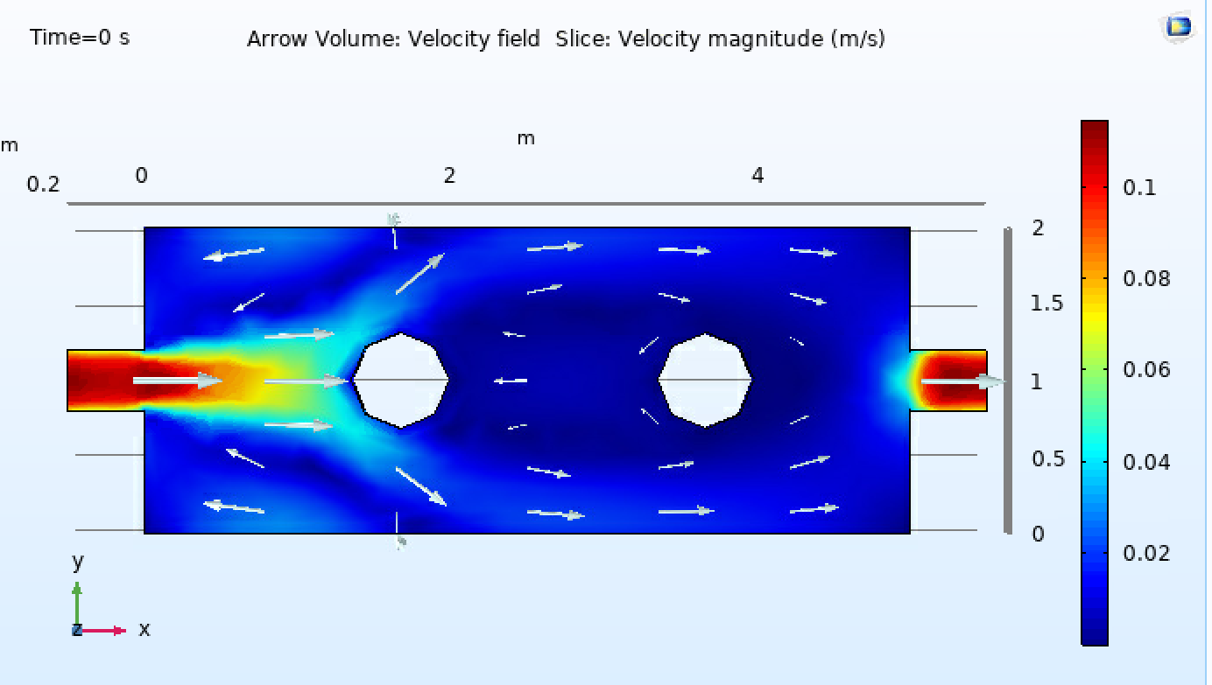

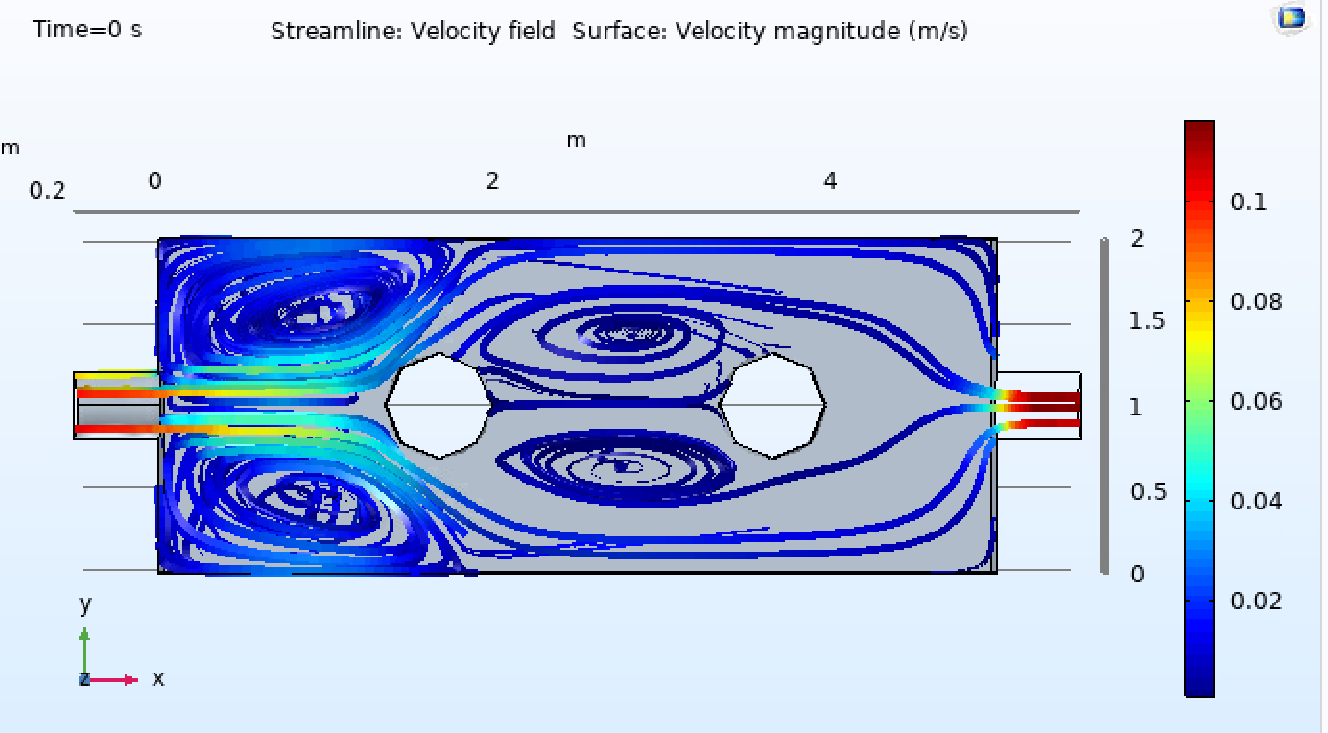

WATER 20℃ Dynamic Viscosity μ = νρ: 1.01×10-3pa.s ρ=1000 0.1 m/s input speed

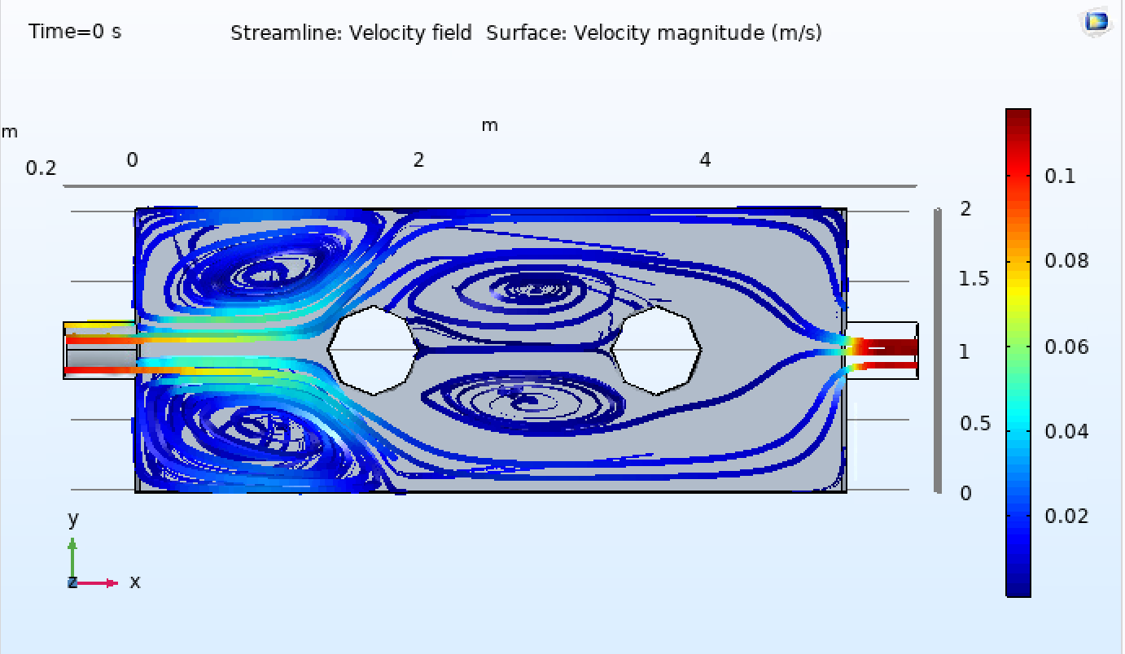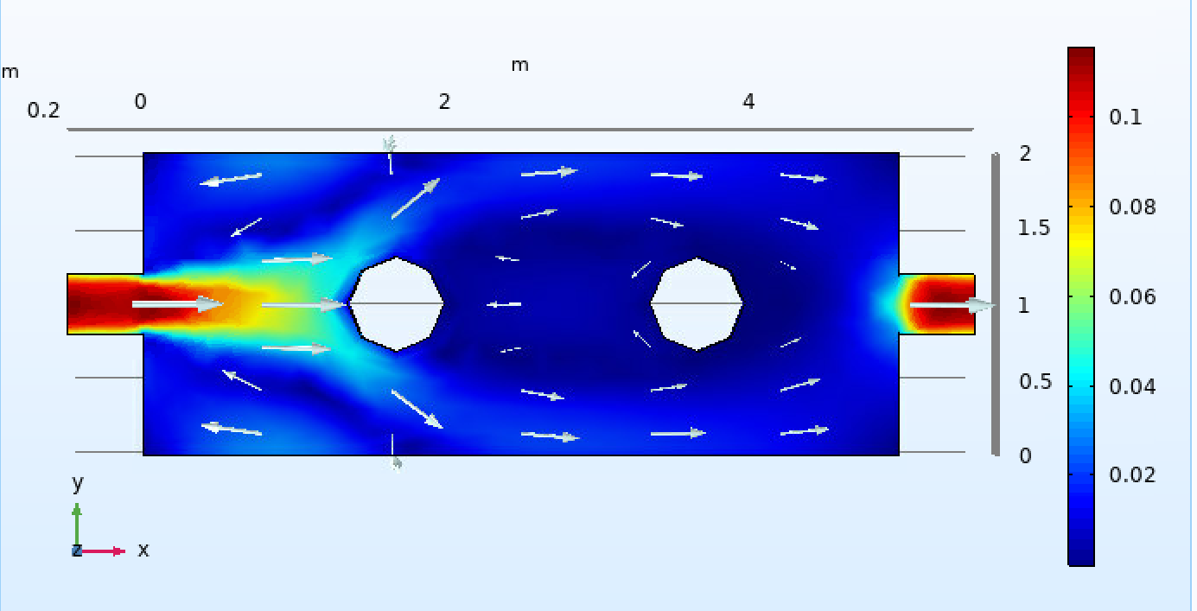

WATER 25℃ Dynamic Viscosity μ = νρ: 8.90×10-4pa.s 0.1 m/s input speed square size

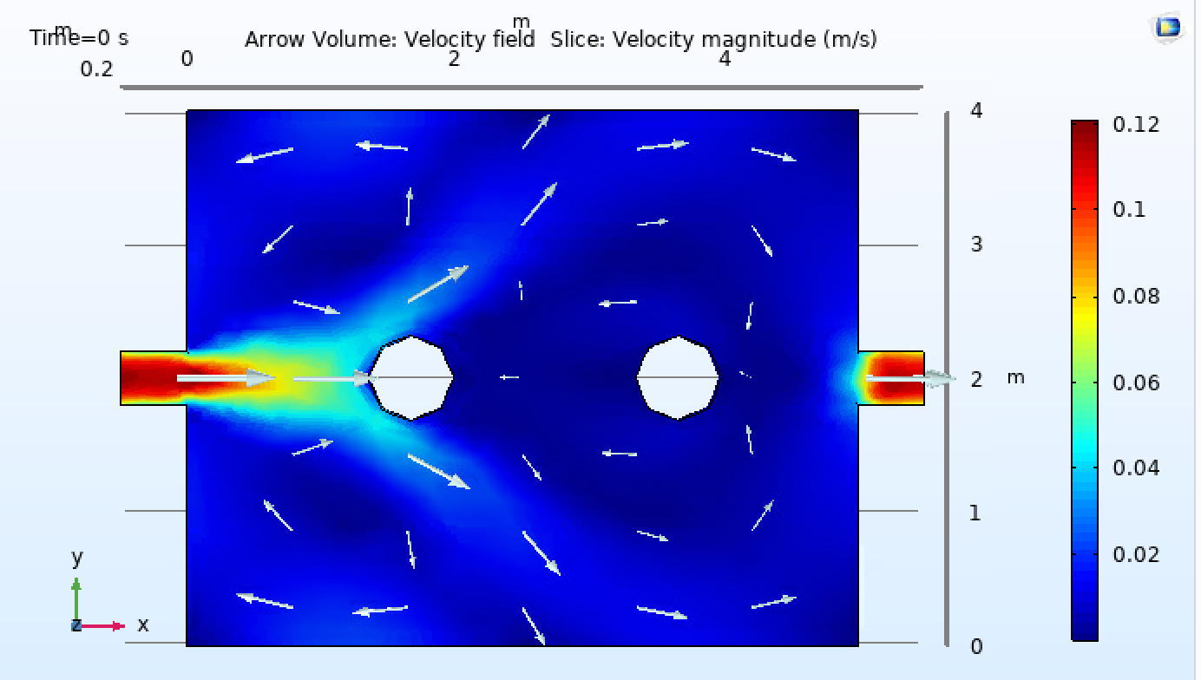

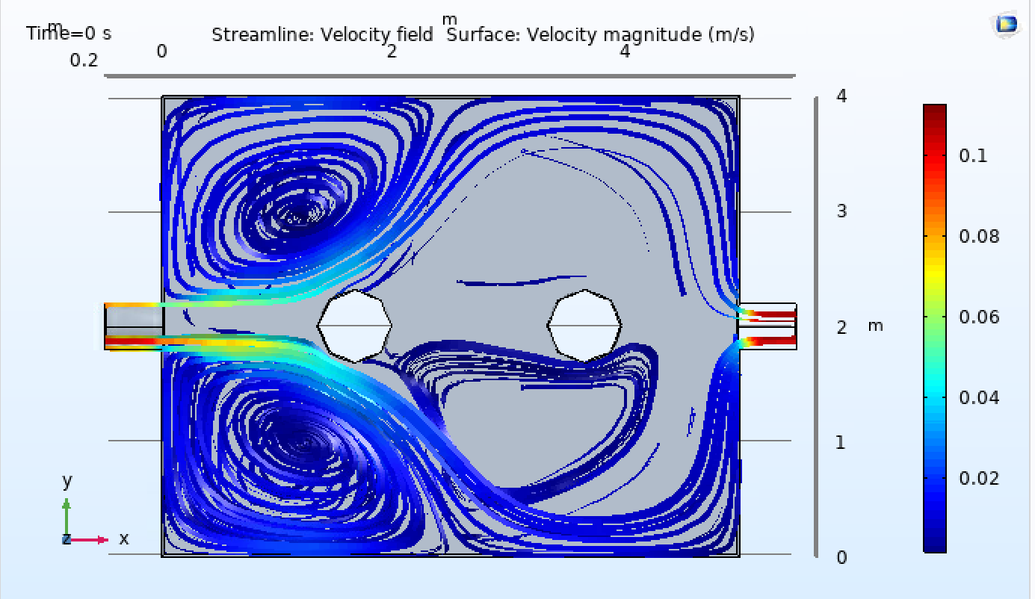

WATER 25℃ Dynamic Viscosity μ = νρ: 8.90×10-4pa.s 0.1 m/s input speed long size

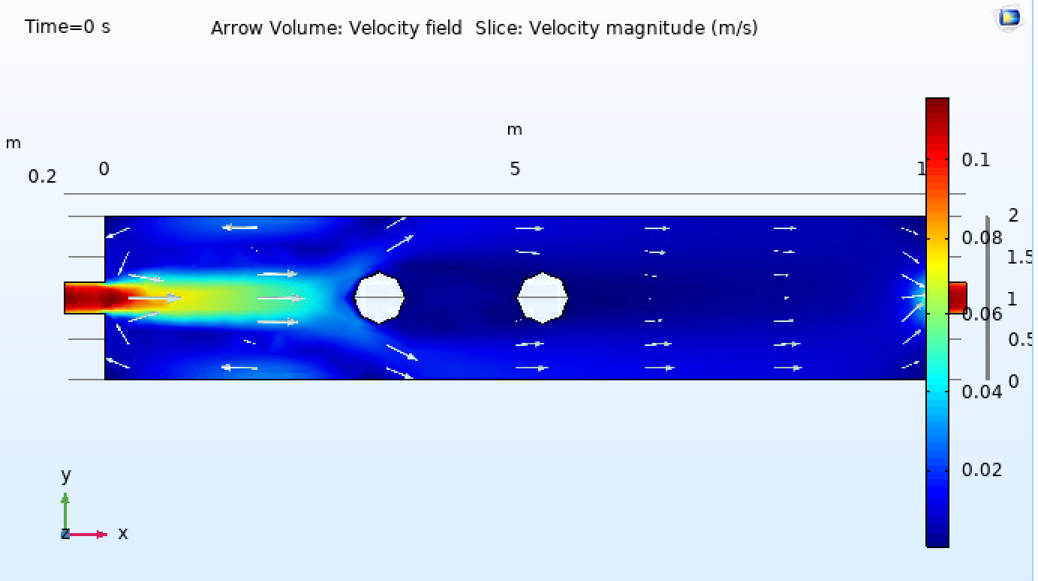

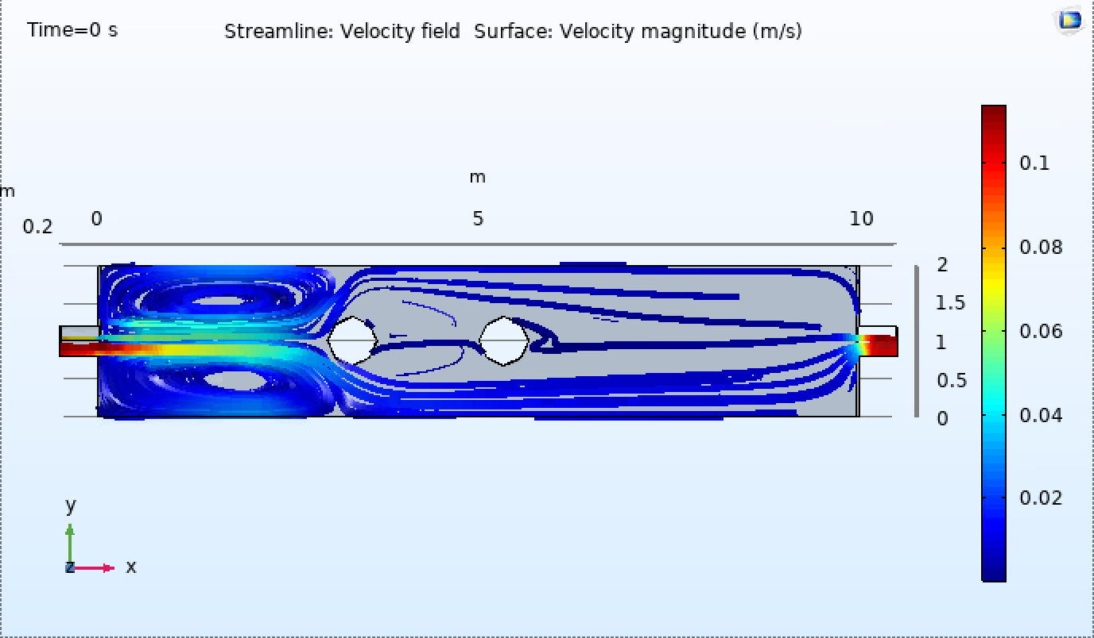

WATER 25℃ Dynamic Viscosity μ = νρ: 8.90×10-4pa.s 0.01 m/s input speed big size input

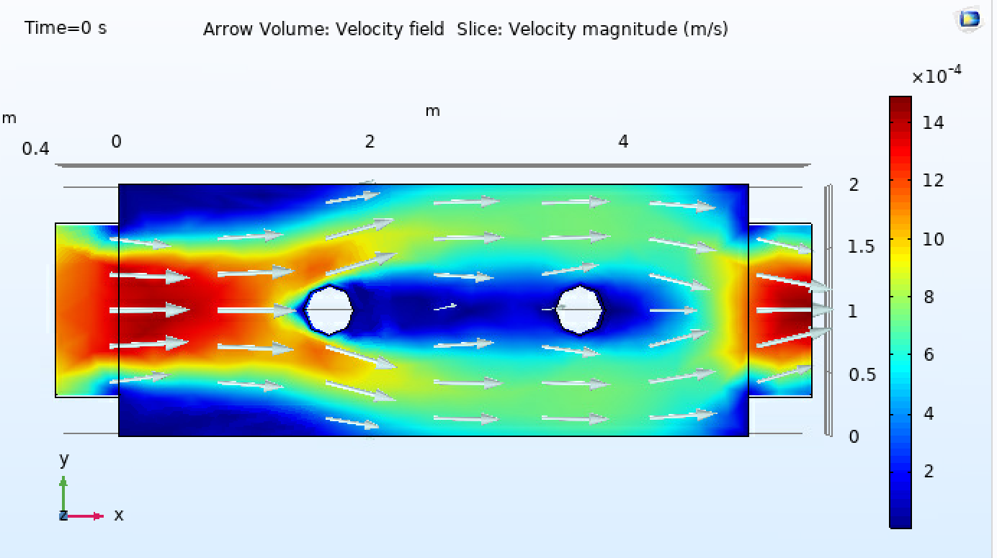

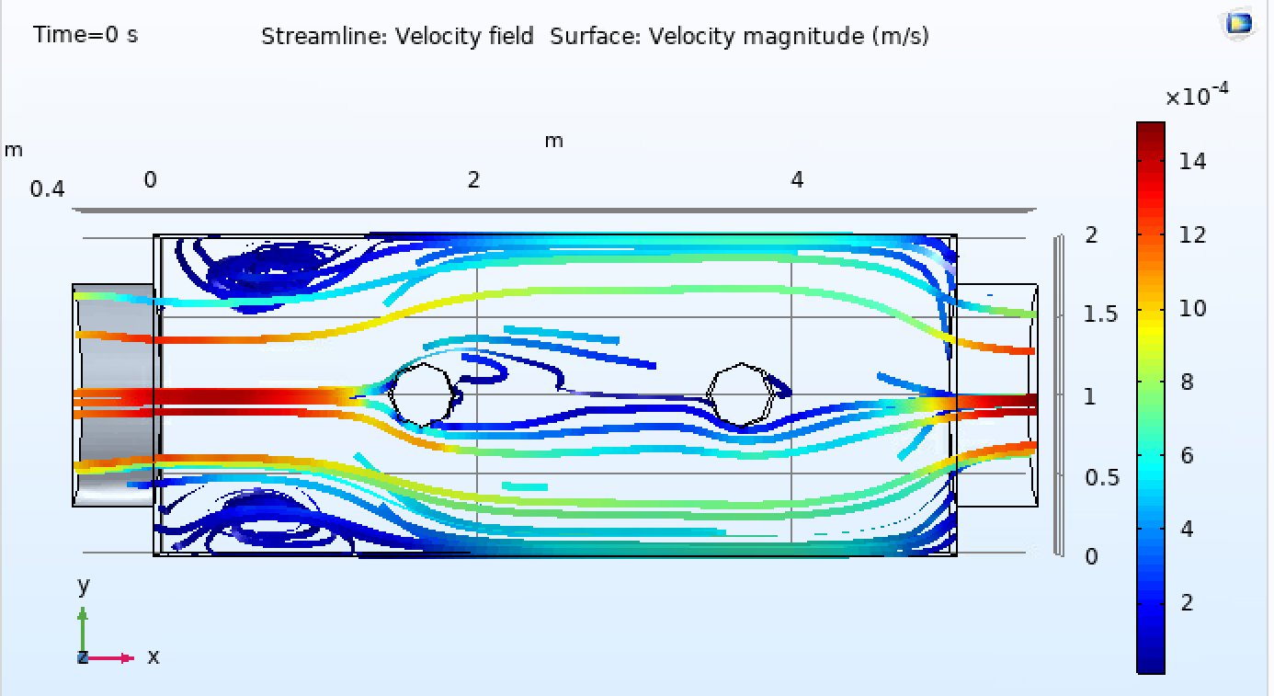

HONEY 25℃ Dynamic Viscosity μ = νρ: 2-10 pa.s (Use 7.5); ρ = 1400-1500 (Use 1450); 0.1 m/s input speed

(Low Reynolds Number now --- Viscous)

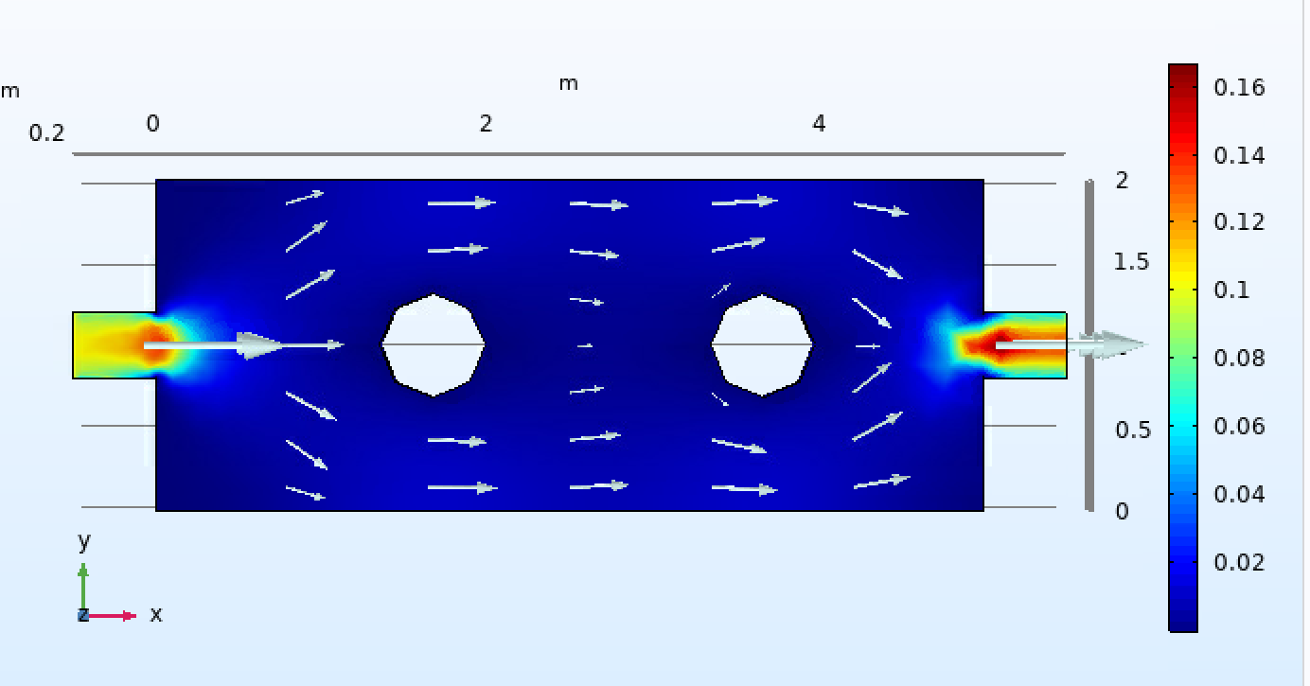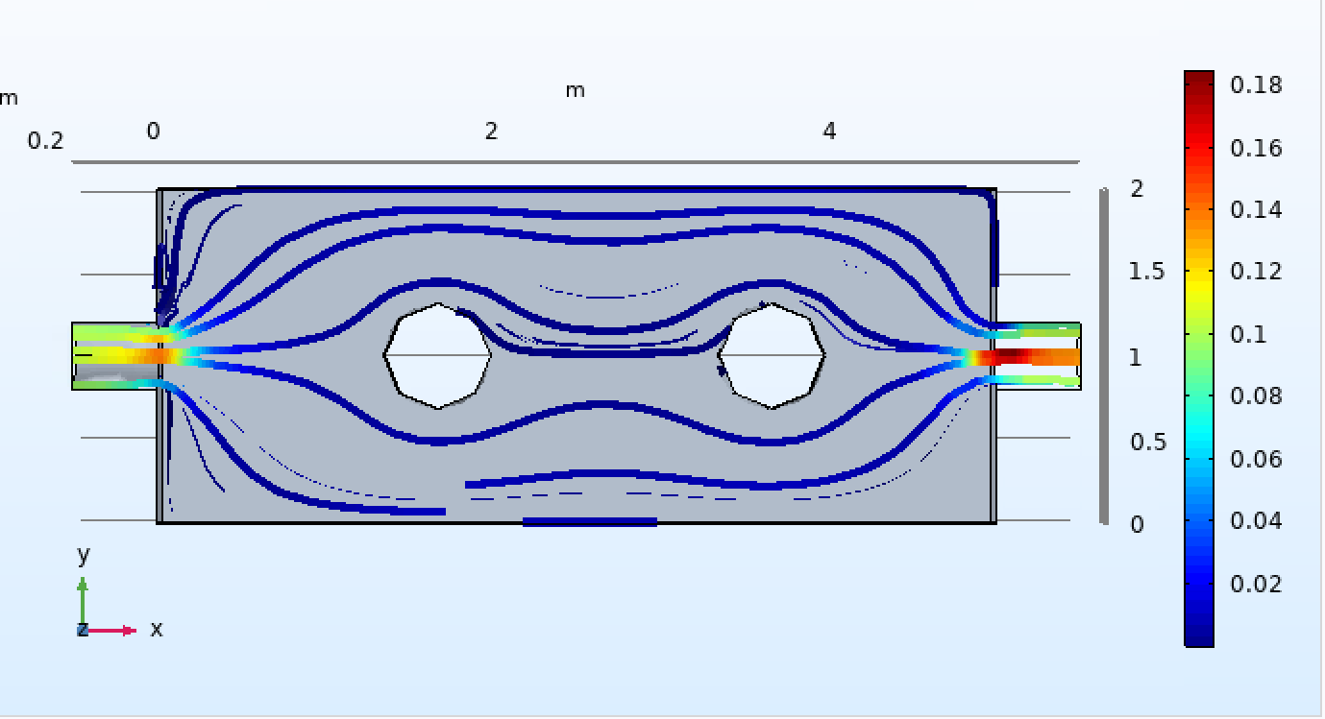

HONEY 25℃ Dynamic Viscosity μ = νρ: 2-10 pa.s (Use 7.5); ρ = 1400-1500 (Use 1450); 1 m/s input speed

