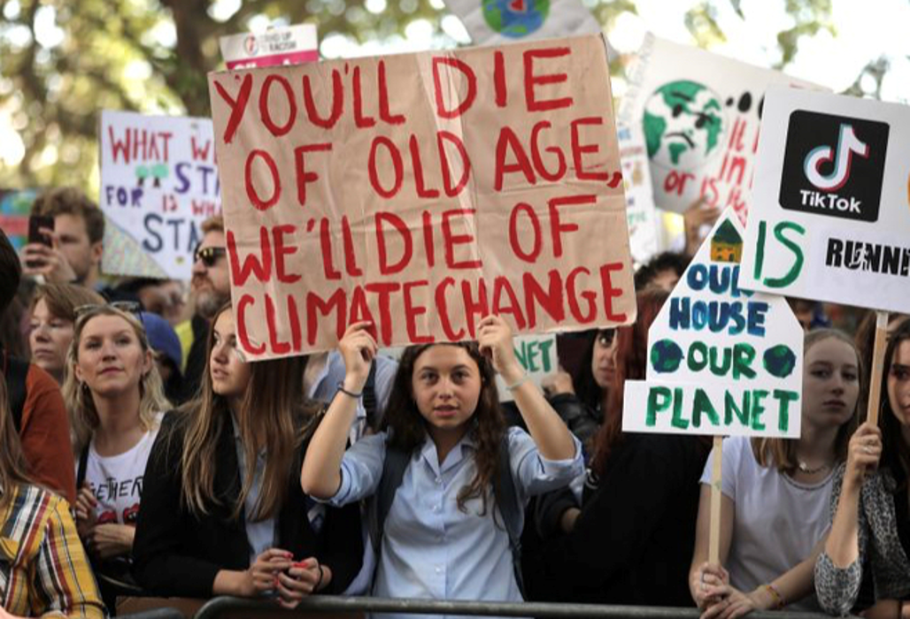
OEfPhD Climate Change Interview Exercise (ver 1.1)

A. Interview Plan

- Do appropriate research on climate change to have an intelligent discussion with English-speaking foreigners;
- Develop an interview plan which frames questions to address the foreigner’s understanding of climate change (what is it), causes, consequences (including generational equity issues), and solutions to climate change (including mitigation and adaptation):
- Identify Interviewer and reporter(s) and define roles;
- Identify (seek out) potential foreign English-speaking interviewees;
- Greeting and introduce to potential interviewees;
- Ask politely if he/she has time for a short interview (approx. 5-7 minutes) in English.
- Explain that this is an exercise for a PhD Oral English and that one person (the interviewer) will ask questions and the other (recorder(s)) will record notes; and
- If a positive response, continue with your questions.
- The interviews may be done as a series of individual interviews, a group interview, or both (some interviewees may be interviewed individually and some may be interviewed in a group) – generally avoid all group interviews
- Thank the interviewee/s and end the interview.
- Review the interviewee’s answers and improve your questions and approach.

B. Interview Report
- Prepare brief written report in WORD (see Appendix 1 sample report style below – be sure to complete the Interview Team Overall Assessments) and complete Table of Statistical Data (at the end of Appendix 1)
- Save report in WORD (with names in alphabetical order) as: (initials of team member)+ (initials of team member) (name in Chinese) & (name in Chinese) OE(10,11, or 12) Cl Ch Interview Report.docx) ) so, for instance: “BSL+XR+ZYQ 白树林&许熔&张焉耆 OE (10,11, or 12) Cl Ch Interview Report.docx” (use alphabetical order with all (3 or 4) names and
- Submit Interview Report to TA Wu by 6pm on Saturday, Oct 12, 2019 as follows:
  - OEfPhD01@163.com (for OE10)
  - OEfPhD02@163.com (for OE11)
  - OEfPhD03@163.com (for OE12)

C. Interview Report Presentation
- Present oral report in class on Wednesday, Oct 16 and/or Oct 23, 2019 (to be confirmed) – MAY use PPT but not required to do so. PPT may include photos with the interviewees.
- Optional PPT could include a title slide with OE students’ names in Chinese and pinyin and class identifier, slide(s) with identification of foreigners interviewed (country and age and program etc.), slide(s) with summary of climate change knowledge and perspective for each interviewee, and slide(s) with summary of your interview team overall assessment. Consider using graphs, charts, and infographics, if appropriate.

[delete the yellow portion of this document prior to submission of Appendix 1]

Sept. 22, 2019

Appendix 1

OE___ (specify whether 10, 11, or 12)
Initials and Name (Chinese+Pinyin) of Student__________
Initials and Name (Chinese+Pinyin) of Student__________
Initials and Name (Chinese+Pinyin) of Student__________
Reply Email (for team):____________________________
Total Time Spent (up to completion of Report): ____(hours)
Date Report Submitted: October __, 2019

Report on Climate Change Interviews at PKU
(this form may be modified)

Sample Individual Interview on 2019/10/__ Interview No. 1
Interviewer: |  | Location:
Nickname of Interviewee |  | Mother Tongue:
Age
Gender
Program | (specify whether PKU Student, Exchange Student from ?, and whether graduate or undergraduate student or teacher)
Major
Nationality
Awareness of
Climate Change
Anthropogenic Climate Change
Causes of
Climate Change
Consequences of
Climate Change
Solutions for climate change
Other Comments

Sample Group Interview on 2019/10/__ Group Interview No. 1
Interviewer: |  | Location:
Nickname of Interviewee 1 |  | Mother Tongue:
Age
Gender
Program | (specify whether PKU Student, Exchange Student from ?, and whether graduate or undergraduate student or teacher)
Major
Nationality
Nickname of Interviewee 2 |  |  | Mother Tongue:
Age
Gender
Program | (specify whether PKU Student, Exchange Student from ?, and whether graduate or undergraduate student or teacher)
Major
Nationality
Nickname of Interviewee 3 |  |  | Mother Tongue:
Age
Gender
Program | (specify whether PKU Student, Exchange Student from ?, and whether graduate or undergraduate student)
Major
Nationality
Awareness of
Climate Change
Anthropogenic Climate Change
Causes of
Climate Change
Consequences of
Climate Change
Solutions for climate change
Other Comments

Interview Team Overall Assessments:

This may include:
- summary of interview process
- summary of opinions expressed/perspectives identified
- how your views on the subject matter have changed
- Identification of interview limitations

Table of Statistical Data

Tasks | Initials of Students Involve | Time Spent (inclusive of all team members)
Climate Change research |  | Hour(s)
Interview Plan preparation and other work |  | Hour(s)
Carrying out interviews |  | Hour(s)
Interview Report preparation and related work |  | Hour(s)
Optional PPT preparation |  | Hour(s)
Total Time: | 100% | ___ hours

May modify questions “on the fly”; no need to go through every question during every interview. See what the interviewee/s knowledge and attitude are and adjust the questions.

