## 设置index.jsp跳转

|  |
| --- |
| <%@ page language=*"java"* import=*"java.util.*"* pageEncoding=*"utf-8"*%>  <%  String path = request.getContextPath();  String basePath = request.getScheme()+"://"+request.getServerName()+":"+request.getServerPort()+path+"/";  response.sendRedirect(basePath+"sys/login_toLoginUI.action");  %> |

## 创建登录action

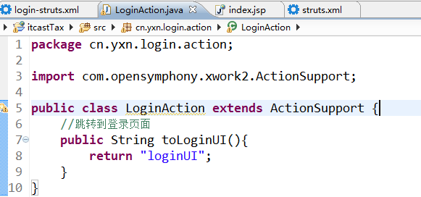

## 创建struts配置文件，注册action



## 4.加入到总配置文件中

