1.

<https://blog.csdn.net/died2369/article/details/120186832>

配置强行改成使用旧版本idc

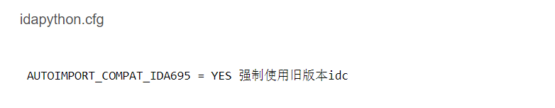

1. <https://blog.xhyeax.com/2021/12/04/idapython-scripts-upgrade/>

## **概述**

执行旧版的IDAPython脚本，提示找不到方法。(如：AttributeError: module 'idc' has no attribute 'MakeUnknown'）  
因为IDA 7.0更新了API，并且从7.1开始默认关闭AUTOIMPORT_COMPAT_IDA695

查看源码（python/3/），发现idc_bc695.py包含旧版api与新版的对应关系。

## **官方文档**

[IDA 7.0: IDAPython backward-compatibility with 6.95 APIs](https://hex-rays.com/products/ida/news/7_0/docs/idapython_backward_compat_695/" \t "https://blog.xhyeax.com/2021/12/04/idapython-scripts-upgrade/_blank)

<https://hex-rays.com/products/ida/news/7_0/docs/idapython_backward_compat_695/>

[IDA 7.0 SDK: Porting from IDA 4.9-6.x API to IDA 7.0 API](https://hex-rays.com/products/ida/news/7_0/docs/api70_porting_guide/" \t "https://blog.xhyeax.com/2021/12/04/idapython-scripts-upgrade/_blank)

<https://hex-rays.com/products/ida/news/7_0/docs/api70_porting_guide/>

## **解决方案**

### **法1 升级脚本**

参照idc_bc695.py，将脚本升级到新版

### **法2 使用idc_bc695**

将脚本中的模块名idc替换为idc_bc695即可

from idc_bc695 import *  
import idc_bc695  
addr = 0x401A86  
for i in range(636):  
 idc_bc695.PatchByte(addr+i,idc_bc695.Byte(addr+i)^0x23)