ClaimIt
A Shared List with Conflict-Safe Claims

Software Engineering Group Project — Assignment 1
Name | Student ID
Liye Zheng | 25305406
Xirui Li | 25305414
Junyu Chen | 25305407
3 November 2026
Word count: 1,466 (excluding title page, references and appendices)
1. Project Definition
Small groups — flatmates, trip groups and student clubs — coordinate shared lists in chat. A claim is only a message: it scrolls away, two members can claim the same item, and nobody can see how many units remain. The organizer discovers the gap at departure. ClaimIt addresses this by providing one cloud-backed list that records each claim once and derives the remaining quantity from the same data. Its value is a single source of truth: every member sees the same state on Android or web, and a conflict becomes visible immediately.
The primary stakeholders are members of three-to-ten-person groups; the secondary stakeholder is the organizer who creates and reconciles the list. The scope for two iterations covers an Android APK and a responsive web app, Firebase Authentication and Cloud Firestore, one list with up to 20 items, claim and release, a conflict response, security rules and continuous integration (CI). Exclusions are chat, payments, notifications, iOS, a custom server, analytics and, until Iteration 2, claim deadlines and per-person limits. Key constraints are a three-person team, one month, two two-week iterations, a free Firebase tier and synthetic demo data.
Three engineering issues follow. First, claim rules will change after the first demo: partial quantities, per-person limits and deadlines are likely additions. We isolate them in a policy module and record changes in the backlog. Second, Android, web and Firestore must share one data model; a mismatch in quantity units, claim ownership or error codes produces inconsistent remaining counts. We fix the schema and a repository contract before UI work. Third, concurrent claims can oversubscribe an item; a read-then-write implementation lets two users claim the last unit. We use one Firestore transaction and test it with a barrier-synchronised concurrency test.
2. Comparison and Selection of Development Approaches
Three approaches were compared: plan-driven development, iterative and incremental development, and agile development. Table 1 summarises the comparison on requirements stability, feedback, change cost, documentation and risk.
Table 1. Comparison of development approaches
Criterion | Plan-driven | Iterative and incremental | Agile (Scrum + XP)
Requirements | Frozen early | Clarified per increment | Emerge through feedback
Feedback | Late | End of each increment | Every one-to-two weeks
Change cost | High | Moderate | Low
Documentation | Heavy upfront | Light, per increment | Just enough, decision records
Risk handling | Late integration | Early, risk-driven | Continuous inspection
Fit for ClaimIt | Poor | Moderate | High

We selected a lightweight Scrum process with XP engineering practices. Scrum supplies the inspection cadence — planning, three short stand-ups per week, review and retrospective — while XP supplies the technical discipline: test-first development for the claim module, a fixed data model and repository contract, CI on every pull request, peer review and small changes (Beck, 1999; Schwaber & Sutherland, 2020). This choice fits a three-person team with uncertain claim rules and two short iterations. A plan-driven approach would freeze the rules before the first demo, when the team has the least information (Royce, 1970); iterative delivery exposes requirement and integration risk earlier (Larman & Basili, 2003; Sommerville, 2016), and CI keeps the cost of change low (Humble & Farley, 2010).
The choice would differ in another context. A distributed team would need asynchronous stand-ups, explicit decision records and a contract-first interface, because tacit coordination is unavailable. A regulated system would require a hybrid: stage gates, traceability and formal verification around an iterative core, since audit evidence cannot be produced retrospectively (Sommerville, 2016).
3. Project Plan
Table 2 presents the prioritised backlog. Each item has a testable acceptance criterion, an owner and an iteration; the first increment is tracked in GitHub Issues.
Table 2. Prioritised backlog
ID | User story | Acceptance criteria (summary) | Priority | Iteration | Owner
1 | Sign in and create a list | APK and web app load; sign-in succeeds; a list is created with a name | P0 | 1 | LZ
2 | Add items with quantities | 1–20 items; name non-empty; quantity > 0; invalid input rejected | P0 | 1 | XL
3 | Claim or release a quantity | Atomic update; claimed + remaining = total; release restores the quantity | P0 | 1 | XL
4 | Handle a conflict | Two concurrent claims: exactly one succeeds; the other receives 409 | P0 | 1 | JC
5 | Enforce access rules | A non-member cannot read or write the list | P0 | 1 | JC
6 | Prove the invariant | 1,000 randomized claim sequences satisfy the invariant | P0 | 1 | JC
7 | Add deadlines and limits | A claim after the deadline is rejected; the per-person limit is enforced | P1 | 2 | LZ
8 | Add audit history and offline queue | History shows actor, quantity and time; a queued claim replays once | P1 | 2 | XL

LZ, XL and JC denote Liye Zheng, Xirui Li and Junyu Chen.
Liye Zheng is Product Owner and owns the Android client; Xirui Li is Tech Lead and owns the Firestore model, transaction and security rules; Junyu Chen is QA/DevOps and owns the web client, CI and evidence. The team agreed that everyone develops and reviews at least one pull request per iteration.
Iteration 1 delivers the walking skeleton and the core claim loop: both clients, authentication, list and item creation, claim and release, the transaction, security rules and CI. Iteration 2 adds deadlines, per-person limits, audit history, an offline queue and hardening.
Table 3 records the main risks. Scope creep is managed by a fixed scope table: changes must replace an item, not add one. Availability risk is managed by sizing iteration goals to 8–10 hours per member per week and naming a backup owner for each issue. Cloud and Android risks are checked in Week 1 against free-tier limits and two emulator profiles. Concurrent-claim defects are managed by the transaction, an idempotency key and property-based tests.
Table 3. Key risks and mitigations
Risk | Likelihood / impact | Mitigation | Owner
Scope creep | High / medium | Fixed scope; changes replace, not add | LZ
Member availability | Medium / high | 8–10 hours per week; backup owner | LZ
Cloud and Android variability | Medium / high | Free-tier check; two emulator profiles | XL
Concurrent-claim defects | Medium / high | Transaction; idempotency; property tests | JC

Figure 1 shows the system overview. The Android app and the web app use the Firebase SDK to authenticate and to read and write Cloud Firestore. A claim is a transaction on the item document: the client reads the remaining quantity, validates it, decrements it and writes the claim in one atomic operation. GitHub Actions builds the APK, runs unit tests and runs Firestore emulator tests on every pull request.
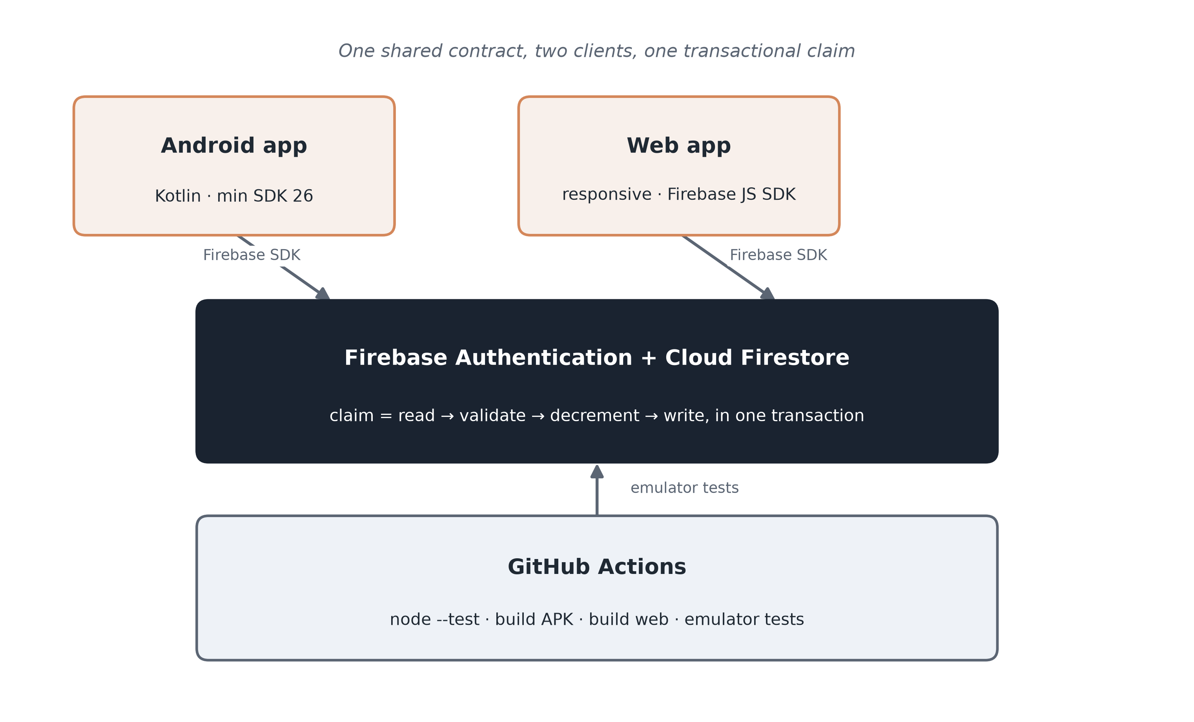
Figure 1. Planned system overview.
Four design decisions follow. First, a managed Firebase backend (Google, n.d.) is preferred to a custom server because it removes deployment, backup and authentication work from a one-month project; the trade-off is vendor lock-in, mitigated by a repository interface. Second, one Firestore schema is shared by both clients; the schema and a repository contract are fixed before UI work, and both clients run against the same emulator fixtures. Third, claims use a transaction rather than a queue: correctness matters more than throughput at this scale, and the transaction is easy to test. Fourth, quantities are integers, so the invariant needs no floating-point tolerance.
4. Workflow Trial
The repository was created with issue and pull request templates and a CI workflow. The trial change was Issue #3, "Claim and release a quantity", with Given/When/Then acceptance criteria. It was implemented on feat/3-claim-release and merged through pull request #4. Two reviewers, Xirui Li and Junyu Chen, approved the change; CI passed on the pull request, and the change was squashed into main as commit ab45e76. Issue #3 closed automatically when the pull request merged.
Evidence is indexed in Appendix B: the issue, the pull request, both reviews, the CI run and the test file. The trial taught three lessons. First, keeping claim as a stub on main made the trial PR small — two files and 144 added lines — so both reviewers could inspect the transaction logic rather than a large, mixed change. Second, a concurrency test is only meaningful when both claims start together; the final test uses Promise.allSettled rather than sequential calls, so the race is exercised and exactly one conflict is asserted. Third, CI currently runs only the domain tests; the Android and web builds must be added to the workflow in Iteration 1, or the green check will overstate what has been verified.
5. Individual Contribution Statements
Table 4 records each member's contribution. Commit counts are not used as evidence; the links point to issue ownership, pull request authorship, review comments, tests and documentation.
Table 4. Contribution summary
Member | Role | Main contributions | Evidence
Liye Zheng (25305406) | Product Owner; Android client | Issue #3; implemented atomic claim and release; PR #4; 9 tests | issue #3, PR #4
Xirui Li (25305414) | Tech Lead; Firestore model | Reviewed and approved PR #4; owns the Firestore schema and transaction design for Iteration 1 | review
Junyu Chen (25305407) | QA/DevOps; web client and CI | Reviewed and approved PR #4; owns CI and the evidence index | review, CI run

References
Beck, K. (1999). Extreme programming explained: Embrace change. Addison-Wesley.
Google. (n.d.). Cloud Firestore documentation. https://firebase.google.com/docs/firestore
Humble, J., & Farley, D. (2010). Continuous delivery: Reliable software releases through build, test, and deployment automation. Addison-Wesley.
Larman, C., & Basili, V. R. (2003). Iterative and incremental development: A brief history. Computer, 36(6), 47–56. https://doi.org/10.1109/MC.2003.1204375
Royce, W. W. (1970). Managing the development of large software systems. Proceedings of IEEE WESCON, 26, 1–9.
Schwaber, K., & Sutherland, J. (2020). The Scrum Guide. https://scrumguides.org/scrum-guide.html
Sommerville, I. (2016). Software engineering (10th ed.). Pearson.
Appendix B: Evidence Index
Repository: https://github.com/yuanye820/claimit
Claim | Evidence | Link
Backlog and priorities | GitHub Issues | issues
Requirement trace | docs/traceability.md | traceability
Tracked requirement | Issue #3 | issue #3
Reviewed change | Pull request #4 | PR #4
Review 1 | Xirui Li approved | review
Review 2 | Junyu Chen approved | review
Automated checks | GitHub Actions CI run | CI run
Test file | test/claim-engine.test.js | test file
Contribution: Liye Zheng | Issue #3 and PR #4 | issue, PR
Contribution: Xirui Li | Review on PR #4 | review
Contribution: Junyu Chen | Review on PR #4 and CI | review, CI
Appendix C: Team Working Agreement
The team agreed on the following initial working agreement. It is kept in docs/working-agreement.md and reviewed at the end of Iteration 1.
- Roles: Liye Zheng (Product Owner; Android client), Xirui Li (Tech Lead; Firestore model and transaction), Junyu Chen (QA/DevOps; web client, CI and evidence). Everyone develops and reviews.
- Cadence: stand-ups on Monday, Wednesday and Friday at 20:00; planning at iteration start; review and retrospective at iteration end.
- Workflow: main branch; issue-named feature branches; pull requests with one approving review and green CI; squash merge.
- Definition of Done: acceptance criteria verified, tests added, documentation updated, reviewed, CI green, no secrets committed.

