《并行计算》上机报告

姓名： | 袁一玮 |  | 学号： | PB18000221 | 日期： | 2021.5.20
上机题目： | MPI并行编程实验
实验环境：
CPU:Xeon(R) Silver 4116; 内存:255G; 操作系统:Debian 10; 软件平台:openmpi;
一、算法设计与分析：
题目一:
使用MPI计算Pi的值，使用了并行规约的方法

题目二:
使用MPI重写PSRS算法

二、核心代码：
题目一:
MPI_Bcast(&n, 1, MPI_UNSIGNED, 0, MPI_COMM_WORLD);
for (int i = rank; i < n; i += size)
{
double x = (i + 0.5) / n;
sum += 4.0 / (1.0 + x * x);
}
MPI_Reduce(&sum, &total, 1, MPI_DOUBLE, MPI_SUM, 0, MPI_COMM_WORLD);
total /= n;

题目二:
各组内排序
mSort(A, id * per, (id + 1) * per - 1);
for (int k = 0; k < num_processes; k++)
samples[k] = A[id * per + k * per / num_processes];
MPI_Gather(samples, num_processes, MPI_INT, global_samples, num_processes, MPI_INT, 0, MPI_COMM_WORLD);
if (id == 0)
{
mSort(global_samples, 0, num_processes * num_processes - 1);
for (int k = 0; k < num_processes - 1; k++)
pivots[k] = global_samples[(k + 1) * num_processes];
pivots[num_processes - 1] = INF;
}
MPI_Bcast(pivots, num_processes, MPI_INT, 0, MPI_COMM_WORLD);

采样后组间交换内容，并完成后续的排序
for (int k = 0, j = id * per; j < id * per + per; j++)
{
if (A[j] < pivots[k])
sizes[k]++;
else
sizes[++k]++;
}
MPI_Alltoall(sizes, 1, MPI_INT, newsizes, 1, MPI_INT, MPI_COMM_WORLD);
newdatassize = newsizes[0];
for (int k = 1; k < num_processes; k++)
{
offsets[k] = offsets[k - 1] + sizes[k - 1];
newoffsets[k] = newoffsets[k - 1] + newsizes[k - 1];
newdatassize += newsizes[k];
}
newdatas = (int *)malloc(newdatassize * sizeof(int));
MPI_Alltoallv(&(A[id * per]), sizes, offsets, MPI_INT, newdatas, newsizes, newoffsets, MPI_INT, MPI_COMM_WORLD);
MPI_Barrier(MPI_COMM_WORLD);
mSort(newdatas, 0, newdatassize - 1);
MPI_Barrier(MPI_COMM_WORLD);
if (id == 0)
global_sizes = (int *)calloc(num_processes, sizeof(int));
MPI_Gather(&newdatassize, 1, MPI_INT, global_sizes, 1, MPI_INT, 0, MPI_COMM_WORLD);
if (id == 0)
{
global_offsets = (int *)calloc(num_processes, sizeof(int));
for (int k = 1; k < num_processes; k++)
global_offsets[k] = global_offsets[k - 1] + global_sizes[k - 1];
}
MPI_Gatherv(newdatas, newdatassize, MPI_INT, A, global_sizes, global_offsets, MPI_INT, 0, MPI_COMM_WORLD);

三、结果与分析：
题目一:
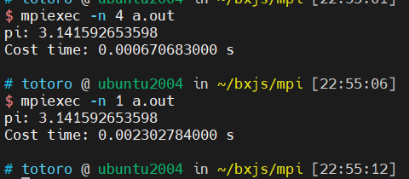
可以看到，四进程的pi计算比单线程快了不少

题目二:
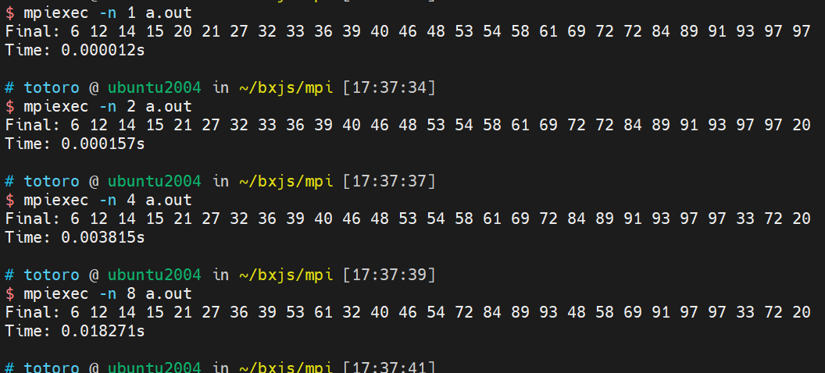
可以看到因为每组计算量并不大，组间的内容交换反而会拖慢总的计算时间

总结：
实验二的算Pi和PSRS算法和实验一相差不大，只是MPI的实现版本有点多且mpich已经停更许久，较新的openmpi与其具体细节有一点差别，花费一些时间

附录（源代码） |  | Pi的MPI：  int main(int argc, char **argv)  {  int n = 100000;  double sum = 0.;  int rank, size;  MPI_Init(&argc, &argv);  MPI_Comm_rank(MPI_COMM_WORLD, &rank);  MPI_Comm_size(MPI_COMM_WORLD, &size);  const double starttime = MPI_Wtime();  MPI_Bcast(&n, 1, MPI_UNSIGNED, 0, MPI_COMM_WORLD);  for (int i = rank; i < n; i += size)  {  double x = (i + 0.5) / n;  sum += 4.0 / (1.0 + x * x);  }  double total;  MPI_Reduce(&sum, &total, 1, MPI_DOUBLE, MPI_SUM, 0, MPI_COMM_WORLD);  total /= n;  const double endtime = MPI_Wtime();  MPI_Finalize();  if (rank == 0)  printf("pi: %.12lf\nCost time: %.12lf s\n", total, endtime - starttime);  return 0;  }  PSRS算法：  void Merge(int *A, int l, int m, int r)  {  int i, j, k, n1 = m - l + 1, n2 = r - m;  int *L = (int *)malloc((n1 + 1) * sizeof(int));  int *R = (int *)malloc((n2 + 1) * sizeof(int));  for (i = 0; i < n1; i++)  L[i] = A[l + i];  for (j = 0; j < n2; j++)  R[j] = A[m + 1 + j];  L[i] = R[j] = INF;  i = j = 0;  for (k = l; k <= r; k++)  if (L[i] <= R[j])  A[k] = L[i++];  else  A[k] = R[j++];  free(L);  free(R);  }  void mSort(int *A, int l, int r)  {  if (l < r)  {  int m = (l + r) / 2;  mSort(A, l, m);  mSort(A, m + 1, r);  Merge(A, l, m, r);  }  }  void psrs(int *A, int n, int id, int num_processes)  {  int *samples, *global_samples, per, *pivots, *sizes, *newsizes, *offsets, *newoffsets, *newdatas, newdatassize, *global_sizes, *global_offsets;  per = n / num_processes;  samples = (int *)malloc(num_processes * sizeof(int));  pivots = (int *)malloc(num_processes * sizeof(int));  if (id == 0)  {  global_samples = (int *)malloc(num_processes * num_processes * sizeof(int));  }  MPI_Barrier(MPI_COMM_WORLD);  mSort(A, id * per, (id + 1) * per - 1);  for (int k = 0; k < num_processes; k++)  samples[k] = A[id * per + k * per / num_processes];  MPI_Gather(samples, num_processes, MPI_INT, global_samples, num_processes, MPI_INT, 0, MPI_COMM_WORLD);  if (id == 0)  {  mSort(global_samples, 0, num_processes * num_processes - 1);  for (int k = 0; k < num_processes - 1; k++)  pivots[k] = global_samples[(k + 1) * num_processes];  pivots[num_processes - 1] = INF;  }  MPI_Bcast(pivots, num_processes, MPI_INT, 0, MPI_COMM_WORLD);  MPI_Barrier(MPI_COMM_WORLD);  sizes = (int *)calloc(num_processes, sizeof(int));  offsets = (int *)calloc(num_processes, sizeof(int));  newsizes = (int *)calloc(num_processes, sizeof(int));  newoffsets = (int *)calloc(num_processes, sizeof(int));  for (int k = 0, j = id * per; j < id * per + per; j++)  {  if (A[j] < pivots[k])  sizes[k]++;  else  sizes[++k]++;  }  MPI_Alltoall(sizes, 1, MPI_INT, newsizes, 1, MPI_INT, MPI_COMM_WORLD);  newdatassize = newsizes[0];  for (int k = 1; k < num_processes; k++)  {  offsets[k] = offsets[k - 1] + sizes[k - 1];  newoffsets[k] = newoffsets[k - 1] + newsizes[k - 1];  newdatassize += newsizes[k];  }  newdatas = (int *)malloc(newdatassize * sizeof(int));  MPI_Alltoallv(&(A[id * per]), sizes, offsets, MPI_INT, newdatas, newsizes, newoffsets, MPI_INT, MPI_COMM_WORLD);  MPI_Barrier(MPI_COMM_WORLD);  mSort(newdatas, 0, newdatassize - 1);  MPI_Barrier(MPI_COMM_WORLD);  if (id == 0)  global_sizes = (int *)calloc(num_processes, sizeof(int));  MPI_Gather(&newdatassize, 1, MPI_INT, global_sizes, 1, MPI_INT, 0, MPI_COMM_WORLD);  if (id == 0)  {  global_offsets = (int *)calloc(num_processes, sizeof(int));  for (int k = 1; k < num_processes; k++)  global_offsets[k] = global_offsets[k - 1] + global_sizes[k - 1];  }  MPI_Gatherv(newdatas, newdatassize, MPI_INT, A, global_sizes, global_offsets, MPI_INT, 0, MPI_COMM_WORLD);  MPI_Barrier(MPI_COMM_WORLD);  free(samples);  free(pivots);  free(sizes);  free(offsets);  free(newdatas);  free(newsizes);  free(newoffsets);  samples = NULL;  pivots = NULL;  sizes = NULL;  offsets = NULL;  newdatas = NULL;  newsizes = NULL;  newoffsets = NULL;  if (id == 0)  {  free(global_samples);  free(global_sizes);  free(global_offsets);  global_samples = NULL;  global_sizes = NULL;  global_offsets = NULL;  }  }  int main(int argc, char *argv[])  {  int A[27] = {15, 46, 48, 93, 39, 6, 72, 91, 14, 36, 69, 40, 89, 61, 97, 12, 21, 54, 53, 97, 84, 58, 32, 27, 33, 72, 20};  double time_start, time_end;  int id, num_processes;  MPI_Init(&argc, &argv);  MPI_Comm_size(MPI_COMM_WORLD, &num_processes);  MPI_Comm_rank(MPI_COMM_WORLD, &id);  if (id == 0)  time_start = MPI_Wtime();  psrs(A, 27, id, num_processes);  if (id == 0)  {  time_end = MPI_Wtime();  printf("Final: ");  for (int i = 0; i < 27; i++)  printf("%d ", A[i]);  printf("\nTime: %lfs\n", time_end - time_start);  }  MPI_Finalize();  return 0;  }

