《并行计算》上机报告

姓名： | 袁一玮 |  | 学号： | PB18000221 | 日期： | 2021.6.18
上机题目： | 多机OpenMP并行编程实验
实验环境：
CPU:HiSilicon Kunpeng 920; 内存:190G; 系统:openEular; 软件平台:openmp;
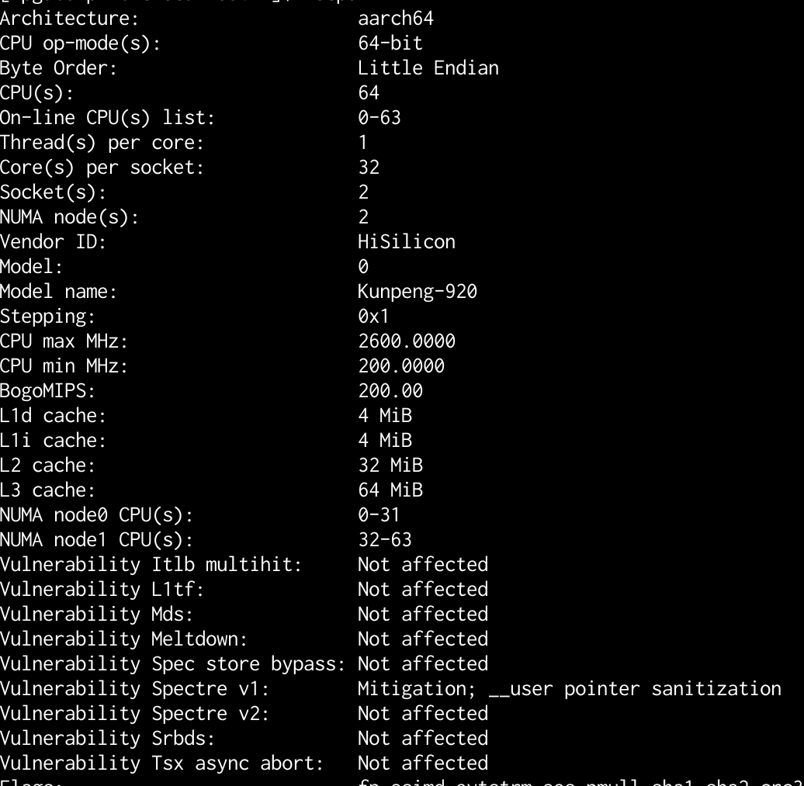
一、算法设计与分析：
题目一:
使用OpenMP在鲲鹏机器上进行快速排序计算

二、核心代码：
题目一:
快速排序main
#pragma omp parallel for
for (int i = 0; i < n; i++) array[i] = rand_r(&seed);

struct timeval start, stop;
gettimeofday(&start, NULL);

#pragma omp parallel default(none) shared(array, n)
{
#pragma omp single nowait
{ QuickSort(array, n); }
}
gettimeofday(&stop, NULL);

double elapse = (stop.tv_sec - start.tv_sec) * 1000 +
(stop.tv_usec - start.tv_usec) / 1000;
cout << elapse << " " << n << endl;

for (int i = 0; i < n - 1; i++) {
if (array[i] > array[i + 1]) {
cerr << "quick sort fails! \n";
break;
}
}

快排实现
void QuickSort(int *&array, int len) {
if (len <= 1) return;
int pivot = array[len / 2];
int left_ptr = 0;
int right_ptr = len - 1;
while (left_ptr <= right_ptr) {
while (array[left_ptr] < pivot) left_ptr += 1;
while (array[right_ptr] > pivot) right_ptr -= 1;
if (left_ptr <= right_ptr) {
swap(array[left_ptr], array[right_ptr]);
left_ptr += 1;
right_ptr -= 1;
}
}
int *sub_array[] = {array, &(array[left_ptr])};
int sub_len[] = {right_ptr + 1, len - left_ptr};

#pragma omp task default(none) firstprivate(sub_array, sub_len)
{ QuickSort(sub_array[0], sub_len[0]); }
#pragma omp task default(none) firstprivate(sub_array, sub_len)
{ QuickSort(sub_array[1], sub_len[1]); }
}

三、结果与分析：
题目一:
执行make之后进行快速排序操作，执行结果和教程中类似，耗时在600附近
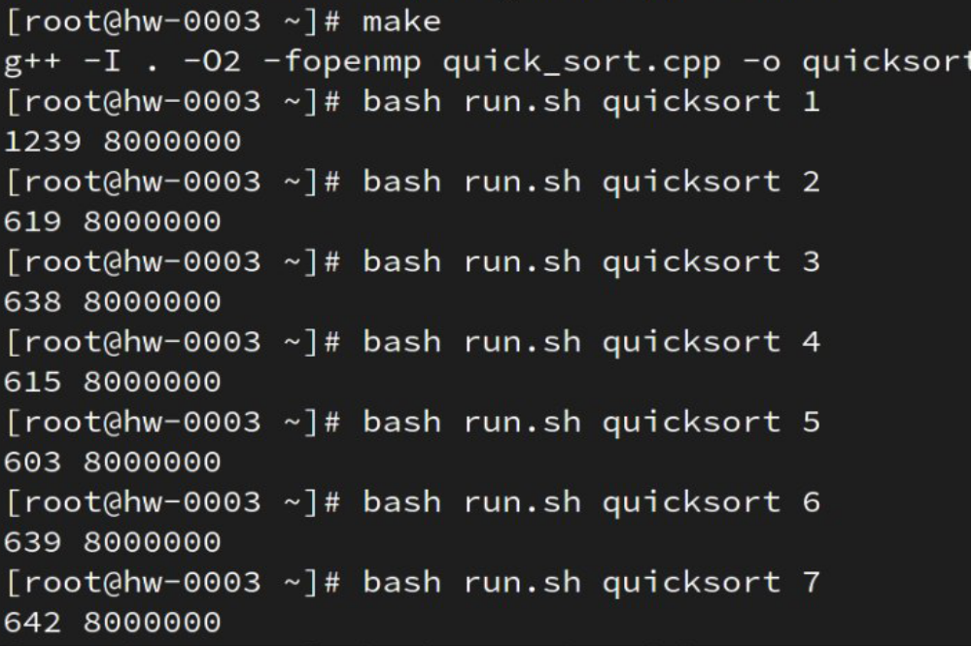

总结：
实验并不是太难，跟教程走一遍和实验一差不多

附录（源代码） |  | 算法源代码（C/C++/JAVA描述）  快速排序  #include <math.h>  #include <stdio.h>  #include <stdlib.h>  #include <sys/time.h>  #include <time.h>  #include <iostream>  #include "omp.h"  using namespace std;  void QuickSort(int *&array, int len) {  if (len <= 1) return;  int pivot = array[len / 2];  int left_ptr = 0;  int right_ptr = len - 1;  while (left_ptr <= right_ptr) {  while (array[left_ptr] < pivot) left_ptr += 1;  while (array[right_ptr] > pivot) right_ptr -= 1;  if (left_ptr <= right_ptr) {  swap(array[left_ptr], array[right_ptr]);  left_ptr += 1;  right_ptr -= 1;  }  }  int *sub_array[] = {array, &(array[left_ptr])};  int sub_len[] = {right_ptr + 1, len - left_ptr};  #pragma omp task default(none) firstprivate(sub_array, sub_len)  { QuickSort(sub_array[0], sub_len[0]); }  #pragma omp task default(none) firstprivate(sub_array, sub_len)  { QuickSort(sub_array[1], sub_len[1]); }  // for (int i = 0; i < 2; i++) QuickSort(sub_array[i], sub_len[i]);  }  int main(int argc, char *argv[]) {  srand(time(NULL));  if (argc != 3) {  cout << "Usage: " << argv[0] << " thread-num array-len\n";  exit(-1);  }  int t = atoi(argv[1]);  int n = atoi(argv[2]);  int *array = new int[n];  omp_set_num_threads(t);  unsigned int seed = 1024;  #pragma omp parallel for  for (int i = 0; i < n; i++) array[i] = rand_r(&seed);  struct timeval start, stop;  gettimeofday(&start, NULL);  #pragma omp parallel default(none) shared(array, n)  {  #pragma omp single nowait  { QuickSort(array, n); }  }  gettimeofday(&stop, NULL);  double elapse = (stop.tv_sec - start.tv_sec) * 1000 +  (stop.tv_usec - start.tv_usec) / 1000;  cout << elapse << " " << n << endl;  for (int i = 0; i < n - 1; i++) {  if (array[i] > array[i + 1]) {  cerr << "quick sort fails! \n";  break;  }  }  return 0;  }  Makefile编译文件  CC = g++  CCFLAGS = -I . -O2 -fopenmp  LDFLAGS = # -lopenblas  all: quicksort  quicksort: quick_sort.cpp  ${CC} ${CCFLAGS} quick_sort.cpp -o quicksort ${LDFLAGS}  clean:  rm quicksort

