## **Create an EC2 instance using awscli**

### **[1] Create a security group**

aws ec2 create-security-group --group-name 22994257-sg --description "security group for development environment"

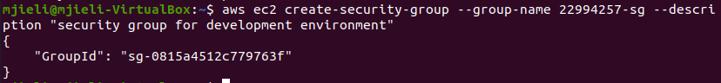

### **[2] Authorise inbound traffic for ssh**

aws ec2 authorize-security-group-ingress --group-name 22994257-sg --protocol tcp --port 22 --cidr 0.0.0.0/0

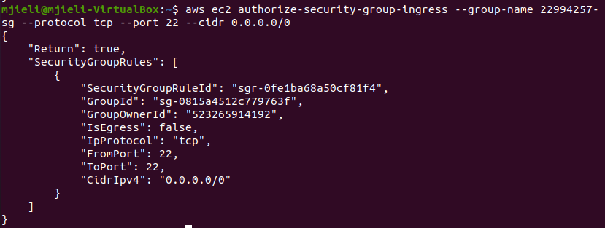

### **[3] Create a key pair that will allow you to ssh to the EC2 instance**

aws ec2 create-key-pair --key-name 22994257-key --query 'KeyMaterial' --output text > 22994257-key.pem





chmod 400 22994257-key.pem

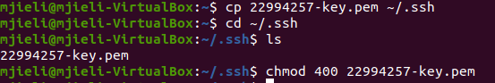

### **[4] Create the instance and note the instance id**

aws ec2 run-instances --image-id ami-d38a4ab1 --security-group-ids 22994257-sg --count 1 --instance-type t2.micro --key-name 22994257-key --query 'Instances[0].InstanceId'



### **[5] Get the public IP address**

aws ec2 describe-instances --instance-ids i-034ed977bb1ce09c3 --query 'Reservations[0].Instances[0].PublicIpAddress'



### **[6] Connect to the instance**

ssh -i 22994257-key.pem ubuntu@54.66.189.53

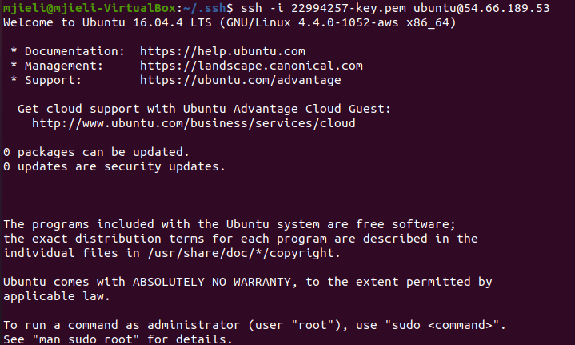

### **[7] Look at the instance using the AWS console**

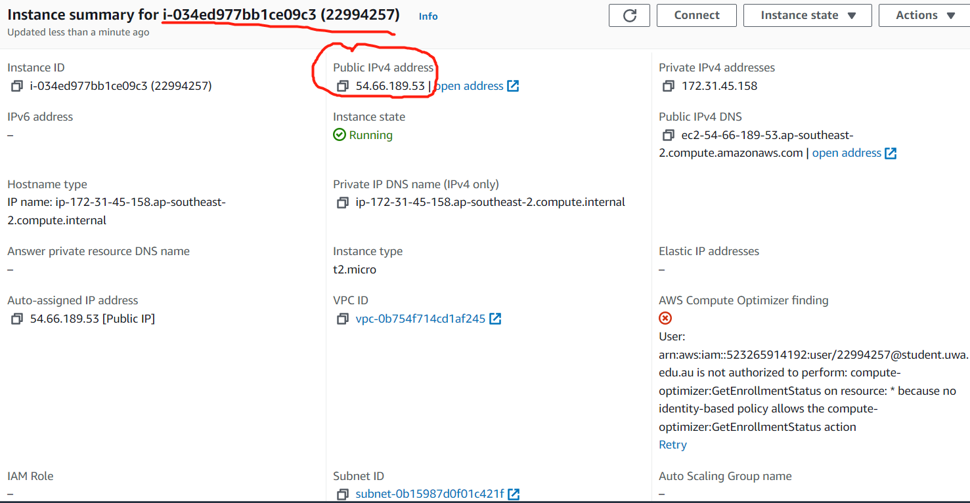

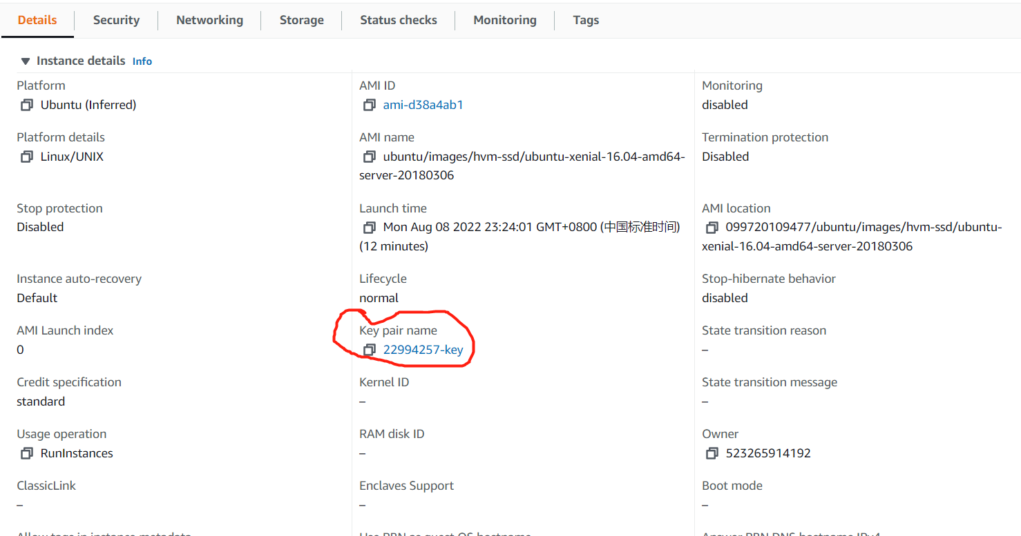

## **Create an EC2 instance Python Boto script**

### **[1][2][3] Repeat the step1-3 using boot**

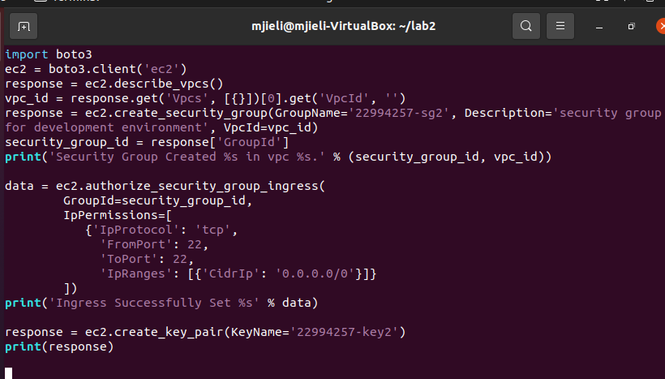

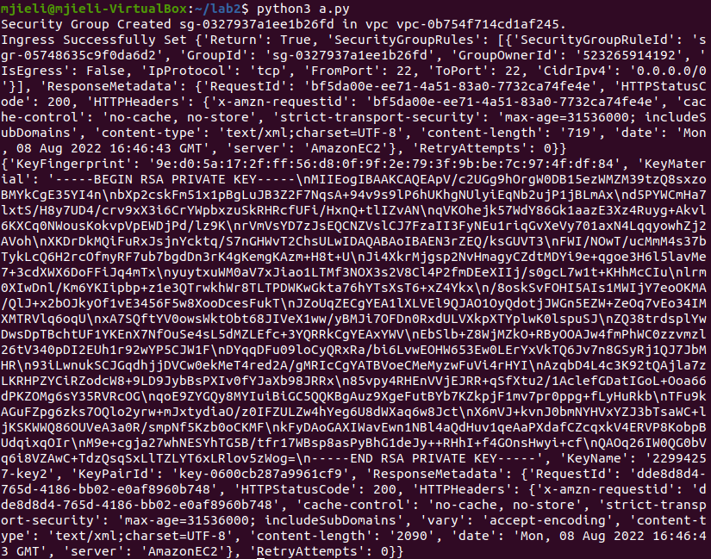

Security Group Created sg-0327937a1ee1b26fd in vpc vpc-0b754f714cd1af245

### **[4] Repeat the step4 to create the instance**

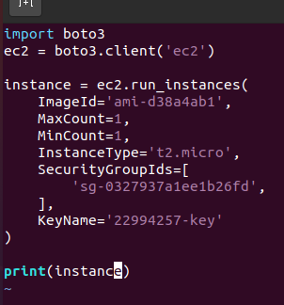

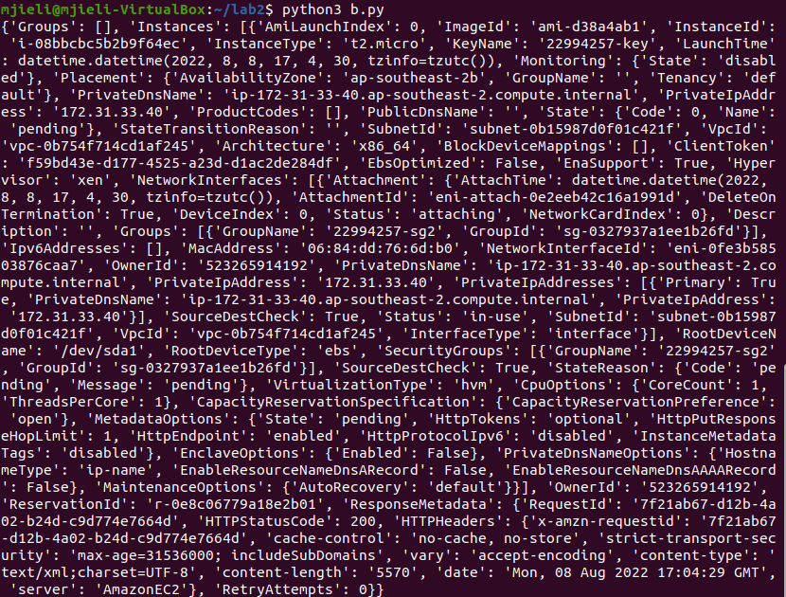

Instance ID is i-08bbcbc5b2b9f64ec

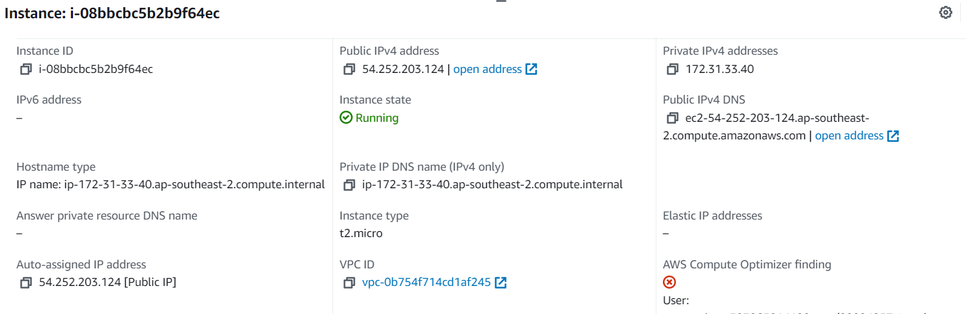

### **[5] Return the public IP of the instance**

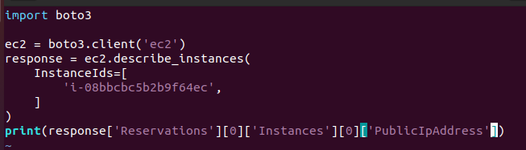

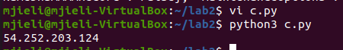

Public address is 54.252.203.124

## **Using Docker**

### **[1] Install Docker and check the version**

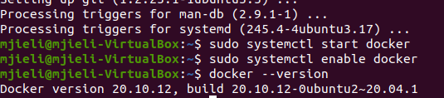

### **[2] Build the docker image**

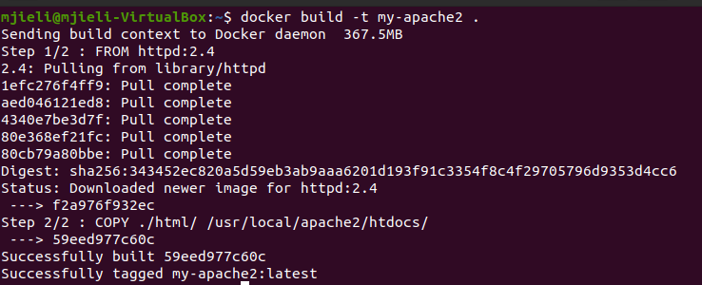

### **[3] Run the image**



### **[4]get Hello World!**

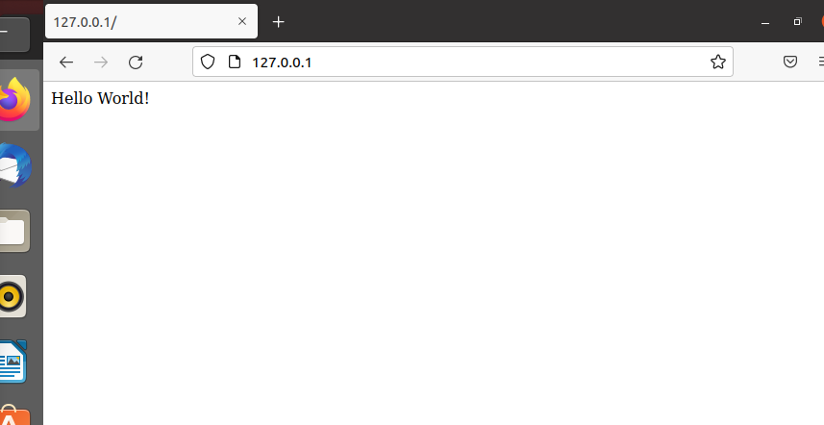

### **[5] Other commands**

