**Lab 3 Notes**

Student ID: 22994257

Name: Gaoyuan Zhang

### **[Step 1] Preparation**

1.Create the directories and files

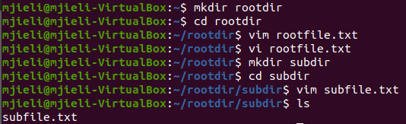

### **[Step 2] Save to S3**

1. Download the cloudstorage.py from github and add some key functions, such as create_bucket, upload_file

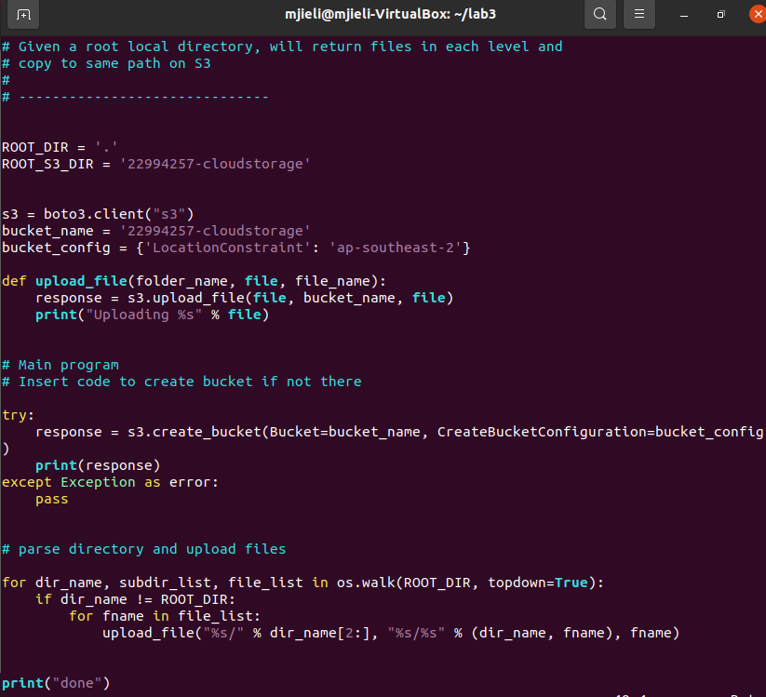

2. Run the python code. It can create bucket, parse directory and upload files.

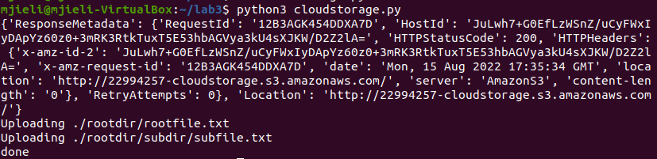

3. Confirm the result on S3 console. It has a right folder-file hierarchy.

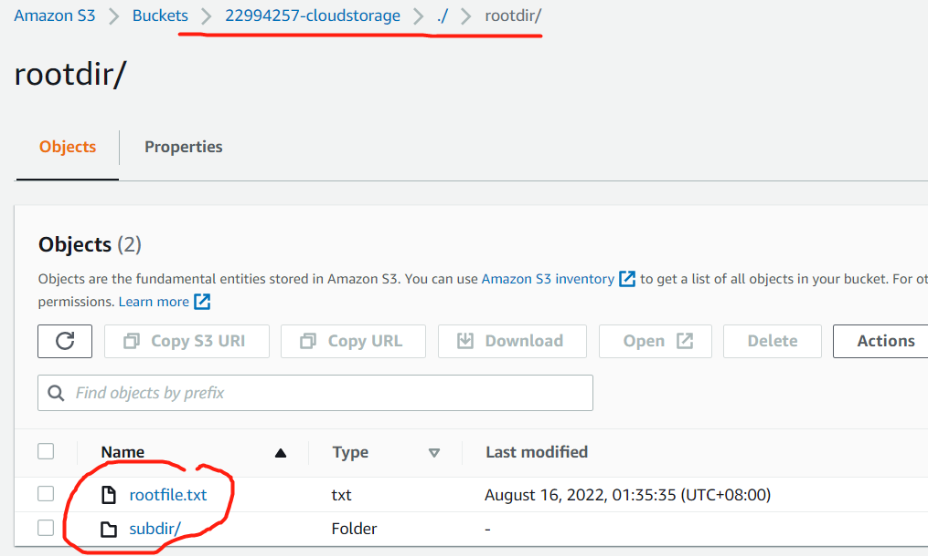

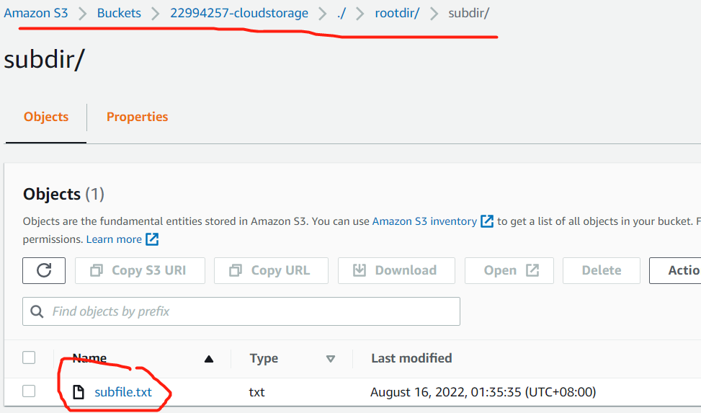

### **[Step 3] Restore from S3**

1. Create a new program called restorefromcloud.py



2. Define a function download_dir to parse directory and download files. It will download the files from my bucket and put it in the ‘/tmp’ directory.

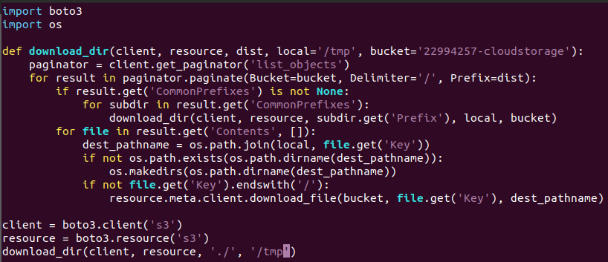

3. The ‘/tmp’ directory before run the program

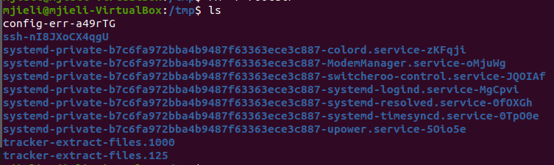

4. Run the program



5. The ‘/tmp’ directory after run the program

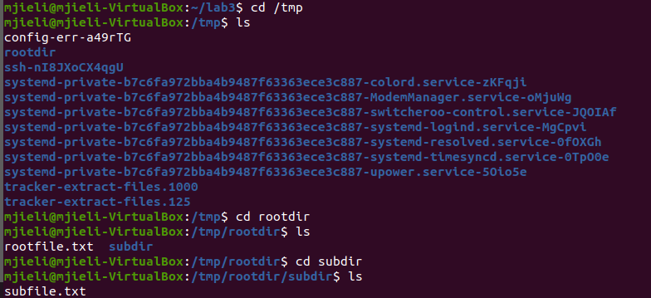

6. It has a right folder-file hierarchy.



### **[Step 4] Write information about files to DynamoDB**

1. Install jre and check the version

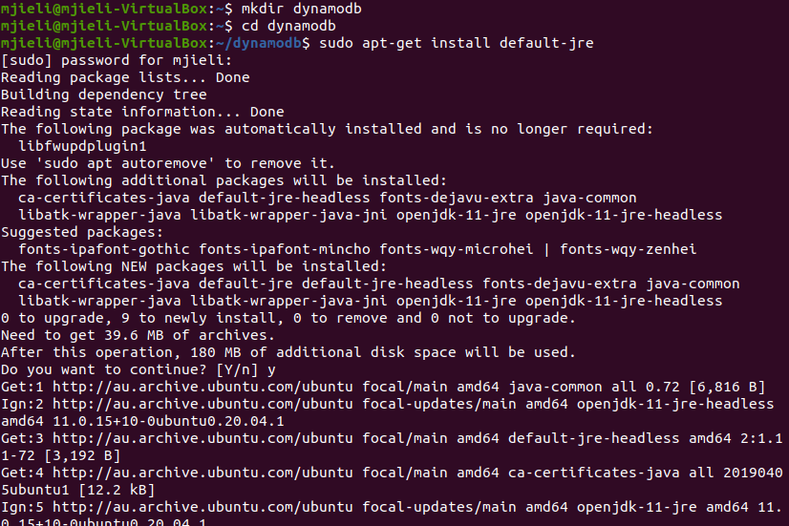

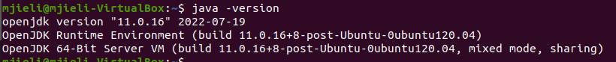

2. Get the file dynamodb_local_latest.tar.gz and unzip it.







3. Run the DynamoDB

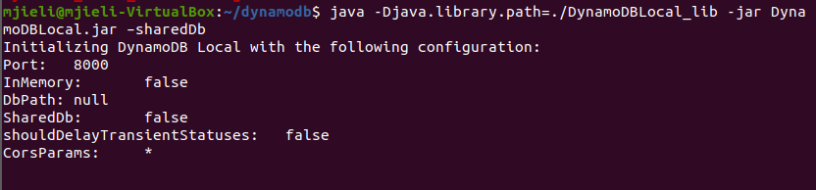

4. Run the create_table.py, which is used to create the table.



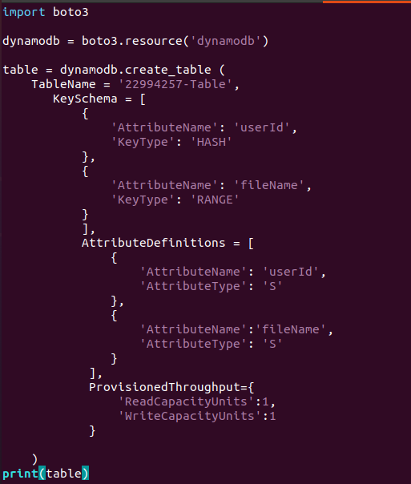

5. Here is the key code. It can get some information about every file that is stored in S3 by reading the object’s variable cur and acl, then write it to the DynamoDB table.

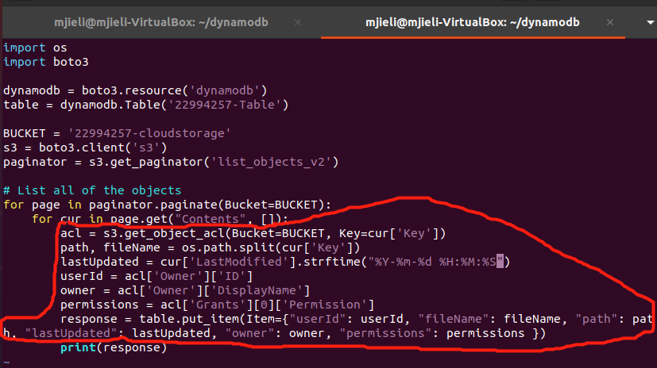

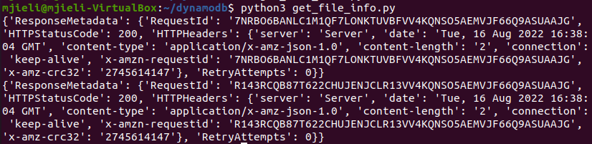

6. Finally, scan the table to check the result.

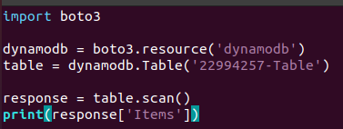

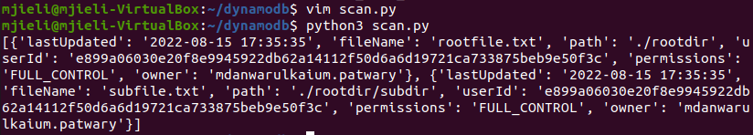

[{'lastUpdated': '2022-08-15 17:35:35',

'fileName': 'rootfile.txt',

'path': './rootdir',

'userId': 'e899a06030e20f8e9945922db62a14112f50d6a6d19721ca733875beb9e50f3c',

'permissions': 'FULL_CONTROL',

'owner': 'mdanwarulkaium.patwary'},

{'lastUpdated': '2022-08-15 17:35:35',

'fileName': 'subfile.txt',

'path': './rootdir/subdir',

'userId': 'e899a06030e20f8e9945922db62a14112f50d6a6d19721ca733875beb9e50f3c',

'permissions': 'FULL_CONTROL',

'owner': 'mdanwarulkaium.patwary'}]