Networking

Step 1: Configure inbound IP on VirtualBox VM

Hints:

1)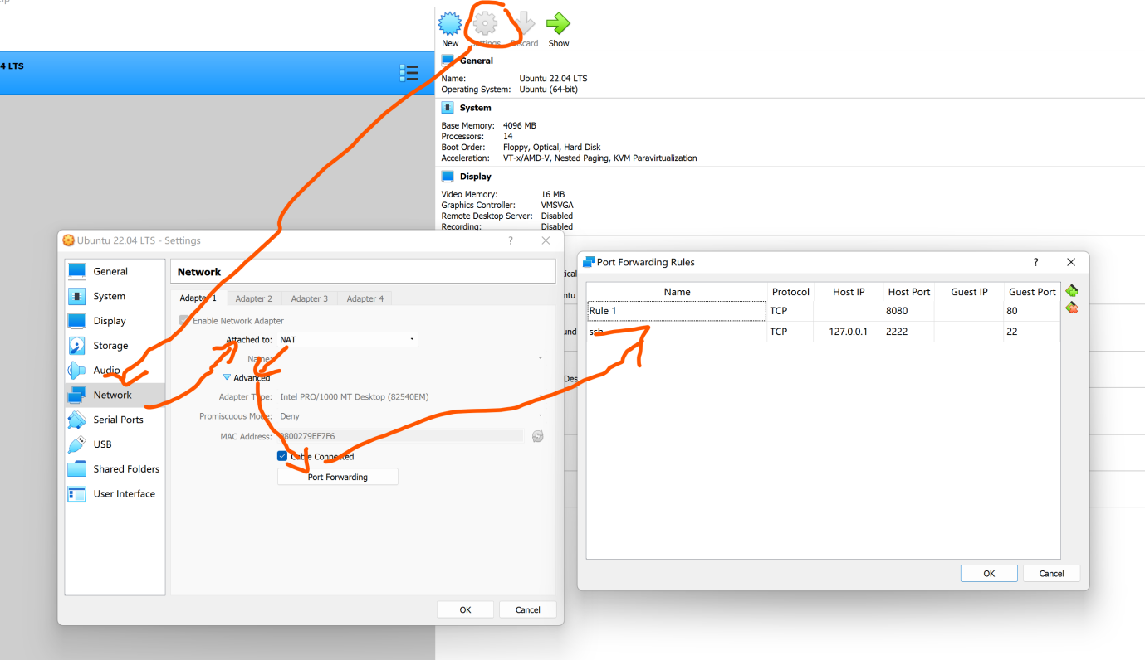

2) If there is an error after you run “sudo service ssh start”

Please run “sudo apt-get install openssh-server” then run “sudo service ssh start” again.

3) run “ssh -p 2222 <usermame>@127.0.0.1” on your machine (NOT Ubuntu!), you can use Windows Powershell. <username> is your Ubuntu username.

4) Test the NAT’d ports by running your docker app and seeing if you can access it from your computer – the url will be [http://127.0.0.1:8080](http://127.0.0.1:8080/)

You can use the scripts in lab 2, Using Docker part. You need to access it on your machine (NOT Ubunrtu!)

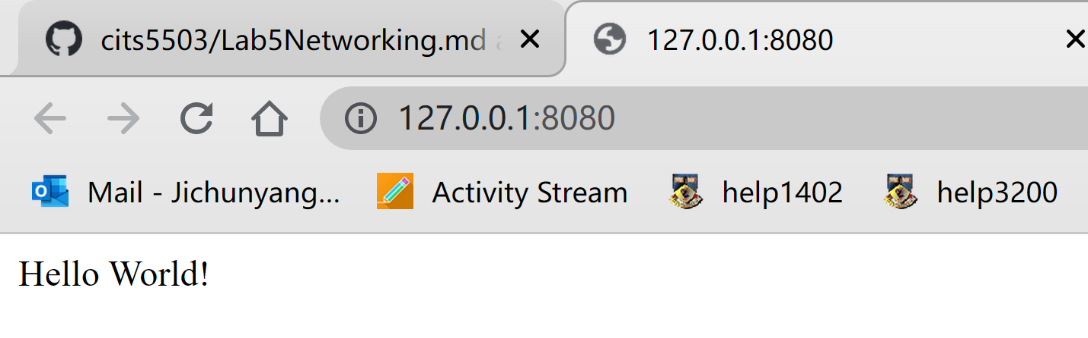

Also, it can work on Ubuntu.

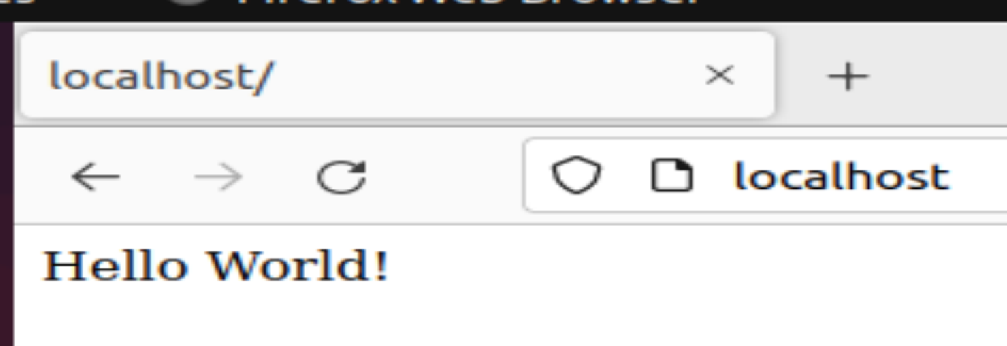

Expected outputs in your lab note:

1) The screenshots of your codes;

2) The 2 screenshots of your bowsers (from your machine and Ubuntu)

Step 2

***Remember Delete the load balancer immediately after completing the lab. You must show a screenshot to prove you have already deleted the created load balancer! Otherwise, this lab note will be marked 0!***

Create 2 instances in different available zones:

AWS_Reion = ‘ap-southeast-2’

Available_Zone_1 = ‘ap-southeast-2a’

Available_Zone_2 = ‘ap-southeast-2b’

Creating an EC2 instance, security group, and key (you can see lab 2), you only need ONE key and ONE security group for two EC2 instances.

<https://blog.knoldus.com/how-to-create-ec2-instance-using-python3-with-boto3/>

This website can help create an instance with python boto3.

You may need to assign a available zone for each instance, you can use “Placement”

For example

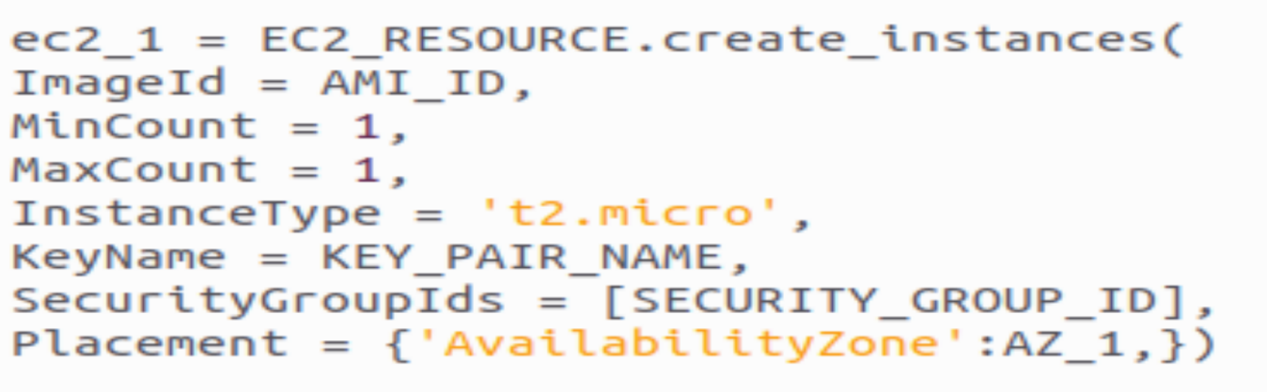

Make sure you get the vpc id, subnet id and instance id, as they are necessary for creating a load balancer, target group and registering your instances into the create target group.

After creating a load balancer and a target group, TragetGroupArn is import, which will be used in creating a listener.

In order to create a listener, the type should be forward, protocol is HTTP.

SSH into instance:

For example:

ssh -i “<your key file name>”<user name>@<Public IPv4 DNS>

In order to install apache2, this website is useful. <https://cloudkatha.com/how-to-install-apache-2-on-aws-ec2-instance-ubuntu-20-04/>