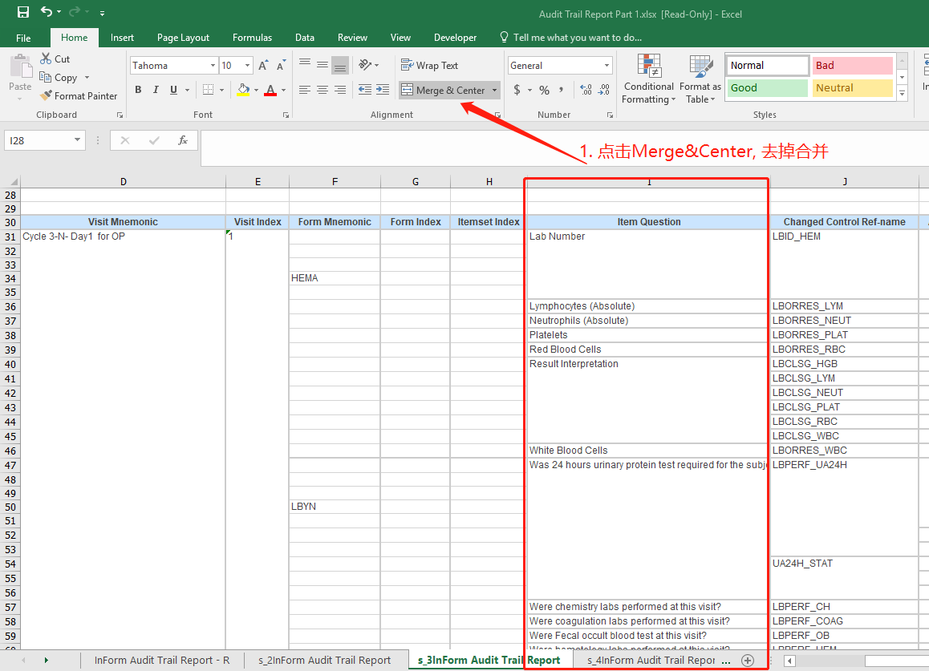

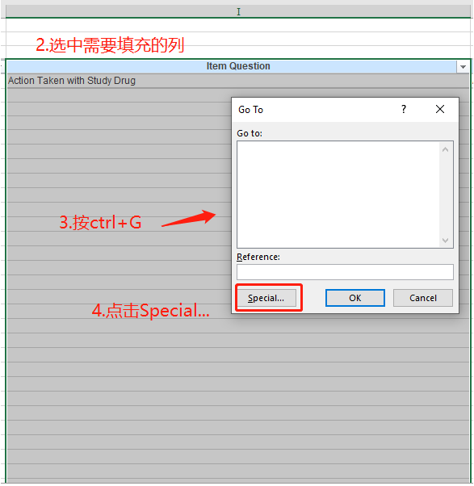

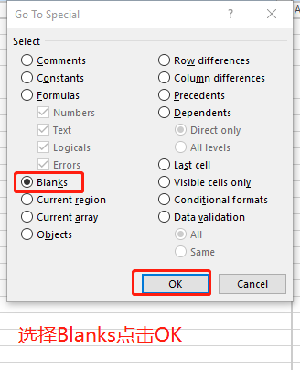

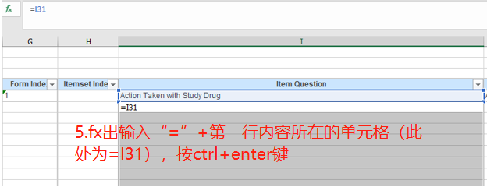

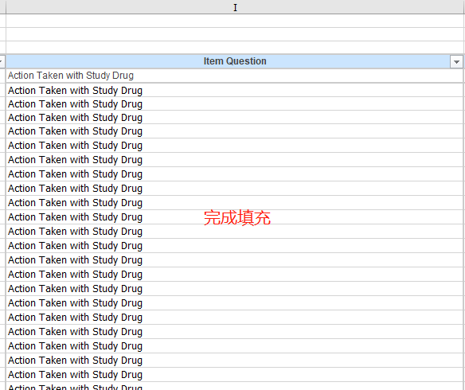



SAS code实现填充的方法：

**data** out;

length tmp_1 - tmp_13 $1000.;

set in;

retain tmp_1 - tmp_13;

array mychar A--M ;

array mytmp tmp_1 - tmp_13;

do iii = **1** to **13**;

if mychar[iii] ^= '' then mytmp[iii] = mychar[iii];

else mychar[iii] = mytmp[iii];

end;

if E ="Visit Index" and _N_ ^=**1** then E="";

if _n_ = **1** then delete;

drop iii tmp_: F G H;

/*label a = "Study Name" b= "Site Mnemonic" c="Subject Number" */

/*d="Visit Mnemonic" e="Visit Index" i="Item Question"*/

/*j="Changed Control Ref-name" k="Audit Order" l="Initial Entry or Modification" */

/*m="Entered Reason" n="Current Value"*/

/*o="Current Value Date/Time" p="Previous Value" q="Previous Value Date/Time";*/

**run**;