**Compute in Hugin:**

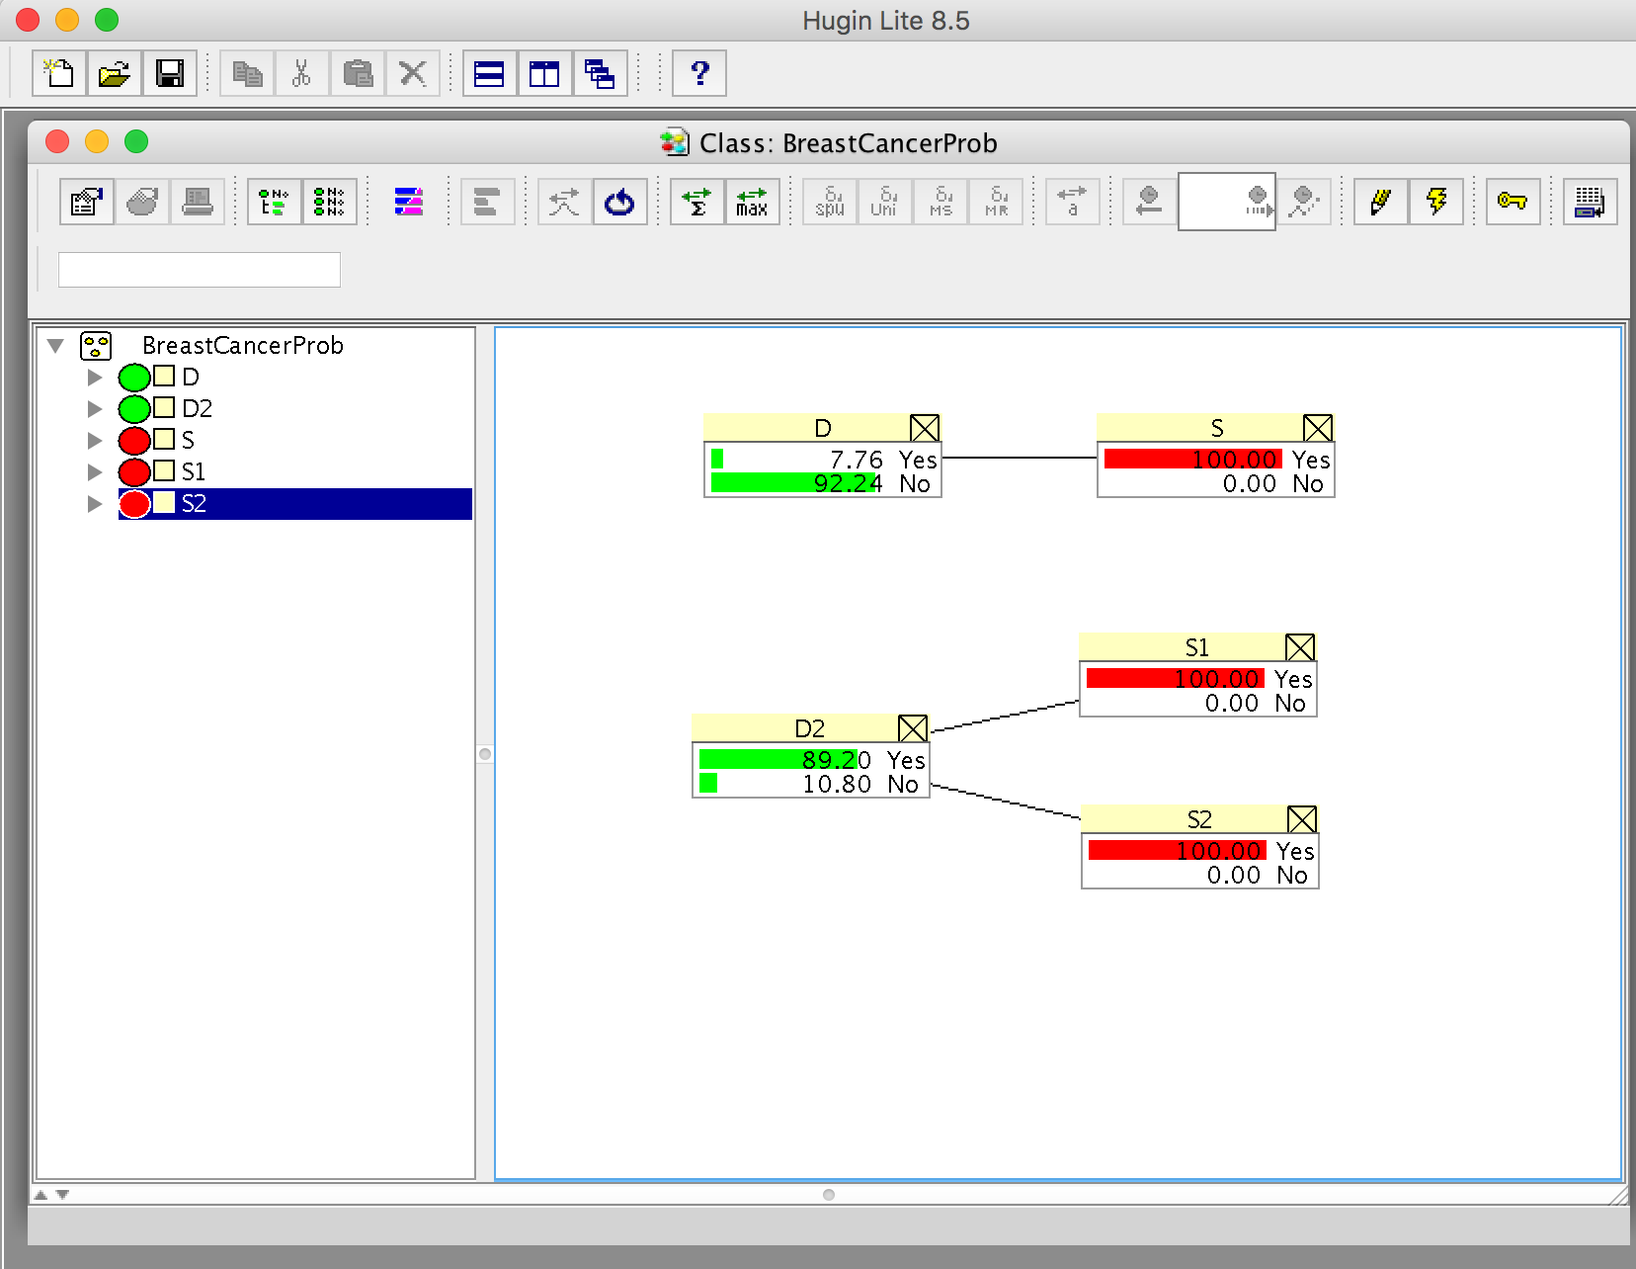

**S1** **value as follow:**

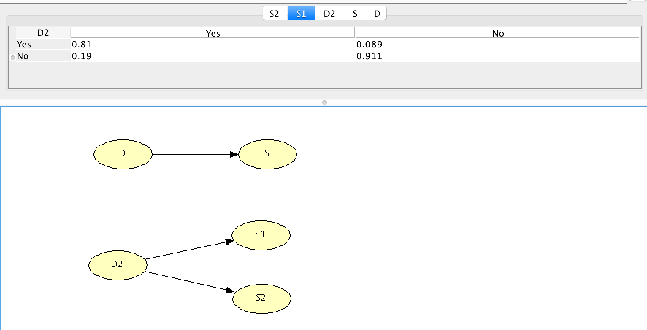

**S2 value as follow:**

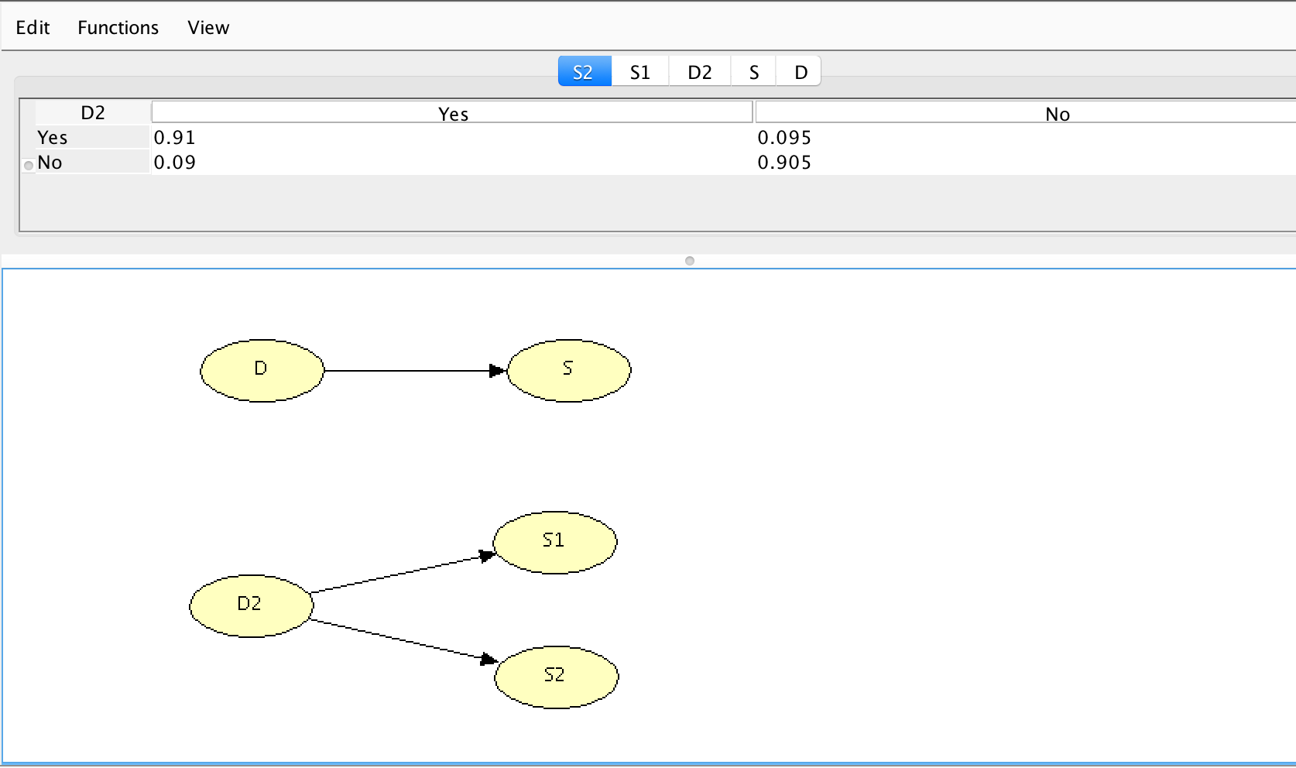

* **Calculate P (D | S)**

P(S)= P (S&D) + P (S &Not D)

= P (D) * P (S|D) + P (Not D) * P (S|Not D)

= 0.01 * 0.8 + 0.99 * 0.096

=0.10304

P (D | S) = P(S|D) * P (D) / P (S)

= 0.8 * 0.01/0.10304

= 0.077

* **Calculate P (D | S1, S2)**

P(S2) = P (D) * P (S2|D) + P (Not D) * P (S2|Not D)

= 0.08 * 0.91 + 0.92 * 0.095

= 0.0728 + 0.0874

= 0.1602

P (S1, S2) = P (D) * P (S1, S2|D) + P (Not D) * P (S1, S2|Not D)

= 0.08 * 0.81 * 0.91 + 0.92 * 0.089 * 0.095

= 0.0667

P (D|S1, S2) = P (D) * P (S1, S2|D) / P (S1, S2)

= 0.08 * 0.81* 0.91 / 0.0667

= 0.892

