Basics

A first principle software that calculates Electron-Defect Interaction.
To develop advanced materials and devices, it is crucial to understand the processes involving electrons and atomic defects in the solid state. This requires computational tools that can predict the physical properties of materials by taking into account their atomic and electronic structure. EDI (Electron-Defect Interaction) is a validated code that provides a unified platform for computing electron interactions, transport, and ultra-fast dynamics in materials. It uses established first-principles methods such as density functional theory as starting points for computing electron dynamics. The current distribution of EDI focuses on electron-defect interactions and related transport properties, including electrical conductivity, scattering rate, and mobility. It also includes routines for computing spin-related information. The transport module enables accurate calculations of charge transport in a wide range of functional materials. The code is efficient with MPI parallelization, and scales linearly with the super cell size.

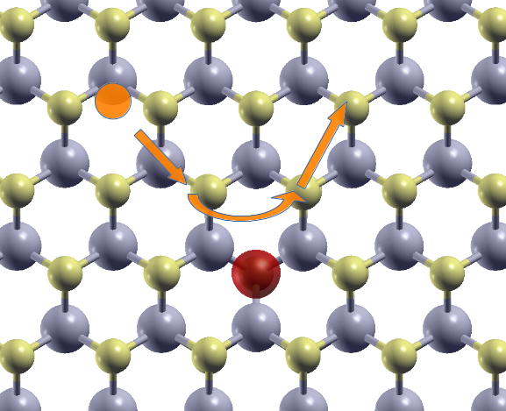

Capabilities
EDI is capable of the following tasks:
- Calculate electron-defect scattering matrix element
  - Neutral defect
  - Charged defect at different Fermi levels
- K-point sampling for 2D system based on triangular integral algorithm

- Calculate carrier mobility

Performance
EDI uses optimal algorithm to calculate different part of scattering matrix element, giving an improved performance of accuracy and efficiency. The calculation cost scales linearly with the system size, making it capable of calculating large systems, requiring only linearly increasing computing resource. Calculation of matrix element is parallelized over k point pairs. EDI could easily run on large HPCs and utilize the full capacity.

Download
The source code could be found here. The documentation could be downloaded here.

