To Bee or Not To Bee
Machine Learning Report
Course: IG.2412
Date: 2026-06-06
Task: Classify pollinator insects from masked high-resolution images.

Summary
This report records the model work for the pollinator image task. We used the mask and image files to build shape, colour, texture, size, and symmetry features, then compared several supervised models. The original table had 39 numeric features. After feature engineering, the modelling table had 80 features.
The best accuracy result came from a soft voting model combining SVM, shrinkage LDA, and ExtraTrees. Its 5-fold cross-validation accuracy was 0.8024 +/- 0.0462, and the holdout accuracy was 0.7600. We would use this model for the hidden test set if the final score is mainly plain accuracy.

Dataset
The available training data contains 250 labelled samples. Images 1-250 have labels and segmentation masks. Images 251-347 are described as the hidden test set in the brief, but those test images are not present in this workspace, so the report is limited to validation and model selection.

Raw class distribution
bug type | count
Bee | 115
Bumblebee | 100
Butterfly | 15
Hover fly | 9
Wasp | 9
Dragonfly | 1
Bee & Bumblebee | 1

For stratified cross-validation we removed Dragonfly and Bee & Bumblebee because each appears only once. Keeping them in a five-fold split would make the fold labels unreliable.

Classes used for validation
bug type | count
Bee | 115
Bumblebee | 100
Butterfly | 15
Hover fly | 9
Wasp | 9

Most common species labels
species | count
Bombus hortorum | 71
Apis mellifera | 58
Bombus pascuorum | 25
Anthidium manicatum | 19
Megachile centuncularis | 17
Eristalis | 9
Vespula germanica | 8
Anthidium | 6
Macroglossum stellatarum | 5
Andrenidae | 4

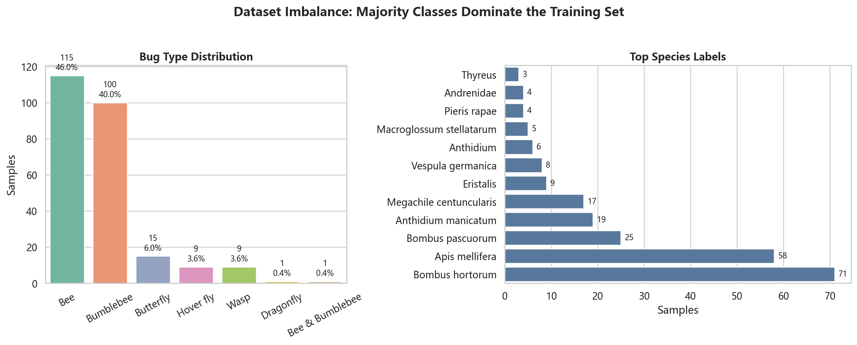
Figure 1. Class imbalance in the labelled training data.

Feature work
The base feature set was built from the masked insect area rather than from the full image. This reduces the influence of the background and keeps the features tied to the object being classified.
- Symmetry: horizontal and vertical mask overlap, plus mask aspect ratio.
- Shape: Hu moments, solidity, eccentricity, extent, perimeter, area, convex area, and compactness.
- Colour: RGB minimum, maximum, mean, median, and standard deviation inside the mask.
- Size and background: bug pixel ratio and background brightness.
- Texture and appearance: colour dominance, edge density, texture contrast, brightness mean, and saturation mean.
We then added derived variables such as RGB ranges, channel ratios, yellow and darkness proxies, bug-background brightness differences, symmetry interactions, shape ratios, Hu-moment aggregates, and edge-texture products. The extra variables were useful because the species are separated by several weak signals rather than one clear measurement.
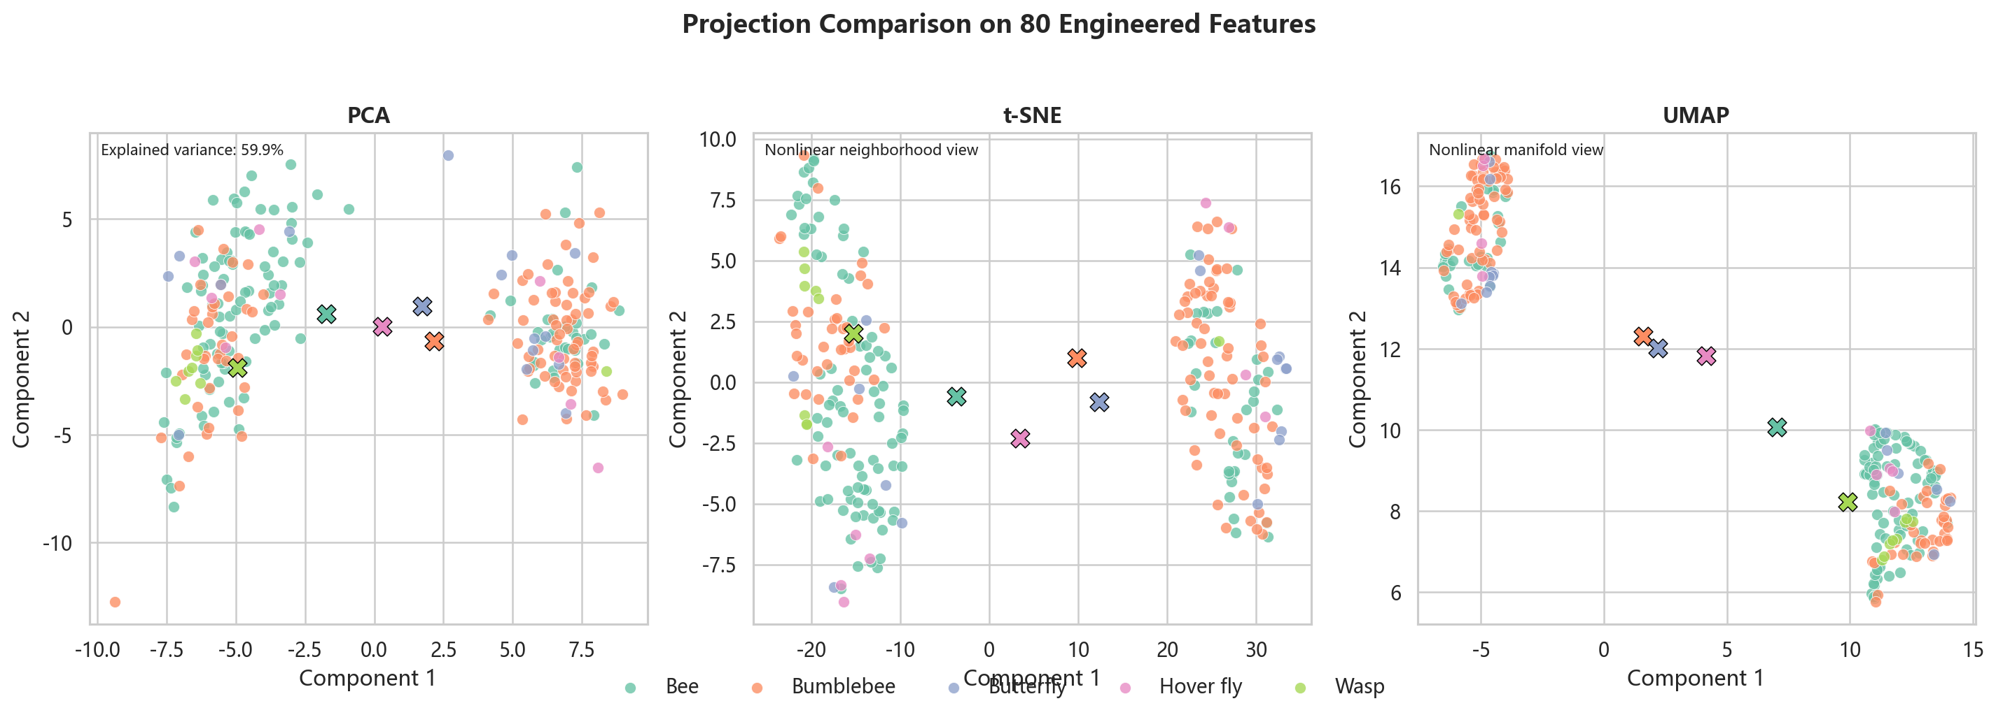
Figure 2. PCA, t-SNE, and UMAP views of the engineered feature table.
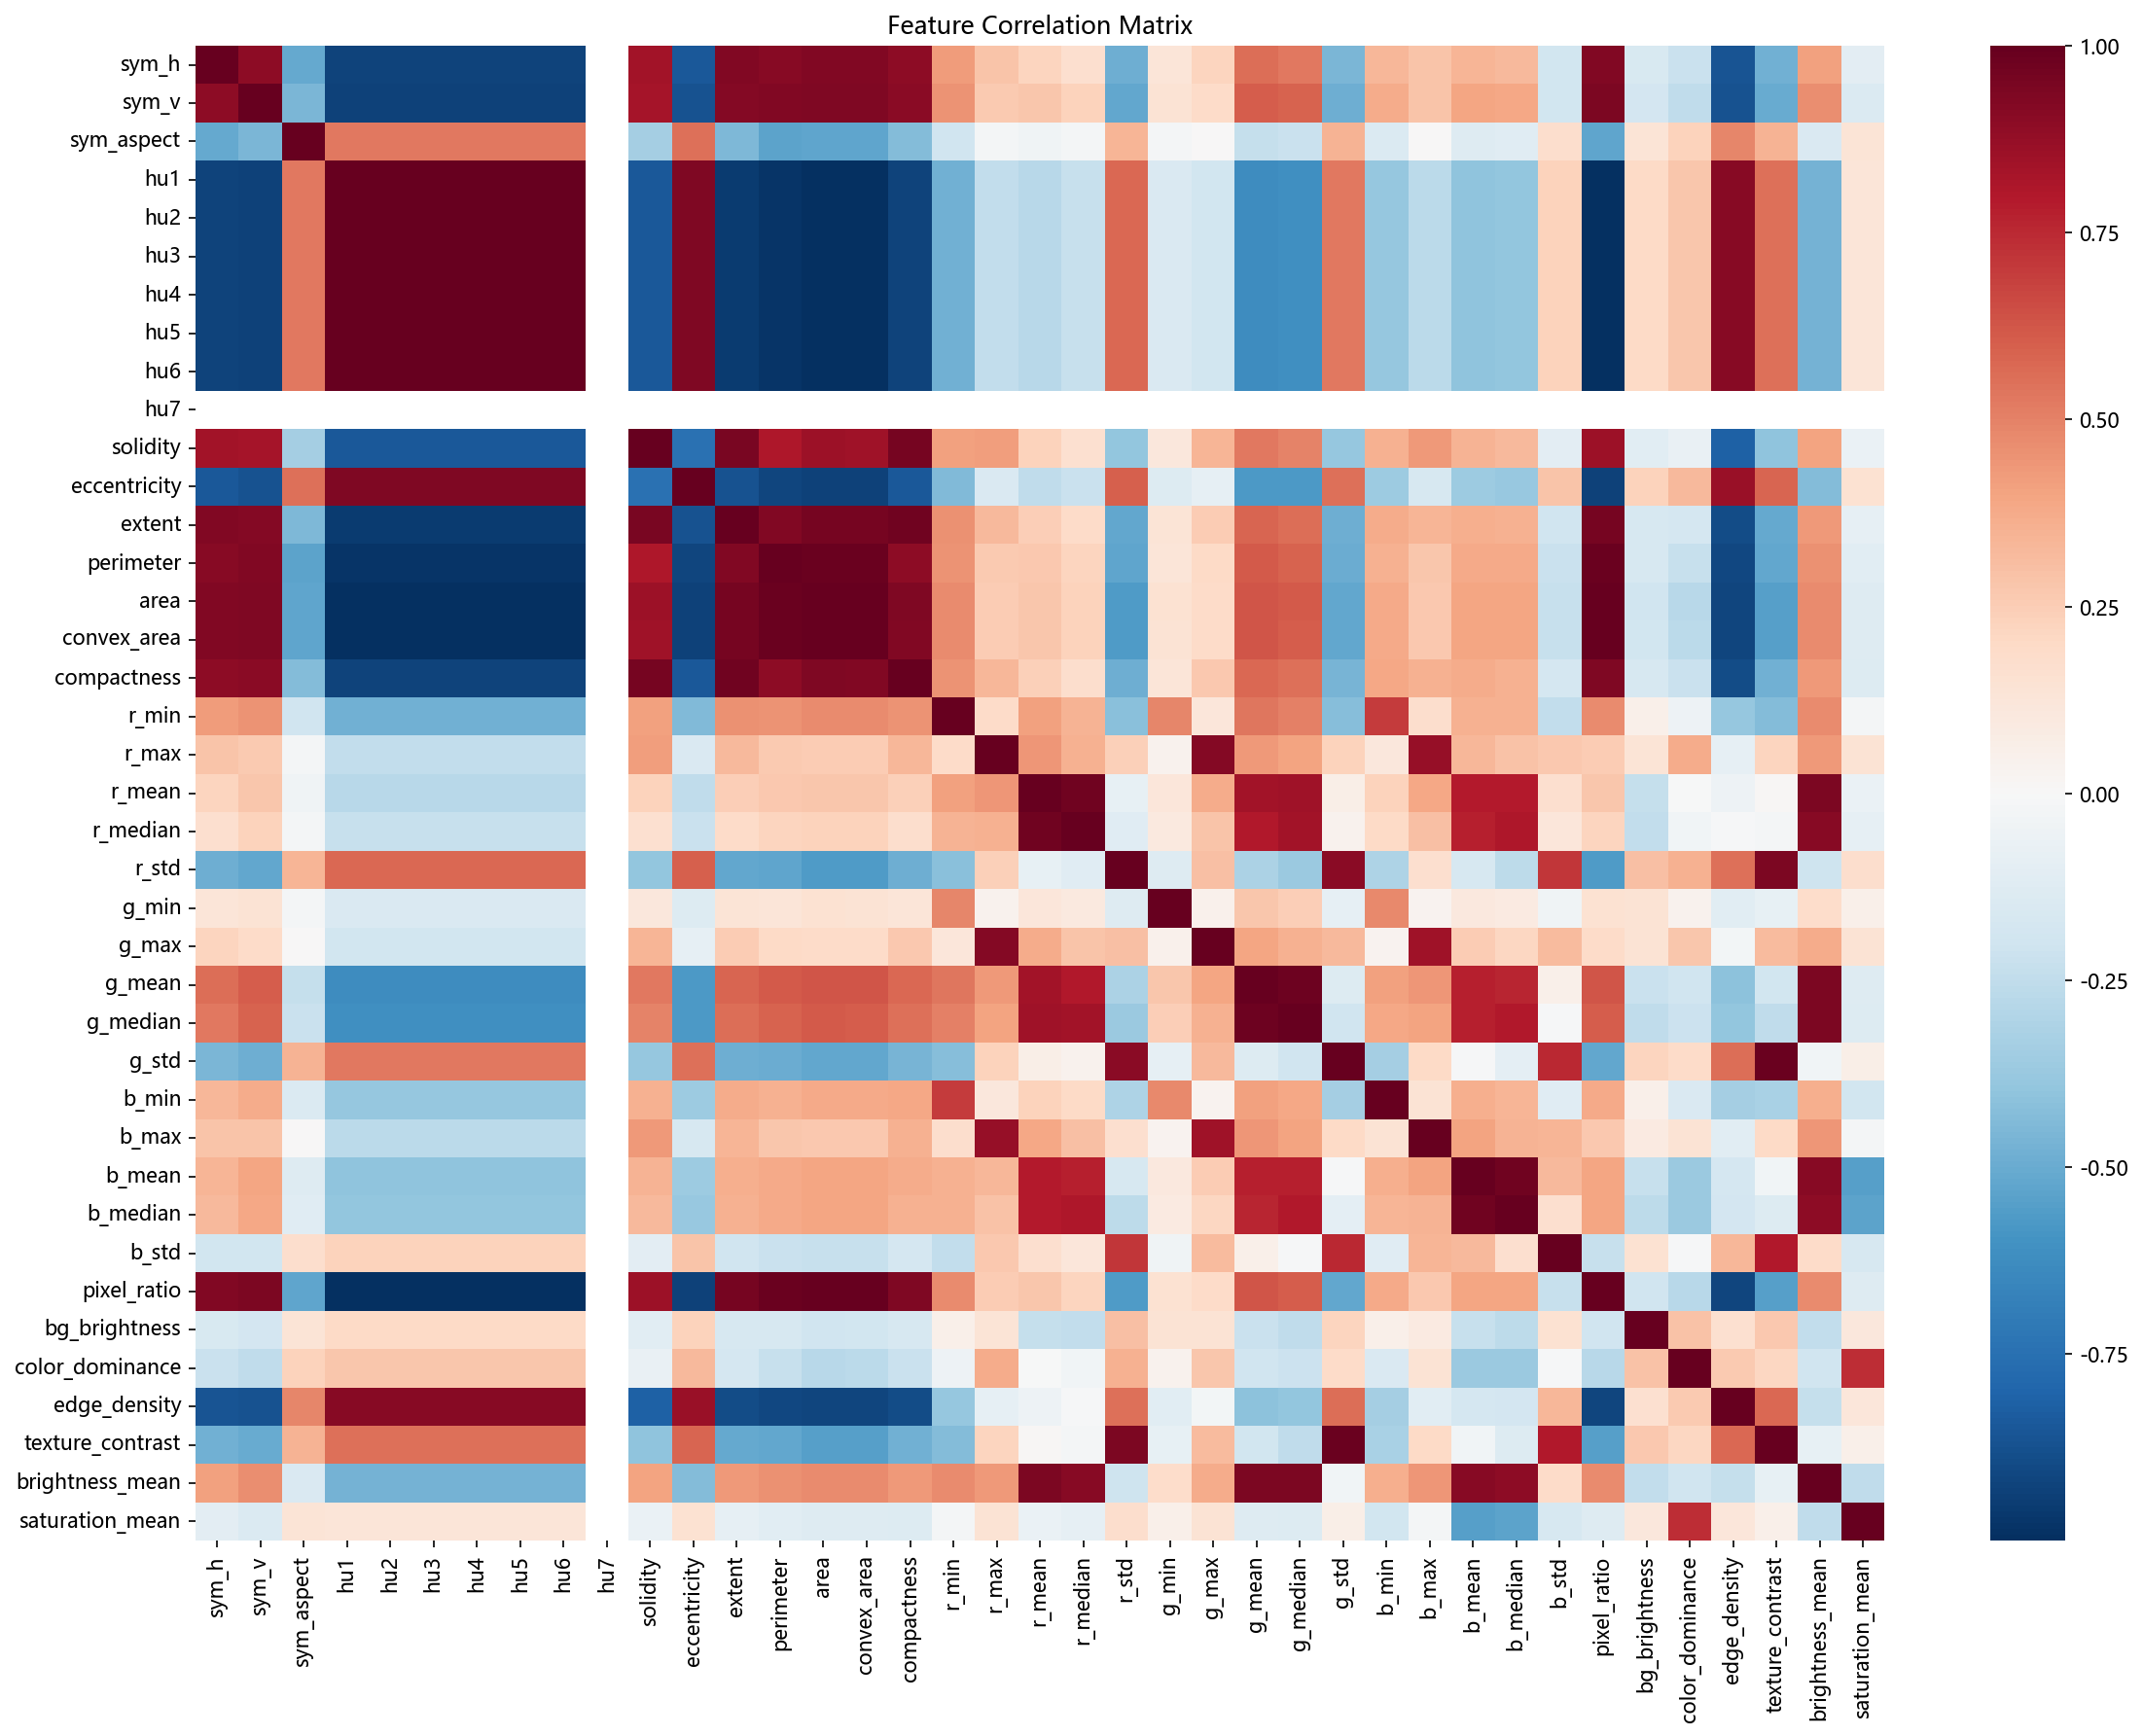
Figure 3. Correlation map for the engineered features.

Model setup
In the first notebook version, scaling was applied before cross-validation. We changed this by putting StandardScaler inside each sklearn Pipeline, so the scaler is fitted only on the training folds. This is a small change in code, but it matters because validation folds should not influence preprocessing.
The main validation method was stratified 5-fold cross-validation. We also kept a fixed 80/20 stratified holdout split as a second check. Accuracy is the main number reported here, while macro F1 and balanced accuracy are used to check whether the smaller classes are being ignored.

Initial models and clustering
Model | Score
Logistic Regression | 0.7094+/-0.0504
KNN (k=5) | 0.7220+/-0.0449
SVM (RBF) | 0.7178+/-0.0415
Random Forest | 0.7253+/-0.0654
KMeans | Sil=0.1876|ARI=0.0808
DBSCAN | Sil=0.6111|ARI=0.0814
LDA | 0.7420+/-0.0391

KMeans and DBSCAN were included only as unsupervised baselines. Their adjusted Rand index values were low, so the clusters do not line up well with the target labels in this feature space.

Tuned supervised models
Model | CV Mean | CV Std | Test Acc
Logistic Regression (balanced) | 0.6407 | 0.0725 | 0.6800
KNN (best) | 0.7382 | 0.0524 | 0.6000
SVM (best) | 0.7623 | 0.0436 | 0.7000
Random Forest (best) | 0.7053 | 0.0594 | 0.7000
Gradient Boosting | 0.6850 | 0.0683 | 0.6400
LDA | 0.7420 | 0.0391 | 0.7000

Among these standard models, SVM had the best cross-validation accuracy. SVM, Random Forest, and LDA all reached 0.7000 on the holdout split, so the holdout result alone was not enough to choose a final model.

Corrected validation and engineered features
After the scaler correction, the original-feature SVM reached 0.7504 cross-validation accuracy. With the engineered features, SVM improved to 0.7702. The voting ensemble improved the same metric to 0.8024. The improvement is not huge, but it is consistent with the visual overlap between Bee and Bumblebee in the embeddings.

Class imbalance experiments
The class counts are uneven, so we tested no resampling, equal oversampling, hybrid_50 resampling, and mild undersampling. The table below keeps the top results from that sweep.
Model | Imbalance Strategy | CV Accuracy Mean | CV Macro F1 Mean | Holdout Accuracy | Holdout Macro F1
Voting SVM+LDA+ET | none | 0.8024 | 0.5979 | 0.7600 | 0.6040
SVM RBF tuned gamma=0.01 | none | 0.7744 | 0.5876 | 0.7200 | 0.4860
SVM RBF C=10 | none | 0.7702 | 0.5783 | 0.7000 | 0.4771
LDA shrinkage | none | 0.7660 | 0.6071 | 0.7200 | 0.6840
SVM RBF C=10 balanced | none | 0.7660 | 0.5630 | 0.7400 | 0.6058
ExtraTrees balanced | none | 0.7540 | 0.5019 | 0.6800 | 0.2958
Voting SVM+LDA+ET | hybrid_50 | 0.7500 | 0.6037 | 0.7400 | 0.6957
Random Forest balanced | none | 0.7456 | 0.5112 | 0.7000 | 0.3011
HistGradientBoosting | none | 0.7420 | 0.5080 | 0.7600 | 0.4536
Voting SVM+LDA+ET | undersample_mild | 0.7379 | 0.5927 | 0.7000 | 0.6256

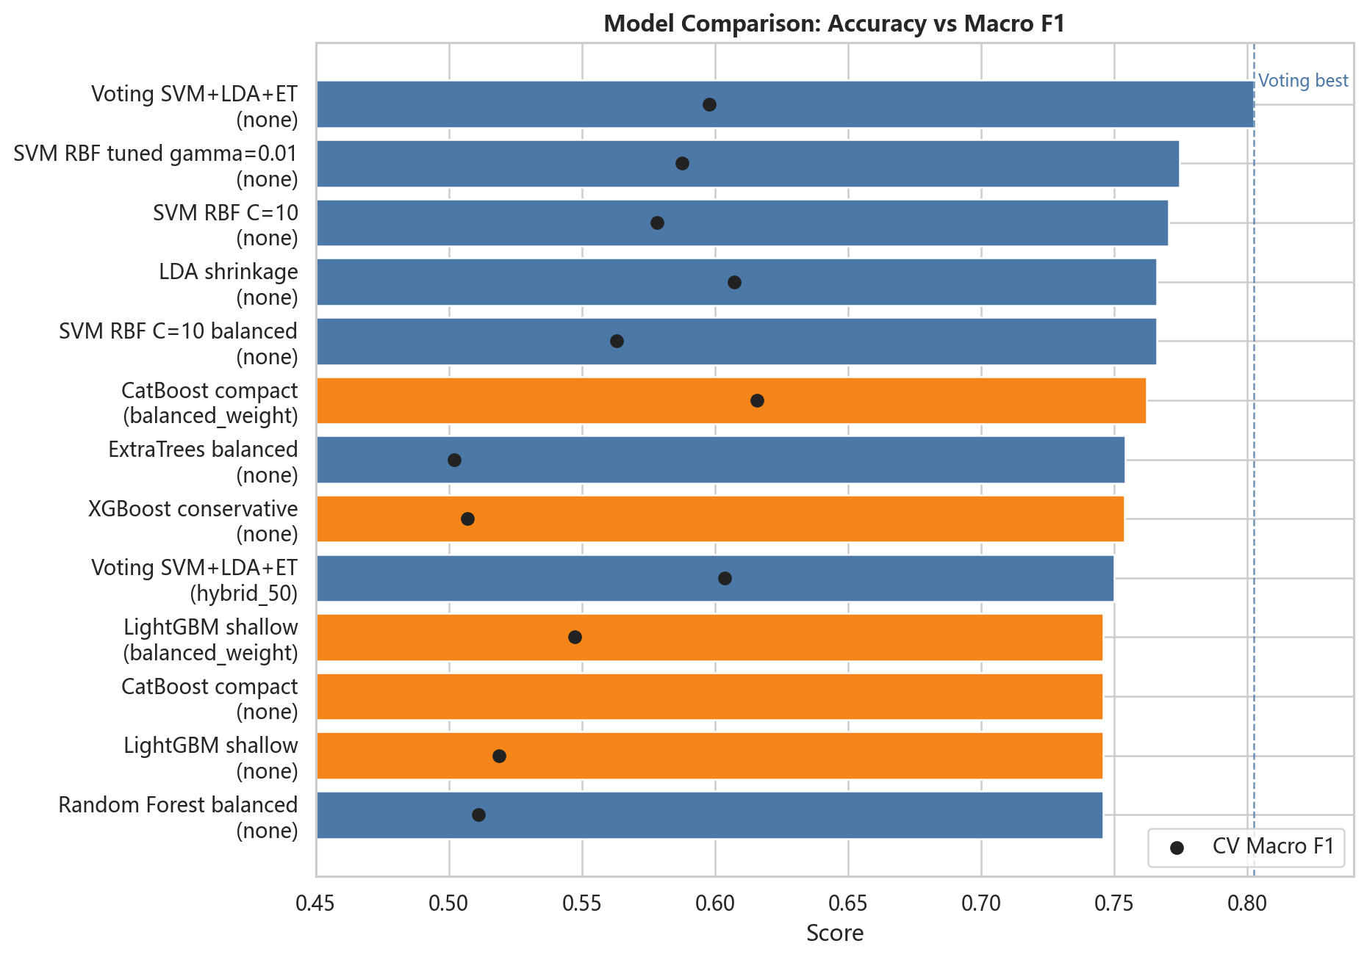
Figure 4. Comparison of the stronger supervised models.

Boosted-tree check
We also tried XGBoost, LightGBM, and CatBoost on the same engineered features. The best boosted-tree run did not beat the soft voting ensemble on cross-validation accuracy.
Model | Family | Imbalance Strategy | CV Accuracy Mean | CV Macro F1 Mean | Holdout Accuracy
CatBoost compact | catboost | balanced_weight | 0.7620 | 0.6158 | 0.6400
XGBoost conservative | xgboost | none | 0.7537 | 0.5069 | 0.7000
LightGBM shallow | lightgbm | balanced_weight | 0.7458 | 0.5473 | 0.6800
CatBoost compact | catboost | none | 0.7457 | 0.4387 | 0.7000
LightGBM shallow | lightgbm | none | 0.7456 | 0.5190 | 0.7000
XGBoost deeper | xgboost | none | 0.7456 | 0.4735 | 0.7200
LightGBM compact | lightgbm | balanced_weight | 0.7418 | 0.5345 | 0.6800
LightGBM compact | lightgbm | none | 0.7418 | 0.4904 | 0.6800

The best boosted-tree accuracy was 0.7620 from CatBoost compact with balanced_weight. The strongest boosted-tree macro F1 was 0.6172 from CatBoost shallow, but its holdout macro F1 was 0.3208, so we did not select it.

Final model choice
Main accuracy model:
- File: best_model_engineered.pkl
- Model: Voting SVM+LDA+ET
- Imbalance strategy: none
- CV accuracy: 0.8024 +/- 0.0462
- CV macro F1: 0.5979
- Holdout accuracy: 0.7600
Macro-F1-oriented alternative from the sweep:
- Model: SVM RBF C=10
- Imbalance strategy: hybrid_50
- CV accuracy: 0.7136 +/- 0.0505
- CV macro F1: 0.6120
- Holdout macro F1: 0.6389
The accuracy model wins the main metric. The hybrid_50 SVM is worth keeping in mind only if the final evaluation rewards minority-class recall more heavily than plain accuracy.
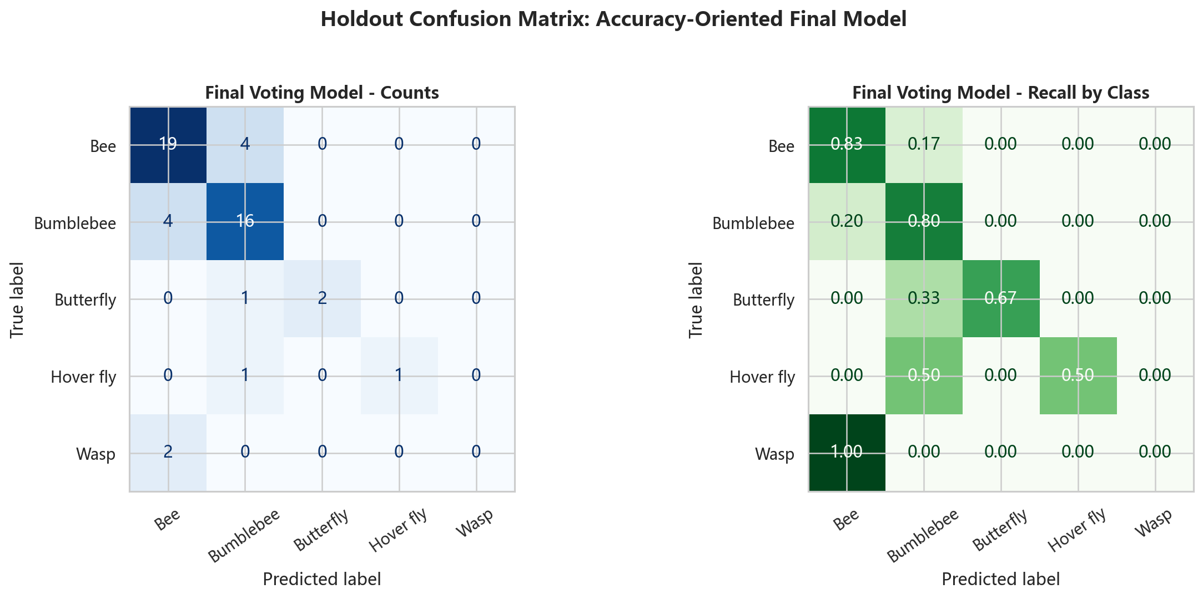
Figure 5. Holdout confusion matrix for the selected voting model.
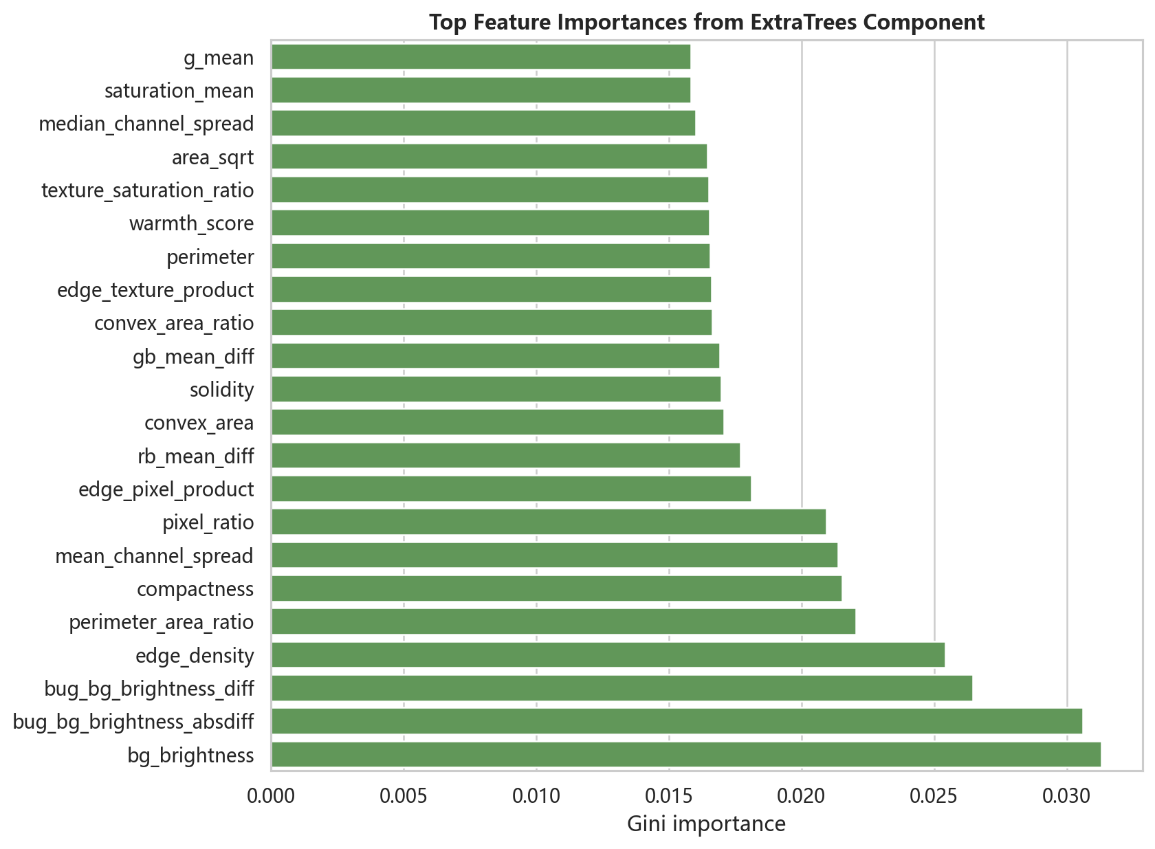
Figure 6. Important engineered features from the ExtraTrees component.
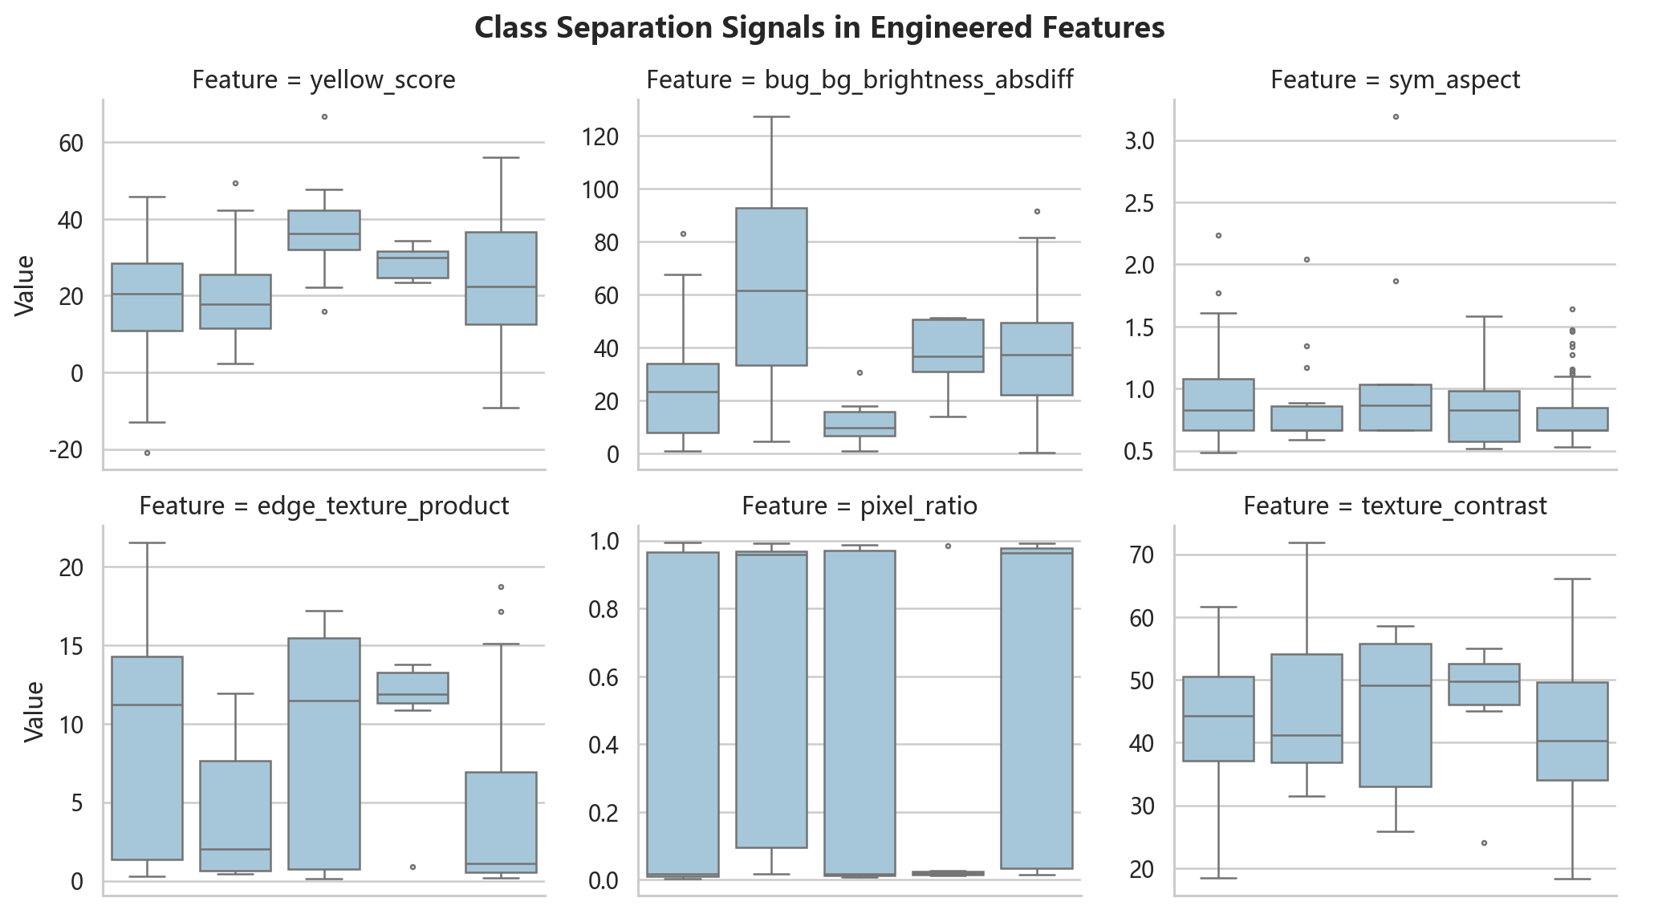
Figure 7. Selected engineered features by class.

Prediction steps
- Extract the same 39 base features from each hidden test image and mask.
- Apply add_engineered_features to produce the 80-feature representation.
- Use the saved feature_cols from best_model_engineered.pkl.
- Run the saved voting model and write a CSV with columns ID and bug type.
bug type | count
Bee | 75
Butterfly | 11
Wasp | 5
Hover fly | 5
Bumblebee | 1
Total | 97

Test Set Predictions
We ran the Voting SVM+LDA+ET model on the 97 hidden test images (251-347). The CSV output predictions_251_347.csv was generated. Below is the predicted class distribution:

Limitations
The final model predicts five classes. Dragonfly and Bee & Bumblebee were excluded from validation because there is only one labelled example of each. If the hidden test set contains those labels, the current model will not handle them directly. Hover fly and Wasp are also based on very small sample counts, so their validation scores should be read with caution.

Conclusion
The selected submission model is the engineered-feature soft voting ensemble. Compared with the corrected single SVM baseline, it raises cross-validation accuracy from 0.7504 to 0.8024 and reaches 0.7600 on the holdout split. The result is not perfect, especially for the small classes, but it is the most reasonable choice from the experiments available in this project.

