**UNIVERSITY OF MIAMI**

Department of Electrical and Computer Engineering

ECE 203

*Name:*

*Section:*

*Date:*

EXPERIMENT 1

**VOLTAGE DIVISION**

**PURPOSE:** The purpose of this lab is to introduce a new student to the basics of electric measurements through the use of a simple voltage divider circuit.

***Equipment***

1 Variable resistance box

1 Digital voltmeter (DVM)

1 D.C. power supply

1 Function generator

1 Oscilloscope

***Preliminary Work***

Fig. 1.1 shows a voltage divider circuit. For this circuit find:

a) The current I in terms of Vs, R1, and RL;

b) The voltage across RL;

c) The DC power delivered to RL, and

d) The power supplied by the source.

e) Request the instructor’s help to gather information in order to answer discussion item (d).

***Experimental Procedure***

I. D.C. Measurements:

a) Set up the circuit shown in Fig. 1.1. Measure and record the actual value of R1.

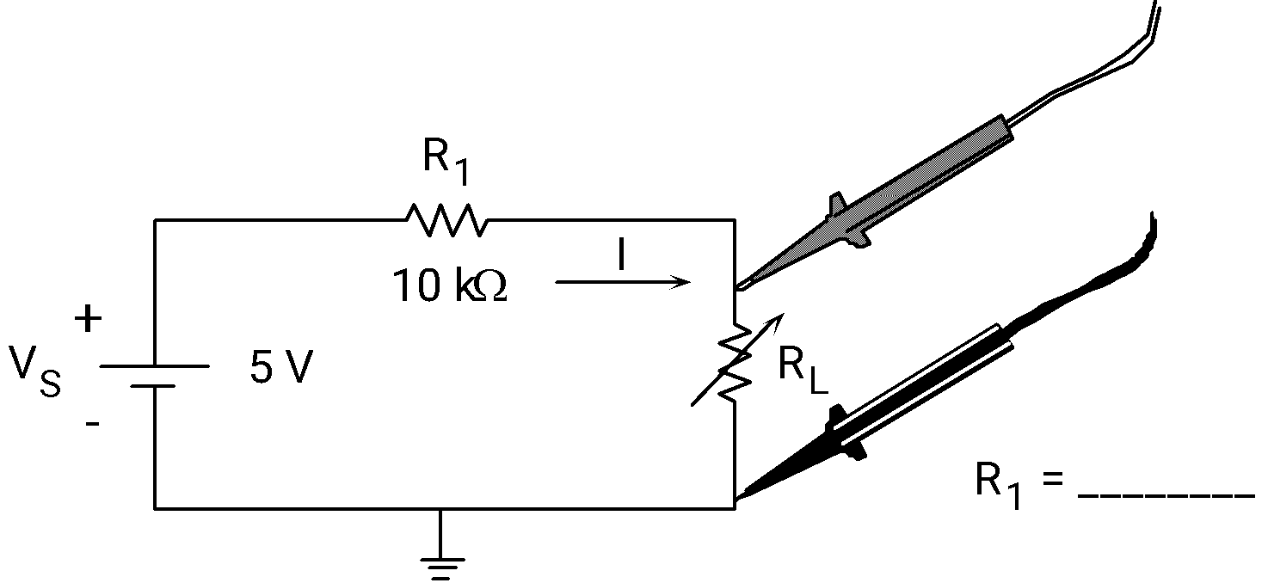

**Figure 1.1** Simple voltage divider circuit with DVM probes shown.

b) Set the dc power supply to 5 V. Measure the voltages across R1 and RL using the DVM as shown in Fig. 1.1 (Set the DVM to measure DC). Vary the RL to the values given in Table 1.1; measure the voltages at each point. Enter all the values in the table under the column labeled *“MEASURED”*.

c) Calculate the voltages across the resistors R1 and RL for all values of RL shown in Table 1.1 using the formulas from your preliminary work. Enter the voltages in the table under the column labeled *“CALCULATED”.* Compare VRL against the measured value by calculating the percentage error. Remember that the percentage error can be found from

*% Error = 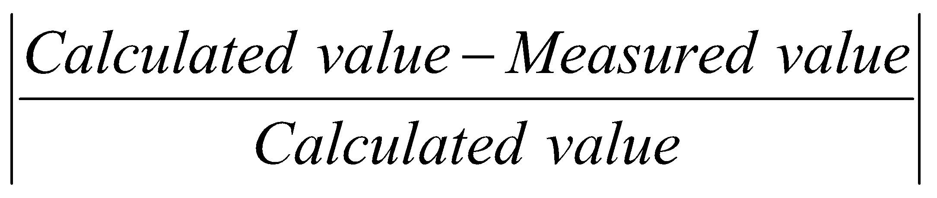x 100%.*

Show a set of calculations for VR1, VR2, and %Error on VRL in detail.

|  | **Measured** | | **Calculated** | | |
| --- | --- | --- | --- | --- | --- |
| **RL (KΩ)** | **VR1 (V)** | **VRL (V)** | **VR1 (V)** | **VRL (V)** | **% Error (VRL)** |
| 1 |  |  |  |  |  |
| 5 |  |  |  |  |  |
| 10 |  |  |  |  |  |
| 15 |  |  |  |  |  |
| 20 |  |  |  |  |  |
| 40 |  |  |  |  |  |

Measured value of Vs = ________ V

**Table 1.1** Measured and calculated dc voltages using DVM

d) Repeat parts (a) - (c) but use the oscilloscope instead of the DVM (see Fig. 1.2). Record your values in Table 1.2. Measure and record the actual value of R1. Note that the measurement has to be taken as VR1=VS-VRL.

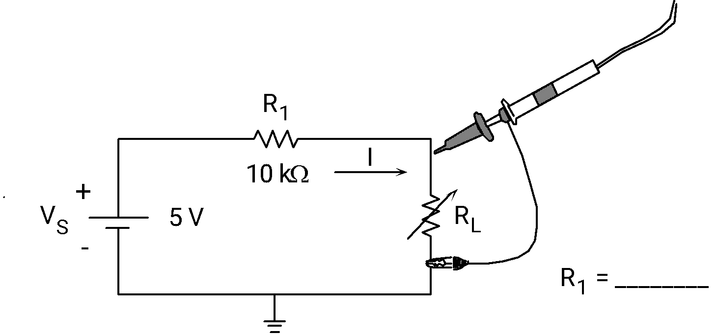

**Figure 1.2** Simple voltage divider circuit with oscilloscope probes shown.

|  | **Measured** | | **Calculated** | | |
| --- | --- | --- | --- | --- | --- |
| **RL (KΩ)** | **VR1 (V)** | **VRL (V)** | **VR1 (V)** | **VRL (V)** | **% Error (VRL)** |
| 1 |  |  |  |  |  |
| 5 |  |  |  |  |  |
| 10 |  |  |  |  |  |
| 15 |  |  |  |  |  |
| 20 |  |  |  |  |  |
| 40 |  |  |  |  |  |

Measured value of Vs = ________ V

**Table 1.2** Measured and calculated dc voltages using oscilloscope.

II. AC Measurements:

a) *DVM measurements:* Replace the dc power supply in Fig. 1.1 with the frequency (function) generator. Adjust the voltage to 5 Vp-p at 1 kHz. Repeat parts (a) - (c) of the dc measurements. Tabulate your data in Table 1.3. Note that the DVM should be in AC mode in order to measure AC rms. values.

|  | **Measured** | | **Calculated** | | |
| --- | --- | --- | --- | --- | --- |
| **RL (KΩ)** | **VR1 (V)** | **VRL (V)** | **VR1 (V)** | **VRL (V)** | **% Error (VRL)** |
| 1 |  |  |  |  |  |
| 5 |  |  |  |  |  |
| 10 |  |  |  |  |  |
| 15 |  |  |  |  |  |
| 20 |  |  |  |  |  |
| 40 |  |  |  |  |  |

Measured value of Vs = ________ Vrms

**Table 1.3** Measured and calculated rms. AC voltages using DVM.

b) *Oscilloscope measurements:*  Repeat part (a) of the ac measurements using the oscilloscope. Tabulate your data in Table 1.4.

|  | **Measured** | | **Calculated** | | |
| --- | --- | --- | --- | --- | --- |
| **RL (KΩ)** | **VR1 (V)** | **VRL (V)** | **VR1 (V)** | **VRL (V)** | **% Error (VRL)** |
| 1 |  |  |  |  |  |
| 5 |  |  |  |  |  |
| 10 |  |  |  |  |  |
| 15 |  |  |  |  |  |
| 20 |  |  |  |  |  |
| 40 |  |  |  |  |  |

Measured value of Vs = ________ Vp-p

**Table 1.4** Measured and calculated peak-to-peak AC voltages using oscilloscope.

***Discussion of Results***

a) Comment on the benefits of using either the DVM or the SCOPE for particular situations.

b) Find the current in the circuit of Fig. 1.1 when RL = 50 kΩ.

c) In the circuit of Fig. 1.3 R1 is fixed. Derive the condition under which maximum power will be delivered to R2. Why?

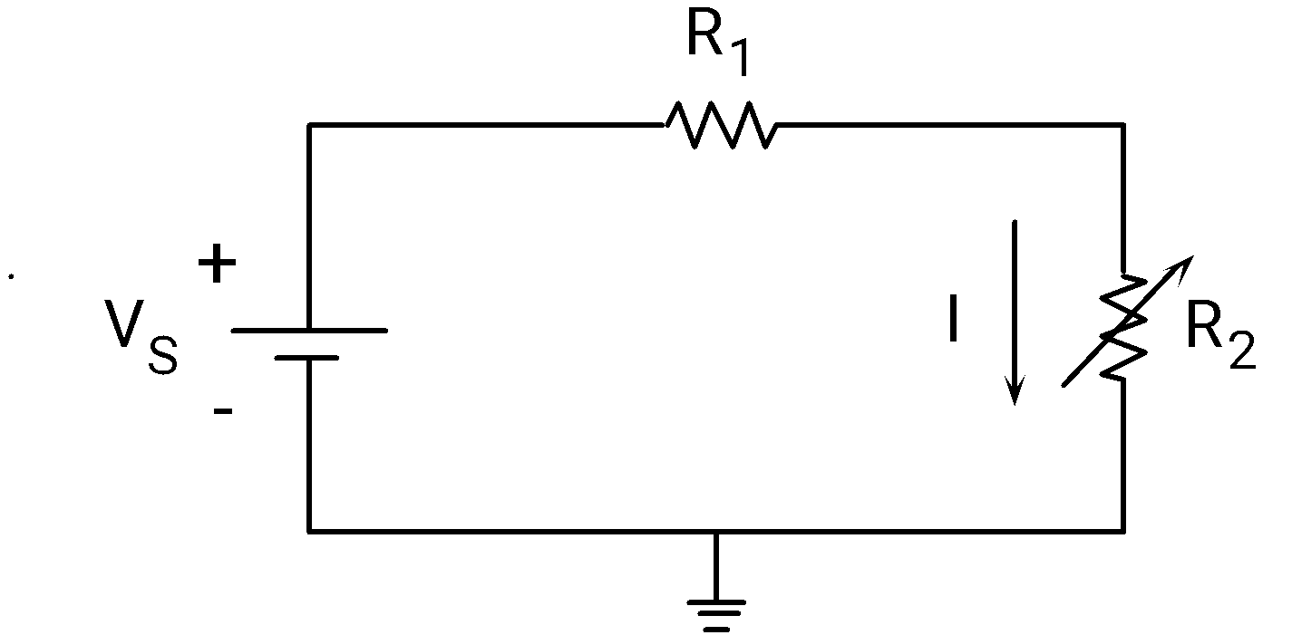

**Figure 1.3** Simple voltage divider circuit.

d) Prepare a table indicating the possible measurements that can be carried out using each equipment you used during the experiment.

e) Write a conclusion.