**UNIVERSITY OF MIAMI**

Department of Electrical and Computer Engineering

EEN 203

*Name:*

*Section:*

*Date:*

**OPERATIONAL AMPLIFIERS / PART I**

***Purpose***

The purpose of this experiment is to demonstrate some basic operational amplifier circuits, namely the inverting, summing, and non-inverting amplifiers as well as the voltage follower. All these circuits operate in the closed-loop mode. The inverting amplifier’s closed loop voltage gain can be less than, equal to or greater than one. Its output signal is always inverted with respect to its input signal, as the name implies. On the other hand, the non-inverting amplifier’s closed loop voltage gain is always greater than one, while its input and output signals are in phase. The summing amplifier, as the name implies, is used to obtain the algebraic sum of multiple inputs. Each input can be weighed by different gain factors. The voltage follower acts as a buffer with high input and low output impedances.

***Background***

The operational-amplifier is probably the most frequently used linear integrated circuit available. This device exhibits various desirable characteristics. Open-loop characteristics refer to those of an amplifier having no feedback elements between output and input. Closed-loop characteristics are those of an amplifier having an external feedback element or group of elements. When an element (i.e., a resistor, capacitor, inductor, etc) is connected from one of the input terminals to the output terminal, it will provide feedback, whereby a portion of the output voltage is added or subtracted from the input. Ideal operational-amplifiers have open-loop voltage gains of infinity. This gain is denoted as AVOL. Other desirable properties of ideal op-amps are the infinite input resistance and the zero output resistance. A circuit building block that can behave in this fashion

finds unlimited applications in electronic circuits as it provides isolation from one stage to another and eliminates loading. The circuit equivalent of an ideal op-amp is shown in Fig. 1.

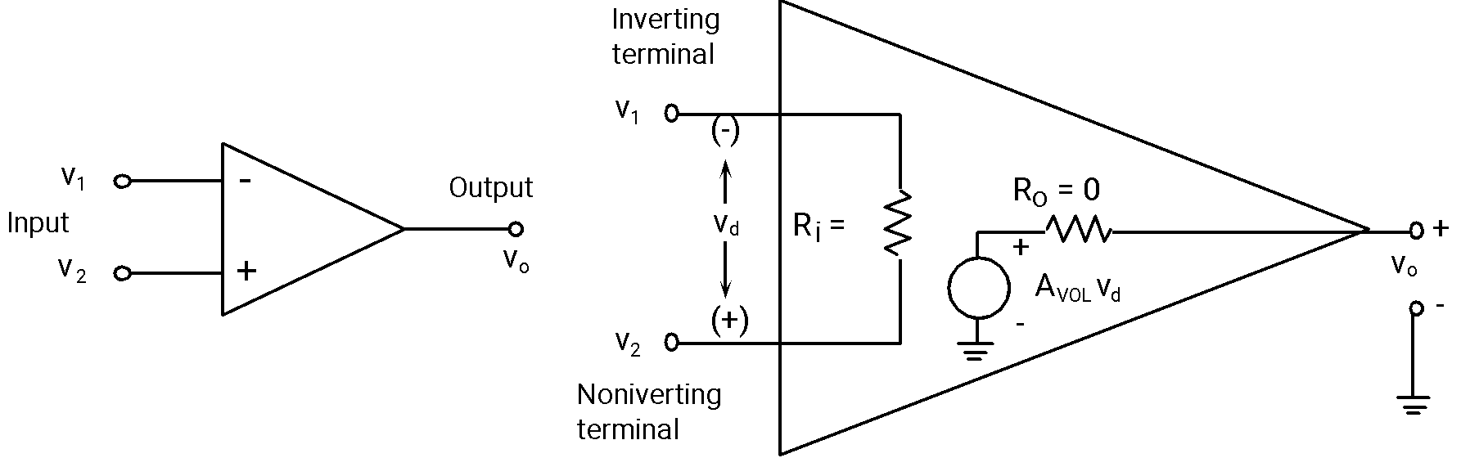

(a) (b)

**Figure 1:** (a) Op-amp circuit diagram, (b)Ideal op-amp equivalent circuit.

Practical op-amps, however, do not have infinite input impedance and zero output impedance. Values vary from one manufacturer to another but typical ones are more than 1 MΩ and 75 Ω for the input and output impedance’s, respectively.

Most applications require that the operational-amplifier be operated in the closed-loop mode. In this case the gain is no longer infinite but depends on the external circuitry attached to it. Two basic configurations that are commonly used are the *inverting* and the *non-inverting* amplifiers. These configurations will be studied in this experiment.

***Preliminary Work***

1. For the op-amp inverting amplifier circuit of Fig. 2, derive the closed loop voltage gain expression

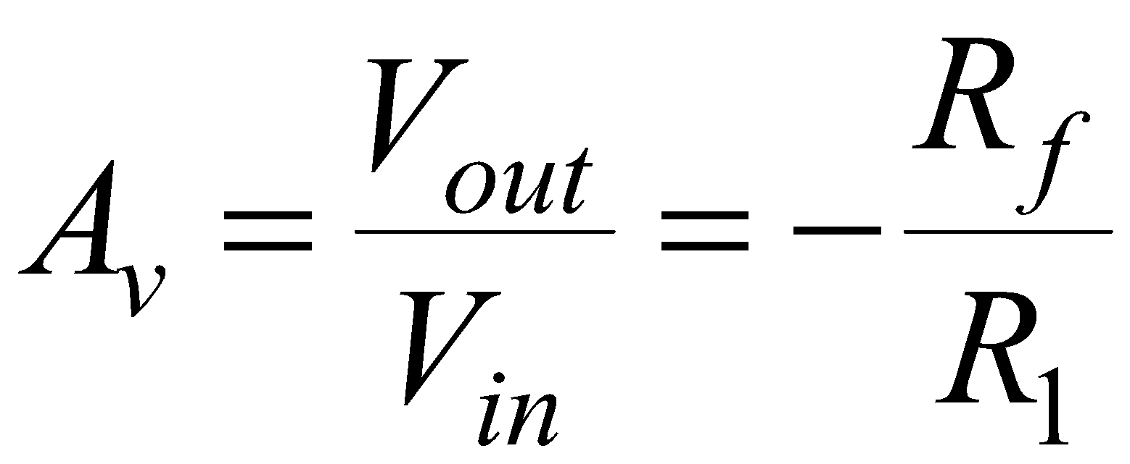

and select values for Rf and R1 for gains of

i ) Av = −10, and

ii) Av = −1.

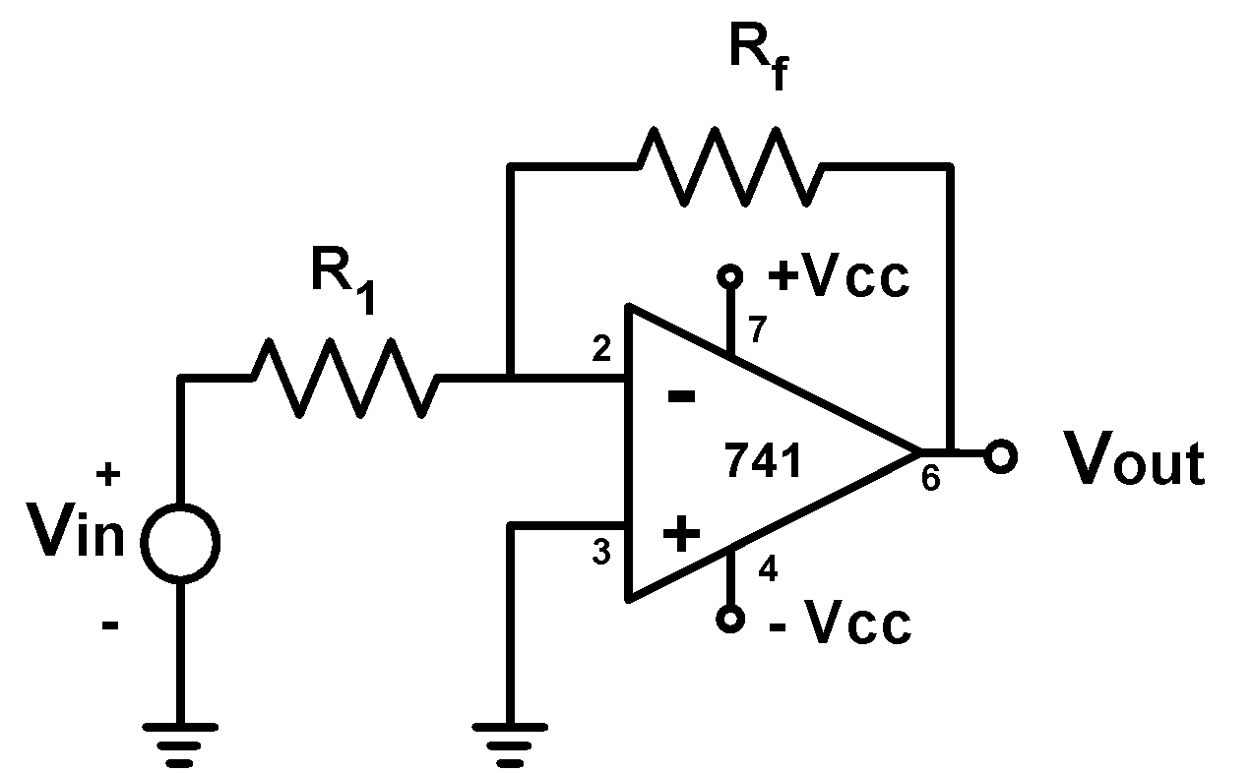

**Figure 2:** Inverting op-amp circuit.

1. For the summing amplifier circuit of Fig. 3, derive the output voltage expression

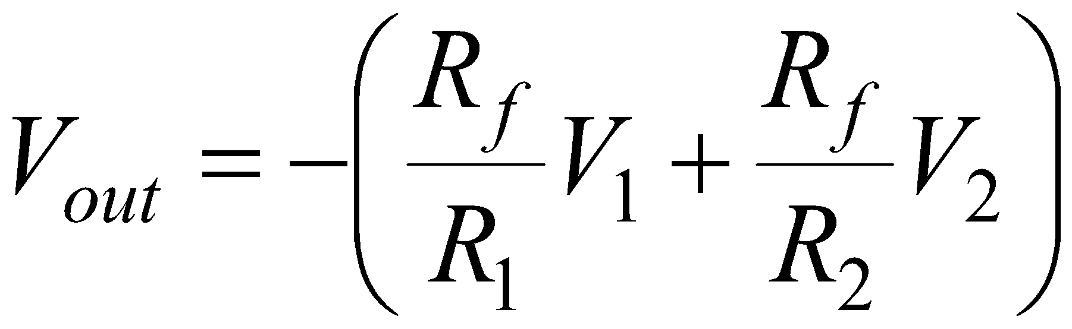

Choose values for Rf, R1, and R2 to have Vout = – (3V1 + 5V2).

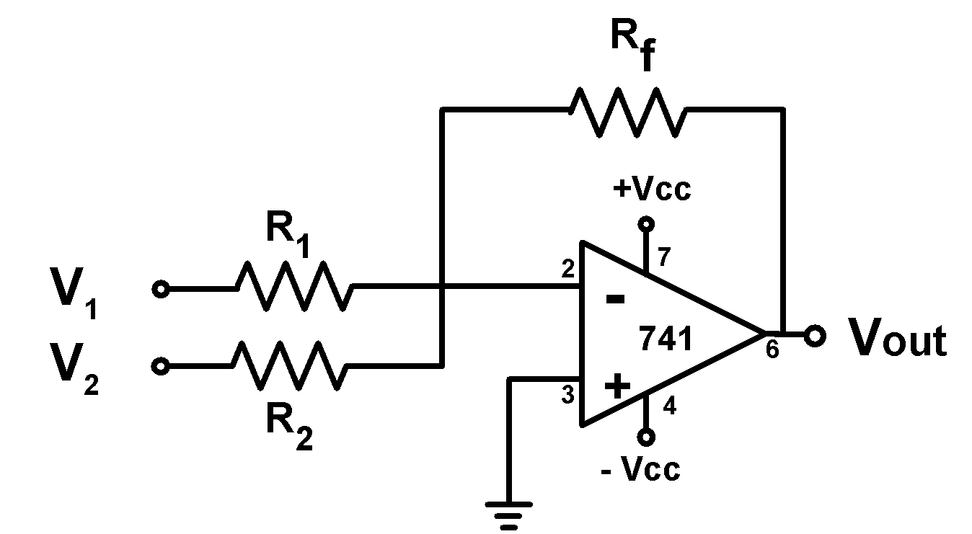

**Figure 3:** Summing op-amp circuit.

3. For the non-inverting amplifier circuit of Fig. 4, derive the closed loop voltage gain expression

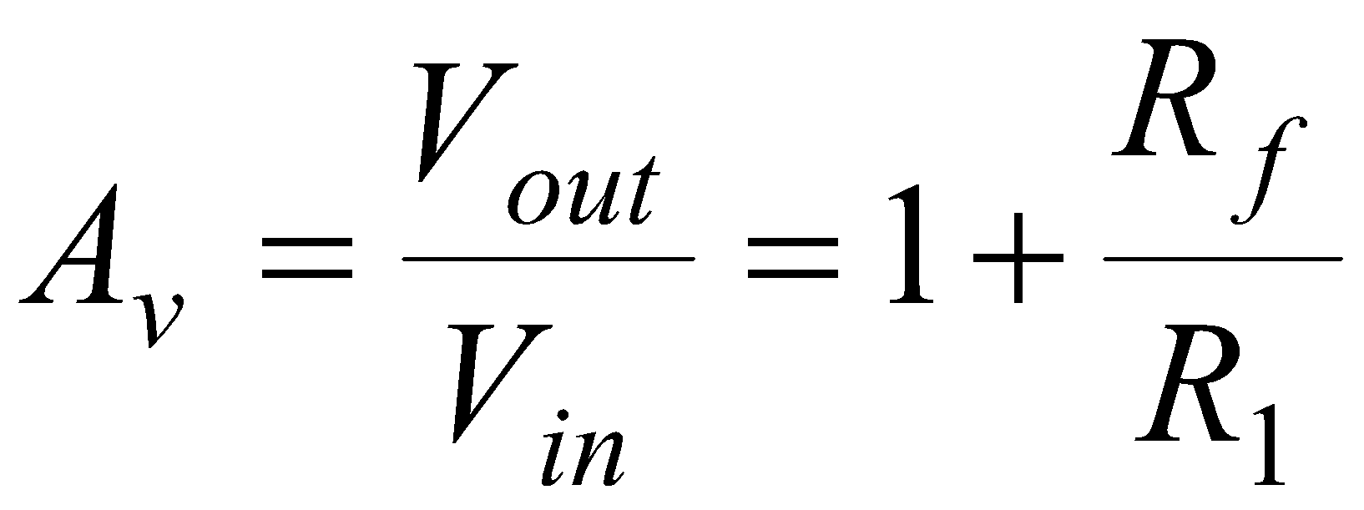

and choose values for Rf and R1 to have a gain of Av = 11.

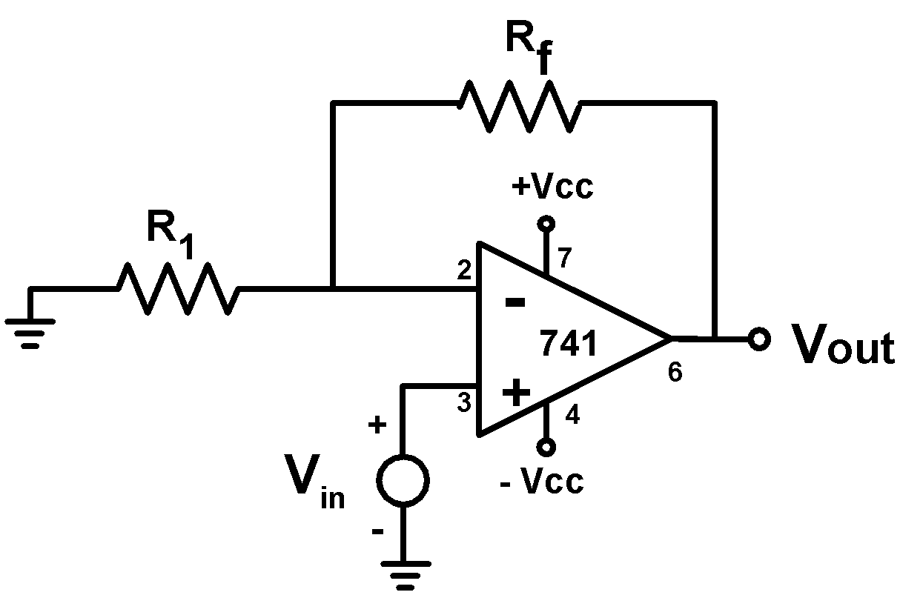

**Figure 4:** Non-inverting op-amp circuit.

***Experimental Procedure***

I. Inverting Amplifier:

Set up the circuit of Fig. 5 for gain of Av = −10, using the resistor values from your preliminary work.



Rf = R1 =

**Figure 5:** Inverting amplifier.

Adjust ±VCC = ±15 V. Apply a sinusoidal input signal of frequency f = 1 kHz. Displaying Vin and Vout on the oscilloscope simultaneously, sketch the waveforms with their phase relation shown clearly. To obtain the phase relationship one has to use the oscilloscope in CHOP viewing mode.

What are the maximum positive and negative swings at the output?

+V(out max) = ______ -V(out max) = ______

+Vcc used = ______ -Vcc used=______

II. Summing Amplifier:

Set up the circuit of Fig. 6 to add **3V1 + 5V2**. Use the resistor values from your preliminary work.



**Figure 6:** Summing amplifier circuit.

R1 = R2 = Rf =

Adjust ±VCC = ±15 V. Apply a sinusoidal input V1 of frequency *f* = 1kHz and a DC input V2 to the inputs of Fig. 6. Sketch V1, V2, and Vout.

**Make sure that the output voltage will not exceed the values from the last part (no clippings!).**

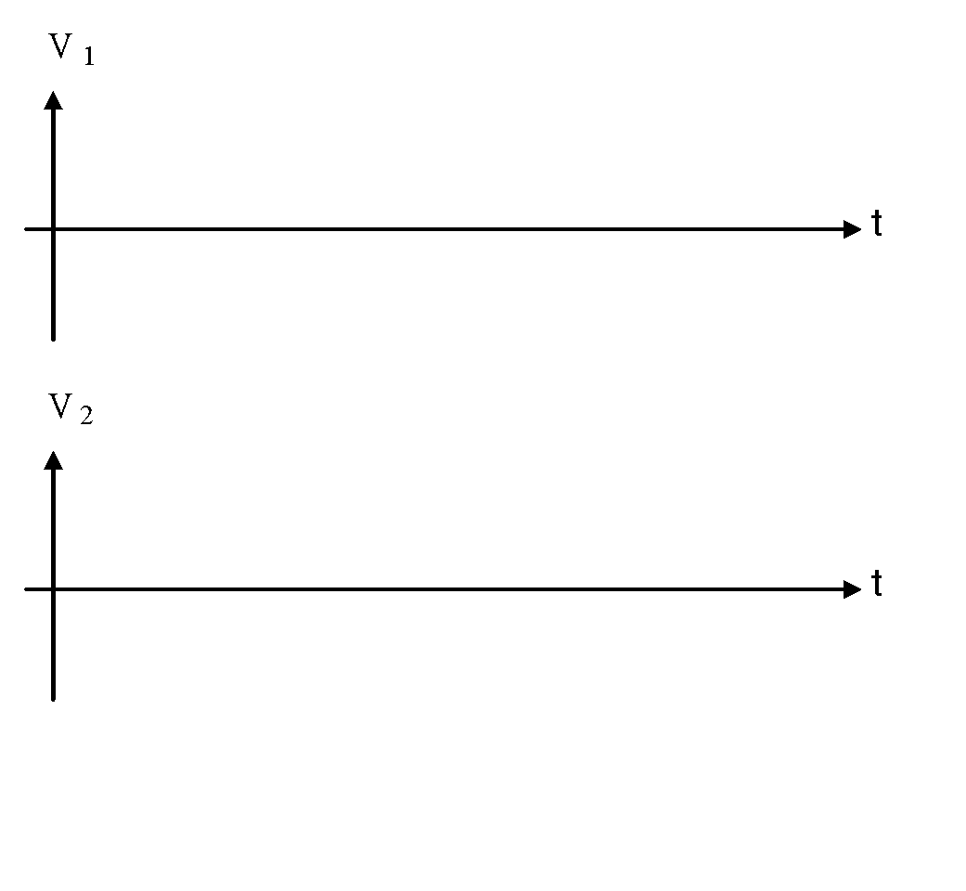

V1(p-p) = V2 = Vout =

III. Non-Inverting Amplifier:

Set up the circuit of Fig. 7, for a gain of Av = 11. Use the resistor values from your preliminary work.

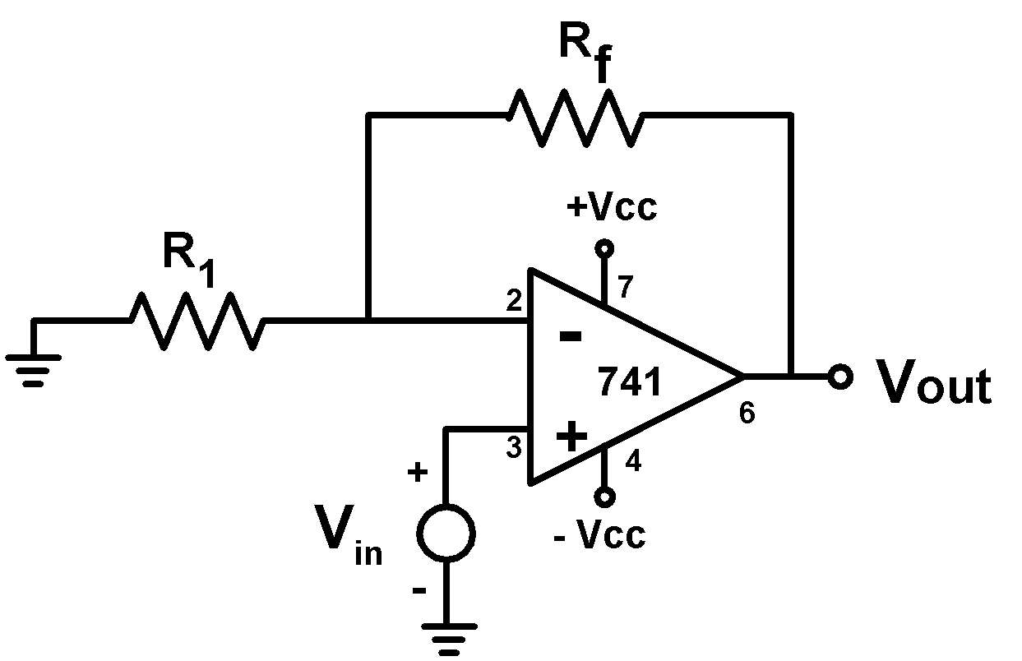

R1 = Rf =

**Figure 7:** Non-inverting amplifier circuit.

Adjust ±VCC = ±15 V. Apply a sinusoidal input signal Vin of frequency *f* = 1kHz. Displaying Vin and Vout on the oscilloscope simultaneously, sketch the waveforms showing their phase relation clearly. Measure Vin, Vout, and calculate the gain Av.

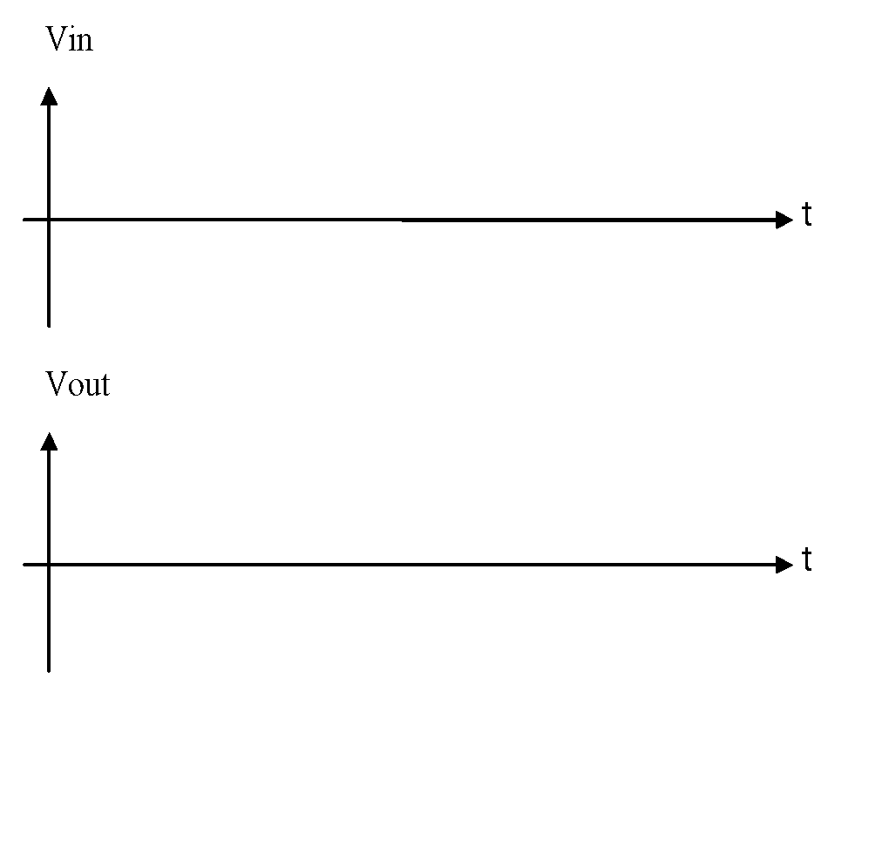

Vin (p-p) = Vout (p-p) = Av = =

IV. The Voltage Follower:

Connect the circuit of Fig. 8. With Vin = 5 Vpeak at 1 kHz, measure the output voltage Vout. Note the phase angle of the output Vo with respect to the input Vin. Repeat this procedure with Vin = 10 Vdc and again with Vin = 2 Vpeak square wave. Plot your findings in the graphs provided.

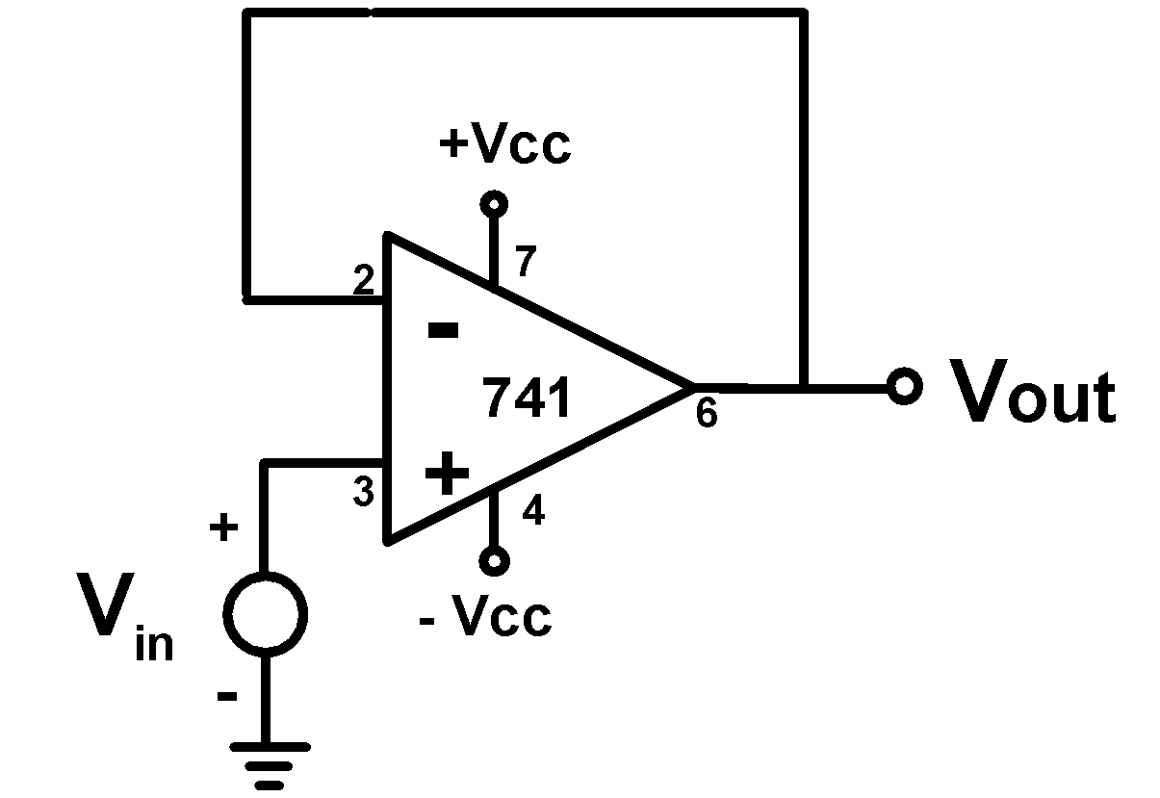

**Figure 8:** Voltage follower circuit.

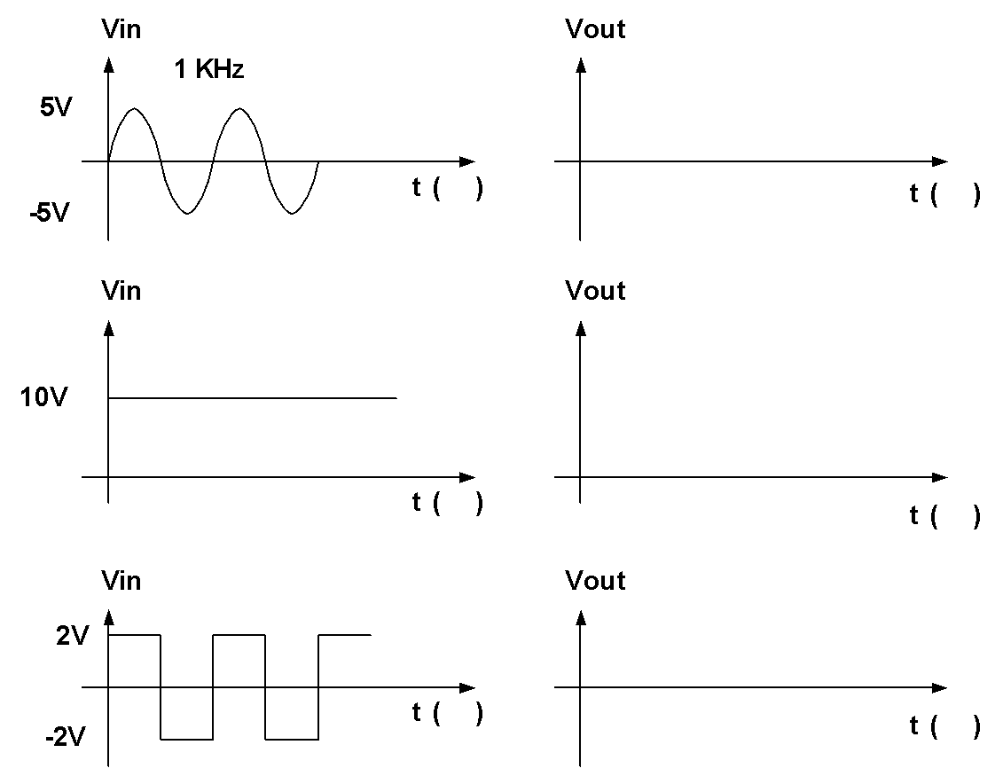

***PSpice***

A basic sub-circuit to model an Op-Amp is shown below. With Rid = 6 MΩ, Ro = 75 Ω and AVOL = 200,000 use PSpice to simulate an inverting amplifier with a gain of -10.

Repeat the simulation with the 741 instead of the sub-circuit and comment on the results.

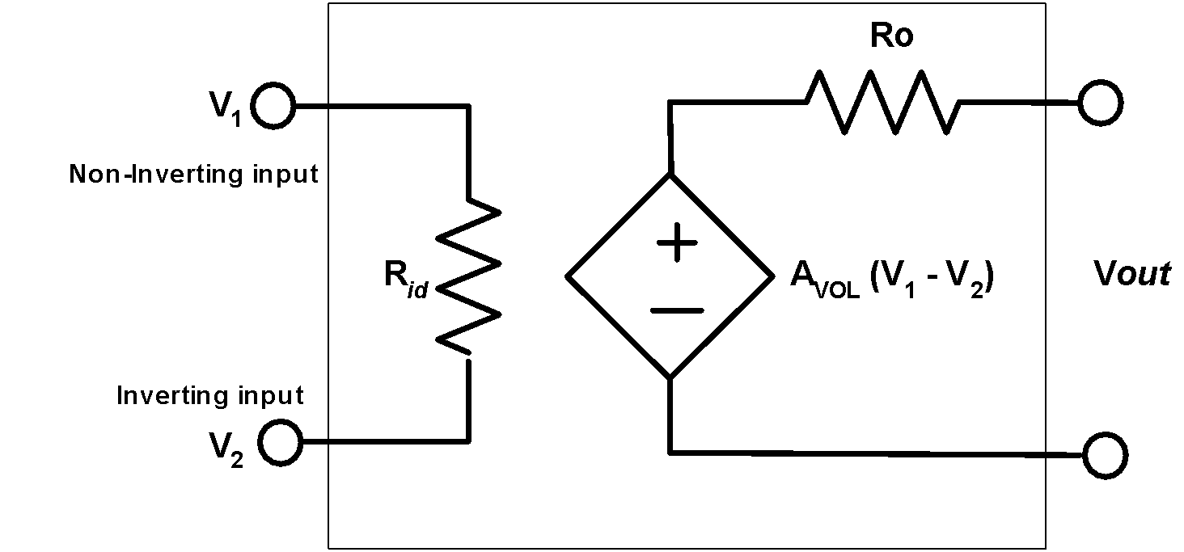

***Discussion of the Results***

1. Design a summing amplifier to give $V_{out}=+\left(3V_{1}+5V_{2}\right)$. Draw the circuit diagram and label resistor values.
2. Write a conclusion.