**UNIVERSITY OF MIAMI**

Department of Electrical and Computer Engineering

EEN 203

*Name:*

*Section:*

*Date:*

EXPERIMENT 6

**A LABORATORY DESIGN EXPERIMENT**

**Band pass Filter Design**

**PURPOSE:** The purpose of this lab is to design, simulate, build and test a simple band pass filter using passive components. The experiment is designed to provide the student with skills associated with preparing and executing a design oriented problem with minimum supervision.

***Introduction***

A filter network is generally designed to pass signals in a specific frequency range (pass band) and reject or attenuate signals whose frequency spectrum is outside the pass band (stop band). Ideally, we would like to have a filter pass frequencies in the range 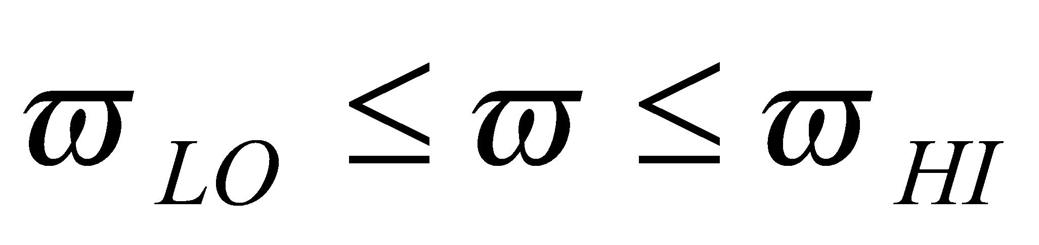and completely reject frequencies that are outside this band. However it is not possible to design such a filter with linear circuit elements such as capacitors and resistors. The characteristics of an ideal (solid) and typical (dashed) band pass filter are given in Fig. (1).

**Figure 1.** Band-pass filter characteristics (frequency response).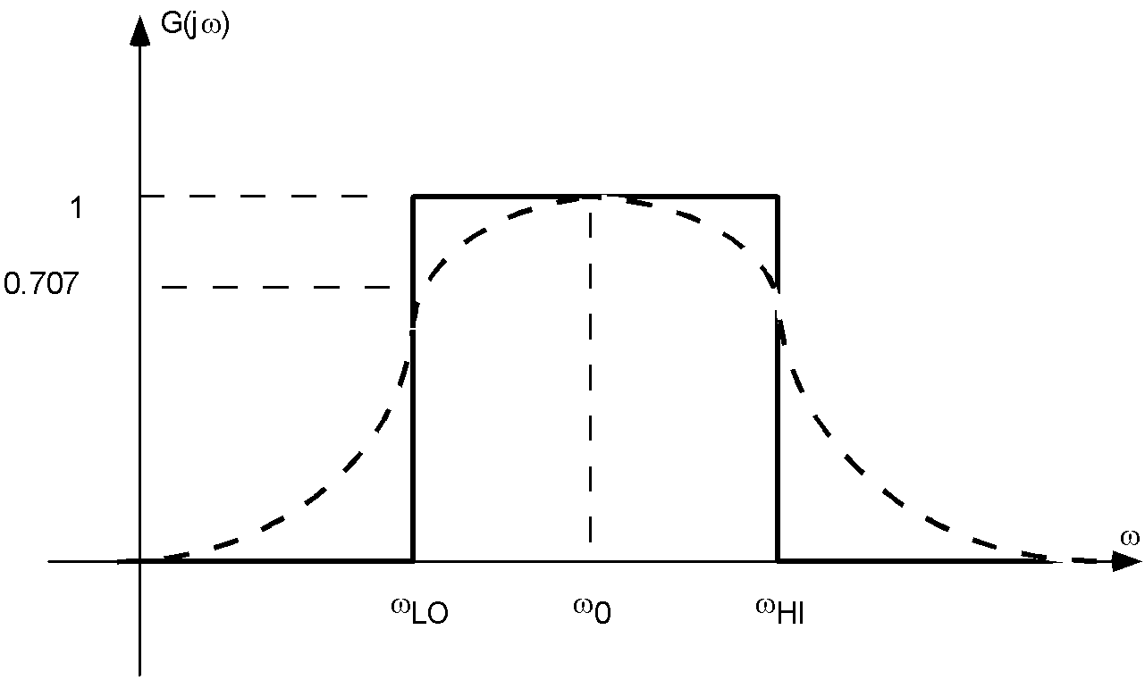

The frequency response of a band-pass filter can be characterized by the following measures. The center frequency 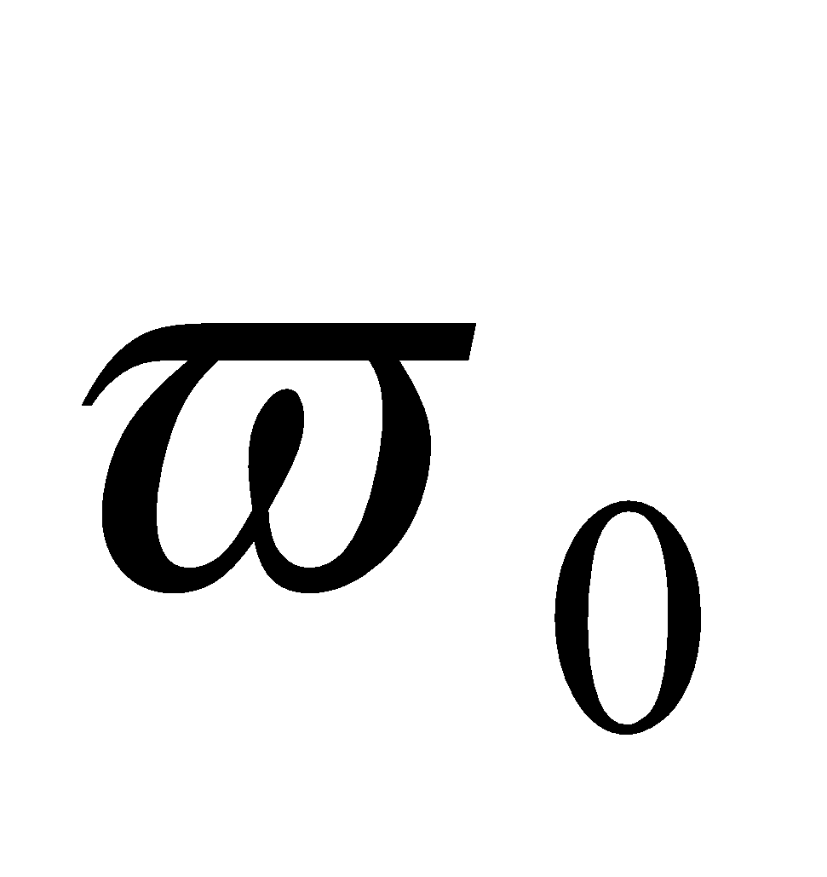of the filter. This is the frequency at which the maximum amplitude occurs. The upper and lower break frequencies or the *cutoff frequencies* 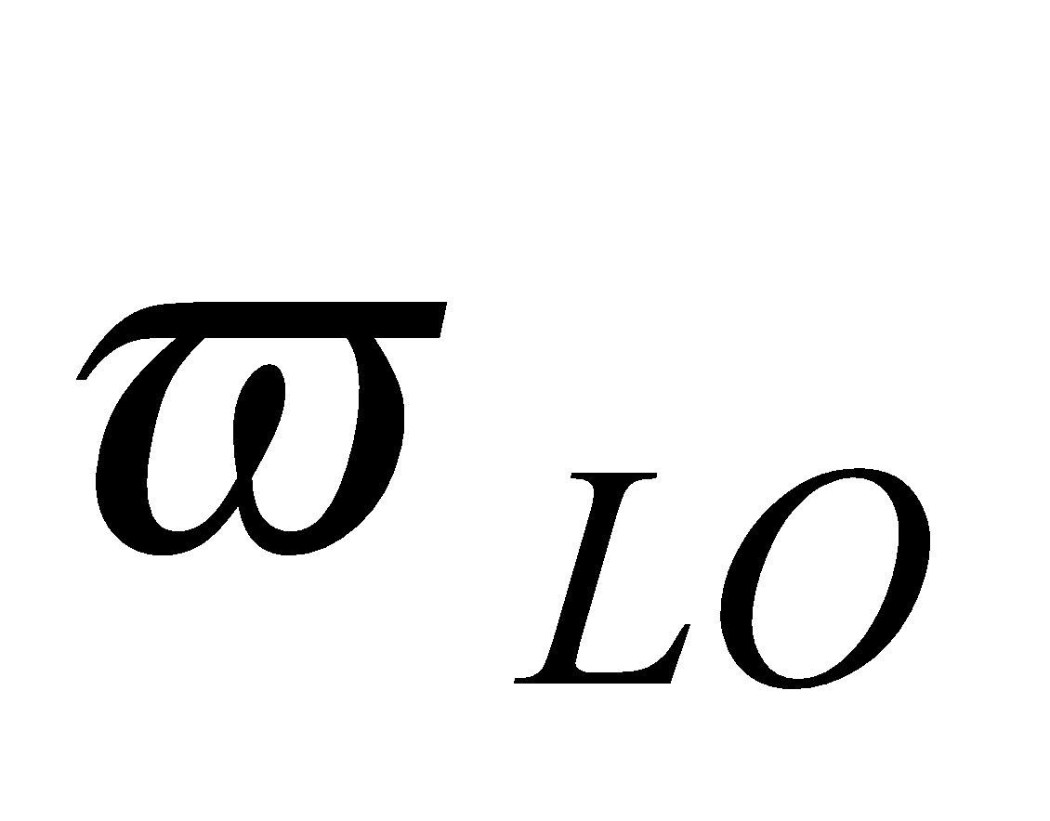and 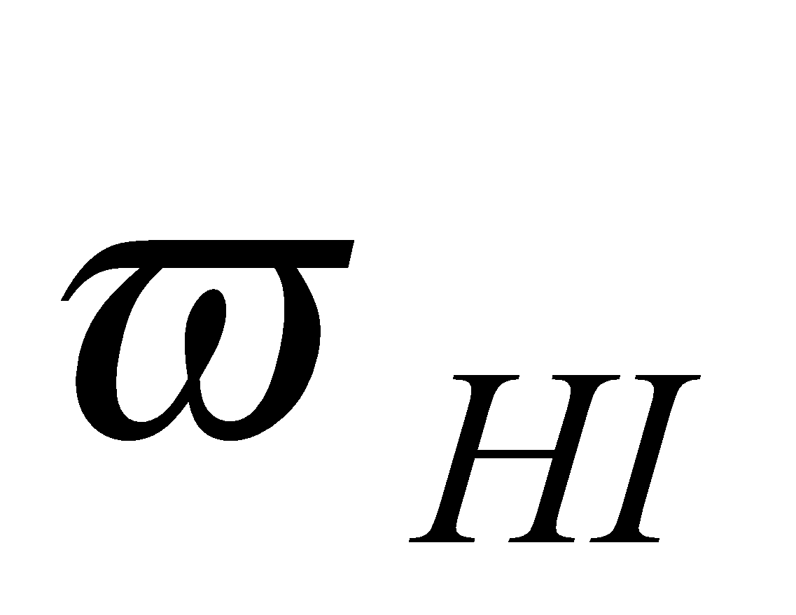. The *cutoff frequency* of the filter is where the amplitude is 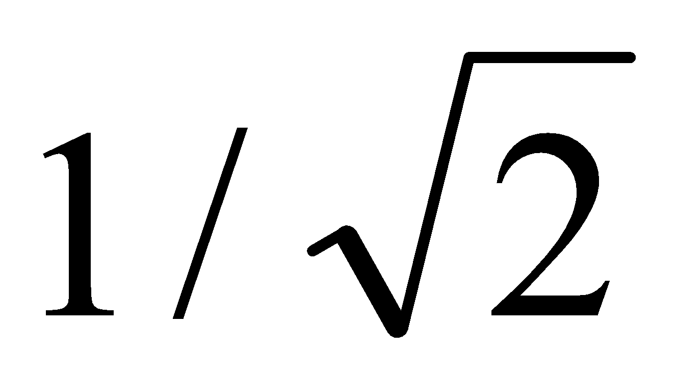 of the maximum value. Then the width of the pass band, called the *bandwidth* (BW) of the filter, is given by the expression

BW = - .

The design specifications for filters are given in terms of the characteristics of the frequency response of the filter. The band pass filter that is chosen for this exercise is given in Fig. (2). It uses a cascade of a high pass filter (HPF) and a low pass filter (LPF) consisting entirely of capacitors and resistors. The theoretical equations obtained via the chosen circuit can be used together with the design specifications to find the values of the passive components.



**Figure 2.** Band-pass filter

Note that commercially available capacitors and resistors take a finite set of values. Hence prior to constructing the circuit for measurements, one has to approximate the values obtain via theoretical computations to values that are readily available in the laboratory.

The band pass filter design should consist of the following stages:

1. **Theoretical calculations**: Design the filter using theoretical equations and the specifications.
2. **Pspice simulation**: Use the design values obtained from the previous step to simulate the band-pass filter characteristics. Further fine-tuning of the passive components can be carried out in this step to obtain the passive component values that provide the exact design specifications.
3. **Measurements:** The values obtained via the simulation are used to construct the circuit in the laboratory and relevant measurements are done to verify the characteristics obtained via the Pspice simulation. At this stage one has to use readily available component values in order to construct the circuit.

***Design Specifications***

Design the band-pass filter given in Fig (2) for 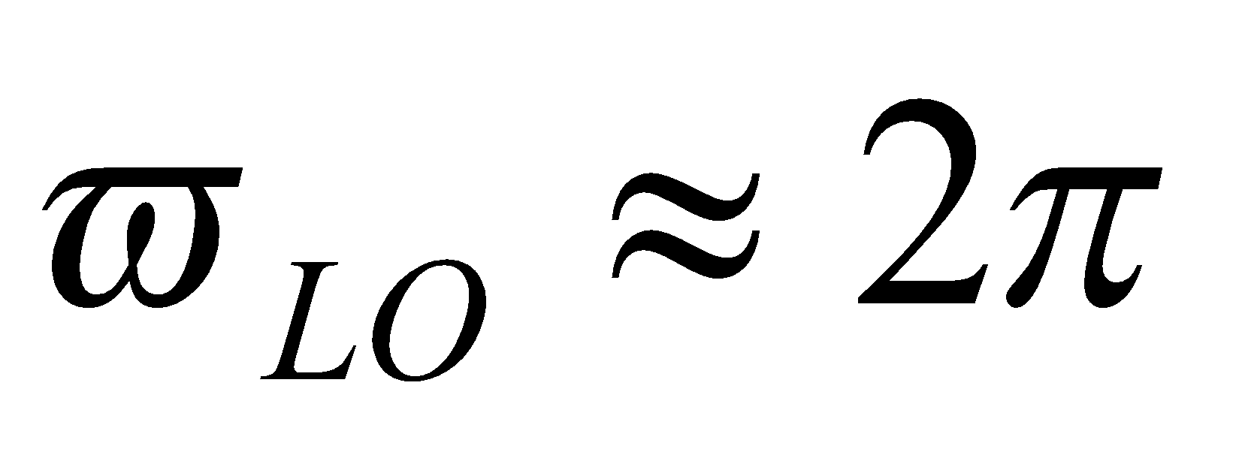krad/s lower cutoff frequency and 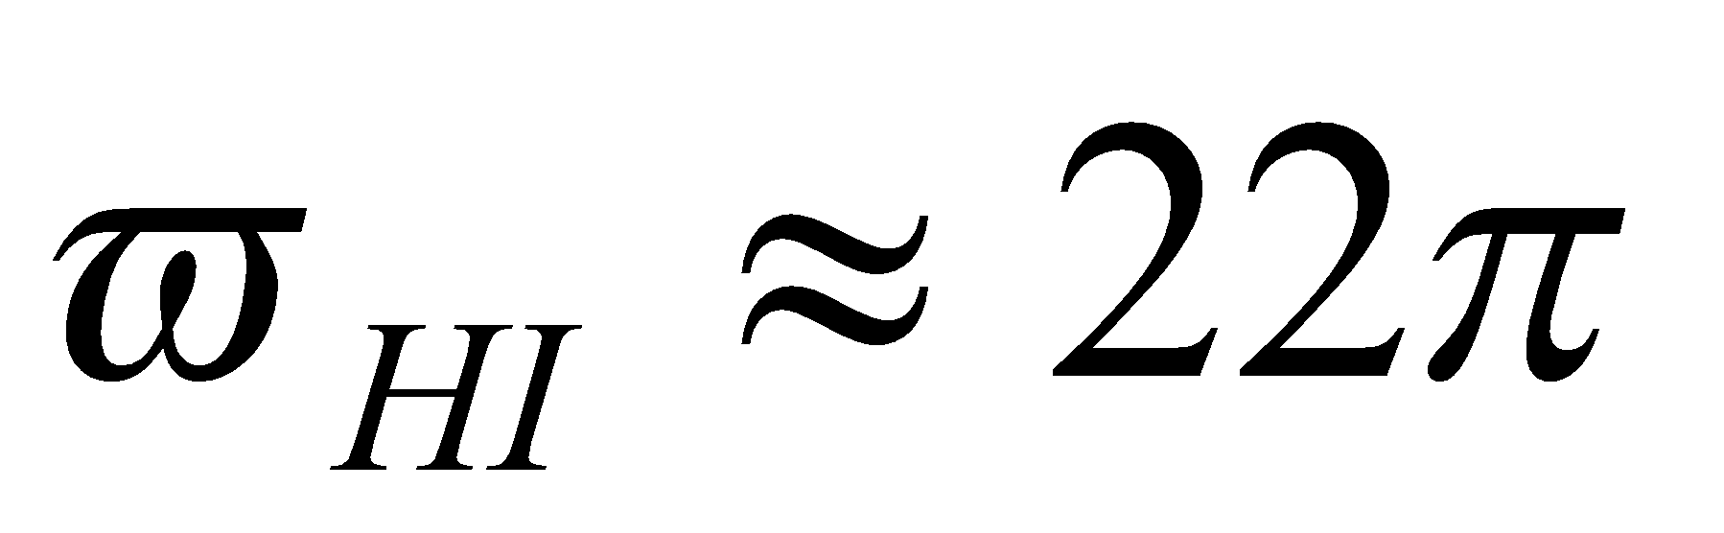 krad/s upper cutoff frequency. Note that the resistor and capacitor values should be chosen from the range available in the laboratory.

***Results***

The following guidelines can be used to prepare the design report in the standard lab manual format.

**STAGE A**

Design your circuit based on the specifications given above for the filter shown in Fig. (2). Show all derivations and calculations used for the design. Briefly describe the design approach you have taken providing any assumptions you have made.

**STAGE B**

Use Pspice schematics to simulate the results from Stage A and verify that the design specifications are met. Provide all programs and graphs to support your claims. If the theoretical values obtained do not provide exact design specifications, describe the method you have used in order to fine-tune the designed values.

***Hint:*** Use the parametric sweep capability in Pspice to fine-tune the design.

**STAGE C**

Build your circuit using discrete components and verify the designed and simulated values. Collect all relevant data to support any claims you will be making. Briefly describe the measurement procedure. Use semilog paper or software programs like Excel to plot the frequency response of the filter.

All results should be logically ordered in the report and sufficient information should be provided to support any claims you are making. Compare the measured results and the simulated results and discuss any differences giving reasons.