**UNIVERSITY OF MIAMI**

Department of Electrical and Computer Engineering

EEN 203

*Name:*

*Section:*

*Date:*

EXPERIMENT 8

**INTRODUCTION TO DIGITAL ELECTRONICS**

**PURPOSE:** The purpose of this lab is to introduce the student to two common building blocks in the design of digital circuits: the *AND* gate and the *OR* gate. Diode circuits will be built first to simulate the functions of the AND and the OR gates, respectively. Then, two popular TTL integrated circuits that perform these functions will be tested.

**Figure 8a** Simple Digital Circuit elements: symbols, truth tables & Boolean expressions

***Equipment***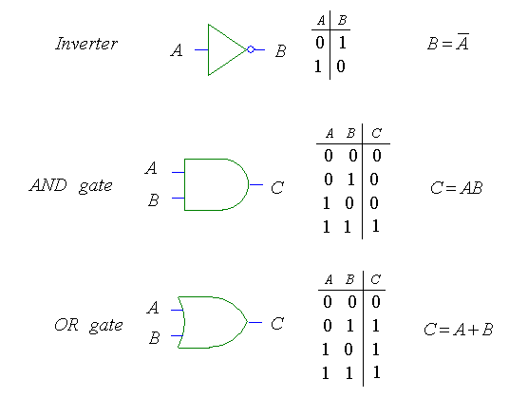

1 DC Power Supply

2 Diodes

1 1 kΩ resistor

1 7408 IC

1 7432 IC

***Preliminary Work***

1) Draw the logic diagram to implement the following functions using AND and OR gates. Form a truth table for each and show the output state for each possible input combinations (notice that there are 16 possible input combinations).

a) *Y = AB + CD*

b) *Y = (A+ B)(C + D)*

c) *Y = A(BC + D)*

***Experimental Procedure***

I. Diode AND Gate:

Set up the circuit shown in Fig. 8.1. Collect data with the D.V.M. and complete Table 8.1.

**Figure 8.1** Simple AND gate. **Table 8.1**

II. Diode OR Gate:

Set up the circuit shown in Fig. 8.2. Collect data with the D.V.M. and complete Table 8.2.

**Figure 8.2** Simple OR gate. **Table 8.2**

III. Explain how the circuits in parts I and II work and comment on the results you obtained.

IV. Integrated Circuit Logic Gates:

Repeat parts I and II but this time use the 7408 quad AND gates the 7432 quad OR gates shown in Figs. 8.3 and 8.4, respectively. Collect your data in Tables 8.3 and 8.4. The integrated circuits have to be activated by giving VCC = 5V and GND = 0V via a DC power supply.

**Figure 8.3** TTL’s 7408 quad AND gates. **Figure 8.4** TTL’s 7432 quad OR gates.

**Table 8.3 Table 8.4**

V. Build the circuit to evaluate the Boolean function *Y = AB + CD.* The logic diagram was found in the preliminary work. Fill in the truth table below using the D.V.M.

| **A (Volts)** | **B (Volts)** | **C (Volts)** | **D (Volts)** | **Y (Volts)** |
| --- | --- | --- | --- | --- |
| 0 | 0 | 0 | 0 |  |
| 0 | 0 | 0 | 5 |  |
| 0 | 0 | 5 | 0 |  |
| 0 | 0 | 5 | 5 |  |
| 0 | 5 | 0 | 0 |  |
| 0 | 5 | 0 | 5 |  |
| 0 | 5 | 5 | 0 |  |
| 0 | 5 | 5 | 5 |  |
| 5 | 0 | 0 | 0 |  |
| 5 | 0 | 0 | 5 |  |
| 5 | 0 | 5 | 0 |  |
| 5 | 0 | 5 | 5 |  |
| 5 | 5 | 0 | 0 |  |
| 5 | 5 | 0 | 5 |  |
| 5 | 5 | 5 | 0 |  |
| 5 | 5 | 5 | 5 |  |

**Table 8.3**

***Discussion of Results***

1) Discuss the application of digital circuits giving examples.

2) Digital circuits are not really digital. They are actually analog circuits that are designed to

approximate digital functions.

i) Explain why digital circuits must allow for a range of analog

values in order to represent a binary 1 or 0.

ii) How does this restrict the operation of digital circuits?

3) Write a conclusion.