Decorator Pattern

Motivation

Extending an object‘s functionality can be done statically (at compile time) by using inheritance however it might be necessary to extend an object‘s functionality dynamically (at runtime) as an object is used.

动态地给一个对象添加一些额外的职责。就增加功能来说，Decorator模式相比生成子类更为灵活。

Intent

The intent of this pattern is to add additional responsibilities dynamically to an object.

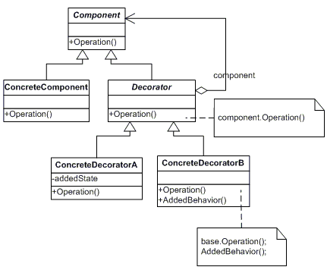

* Component
  + defines the interface for objects that can have responsibilities added to them dynamically.
* ConcreteComponent
  + defines an object to which additional responsibilities can be attached.
* Decorator
  + maintains **a reference to a Component object** and defines an interface that conforms to Component's interface.
* ConcreteDecorator
  + **adds** responsibilities to the component.

