**CS7646 Manual Strategy Project Report**

Author: Yu Bai (GID ybai67)

Date: 11/04/2017

**Part 1: Technique Indicators**

Five technique indicators are considered in this project: simple moving average (SMA), percentage Bollinger® band (%BB), relative strength index (RSI), momentum and moving standard deviation. Each is described with a figure illustration below.

**SMA:**

The SMA at a given date $t$ is calculated as the mean of the price over a lookback period from $t-n$ to $t$. Figure 1 illustrates the SMA (red line) of JPM from Jan 2008 to Dec 2009 with a lookback window of 20 days (the number of trading days per month). As expected, the SMA follows the price but much smoother. It also crosses the price when the price direction reverses. We choose the SMA because it typically, as the average price over many days, represents the true value of a stock. Thus, comparing the price to the SMA can help decide if the stock is over- or underpriced. In addition, we use the price-SMA crossovers to help identify the potential reversal of the current trend.

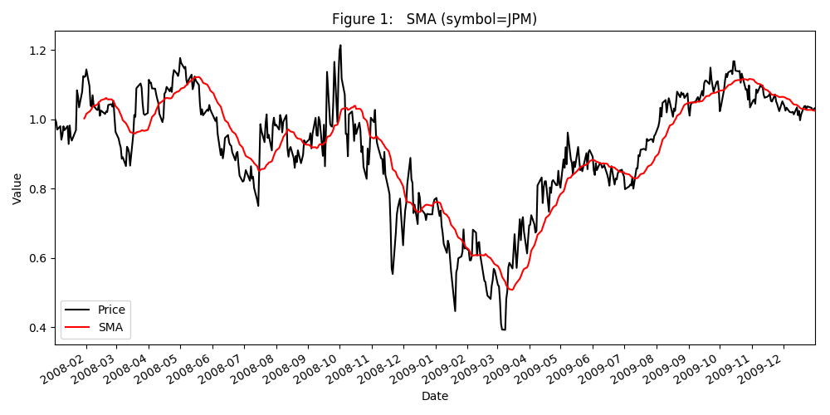

**%BB:**

The percentage of Bollinger® band indicator is derived from the Bollinger® band (BB). Given the simple moving average of the price over a lookback period (aka SMA above) and the standard deviation of the price over the same period (SV), the top and bottom Bollinger® bands locate at 2-fold SV above or below the SMA, respectively (Figure 2, blue lines). The spread between the top and bottom bands is considered as the bandwidth. The %BB (Figure 2, red dotted line) is then calculated as the difference of the price relative to the bottom Bollinger® band, normalized to the bandwidth: (price – bottom BB)/(top BB – bottom BB). We use %BB to identify the events when the price is significantly different from the SMA. Typically, when %BB >1, the price is higher than the SMA by more than 2 standard deviation (exceeding the top Bollinger® band) and thus may be considered overbought. Conversely, when %BB<0, the price is lower than the bottom Bollinger® band and may be considered oversold.

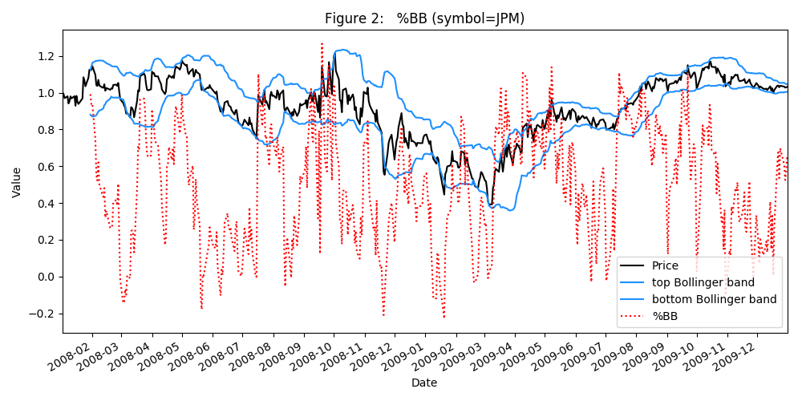

**RSI**:

The RSI is related to the relative strength (RS). The RS is the ratio of the average upward price change in the lookback period, to the average downward price change in the lookback. Note the up- and downward changes refer to the magnitude without the sign so both are positive values. The RSI is then calculated as 100 – 100/(1+RS), which is essentially the percentage of the upward change with respect to the total of the up- and downward changes. RSI is a useful indicator of the price trend. Figure 3 shows the RSI curve of the JPM stock from Jan 2008 to Dec 2009 with a look back window of 20 days. We can see that low and the RSI oscillates between low and high accompanying down and up trend of the price, respectively.

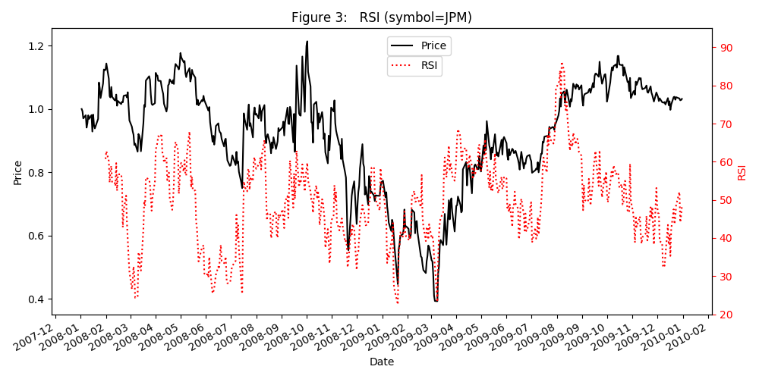

**Momentum:**

Momentum is computed as the percentage price change at the current date $t$ relative to the previous date $t-n$, i.e. $\frac{price\left[t\right]}{price\left[t-n\right]}-1$, where $n$ is the lookback window size. It is a measurement of how strong the price trend is. In this project, we combine the momentum with the SMA-price crossover to identify more robust changes in the price trend. The momentum of JPM with 40-day lookback period from January 2008 to December 2009 is shown in Figure 4. Note that the momentum is near 0 when the price merely oscillates but without a significant trend, for instance, March to April and mid-July to mid-August in 2008. In contrast, large momentums tend to coincide with the transition of the significant price trend, like the price reversal in May, early July, September of 2008, and in March, May, September of 2009. Thus, the momentum can help distinguish the random price oscillations from potentially real price reversal at the SMA-price crossovers.

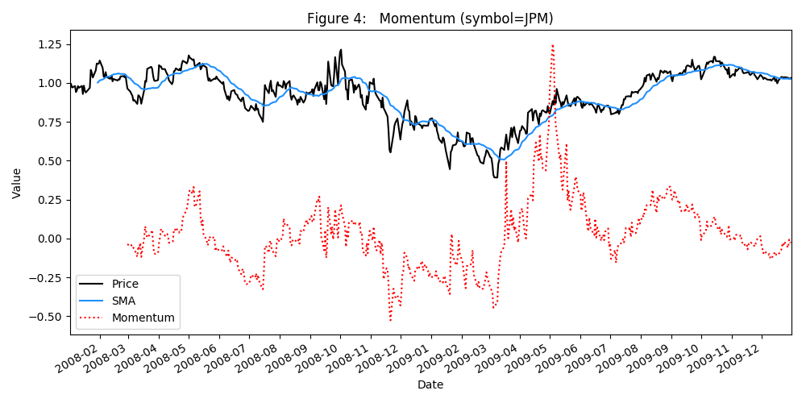

**(relative) Moving Standard Deviation:**

The moving standard deviation is the same standard deviation of the price over the rolling lookback window (SV) used in the %BB calculation. Note that, in general, the magnitude of the moving standard deviation is not independent of the price value but rather correlates positively with it. Thus, we further divide it by the corresponding SMA to remove the impact of the price value itself. The resulting relative moving standard deviation is a fairer assessment of the noise level across different price values.

As shown in Figure 5, the relative moving standard deviation is high when the price is unstable, such as during the period of September 2008 to May 2009. It is much lower after September 2009. Similar as the momentum, we choose the moving standard deviation to aid distinguishing the real price trend reversals from the instability of the price itself, since the latter comes with higher variances.

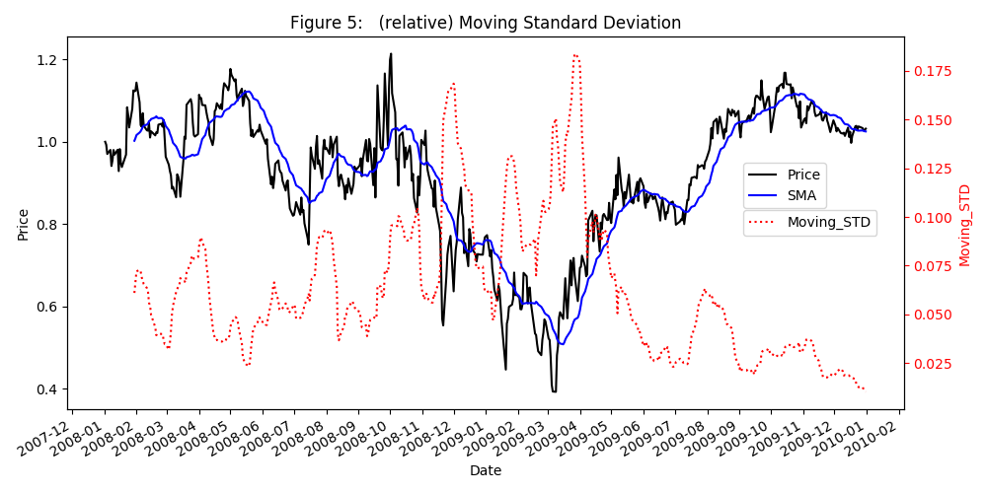

**Part 2: Best Possible Strategy**

Assuming we can peek into the future, and there is zero impact & commission, the best possible strategy is to trade maximum amount everyday according to the price change, if any, in the next day. That is, go long or short to the maximum allowable holdings if the price increases or drops the next day, respectively. If there is no price change or the perspective trade will violate the holding limit, then no trading is conducted. For example, if the price will drop the next day and our current holding is +1000, we short 2000 shares. At the next day, if the price shall drop again the day after, we will do nothing since we are already at the maximum allowed short position (aka -1000). This strategy is the best possible because it captures every gain opportunity permitted by the holding limits. As shown in Figure 6, this strategy vastly outperforms the benchmark over the In-Sample period (678610.0 vs 101230.0 in final portfolio value). Table 1 also summarizes the performance of the best possible strategy and its benchmark: 5.7861 vs. 0.0123 in cumulative return, 0.00382 vs. 0.000168 in average daily return, 0.00454782 vs 0.017004 in daily return standard deviation, and 13.3227698 vs. 0.1569184 in Sharpe ratio.

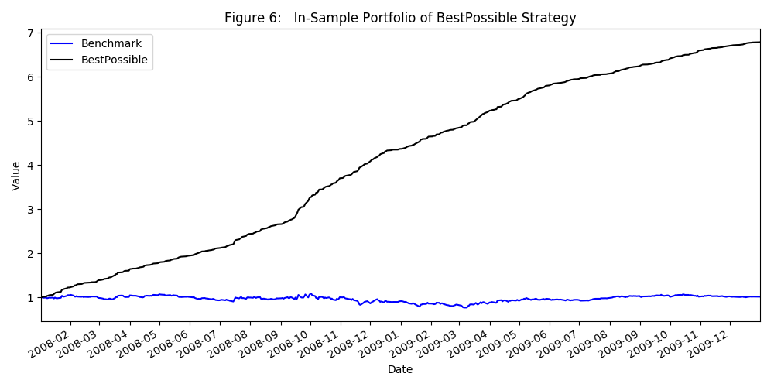

Table 1



**Part 3: Manual Strategy**

As listed below, the post-tweaking manual strategy consists of rule based criteria for the entry and exit actions. The entry criteria contain separate rules for going long and short. We combine all five indicators to formulate the rules because a signal consistently identified by multiple indicators are more likely to be real.

Long entry: if Price/SMA<0.95 **AND** %BB<0 **AND** RSI<35 **AND** (rel.) moving standard deviation <=0.07 **AND** momentum<-0.1, go

to +1000 holding unless already at +1000,

Short entry: if Price/SMA>1.05 **AND** %BB>1 **AND** RSI>60 **AND** (rel.) moving standard deviation <=0.07 **AND** momentum>0.12, go

to -1000 holding unless already at -1000,

Exit: if SMA-Price crossover **AND** (rel.) moving standard deviation <=0.06 **AND** |momentum|>0.2, go to 0 holding,

Do nothing: if none of above is met. (Note we essentially do nothing if the long entry is met but currently with +1000

holding, or the short entry is satisfied but currently with -1000 holding)

wherein SMA, %BB, RSI and moving Stdev use a lookback window of 20 days, and momentum uses a window of 40 days.

The SMA, %BB and RSI are common indicators for identifying the divergence of the price from the true stock value. The price-value divergence provides entry opportunities. When the price is lower than the SMA by a certain amount, lower than the bottom Bollinger® band, and there exist more downward days than the upward days, it is logical to consider the stock may be underpriced. Hence a long entry may be initiated. Nevertheless, from the above Figure1-6 we see that the in-sample price can be quite unstable, resulting false long signals. We therefore add the low moving standard deviation and high momentum requirements to filter out the instability-induced false entry. The short entry rule is constructed similarly but with the reciprocal thresholds of the indicators.

We adopt the common practice of using SMA-price crossover to mark the exit signal. As shown in Figure 1, SMA-price crossovers occur when the current price trend will terminate (presumably reverse). Therefore, it makes sense to exit the current position to which one presumably enters according to the current trend. Notably, the price instability also generates many crossovers that don’t match the correct boundaries of the price trend. Hence, we apply the low moving standard deviation and high momentum constraints here as well.

The parameters to calculate the indicators and to define the rules are manually tweaked using the in-sample data. The final portfolio reaches $137606.9, outcompeting the benchmark of $101027.7 (Figure 7). The long and short entries are marked with the green and red vertical lines in Figure 7, respectively. We can see that a short position is properly entered before the major down market between 2008-09 and 2009-02, followed by a long entry to capture the subsequent major up market. The ~38% cumulative return and the proper trading entries indicate the manual strategy is efficient.

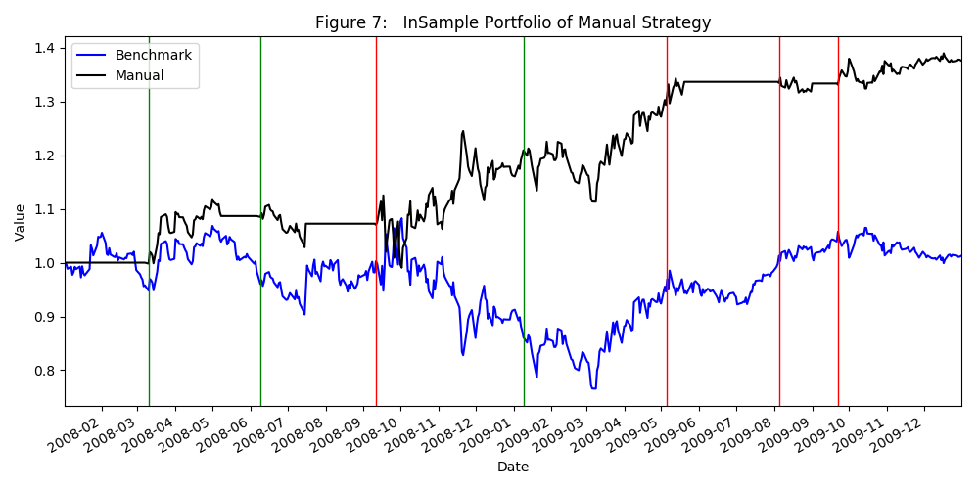

**Part 4: Compare the In- and Out-Sample performance of the Manual Strategy**

The In-sample and out-sample performances of the manual strategy are compared in Figure 7 (above, In-sample) and Figure 8 (out-sample) and in Table 2.

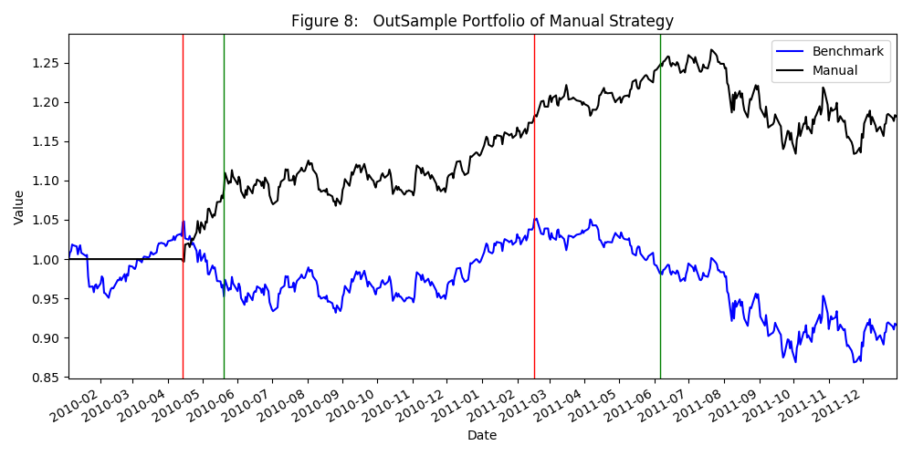

Table 2: 

We can see that the manual strategy is better than the benchmark for both In- and Out-sample. However, the Out-sample performance of the manual strategy is not as good as its In-Sample performance. The cumulative return drops from ~0.376 to ~0.182. The daily return decreases from 0.000714 to 0.000353. The Sharpe ratio falls from 0.892 to 0.843. Further, as shown in Figure 8, the last long entry takes place in 2011-06 but the price declines afterward. The loss due to this improper trading offsets most of the previous gain and thus the end return is not impressive.

The sub-optimal performance of the strategy in the Out-samples, relative to the In-Sample performance, is understandable. The strategy is optimized only using the In-Sample. It does not take generalizability into consideration at all and hence not take any precaution to reduce overfitting. In addition, two-year is a relative short time period, the In-Sample data may not be sufficient to make the strategy general. These reasons likely render an overfitting strategy that works well for the In-Sample but not for the unseen Out-sample.