# 破解pycharm专业版

1.pycharm下载链接:

2.pycharm安装

3.下载JetbrainsCrack.jar文件

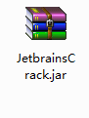

4.找到PyCharm安装目录下的bin目录，将下好的JetbrainsCrack.jar文件复制到bin文件中

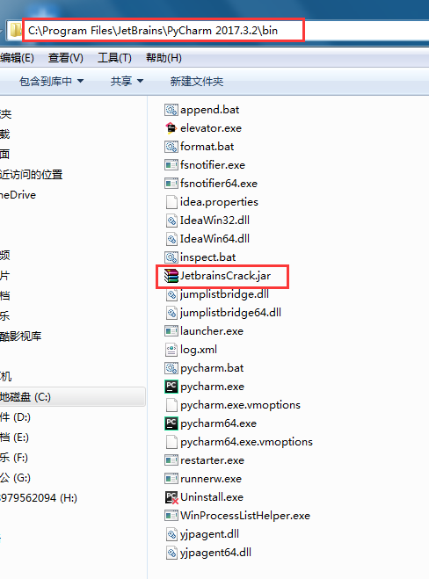

5. 用记事本打开 pycharm.exe.vmoptions 和 pycharm64.exe.vmoptions 这2个文件，在这2个文件末行分别加上-javaagent:C:\Program Files\JetBrains\PyCharm 2017.1.2\bin\JetbrainsCrack-2.6.2.jar

注意：后面的路径为刚才jar文件的路径，如果pycharm不是安装在默认路径的，自己选择jar的绝对路径

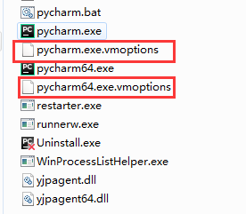

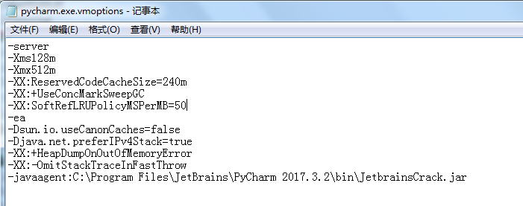

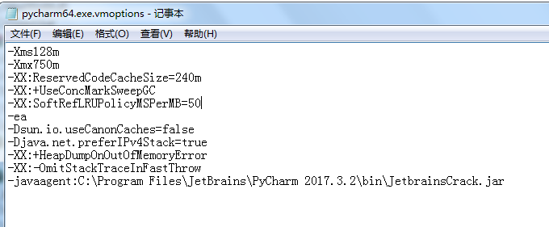

6. 最后一步，把以下自定义激活码复制进去激活

{"licenseId":"1454467925669","licenseeName":"yubajin","assigneeName":"","assigneeEmail":"1803279085@qq.com","licenseRestriction":"","checkConcurrentUse":false,"products":[{"code":"II","paidUpTo":"2099-12-31"},{"code":"DM","paidUpTo":"2099-12-31"},{"code":"AC","paidUpTo":"2099-12-31"},{"code":"RS0","paidUpTo":"2099-12-31"},{"code":"WS","paidUpTo":"2099-12-31"},{"code":"DPN","paidUpTo":"2099-12-31"},{"code":"RC","paidUpTo":"2099-12-31"},{"code":"PS","paidUpTo":"2099-12-31"},{"code":"DC","paidUpTo":"2099-12-31"},{"code":"RM","paidUpTo":"2099-12-31"},{"code":"CL","paidUpTo":"2099-12-31"},{"code":"PC","paidUpTo":"2099-12-31"}],"hash":"2911276/0","gracePeriodDays":7,"autoProlongated":false}

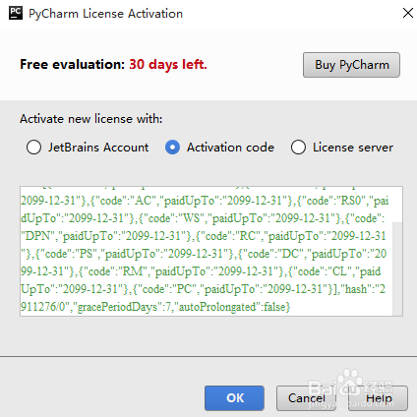

# Python | 开发环境IDE PyCharm配置

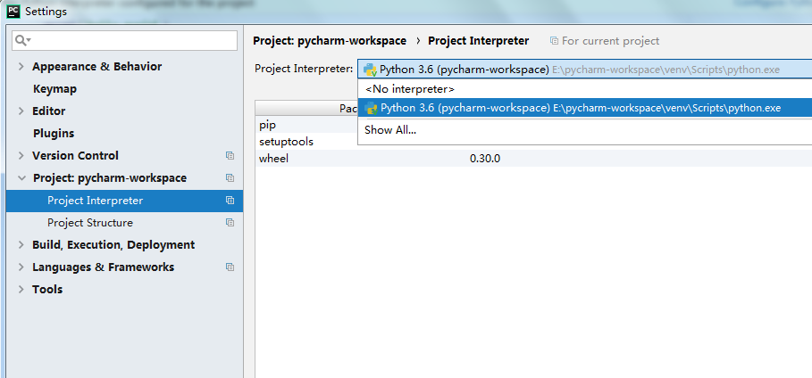

# [Pycharm连接Github](http://blog.csdn.net/tzs_1041218129/article/details/51584996)

绑定账号

1.File->Settings->Version Control->Github

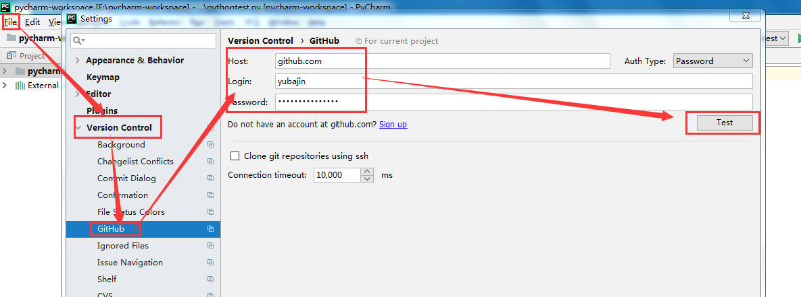

2. 下载git,选择Git安装路径 设置github后选择git，输入你git.exe的安装位置路径,下面是我的git.exe的位置：**D:\Git\bin\git.exe**,然后点击**OK**

# Tensorflow安装

pip install --ignore-installed --upgrade https://storage.googleapis.com/tensorflow/windows/cpu/tensorflow-1.0.0-

