# Hardware

DUO3D camera

# Knowledge Center

## Bias Error

Bias error is nonzero output signal which appears in the sensor output when input is zero. The bias offset causes the sensor output to offset from the true data by a constant value. This error is not dependent on external forces applied to the sensor. Bias error can be divided into three categories, including a static part (or bias offset), a random part (or drift), and a temperature dependent part. The static bias and temperature bias can be compensated in the calibration process. Static bias can be measured by averaging the sensor output for a zero input signal. To compensate for this bias, it should be subtracted from the output data. The drift bias has a random nature and cannot be fixed in the calibration process. It should be treated as a stochastic error.

# Results

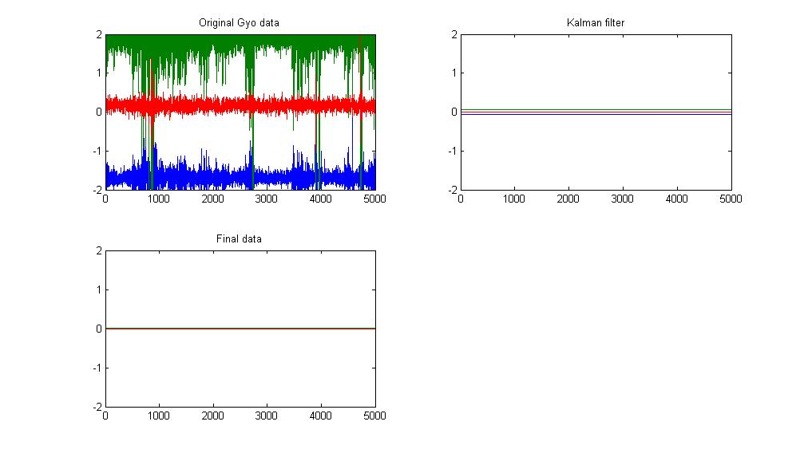

Figure remove noise and bias error