ELE 448 Lab 1

Due by 05 February, 2020

Instructions:

1. Set up Cadence on your account
   1. Create a directory in a command window in your home directory, e.g. “*mkdir digital_IC*”
   2. Go to the course website, *https://www.ele.uri.edu/courses/ele448/spring.2018/*
      1. Save this website for future reference
      2. Navigate to Lab 1 🡪IC615 Links
2. ln -s /net/common/cad/NCSU/DesignKits/ncsu-cdk-1.6.0.beta/cdssetup cdssetup
3. ln -s /net/common/cad/NCSU/DesignKits/ncsu-cdk-1.6.0.beta/cdssetup/display.drf display.drf
4. ln -s /net/common/cad/NCSU/DesignKits/ncsu-cdk-1.6.0.beta/cdssetup/cdsinit .cdsinit
5. ln -s /net/common/cad/NCSU/DesignKits/ncsu-cdk-1.6.0.beta/cdssetup/cdsenv .cdsenv
   * 1. Copy the 4 lines into the cmd window when in the directory that you created in (a)
     2. You can now run Cadence by typing *IC615* into the linux terminal while in your working directory
   1. Save t92y bsim3v3 Parameters to your directory
      1. These are the spice parameters that will be used to run simulations in the future so it is useful to have easy access to them

**Note:**

* Some useful linux instructions are:
  + pwd – present working directory
  + mkdir *directory_name* – makes a folder, *directory_name* in the current directory
  + cd */path/to/dir* – navigate to the specified directory
  + cd .. – move back to the previous directory
  + ls – lists objects that are in the current directory

1. Create a Library in Cadence
   1. Go to file 🡪 new 🡪 Library
   2. Add a name for your library and leave the path blank
   3. Select attach to existing library
      1. Choose TSMC 0.2u to have access to this technology
2. Create a schematic for an inverter
   1. Select your newly created library
   2. Go to file 🡪 new 🡪 cell view
   3. Setup the following
      1. Name: Inverter
      2. View Name: Schematic
      3. Tool: Schematic
   4. Create the inverter:

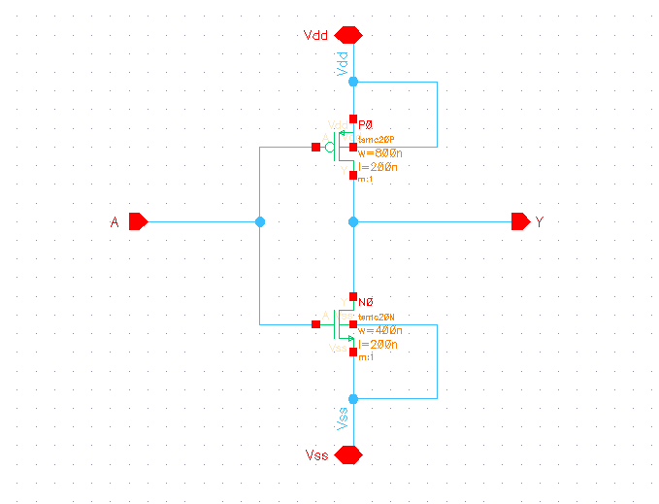

**Note:**

* Adding parts to your schematic
  + Add 🡪 instance (or use the keyboard shortcut, i)
  + Use the component browser to find devices (search NCSU Analog Parts for MOSFETS)
  + Clicking ESC on the keyboard will end the add part instance
* Adding Pins
  + Add 🡪 pin (or use the keyboard shortcut, p)
  + Choose the pin name and type
    - Input
    - Output
    - Bidirectional (use for Vdd and Vss pins)
* Other useful shortcuts:
  + w – wire
  + l – label
    - labels can be used to makes connections rather than wires
  + u – undo
  + m – move
  + del – delete

1. Create a symbol for your inverter
   1. While in the schematic window, go to create 🡪 cell view 🡪 from cell view
      1. The default symbol is a rectangle with the pins you specified in your schematic
      2. You can change the symbol as desired to something meaningful
      3. Do not label the pins of the symbol to anything other than the way they are labeled in your schematic or else you will encounter errors
2. Create a schematic for a 2-input NAND

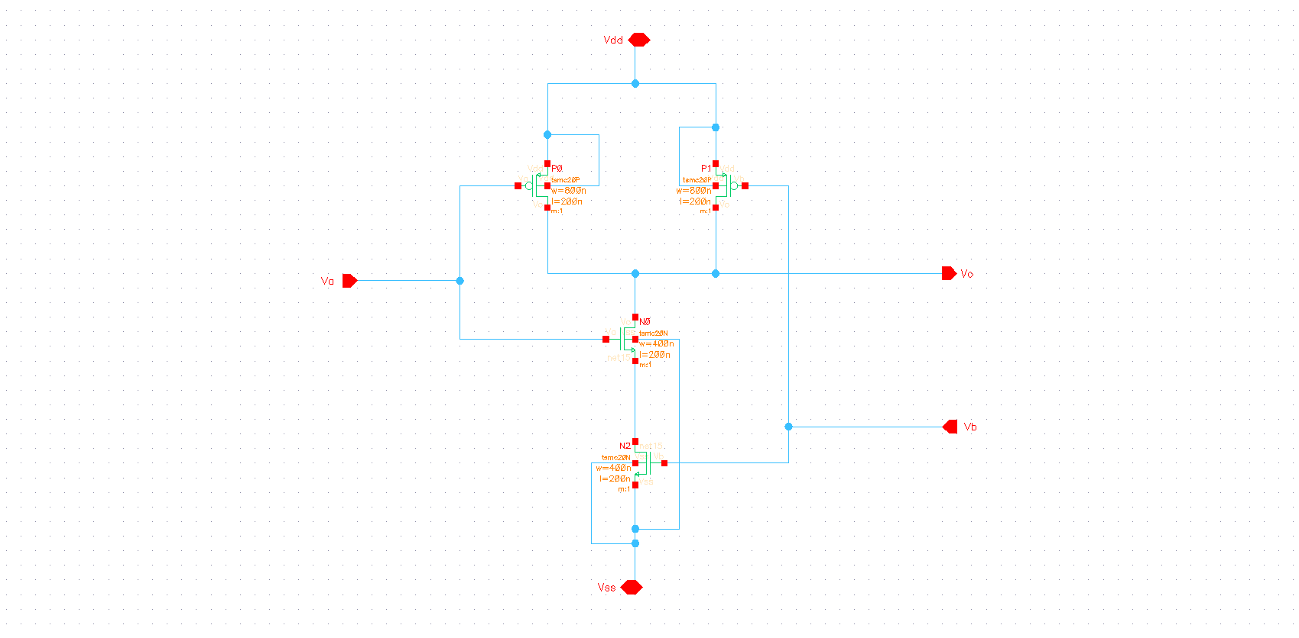

1. Create a symbol for the 2-input NAND
2. Create a schematic for a double inverter
3. Create a symbol for a double inverter

Lab Write-up:

1. Cadence
   1. Describe the environment/organization of the software
2. Inverter
   1. Schematic
      1. Provide an image
      2. What components were used?
      3. Describe how the inverter functions
   2. Symbol
      1. Provide an image
3. Double Inverter
   1. Schematic
      1. Provide an image
      2. What components were used?
      3. Describe how this design could be useful
   2. Symbol
      1. Provide an image
4. 2-input NAND
   1. Schematic
      1. Provide an image
      2. What components were used?
      3. Describe how the 2-input NAND functions
   2. Symbol
      1. Provide an image
5. Other things to consider in your report
   1. Why is the channel width of the PMOS double the width of the NMOS?

Preparation for Next Lab:

1. Read sections 2.1 and 2.2 of the lab manual from the course website given above to gain a basic understanding of ring oscillators
   1. Note that this lab manual is not up to date, so the actual lab instructions in the manual will differ from this class
   2. If time permits, create a schematic and symbol of a ring oscillator that consists of 1 2-input NAND and 10 inverters