## Setup Laravel and Vuejs project with Vuetify and authentication using laravel breeze api and vuejs that should have login user, register user , reset password and verify email before login.

## Crud Operation in single page.

1. **Setup Laravel and Vuejs project with Vuetify and authentication using laravel breeze api and vuejs that should have login user, register user , reset password and verify email before login.**

### Setup in Laravel:

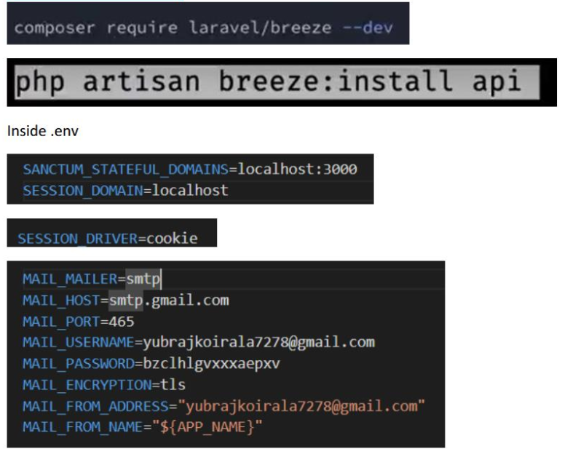

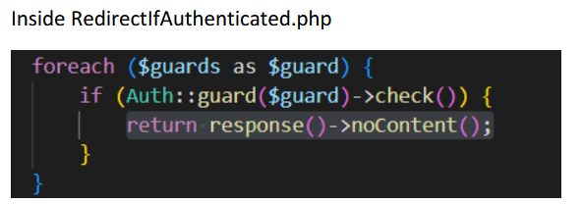

If you don’t want to verify email then above setup is enough but if you want to verify email the write below logic:

* Ensure **MustVerifyEmail** is Implemented in **app/Models/User.php:**

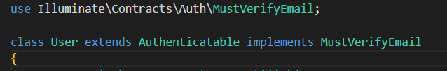

* Inside routes/auth.php

Route::get('/verify-email/{id}/{hash}', \App\Http\Controllers\Auth\CustomVerifyEmailController::class)

    ->middleware(['auth:sanctum', 'signed', 'throttle:6,1'])

    ->name('verification.verify');

Route::post('/email/verification-notification', [EmailVerificationNotificationController::class, 'store'])

    ->middleware(['auth', 'throttle:6,1'])

    ->name('verification.send');

Route::get('/email/verify', [VerificationController::class, 'notice'])

    ->middleware('auth:sanctum')

    ->name('verification.notice');

* Create **app/Http/Controllers/Auth/VerificationController.php:**

<?php

namespace App\Http\Controllers\Auth;

use App\Http\Controllers\Controller;

use Illuminate\Http\Request;

class VerificationController extends Controller

{

    public function notice(Request $request)

    {

        if ($request->user()->hasVerifiedEmail()) {

            return response()->json(['message' => 'Email already verified'], 200);

        }

        return response()->json(['message' => 'Please verify your email address'], 403);

    }

}

* Open **VerifyEmailController.php** and overwrite invoke method**:**

 public function __invoke(Request $request)

    {

        if ($request->user()->hasVerifiedEmail()) {

            return response()->json(['message' => 'Email already verified'], 200);

        }

        if (

            $request->route('id') == $request->user()->getKey() &&

            hash_equals((string) $request->route('hash'), sha1($request->user()->getEmailForVerification()))

        ) {

            $request->user()->markEmailAsVerified();

            event(new \Illuminate\Auth\Events\Verified($request->user()));

            return response()->json(['message' => 'Email verified successfully'], 200);

        }

        return response()->json(['message' => 'Invalid verification link'], 403);

    }

* Inside api.php

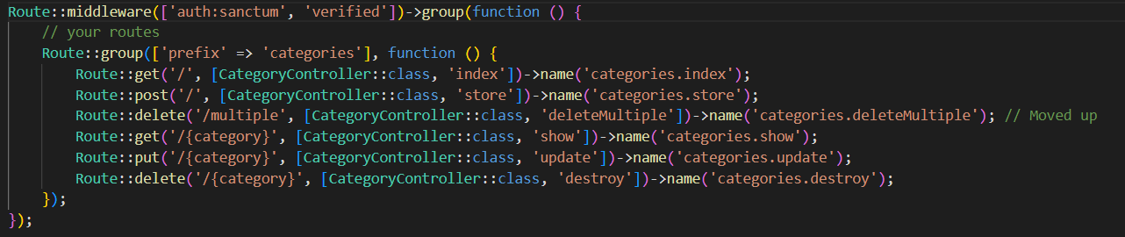

* Make new controller



<?php

namespace App\Http\Controllers\Auth;

use App\Http\Controllers\Controller;

use Illuminate\Http\Request;

use Illuminate\Auth\Events\Verified;

class CustomVerifyEmailController extends Controller

{

    public function __invoke(Request $request)

    {

        if ($request->user()->hasVerifiedEmail()) {

            return redirect(config('app.frontend_url') . '/admin/home');

        }

        if ($request->route('id') == $request->user()->getKey() &&

            hash_equals((string) $request->route('hash'), sha1($request->user()->getEmailForVerification()))) {

            $request->user()->markEmailAsVerified();

            event(new Verified($request->user()));

            return redirect(config('app.frontend_url') . '/verification-success');

        }

        return response()->json(['message' => 'Invalid verification link'], 403);

    }

}

1. Setup in vuejs.

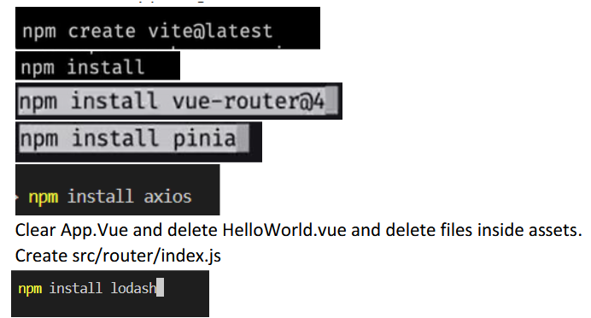

Inside vite.config.js

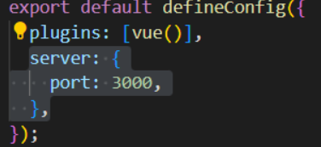

Inside src/axios.js

import axios from "axios";

// Base configuration

axios.defaults.baseURL = "http://localhost:8000"; // Ensure this matches your backend

axios.defaults.withCredentials = true; // For cookies and CSRF

// Request interceptor to add CSRF token

axios.interceptors.request.use(

  (config) => {

    try {

      const cookies = document.cookie.split('; ');

      const tokenRow = cookies.find((row) => row.startsWith('XSRF-TOKEN='));

      if (tokenRow) {

        const token = decodeURIComponent(tokenRow.split('=')[1]);

        config.headers['X-XSRF-TOKEN'] = token;

      }

      return config;

    } catch (error) {

      console.error("Error setting CSRF token:", error);

      return config; // Proceed anyway to avoid breaking requests

    }

  },

  (error) => {

    return Promise.reject(error);

  }

);

export default axios;

Setup Vuetify:



Inside src/plugins/vuetify.js

// src/plugins/vuetify.js

import { createVuetify } from 'vuetify';

import 'vuetify/styles'; // Import Vuetify styles

// Optional: Import components and directives if you want to use them explicitly

import * as components from 'vuetify/components';

import * as directives from 'vuetify/directives';

const vuetify = createVuetify({

  components,

  directives,

});

export default vuetify;

Inside src/main.js

// src/main.js

// Import Vue's createApp function

import { createApp } from 'vue'

// Import the main App component

import App from './App.vue'

// Import global Axios configuration

import './axios'

// Import Pinia (State Management)

import { createPinia } from 'pinia'

// Import Vue Router (Routing)

import router from './router'

// Import Vuetify configuration

import vuetify from './plugins/vuetify'

import '@mdi/font/css/materialdesignicons.css';

// Create an instance of Pinia

const pinia = createPinia();

// Create a Vue application instance

const app = createApp(App);

// Use Pinia for state management

app.use(pinia);

// Use Vue Router for handling routes

app.use(router);

// Use Vuetify for UI components

app.use(vuetify);

// Mount the app to the DOM

app.mount('#app');

Now, you can use vuetify..

For icon

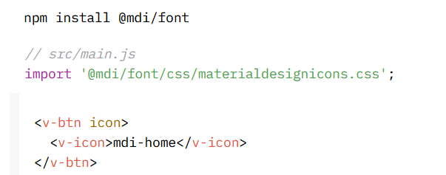

* Inside src/router/index.js

import { createRouter, createWebHistory } from "vue-router";

import { useAuthStore } from "../stores/auth";

const routes = [

    {

        path: "/",

        name: "Frontend",

        component: () => import("../components/frontend/layouts/FrontendLayout.vue"),

        children: [

            {

                path: "",

                name: "Home",

                component: () => import("../components/frontend/Home.vue"),

            },

        ],

    },

    {

        path: "/auth",

        name: "Auth",

        component: () => import("../components/auth/layouts/AuthLayout.vue"),

        children: [

            {

                path: "/login",

                name: "Login",

                component: () => import("../components/auth/Login.vue"),

                meta: { guestOnly: true },

            },

            {

                path: "/register",

                name: "Register",

                component: () => import("../components/auth/Register.vue"),

                meta: { guestOnly: true },

            },

            {

                path: "/forget-password",

                name: "ForgetPassword",

                component: () => import("../components/auth/ForgetPassword.vue"),

                meta: { guestOnly: true },

            },

            {

                path: "/password-reset/:token",

                name: "ResetPassword",

                component: () => import("../components/auth/ResetPassword.vue"),

                meta: { guestOnly: true },

            },

            {

                path: "/verify-email",

                name: "VerifyEmail",

                component: () => import("../components/auth/VerifyEmail.vue"),

                meta: { requiresAuth: true, unverifiedOnly: true },

            },

            {

                path: "/verification-success",

                name: "VerificationSuccess",

                component: () => import("../components/auth/VerificationSuccess.vue"),

                meta: { requiresAuth: true },

            },

        ],

    },

    {

        path: "/admin",

        name: "Admin",

        component: () => import("../components/backend/layouts/BackendLayout.vue"),

        children: [

            {

                path: "home",

                name: "Dashboard",

                component: () => import("../components/backend/Home.vue"),

                meta: { requiresAuth: true, requiresVerified: true },

            },

            {

                path: "category",

                name: "Category",

                component: () => import("../components/backend/category/Category.vue"),

                meta: { requiresAuth: true, requiresVerified: true },

            },

        ],

    },

];

const router = createRouter({

    history: createWebHistory(),

    routes,

});

router.beforeEach(async (to, from, next) => {

    const authStore = useAuthStore();

    if (!authStore.authUser) {

        await authStore.getUser();

    }

    if (to.meta.requiresAuth && !authStore.authUser) {

        return next({ name: "Login" });

    }

    if (to.meta.requiresVerified && authStore.authUser && !authStore.emailVerified) {

        return next({ name: "VerifyEmail" });

    }

    if (to.meta.unverifiedOnly && authStore.authUser && authStore.emailVerified) {

        return next({ name: "Dashboard" });

    }

    if (to.meta.guestOnly && authStore.authUser) {

        return next({ name: "Dashboard" });

    }

    authStore.resetFields();

    next();

});

export default router;

**Create below files**

a) Src/components/auth/layouts/AuthLayout.vue,

src/components/auth/Login.vue,Register.vue,ResetPassword.vue,ForgetPassword.vue, VerificationSuccess.vue, VerifyEmail.vue.

b) Src/components/frontend/layouts/FrontendLayout.vue, frontend/Home.vue

c) Src/components/backend/layouts/BackendLayout.vue,backend/Home.vue,

backend/category/Category.vue

* **Inside App.vue**

<script setup>

import { ref } from 'vue';

import { useRouter } from 'vue-router';

const isLoading = ref(false);

const router = useRouter();

// Show loader when navigation starts

router.beforeEach((to, from, next) => {

    isLoading.value = true;

    next();

});

// Hide loader when navigation is done

router.afterEach(() => {

    setTimeout(() => {

        isLoading.value = false;

    }, 500); // Small delay for smoother transition

});

</script>

<template>

    <main>

        <!-- Page Loader -->

        <v-overlay v-model="isLoading" class="loader-overlay" :scrim="false">

            <v-progress-circular indeterminate size="64" color="primary" />

        </v-overlay>

        <!-- The child routes will be injected here -->

        <router-view />

    </main>

</template>

<style scoped>

/* Page Loader Styles */

.loader-overlay {

    display: flex;

    align-items: center;

    justify-content: center;

    z-index: 9999;

    background: rgba(255, 255, 255, 0.8);

}

</style>

* **Inside src/stores/auth.js for authentication**

import { defineStore } from "pinia";

import { ref } from "vue";

import axios from "axios";

import router from "../router";

export const useAuthStore = defineStore("auth", () => {

    // ==========state===========

    const authUser = ref(null);

    const authErrors = ref([]);

    const authStatus = ref(null);

    const loading = ref(false);

    const emailVerified = ref(false);

    // ============Fetch the CSRF token==========

    const getToken = async () => {

        await axios.get("/sanctum/csrf-cookie");

    };

    // =========Get authenticated user============

    const getUser = async () => {

        try {

            await getToken();

            const { data } = await axios.get("/api/user");

            authUser.value = data;

            emailVerified.value = data.email_verified_at !== null;

        } catch (error) {

            authUser.value = null;

            emailVerified.value = false;

        }

    };

    // ==========Handle user login===========

    const handleLogin = async (credentials) => {

        try {

            loading.value = true;

            await getToken();

            await axios.post("/login", credentials);

            await getUser();

            if (emailVerified.value) {

                router.push("/admin/home");

            } else {

                router.push("/verify-email");

            }

        } catch (error) {

            if (error.response?.status === 422) {

                authErrors.value = error.response.data.errors;

            }

        } finally {

            loading.value = false;

        }

    };

    // =========Handle user registration==========

    const handleRegister = async (userDetails) => {

        try {

            loading.value = true;

            await getToken();

            await axios.post("/register", userDetails);

            await getUser();

            router.push("/verify-email");

        } catch (error) {

            if (error.response?.status === 422) {

                authErrors.value = error.response.data.errors;

            }

        } finally {

            loading.value = false;

        }

    };

    // =========Handle user logout=========

    const handleLogout = async () => {

        try {

            await axios.post("/logout");

            authUser.value = null;

            emailVerified.value = false;

            router.push("/login");

        } catch (error) {

            console.error("Logout failed:", error);

        }

    };

    // =========Handle forget password==========

    const handleForgetPassword = async (email) => {

        try {

            loading.value = true;

            await getToken();

            const response = await axios.post("/forgot-password", { email });

            authStatus.value = response.data.status;

        } catch (error) {

            if (error.response?.status === 422) {

                authErrors.value = error.response.data.errors;

            }

        } finally {

            loading.value = false;

        }

    };

    // ==========Handle reset password===========

    const handleResetPassword = async (resetData) => {

        try {

            loading.value = true;

            await getToken();

            const response = await axios.post("/reset-password", resetData);

            authStatus.value = response.data.status;

            router.push("/login");

        } catch (error) {

            if (error.response?.status === 422) {

                authErrors.value = error.response.data.errors;

            }

        } finally {

            loading.value = false;

        }

    };

    // ===========handle to resend verify email link=======

    const resendVerification = async () => {

        try {

            loading.value = true;

            await getToken();

            const response = await axios.post("/email/verification-notification");

            authStatus.value = response.data.message;

        } catch (error) {

            authErrors.value = error.response?.data.errors || ['Failed to resend email'];

        } finally {

            loading.value = false;

        }

    };

    // ========handle reset fields=========

    const resetFields = () => {

        authErrors.value = [];

        authStatus.value = null;

        loading.value = false;

    };

    return {

        authUser,

        authErrors,

        getUser,

        handleLogin,

        handleRegister,

        handleLogout,

        handleForgetPassword,

        resetFields,

        handleResetPassword,

        authStatus,

        loading,

        emailVerified,

        resendVerification,

    };

});

* Login.vue

<script setup>

import { ref } from "vue";

import { useAuthStore } from "../../stores/auth";

// Access the authentication store

const authStore = useAuthStore();

// Properties

const form = ref({

  email: "",

  password: "",

});

</script>

<template>

  <v-container class="fill-height d-flex align-center justify-center">

    <v-row justify="center">

      <v-col cols="12" sm="8" md="5">

        <v-card elevation="10" class="pa-5 rounded-xl">

          <v-card-title class="text-center">

            <h3 class="font-weight-bold text-primary">Sign In</h3>

          </v-card-title>

          <v-card-text>

            <v-form @submit.prevent="authStore.handleLogin(form)">

              <v-text-field v-model="form.email" label="Email Address" type="email" placeholder="Enter your email"

                id="email" variant="outlined" class="mb-3 rounded-lg" density="comfortable"

                :error-messages="authStore.authErrors.email?.[0] || ''">

              </v-text-field>

              <v-text-field v-model="form.password" label="Password" type="password" placeholder="Enter your password"

                id="password" variant="outlined" class="mb-3 rounded-lg" density="comfortable"

                :error-messages="authStore.authErrors.password?.[0] || ''">

              </v-text-field>

              <div class="d-flex justify-space-between mb-3">

                <router-link :to="{ name: 'ForgetPassword' }" class="text-primary text-decoration-none text-caption">

                  Forgot Password?

                </router-link>

              </div>

              <v-btn type="submit" color="primary" block class="rounded-lg text-capitalize py-3"

                :loading="authStore.loading" :disabled="authStore.loading">

                {{ authStore.loading ? "Signing in..." : "Login" }}

              </v-btn>

            </v-form>

            <div class="text-center mt-4">

              <p class="mb-0 text-caption">

                Not a member yet?

                <router-link :to="{ name: 'Register' }" class="text-primary font-weight-medium">

                  Sign Up

                </router-link>

              </p>

            </div>

          </v-card-text>

        </v-card>

      </v-col>

    </v-row>

  </v-container>

</template>

<style scoped>

.text-primary {

  color: #1976d2 !important;

  /* Vuetify Primary */

}

.rounded-xl {

  border-radius: 16px;

}

/* Ensure full-height centering */

.fill-height {

  min-height: 100vh;

  /* Full screen height */

}

</style>

* Register.vue

<script setup>

import { ref } from "vue";

import { useAuthStore } from "../../stores/auth";

// Access the authentication store

const authStore = useAuthStore();

// Properties

const form = ref({

  name: "",

  email: "",

  password: "",

  password_confirmation: "",

});

</script>

<template>

  <v-container class="fill-height d-flex align-center justify-center">

    <v-row justify="center">

      <v-col cols="12" sm="8" md="5">

        <v-card elevation="10" class="pa-5 rounded-xl">

          <v-card-title class="text-center">

            <h3 class="font-weight-bold text-primary">Register</h3>

          </v-card-title>

          <v-card-text>

            <v-form @submit.prevent="authStore.handleRegister(form)">

              <v-text-field v-model="form.name" label="Full Name" type="text" placeholder="Enter your full name"

                id="name" variant="outlined" class="mb-3 rounded-lg" density="comfortable"

                :error-messages="authStore.authErrors.name?.[0] || ''">

              </v-text-field>

              <v-text-field v-model="form.email" label="Email Address" type="email" placeholder="Enter your email"

                id="email" variant="outlined" class="mb-3 rounded-lg" density="comfortable"

                :error-messages="authStore.authErrors.email?.[0] || ''">

              </v-text-field>

              <v-text-field v-model="form.password" label="Password" type="password" placeholder="Enter your password"

                id="password" variant="outlined" class="mb-3 rounded-lg" density="comfortable"

                :error-messages="authStore.authErrors.password?.[0] || ''">

              </v-text-field>

              <v-text-field v-model="form.password_confirmation" label="Confirm Password" type="password"

                placeholder="Re-enter your password" id="password_confirmation" variant="outlined"

                class="mb-3 rounded-lg" density="comfortable">

              </v-text-field>

              <v-btn type="submit" color="primary" block class="rounded-lg text-capitalize py-3"

                :loading="authStore.loading" :disabled="authStore.loading">

                {{ authStore.loading ? "Registering..." : "Register" }}

              </v-btn>

            </v-form>

            <div class="text-center mt-4">

              <p class="mb-0 text-caption">

                Already have an account?

                <router-link :to="{ name: 'Login' }" class="text-primary font-weight-medium">

                  Sign In

                </router-link>

              </p>

            </div>

          </v-card-text>

        </v-card>

      </v-col>

    </v-row>

  </v-container>

</template>

<style scoped>

.text-primary {

  color: #1976d2 !important;

  /* Vuetify Primary */

}

.rounded-xl {

  border-radius: 16px;

}

/* Ensure full-height centering */

.fill-height {

  min-height: 100vh;

  /* Full screen height */

}

</style>

* ForgetPassword.vue

<script setup>

import { ref } from "vue";

import { useAuthStore } from "../../stores/auth";

// Access the auth store

const authStore = useAuthStore();

// Reactive properties

const email = ref("");

// Handle the forget password form submission

const handleForgetPassword = async () => {

    // Call the store method to handle the forgot password logic

    await authStore.handleForgetPassword(email.value);

    // Reset email and display success message

    email.value = "";

};

</script>

<template>

    <v-container class="fill-height d-flex align-center justify-center">

        <v-row justify="center">

            <v-col cols="12" sm="8" md="5">

                <v-card elevation="10" class="pa-5 rounded-xl">

                    <v-card-title class="text-center">

                        <h3 class="font-weight-bold text-primary">Forgot Password</h3>

                    </v-card-title>

                    <v-card-text>

                        <v-alert v-if="authStore.authStatus" type="success" class="mb-4" text>

                            {{ authStore.authStatus }}

                        </v-alert>

                        <v-form @submit.prevent="handleForgetPassword">

                            <v-text-field v-model="email" label="Email Address" type="email"

                                placeholder="Enter your email" id="email" variant="outlined" class="mb-3 rounded-lg"

                                density="comfortable" :error-messages="authStore.authErrors.email?.[0] || ''">

                            </v-text-field>

                            <v-btn type="submit" color="primary" block class="rounded-lg text-capitalize py-3"

                                :loading="authStore.loading" :disabled="authStore.loading">

                                {{ authStore.loading ? "Processing..." : "Submit" }}

                            </v-btn>

                        </v-form>

                    </v-card-text>

                </v-card>

            </v-col>

        </v-row>

    </v-container>

</template>

<style scoped>

.text-primary {

    color: #1976d2 !important;

    /* Vuetify Primary */

}

.rounded-xl {

    border-radius: 16px;

}

/* Ensure full-height centering */

.fill-height {

    min-height: 100vh;

    /* Full screen height */

}

</style>

* ResetPassword.vue

<script setup>

import { ref } from "vue";

import { useAuthStore } from "../../stores/auth";

import { useRoute } from "vue-router";

// Access the auth store and route

const authStore = useAuthStore();

const route = useRoute();

// Reactive properties

const form = ref({

    password: "",

    password_confirmation: "",

    email: route.query.email,

    token: route.params.token,

});

</script>

<template>

    <v-container class="fill-height d-flex align-center justify-center">

        <v-row justify="center">

            <v-col cols="12" sm="8" md="5">

                <v-card elevation="10" class="pa-5 rounded-xl">

                    <v-card-title class="text-center">

                        <h3 class="font-weight-bold text-primary">Reset Password</h3>

                    </v-card-title>

                    <v-card-text>

                        <v-alert v-if="authStore.authStatus" type="success" class="mb-4" text>

                            {{ authStore.authStatus }}

                        </v-alert>

                        <v-form @submit.prevent="authStore.handleResetPassword(form)">

                            <v-text-field v-model="form.password" label="New Password" type="password"

                                placeholder="Enter your new password" id="password" variant="outlined"

                                class="mb-3 rounded-lg" density="comfortable"

                                :error-messages="authStore.authErrors.password?.[0] || authStore.authErrors.email?.[0] || ''">

                            </v-text-field>

                            <v-text-field v-model="form.password_confirmation" label="Confirm Password" type="password"

                                placeholder="Re-enter your password" id="password_confirmation" variant="outlined"

                                class="mb-3 rounded-lg" density="comfortable">

                            </v-text-field>

                            <v-btn type="submit" color="primary" block class="rounded-lg text-capitalize py-3"

                                :loading="authStore.loading" :disabled="authStore.loading">

                                {{ authStore.loading ? "Processing..." : "Submit" }}

                            </v-btn>

                        </v-form>

                    </v-card-text>

                </v-card>

            </v-col>

        </v-row>

    </v-container>

</template>

<style scoped>

.text-primary {

    color: #1976d2 !important;

    /* Vuetify Primary */

}

.rounded-xl {

    border-radius: 16px;

}

/* Ensure full-height centering */

.fill-height {

    min-height: 100vh;

    /* Full screen height */

}

</style>

* VerifyEmail.vue

<script setup>

import { useAuthStore } from "../../stores/auth";

import { onMounted } from "vue";

import router from "../../router";

const authStore = useAuthStore();

onMounted(async () => {

    const interval = setInterval(async () => {

        await authStore.getUser();

        if (authStore.emailVerified) {

            clearInterval(interval);

            router.push("/admin/home");

        }

    }, 2000);

});

</script>

<template>

    <v-container class="fill-height d-flex align-center justify-center">

        <v-row justify="center">

            <v-col cols="12" sm="8" md="5">

                <v-card elevation="10" class="pa-5 rounded-xl">

                    <v-card-title class="text-center">

                        <h3 class="font-weight-bold text-primary">Verify Your Email</h3>

                    </v-card-title>

                    <v-card-text>

                        <p class="text-center">

                            A verification link has been sent to {{ authStore.authUser.email }}.

                            Please check your inbox and click the link to verify your email.

                        </p>

                        <v-btn color="primary" block class="rounded-lg text-capitalize py-3 mt-4"

                            :loading="authStore.loading" :disabled="authStore.loading"

                            @click="authStore.resendVerification">

                            {{ authStore.loading ? "Resending..." : "Resend Verification Email" }}

                        </v-btn>

                        <div class="text-center mt-4">

                            <v-btn text @click="authStore.handleLogout" class="text-caption">

                                Sign Out

                            </v-btn>

                        </div>

                    </v-card-text>

                </v-card>

            </v-col>

        </v-row>

    </v-container>

</template>

<style scoped>

.text-primary {

    color: #1976d2 !important;

}

.rounded-xl {

    border-radius: 16px;

}

.fill-height {

    min-height: 100vh;

}

</style>

* VerificationSuccess.vue

<script setup>

import { useAuthStore } from "../../stores/auth";

import { onMounted } from "vue";

import router from "../../router";

const authStore = useAuthStore();

onMounted(async () => {

    await authStore.getUser();

    if (authStore.emailVerified) {

        setTimeout(() => router.push("/admin/home"), 2000); // Redirect after 2 seconds

    } else {

        router.push("/verify-email");

    }

});

</script>

<template>

    <v-container class="fill-height d-flex align-center justify-center">

        <v-row justify="center">

            <v-col cols="12" sm="8" md="5">

                <v-card elevation="10" class="pa-5 rounded-xl">

                    <v-card-title class="text-center">

                        <h3 class="font-weight-bold text-primary">Email Verified</h3>

                    </v-card-title>

                    <v-card-text>

                        <p class="text-center">Your email has been successfully verified. Redirecting to dashboard...

                        </p>

                    </v-card-text>

                </v-card>

            </v-col>

        </v-row>

    </v-container>

</template>

<style scoped>

.text-primary {

    color: #1976d2 !important;

}

.rounded-xl {

    border-radius: 16px;

}

.fill-height {

    min-height: 100vh;

}

</style>

* Backend/layouts/Dashboard.vue

<script setup>

import { ref } from "vue";

import { useRoute } from "vue-router";

import { useAuthStore } from "../../../stores/auth"

// Access the authentication store

const authStore = useAuthStore();

// Drawer state (open by default on larger screens)

const drawer = ref(true);

// Navigation items

const navItems = [

  { title: "Dashboard", icon: "mdi-home", route: "/admin/home" },

  { title: "Category", icon: "mdi-cart", route: "/admin/category" },

];

// Get current route

const route = useRoute();

// Check if the item is active

const isActive = (itemRoute) => {

  return route.path === itemRoute;

};

// Methods

const logout = () => {

  authStore.handleLogout();

};

</script>

<template>

  <!-- App Bar with Background Color -->

  <v-app-bar app elevation="2" color="teal darken-3" class="px-4">

    <v-app-bar-nav-icon @click="drawer = !drawer">

      <v-icon color="white">mdi-menu</v-icon>

    </v-app-bar-nav-icon>

    <v-toolbar-title class="white--text font-weight-bold">

      E-Commerce Hub

    </v-toolbar-title>

    <v-spacer></v-spacer>

    <v-btn icon class="mx-1">

      <v-icon color="white">mdi-bell</v-icon>

    </v-btn>

    <v-btn icon class="mx-1" @click="logout">

      <v-icon color="white">mdi-logout</v-icon>

    </v-btn>

  </v-app-bar>

  <!-- Navigation Drawer -->

  <v-navigation-drawer v-model="drawer" app permanent color="teal darken-3">

    <v-list dense class="pt-4">

      <v-list-item v-for="item in navItems" :key="item.title" :to="item.route" :active="isActive(item.route)"

        class="d-flex align-center pa-2" active-class="active-item">

        <v-icon color="white" class="mr-3">{{ item.icon }}</v-icon>

        <span class="white--text text-subtitle-1">{{ item.title }}</span>

      </v-list-item>

    </v-list>

  </v-navigation-drawer>

</template>

<style scoped>

/* Active Item Styling */

.active-item {

  background-color: rgba(255, 255, 255, 0.2) !important;

  color: white !important;

}

.active-item .v-icon {

  color: white !important;

}

/* App Bar Enhancements */

.v-app-bar {

  box-shadow: 0 2px 10px rgba(0, 0, 0, 0.15);

}

.v-toolbar-title {

  font-size: 1.8rem;

}

/* Navigation Drawer Enhancements */

.v-navigation-drawer {

  width: 240px;

}

.v-navigation-drawer .v-list-item {

  padding: 16px;

  font-weight: 500;

  transition: background-color 0.3s ease;

}

.v-navigation-drawer .v-list-item:hover {

  background-color: rgba(255, 255, 255, 0.1);

}

/* Make the drawer content more consistent */

.v-list-item {

  border-radius: 8px;

}

/* Responsive Behavior: Make Drawer Toggleable on Smaller Screens */

@media (max-width: 768px) {

  .v-navigation-drawer {

    width: 200px;

  }

  .v-app-bar {

    font-size: 1rem;

  }

}

</style>

* Inside BackendLayout.vue

<script setup>

import Dashboard from './Dashboard.vue'

</script>

<template>

    <v-app>

        <!-- Dashboard -->

        <Dashboard />

        <!-- Main Content Area -->

        <v-main>

            <main>

                <!-- Child routes will be injected here -->

                <router-view />

            </main>

        </v-main>

    </v-app>

</template>

* Inside FrontendLayout.vue and AuthLayout.vue

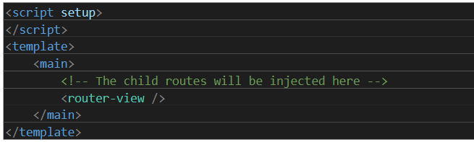

* Home.vue

<template>

    <v-container class="py-6">

        Home Page

    </v-container>

</template>

<script setup></script>

## **Crud Operation in single:**

* Make model and migration for Category:

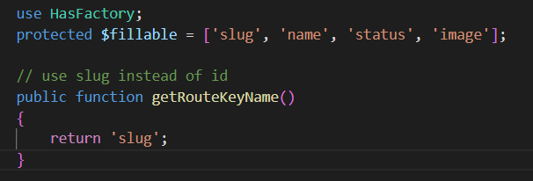

* Make resource:



* Inside CategoryResource:

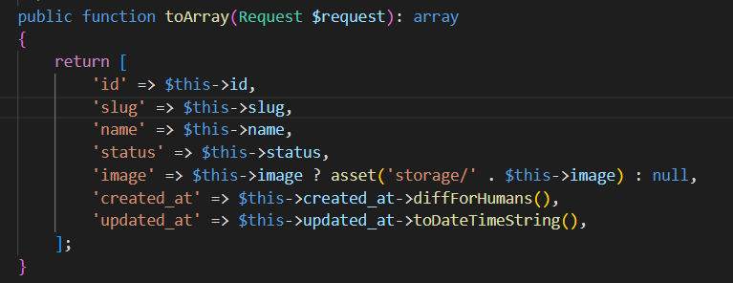

* Make resource controller:



* Inside CategoryController.php

 /**

     * Display a listing of the resource.

     */

    public function index(Request $request)

    {

        $perPage = $request->query('per_page', 10);

        $search = $request->query('search', '');

        $status = $request->query('status', ''); // New status filter

        $sortBy = $request->query('sort_by', 'created_at');

        $sortDirection = $request->query('sort_direction', 'desc');

        $query = Category::query();

        if ($search) {

            $query->where(function ($q) use ($search) {

                $q->where('name', 'like', '%' . $search . '%')

                    ->orWhere('status', 'like', '%' . $search . '%');

            });

        }

        if ($status) {

            $query->where('status', $status); // Exact match for status

        }

        $allowedSorts = ['name', 'status', 'updated_at']; // Updated to include updated_at

        $sortBy = in_array($sortBy, $allowedSorts) ? $sortBy : 'updated_at';

        $sortDirection = in_array(strtolower($sortDirection), ['asc', 'desc']) ? $sortDirection : 'desc';

        $query->orderBy($sortBy, $sortDirection);

        $categories = $query->paginate($perPage);

        return CategoryResource::collection($categories);

    }

    /**

     * Store a newly created resource in storage.

     */

    public function store(Request $request)

    {

        $validator = Validator::make($request->all(), [

            'name' => 'required|string|max:255|unique:categories,name',

            'status' => 'required|in:active,inactive',

            'image' => 'required|image|max:2048', // Max 2MB

        ]);

        if ($validator->fails()) {

            return response()->json([

                'errors' => $validator->errors()

            ], 422);

        }

        $data = $request->all();

        if ($request->hasFile('image')) {

            $data['image'] = $request->file('image')->store('categories', 'public');

        }

        $category = Category::create($data);

        return new CategoryResource($category);

    }

    /**

     * Display the specified resource.

     */

    public function show(Category $category)

    {

        return new CategoryResource($category);

    }

    /**

     * Update the specified resource in storage.

     */

    public function update(Request $request, Category $category)

    {

        $validator = Validator::make($request->all(), [

            'name' => 'sometimes|required|string|max:255',

            'status' => 'sometimes|required|in:active,inactive',

            'image' => 'nullable|image|max:2048',

        ]);

        if ($validator->fails()) {

            return response()->json([

                'errors' => $validator->errors()

            ], 422);

        }

        $data = $request->all();

        if ($request->hasFile('image')) {

            if ($category->image) {

                Storage::disk('public')->delete($category->image);

            }

            $data['image'] = $request->file('image')->store('categories', 'public');

        }

        $category->update($data);

        return new CategoryResource($category);

    }

    /**

     * Remove the specified resource from storage.

     */

    public function destroy(Category $category)

    {

        if ($category->image) {

            Storage::disk('public')->delete($category->image);

        }

        $category->delete();

        return response()->json(null, 204);

    }

    /**

     * Delete multiple categories

     */

    public function deleteMultiple(Request $request)

    {

        $validator = Validator::make($request->all(), [

            'slugs' => 'required|array',

            'slugs.*' => 'required|string|exists:categories,slug',

        ]);

        if ($validator->fails()) {

            return response()->json([

                'errors' => $validator->errors()

            ], 422);

        }

        $slugs = $request->input('slugs');

        DB::transaction(function () use ($slugs) {

            $categories = Category::whereIn('slug', $slugs)->get();

            foreach ($categories as $category) {

                if ($category->image) {

                    Storage::disk('public')->delete($category->image);

                }

                $category->delete();

            }

        });

        return response()->json(null, 204);

    }

* Inside Api.php

Route::middleware(['auth:sanctum', 'verified'])->group(function () {

    // your routes

    Route::group(['prefix' => 'categories'], function () {

        Route::get('/', [CategoryController::class, 'index'])->name('categories.index');

        Route::post('/', [CategoryController::class, 'store'])->name('categories.store');

        Route::delete('/multiple', [CategoryController::class, 'deleteMultiple'])->name('categories.deleteMultiple'); // Moved up

        Route::get('/{category}', [CategoryController::class, 'show'])->name('categories.show');

        Route::put('/{category}', [CategoryController::class, 'update'])->name('categories.update');

        Route::delete('/{category}', [CategoryController::class, 'destroy'])->name('categories.destroy');

    });

});

* In Vuejs inside src/stores/category.js

// src/stores/category.js

import { defineStore } from "pinia";

import { ref } from "vue";

import axios from "axios"; // Assuming your axios configuration is here

export const useCategoryStore = defineStore("category", () => {

    // ========= State =========

    const categories = ref([]); // List of all categories

    const currentCategory = ref(null); // Single category for view/edit

    const categoryErrors = ref([]); // Validation or API errors

    const loading = ref(false); // Loading state for async operations

    const pagination = ref({}); // Pagination metadata

    // ======= Fetch all categories (View/List) =======

    const fetchCategories = async (page = 1, perPage = 10, search = '', sortBy = 'updated_at', sortDirection = 'desc', status = '') => {

        try {

            loading.value = true;

            // Start with basic params

            const params = {

                page,

                per_page: perPage,

                sort_by: sortBy,

                sort_direction: sortDirection,

            };

            // Add 'search' to params if it's provided

            if (search) {

                params.search = encodeURIComponent(search);

            }

            // Add 'status' to params if it's provided

            if (status) {

                params.status = encodeURIComponent(status);

            }

            // Build the query string

            const query = new URLSearchParams(params).toString();

            // Fetch data using axios

            const response = await axios.get(`/api/categories?${query}`);

            console.log('Full API Response:', response.data);

            // Set the categories and pagination values

            categories.value = response.data.data || [];

            pagination.value = response.data.meta;

            return response;  // Return full response for consistency

        } catch (error) {

            console.error("Fetch error:", error.response?.data || error.message);

            // Reset values on error

            categories.value = [];

            pagination.value = { total: 0, current_page: 1, last_page: 1, per_page: perPage };

            throw error;

        } finally {

            loading.value = false;

        }

    };

    // ======= Fetch a single category (View/Edit) =======

    const fetchCategory = async (slug) => {

        try {

            loading.value = true;

            const response = await axios.get(`/api/categories/${slug}`);

            currentCategory.value = response.data.data;

        } catch (error) {

            console.error("Error fetching category:", error);

            categoryErrors.value = error.response?.data?.errors || ["Category not found"];

            currentCategory.value = null;

        } finally {

            loading.value = false;

        }

    };

    // ======= Store/Create a new category =======

    const storeCategory = async (categoryData) => {

        try {

            loading.value = true;

            categoryErrors.value = [];

            const response = await axios.post("/api/categories", categoryData, {

                headers: { "Content-Type": "multipart/form-data" },

            });

            const newCategory = response.data.data;

            return newCategory;

        } catch (error) {

            if (error.response && error.response.status === 422) {

                categoryErrors.value = error.response.data.errors;

            } else {

                console.error("Error creating category:", error);

            }

            throw error;

        } finally {

            loading.value = false;

        }

    };

    // ======= Update an existing category =======

    const updateCategory = async (slug, categoryData) => {

        try {

            loading.value = true;

            categoryErrors.value = [];

            categoryData.append('_method', 'PUT');

            const response = await axios.post(`/api/categories/${slug}`, categoryData, {

                headers: { "Content-Type": "multipart/form-data" },

            });

            const updatedCategory = response.data.data;

            return updatedCategory; // Return updated category for local update

        } catch (error) {

            if (error.response && error.response.status === 422) {

                categoryErrors.value = error.response.data.errors;

            } else {

                console.error("Error updating category:", error);

            }

            throw error;

        } finally {

            loading.value = false;

        }

    };

    // ======= Delete a category =======

    const deleteCategory = async (slug) => {

        try {

            loading.value = true;

            await axios.delete(`/api/categories/${slug}`);

            return slug;

        } catch (error) {

            console.error("Delete error:", error.response?.data || error.message);

            throw error;

        } finally {

            loading.value = false;

        }

    };

    // ==========Delete multiple categories=========

    const deleteMultipleCategories = async (slugs) => {

        try {

            loading.value = true;

            await axios.delete("/api/categories/multiple", {

                data: { slugs } // Ensure slugs are sent in the request body

            });

        } catch (error) {

            console.error("Delete multiple error:", error.response?.data || error.message);

            throw error;

        } finally {

            loading.value = false;

        }

    };

    // ======= Reset errors =======

    const resetErrors = () => {

        categoryErrors.value = [];

    };

    // ======= Return state and actions =======

    return {

        categories,

        currentCategory,

        categoryErrors,

        loading,

        pagination,

        fetchCategories,

        fetchCategory,

        storeCategory,

        updateCategory,

        deleteCategory,

        deleteMultipleCategories,

        resetErrors,

    };

});

* Inside src/components/backend/category/Category.vue

<script setup>

import { ref, watch } from "vue";

import { useCategoryStore } from "../../../stores/category";

import debounce from "lodash/debounce";

const categoryStore = useCategoryStore();

// Table state

const page = ref(1);

const itemsPerPage = ref(10);

const search = ref("");

const sortBy = ref([{ key: "updated_at", order: "desc" }]);

const statusFilter = ref("");

const selectedCategories = ref([]); // New state for selected categories

// Image Modal state

const showImageModal = ref(false);

const selectedImage = ref(null);

const hoverImage = ref(false);

// Add/Edit Modal state

const showAddModal = ref(false);

const newCategory = ref({ name: "", status: "active", image: null });

const addForm = ref(null);

const serverErrors = ref({ name: [], status: [], image: [] });

// Edit Modal trigger

const showEditModal = ref(false);

// Validation rules

const rules = {

    name: [

        (v) => !!v || "Name is required",

        (v) => (v && v.length <= 255) || "Name must be less than 255 characters",

    ],

    status: [

        (v) => !!v || "Status is required",

        (v) => ["active", "inactive"].includes(v) || "Status must be 'active' or 'inactive'",

    ],

    image: [

        (v) => !!v || "Image is required",

        (v) => !v || v.size <= 2 * 1024 * 1024 || "Image must be less than 2MB",

    ],

};

// Table headers with checkbox

const headers = [

    {

        title: "",

        key: "data-table-select",

        sortable: false,

        width: "50px"

    },

    { title: "Image", key: "image", sortable: false },

    { title: "Name", key: "name", sortable: true },

    { title: "Status", key: "status", sortable: true },

    { title: "Created At", key: "created_at", sortable: true },

    { title: "Actions", key: "actions", sortable: false },

];

// Load items from server

const loadItems = debounce(async (options) => {

    page.value = options.page;

    itemsPerPage.value = options.itemsPerPage;

    sortBy.value = options.sortBy.length ? options.sortBy : [{ key: "created_at", order: "desc" }];

    const sort = sortBy.value[0];

    await categoryStore.fetchCategories(

        page.value,

        itemsPerPage.value,

        search.value,

        sort.key,

        sort.order,

        statusFilter.value

    );

}, 300);

// Debounced search and status filter

const updateFilters = debounce(() => {

    page.value = 1;

    loadItems({ page: page.value, itemsPerPage: itemsPerPage.value, sortBy: sortBy.value });

}, 500);

// Watch filters

watch([search, statusFilter], updateFilters);

// Image modal handlers

const openImageModal = (imageUrl) => {

    selectedImage.value = imageUrl;

    showImageModal.value = true;

};

// Add modal handlers

const resetNewCategory = () => ({

    name: "",

    status: "active",

    image: null,

});

const openAddModal = () => {

    newCategory.value = resetNewCategory();

    categoryStore.resetErrors();

    serverErrors.value = { name: [], status: [], image: [] };

    showAddModal.value = true;

};

const closeAddModal = () => {

    showAddModal.value = false;

};

// Edit modal handlers

const openEditModal = async (slug) => {

    try {

        await categoryStore.fetchCategory(slug);

        newCategory.value = {

            slug: slug,

            name: categoryStore.currentCategory.name,

            status: categoryStore.currentCategory.status,

            image: null

        };

        categoryStore.resetErrors();

        serverErrors.value = { name: [], status: [], image: [] };

        showEditModal.value = true;

    } catch (error) {

        console.error('Error opening edit modal:', error);

    }

};

const closeEditModal = () => {

    showEditModal.value = false;

    newCategory.value = resetNewCategory();

};

// Submit new category

const submitCategory = async () => {

    const { valid } = await addForm.value.validate();

    if (!valid) return;

    const formData = new FormData();

    formData.append("name", newCategory.value.name);

    formData.append("status", newCategory.value.status);

    if (newCategory.value.image) formData.append("image", newCategory.value.image);

    try {

        await categoryStore.storeCategory(formData);

        showAddModal.value = false;

        page.value = 1;

        sortBy.value = [{ key: "created_at", order: "desc" }];

        await loadItems({ page: page.value, itemsPerPage: itemsPerPage.value, sortBy: sortBy.value });

    } catch (error) {

        if (categoryStore.categoryErrors) {

            serverErrors.value = {

                name: categoryStore.categoryErrors.name || [],

                status: categoryStore.categoryErrors.status || [],

                image: categoryStore.categoryErrors.image || [],

            };

        }

    }

};

// Submit edited category

const submitEditCategory = async () => {

    const { valid } = await addForm.value.validate();

    if (!valid) return;

    const formData = new FormData();

    formData.append("name", newCategory.value.name);

    formData.append("status", newCategory.value.status);

    if (newCategory.value.image) formData.append("image", newCategory.value.image);

    try {

        await categoryStore.updateCategory(newCategory.value.slug, formData);

        showEditModal.value = false;

        await loadItems({ page: page.value, itemsPerPage: itemsPerPage.value, sortBy: sortBy.value });

    } catch (error) {

        if (categoryStore.categoryErrors) {

            serverErrors.value = {

                name: categoryStore.categoryErrors.name || [],

                status: categoryStore.categoryErrors.status || [],

            };

        }

    }

};

// Status chip color

const getStatusColor = (status) => (status === "active" ? "green" : "red");

// CRUD operations

const editCategory = (slug) => {

    openEditModal(slug);

};

const deleteCategory = async (slug) => {

    if (!confirm("Are you sure you want to delete this category?")) return;

    try {

        await categoryStore.deleteCategory(slug);

        await loadItems({ page: page.value, itemsPerPage: itemsPerPage.value, sortBy: sortBy.value });

    } catch (error) {

        alert("Failed to delete category. Please try again.");

        await loadItems({ page: page.value, itemsPerPage: itemsPerPage.value, sortBy: sortBy.value });

    }

};

// Multiple delete handler

const deleteMultipleCategories = async () => {

    if (!confirm("Are you sure you want to delete the selected categories?")) return;

    try {

        await categoryStore.deleteMultipleCategories(selectedCategories.value);

        selectedCategories.value = []; // Clear selection

        await loadItems({ page: page.value, itemsPerPage: itemsPerPage.value, sortBy: sortBy.value });

    } catch (error) {

        alert("Failed to delete categories. Please try again.");

        await loadItems({ page: page.value, itemsPerPage: itemsPerPage.value, sortBy: sortBy.value });

    }

};

</script>

<template>

    <v-container class="py-6">

        <!-- Filters and Search -->

        <v-card class="pa-4 mb-4 rounded-lg elevation-2">

            <v-row align="center" justify="space-between">

                <v-col cols="12" sm="6" md="4">

                    <v-text-field v-model="search" label="Search Categories" prepend-inner-icon="mdi-magnify"

                        variant="outlined" clearable density="comfortable" class="rounded-lg" />

                </v-col>

                <v-col cols="12" sm="6" md="4">

                    <v-select v-model="statusFilter" :items="[

                        { title: 'All', value: '' },

                        { title: 'Active', value: 'active' },

                        { title: 'Inactive', value: 'inactive' }

                    ]" label="Filter by Status" prepend-inner-icon="mdi-filter" variant="outlined"

                        density="comfortable" class="rounded-lg" clearable />

                </v-col>

                <v-spacer />

                <v-col cols="12" sm="auto">

                    <v-btn color="teal-darken-2" dark class="rounded-lg px-4 mr-2" @click="openAddModal">

                        <v-icon left>mdi-plus</v-icon> Add Category

                    </v-btn>

                    <v-btn color="red-darken-2" dark class="rounded-lg px-4"

                           :disabled="selectedCategories.length === 0"

                           @click="deleteMultipleCategories">

                        <v-icon left>mdi-delete</v-icon> Delete Selected

                    </v-btn>

                </v-col>

            </v-row>

        </v-card>

        <!-- Data Table -->

        <v-card class="rounded-lg elevation-2">

            <v-data-table-server

                v-model:items-per-page="itemsPerPage"

                :headers="headers"

                :items="categoryStore.categories"

                :items-length="categoryStore.pagination.total || 0"

                :loading="categoryStore.loading"

                item-value="slug"

                v-model:sort-by="sortBy"

                v-model="selectedCategories"

                show-select

                :items-per-page-options="[5, 10, 20, 50]"

                @update:options="loadItems">

                <template v-slot:item.image="{ item }">

                    <v-img v-if="item.image" :src="item.image" height="40" width="40"

                        class="my-2 rounded-lg cursor-pointer" @click="openImageModal(item.image)" />

                    <span v-else>No Image</span>

                </template>

                <template v-slot:item.status="{ item }">

                    <v-chip :color="getStatusColor(item.status)" small class="text-uppercase font-weight-bold">

                        {{ item.status }}

                    </v-chip>

                </template>

                <template v-slot:item.actions="{ item }">

                    <v-btn icon color="warning" size="small" @click="editCategory(item.slug)">

                        <v-icon>mdi-pencil</v-icon>

                    </v-btn>

                    <v-btn icon color="red-darken-2" size="small" class="ms-2" @click="deleteCategory(item.slug)">

                        <v-icon>mdi-delete</v-icon>

                    </v-btn>

                </template>

            </v-data-table-server>

        </v-card>

        <!-- Image Modal -->

        <v-dialog v-model="showImageModal" max-width="500">

            <v-card class="rounded-lg elevation-3">

                <v-card-title class="d-flex align-center" style="background: linear-gradient(45deg, #00695c, #00897b)">

                    <span class="text-h6 font-weight-bold text-white">Category Image</span>

                    <v-spacer />

                    <v-btn icon @click="showImageModal = false" variant="plain">

                        <v-icon color="white">mdi-close</v-icon>

                    </v-btn>

                </v-card-title>

                <v-card-text class="text-center py-4">

                    <v-img :src="selectedImage" max-height="400" contain class="mx-auto rounded-lg" />

                </v-card-text>

            </v-card>

        </v-dialog>

        <!-- Add Category Modal -->

        <v-dialog v-model="showAddModal" max-width="500" persistent transition="dialog-bottom-transition">

            <v-card rounded="xl" elevation="12">

                <v-card-title class="py-4 px-6" style="background: linear-gradient(45deg, #00695c, #00897b)">

                    <v-row align="center">

                        <v-col>

                            <span class="text-h6 font-weight-medium text-white">Add New Category</span>

                        </v-col>

                        <v-col cols="auto">

                            <v-btn icon @click="closeAddModal" variant="text" color="white" class="mt-n1">

                                <v-icon>mdi-close</v-icon>

                            </v-btn>

                        </v-col>

                    </v-row>

                </v-card-title>

                <v-card-text class="pa-6">

                    <v-form ref="addForm" @submit.prevent="submitCategory" class="d-flex flex-column gap-4">

                        <!-- category name -->

                        <v-text-field v-model="newCategory.name" label="Category Name" prepend-icon="mdi-tag"

                            density="comfortable" variant="outlined" color="teal-darken-2" class="rounded-lg mb-4"

                            :rules="rules.name" required :error-messages="serverErrors.name" />

                            <!-- select category status -->

                        <v-select v-model="newCategory.status" :items="[

                            { title: 'Active', value: 'active' },

                            { title: 'Inactive', value: 'inactive' }

                        ]" label="Status" prepend-icon="mdi-toggle-switch" density="comfortable" variant="outlined"

                            color="teal-darken-2" class="rounded-lg mb-4" :rules="rules.status" required

                            :error-messages="serverErrors.status" />

                            <!-- upload category image -->

                        <v-file-input v-model="newCategory.image" label="Category Image" prepend-icon="mdi-image"

                            accept="image/*" density="comfortable" variant="outlined" class="rounded-lg mb-4"

                            color="teal-darken-2" :error-messages="serverErrors.image" />

                            <!-- create new category -->

                        <v-btn type="submit" color="teal-darken-2" variant="flat" size="large" block

                            :loading="categoryStore.loading" class="mt-4 rounded-lg" elevation="2">

                            Save Category

                        </v-btn>

                    </v-form>

                </v-card-text>

            </v-card>

        </v-dialog>

        <!-- Edit Category Modal -->

        <v-dialog v-model="showEditModal" max-width="500" persistent transition="dialog-bottom-transition">

            <v-card rounded="xl" elevation="12">

                <v-card-title class="py-4 px-6" style="background: linear-gradient(45deg, #00695c, #00897b)">

                    <v-row align="center">

                        <v-col>

                            <span class="text-h6 font-weight-medium text-white">Edit Category</span>

                        </v-col>

                        <v-col cols="auto">

                            <v-btn icon @click="closeEditModal" variant="text" color="white" class="mt-n1">

                                <v-icon>mdi-close</v-icon>

                            </v-btn>

                        </v-col>

                    </v-row>

                </v-card-title>

                <v-card-text class="pa-6">

                    <v-form ref="addForm" @submit.prevent="submitEditCategory" class="d-flex flex-column gap-4">

                        <!-- category name -->

                        <v-text-field v-model="newCategory.name" label="Category Name" prepend-icon="mdi-tag"

                            density="comfortable" variant="outlined" color="teal-darken-2" class="rounded-lg mb-4"

                            :rules="rules.name" required :error-messages="serverErrors.name" />

                            <!-- select category status -->

                        <v-select v-model="newCategory.status" :items="[

                            { title: 'Active', value: 'active' },

                            { title: 'Inactive', value: 'inactive' }

                        ]" label="Status" prepend-icon="mdi-toggle-switch" density="comfortable" variant="outlined"

                            color="teal-darken-2" class="rounded-lg mb-4" :rules="rules.status" required

                            :error-messages="serverErrors.status" />

                            <!-- upload category image -->

                        <v-file-input v-model="newCategory.image" label="Category Image" prepend-icon="mdi-image"

                            accept="image/*" density="comfortable" variant="outlined" class="rounded-lg mb-4"

                            color="teal-darken-2" :error-messages="serverErrors.image" />

                            <!-- update category -->

                        <v-btn type="submit" color="teal-darken-2" variant="flat" size="large" block

                            :loading="categoryStore.loading" class="mt-4 rounded-lg" elevation="2">

                            Update Category

                        </v-btn>

                    </v-form>

                </v-card-text>

            </v-card>

        </v-dialog>

    </v-container>

</template>

<style scoped>

.cursor-pointer {

    cursor: pointer;

}

</style>