Contact Information
Mob. No. : 9841523359, 9818072373
e-mail : baramkrishna@gmail.com
Address : Gorkha Dstrict, Gandaki Zone,
-Permanent Barpark Sulikot -5
-Temporary Lalitpur, Ranibu-13

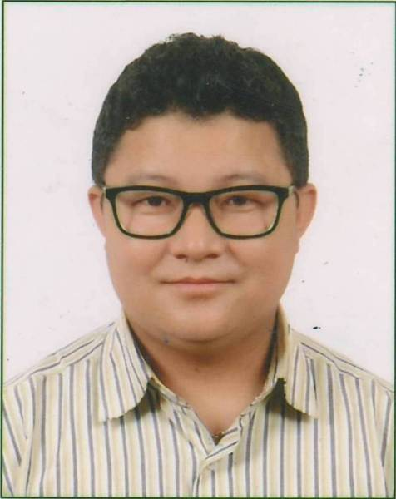 KRISHNA BAHADUR BARAM

KRISHNABAHADUR BARAM

Personal Information
Father Name : Nar Bahadur Baram
Mother Name : Dil Maya Baram
Sex : Male
Marital Status : Married
Date of Birth : 28th, Sept 1985 (12-06-2042)
Citizenship No. : 103937 (Gorkha)
License No. : 01-06-00848119 (Bagmati)
Indigenous Nationalities : 3/3734
Religion : Hindu
PAN No. : 102872309

Educational Information
Master in Business Studies : Public Youth Campus (TU) Running not complete
Bachelor in Business Studies : Public Youth Campus (TU) 2nd Division.
Certificate Level : Saraswoti Multiple Campus (TU) 3rd Division.
School Leaving Certificate : Surya Jyoti Secondary School (HSB) 2nd Division.

Training Experience
Computer Training : Basic Computer Course.
A+ & Net+ : Computer Hardware & Networking Course.
(Aptech Computer Education)

Working Experience
JYOTI GROUP
Syakar Company Limited (Honda/Herohonda)
(Hire Purchase Department)
(Working 10 years)
Senior Accountant
Responsibility/Duties
- Preparing Motorcycle Hire purchase Scheme.
- Create customer ledger & installment posting.
- Settlement of individual customer account.
- Preparing financial report.
- Making Receipt & payment Voucher.
- Typing all type of letter in Nepali & English.

Sales/Loan Recovery Officer
Responsibility/Duties
- MC sales in finance scheme.
- Installment & Margin collection from customer & daily deposited in Bank.
- Reporting to H/O Daily/Weekly/Monthly about the Cash collection, MC Sales & Customer inquiry.
- Follow up & Collection Due Payments

Insurance Surveyor Office
Assistant (Part Time)
- Preparing Motorcycle/Scooter claim settlement report.

LAXMI GROUP
Laxmi Intercontinental Pvt. Ltd. (Hyundai Motors)

Account Assistant II (July, 2015 to March, 2016)
Responsibility/Duties
- Updating individual dealer wise sheet.
- Updating dealer master sheet (LC wise vehicle details, delivery, invoice, and ownership transfer and payment realization).
- Preparing memo for issuance of tax invoice.
- Preparing documents of dealers for payment.
- Calculation of interest on every payment realization and if interest is chargeable, then making entries in the software (i.e. tally) of those transactions.
- Checking the validity of service coupons sent by dealers.
- Issuing service booklets and keeping records of those issued to showroom as well as dealers.
- Checking the bills of dent paint sent by LI Auto Services and LI Service Center Pvt. Ltd.

BAJRA GROUP
Bajra Automobile Pvt. Ltd. /Bajra Autotrading Pvt. Ltd.
(Honda Motorcycle/Scooter) (Hire Purchase/Account Department)

Finance Officer (15 March 2016 to Until Now)
Head of Finance Division
- Handling All Installment Sale/Recovery
- Handling Sales/Collection/Settlement.
- Handling all Hire purchase Account.
- Handling all Motorcycle/Scooter, Vehicle, and Stock & Property Insurance.
- Handling VAT Return, TDS/Salary/Monthly Incentive
- Preparing Projected B/S

Everest Insurance Company Limited
Lagankhel Branch.

Jr. Sales & Marketing Officer
Joining Date : May 11th,2021 but my personal heath issue I was Not join that date.

RS Concern, PACT Concern & Shivashakti Alcoholic Beverage Industries
Pvt. Ltd.
(Part Time)
- VAT Return
Monthly Online TDS & Tax Paid to Tax office.
Preparing Yearly Financial report.

Software/Computer Knowledge
- Strong Knowledge of SSRC Hire Purchase Accounting Software.
- Strong Knowledge of Navigator Accounting Software.
- Strong Knowledge of Microsoft Word, Excel, Power Point, e-mail etc.
- Strong Knowledge of Computer Hardware (A+).
- Strong Knowledge of Networking (Net +) LAN System
- Strong Knowledge of Nepali & English Typing.

I hereby declare that above mentioned information are true & factual.

Thanking You,
Krishna Bahadur Baram

