CURRICULUM VITEA

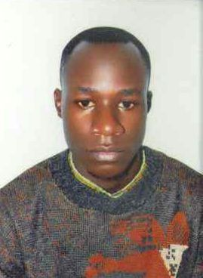
NAME : ABDARAH RATIF KASIKO
TEL : +971523864034
EMAIL : abdarahratif@gmail.com NATIONALITY: UGANDAN
VISA STATUS : CANCELLED VISA
STEWARD/ DISH WASHER

OBJECTIVE:
Good and hospitality management with honesty and humility towards successes.
To pursue a challenging career For a diverse environment where My skills, experience and personal Attributes can be fully utilized, Aiming at both continuous self- Development and organizational Growth.

EXPERIENCE
GOLDEN GARAGE: DUBAI [ 2019-AUG]-2021
HELPER/ CLEANER
Keys accomplished
- Assist mechanics with repairing vehicles and equipments;
- Cleans and maintains shop equipment and tools;
- Maintain and monitors parts and fluid inventories;
- Operates various hand tools, including spray gun, sander, grinder, grease gun.
- Performs minor equipment repair in the field;
- Repairs flat tires and tubes, including dismounting; and picks up supplies and parts from vendors or suppliers as necessary.

ALKHAN CAR WASH: DUBAI 2017-2018
CAR WASH ATTENDANT
- Clean customers cars and to provide excellent customer services.
- Washing the interiors and exteriors of the car, dispose of trush, vacuum
Floors and seat, polish surfaces, and clean the inside of the windshield
And windows.
- For car exteriors, pre sork, soap, rinse, and dry the car.
- Appling wax and clean tires.

KEY STRENGTH
- Experience developing sales.
- Active public speaker.
- Proven team working skills.
- Customer Services skills.
EDUCATION
❖ High School Certificate (UACE)
❖ High School Certificate (UCE)
HOBBIES
- Reading (journal, Newspapers, Magazines)
- Internet surfing, Research and new discoveries
- Games (Football, Volley Ball)
- Making friendship

Referees: will be provided upon request thanks

