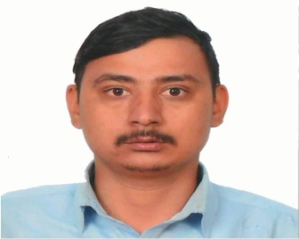

**RAJESH SAPKOTA**

* Verifying client's big transactions by complying with bank's financial policies and procedures.
* Maintaining accurate, and complete transaction reports on daily basis.
* Issuing banker checks, demand drafts and pay orders.
* Evaluating and providing better customer service to enhance customer satisfaction rate for the bank.

Good knowledge of various banking and accounting tools.

Microsoft Office and preparing Google Spreadsheets

Technical Skills

professional experience

Sapkotarajesh250@gmail.com

Dadikot-4, Bhaktapur

Strive to the best in my area of performance. I believe in any industry whether manufacturing or service, customer satisfaction is core factor for any business to succeed, hence I work in the direction where I can achieve satisfaction of customer together with organizational success as well as grow better as an employee to be a successful leader with effective managerial skills and knowledge in the work field.

Strong communication

* Record keeping of daily activities, that is purchase, sales, received, payment, bank statement
* Keeping systematic record of purchase book, sales book, party ledger, stock book etc.
* Providing the systematic report of monthly VAT, debtors, creditors, duties & taxes, profit & loss account to management team.

Accountant  
Promotional Manpower Services /Koteshwor, mar-2016 to may-2017

Attention to detail

9860656454

contact

profile

Office Assistant  
*Nefscun/Naya Baneshwor, 2018 – Present*

key skills

Team leadership

Analytical thinking, planning

Organization and prioritization

Problem solving

Education

Bachelor/Management, TRIBHUVAN UNIVERSITY 2014-2018

Intermediate/Management, H.S.E.B

*2010-2012*