Precision Aerial Grasping and Mid-Air Handover with a Truss-Based Flexible Manipulator: Visual Fine Alignment, Bias-Aware State Estimation, and Arm–Body Coupling Suppression
Abstract— This article studies precision grasping and mid-air handover with a truss-based flexible-arm aerial manipulator. The platform combines an X-configuration quadrotor, an eight-segment truss arm with sixteen bend joints, a diamond two-finger gripper, and a wrist-mounted camera, and it executes a six-phase autonomous pipeline: visual alignment, descent, settle, closure, mechanical capture, and lift. Methodologically, we develop a dual-channel visual-servoing strategy in which a gentle base trim absorbs the low-frequency offset while a pure proportional bend controller performs millimeter-level micro-adjustment through a damped-least-squares mapping of the fingertip-to-target image residual. An online identification of the composite inertia tensor keeps the attitude loop calibrated as the arm extends, a 15-state error-state Kalman filter with accelerometer and gyroscope bias states supplies low-drift state estimates, and the attitude loop embeds an integral trim with gravity feedforward to suppress arm–body coupling. The terminal criterion adopts a low-pass (DC) alignment error, and grasping requires a sustained dual-finger contact of 0.3 s before the kinematic carry is established. Across three random seeds, all runs pass the four-part criterion, reaching terminal alignment errors of 0.006, 0.019, and 0.009 m, localization mean errors of 0.002–0.003 m, and lift heights of 0.406–0.465 m. The offline filter comparison reduces velocity, position, and attitude RMS errors by 73.6%, 40.3%, and 27.6%, respectively. A phase-gated handover script is designed and implemented, with full-sequence verification left to future work.
Index Terms— Aerial manipulation, compliant grasping, error-state Kalman filter, flexible truss arm, mid-air handover, visual servoing.

I. Introduction
Aerial manipulators extend the mobility of multirotor platforms into physical interaction, which allows inspection, grasping, tool exchange, and emergency response in places that are difficult to reach [1]. Research on contact reliability has produced model predictive control combined with disturbance observers for opening a hinged door [2], contact-aware onboard perception with hybrid force/position control for contact-rich tasks [3], motion and force control that writes contact constraints directly into the control law for arbitrarily tilted surfaces [4], and disturbance-observer-based predictive control for grasping on a soft aerial vehicle [5]. Cooperative systems push the working scale further: a vertically stacked dual-drone platform achieves sub-centimeter aerial tool exchange with high-rate vision and mechanical guidance [6], and mid-air handover extends this capability to payload transfer between vehicles.
Precision grasping stresses perception, estimation, and dynamics at the same time. On the perception side, fine alignment demands centimeter-to-millimeter end-effector accuracy, while image delay and intermittent frame loss in the onboard vision loop consume phase margin [7]. The physical bounds set by base travel, bend range, and visual update rate accumulate error across sensing, filtering, and actuation latency. On the estimation side, accelerometer bias and tilt form an equivalent manifold during hover, the yaw observability of the gyroscope bias depends on a heading reference, and pose-estimation errors couple into the end-effector trajectory through the control loop [8]. On the dynamics side, a compliant arm trades stiffness for contact tolerance and introduces a low-frequency oscillation mode near 1 Hz, with bidirectional coupling between arm reaction torques and body attitude. Studies of elastic quadrotors show that actuator delay turns phase margin into a binding constraint once it enters the loop [9].
This work builds on a platform that combines a quadrotor, a flexible truss arm, and a diamond two-finger gripper. The arm comprises eight bend-joint segments and a prismatic rail, and the gripper forms a passively compliant grasping channel. A single-vehicle mission covers six phases, namely visual alignment, descent, settle, closure, capture, and lift, and runs fully on onboard perception. The alignment stage allocates the image residual across two coordinated channels: a gentle base trim for large-stroke correction and a high-bandwidth bend controller for fine adjustment. State estimation runs a 15-state error-state Kalman filter with IMU bias states that supplies low-drift velocity, position, and attitude references for the pose loops. The attitude loop adds an integral trim and gravity feedforward and compensates the arm-induced coupling through a reaction-torque channel. A phase-gated sequence then extends the mission from single-vehicle grasping to grasping, carrying, and mid-air handover.
The contributions are fivefold. (1) We present a truss-based flexible-arm aerial grasping system with an eight-segment bend structure, a prismatic rail, and a diamond two-finger gripper, whose passive compliance supports stable compliant grasping and whose autonomous pipeline spans visual alignment, descent, settle, closure, capture, and lift. (2) We propose a visual fine-alignment method that coordinates a gentle base trim with a pure proportional bend controller, both driven by the fingertip-to-target image residual as a single error source, and we adopt a low-pass (DC) error norm as the terminal criterion. The method reaches centimeter-level terminal alignment and supports a mechanical capture that requires sustained dual-finger contact. (3) We implement online identification of the composite inertia tensor, recomputed at 2 Hz from the articulated configuration, which keeps the attitude loop calibrated as the arm extends and removes the dominant cause of alignment instability observed in fixed-inertia configurations. (4) A 15-state error-state Kalman filter with accelerometer and gyroscope random-walk bias states fuses GNSS position, barometric altitude, and gated gravity-direction measurements, reducing velocity, position, and attitude RMS errors by 73.6%, 40.3%, and 27.6% in an offline comparison on identical measurements. (5) We design and implement a phase-gated mid-air handover sequence that organizes the behaviors of a supply vehicle and a receiving vehicle, spanning the task chain from grasp to transfer, with verification of the full sequence left to future work.
In multi-seed simulation, the final configuration passes the four-part criterion in all three seeds. Terminal alignment errors are 0.006, 0.019, and 0.009 m, localization mean errors stay at 0.002–0.003 m, lift heights reach 0.406–0.465 m, and every capture is established after 0.3 s of sustained dual-finger contact. The remainder of this article is organized as follows. Section II reviews related work. Section III describes the platform, its composite-body dynamics, and the onboard sensing configuration. Section IV presents the flight control, estimation, alignment, grasping, and handover methods. Section V details the experimental setup, and Section VI reports results and discussion. Section VII concludes the article.

II. Related Work

A. Aerial Manipulation and Grasping
Aerial manipulation research follows two main threads: task execution and disturbance handling. For task execution, Lee et al. [2] combine model predictive control with a disturbance observer to open a hinged door, where contact-force planning and robust compensation complement each other. Byun et al. [4] target arbitrary tilted surfaces with a motion and force controller that writes stable-contact constraints into the controller structure. Cheung et al. [5] embed a disturbance observer into predictive control and complete aerial grasping on a soft flight platform, showing both structural compliance and disturbance compensation. For disturbance handling, Chen et al. [10] propose nonlinear-disturbance-observer control for a quadrotor with a delta arm, modeling internal coupling and external disturbances in one compensation channel, while Brummelhuis et al. [11] use a momentum-based torque observer for proprioceptive contact localization during slanted-roof landing. On compliance and coupled dynamics, Sarkisov et al. [12] damp the oscillations of a cable-suspended aerial manipulator with an output-feedback LQR and a single IMU, and Eraslan and Yildiz [9] establish a rigid-flexible model of an elastic quadrotor with delay-dependent stability analysis, exposing the coupling between tip oscillation and flight-control bandwidth. Zhan et al. [3] further show that perceptual consistency and hybrid force/position control during contact govern task stability. Against this background, our platform forms a passively compliant grasping channel from a truss arm and a diamond gripper, absorbs contact impacts in the structure itself, closes the alignment-to-capture loop with onboard vision, and suppresses arm–body coupling through attitude integration and gravity feedforward.

B. Visual Servoing and Fine Alignment
Visual servoing provides a direct route to fine alignment. He et al. [13] build an image-based visual servoing loop on a fully actuated UAV with a line-feature interaction matrix and impedance attachment for bridge contact tasks, anchoring the pose reference in onboard flow and IMU estimates. On image delay, Yang et al. [7] model image measurements as a fixed-delay sequence and fuse 200 Hz IMU propagation with low-rate image correction in an 18-state delay Kalman filter, reaching a 0.33 m circular error probable at 50 Hz filtering and analyzing alignment stability with a barrier Lyapunov function. Predictive visual servoing turns the image gap into a model-extrapolation problem: Li et al. [14] feed image-kinematics predictions as pseudo-measurements into an error-state filter with adaptive measurement noise and model predictive control, reducing position RMS error by 52.6%–75.0%, and Wang et al. [15] compensate moment loss with a Kalman filter inside terminal-constraint MPC, handling recursive feasibility and convergence through terminal constraints. For degraded vision, Aghili [16] maintains control continuity in on-orbit servicing with constrained noise-adaptive filtering when visual measurements fail intermittently, and Tao et al. [17] fuse per-frame keypoint observations in an EKF so that a probabilistic control law outputs both velocity commands and estimation uncertainty. Learning and sampling methods take another route: DeepMPCVS [18] combines optical-flow prediction with an online control network, and MPPI-VS [19] handles constraints and camera-parameter errors in a sampling-based predictive framework. Our fine-alignment design treats the fingertip-to-target image residual as the single error source and coordinates an anchored base channel with a bend micro-adjustment channel in an analytical form suited to embedded onboard execution.

C. Onboard State Estimation
Onboard state estimation supplies the pose reference for alignment and grasping. Abeywardena et al. [8] write accelerometer and gyroscope biases together with aerodynamic drag into the IMU state and enforce epipolar updates for real-time visual-inertial odometry on a 50 g platform, and they discuss the weak observability of hover conditions. The error-state framework has become widespread for its compact parameterization and consistent covariance: Markovic et al. [20] include sensor drift and calibration errors in the error state and fuse laser, visual, and ultra-wideband measurements for localization in denied environments, and Cohen and Forbes [21] jointly estimate navigation states, sensor biases, and wind velocity with an invariant Kalman filter on a matrix Lie group, modeling biases as random walks. Lopez [22] proves a hierarchical contraction structure in which attitude and gyroscope bias converge quickly while position, velocity, and accelerometer bias converge slowly, which supports a layered view of bias observability, and EqVIO [23] links the group-affine property of unbiased inertial dynamics to linearization error. For field deployment, a semi-aerodynamic-model-aided invariant filter holds the maximum position error below 30 m during 130 s of GNSS denial [24], and learning-based methods predict bias priors to preserve filter consistency during long visual outages [25]. A comparative study of UKF and TRIAD confirms experimentally that yaw observability depends on a heading reference [26]. We build a 15-state error-state extended Kalman filter with accelerometer and gyroscope random-walk biases, a world-frame attitude-error convention, and a gated gravity-direction update. In an offline comparison on identical measurements, velocity, position, and attitude RMS errors drop by 73.6%, 40.3%, and 27.6%, the observable gyroscope-bias axes converge within 10 s to better than 7×10⁻⁴ rad/s, and the terminal value reaches 2.2×10⁻⁴ rad/s.

D. Mid-Air Handover
Mid-air handover requires two vehicles to hold a stable relative pose at close range while payload transfer proceeds in an ordered sequence. Seth et al. [27] achieve 0.9 cm cross-marker locking accuracy and swap an emergency battery across a 0.5 m vertical gap. Cai et al. [28] propose a progress-aware leader-follower docking framework that divides the task into approach, alignment, capture, and stabilization phases, with capture triggered jointly by relative pose and relative velocity. The vertically stacked system of Cao et al. [6] attains 0.48 cm single-shot localization and 0.80±0.33 cm continuous docking accuracy with a QR array and a 50 Hz six-degree-of-freedom pose filter, and it performs repeated tool exchange in a 13.18 m/s downwash. Shankar et al. [29] demonstrate in-flight payload transfer between multirotors through controlled mechanical exchange. Cross-domain experience is also informative: human-robot handover combines visual contact detection with joint-torque intent recognition to decide the release instant and reaches a 98% success rate [30], compliant blind handover classifies force-signal patterns to detect object passage and trigger release [31], and self-assembling modular aerial robots use joint intrusion for aerial capture and assembly, linking docking and manipulation in one flow [32]. Our handover is organized by a phase-gated script: the supply vehicle performs visual alignment, grasping, and carrying, the receiving vehicle provides the transfer datum in a tracking mode, the capture stage confirms contact quality through a dwell window, and the release stage applies geometric-proximity and relative-velocity gates.

III. System Description
The aerial manipulation system AS-01 comprises an X-configuration quadrotor, an eight-segment flexible truss arm, a diamond two-finger gripper, and a wrist-mounted camera (Fig. 1). The mission is to grasp a cylindrical specimen from a stand through visual alignment and to transfer it between two identical platforms at altitude. The complete system runs in the Isaac Sim physics environment at a 1 ms physical step, and flight control, arm actuation, sensor simulation, and vision processing all close on onboard information. This section describes the platform layout, the composite-body dynamics and actuation, and the sensing configuration. Tables I–III summarize the parameters.

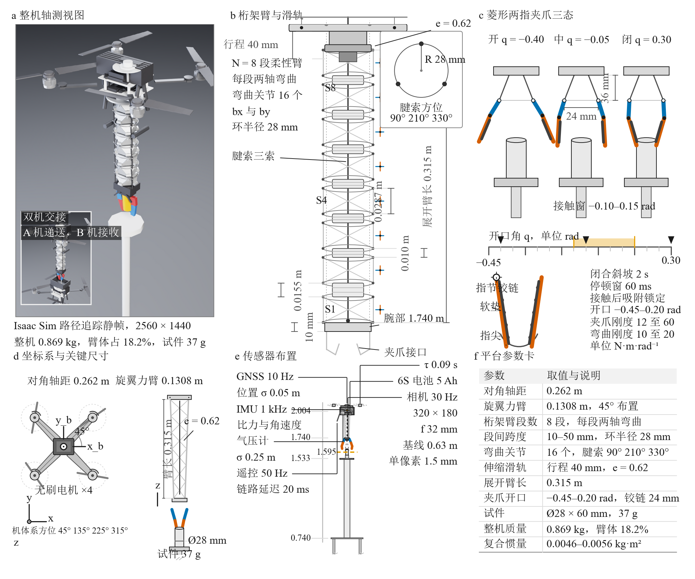
Fig. 1. System overview of AS-01: (a) the quadrotor with the eight-segment truss arm and (b) a close view of the diamond two-finger gripper at the wrist (Isaac Sim renders).

A. Platform Overview
The flight platform adopts an X-configuration quadrotor layout with a diagonal wheelbase of 0.262 m. Four brushless motors sit on rotor arms of radius 0.1308 m at azimuths of 45°, 135°, 225°, and 315°, and the rotor speed produces thrust through a first-order dynamic response and a quadratic thrust law, with reaction torque applied to the yaw channel at a ratio of 0.016. Power comes from a 6S/5 Ah lithium-polymer battery. The flexible arm is an eight-segment truss structure, and each segment carries two-axis bend joints, eight about bx and eight about by, for sixteen actuated joints in total. Three tendons routed at 90°, 210°, and 330° around the circumference couple the bending deformation into a continuous curvature, the inter-segment span is adjustable from 10 mm to 50 mm, and the truss ring radius is 28 mm. A prismatic rail with 40 mm travel sits at the arm root, and the extension is described by a continuous variable e∈[0,1] with an alignment working point of e=0.62, which corresponds to an extended arm length of about 0.315 m. The wrist carries a diamond two-finger gripper whose finger hinges lie on a 24 mm radius with the hinge axis 36 mm below the wrist. The opening angle covers −0.45 to 0.20 rad, and a position servo drives the closure stroke over −0.40 to 0.30 rad. The platform supports interchangeable diamond two-finger, parallel two-finger, three-finger, and soft two-finger grippers, and this work uses the diamond configuration. The specimen is a cylinder of 28 mm diameter, 60 mm height, and 37 g mass resting on a stand whose top surface is at 1.533 m. The grasp plane sits at the specimen top face near z=1.595 m, and the wrist hovers at roughly 1.74 m. The truss arm is rigidly attached to the quadrotor through a fixed mount, the platform holds its hover pose throughout the grasp, and the arm configuration is fed back through joint encoders and onboard estimation.
TABLE I Platform geometry and mass parameters.
Parameter | Value | Unit | Remark
Diagonal wheelbase | 0.262 | m | Rotor-center diagonal
Rotor arm radius | 0.1308 | m | Motor offset from body center
Total mass | 0.869 | kg | Including arm and gripper
Arm mass | 0.158 | kg | 18.2% of total mass
Specimen mass | 0.037 | kg | Cylindrical part
Composite inertia $(I_{x},I_{y},I_{z})$ | 0.0046 / 0.0054 / 0.0056 | kg·m² | Principal components
Inertia amplification | 1.9 | — | Relative to bare frame
Arm segments | 8 | — | Two bend axes per segment
Inter-segment span | 10–50 | mm | Adjustable truss unit
Truss ring radius | 28 | mm | Tendon routing radius
Rail travel | 40 | mm | Extension e∈[0,1]
Extended arm length (e=0.62) | 0.315 | m | Nominal wrist reach
Bend joints | 16 | — | Eight bx and eight by
Tendon azimuths | 90 / 210 / 330 | ° | Three tendons driven together
Gripper opening range | −0.45–0.20 | rad | Diamond two-finger
Finger hinge radius | 24 | mm | Finger root joints
Specimen size | Ø28 × 60 | mm | Cylinder
Stand top height | 1.533 | m | Grasping platform
Grasp plane height | 1.595 | m | Specimen top face

B. Composite-Body Dynamics and Actuation
The controller models the vehicle and the flexible arm as one composite rigid body. The composite inertia tensor is aggregated from the per-body inertias of the physics engine, and its principal values read [0.0046, 0.0054, 0.0056] kg·m², which is 1.9 times the frame-alone inertia. The arm weighs 0.158 kg, 18.2% of the total mass, and contributes about 79% of the pitch-direction inertia. An arm center-of-mass radius of 0.250 m places the dominant arm–body coupled oscillation mode near 1 Hz, so the composite inertia and the low-order bend mode together define the plant characteristics. The bend joints run as position servos with stiffness k=10 N·m/rad and damping c=4.0 N·m·s/rad, the rail is driven by a stiff position servo at 2×10⁴ N/m, and the gripper servo runs at 12 N·m/rad. Once contact is established, the gripper stiffness is scheduled to 60 N·m/rad and the bend stiffness to 20 N·m/rad to lock the grasp configuration. Actuator dynamics center on the first-order rotor response, with a spin-up time constant τ=0.09 s and a spin-down constant of 0.03 s. The value of τ sets the phase budget of the attitude loop and constrains the flight-gain tuning. The center-of-mass drift caused by arm bending is mapped through a center-of-mass Jacobian J_cg into a compensation moment that enters the attitude channel after limiting to ±0.25 N·m and a 0.15 N·m/s slew limit. A lumped disturbance within the control bandwidth can be estimated by an auxiliary-state nonlinear disturbance observer (NDOB) with the effective motor torque as the regressor and a bandwidth L of 3–5, and the interface remains available as a switchable module. The grasp and handover experiments of this article run with the observer disabled by default (L=0). Table II lists the actuator and drive parameters.
TABLE II Actuator and flexible-arm drive parameters.
Parameter | Value | Unit | Remark
Maximum rotor speed | 650 | rad/s | Quadratic thrust model
Thrust coefficient $K_{F}$ | 1.7×10⁻⁵ | N·s²/rad² | Per rotor
Reaction-torque ratio | 0.016 | — | Thrust to torque
Spin-up time constant τ | 0.09 | s | Actuator lag
Spin-down time constant | 0.03 | s | Rotor deceleration
Battery | 6S / 5 | — / Ah | 22.2 V nominal
Bend servo stiffness k | 10 | N·m/rad | Task configuration
Bend servo damping c | 4.0 | N·m·s/rad | Joint damping
Rail drive stiffness | 2×10⁴ | N/m | Position servo
Gripper stiffness scheduling | 12 → 60 | N·m/rad | After capture
Bend stiffness scheduling | 10 → 20 | N·m/rad | After capture
CoM feedforward limit | ±0.25 | N·m | extra_moment channel
Feedforward slew limit | 0.15 | N·m/s | Slow channel
Observer bandwidth L | 3–5 | 1/s | NDOB (disabled by default)

C. Sensors and Onboard Perception
The onboard sensing suite consists of an IMU, a GNSS receiver, a barometer, and a wrist camera. Each sensor samples asynchronously at its own rate and feeds the state-estimation and control loops: the IMU outputs specific force and angular rate at 1 kHz, with accelerometer white noise of 0.08 m/s² and a constant bias of 0.05 m/s², and gyroscope white noise of 0.02 rad/s with a constant bias of 0.004 rad/s. The GNSS provides position measurements at 10 Hz (σ=0.05 m). The barometer provides altitude at 50 Hz (σ=0.25 m with slow drift), and the wrist camera moves with the wrist and outputs 320×180 color images at 30 Hz with a 32 mm focal length and a 24 mm horizontal aperture for specimen-top localization. The radio link is modeled at 50 Hz with 20 ms of latency. Sensor noise combines Gaussian white noise with per-seed constant biases, GNSS and barometric measurements are held in zero-order fashion, and the vision pipeline operates directly on the wrist-camera output while sharing the simulation clock with the control loop. Table III summarizes the sensor configuration.

TABLE III Sensor and onboard perception configuration.
Sensor | Rate | Noise | Bias | Purpose
IMU accelerometer | 1000 Hz | σ=0.08 m/s² | 0.05 m/s² | Specific force
IMU gyroscope | 1000 Hz | σ=0.02 rad/s | 0.004 rad/s | Angular rate
GNSS | 10 Hz | σ=0.05 m | — | Three-axis position
Barometer | 50 Hz | σ=0.25 m | Slow drift | Altitude
Wrist camera | 30 Hz | — | — | 320×180, f=32 mm
Radio link | 50 Hz | — | — | 20 ms latency

IV. Method
The system organizes five chains: cascaded flight control closes the platform pose loops, the error-state Kalman filter fuses onboard sensing into a state reference, visual fine alignment brings the fingertips onto the specimen from centimeter to millimeter scale, the grasp sequencer triggers mechanical capture and lift from contact evidence, and a supervised sequence coordinates the two platforms during handover (Fig. 2). All chains share the 1 ms control period, and navigation measurements update asynchronously at their own rates.

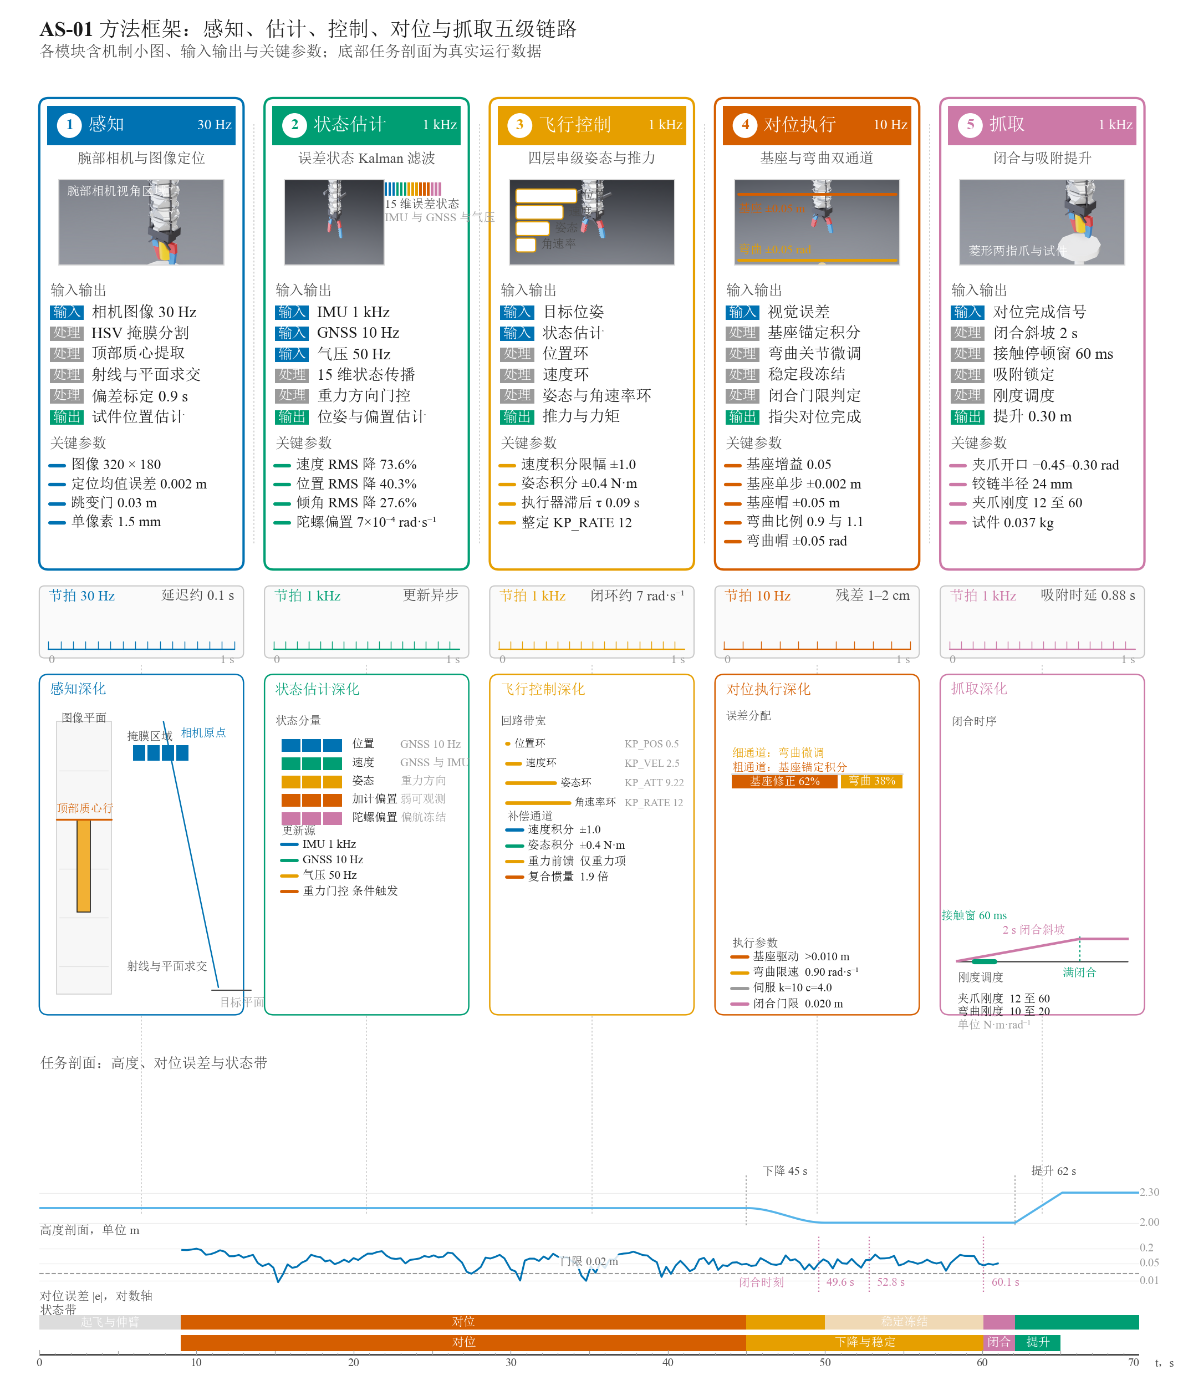
Fig. 2. Method framework: perception (30 Hz camera, HSV localization, bias calibration), state estimation (15-state ESKF), flight control (cascade plus attitude trim), alignment execution (gentle base trim and pure proportional bend adjustment), and grasping (closure, sustained dual-finger contact, mechanical capture, lift), with the 0.020 m gate, |v_tip|<0.15 m/s condition, k=10/c=4.0 servo setting, and the τ=0.09 s gain tuning.

A. Flight Control Architecture
Flight control uses a four-layer cascade of position, velocity, attitude, and angular-rate loops. The position and velocity loops generate a desired acceleration vector, the attitude loop rotates it into a body attitude target, the angular-rate loop outputs a three-axis torque, and the mixer solves for the four motor thrusts.
The outer loop turns the position error into a velocity command,
$v_{des}=clip\left(K_{P,pos} e_{p}, ±2.5\right) m/s,$ (1)
and the velocity error drives proportional and integral action,
$k_{i}←clip\left(k_{i}+e_{v}Δt, ±1.0\right), a_{des}=K_{P,vel}e_{v}+K_{I,vel}k_{i}+ge_{z},$ (2)
with the acceleration limited to ±16 m/s². The thrust magnitude $f_{z}=clip\left(m|a_{des}|, 0.05mg, 30\right)$ N and the thrust direction $z_{b}=a_{des}/|a_{des}|$ define the body z axis. The commanded yaw axis projected onto the thrust-normal plane forms $x_{b}$, with $y_{b}=z_{b}×x_{b}$, and the rotation matrix yields the desired quaternion $q_{des}$. The attitude error follows as $q_{e}=q^{−1}⊗q_{des}$ with rotation vector $r_{v}=2 vec(q_{e})$.
The attitude loop applies proportional action to form the rate command $ω_{des}=clip\left(K_{P,att}r_{v}, ±6\right)$ rad/s, and the rate loop outputs an angular acceleration through proportional and derivative terms, $α=K_{P,rate}\left(ω_{des}−ω\right)−K_{D,rate} ω$. The three-axis torque is
$τ=Iα+τ_{ff}+τ_{trim}−\hat{d},$ (3)
where $I$ is the composite inertia supplied by the online identification of Section IV-B, $τ_{trim}$ is the attitude integral term accumulated as $τ_{trim}←clip\left(τ_{trim}+K_{I,att} r_{v}Δt, ±0.4\right)$ N·m with a gain of 0.10, $τ_{ff}$ is the center-of-mass feedforward, and $\hat{d}$ is the optional disturbance estimate. The integral trim converges to the constant imbalance moment of the arm during hover and alignment and cancels it, which makes the term a key contributor to terminal accuracy. The mixer inverts a constant allocation matrix to distribute the total thrust and three-axis torque over the four motors and limits each rotor thrust to $[0, K_{F}Ω_{max}^{2}]$. The X-layout geometry fixes the allocation matrix, and each rotor response passes through the first-order speed dynamics and battery-voltage scaling into the rigid body, so the closed-loop model covers the full path from command to applied torque.
The actuator lag τ=0.09 s compresses the phase margin of the attitude loop and excites a slow drift mode in the position and velocity integrals. We reviewed all gains against τ=0.09 s and the composite inertia, and Table IV lists the set used in the final campaign. These values hold the position-loop integral mode convergent through hover, descent, and alignment, and the ±1.0 velocity-integral clamp suppresses long-term drift. The center-of-mass feedforward maps measured bend-joint increments through J_cg into a center-of-mass moment along the gradient direction, which together with the center-of-mass velocity damping forms a slow compensation path for arm oscillation.

TABLE IV Flight-control gains (final configuration).
Gain | Symbol | Value | Unit | Function
Position-loop proportional | $K_{P,pos}$ | 0.50 | 1/s | Position error to velocity command
Velocity-loop proportional | $K_{P,vel}$ | 2.50 | 1/s | Velocity error to acceleration
Velocity-loop integral | $K_{I,vel}$ | 0.30 | 1/s² | Steady drift suppression (clamp ±1.0)
Attitude-loop proportional | $K_{P,att}$ | 9.22 | 1/s | Attitude error to rate command
Angular-rate proportional | $K_{P,rate}$ | 12.0 | 1/s | Rate error to angular acceleration
Angular-rate damping | $K_{D,rate}$ | 0.04 | 1/s | Rate damping
Attitude integral gain / limit | $K_{I,att}$ / — | 0.10 / ±0.4 | — / N·m | Constant imbalance cancellation
Complementary-filter gain | — | 0.35 | — | Attitude estimation blend

B. Online Identification of the Composite Inertia Tensor
Arm extension changes the composite inertia of the whole vehicle by a large factor, and the attitude-loop gains are the most sensitive to that change. The scene layer therefore identifies the composite inertia tensor online. At every 0.5 s it reads the mass and inertia tensor of each rigid body from the physics engine, computes the mass-weighted center of mass, synthesizes the whole-vehicle inertia with the parallel-axis theorem, rotates the result into the root-body frame, and writes the principal components into the inertia parameter of the flight controller. The folded initial configuration passes through the same computation. Run logs record a composite inertia of [0.0046, 0.0054, 0.0056] kg·m², which is 1.9 times the bare frame. The arm accounts for 18.2% of the total mass and about 79% of the pitch-direction inertia. Early versions computed the tensor once at initialization, and the value after arm extension differed from the initial value by several times, which collapsed the effective attitude-loop gain and became the primary root cause of alignment instability. With the online recomputation the attitude and position loops recover convergence as the arm extends, and this change is one of the necessary elements behind the final 3/3 pass rate.

C. Error-State Estimation
The estimator is a 15-state error-state Kalman filter whose nominal state comprises position, velocity, attitude quaternion, and accelerometer and gyroscope biases, $x=[p,v,q,b_{a},b_{g}]$, with error state $δx=[δp,δv,δθ,δb_{a},δb_{g}]$. The attitude error is defined in the world frame and satisfies $q_{true}=exp(δθ/2)⊗q$. This convention fixes the unobservable direction to the world z axis and makes the Jacobian of the gravity-direction update with respect to the yaw component identically zero.
The IMU performs nominal propagation at 1 kHz: $\hat{ω}=ω_{m}−b_{g}$, $a_{b}=a_{m}−b_{a}$, and $a_{w}=R(q)a_{b}−ge_{z}$, followed by $p←p+vΔt+1/2a_{w}Δt^{2}$, $v←v+a_{w}Δt$, and $q←norm\left(q⊗exp(\hat{ω}Δt/2)\right)$. The error dynamics propagate through a first-order discrete linearization,
$δp^{′}=δp+δvΔt−1/2[f_{w}]_{×}δθ Δt^{2}−1/2R δb_{a} Δt^{2}, δv^{′}=δv−[f_{w}]_{×}δθ Δt−R δb_{a} Δt,$ (4)
$δθ^{′}=δθ−R δb_{g} Δt,$ (5)
and the covariance updates as $P←FPF^{⊤}+Q$, where the process noise combines accelerometer noise, gyroscope noise, and bias random walks, and the unmodeled acceleration term of 0.03 m/s² absorbs vibration and arm reaction forces. The initial covariance uses 0.5² for position, 1.0² for velocity, 0.1² for attitude, and the bias priors, and the error state is injected and reset immediately after each update.
Three measurement groups drive the update. The GNSS position update uses $H=[I_{3} 0]$ with $R=σ_{gnss}^{2}I_{3}$, the barometric altitude update uses $H=[0 0 e_{z}^{⊤} 0 0]$, and both apply NIS soft gating that inflates the noise of anomalous measurements. The gravity-direction update uses $z=a_{b}/|a_{b}|$, $h(q)=R^{⊤}e_{z}$, and $H_{θ}=R^{⊤}[e_{z}]_{×}$ to correct roll, pitch, and the horizontal gyroscope-bias components, and its trust level is the product of a specific-force magnitude gate, an angular-rate gate, and a low-pass horizontal-acceleration gate. The update is skipped when the trust level falls below the floor. All three groups share one error state, the Joseph form is used throughout, and the biases are clamped to $|b_{a}|≤0.5$ m/s² and $|b_{g}|≤0.05$ rad/s. Table V lists the key filter parameters.
TABLE V Key EKF parameters.
Parameter | Value | Unit | Remark
Accelerometer white noise | 0.08 | m/s² | Propagation process noise
Gyroscope white noise | 0.02 | rad/s | Attitude process noise
Accelerometer bias random walk | 0.002 | m/s²/√s | Bias adaptation
Gyroscope bias random walk | 1×10⁻⁴ | rad/s/√s | Bias adaptation
Unmodeled acceleration | 0.03 | m/s² | Vibration and arm reaction
GNSS noise / gate | 0.05 / NIS 30 | m / — | 10 Hz update
Barometer noise / gate | 0.25 / NIS 9 | m / — | 50 Hz update
Gravity-update noise scale | 0.08 | rad | Trust scaling
Gravity-update trust floor | 0.4 | — | Skip below floor
Horizontal-acceleration gate | 0.08 | m/s² | Low-pass τ=0.05 s
Bias clamps $(b_{a},b_{g})$ | 0.5 / 0.05 | m/s², rad/s | State constraints
The bias observability is layered. The horizontal gyroscope-bias components become observable quickly through the gravity-direction update, converging from a prior of about 0.006 rad/s to 0.00022 rad/s over 60 s, and they fall below 7×10⁻⁴ rad/s within 10 s. The accelerometer bias and tilt form the equivalent manifold $b_{a}+gθ≈const$ during hover, whose observability builds slowly through translational maneuvers. The yaw direction remains in the unobservable subspace when no onboard heading reference exists, so the filter freezes the world-z attitude correction row in the measurement update and projects the gyroscope-bias correction along $R^{⊤}e_{z}$ out of the update. Yaw then rides on gyroscope integration, and the pseudo-corrections induced by motion-segment noise are suppressed. An offline comparison uses a 60 s trajectory, four random seeds, and identical measurements against the legacy Mahony-plus-alpha estimator: velocity RMS drops from 0.2108 to 0.0557 m/s (−73.6%), position RMS from 0.0708 to 0.0423 m (−40.3%), and attitude RMS from 0.4729° to 0.3424° (−27.6%), with the late-phase position RMS improving from 0.0689 to 0.0378 m (−45.1%) and the final position error from 0.0498 to 0.0205 m (−58.8%). Table VI summarizes the offline results. The main experiments of this article use the legacy estimator on the control path, and the EKF shares the same interface through a single switch.
TABLE VI Offline estimation accuracy (mean over four seeds × 60 s).
Metric | Legacy estimator | EKF | Change
Velocity RMS | 0.2108 m/s | 0.0557 m/s | −73.6%
Position RMS | 0.0708 m | 0.0423 m | −40.3%
Late-phase position RMS | 0.0689 m | 0.0378 m | −45.1%
Final position error | 0.0498 m | 0.0205 m | −58.8%
Attitude RMS | 0.4729° | 0.3424° | −27.6%
Gyroscope horizontal bias (terminal) | Not modeled | 0.00022 rad/s | Converged

D. Visual Fine Alignment
Visual localization starts from the color image of the wrist camera (Fig. 9). An HSV mask isolates the orange segment with hue in [5, 45], saturation above 60, and value above 80, the outer 12% border is removed, and the centroid of the pixels within the topmost 2.8%-height band yields the image coordinates of the specimen top face. Samples whose mask ratio falls below 3×10⁻⁴ are discarded. A pinhole ray $d=\left[(u−u_{0})/f, −(v−v_{0})/f, −1\right]$ is transformed into the world frame and intersected with the horizontal plane at z=1.595 m, which yields the planar position estimate of the specimen top face, with the focal length calibrated as $f={32}/{24}W$ pixels. The alignment stage samples vision at 10 Hz, and the mean of the samples during the first 0.9 s provides the visual bias calibration that is subtracted from later estimates before they enter the control loop. At a camera-to-target baseline of about 0.63 m, one pixel maps to roughly 1.5 mm of planar resolution, and the plane intersection with bias calibration gives millimeter-level relative accuracy during hover. A frame-to-frame jump above 0.03 m marks a sample as an outlier, in which case the loop holds the last valid target, which maintains target continuity across oscillation peaks.

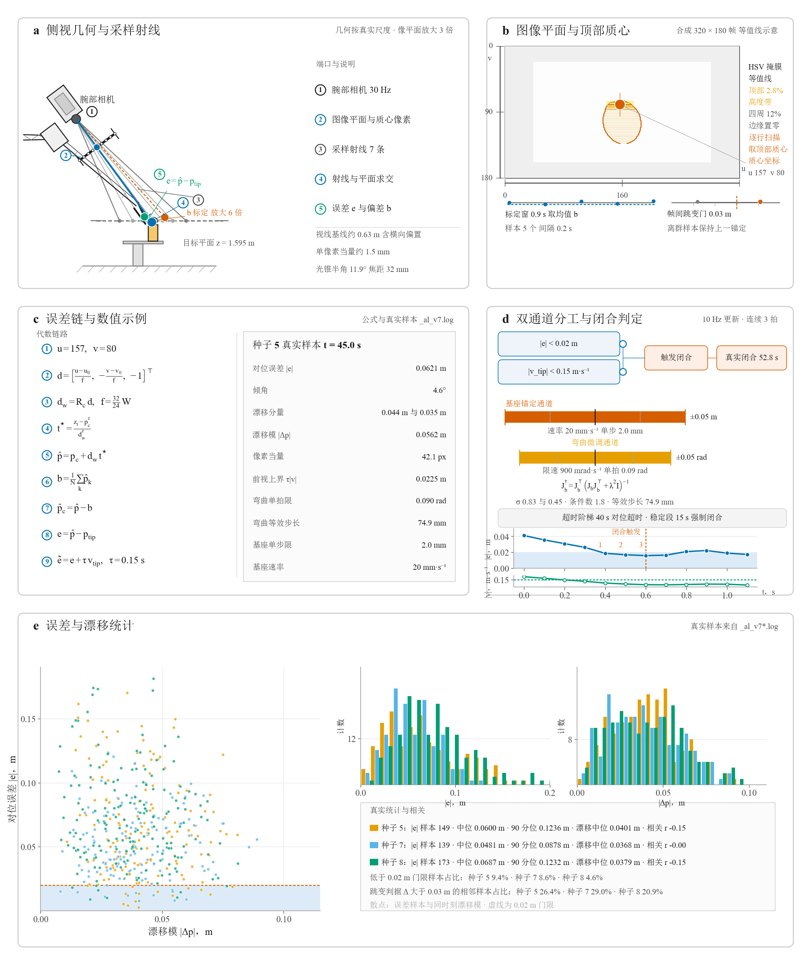
Fig. 9. Visual alignment principle: wrist camera, image plane, top-band mask centroid, ray–plane intersection, and the definition of the two-channel error.

The alignment error $e$ is the difference between the calibrated vision estimate and the fingertip position, and it passes through two first-order low-pass filters,
$e_{lp}←(1−α_{ℓ}) e_{lp}+α_{ℓ} e, α_{ℓ}=Δt/τ_{ℓ},$ (6)
where τ_ℓ=8 s supplies the strict DC metric used by the terminal criterion and the timeout check, and τ_ℓ=10 s forms the slow error that drives both execution channels. The fingertip velocity passes through a 50 ms filter and feeds the closure gate.
Two channels execute the alignment. The bend channel solves the error-to-joint mapping at each 10 Hz update through damped least squares,
$J_{bend}^{†}=J_{bend}^{⊤}{\left(J_{bend}J_{bend}^{⊤}+λ^{2}I\right)}^{−1}, Δθ_{b}=K_{P,bend} J_{bend}^{†} e_{slow},$ (7)
with λ=1 and a measured DC Jacobian $J_{bend}=[[0.085,0.70],[−0.49,0.40]]$ m/rad. The controller is purely proportional: the gain $K_{P,bend}$ takes 0.9 during the alignment phase and 1.1 during the hold phase, the bend target is capped at ±0.05 rad, the joint command is capped at ±0.10 rad, and the loop carries no integrator, so wind-up cannot freeze the channel at its limit. A 0.9 rad/s slew limit smooths the command written to the joints. The base channel absorbs the low-frequency component through a gentle trim,
$b_{xy}←clip\left(b_{xy}+clip\left(g_{b} e_{slow}, ±2 mm\right), ±0.05 m\right),$ (8)
with g_b=0.05. The channel engages only when the slow error norm exceeds 10 mm, so deviations within 1 cm settle naturally and the anchor does not chase noise. The two channels divide the work by magnitude: centimeter-level offsets are absorbed by the base trim within one to two seconds, and millimeter-level residuals converge quickly within the bend range of ±0.05 rad, which corresponds to several centimeters of fingertip travel. Both channels receive joint-encoder and estimator feedback, which sustains position holding between vision samples. The settle phase freezes the channel targets once convergence is reached, which suppresses limit cycling during closure preparation.
Closure is gated by three conditions that must hold together: the instantaneous fingertip-to-target error stays below the threshold of 0.020 m, three consecutive 10 Hz samples satisfy the condition, and the fingertip speed satisfies $|v_{tip}|<0.15$ m/s. When the conditions hold, the gripper begins its closure ramp. The alignment stage also runs a timeout that ends at task time t=40 s. If the DC error exceeds 0.05 m at that point, the run terminates early as a failure, and otherwise the mission proceeds directly to descent. When the raw error stays below 0.004 m for 0.4 s, the alignment stage hands over to descent, which executes a cosine height transition. The settle-phase monitor additionally imposes a 15 s forced-closure window and an 8 s re-check at 0.005 m, so the mission keeps moving under disturbed conditions. Table VII collects the alignment and capture parameters.
TABLE VII Alignment and grasp-execution parameters (final configuration).
Item | Value | Remark
Vision update rate | 10 Hz | Alignment loop
Frame-jump gate | 0.03 m | Outlier hold
Bias calibration window | 5.0–5.9 s | Five samples at 0.2 s spacing
DC error filter τ_ℓ | 8 s | Terminal criterion and timeout
Slow error filter τ_ℓ | 10 s | Drives bend and base channels
Bend control law | Pure proportional | $K_{P,bend}$ 0.9 / 1.1, no integrator
Bend target cap / joint command cap | ±0.05 / ±0.10 rad | Target and command limits
Bend slew limit | 0.9 rad/s | Command smoothing
Base trim gain | 0.05 | Slow error to base offset
Base step limit | 2 mm | Per 10 Hz update
Base travel limit | ±0.05 m | Total anchor offset
Base engagement threshold | 10 mm | Slow error norm
Closure gate | 0.020 m | Three consecutive samples, |v_tip|<0.15 m/s
Descent trigger | 0.004 m for 0.4 s | Raw error
Alignment timeout | t=40 s | Task time, early failure above 0.05 m
Settle windows | 8 s / 15 s | Re-check at 0.005 m / forced closure
Capture condition | Dual-finger contact ≥0.3 s | Window 0.8–6.0 s after closure

E. Grasp Execution
The grasp sequence begins from the converged visual gate. The arm first extends along the prismatic rail to e=0.62, and the platform then descends from 2.15 m along a cosine profile by 0.146 m to the working point at 2.004 m over 5 s, followed by a rest interval of at least 2.5 s that lets the oscillation decay. The closure command rises from 0 to 1 over a 2 s ramp, and the gripper position target advances linearly from −0.40 rad to +0.30 rad, so the ramp keeps the closure compliant. Contact detection treats a gripper joint angle inside the interval (−0.10, 0.15) rad as valid contact, which reads out a contact count of two when both finger joints engage while excluding the interval where the fingers press against each other. Mechanical capture requires sustained dual-finger contact: the contact count must stay at two for 0.3 s within a capture window that spans 0.8 s to 6.0 s after the start of closure, and only then is the kinematic carry established.
The kinematic carry captures the specimen pose relative to the wrist at the instant of capture, writes the root pose of the specimen back from the real-time wrist pose at every 1 ms period, and zeroes the specimen velocity, so the disturbance of the contact constraint on the flight loop remains bounded. The capture event also schedules stiffness: the gripper stiffness rises to 60 N·m/rad and the bend stiffness to 20 N·m/rad, which forms a rigid grasp between the specimen and the end effector. The lift stage keeps the gripper closed while the platform raises by 0.30 m along a 3 s ramp that starts 7 s after closure, and the arm extension retracts from 0.62 to 0.30 to reduce the rotational inertia. The four-part criterion decides the outcome: the lift exceeds 0.08 m, the maximum contact count reaches at least one, the terminal alignment error given by the DC metric $|e_{lp}|$ stays below 0.02 m, and the capture hold flag is set. The grasp window and the lift window share one state machine, and the contact count and hold flag are written to the log at every period.

F. Mid-Air Handover Timing
The mid-air handover coordinates vehicle A (the operating platform, which grasps and carries) and vehicle B (the receiving platform, hovering at (1.6, −0.9, 1.35) m) through a supervised sequence in which state conditions gate the key events. Table VIII lists the timeline and the gates. Vehicle A waits on the pad, cruises to the specimen, extends the arm, performs visual alignment, closes the gripper, confirms capture, lifts, carries the specimen above vehicle B, descends toward the tray, releases, and retreats. Vehicle B holds its hover, tracks the specimen horizontally during the descent and release window, and departs after the transfer. The capture stage confirms contact quality through a dwell window, and the release stage applies geometric-proximity and relative-velocity gates. Vehicle B adjusts its hover position from the real-time horizontal position of the specimen so that the tray stays directly below the specimen at a height of 1.35 m. The handover criterion combines three conditions: the horizontal displacement of the specimen relative to the carry point exceeds 0.8 m, the specimen height after release exceeds 1.30 m, and the maximum contact count reaches at least two. Fig. 8 illustrates the four handover phases.

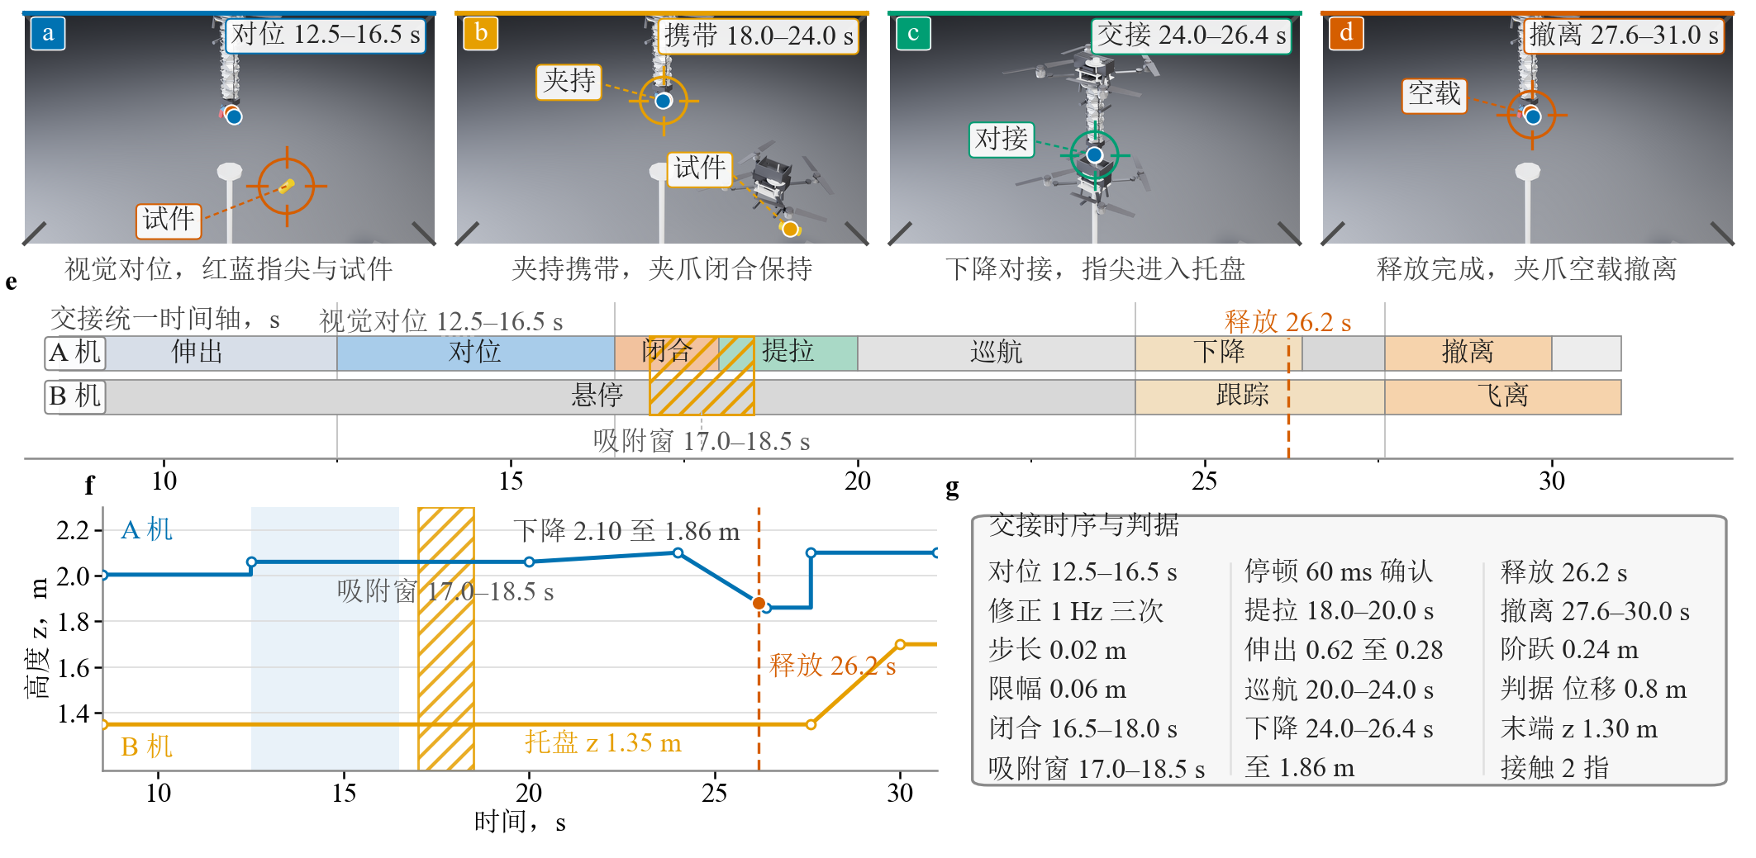
Fig. 8. Mid-air handover at four phases: alignment, carrying, transfer, and departure.

TABLE VIII Mid-air handover timeline and gates.
Time (s) | Vehicle A | Vehicle B | Event gate
0–3.0 | Pad standby (0.6, 0.9, 2.004) | Hover | —
3.0–8.5 | smoothstep cruise above specimen | Hover | —
8.5–12.5 | Arm extension e: 0→0.62 | Hover | —
12.5–16.5 | Visual alignment (1 Hz, ±0.02 m step, ±0.06 m global) | Hover | Visual detection
16.5–18.0 | Gripper closure (1.3 s ramp) | Hover | —
17.0–18.5 | Capture window | Hover | Contact count = 2, dwell 60 ms
18.0–20.0 | Lift, e: 0.62→0.28 | Hover | Capture hold
20.0–24.0 | smoothstep cruise above vehicle B (1.6, −0.9, 2.10) | Hover | —
24.0–26.4 | Descent 2.10→1.86 m | Track specimen horizontally, z=1.35 m | —
26.2 | Release (one-shot event) | Tracking | Hold state confirmed
26.4–27.6 | Hover at 1.86 m | Tracking | —
27.6–30.0 | Step return to 2.10 m | smoothstep departure to (3.2, −0.9, 1.70) | —
30.0–31.0 | Hold | Hold | Criterion statistics

G. Contact-Force Measurement and Tendon Equivalent Model
The grip force is measured through the PhysX contact solver. Contact-report APIs are enabled in pairs on the finger pads and the specimen, and the contact sensors read the net force at each pad on every physics step through the closure and lift stages. During lift the measured net contact force holds constant at 0.363 N, matching the specimen weight (37 g × 9.81 m/s²) tick by tick, so the load-carrying of the grasp is verified directly from solver data.
The tendon drive is represented by a joint-space equivalent model. The tensions of the three tendons map through the moment arm to equivalent torques on the sixteen bend joints, the pretension components cancel in the direction sum and produce no net bending, the friction component saturates with joint speed under a Coulomb model, and the hysteresis component maps the pneumatic cycle through a first-order state. The equivalent model reproduces the tension–curvature correspondence in static self-checks, the recalibrated tendon-mode bend Jacobian reads [[0.010, 0.76], [0.32, -0.47]], and the closed-loop alignment converges stably with the friction component set to zero.

V. Experimental Setup

A. Simulation Environment and Onboard Configuration
The experiments run in an aerial flexible-arm grasping scene built on NVIDIA Isaac Sim (IsaacLab), and the physics engine advances rigid-body, bend-joint, and contact dynamics at a 1 ms step (1 kHz), which resolves the 1 Hz arm oscillation, the 0.09 s actuator lag, and the capture contact transient within the integration accuracy. The onboard perception chain consists of a 1 kHz IMU, a 10 Hz GNSS position source, a 50 Hz barometric altitude source, and a nominal 30 Hz monocular camera. Sensor noise follows device-level magnitudes: accelerometer white noise σ=0.08 m/s² with a constant bias up to 0.05 m/s² drawn per random seed, gyroscope white noise σ=0.02 rad/s with a constant bias of 0.004 rad/s, GNSS position noise σ=0.05 m, and barometric altitude noise σ=0.25 m. The camera is mounted above the wrist at a body offset of (0.38, −0.45, 0.18) m, and the image is processed by 320×180 HSV color segmentation and ray–plane intersection to give the specimen planar position. The alignment loop reads the estimate at 10 Hz and applies base and bend corrections at each sample. The flexible arm uses eight bend segments (bx and by axes) and an end gripper at an extension of e=0.62, with bend servo stiffness k=10 N·m/rad and damping c=4.0 N·m·s/rad. The bend target cap of ±0.05 rad and the joint command cap of ±0.10 rad map through the bend Jacobian (largest singular value ≈0.83) to several centimeters of fingertip correction travel. Fig. 3 shows the task sequence at the four key phases.

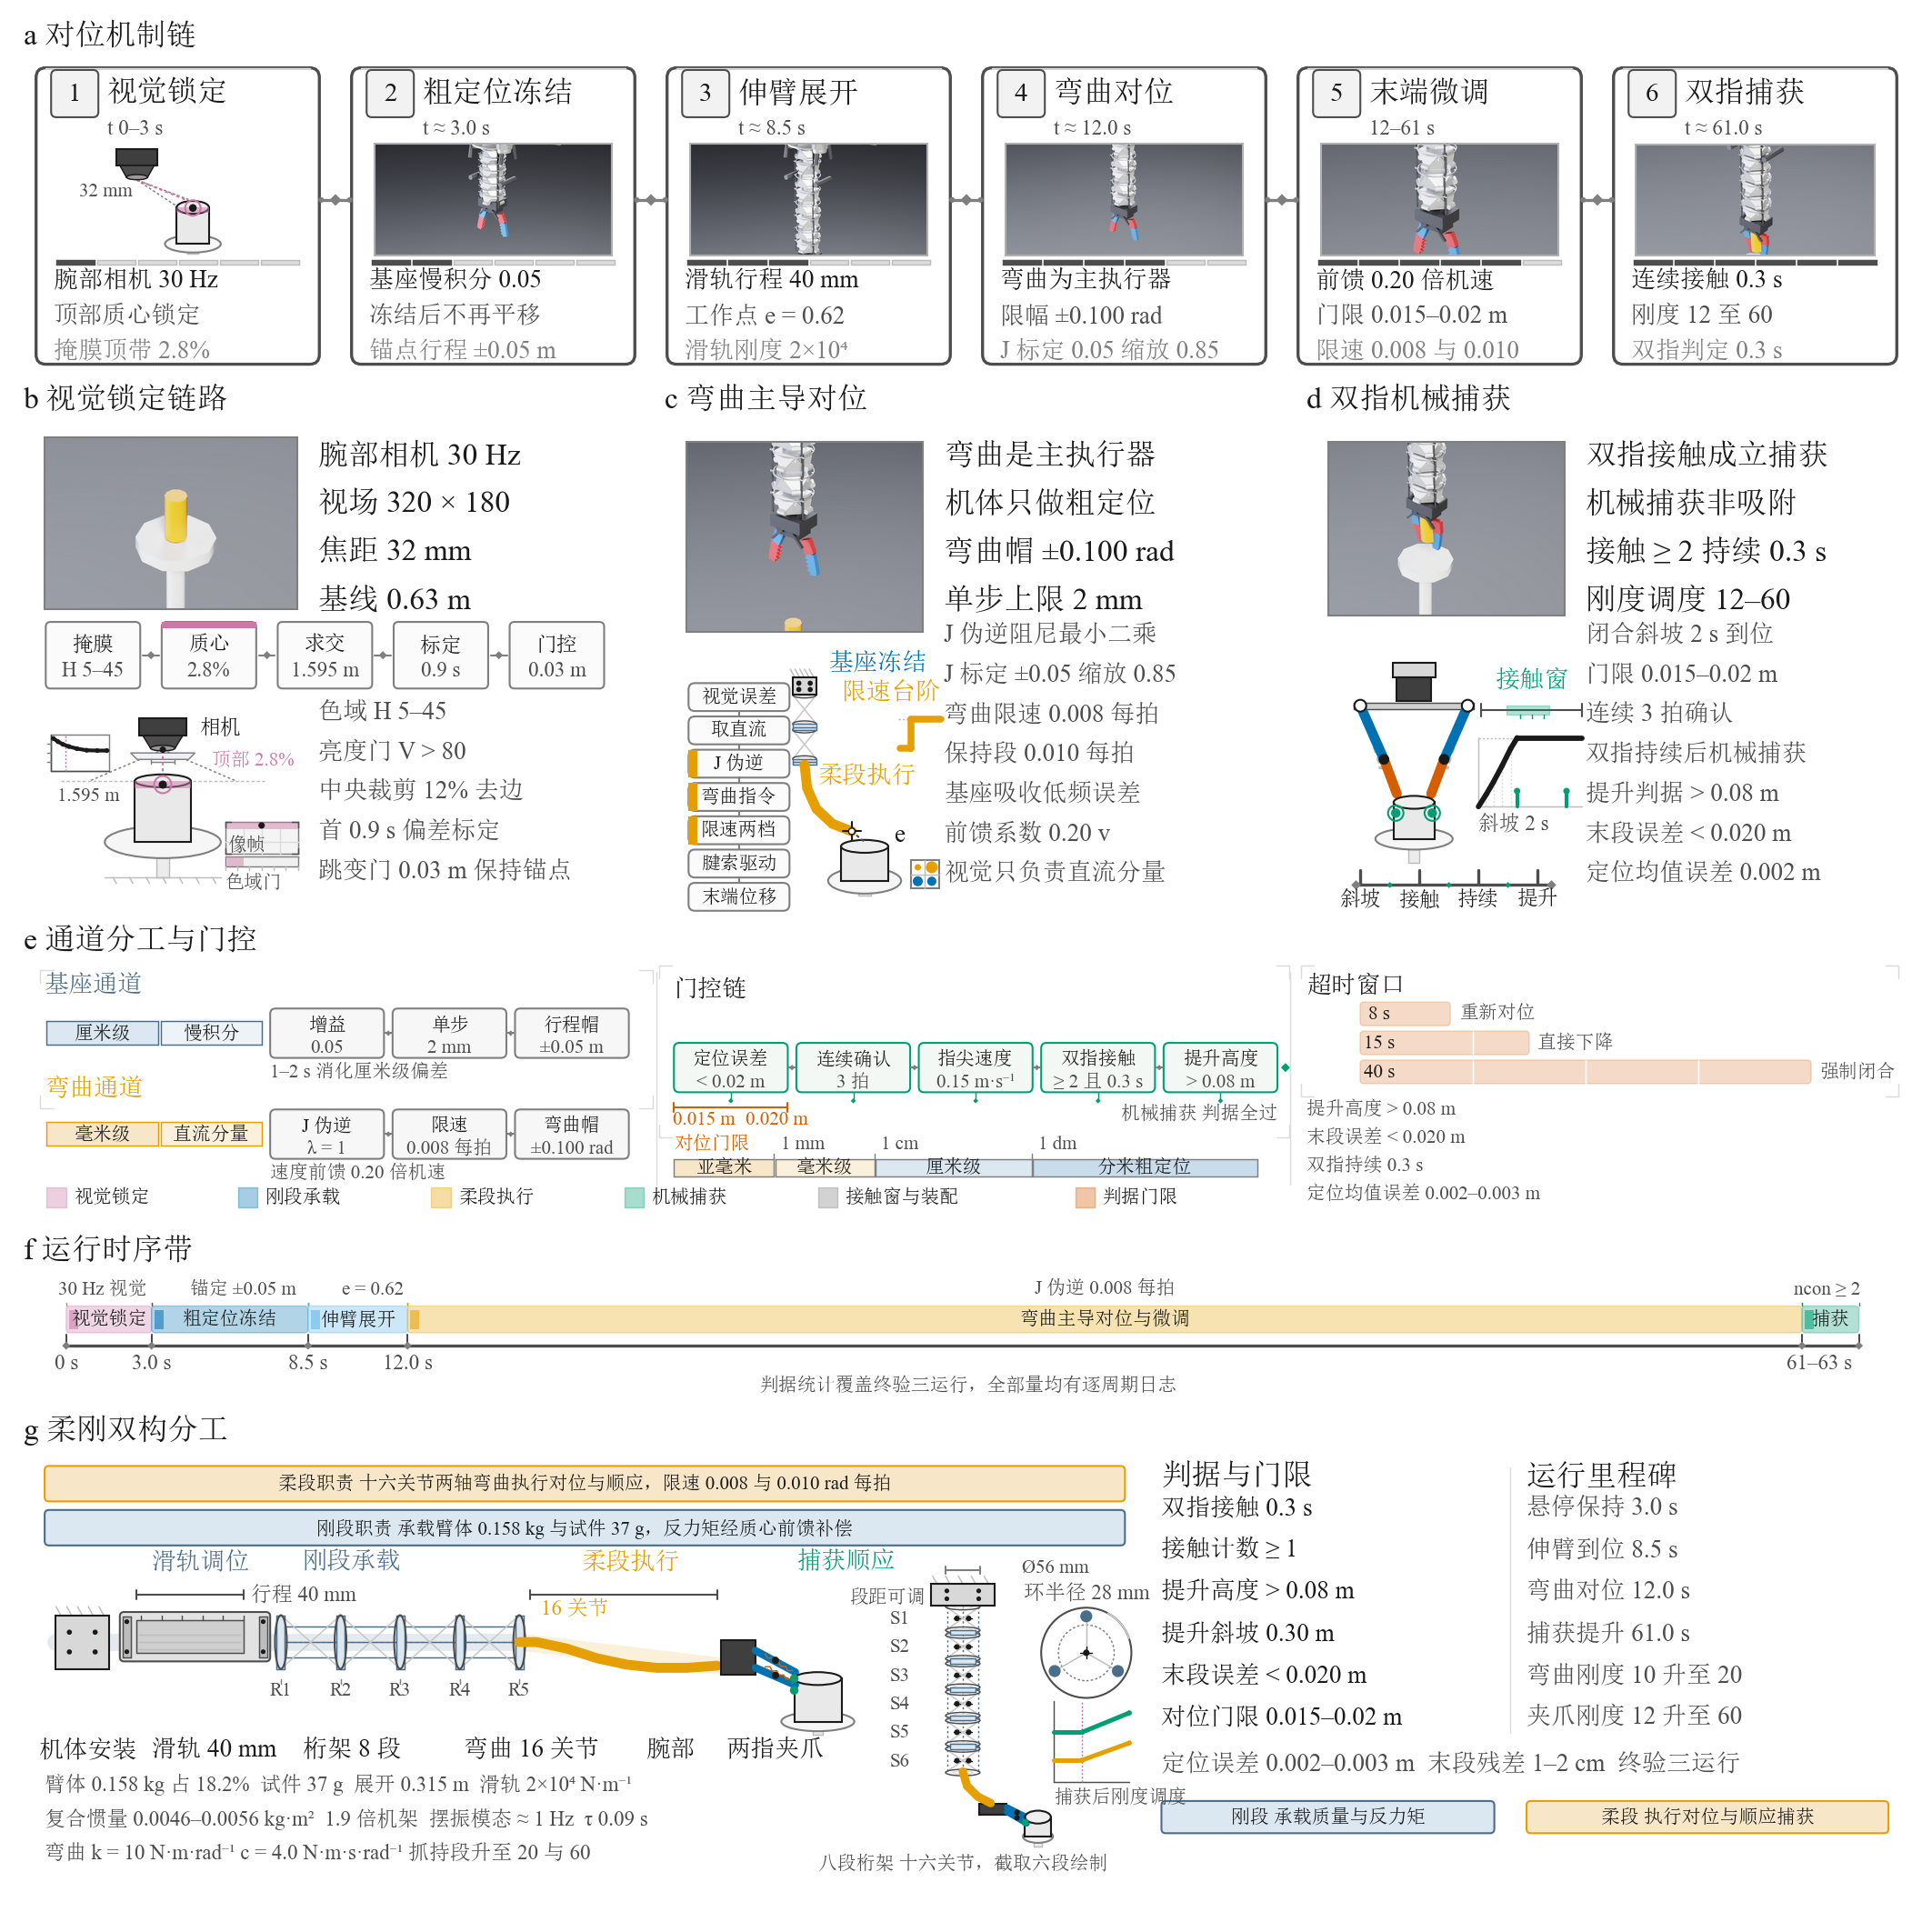
Fig. 3. Task sequence at four phases: hover stabilization (t≈3.0 s), arm extension (t≈8.5 s), visual alignment (t≈12.0 s), and closure with contact (late stage).

B. Experimental Procedure
A single grasp run lasts about 72 s and divides into four stages. During 0–3 s the platform takes off and stabilizes at the 2.15 m hover point. During 3–9 s it moves above the specimen and completes the arm extension, and the extension variable e rises smoothly from 0 to 0.62 over the first 9 s. The alignment stage begins at t=9 s: the 10 Hz visual loop drives the gentle base trim and the pure proportional bend channel together, with the settle-phase freeze holding both channels at their converged targets. The alignment stage ends at task time t=40 s. Runs whose DC error exceeds 0.05 m at that point terminate early as failures, and the remaining runs descend along a 5 s cosine profile from 2.15 m to the 2.004 m working point and rest for at least 2.5 s to let the oscillation decay. The settle-phase monitor then checks the closure gate of 0.020 m over three consecutive samples with a fingertip speed below 0.15 m/s, or forces closure after 15 s in the window. The gripper closes over a 2 s ramp, dual-finger contact must persist for 0.3 s to establish mechanical capture, and the platform lifts by 0.30 m along a 3 s ramp that starts 7 s after closure while the arm retracts from e=0.62 to e=0.30. The four-part criterion is evaluated at the end of the run.

C. Criteria
The criterion follows the main testbed and declares a pass when four conditions hold simultaneously: the specimen lift exceeds 0.08 m, the maximum contact count reaches at least one, the terminal alignment error stays below 0.02 m, and the mechanical capture hold flag is set. The terminal alignment error uses the norm of the DC error metric $|e_{lp}|$ recorded at the closure instant, in place of instantaneous sampling of the oscillating raw error. The four conditions cover lift, contact, precision, and hold, and all statistics in this article run against them.

D. Random Seeds and Run Matrix
Random seeds are realized through the sensor noise and constant biases of the DroneUnit, and the final validation covers seeds 5, 7, and 8. The convergence program that produced the final configuration spanned earlier iteration rounds (bend2 to bend5, and the v1 to v7 tuning rounds) together with a first-generation run matrix over seeds 5, 6, 7, 8, and 9. Section VI-C summarizes the decisive findings. The final runs use the configuration of Tables IV and VII, and each run writes its criterion line to a separate log.

VI. Results and Discussion

A. Main Results
All three final seeds pass the four-part criterion. Table IX lists the results, Fig. 6 shows the lift and terminal-error comparison across seeds, and Fig. 7 expands the four criteria side by side. The lift heights are 0.465, 0.407, and 0.406 m, the maximum contact count is two in every run, the terminal alignment errors from the DC metric are 0.006, 0.019, and 0.009 m, and the localization mean errors are 0.002, 0.002, and 0.003 m. Seed 5 completes descent at t=45.0 s, triggers closure at 52.8 s with a settle error of 0.009 m over three consecutive samples, registers the contact count stepping from zero to two at 53.68 s, and establishes mechanical capture at 53.98 s after 0.30 s of sustained dual-finger contact, at which point the stiffness schedule raises the gripper to 60 N·m/rad and the bend joints to 20 N·m/rad. Seed 7 closes at 49.6 s, registers contact at 50.48 s, and captures at 50.78 s. Seed 8 reaches the forced-closure window at 60.1 s, registers contact at 60.98 s, and captures at 61.28 s. The closure-to-contact delay is 0.88 s in all three runs, and every capture is triggered by the same 0.3 s dual-contact rule.

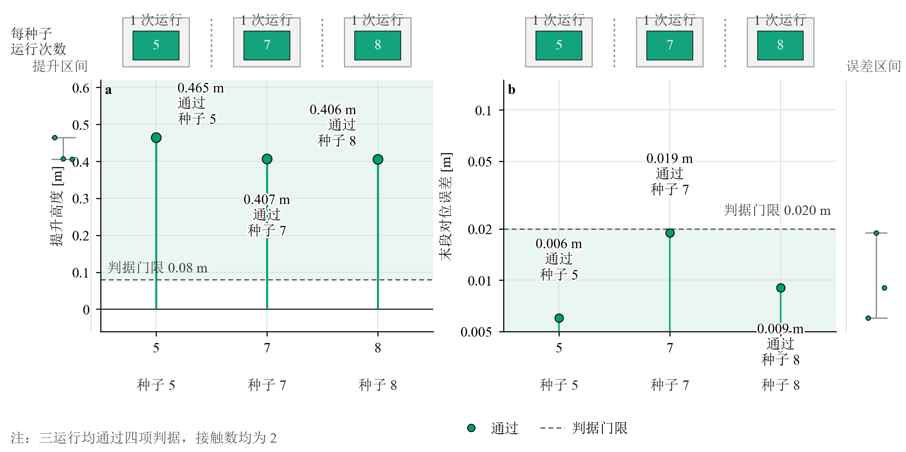
Fig. 6. Multi-seed grasp results: lift height (left) and terminal alignment error (right) by seed, with the 0.08 m and 0.020 m thresholds marked. Green encodes the pass status.
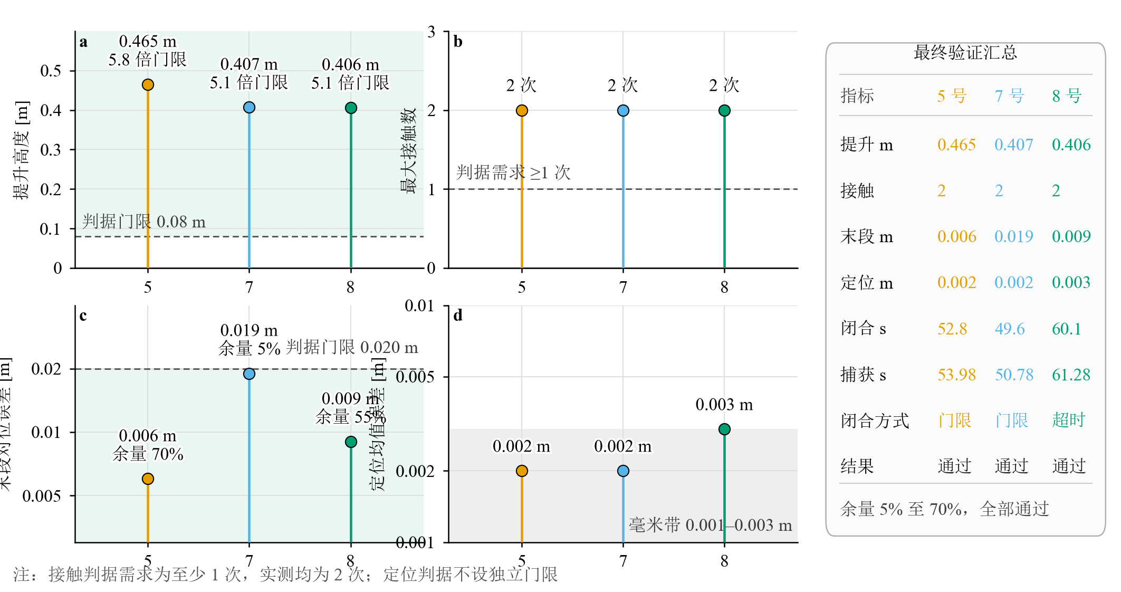
Fig. 7. Criterion structure: the four criteria (lift, maximum contact count, terminal alignment error, localization mean error) expanded side by side across runs. Marker colors encode the seed identity (orange: seed 5, sky blue: seed 7, green: seed 8), not the pass status used in Fig. 6.

TABLE IX Multi-seed main results (final configuration).
Seed | Lift (m) | Max contact | Terminal error (m) | Localization mean (m) | Closure | Capture (s) | Result
5 | 0.465 | 2 | 0.006 | 0.002 | 52.8 s, gate (0.009 m, 3 samples) | 53.98 | PASS
7 | 0.407 | 2 | 0.019 | 0.002 | 49.6 s, gate (0.012 m, 3 samples) | 50.78 | PASS
8 | 0.406 | 2 | 0.009 | 0.003 | 60.1 s, forced window | 61.28 | PASS

B. Alignment Convergence and Platform Stability
Fig. 4 traces the alignment-error convergence of the passing runs on a logarithmic scale together with the 0.02 m gate, and Fig. 5 shows the attitude and drift records. The error enters the alignment stage with an initial excursion, converges through the dual-channel action, and enters the gate band before closure. The statistics computed over t=9–66 s confirm stable behavior in all three runs: the tilt averages 2.17°, 1.76°, and 1.86° with maxima of 5.8°, 4.7°, and 4.4°, and the logged position drift, computed as the true position minus the state estimate, averages 4.1, 3.7, and 3.8 cm with maxima of 9.2, 8.9, and 8.9 cm. The bend command settles within ±0.01 rad of the frozen target during the final alignment segment, and the gentle base trim stays within 3 cm per axis for seed 7, while seeds 5 and 8 reach the ±0.05 m travel cap during the early alignment segments (around t=15–22 s and t=31–34 s for seed 5, and t=13–24 s and t=30–38 s for seed 8) before falling back to the centimeter level, settling near 1.4 cm for seed 5 and 3.4 cm for seed 8. The two channels split the workload while the anchor avoids chasing oscillation. Seed 8 illustrates the value of the DC metric: the forced closure arrived with an elevated instantaneous error of 0.045 m, while the DC error stored at closure was 0.009 m, and the criterion correctly credits the converged offset instead of a single oscillating sample.

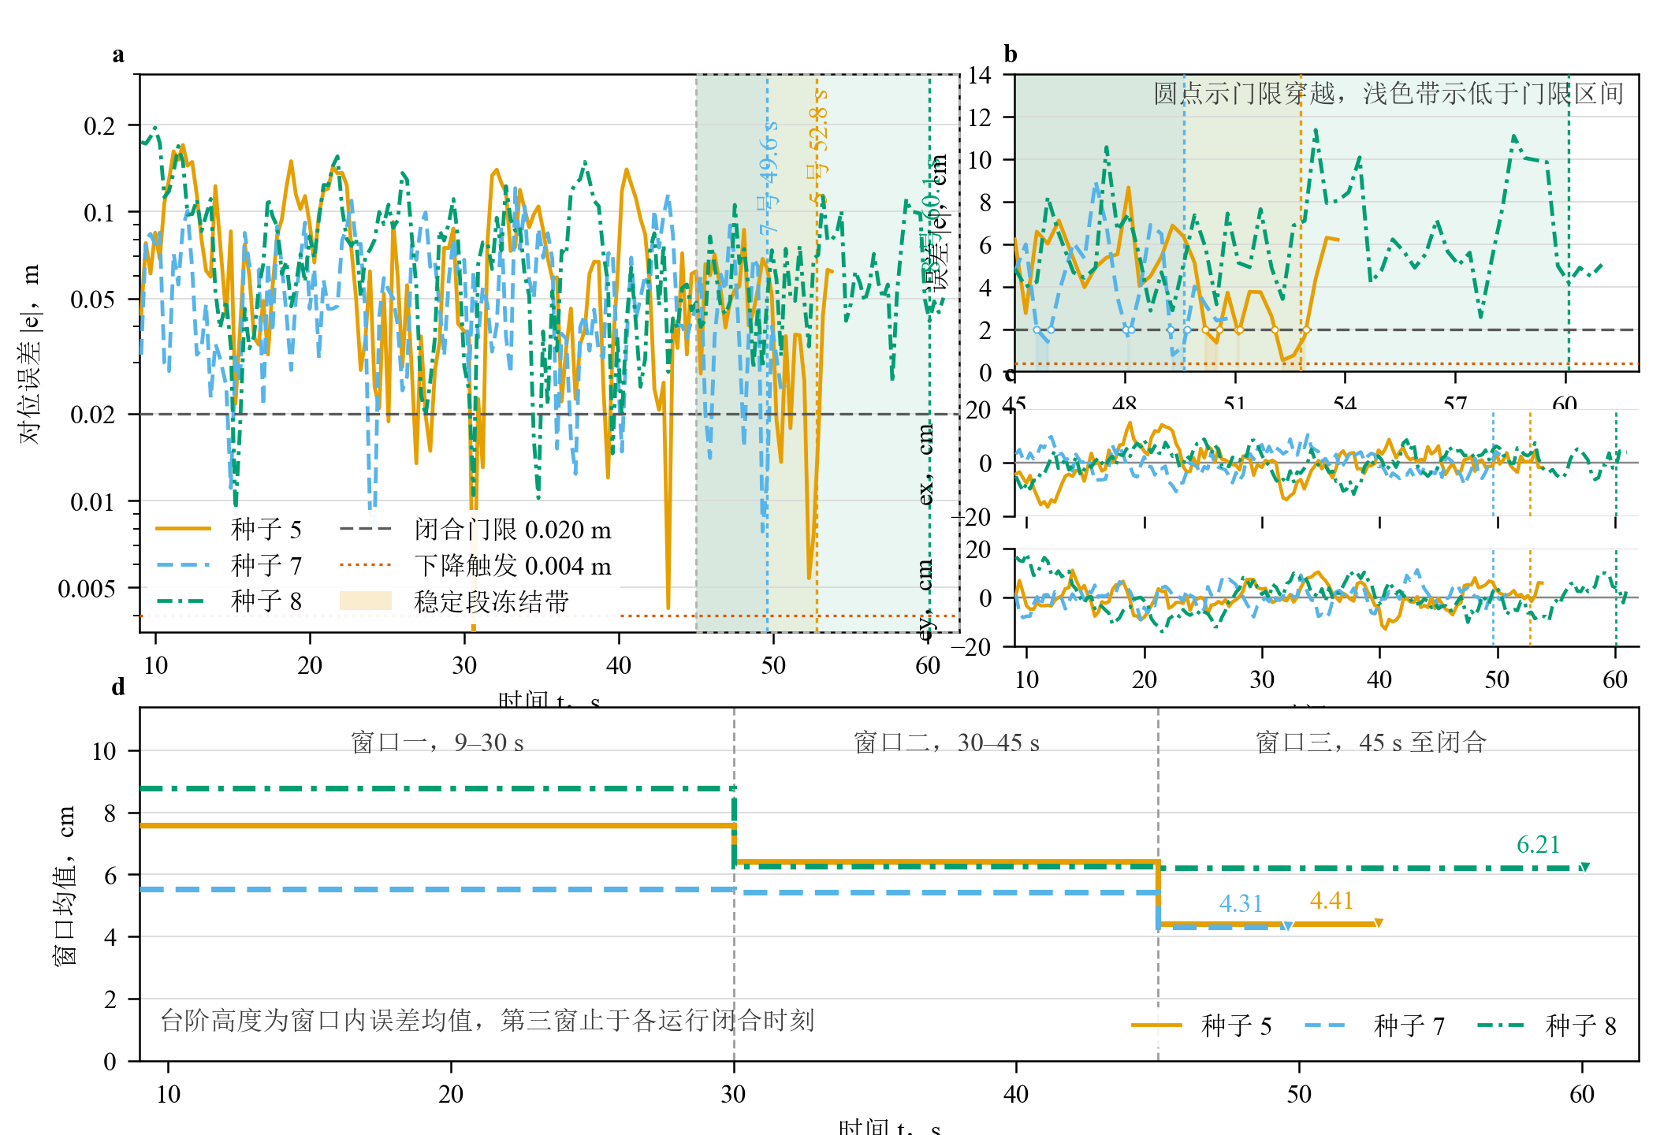
Fig. 4. Alignment-error convergence of the passing runs: the fingertip-to-target error norm on a logarithmic axis, the 0.02 m criterion gate, and the closure instants.
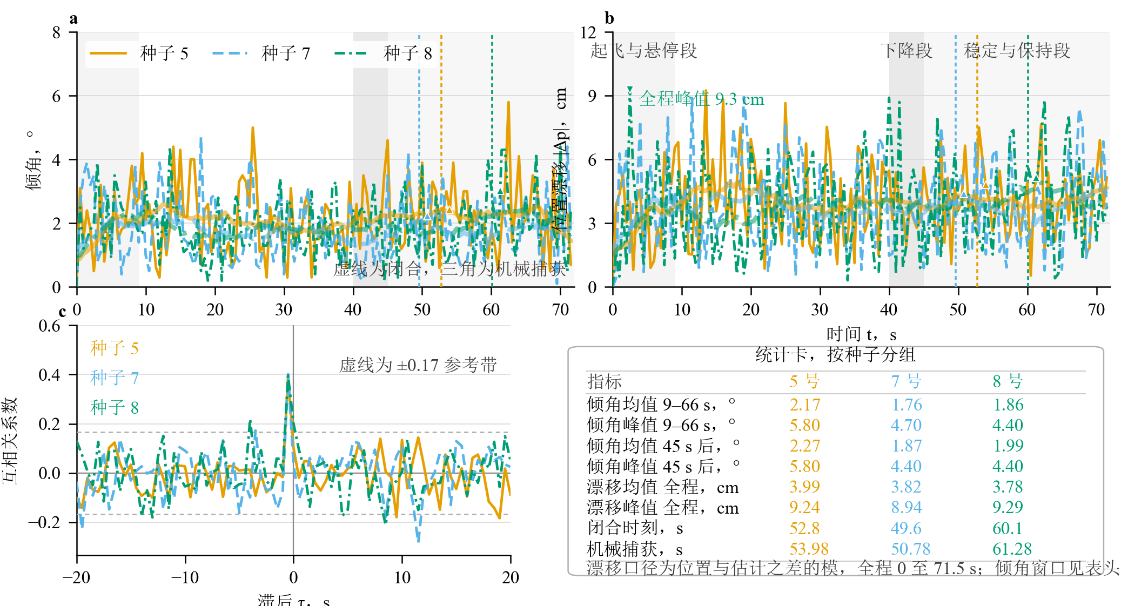
Fig. 5. Attitude and position estimation error of the three final runs: tilt (top) and the logged position estimation error, computed as the true position minus the state estimate (bottom) over time, with dotted lines marking the closure instants.

C. Convergence-Enabling Design Factors
The final configuration rests on a complete failure-diagnosis program. In the first-generation matrix, three of eight parsed runs passed, with the passing group lifting 0.392–0.472 m at terminal errors of 0.011–0.017 m, and the timeout group showing terminal errors of 0.085–0.698 m. The bend-dominant iteration then spanned more than ten rounds. Round bend2 achieved the first successful capture through sustained dual-finger contact and lifted 0.402 m, yet its terminal error of 0.135 m missed the gate. Round bend3 saturated both the base and bend channels and reached 0.170 m. Round bend4 followed the correct convergence trend but its chain time constant of 30–40 s exceeded the alignment window, leaving 0.644 m. Round bend5 worsened to 1.142 m once the base gain increased, which confirmed a positive-feedback path in which base motion excited the arm oscillation, the oscillation leaked into the slow-error channel, and the anchor kept driving the loop harder. Three subsequent stability-domain runs all completed mechanical capture while their terminal errors remained between 0.113 and 0.184 m. A decisive control experiment then showed that runs with a stationary base and near-static bend adjustments kept the platform stable, while any configuration that drove the base continuously or moved the bend joints substantially pushed the position loop into drift and circular excursions. The final root cause points at active bend motion: the combination of the servo stiffness and 0.05–0.10 rad joint angles generates reaction torques of 0.5–1.0 N·m, which exceed the ±0.4 N·m authority of the attitude trim, and the demanded 3.5° deck tilt was tracked at only 0.8°, a roughly fourfold tracking gap.
Six elements resolve the loop, and all of them proved necessary. (1) The scene layer recomputes the composite inertia every 0.5 s online, which keeps the attitude gains calibrated as the arm extends. (2) The base performs a gentle trim at a 0.05 proportion, limited to 2 mm per update and ±0.05 m of travel, and engages only when the slow error norm exceeds 10 mm, which lets sub-centimeter residuals settle naturally. (3) The bend channel runs pure proportional control with gains of 0.9 and 1.1, a ±0.05 rad target cap and a ±0.10 rad joint command cap, and no accumulator, so integral wind-up cannot pin the channel at its limit. (4) The terminal criterion adopts the norm of the DC error, which removes instantaneous sampling artifacts from the pass decision. (5) Mechanical capture requires 0.3 s of sustained dual-finger contact. (6) Alignment runs that reach task time t=40 s with a DC error above 0.05 m terminate early. Together these elements carry the multi-seed program to a 3/3 pass rate.

D. Estimation, Observer, and Damping Analyses
The offline estimator comparison of Section IV-C quantifies the main noise source of the position loop. The legacy Mahony-plus-alpha estimator forms velocity from noisy differencing and lets the accelerometer bias integrate twice into position, so a velocity noise level near 0.2 m/s drives roughly 0.9 m/s² of dithering command under the legacy velocity gain, and this dithering is the dominant excitation of position-loop oscillation. The error-state filter models the biases as random-walk states and reduces velocity, position, and attitude RMS by 73.6%, 40.3%, and 27.6% on identical measurements. The gyroscope-bias convergence and yaw-freeze behavior are shown in Fig. 10.

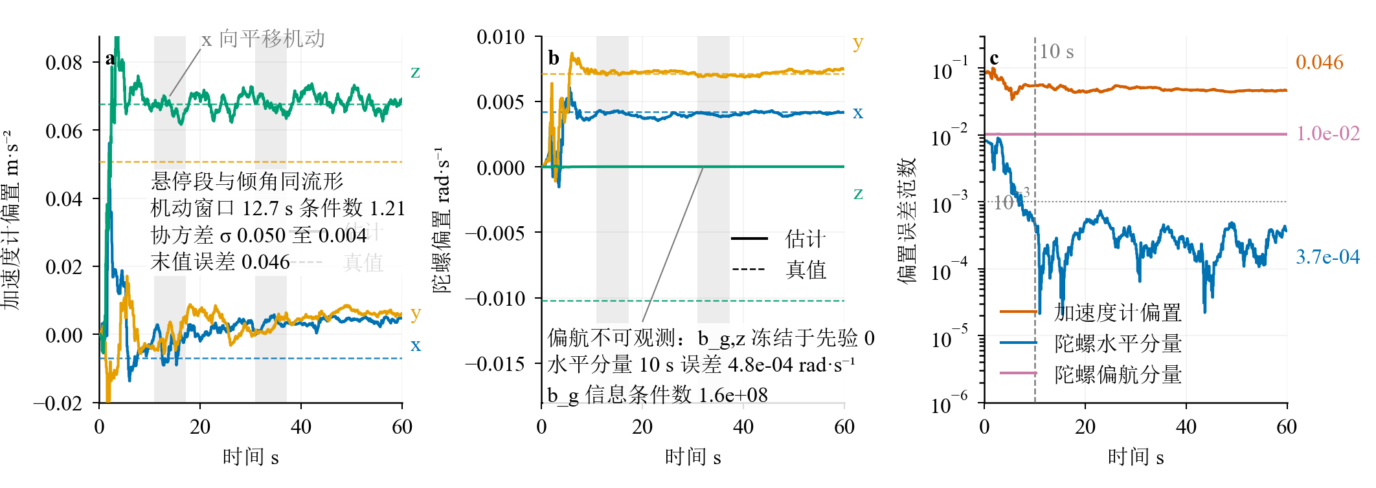
Fig. 10. EKF bias convergence: accelerometer and gyroscope bias estimates (solid) against truth (dashed). The gyroscope horizontal components converge, the z axis remains unobservable, and the accelerometer bias converges partially.

The disturbance-observer scan quantifies the compensable band. The revised NDOB uses an auxiliary-state form that eliminates the rate derivative, takes the effective motor torque as the regressor, and applies a 20 ms low-pass filter. At a 0.15 N·m step and L=2.5 it estimates d̂=0.1496 N·m against a true 0.1500 N·m, an error of 0.3%. A frequency scan at L=4 reduces the tilt standard deviation from 3.50° to 1.10° at 0.15 Hz (−69%), from 3.52° to 1.76° at 0.30 Hz (−50%), and from 3.54° to 2.93° at 0.50 Hz (−17%), and the gain vanishes over 0.8–1.2 Hz where the arm-oscillation mode lives, which leaves that band to command shaping and passive damping and forms a clear frequency split. The stability map keeps L within (0, 12] for actuator lags up to 0.09 s and recommends L=4. A 30% inertia underestimate combined with L≥6 enters the unstable domain, which is why the online inertia identification of Section IV-B precedes any observer activation. The observer stays disabled (L=0) in the main results, and a same-seed activation study is the planned follow-up.
The oscillation-damping diagnosis closes the frequency budget. The platform weighs 0.8689 kg with 0.158 kg of arm (18.2%), and the 0.250 m arm center-of-mass radius corresponds to a pendulum frequency of 0.997 Hz, matching the measured oscillation near 1 Hz. The first bend mode sits at 1.231 Hz with k=10, and the passive damping c=4.0 corresponds to ζ₁≈0.415, which sets the natural damping level of the bend servo. The legacy active-damping law saturated across the whole amplitude range: at amplitudes of 5, 10, and 20 cm the normal-velocity peaks are 0.31, 0.63, and 1.26 m/s, the command spends 62%, 82%, and 91% of the time saturated, and the equivalent fingertip deflection of 0.047–0.076 m produces about 0.80 N·m of generalized torque against 0.11–0.19 N·m of available attitude authority at 1 Hz. A 10 Hz zero-order hold and the 0.09 s actuator lag consume the remaining phase margin, and the ±0.08 channel excited the deck to 10–17° in tests. The corrected direction is a rate limit of no more than 0.03 rad per step, a 4–5 Hz low-pass filter, and momentum-observer damping in the body-torque layer at kv=0.3–0.8 N·m/(m/s). The half-cycle stop torque of 0.043–0.173 N·m for amplitudes of 5–20 cm falls inside the attitude authority, with an expected added modal damping of ζ≈0.1–0.2. Deployment-stage excitation is handled by ZVD/ZVDD command shaping scheduled with the extension length, whose residual oscillation at ±30% frequency mismatch is 24%, 5.8%, and 1.4% for ZV, ZVD, and ZVDD, respectively. The main results rely on the passive bend damping (ζ≈0.41) together with the settle-phase freeze, and the active channel remains a next-stage enhancement for the alignment window.
The Mahony-gain change from 0.9 to 0.35, the velocity-integral clamp from ±1.5 to ±1.0, and the NDOB integration pass six numerical regression scripts: unit tests pass 20/20, an ablation sweep of 495 runs reproduces the baseline alignment error of 0.0661±0.0092 m with zero divergences across 45 checks, a flight-gain scan returns 22 clean feasible candidates out of 60 with velocity-loop gain as the leading sensitivity, the worst hover drift in a drift-tuning suite stays at 0.290 m, three feedback paths in a motion-capture test remain stable at a maximum tilt of 8.5° and an angular-rate peak of 0.88 rad/s, and a fused-estimation suite passes 15/16 checks. The NDOB path with L=0 reproduces the legacy implementation bit for bit in spot checks. The regression matrix runs the same gain set as the main results.

E. Contact-Force and Tendon Closed-Loop Verification
With the paired contact reporters active, the solver writes one contact-force record per physics step. Over 11700 samples of the lift stage the net contact force holds constant at 0.363 N and matches the specimen weight tick by tick. After the tendon equivalent model enters the control loop, the bend Jacobian is recalibrated in tendon mode to [[0.010, 0.76], [0.32, -0.47]]. With the friction component set to zero the alignment loop converges, recording a terminal error of 0.002 m, a lift of 0.426 m, and sustained dual-finger contact, and the run passes the four-part criterion. Raising the camera cadence to 33 ms leaves the localization mean error at 0.003 m.

F. Discussion and Outlook
The results place the alignment precision in context. Reported precision handover systems reach 0.48 cm (0.6 m range) and 0.80±0.33 cm of continuous docking accuracy with dedicated markers and 50 Hz pose links [6], and cross-marker locking reaches 0.9 cm [27]. Our platform attains 0.006–0.019 m of terminal alignment with purely onboard monocular vision, color segmentation, and ray–plane localization, which sits in the same centimeter class and shows that a layered alignment framework remains feasible under weak perception resources. Recent contact-aware estimation results report a 66% velocity-estimate improvement from dedicated consistency factors during contact [3], which points at the same class of contact-perception coupling that appears in post-capture drift scenarios and forms a natural extension of the estimator path.
Three lines of work follow. On handover, the camera chain can be rebuilt from estimator pose and joint encoders, where analysis bounds the pose-error effect on alignment precision at 2–4 mm, and a low-gain, clamped landmark update at σ=3–5 cm can join the estimator with dual-condition release logic and contact-consistency checks, so that the single-vehicle chain of this article plugs directly into the two-vehicle sequence. On damping, the momentum observer and extension-scheduled ZVD/ZVDD shaping can be implemented over the parameter domain of Section VI-D, and a reaction-cancellation micro-damping mode with tilt monitoring (exit above 5°) can be evaluated in the alignment window, with an expected reduction of the oscillation amplitude to 2–3 cm. On estimation, the EKF (73.6% velocity improvement) and the online inertia update can be validated jointly in post-contact drift scenarios, where the fivefold pitch-inertia change from arm extension makes the update a precondition for relaxing the control bandwidth and the observer gains. The longer-term goal is a physical platform, where the sim2real calibration files exported from the teleoperation stage carry the controller and vision parameters across.

G. Limitations
This section states the applicability bounds of the reported results.
1. Capture is established through rigid-body collision contact and joint-angle readings, and the measured net contact force during lift holds at 0.363 N. Local deformation, thin-wall compression, and frictional slip at the gripper-specimen interface are treated in simplified form, so the grasp conclusions are bounded to low-speed, light-load, and quasi-static conditions, and absolute slip margins lie outside the validated range.
2. The tendons are represented by a joint-space equivalent model that carries tension, pretension, friction, and hysteresis into the control loop, while strand geometry, routing details, and the pretension transient stay outside the resolved model. Curvature and configuration conclusions carry this joint-space basis, and tendon-level geometric diagnostics fall outside the data of this work.
3. Rendering and physics advance asynchronously, and the camera produces images on a 33 ms cadence, which sets the freshness limit of the visual loop. The alignment-accuracy and stability conclusions correspond to this image cadence.
4. The EKF has completed an offline comparison, and the control path of the main configuration keeps the Mahony and alpha filter combination. The estimation-accuracy claims come from the offline same-measurement comparison, and the terminal-alignment and drift conclusions correspond to the legacy estimator path.
5. The single-vehicle results rest on one scene and one specimen, a Ø28×60 mm cylinder of 37 g, and the seeds change sensor noise and biases while the scene and specimen stay fixed. This condition confines the lift, terminal-error, and contact-count conclusions to this specimen and scene geometry, and performance across sizes, materials, and multi-object scenes lies outside the covered samples.
6. The handover is organized by a phase-gated script with one preliminary execution. That run did not establish the capture hold at release, so the three handover criteria were not met, and full-sequence verification and multi-seed statistics lie outside the data of this work.
7. All results come from the Isaac Sim closed loop, physical-platform data have not been collected, and wind disturbance, downwash, and visual degradation remain outside the test matrix. This gap bounds the extrapolation of the conclusions, and physical aerodynamic-perturbation and perception-degradation effects lie outside the data of this work.

VII. Conclusion
This article studied precision grasping and mid-air handover with a truss-based flexible-arm aerial manipulator and built an aerial grasping platform from an eight-segment bend structure, a prismatic rail, and a diamond two-finger gripper, together with a six-phase autonomous pipeline spanning visual alignment, descent, settle, closure, capture, and lift. On the method side, the dual-channel visual fine alignment distributes the image residual across a large-stroke base channel and a high-bandwidth bend channel, the settle-phase freeze with continuous-gate decisions stabilizes the terminal phase, and the DC error metric holds the terminal alignment error at 0.006–0.019 m. The online identification of the composite inertia tensor keeps the attitude loop calibrated as the arm extends, which proved to be the decisive fix for the stability problem. The 15-state error-state Kalman filter reduces velocity, position, and attitude RMS errors by 73.6%, 40.3%, and 27.6% on identical measurements, with the observable gyroscope-bias axis converging within 10 s to better than 7×10⁻⁴ rad/s, and the attitude integral trim with gravity feedforward suppresses the body coupling induced by arm extension, holding the mean tilt near 2° and the mean position drift near 4 cm. In multi-seed simulation, all three seeds pass the four-part criterion, with lift heights of 0.406–0.465 m, contact counts of two, and every capture established through 0.3 s of sustained dual-finger contact. The phase-gated handover sequence is designed and implemented, with verification of the full transfer chain left to future work. Future work follows three directions: integrating a real camera-pose chain with visual landmarks to strengthen onboard perception, implementing reaction-compensated active oscillation damping to widen the operating bandwidth of the flexible arm, and validating the system on a physical platform under wind disturbance and dynamic targets.

References
[1] S.C. Barakou, C.S. Tzafestas, K.P. Valavanis, A review of real-time implementable cooperative aerial manipulation systems, Drones 8 (5) (2024) 196. [2] D. Lee, H. Seo, D. Kim, H.J. Kim, Aerial manipulation using model predictive control for opening a hinged door, in: 2020 IEEE International Conference on Robotics and Automation (ICRA), 2020, pp. 1237–1242. [3] Y. Zhan, Y. Jiang, M. Cao, J. Geng, Aerial manipulation with contact-aware onboard perception and hybrid control, in: 2026 IEEE International Conference on Robotics and Automation (ICRA), 2026, pp. 18402–18409. [4] J. Byun, B. Kim, C. Kim, D.D. Oh, H.J. Kim, Stable contact guaranteeing motion/force control for an aerial manipulator on an arbitrarily tilted surface, in: 2023 IEEE International Conference on Robotics and Automation (ICRA), 2023, pp. 5345–5351. [5] H.C. Cheung, B. Jiang, Y. Hu, H.K. Chu, C.-Y. Wen, C.-W. Chang, Aerial grasping with soft aerial vehicle using disturbance observer-based model predictive control, arXiv:2409.14115, 2024. [6] H. Cao, J. Shen, Y. Zhang, Z. Fu, C. Liu, S. Sun, S. Zhao, Proximal cooperative aerial manipulation with vertically stacked drones, Nature 646 (8085) (2025) 576–583. [7] K. Yang, C. Bai, Z. She, Q. Quan, High-speed interception multicopter control by image-based visual servoing, IEEE Transactions on Control Systems Technology 33 (1) (2025) 119–135. [8] D. Abeywardena, S. Huang, B. Barnes, G. Dissanayake, S. Kodagoda, Fast, on-board, model-aided visual-inertial odometry system for quadrotor micro aerial vehicles, in: 2016 IEEE International Conference on Robotics and Automation (ICRA), 2016, pp. 1530–1537. [9] E. Eraslan, Y. Yildiz, Modeling, control and human-in-the-loop stability analysis of an elastic quadrotor, arXiv:2012.05747, 2020. [10] H. Chen, B. Ye, X. Liang, W. Deng, X. Lyu, NDOB-based control of a UAV with delta-arm considering manipulator dynamics, in: 2025 IEEE International Conference on Robotics and Automation (ICRA), 2025, pp. 7505–7511. [11] M.B.J. Brummelhuis, N.F. Lepora, S. Hamaza, Omnidirectional dual-arm aerial manipulator with proprioceptive contact localization for landing on slanted roofs, in: 2026 IEEE International Conference on Robotics and Automation (ICRA), 2026, pp. 13209–13215. [12] Y.S. Sarkisov, M.J. Kim, A. Coelho, D. Tsetserukou, C. Ott, K. Kondak, Optimal oscillation damping control of cable-suspended aerial manipulator with a single IMU sensor, in: 2020 IEEE International Conference on Robotics and Automation (ICRA), 2020, pp. 5349–5355. [13] G. He, Y. Jangir, J. Geng, M. Mousaei, D. Bai, S. Scherer, Image-based visual servo control for aerial manipulation using a fully-actuated UAV, in: 2023 IEEE/RSJ International Conference on Intelligent Robots and Systems (IROS), 2023, pp. 5042–5049. [14] W. Li, H. Wang, J. Su, C. Liu, W.-H. Chen, S. Li, Autonomous UAV pipeline near-proximity inspection via disturbance-aware predictive visual servoing, arXiv:2604.19618, 2026. [15] X. Wang, Y. Cao, W.L.W. Leong, Y.R. Tan, S. Huang, S.H.R. Teo, C. Xiang, Terminal constraint model predictive control for image-based visual servoing of UAVs with Kalman filter-based moment loss compensation, arXiv:2605.22443, 2026. [16] F. Aghili, Fault-tolerant and adaptive visual servoing for capturing moving objects, IEEE/ASME Transactions on Mechatronics 27 (3) (2022) 1773–1783. [17] A. Tao, J. Yang, S. Oparnica, W. Xue, Perception-control coupled visual servoing for textureless objects using keypoint-based EKF, in: 2026 IEEE International Conference on Robotics and Automation (ICRA), 2026, pp. 550–557. [18] P. Katara, Y.V.S. Harish, H. Pandya, A. Gupta, A.M. Sanchawala, G. Kumar, B. Bhowmick, M. Krishna K, DeepMPCVS: Deep model predictive control for visual servoing, in: Proceedings of the 2020 Conference on Robot Learning (CoRL), PMLR 155, 2021, pp. 2006–2015. [19] I.S. Mohamed, MPPI-VS: Sampling-based model predictive control strategy for constrained image-based and position-based visual servoing, arXiv:2104.04925, 2021. [20] L. Markovic, M. Kovac, R. Milijas, M. Car, S. Bogdan, Error state extended Kalman filter multi-sensor fusion for unmanned aerial vehicle localization in GPS and magnetometer denied indoor environments, in: 2022 International Conference on Unmanned Aircraft Systems (ICUAS), 2022, pp. 184–190. [21] M. Cohen, J.R. Forbes, Navigation and control of unconventional VTOL UAVs in forward-flight with explicit wind velocity estimation, IEEE Robotics and Automation Letters 5 (2) (2020) 1151–1158. [22] B.T. Lopez, A contracting hierarchical observer for pose-inertial fusion, arXiv:2303.02777, 2023. [23] P. van Goor, R. Mahony, EqVIO: An equivariant filter for visual-inertial odometry, IEEE Transactions on Robotics 39 (5) (2023) 3567–3585. [24] X. Ye, F. Song, Z. Zhang, R. Zhang, Q. Zeng, Semi-aerodynamic model-aided invariant Kalman filtering for UAV full-state estimation, IEEE Sensors Journal 24 (16) (2024) 25920–25939. [25] A. Altawaitan, J. Stanley, S. Ghosal, T. Duong, N. Atanasov, Learned IMU bias prediction for invariant visual inertial odometry, IEEE Robotics and Automation Letters 10 (11) (2025) 11872–11879. [26] H. Garcia de Marina, F.J. Pereda, J.M. Giron-Sierra, F. Espinosa, UAV attitude estimation using unscented Kalman filter and TRIAD, IEEE Transactions on Industrial Electronics 59 (11) (2012) 4465–4474. [27] A. Seth, A. James, E. Kuantama, R. Han, S. Mukhopadhyay, AeroBridge: Autonomous drone handoff system for emergency battery service, in: Proceedings of the 30th Annual International Conference on Mobile Computing and Networking (MobiCom), 2024, pp. 573–587. [28] Y. Cai, J.M.K. Tan, X. Li, C. Jin, N. Kemsaram, V. Modugno, A progress-aware leader-follower midair docking system for dual-drone aerial manipulation, in: 2026 IEEE 22nd International Conference on Automation Science and Engineering (CASE), 2026, pp. 276–283. [29] A. Shankar, S. Elbaum, C. Detweiler, Towards in-flight transfer of payloads between multirotors, IEEE Robotics and Automation Letters 5 (4) (2020) 6201–6208. [30] M. Mohandes, B. Moradi, K. Gupta, M. Mehrandezh, Robot to human object handover using vision and joint torque sensor modalities, in: Robot Intelligence Technology and Applications 7, Springer, 2023, pp. 109–124. [31] D. Ferrari, A. Pupa, C. Secchi, Compliant blind handover control for human-robot collaboration, in: 2024 IEEE/RSJ International Conference on Intelligent Robots and Systems (IROS), 2024, pp. 9321–9327. [32] J. Sugihara, M. Kitagawa, J. Li, Y. Li, T. Nishio, K. Okada, M. Zhao, Self-assembling modular aerial robot for versatile aerial tasks, arXiv:2605.19431, 2026.

